How Does Increasing Heterozygote Advantage Influence the Rescue Probability of Diploid vs. Tetraploid Populations?

**Abstract**

In theoretical ecology, understanding the factors that enhance population survival is key. Polyploidy, a condition of having multiple sets of chromosomes, is prevalent in certain species and is thought to confer resilience to environmental challenges. This project examines whether polyploidy, specifically tetraploids, enhances population survival when heterozygote advantage (selection coefficient) is increased. How does increasing heterozygote advantage influence the survival rates of diploid vs. tetraploid populations? This question aims to explore the differential impact of selection coefficients on populations with varying ploidy levels, investigating if tetraploid populations have a survival advantage under selective pressures favouring heterozygotes.

**Introduction**

Polyploidy is the heritable condition of possessing more than two complete sets of chromosomes. Most polyploids have an even number of sets of chromosomes, with four being the most common (tetraploids). Polyploids are very common among plants and common among fish and amphibians and are usually fit and well adapted. It has been a significant driver in plant evolution, providing increased genetic variation and mutation rates, which are essential components of adaptation. Looking at the survival advantage in tetraploids, this research explores how genetic variation translates to real evolutionary success. Whether the added genetic material genuinely translates to a buffer against extinction, to help understand better natural selection mechanisms and adaptive potential.

Understanding how heterozygote advantage affects the survival rates of diploid versus tetraploid populations is a compelling question in evolutionary biology, as it delves into the complex interactions between genetics, natural selection, and population dynamics. Heterozygote advantage, often referred to as overdominance, is the scenario where heterozygous individuals exhibit a higher fitness than either homozygous type. This concept is fundamental in explaining the maintenance of genetic diversity within populations, especially for traits governed by a single locus with two alleles. Exploring this phenomenon in diploid and tetraploid populations opens avenues for understanding how genetic configurations and ploidy levels impact evolutionary trajectories, particularly under selective pressures. Given the prevalence of polyploidy in plants and its occasional occurrence in animals, examining these dynamics is crucial for a broader comprehension of adaptive mechanisms in various life forms.

One of the primary reasons this question is interesting is that polyploidy introduces unique genetic advantages and challenges. In a diploid organism, each individual possesses two sets of chromosomes, whereas tetraploids have four. This difference not only affects the gene dosage but also impacts how selection operates on alleles in the population. For instance, in a tetraploid population, the presence of two additional alleles at each locus increases the complexity of how selection acts on genetic variants. More heterozygosity can theoretically lead to greater buffering against deleterious alleles, allowing tetraploid populations to exhibit increased resilience and adaptability. Furthermore, polyploidy is a significant driver of speciation in plants, contributing to the emergence of new species with unique ecological adaptations (Otto & Whitton, 2000; Soltis & Soltis, 2000). Therefore, understanding the interplay between ploidy levels and heterozygote advantage may reveal key insights into species survival and evolutionary success.

As the heterozygote advantage or selection coefficient increases, the dynamics between diploid and tetraploid populations diverge notably. In diploid populations, the advantage conferred to heterozygotes can lead to a balanced polymorphism, where multiple alleles are stably maintained within the population. This balance occurs because heterozygous individuals have higher fitness, reducing the probability that any one allele will become fixed and dominate the gene pool. Consequently, diploid populations with a strong heterozygote advantage exhibit increased genetic diversity and resilience against selective pressures, which may improve their long-term survival rates in fluctuating environments (Crow & Kimura, 1970).

In contrast, tetraploid populations experience a more complex interaction due to the presence of four alleles at each locus. With increasing heterozygote advantage, tetraploid populations may exhibit an even greater retention of genetic diversity than diploids. For instance, the buffering effect of polyploidy can prevent the rapid loss of rare alleles, thus enabling the population to retain a broader genetic base. Additionally, tetraploids may be able to exploit environmental niches that are inaccessible to diploids due to their increased genomic flexibility and ability to harbor a wider range of allelic combinations (Comai, 2005). This flexibility could be beneficial in fluctuating or stressful environments, where a variety of genetic combinations may allow for a quicker and more adaptive response.

The implications of these dynamics are supported by research showing that polyploid plants often have broader ecological niches than their diploid counterparts, likely due to their ability to maintain higher levels of heterozygosity (Madlung, 2013). For instance, species within the genera *Trifolium* and *Arabidopsis* display substantial variation in survival and adaptation based on ploidy levels, indicating that polyploidy provides a selective advantage under certain environmental conditions (Otto & Whitton, 2000). Moreover, theoretical models have demonstrated that polyploid populations with high heterozygosity can maintain more stable population sizes, which contributes to their resilience over time (Crow & Kimura, 1970; Soltis et al., 2014). However, polyploidy is not universally beneficial; the advantage it confers may be context-dependent, varying with factors such as population size, mutation rate, and environmental stability.

Another layer to consider is that while tetraploid populations may benefit from a higher selection coefficient in terms of survival, they may also face challenges related to genome stability and reproductive compatibility. The additional sets of chromosomes in tetraploids can lead to complications during meiosis, which may result in reduced fertility or the production of aneuploid offspring (Soltis & Soltis, 2000). These factors can impose a constraint on the evolutionary potential of tetraploids, balancing out some of the benefits conferred by increased heterozygosity. Nevertheless, empirical studies have shown that, in the face of strong selection for heterozygote advantage, tetraploid populations are more likely to preserve beneficial alleles and exhibit greater adaptability over generations than diploid populations (Otto, 2007).

**Model & Methods**

This simulation model of this project examines how increasing heterozygote advantage impacts the survival rates of diploid and tetraploid populations. Initial population parameters were set up for both population types, each starting with 250 individuals of the fully susceptible homozygous genotypes (rr in diploids and rrrr in tetraploids), thereby mimicking a scenario in which resistance must evolve for the population to survive.

Fig1. A visual representation of the model.

The simulation included two primary functions: simulate_pop_diploid for diploid populations and simulate_pop_tetraploid for tetraploid populations. Each function iteratively applied selective pressures across generations, accounting for decay rates and mutation rates to reflect the effects of herbicide application. A decay rate of 0.155 represented the lethality of herbicide application, while mutation rates were kept low (0.01) to realistically simulate the rare emergence of resistance alleles.

To introduce varying levels of heterozygote advantage, a selection coefficient table was generated with a custom function, create_sel_coeffs, which produced a matrix of selection coefficients ranging from low to high heterozygote advantages. Each row in this table represented a different level of heterozygote advantage, with 500 replicates run per level to determine the probability of survival. For each simulation run, populations were recorded as “survived” if any individuals remained at the end of 100 generations.

To visualize results, survival rates for each level of heterozygote advantage were plotted, comparing diploid and tetraploid populations. The main graph (Figure 1) demonstrates the survival rate trends as heterozygote advantage increases.

1. **Population Simulations**: Developed functions to simulate population dynamics for both diploid and tetraploid genotypes over multiple generations.
2. **Selection Coefficient Table**: Created a table of increasing selection coefficients representing heterozygote advantage. (Refer to Fig3. for fitness landscape visualization)
3. **Replication**: Conducted 500 replicates for each heterozygote advantage level across both ploidy levels, recording survival rates at the end of each simulation.

**Results**

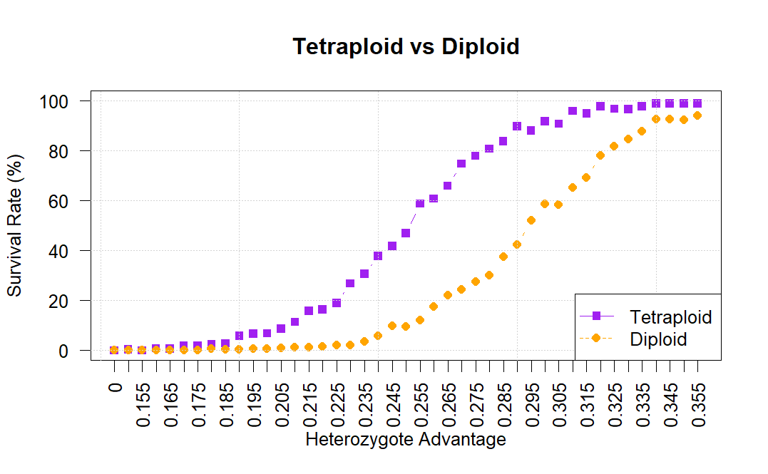

Fig2. The decay rate is shown by the red arrow. The survival rate of tetraploid populations increases with heterozygote advantage. At moderate levels, survival begins to increase rapidly, reaching near-certainty at high heterozygote advantages. This pattern suggests that tetraploids benefit significantly from even moderate selection for heterozygotes.

The comparative plot highlights that tetraploid populations have consistently higher survival rates than diploids at equivalent heterozygote advantage levels. This advantage is most pronounced at moderate levels of heterozygote advantage, illustrating that tetraploids require less extreme fitness benefits to achieve high survival.

**Discussion**

The results support the hypothesis, showing that increasing heterozygote advantage improves survival in both ploidy levels but benefits tetraploids more significantly. Tetraploid appears to offer a buffering capacity against environmental pressures, likely due to increased genetic flexibility and allelic combinations. This could explain the prevalence of polyploidy in certain species and environments where genetic diversity and adaptability are beneficial.

In summary, the results clearly indicate that increasing heterozygote advantage has a positive effect on survival rates for both diploid and tetraploid populations, with tetraploids demonstrating superior survival rates under moderate to high levels of heterozygote advantage. These findings answer the research question by showing that tetraploid populations are inherently more resilient under conditions of heterozygote advantage compared to diploid populations. This suggests that tetraploids may provide an evolutionary benefit in environments where heterozygote advantage is a significant factor, potentially explaining the prevalence of polyploidy in certain plant species and ecological niches. The results underscore the role of genetic structure in population resilience and provide insights into how selection pressures influence the survival of diploid and tetraploid populations differently, affirming that tetraploids offers a survival advantage in scenarios with favourable heterozygote selection.

**References**

* Comai, L. (2005). The advantages and disadvantages of being polyploid. *Nature Reviews Genetics, 6*(11), 836-846.
* Crow, J. F., & Kimura, M. (1970). *An Introduction to Population Genetics Theory*. Harper & Row.
* Madlung, A. (2013). Polyploidy and its effect on evolutionary success: old questions revisited with new tools. *Heredity, 110*(2), 99-104.
* Otto, S. P. (2007). The evolutionary consequences of polyploidy. *Cell, 131*(3), 452-462.
* Otto, S. P., & Whitton, J. (2000). Polyploid incidence and evolution. *Annual Review of Genetics, 34*(1), 401-437.
* Soltis, P. S., & Soltis, D. E. (2000). The role of genetic and genomic attributes in the success of polyploids. *Proceedings of the National Academy of Sciences, 97*(13), 7051-7057.
* Soltis, P. S., Marchant, D. B., Van de Peer, Y., & Soltis, D. E. (2014). Polyploidy and genome evolution in plants. *Current Opinion in Genetics & Development, 24*, 134-141.

**Author Contributions**

The project topic was developed and refined collaboratively by Rüya Eylül Arslan and Aigerim Adilbekova. Rüya Eylül Arslan was mainly responsible for the coding, and presentation design. Aigerim Adilbekova contributed by writing the report and collaborating in background research. Both authors discussed the approach together.

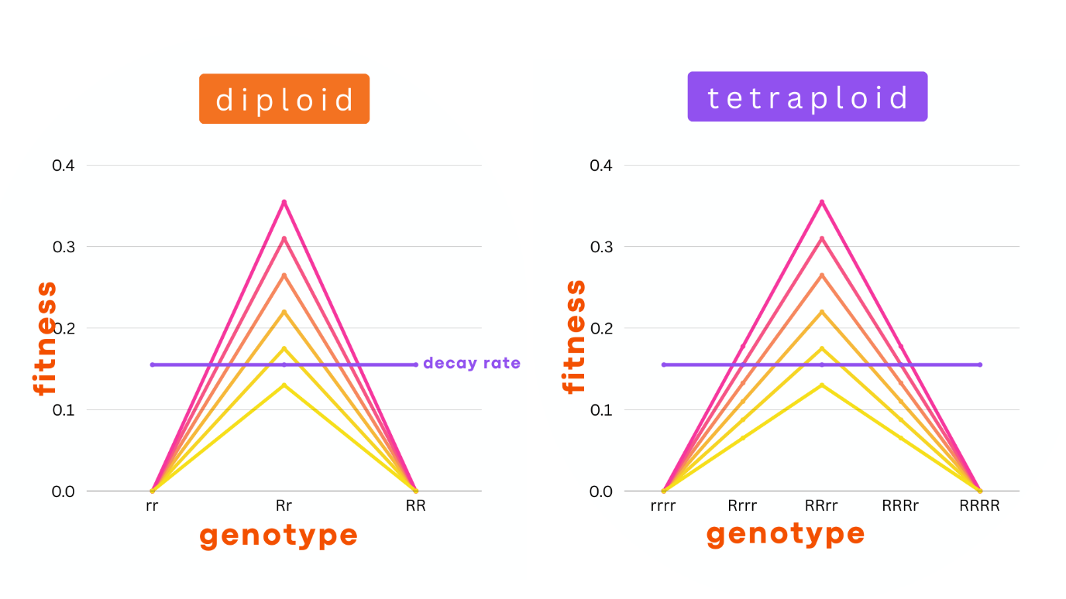

Fig3. Fitness Landscape model for diploid and tetraploid genotypes.