Hydrologic Modeling

Reza Abdi – HW#4

A short discussion of the main problems with the model you created. This should include a list of 3 changes/additions you would make to improve your model. You should reflect on the plots produced in parts d) and e) to motivate your suggested changes/additions (i.e. where is the model doing well and where the model is doing poorly?).

Considering the predicted and observed annual average daily discharge, it seems that the predictions have a specified situation comparing with the observed discharges. However, as shown in figure 1, there is a specific year (1943) which the gap between the modeled and observed discharges is more that the rest of the years. Although the reservoirs have been made after 1960, the reason should be an abnormal water usage at that time. I checked the google to find the possible reasons, but I could not find the reason.

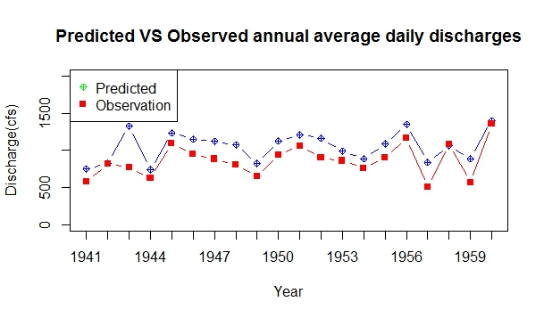

**Figure 1.** Observed and modeled annual daily discharges

There are some mistakes in concern with the comparison of predicted and observed monthly average discharges. Figure 2 shows that during October to February observed flow discharge are less than the predictions However, beginning February, the amount of observed discharge increases. This issue might have one important reason which is snowmelt. The model did not consider snowmelt during warmer months and for colder months, some of the precipitation turns to snow and would not be considered as neither ET nor runoff. Another reason could be the infiltration issue. The model in this assignment does not consider infiltration and it can impact the amount of observed amount of discharge.

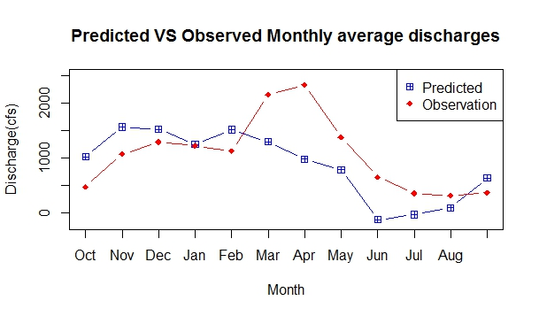

**Figure 2.** Observed and modeled monthly average discharges