CIS 554 Object Oriented Programming in C++

Assignment #4

**Name: Reza Abdi**

**SUID: reabdi**

1. Issues encountered sorting large arrays and vectors with recursion. How did you fix the issue(s) encountered?

While sorting large arrays and vectors of size greater than 3500, stack overflow error was happening and the window was crashing (as shown in figure 1). According to the references, the size of the call stack depends on several factors, such as the language, machine architecture, and amount of available memory. Main result of a stack overflow is an attempt to allocate more memory on the stack than will fit. I fixed this issue by increasing the stack size up to 10 Mbyte.

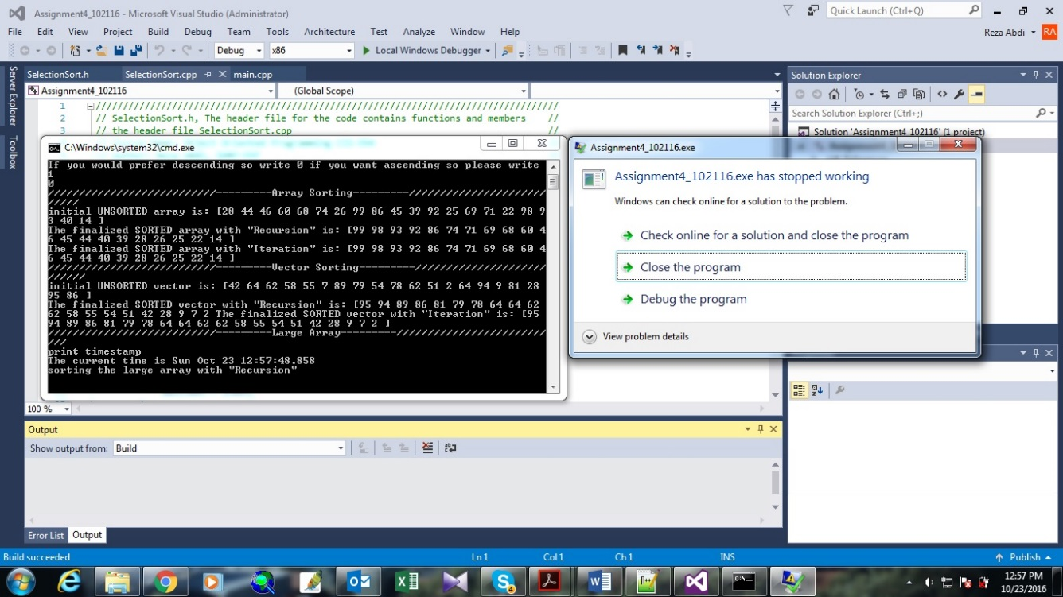

Figure 1. The error message which I had in my running

1. The difference in performance between sorting with recursion version iteration. Which performed better, and **why**?

For small array or small vector, the difference in performance of iteration and recursion methodologies was not impressive. But for large arrays and vectors, iteration performed better than recursion. For example, in large arrays (7000 members), the code spent 0.123 second for sorting the array in recursive method. However, for same array the iterative methodology took 0.004 second. The bigger difference is for vectors where the recursive function took 13.116 second to sort the vector but in iterative method it took 0.009 second which is much better. These results are shown in figure 2. The reason for better performance of the iterative method as mentioned in the lecture for recursion: overhead of repeated function calls and each recursive call causes another copies of the function to be created and this causes weaker performance in large amount of data. So it the size of memory is very important driver for these two method.

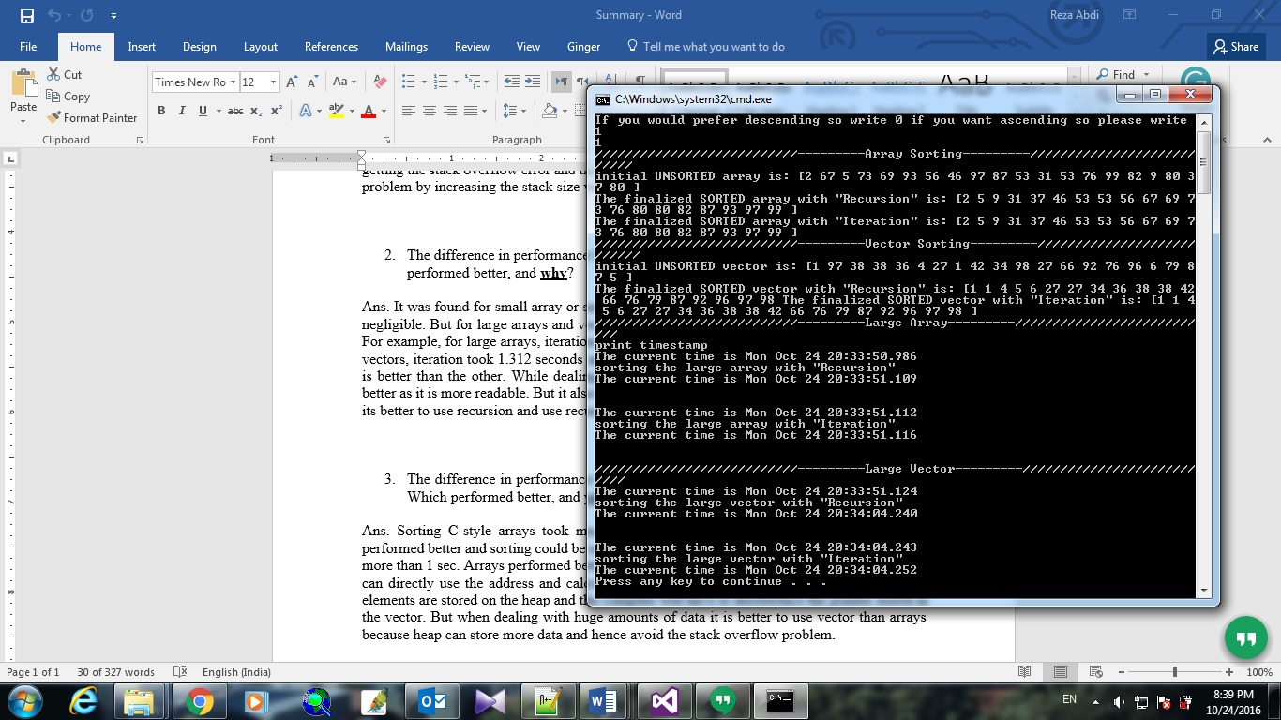

Figure 2. The performance of the code

1. The difference in performance between sorting C-Style arrays versus the STL vector. Which performed better, and **why**?

Considering arrays, in recursion and iteration methods, time difference was 0.119 second but in vector structure recursion and iteration methodologies, time difference was 13.107 seconds. So, apparently vector sorting is slower than array. The reason might be the amount and allocation of spaces for future elements. The compiler’s proficiency plays an important role in this issue and it can be effective for the time consuming for sorting.