**Screenshots**

Home page first half:



Home page second half, bottom page, couldn’t take screen shot of full page:



Blog page, adding article screen shot:

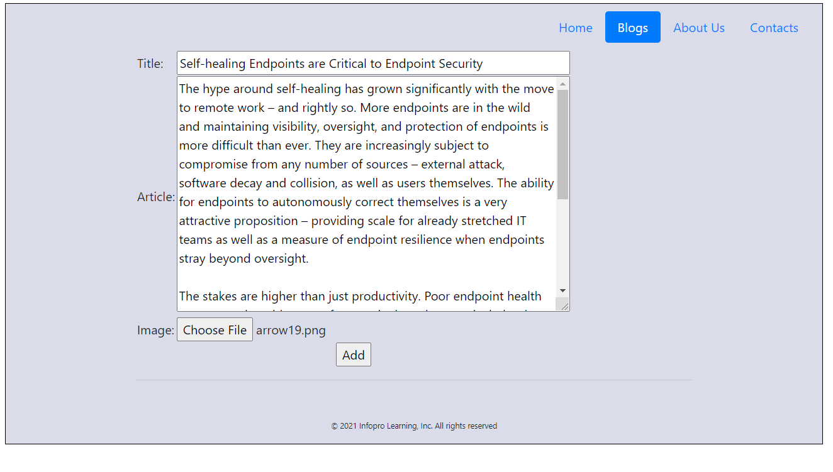

Onclick ‘Add’ button it adds blog in the bottom and clears data in the ‘title’ and ‘article’ fields, as shown below:

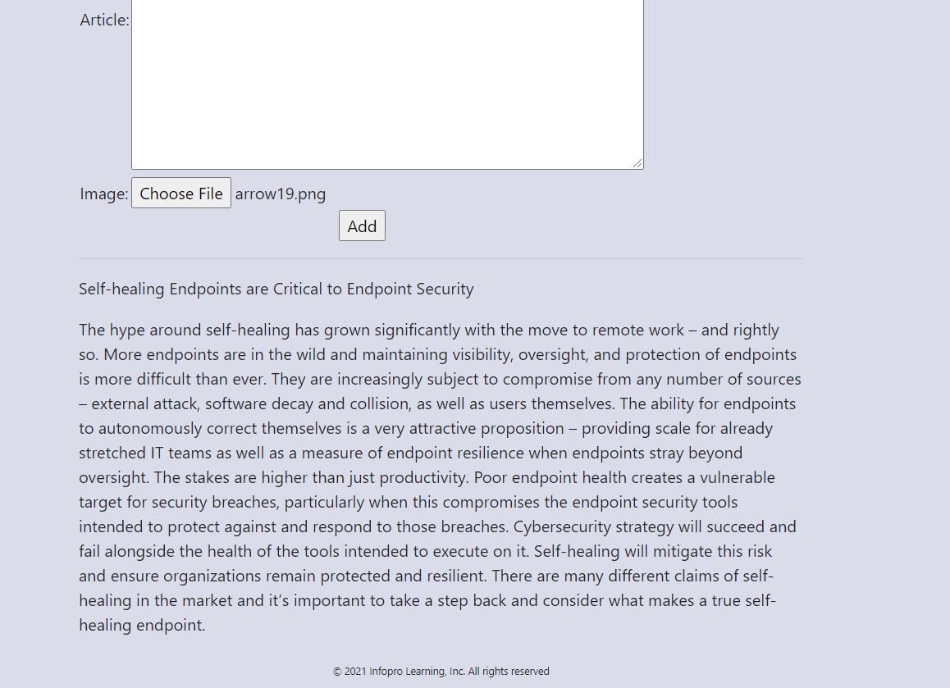

Multiple blogs looks like below:



I tried display ‘title’ in Bold by adding setAttribute class in my javascript and class styling in css but was not successful.