**Session 1: Assignment 1**

**Task 1:**

1. Install Jupyter notebook and run the first program and share the screenshot of the output.

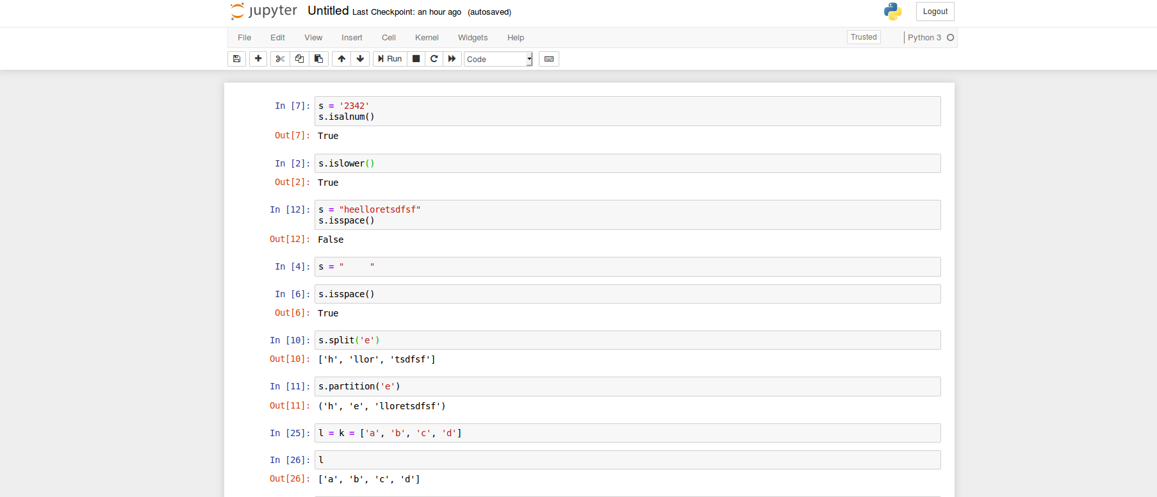

2. Write a program which will find all such numbers which are divisible by 7 but are not a multiple

of 5, between 2000 and 3200 (both included). The numbers obtained should be printed in a

comma-separated sequence on a single line.

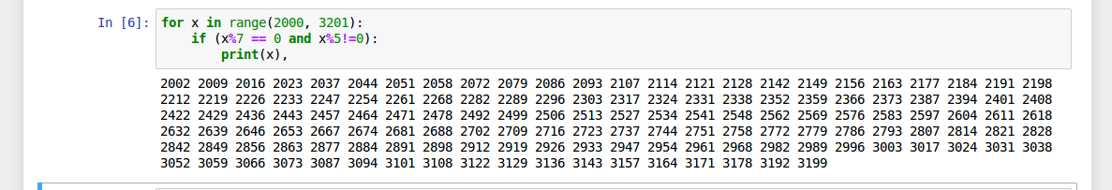

3. Write a Python program to accept the user's first and last name and then getting them printed in

the the reverse order with a space between first name and last name.

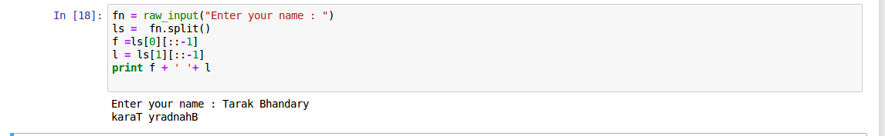

4. Write a Python program to find the volume of a sphere with diameter 12 cm

Formula: V=4/3 * π * r3



Cont...

**Task2:**

1. Write a program which accepts a sequence of comma-separated numbers from console and

generate a list.

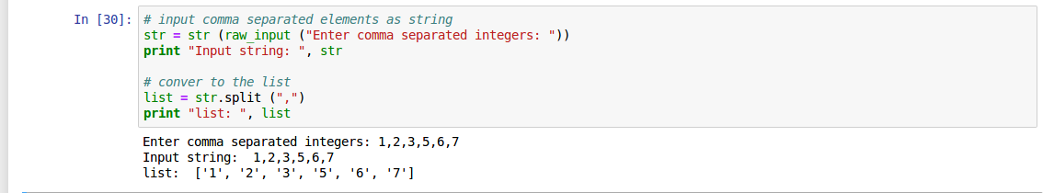

2. Create the below pattern using nested for loop in Python.

*

* *

* * *

* * * *

* * * * *

* * * *

* * *

* *

*

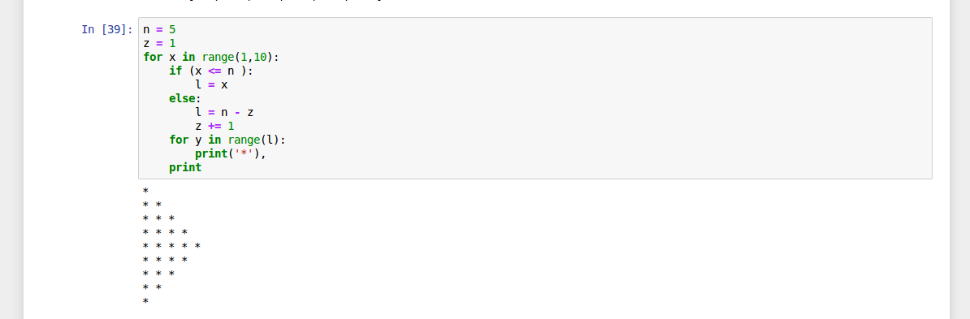3. Write a Python program to reverse a word after accepting the input from the user.

Sample Output:

Input word: AcadGild

Output: dilGdacA

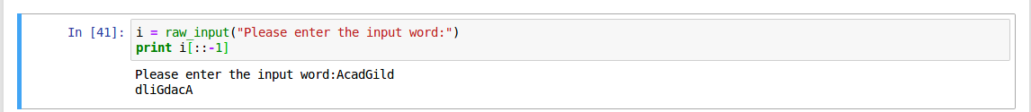

4. Write a Python Program to print the given string in the format specified in the ​ sample output.

WE, THE PEOPLE OF INDIA, having solemnly resolved to constitute India into a

SOVEREIGN, SOCIALIST, SECULAR, DEMOCRATIC REPUBLIC and to secure to all

its citizens

Sample Output:

WE, THE PEOPLE OF INDIA,

having solemnly resolved to constitute India into a SOVEREIGN, !

SOCIALIST, SECULAR, DEMOCRATIC REPUBLIC

and to secure to all its citizens

