**ARM, CLI, Powershell, Terraform, SDKs**

**Basics**

Management Group – [Azure Doc](https://learn.microsoft.com/en-us/azure/governance/management-groups/overview)

Subscription - [Doc](https://learn.microsoft.com/en-us/microsoft-365/enterprise/subscriptions-licenses-accounts-and-tenants-for-microsoft-cloud-offerings?view=o365-worldwide)

Resource Manager - [Doc](https://learn.microsoft.com/en-us/azure/azure-resource-manager/management/overview)

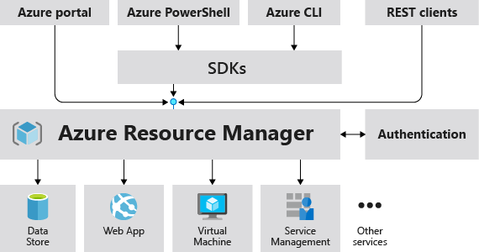

Advisor - [Doc](https://learn.microsoft.com/en-us/azure/advisor/advisor-reference-cost-recommendations)

Cost Management - [Doc](https://learn.microsoft.com/en-us/azure/cost-management-billing/costs/overview-cost-management)

Policy - [Doc](https://learn.microsoft.com/en-us/azure/governance/policy/overview)

Resource Locks - [Doc](https://learn.microsoft.com/en-us/azure/azure-resource-manager/management/lock-resources?tabs=json)

Tags - [Doc](https://learn.microsoft.com/en-us/azure/azure-resource-manager/management/tag-resources)

**Compute**

Azure Virtual Machines (VMs) – Running workloads

Azure Kubernetes Service (AKS) – Container orchestration

Azure App Service – Deploying web applications

**Identity & Access Management (IAM)**

Azure Active Directory (Azure AD) – Authentication & SSO

Role-Based Access Control (RBAC) – Managing permissions

Managed Identities – Securely accessing Azure services

**Active Directory**

<https://learn.microsoft.com/en-us/entra/fundamentals/whatis>

Service Principal

Users & Groups

**Networking**

Virtual Network (VNet) – Secure communication

Network Security Groups (NSG) – Controlling traffic

Azure Private Link – Private access to Azure services

**Load Balancing & Traffic Management (1.5 Hours)**

Azure Load Balancer (Layer 4 Traffic Distribution)

Azure Application Gateway (Layer 7 Load Balancer with SSL termination & WAF)

Azure Front Door (Global Load Balancer & CDN)

**Storage**

Azure Blob Storage – Storing unstructured data

Azure Files – Managed file shares

Azure Storage Accounts – Managing storage

**Security**

Azure Security Center – Continuous security assessment

Azure Key Vault – Managing secrets and certificates

Microsoft Defender for Cloud – Threat protection

**Observability**

Azure Monitor – Metrics and logs

Azure Log Analytics – Querying logs

Azure Application Insights – Application performance monitoring

**Final Project: Deploy a Full Dockerized Application using Azure DevOps CICD**

* Push a Docker image to Azure Container Registry (ACR)
* Deploy the image to AKS using CI/CD Pipelines
* Expose the app using Azure Application Gateway & Front Door
* Implement Monitoring & Security Best Practices