# Hieu Nguyen

# GTID: 903185448

# Email: [hieu@gatech.edu](mailto:hieu@gatech.edu)

# 10/5/15

**CS-6475 Computational Photography Assignment 6**

For my image blending assignment, I wanted to explore the art of face swapping. However, I settled on creating a sort of hero/villain blended headshot. The black image I chose was of Harley Quinn from the upcoming movie, Suicide Squad. The white image I chose was of the actress who plays her, Margot Robbie. Both images were found on the Internet [here](http://images-cdn.moviepilot.com/images/c_fill,h_350,w_700/t_mp_quality/ln62efqt80dpf9eperpx/why-margot-robbie-s-harley-quinn-will-take-dc-movies-to-the-next-level-after-suicide-squad-588873.jpg) and [here](http://sourcefed.com/wp-content/uploads/2014/11/margot-robbie.jpg), respectively. I used Gimp to adjust the orientation and make both images have the same dimensions. I also used Gimp to create a black and white image mask, drawn freehand using the eraser tool. This mask is unique because it isn’t just a half/half face. I was able to take interesting features from both images and perform a smooth blending. Specifically, I took the sinister makeup, corner smirk, and gun in hand from the black image. And the innocent smile and hair from the white image.

Results

Input

black.jpg white.jpg

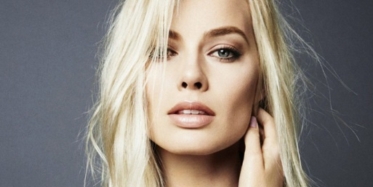

mask.jpg

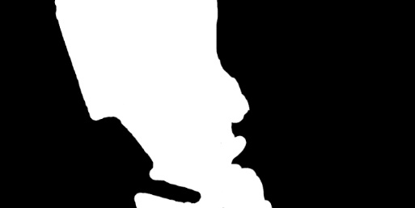

Output

gauss_pyr_black.jpg gauss_pyr_white.jpg gauss_pyr_mask.jpg

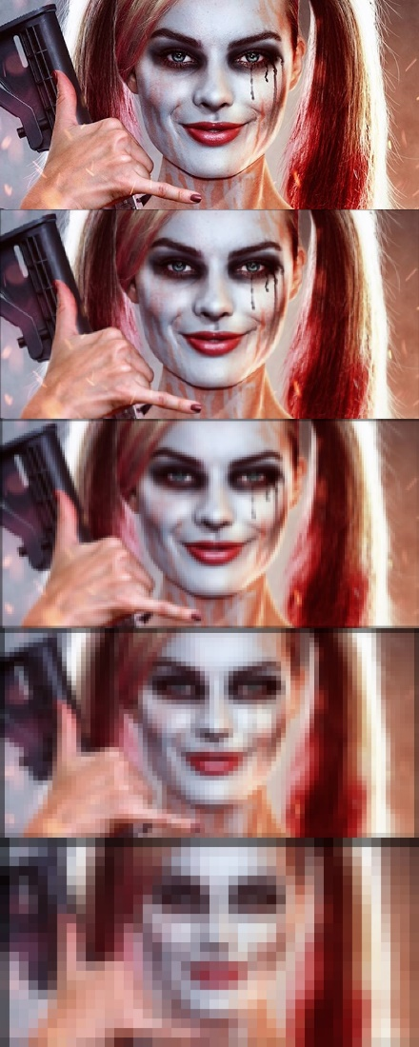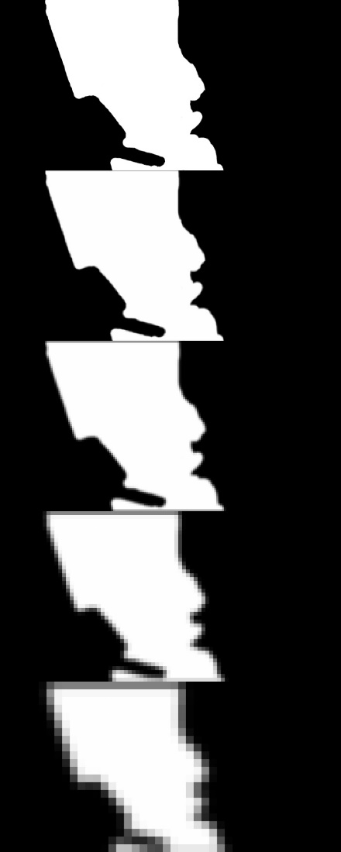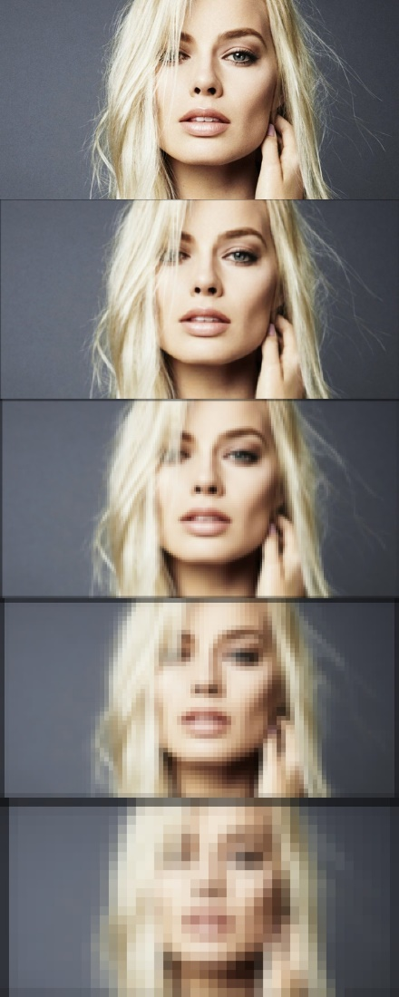

lapl_pyr_black.jpg lapl_pyr_white.jpg outpyr.jpg

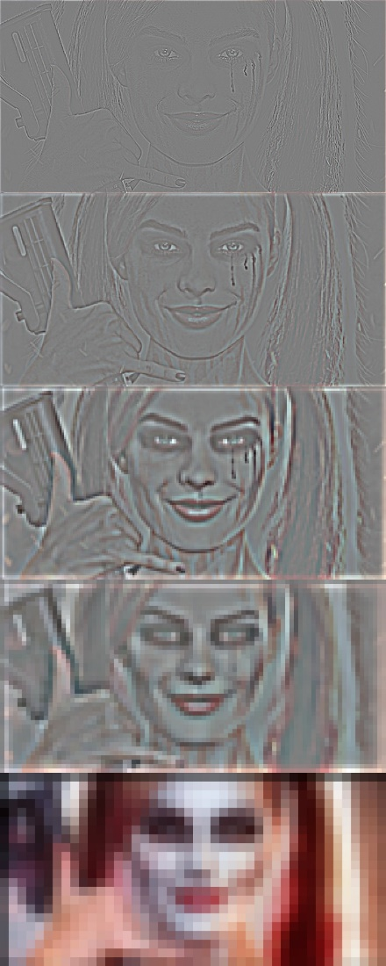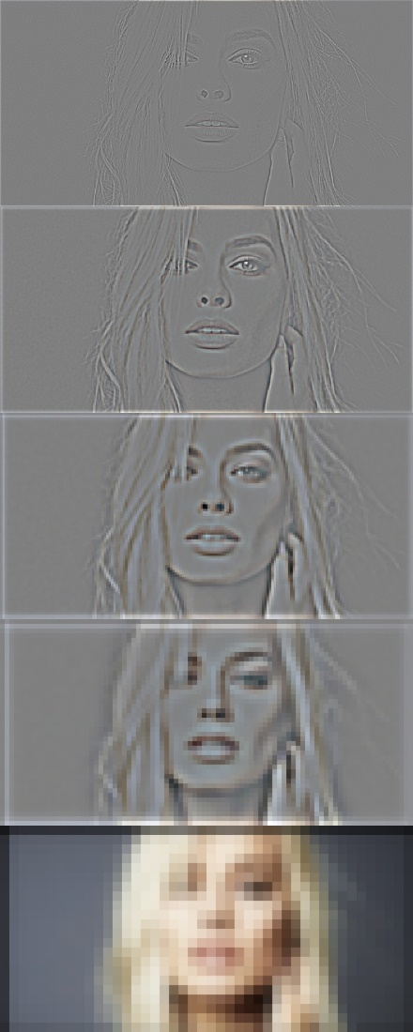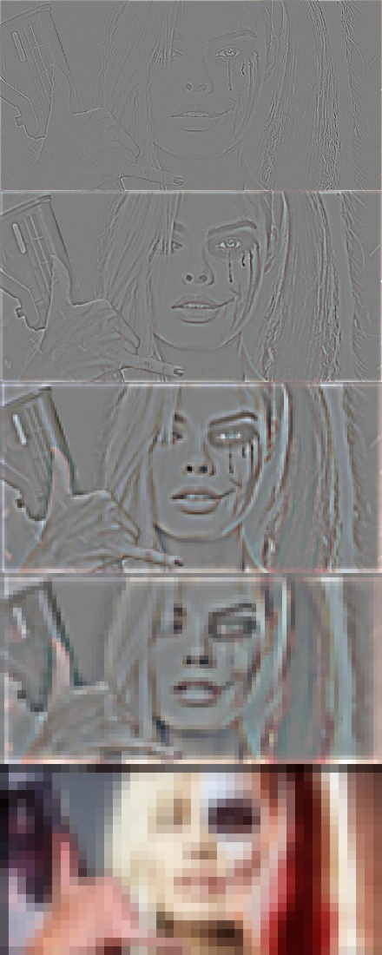

outimg.jpg



Part 0: Reduce and Expand

1. reduce()

This function takes an image, convolves it with 5x5 kernel a=0.4, and then subsamples it down to a quarter of the size (dividing the height and width by two). I took advantage of numpy indexing techniques to index every other row and column.

def reduce(image):

# Convolve input image with kernel for Gaussian smoothing

kernel = generatingKernel(0.4)

convolved = scipy.signal.convolve2d(image, kernel, mode='same')

# Subsample with numpy indexing to take every other row/column

reduced = convolved[::2, ::2]

return reduced

1. expand ()

This function takes an image and supersamples it to four times the size (multiplying the height and width by two). First, I created a zeros numpy array of twice the input size, then used indexing techniques to assign every other row and column to the output. The output is then convolved with a 5x5 kernel a=0.4 and multiplied by 4 to scale the image intensities to the proper values. This scaling is needed because of the resulting convolution output on an image with “empty” rows and columns. The pixel values are effectively divided by 4 over the kernel space, so they must be scaled up to obtain the appropriate pixel intensity.

def expand(image):

# Create image twice the size of input

upsampled = np.zeros((2*len(image), 2*len(image[0])))

# Assign every other row/col of input to output

upsampled[::2, ::2] = image

# Convolve input image with kernel for Gaussian smoothing

kernel = generatingKernel(0.4)

convolved = scipy.signal.convolve2d(upsampled, kernel, mode='same')

# Multiply output by 4 to scale image back up

expanded = convolved * 4

return expanded

Part 1: Gaussian and Laplacian Pyramids

1. gaussPyramid()

This function takes an image and builds a Gaussian pyramid out of it. This is accomplished by recursively appending the reduced images.

def gaussPyramid(image, levels):

# Iteratively call the reduce function to build a pyramid

output = [image]

for i in xrange(levels):

output.append(reduce(output[i]))

return output

1. laplPyramid

This function takes a Gaussian pyramid constructed by the previous function, and turns it into a Laplacian pyramid, which is essentially the difference of Gaussian pyramid levels. For each level, the immediate lower level is expanded. A check is done to ensure the expanded image dimensions are identical to the target image, otherwise cropping is performed (removing excessive rows/columns). The Laplacian level is then calculated by taking the difference. This continues until the top level, which is identical to the top level of the Gaussian pyramid because no further difference can be done.

def laplPyramid(gaussPyr):

# Iterate over Gaussian pyramid levels

output = []

for i in xrange(len(gaussPyr)-1):

# Expand lower level of pyramid

expanded = expand(gaussPyr[i+1])

# Crop expanded image if wrong target dimensions

if (len(expanded) != len(gaussPyr[i])):

expanded = expanded[0:len(gaussPyr[i]), :]

if (len(expanded[0]) != len(gaussPyr[i][0])):

expanded = expanded[:, 0:len(gaussPyr[i][0])]

# Calculate Laplacian pyramid

output.append(gaussPyr[i] - expanded)

# Last element of Laplacian pyramid is identical to input

output.append(gaussPyr[len(gaussPyr)-1])

return output

Part 2: Writing the blend and collapse functions

1. blend()

This function takes three pyramids (white Laplacian, black Laplacian, mask Gaussian) and performs an alpha-blend of the two Laplacian pyramids according to the mask pyramid. This is done recursively for each level of the pyramid.

def blend(laplPyrWhite, laplPyrBlack, gaussPyrMask):

# Iterate over each level to calculate the blended pyramid

blended_pyr = []

for i in xrange(len(gaussPyrMask)):

blended_pyr.append(gaussPyrMask[i]*laplPyrWhite[i] + (1 - gaussPyrMask[i])*laplPyrBlack[i])

return blended_pyr

1. collapse()

This function flattens a given Laplacian pyramid into an image. It starts from the smallest level and recursively expands and adds the expanded level to the next level. There is also a check performed to ensure the dimensions are correct, otherwise cropping is performed. This continues until the penultimate level is flattened onto the base level.

def collapse(pyramid):

# Iterate over pyramid levels starting from smallest (in reverse)

output = pyramid[len(pyramid)-1]

for i in xrange(len(pyramid)-1, 0, -1):

# Expand smaller level to next level

expanded = expand(output)

# Crop expanded image if wrong target dimensions

if (len(expanded) != len(pyramid[i-1])):

expanded = expanded[0:len(pyramid[i-1]), :]

if (len(expanded[0]) != len(pyramid[i-1][0])):

expanded = expanded[:, 0:len(pyramid[i-1][0])]

# Flatten expanded onto next level

output = expanded + pyramid[i - 1]

return output

Catdog Results

Input

black.jpg white.jpg

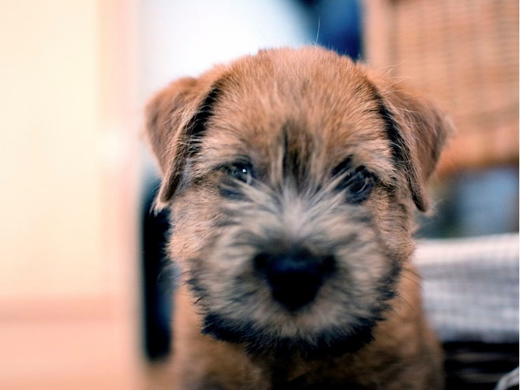 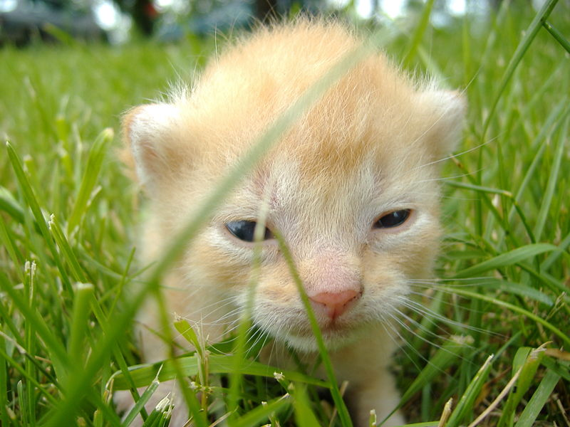

mask.jpg

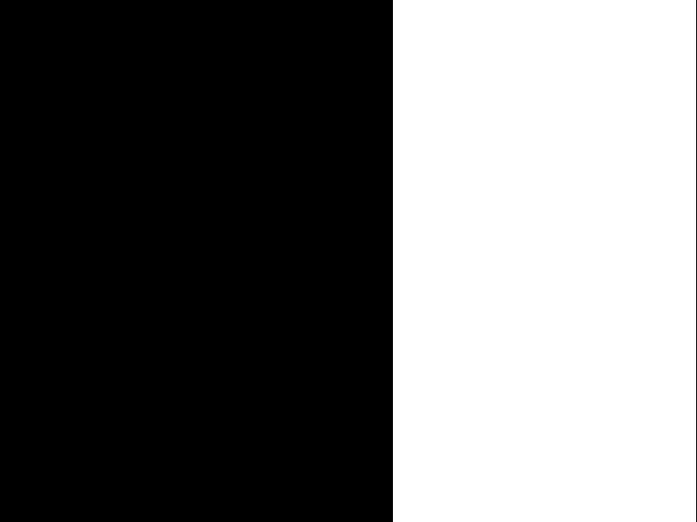

Output

gauss_pyr_black.jpg gauss_pyr_white.jpg gauss_pyr_mask.jpg

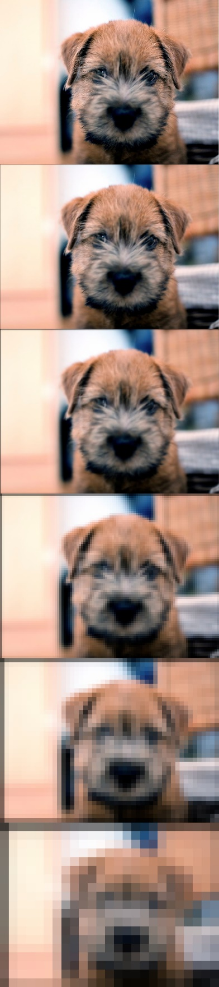 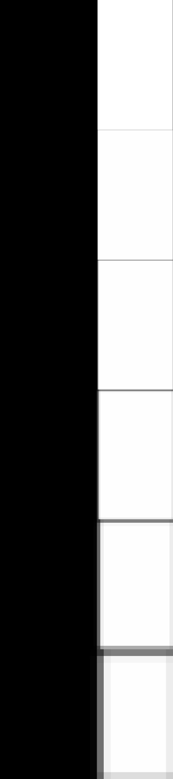 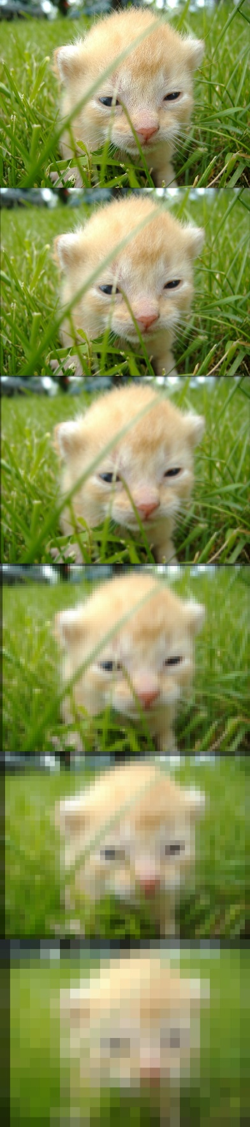

lapl_pyr_black.jpg lapl_pyr_white.jpg outpyr.jpg

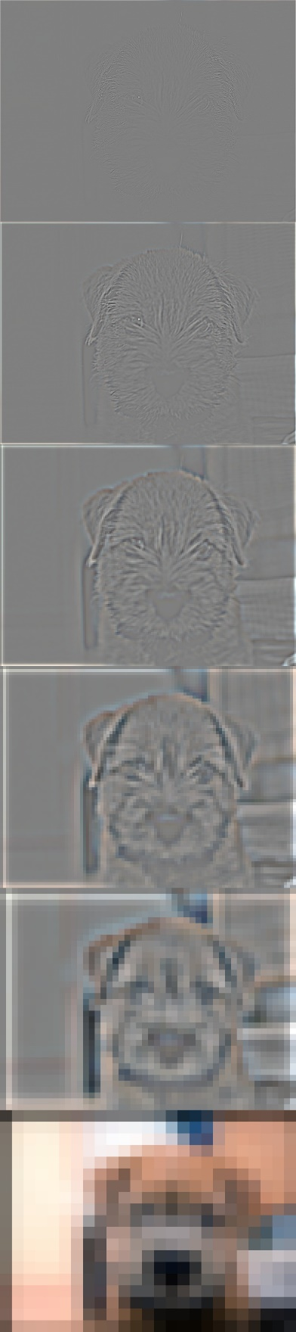 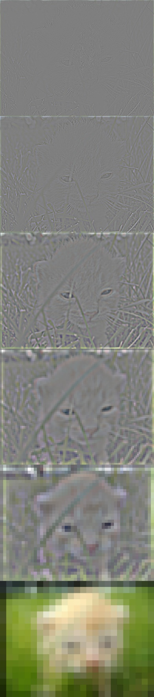 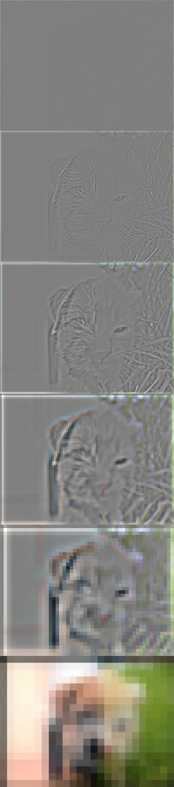

outimg.jpg

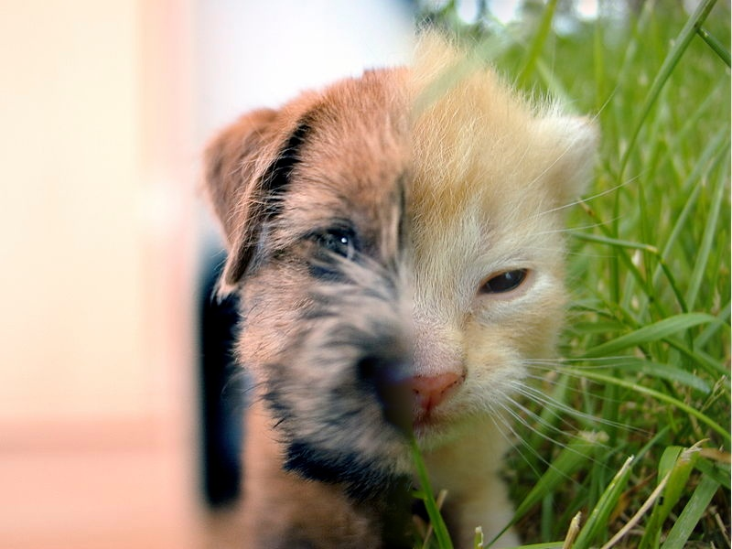

Other Notes

This was a really neat assignment. It allowed me to explore a systematic image pipeline for performing image blending, which in the end generated a fantastic result. I still have some difficulty wrapping my head around the mathematics of it all, but I now understand how intricate these blending techniques can be. From stunning panoramas to the next FatBooth app, image blending techniques are essential to many image processing applications. I’d like to explore other blending algorithms and recent advances.