Part B – Funds, Sentiment & UNSW-Trader Application
KUSHAGRA SINGH z5632343

FINS3645 Project 2026

1. UNSW-Trader and Backtest Design
For Part B, I developed UNSW-Trader as an investor-facing product that turns the project’s price and news data into a set of systematic funds and a simple decision-support application. The target user is an investor who wants diversified exposure to equities, cryptocurrency, or both, but does not necessarily want to estimate portfolio weights or interpret raw market data independently. The value proposition is therefore straightforward: UNSW-Trader lets an investor compare systematic funds, understand their risk and return, inspect current target holdings, combine funds into a personal allocation, and follow sector-level financial-news sentiment in one place.
I deliberately built a wider fund universe than the minimum required. The final set contains 12 funds created from three asset families, Equity, Crypto and Combined equity-plus-crypto, crossed with four portfolio methods: Equal Weight, Minimum Variance, Maximum Sharpe and Risk Parity. I treat each family-method pair as a separate investable fund because this is the level at which a user actually makes an investment decision and at which a fact sheet is meaningful. The broader design also lets me separate two questions that would be difficult to answer with only two combined funds: whether the asset family matters, and whether a more sophisticated optimisation method actually improves realised out-of-sample performance.

1.1 Portfolio methods
Equal Weight is my simplest benchmark. It allocates the same proportion of capital to every available asset and therefore does not rely on estimated expected returns or covariances to determine relative weights. Minimum Variance instead chooses the long-only portfolio with the lowest estimated variance. Maximum Sharpe chooses the long-only allocation with the highest estimated expected return per unit of volatility, using a risk-free rate of zero. Risk Parity aims to distribute risk contribution more evenly rather than distributing dollars evenly. All optimised portfolios are constrained to long-only weights that sum to one, so there is no short selling or leverage hidden inside the reported performance.
Equal Weight remains important as a benchmark because a complex method should improve the out-of-sample investor outcome, not simply be mathematically more advanced.

1.2 Walk-forward out-of-sample methodology
The backtest is walk-forward and genuinely out of sample. I use a 252-observation trailing estimation window and rebalance monthly. At each rebalance date, the optimiser only receives returns that occurred before that date. The resulting weights are then applied forward until the next rebalance. The initial estimation window is therefore used to form the first live portfolio rather than being incorrectly counted as investable performance. The first live date is 4 January 2021 for the Equity and Combined families and 1 October 2020 for Crypto-only funds.
This design is more demanding than optimising once over the full dataset. A full-sample optimisation would allow information from the end of the sample to influence weights shown at the beginning, which would make the historical result unrealistically strong. In my implementation, future observations cannot change weights that were already formed. I verified this directly in test_backtest.py by perturbing returns after a known rebalance date and confirming that all weights on or before that date remain unchanged. A separate test confirms that weights are non-negative and sum to one across all portfolio methods. These checks convert the no-look-ahead assumption from a design claim into something I have explicitly tested.

1.3 Trading calendars and annualisation
I use 252 periods per year for Equity and Combined funds because these strategies operate on the equity trading calendar. Crypto-only funds use 365 because cryptocurrency trades continuously. When crypto is used inside a Combined fund, it is reindexed to the equity trading days so the two asset classes can be held in one portfolio on a common decision calendar. Weekend crypto moves are therefore not treated as separate Combined-fund observations. This choice is not perfect, weekend information can matter for cryptocurrency, but it avoids mixing incompatible daily calendars inside one portfolio return series and keeps annualisation consistent with the dates on which the combined strategy is evaluated.
For Sharpe ratios I assume a risk-free rate of zero, as permitted by the brief. I also assume zero transaction costs. This makes the results gross strategy returns rather than net investor returns. The assumption is acceptable for the baseline analysis, but it becomes a limitation when comparing strategies that may generate different levels of turnover. I return to this in my recommendations because a strategy that looks better before costs can lose that advantage once trading is included.

2. Out-of-Sample Results and Fund Fact Sheets
Table 1 summarises the full 12-fund universe. I report annualised return, annualised volatility, Sharpe ratio, maximum drawdown and cumulative return, together with each fund’s first live date and annualisation convention. The purpose of the table is not to identify one universal winner. It shows that the meaning of “best” changes depending on whether an investor prioritises growth, volatility, drawdown control or risk-adjusted return.
fund | ann_return | ann_vol | sharpe | max_drawdown | cumulative_return | first_live | periods_per_year
Equity equal weight | 13.7% | 16.2% | 0.85 | -20.3% | 44.7% | 2021-01-04 | 252
Equity min variance | 6.1% | 12.8% | 0.48 | -15.4% | 17.1% | 2021-01-04 | 252
Equity max sharpe | 10.9% | 18.2% | 0.60 | -26.1% | 31.7% | 2021-01-04 | 252
Equity risk parity | 13.7% | 16.2% | 0.85 | -20.3% | 44.7% | 2021-01-04 | 252
Crypto equal weight | 75.5% | 81.0% | 0.93 | -81.6% | 295.7% | 2020-10-01 | 365
Crypto min variance | 82.1% | 65.1% | 1.26 | -71.3% | 624.4% | 2020-10-01 | 365
Crypto max sharpe | 22.9% | 77.3% | 0.30 | -89.3% | -20.8% | 2020-10-01 | 365
Crypto risk parity | 76.9% | 79.1% | 0.97 | -79.5% | 335.3% | 2020-10-01 | 365
Combined equal weight | 16.4% | 21.3% | 0.77 | -28.7% | 52.3% | 2021-01-04 | 252
Combined min variance | 6.2% | 12.8% | 0.48 | -15.6% | 17.3% | 2021-01-04 | 252
Combined max sharpe | 25.6% | 24.7% | 1.04 | -26.3% | 96.2% | 2021-01-04 | 252
Combined risk parity | 16.4% | 21.3% | 0.77 | -28.7% | 52.3% | 2021-01-04 | 252
Table 1. Out-of-sample performance metrics for all 12 funds. Returns, volatility and drawdowns are shown in percentage terms; equity/combined funds use 252 periods per year and crypto-only funds use 365.

2.1 Equity funds
The equity results provide the clearest example of why I kept a simple benchmark. Equity Equal Weight earned 13.7% annualised with 16.2% volatility, a Sharpe ratio of 0.85 and a maximum drawdown of -20.3%. Equity Maximum Sharpe, despite explicitly optimising estimated risk-adjusted return, earned only 10.9% with a Sharpe ratio of 0.60 and a deeper -26.1% drawdown. In other words, the optimisation objective looked attractive in the estimation window but did not translate into superior realised performance.
A likely explanation is estimation error. Maximum-Sharpe optimisation is sensitive to noisy historical mean returns, so weights that look optimal in one estimation window may not remain optimal in the next month. Equal Weight avoids forecasting relative winners, which helps explain why the simpler rule was more robust here.
Equity Minimum Variance behaved much more like its design objective. It reduced annualised volatility to 12.8% and maximum drawdown to -15.4%, the lowest downside risk among the equity strategies, but annualised return fell to 6.1% and Sharpe to 0.48. This is a genuine risk-return trade-off rather than a failure. The strategy sacrificed upside to protect capital more effectively. For a defensive investor that may be desirable even though it ranks poorly on return.
An unusual result is that Equity Equal Weight and Equity Risk Parity are identical in the reported performance. I do not interpret this as a coding bug. With a broad universe of roughly 50 equities whose volatilities are sufficiently similar, the risk-parity solution can collapse toward an equal allocation. This is a data-dependent outcome. It also illustrates why the weights-over-time exhibit is useful: the portfolio construction method should be assessed through the allocations it actually produces, not only by its name.
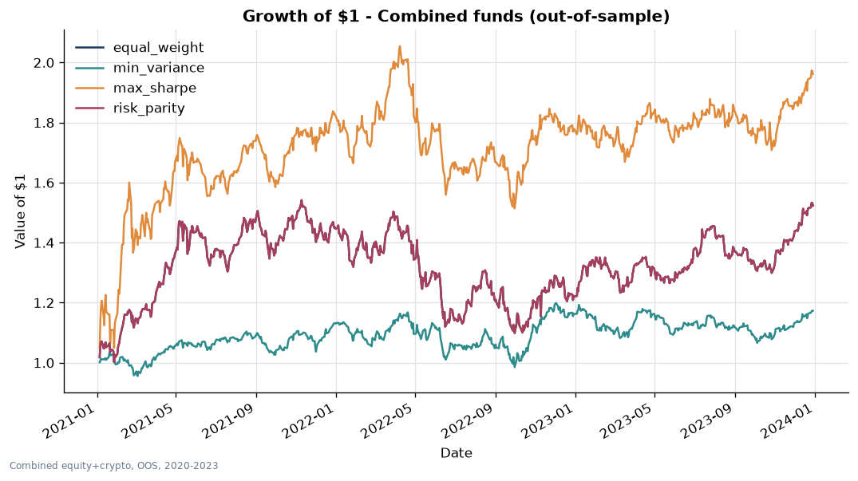
Figure 1. Growth of $1 for the four Combined equity-plus-crypto funds over the out-of-sample period. The chart compares cumulative wealth across the Combined methods only.
Figure 1 compares the four Combined strategies on a common wealth scale. Combined Maximum Sharpe finishes with the strongest growth, while Combined Minimum Variance grows more slowly. The chart therefore reinforces the trade-off already visible in Table 1: the method that delivers the strongest growth also accepts more risk than the defensive minimum-variance alternative.

2.2 Crypto funds
Crypto Minimum Variance produced the highest Sharpe ratio in the entire fund set. It earned 82.1% annualised with a Sharpe ratio of 1.26. On a return-per-unit-of-volatility basis, that is an impressive result. However, its maximum drawdown was -71.3%. An investor could therefore have experienced a loss of more than two-thirds from a previous peak while holding the strategy. This is the clearest example in my project of why Sharpe ratio should not be treated as a synonym for safety.
The remaining crypto funds reinforce the same risk message. Equal Weight earned 75.5% annualised but suffered an -81.6% drawdown; Risk Parity earned 76.9% with a -79.5% drawdown. Crypto Maximum Sharpe was weakest, with a 0.30 Sharpe and -89.3% maximum drawdown. High headline returns therefore came with extreme path risk.
These results reinforce the estimation-error problem observed in equities, but in a much more volatile environment. Minimum Variance does not need an expected-return forecast and therefore focuses on the comparatively more stable covariance structure. Maximum Sharpe relies on both means and covariance. In crypto, where historical returns are particularly unstable, that additional estimation burden appears to have produced a much less robust allocation out of sample.
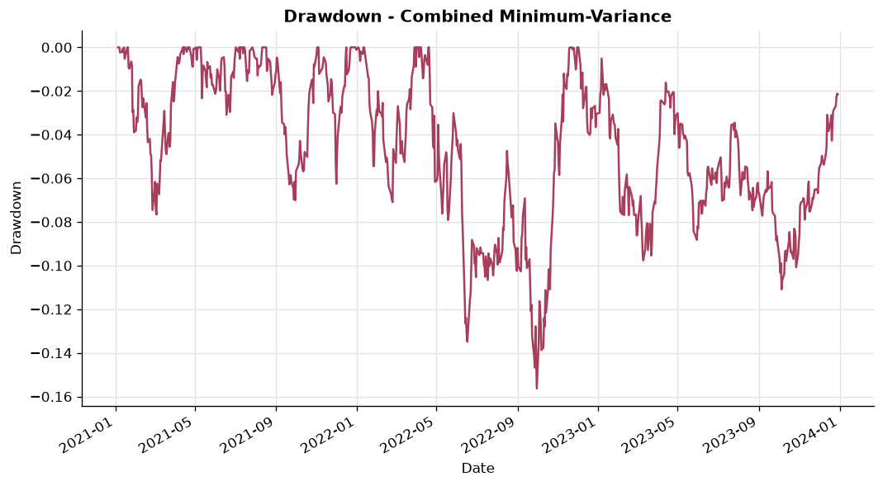
Figure 2. Drawdown of the Combined Minimum-Variance fund over the out-of-sample period. Drawdown is measured as the percentage decline from the strategy’s previous wealth peak.
Figure 2 focuses specifically on Combined Minimum Variance and shows why I describe it as the defensive combined strategy. Its drawdowns are comparatively contained, with a maximum drawdown of about -15.6%, which is consistent with the objective of minimising portfolio variance. This exhibit should therefore be read as evidence of downside control for that fund rather than as a comparison of all 12 strategies.

2.3 Combined equity-plus-crypto funds
The Combined funds are central to the project because they test whether adding crypto to an equity portfolio creates useful diversification rather than simply adding risk. Combined Maximum Sharpe was the strongest combined strategy: it earned 25.6% annualised, with 24.7% volatility, a Sharpe ratio of 1.04 and maximum drawdown of -26.3%. Its cumulative return was 96.2%. It therefore delivered substantially more growth and a higher Sharpe ratio than every equity-only fund, while avoiding the extreme -70% to -89% drawdowns seen in the crypto-only strategies.
In this sample, adding crypto to equities improved the realised risk-return trade-off without reproducing the extreme drawdowns of the crypto-only funds. I treat this as sample-specific evidence rather than a claim that crypto will always diversify equities, since correlations can change across market regimes.
Combined Minimum Variance again did what its objective suggests. It earned only 6.2% annualised, but volatility was 12.8% and maximum drawdown was -15.6%. Combined Equal Weight and Combined Risk Parity both earned 16.4% with a Sharpe ratio of 0.77 and drawdown of -28.7%. The contrast between Combined Maximum Sharpe and Combined Minimum Variance is useful for the app: the first is more suitable for an investor prioritising growth, while the second is a more defensive product for an investor who values drawdown control.
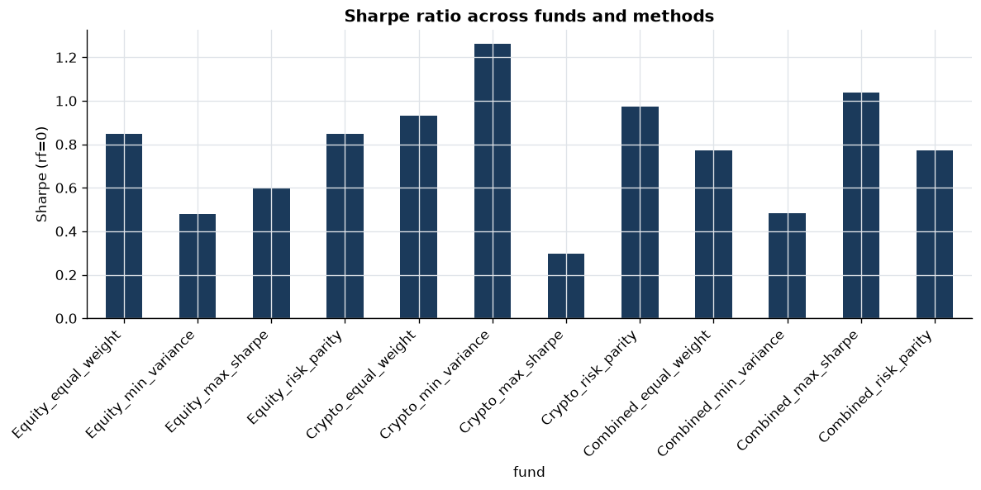
Figure 3. Out-of-sample Sharpe ratio by fund. Crypto Minimum Variance has the highest Sharpe, while Combined Maximum Sharpe is the strongest combined strategy; the figure also shows that Maximum Sharpe optimisation does not automatically produce the highest realised Sharpe.
Figure 3 summarises the main risk-adjusted performance result. The ranking is not aligned with the names of the optimisation methods. In particular, Equity and Crypto Maximum Sharpe do not achieve the highest realised Sharpe within their families. That gap between optimisation objective and realised outcome is exactly why I evaluate the strategies walk-forward rather than judging them from their in-sample optimisation target.
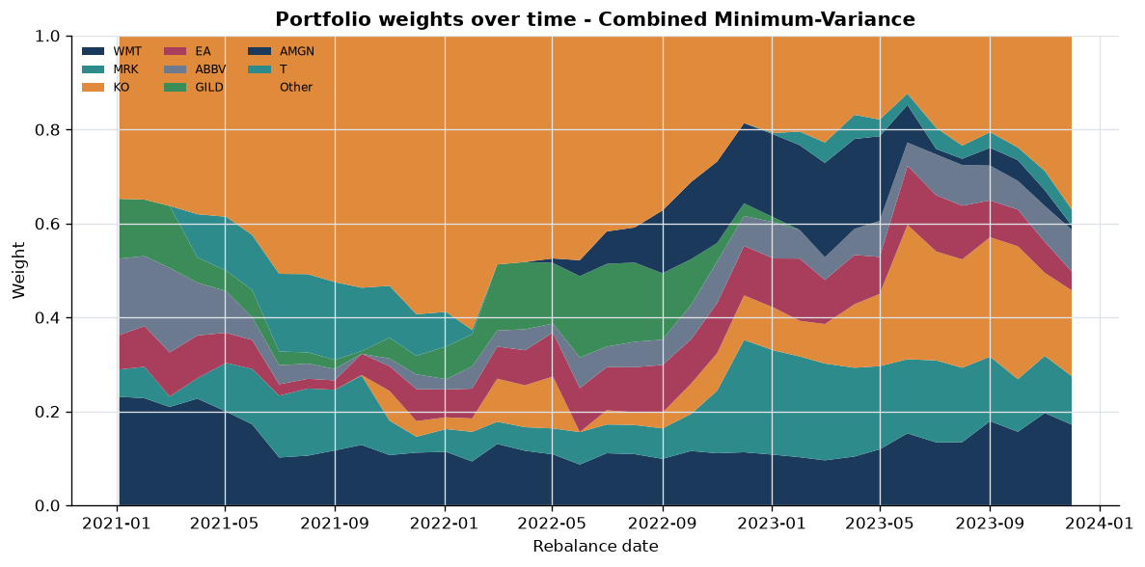
Figure 4. Target weights over time for the Combined Minimum-Variance fund at monthly rebalance dates. The eight largest average holdings are shown separately and the remaining positions are grouped as “Other”.
Figure 4 shows that Combined Minimum Variance is not one static full-sample allocation. Its target weights change as the 252-day estimation window rolls forward, which is consistent with the walk-forward design. The latest rebalance weights are also the holdings surfaced in the fund fact sheet.

3. Standalone Sector News Sentiment Index
Price data tell me what the market did, but they do not directly measure the tone of information reaching investors. I therefore created a standalone sector news-sentiment index from 146,830 financial headlines. Each headline is first scored using VADER’s compound sentiment measure. I then average multiple headlines for the same ticker and day to create a ticker-day score. Finally, ticker-day scores are averaged within each equity sector so that tickers are equally weighted. This last step is important because a company with unusually heavy news coverage should not dominate the sentiment of an entire sector simply because more headlines were written about it.
For ticker-days with no new headline, I forward-fill the most recent available sentiment observation. I chose this because the last observed news tone remains the latest information available until something new arrives. The choice is defensible but not neutral: it assumes that the information remains relevant rather than immediately decaying. A neutral-fill rule would make a different assumption, while dropping no-news days would create a sparse series that is harder to align with trading dates. Forward filling therefore gives me a continuous index, but it can allow old news to remain influential for too long.
I preserve the headline text sufficiently for VADER to use punctuation and emphasis rather than aggressively stripping the text into plain tokens. This matters because punctuation, intensifiers and wording can change the sentiment score. At the same time, VADER is a general-purpose lexicon, so keeping the original text does not solve the separate problem that some finance-specific words are missing or weakly represented. That limitation motivates my lexicon extension in Section 4.
To keep the investment use of sentiment look-ahead safe, I lag the signal by at least one trading day relative to the trading day to which the headline is aligned. A headline aligned to Monday is therefore first usable for Tuesday’s decision. This is particularly important around weekends: a Saturday or Monday headline aligned to Monday cannot be used to pretend that Monday’s portfolio knew the information before it became available. The lag keeps the text pipeline consistent with the same information discipline used in the fund backtests.
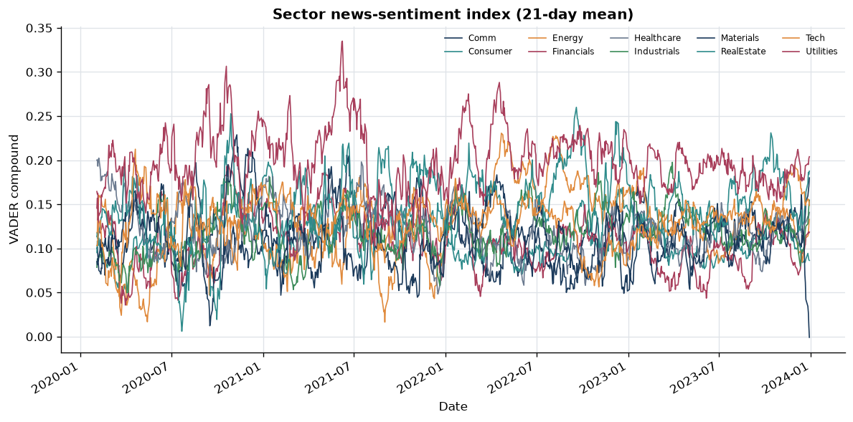
Figure 5. Equal-weight sector news-sentiment index over time, based on VADER compound scores aggregated from headline to ticker-day and then sector. The series is forward-filled on no-news days and is a noisy proxy for news tone rather than a direct measure of expected returns.
Figure 5 shows clear cross-sector variation in the 21-day smoothed sentiment series. Utilities is visibly elevated for much of the sample, while Real Estate also records several relatively high periods and sharp swings; most of the remaining sectors spend much of the time clustered closer together. I do not interpret these differences as expected-return forecasts. The index is a noisy proxy for news tone: headlines can be ambiguous, repetitive or already incorporated into prices, so its economic value must be tested rather than assumed.
The baseline VADER output also revealed a practical weakness: almost half of the 146,830 headlines were classified as neutral. Some genuinely neutral financial headlines are expected, but inspection showed that finance-specific expressions such as “outperform”, “bullish”, “upgrade” and “rally” could receive a neutral score. This created a clear, testable innovation opportunity: improve VADER’s domain sensitivity and then measure whether that improvement changes both the sentiment distribution and investment results.

4. Innovation: Finance-Specific VADER Lexicon
My main sentiment innovation was to extend VADER with a finance-specific lexicon rather than replacing it with a black-box model. I chose this approach because it is transparent: I can identify which financial terms change the score, quantify the effect through an ablation comparison, and still retain the original VADER pipeline. The objective was not to force the sentiment index to become more positive. It was to reduce cases where financially meaningful language was incorrectly treated as neutral.
model | n_headlines | neutral_rate | mean_abs_compound | pct_positive | pct_negative
plain_vader | 146,830 | 49.6% | 0.199 | 37.4% | 13.0%
finance_lexicon | 146,830 | 46.9% | 0.218 | 40.2% | 13.0%
Table 2. Finance-lexicon ablation across 146,830 headlines. The extension reduces neutral classifications and increases average sentiment magnitude, with most of the change occurring on the positive side.
The ablation in Table 2 provides direct evidence that the extension changes the model in the intended direction. The neutral rate falls from 49.6% under plain VADER to 46.8% with the finance lexicon, a reduction of about 2.7 percentage points. Mean absolute compound sentiment rises from 0.199 to 0.218, indicating a stronger signal rather than simply relabelling observations without changing magnitude. Positive classifications rise from 37.4% to 40.2%, while negative classifications remain almost unchanged at about 13.0%.
At the individual-headline level, 4,196 headlines were rescued from false-neutral classifications. Examples include headlines containing “rally”, “bullish”, “outperform”, “upgrade”, “soar” and earnings “beat” language. These are phrases that an investor would normally interpret as directional financial information, yet plain VADER can return a compound score of zero. The rescued-example file gives me a qualitative check alongside the aggregate ablation: the improvement is not only a statistical shift in the distribution; it is visible in specific finance-relevant cases.
However, the ablation also reveals an important weakness in my own extension. The change is overwhelmingly positive. Positive classifications rise by roughly 2.7 percentage points while the negative share is essentially unchanged. That means the current lexicon is much better at rescuing bullish language than bearish language. I consider this a genuine finding rather than something to hide. A domain lexicon that expands only one side of the vocabulary can introduce a directional bias into the index even if every individual term seems reasonable.
This positive skew also changes how I interpret the stronger mean absolute compound score. A stronger signal is useful only if the added strength reflects better classification rather than systematic optimism. The next version should therefore expand bearish finance terms and validate the resulting scores against labelled financial text. The key innovation in this project is not simply that I added words to VADER; it is that I implemented the extension, compared it against the baseline, identified where it improved the model, and also identified where the evidence shows it remains unbalanced.

5. Fusion: Does Sentiment Improve the Fund?
After improving the domain sensitivity of the sentiment measure, I tested whether the signal actually adds economic value. This is a separate question from whether the lexicon classifies financial language more sensibly. A text model can be technically better and still fail as an investment signal if the information is already priced, too noisy, too slow, or mapped into portfolio weights poorly.
strategy | ann_return | ann_vol | sharpe | max_drawdown | cumulative_return
base_max_sharpe | 10.88% | 18.24% | 0.597 | -26.12% | 31.66%
sentiment_tilted | 10.81% | 18.30% | 0.591 | -26.53% | 31.33%
Table 3. Before-versus-after fusion comparison for Equity Maximum Sharpe. The sentiment tilt slightly reduces return and Sharpe and slightly increases drawdown.
I apply the sentiment signal to the Equity Maximum Sharpe fund because the news data are equity-linked. The baseline target weights are tilted using the lagged cross-sectional sentiment signal and then normalised back to a fully invested portfolio. Importantly, the fusion remains look-ahead safe: the signal is lagged by at least one trading day, so the decision on day t can only use sentiment from day t-1 or earlier. Even under this look-ahead-safe implementation, the sentiment extension does not improve performance.
The result is slightly negative. The base Equity Maximum Sharpe fund has an annualised return of 10.88%, volatility of 18.24%, Sharpe of 0.597 and maximum drawdown of -26.12%. After the sentiment tilt, annualised return falls to 10.81%, volatility rises to 18.30%, Sharpe falls to 0.591 and maximum drawdown becomes slightly worse at -26.53%. Cumulative return also falls from 31.66% to 31.33%. The differences are small, but the direction is clear: this implementation of sentiment does not improve the fund.
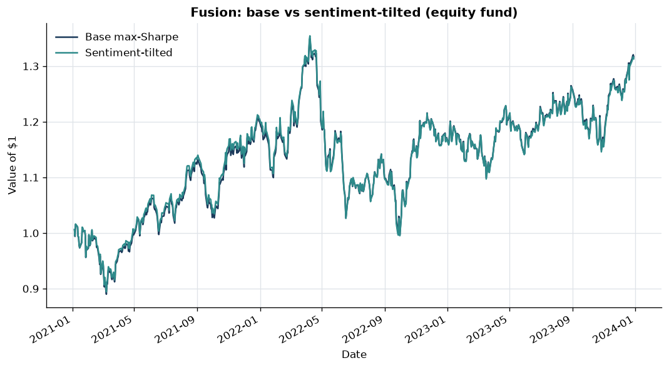
Figure 6. Growth comparison of the baseline Equity Maximum Sharpe fund and the sentiment-tilted version. The two paths are close, but the tilted strategy finishes slightly behind, confirming that the basic fusion does not add out-of-sample value.
Figure 6 shows why it would be misleading to describe the fusion as a success based only on the fact that sentiment was integrated. The paths are similar, but the tilted portfolio does not create a persistent performance advantage. I retain this negative result because the brief rewards an implemented and critically assessed extension rather than only an extension that happens to outperform.
There are three likely reasons. First, headline sentiment is noisy. A positive headline can be backward-looking, already expected, or irrelevant to the next return. Second, the fund rebalances monthly while the sentiment signal is constructed at a daily frequency. By the time a monthly rebalance acts on recent news, much of the information may already have been incorporated into prices. Third, the tilt itself is crude: it assumes that a simple monotonic adjustment from sentiment to weight is appropriate across companies, sectors and market regimes. The result therefore tells me more than “sentiment failed”. It tells me that the current measurement-to-portfolio mapping is not strong enough to overcome noise and timing mismatch.
This distinction is one of the most important lessons from Part B. The finance lexicon produces clear classification evidence: fewer false-neutral headlines and stronger finance-relevant scores. Yet the economic test does not improve. Technical signal quality and investment usefulness are different standards. A robust FinTech product should report both rather than selecting only the evidence that looks favourable.

6. Streamlit App and Investor Journey
I built the Streamlit application as the serving layer for the project rather than as another analysis notebook. The target user is a financially aware retail investor who wants to compare systematic strategies without needing to run Python or understand the optimisation code. I designed the app around four tabs that follow a simple investor journey: Compare Funds, Fund Fact Sheet, Build Allocation and Sentiment.
The Compare Funds tab gives the broad view first, placing return beside volatility, Sharpe and drawdown so the user is not pushed toward the highest-return strategy alone. This is important because my results show that the strongest headline return can also involve severe downside risk.
The Fund Fact Sheet then links each strategy’s performance to its growth of $1, drawdown history and latest target holdings, so the user can see both how the fund behaved and what it currently targets.
The Build Allocation tab lets users combine funds and inspect the historical characteristics of the blended portfolio. This turns the analysis into a practical allocation tool and allows different risk preferences to be expressed rather than forcing one fund on every investor.
The Sentiment tab surfaces the sector index and allows the user to follow the unstructured-data side of the project. I intentionally present sentiment as contextual analytics rather than as a guaranteed buy or sell signal. That design is consistent with my own fusion evidence: the index contains interpretable information, but the basic sentiment tilt does not improve the equity fund out of sample.

6.1 Build-versus-serve architecture
A key implementation decision was separating computation from deployment. The live Streamlit app reads precomputed artifacts from the results/ directory. It does not rerun VADER and it does not recompute the walk-forward backtests when a user opens the page. This keeps the app responsive and reliable on a basic hosted machine and avoids making the user wait for expensive analysis that has already been completed. It also makes the architecture easier to reason about: scripts generate validated results, while Streamlit serves those results to the investor.
This separation directly addresses one of the practical risks in deployment. A research pipeline may be acceptable when it takes time to run locally, but a deployed user interface needs predictable performance. By serving precomputed CSVs and figures, I reduce the chance that a solver, sentiment dependency or data-processing step fails during a user session. The public repository also makes the implementation inspectable rather than relying on a private hand-in.
Public GitHub repository: https://github.com/reachkushagrasingh-lang/unsw-trader
Live UNSW-Trader Streamlit application: https://reachkushagrasingh-lang-unsw-trader-streamlit-app-c9vx6t.streamlit.app/

7. Critical Reflection and Recommendations
A major strength of my Part B work is the breadth of the genuinely out-of-sample comparison. The 12 funds show that asset family and optimisation method both matter: Maximum Sharpe did not dominate, Minimum Variance consistently reduced downside risk, and the Combined family offered a middle ground between equity returns and crypto drawdowns.
The sentiment work is also useful because the evidence is mixed. The finance lexicon rescued thousands of false-neutral headlines, but it is positively skewed and the portfolio fusion slightly underperformed. I therefore distinguish improved text measurement from proven investment value rather than presenting the extension as successful on every dimension.
The fund analysis still has limitations. Zero transaction costs favour active strategies, the 252-day window is a modelling choice, and monthly rebalancing may be too slow for daily news. The Combined calendar also omits separate weekend crypto observations in order to remain aligned with equity trading days.

Recommendation 1: Rebalance the finance lexicon and validate it on labelled financial text
My first recommendation is to expand the sentiment model specifically on the bearish side. The ablation shows why this is necessary: positive classifications increase from 37.4% to 40.2%, while negative classifications remain at roughly 13.0%. I would build a second lexicon pass focused on terms such as downgrades, guidance cuts, misses, defaults, investigations and distress language, then validate both positive and negative terms against a labelled financial-news corpus rather than judging improvement only from score magnitude. I would keep the same ablation framework so that any new version must show whether it reduces false neutrals without creating an artificial directional bias. This is a direct response to the evidence from my current model rather than a generic suggestion to “use better NLP”.

Recommendation 2: Add turnover and transaction-cost modelling to every fund
My second recommendation is to make the fund comparison net of implementation costs. At each monthly rebalance I would calculate turnover as the absolute change in portfolio weights and apply a realistic per-unit trading-cost assumption. The fact sheets would then report both gross and net performance, together with average turnover. This matters most for optimised funds whose target weights can change materially as the estimation window rolls. If Combined Maximum Sharpe still leads after costs, the result becomes much stronger. If its advantage disappears, that is economically important information for the investor. I would also consider adding a turnover penalty to the optimisation so the model explicitly trades off expected portfolio improvement against the cost of changing positions.

Recommendation 3: Match the sentiment horizon to the trading rule and test the fusion out of sample
My third recommendation is to redesign the fusion around the speed of the news signal. A daily sentiment index is unlikely to be used effectively by a portfolio that only meaningfully changes at a monthly rebalance. I would test a faster but still realistic equity rebalance for the sentiment overlay, or separate the slow strategic portfolio weights from a smaller, short-lived sentiment sleeve. I would also replace indefinite forward filling with time decay so a headline’s influence falls as it becomes stale. Tilt strength and decay parameters should be selected on a training or validation period and then frozen before evaluation on untouched out-of-sample data. This would test whether the negative result comes from sentiment having no useful predictive content or from the current monthly, fixed-tilt implementation being too crude to capture it.
Together, these recommendations address the three main weaknesses exposed by my own evidence: directional imbalance in the text model, missing implementation costs in the fund results, and a timing mismatch between daily sentiment and monthly portfolio decisions. They are deliberately specific because the next version of UNSW-Trader should improve the parts that the current results show are weak rather than adding complexity for its own sake.

8. Conclusion
UNSW-Trader brings the main components of Part B into one connected investment workflow. I constructed 12 equity, crypto and combined funds, evaluated them through a walk-forward out-of-sample backtest, built fund fact sheets, created a standalone sector news-sentiment index, extended VADER with finance-specific language, tested the sentiment signal inside an equity fund, and served the precomputed results through a deployed Streamlit application.
The results also changed the way I would judge an investment model. Maximum Sharpe did not automatically deliver the highest realised Sharpe, while the simple Equal Weight equity strategy performed strongly out of sample. Crypto Minimum Variance produced the highest Sharpe in the project but still experienced a -71.3% drawdown, showing that risk-adjusted return is not the same as investor safety. Combined Maximum Sharpe provided the strongest combined result and showed that crypto exposure can improve diversification in this sample without requiring the investor to hold a crypto-only portfolio.
The sentiment extension produced an equally important distinction. The finance lexicon measurably improved the treatment of finance-specific language, but the sentiment tilt slightly reduced portfolio performance. I therefore cannot claim that the current sentiment model creates alpha. What I can show is an evidenced innovation, an honest economic test, and a clear path for improvement. For me, that is the main lesson of the project: a useful FinTech product should not only produce sophisticated models; it should test them under realistic information constraints, show the investor both upside and downside, and be willing to report when an extension does not work as expected.

Appendix A – Supporting Innovation Evidence
The following table shows a compact set of representative rescued examples from the finance-lexicon experiment. Plain VADER assigned a compound score of zero to these headlines, while the finance-adjusted version produced a non-zero score. The full rescued-example CSV remains in the submitted results, while this subset keeps the appendix readable.
Ticker | Headline | Plain VADER | Finance VADER
GE | 3 Reasons Why GE Stock Could Rally Another 20% in 2020 | 0.000 | 0.459
NKE | After an Epic 2019 Rally, I've Got Nike Stock on Hold -- for the Moment | 0.000 | 0.459
V | Does Visa Deserve Its Bullish Valuation? | 0.000 | 0.542
DIS | Dow Jones Futures: Can Stock Market Rally Hold In Bullish Channel As Iran Exits Nuclear Deal? 7 Stocks Near Buy Points | 0.000 | 0.758
T | AT&T's New Network Could Make This Stock Soar | 0.000 | 0.612
O | Raymond James Upgrades Realty Income to Outperform, Announces $79 Price Target | 0.000 | 0.459
BA | Cowen’s Bullish Stance on Boeing (BA) Stock Comes to an End | 0.000 | 0.542
AMGN | BMO Capital Maintains Outperform on Amgen, Raises Price Target to $275 | 0.000 | 0.459
INTC | AMD Continues March Higher As Mizuho Joins Bullish Peers With Upgrade | 0.000 | 0.758
SBUX | Option Traders Make Big Bets Luckin Coffee Rally Isn't Over | 0.000 | 0.459
WFC | Weekly Market Preview: Stocks At Record Highs Ahead of Q4 Earnings (BAC, C, JPM, WFC) | 0.000 | 0.361
NKE | The Rally in Microsoft Stock Will Slow, But Should Continue | 0.000 | 0.250
SBUX | The Rally in Microsoft Stock Will Slow, But Should Continue | 0.000 | 0.250
USB | First Republic (FRC) Q4 Earnings Beat Estimates, Costs Rise | 0.000 | 0.459
Table A1. Representative headlines rescued from a plain-VADER neutral score by the finance-specific lexicon. The full set is retained in lexicon_rescued_examples.csv.

Appendix B – Exhibit Inventory
The table below summarises the generated report exhibits and the exact scope of each figure.
File | Scope | What it shows
growth_of_1.png | Four Combined funds | Cumulative growth of $1
drawdown.png | Combined Minimum Variance | Drawdown from prior wealth peak
sharpe_barplot.png | All 12 funds | Out-of-sample Sharpe ratio
weights_over_time.png | Combined Minimum Variance | Monthly target weights over time
sentiment_index.png | 10 equity sectors | 21-day mean sector news sentiment
fusion_before_after.png | Equity Maximum Sharpe | Base versus sentiment-tilted growth
Table B1. Exhibit inventory checked against the generated files in results/figures/.

