Transformer Architecture – a macro view
Bhupen Sinha

25-07-2024

Table of Contents
Recap on classical sequence models 3
Recurrent Neural Networks (RNNs) 3
Long Short-Term Memory (LSTM) Networks 3
Gated Recurrent Units (GRUs) 4
Transition to Transformers 4
Broad categories of transformers 5
General Architecture 6
How are transformer models different? 8
Key Innovation of Transformer Model: 8
Limitations of RNNs and LSTMs: 8
Summary 8

Recap on classical sequence models

Recurrent Neural Networks (RNNs)
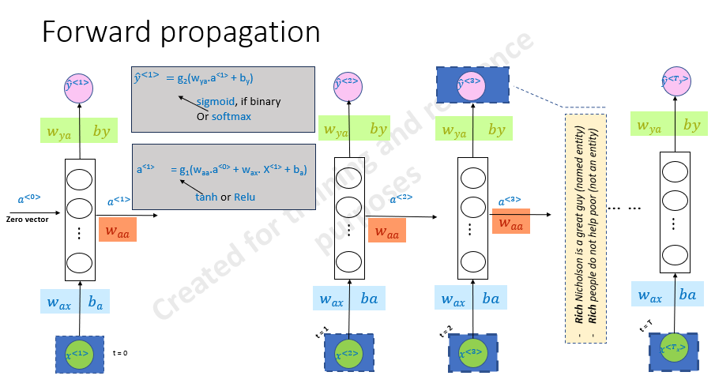
Concept: Sequential processing of data where the output from one step is fed as input to the next step.
Advantages: Ability to maintain temporal information, suitable for tasks like time series prediction and language modelling.
Limitations: Difficulty in learning long-term dependencies due to vanishing and exploding gradient problems

Long Short-Term Memory (LSTM) Networks
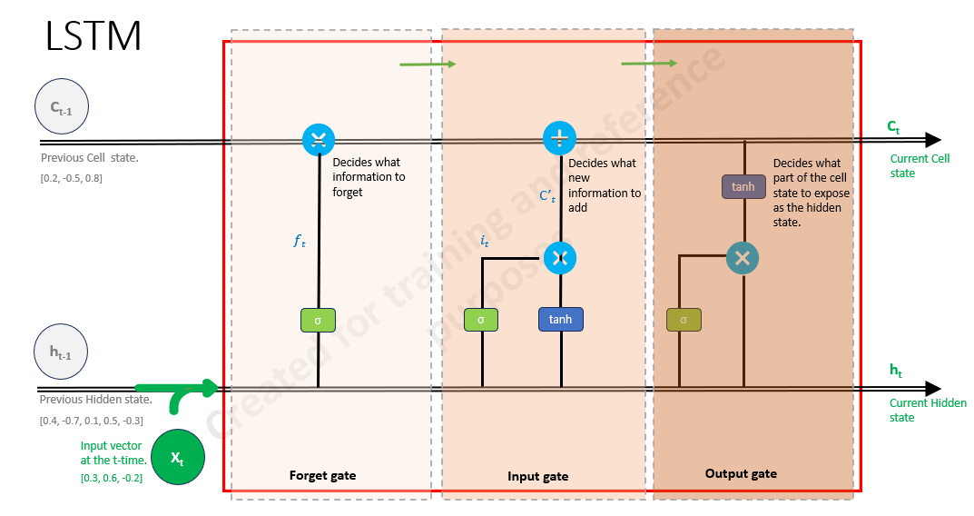

Concept: Special kind of RNN designed to address the vanishing gradient problem, capable of learning long-term dependencies.
Structure: Composed of memory cells, input gate, output gate, and forget gate.
Advantages: Better at capturing long-term dependencies compared to vanilla RNNs.
Limitations: Computationally expensive, still struggles with very long sequences.

Gated Recurrent Units (GRUs)
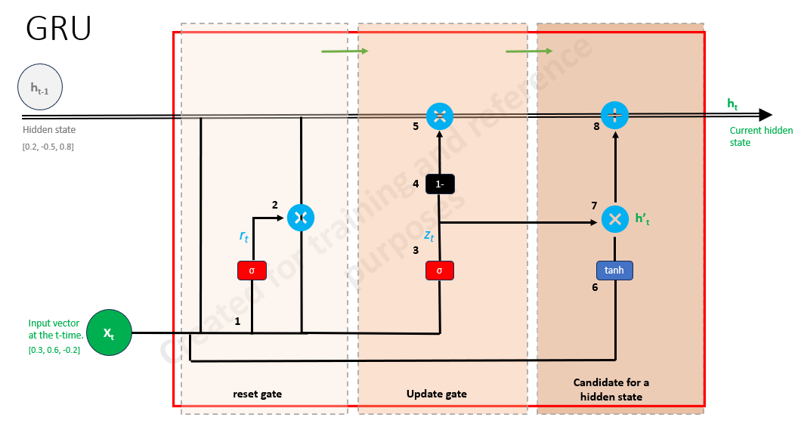
Concept: Similar to LSTMs but with a simpler architecture.
Structure: Combines the cell state and hidden state, with update and reset gates.
Advantages: Efficient and faster to train compared to LSTMs while maintaining performance.
Limitations: Similar challenges with very long sequences as LSTMs.

Transition to Transformers

Motivation: While RNNs, LSTMs, and GRUs are effective, they struggle with issues such as sequential processing inefficiencies and long-range dependency learning.
Innovation Need: A model that can handle sequences in parallel and capture long-range dependencies more effectively.

Introduction to Transformer Architecture
- Concept: A novel architecture that leverages self-attention mechanisms, enabling parallel processing of sequence data.

- Advantages: Ability to model long-range dependencies, parallelizable, and improved performance on various NLP tasks.

- Components: Self-attention, multi-head attention, positional encoding, and feed-forward networks.

Broad categories of transformers

- GPT-like (also called auto-regressive Transformer models)

  - Concept: These models predict the next token in a sequence, generating text one token at a time.
  - Architecture: Typically uses a stack of decoder layers.
  - Key Models: GPT-2, GPT-3, GPT-4.
  - Applications: Text generation, language modelling, conversational agents.

- BERT-like (also called auto-encoding Transformer models)

  - Concept: These models are designed to understand the context of a word within a sentence by looking at both the left and right context simultaneously.
  - Architecture: Uses a stack of encoder layers.
  - Key Models: BERT, RoBERTa, ALBERT.
  - Applications: Text classification, named entity recognition, question answering.

- BART/T5-like (also called sequence-to-sequence Transformer models

- Concept: These models are capable of transforming one sequence into another, making them suitable for tasks like translation and summarization.
- Architecture: Uses both encoder and decoder stacks.
- Key Models: BART, T5.
- Applications: Text summarization, machine translation, text generation.

General Architecture
- Encoder (left):  - The encoder receives an input and builds a representation of it (its features).  - This means that the model is optimized to acquire understanding from the input.  - Decoder (right):  - The decoder uses the encoder’s representation (features) along with other inputs to generate a target sequence.  - This means that the model is optimized for generating outputs. | 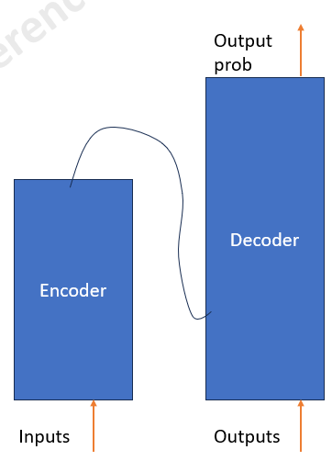
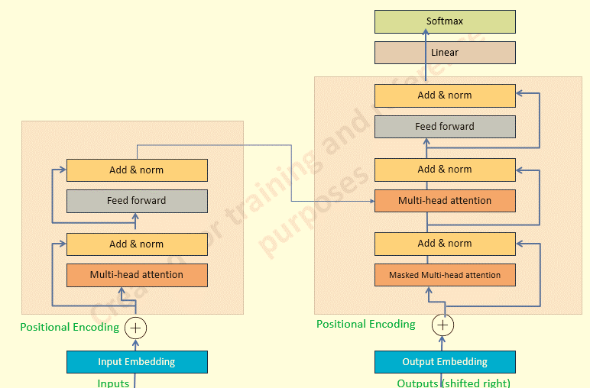

Encoder  The left side of the diagram represents the Encoder part of the Transformer architecture | Decoder  The right side of the diagram represents the Decoder part of the Transformer architecture:
Input Embedding and Positional Encoding: -  - The input tokens are first converted into embeddings.  - Positional encoding is added to these embeddings to incorporate information about the position of each token in the sequence. | Output Embedding and Positional Encoding:  - The target sequence tokens are converted into embeddings.  - Positional encoding is added to these embeddings similarly to the encoder.
Multi-Head Attention:  - The multi-head attention mechanism allows the model to focus on different parts of the input sequence simultaneously.  - It outputs attention scores that are used to weigh the relevance of each token in the sequence. | Masked Multi-Head Attention:  - The masked multi-head attention layer attends to the target sequence.  - Masking is applied to prevent the decoder from attending to future tokens, ensuring the model predicts one token at a time.
Add & Norm:  - A residual connection (Add) is applied by adding the input of the attention layer to its output.  - The result is then passed through layer normalization (Norm). | Add & Norm:  - A residual connection and layer normalization are applied.
Feed Forward:  - A fully connected feed-forward network is applied to each position independently.  - Typically consists of two linear transformations with a ReLU activation in between. | Multi-Head Attention:  - This layer performs attention over the encoder’s output, allowing the decoder to focus on relevant parts of the input sequence.  - It combines information from both the input sequence and the already generated tokens.
Add & Norm:  - Another residual connection is added from the input of the feed-forward layer to its output, followed by layer normalization. | Add & Norm:  - Another residual connection and layer normalization.
Feed Forward:
- A fully connected feed-forward network is applied similar to the encoder.
Add & Norm:
- A final residual connection and layer normalization.
Linear and Softmax:
- The output of the last decoder layer is passed through a linear layer.
- A softmax function is applied to generate the probabilities for the next token in the sequence.

How are transformer models different?

Key Innovation of Transformer Model:
- Transformer models do not rely on Recurrent Neural Networks (RNNs) or Convolutional Neural Networks (CNNs).
- Process input sequences in parallel, enhancing efficiency for training and inference.
- Transformer models require less training time compared to previous architectures like LSTM.

Limitations of RNNs and LSTMs:
- Recurrent Neural Networks (RNNs) were proposed in the 1980s, with significant advancements over the years. (2013)
- Long Short-Term Memory (LSTM) networks were introduced in 2015 by Hochreiter and Schmidhuber, specifically designed to address the vanishing gradient problem.
- Both RNNs and LSTMs compute each component of an input sequence sequentially, leading to slow computation.
- RNNs and LSTMs encounter difficulties in retaining context over long distances within the input sequence.

Summary

Connections
- The encoder stack processes the input sequence and generates encoded representations.
  - Processes the input sequence with multi-head attention and feed-forward layers, using residual connections and layer normalization.
- The decoder stack uses these representations, combined with the target sequence embeddings, to generate the output sequence.
  - Generates the output sequence by attending to both the target sequence (with masking) and the encoded input sequence.
This architecture allows the Transformer to handle long-range dependencies and parallelize processing, making it highly effective for various NLP tasks.

INDEX
No index entries found.

