1.Create, Fetch, update, delete Lead using POST, GET, PATCH, DELETE methods in Postman (Salesforce)
Step 1: Create a new “Lead” through postman using “POST” with end point as https://orgfarm-94551c4714-dev-ed.develop.my.salesforce.com/services/data/v65.0/sobjects/Lead and click on the ‘Send’ button.
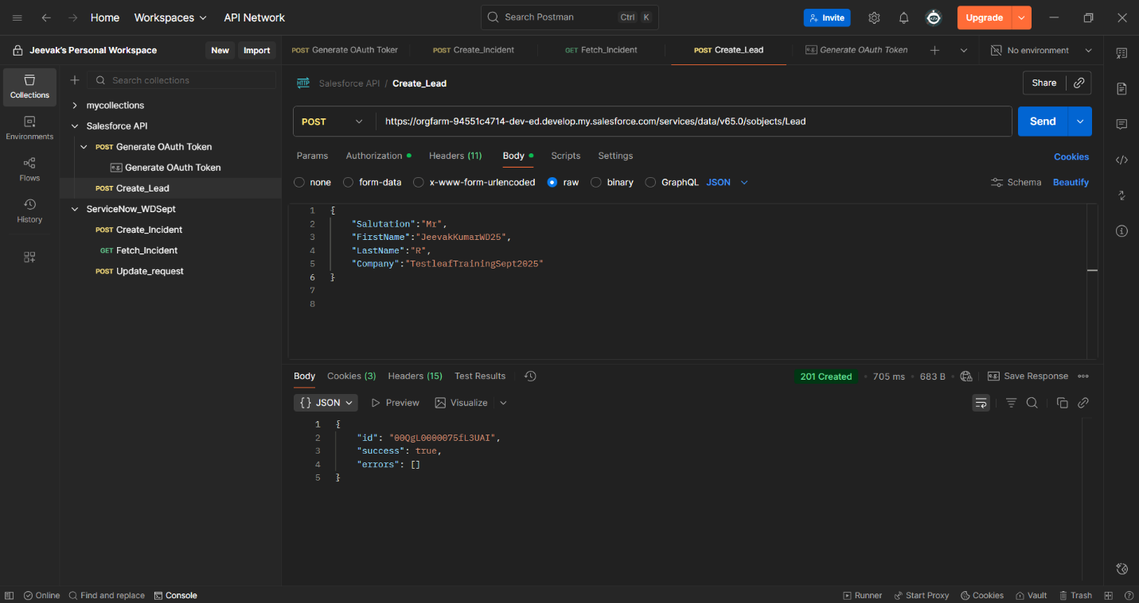
Salesforce
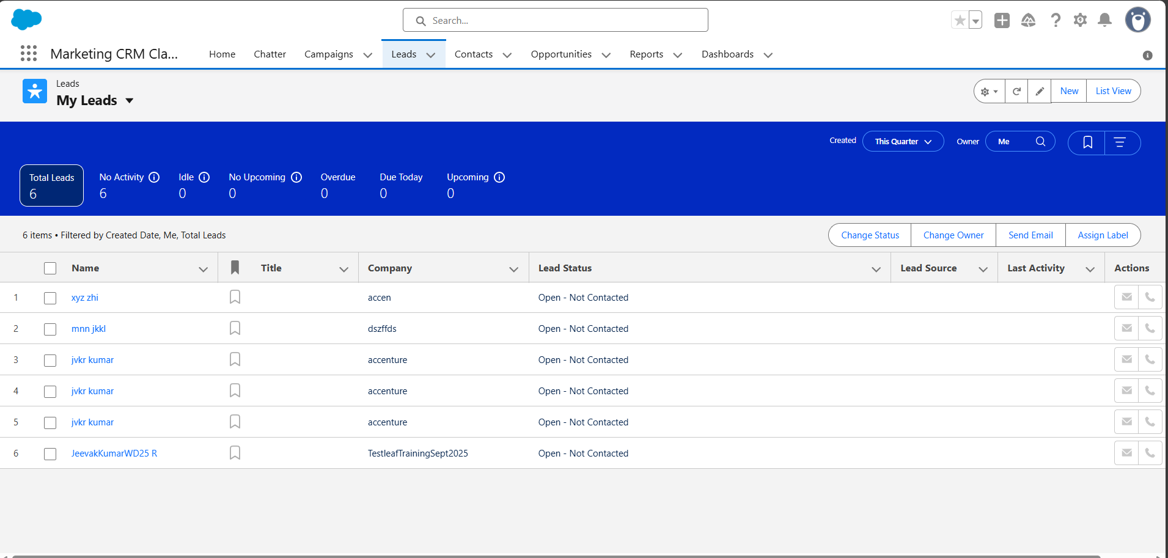

Step 2: Copy the id (00QgL0000075fL3UAI) of the Lead request created in postman and paste it in the ‘Retrieve a record(GET)’ of Postman application and check whether it is displayed.
Copy and paste the ID after Lead (https://orgfarm-94551c4714-dev-ed.develop.my.salesforce.com/services/data/v65.0/sobjects/Lead/00QgL0000075fL3UAI )

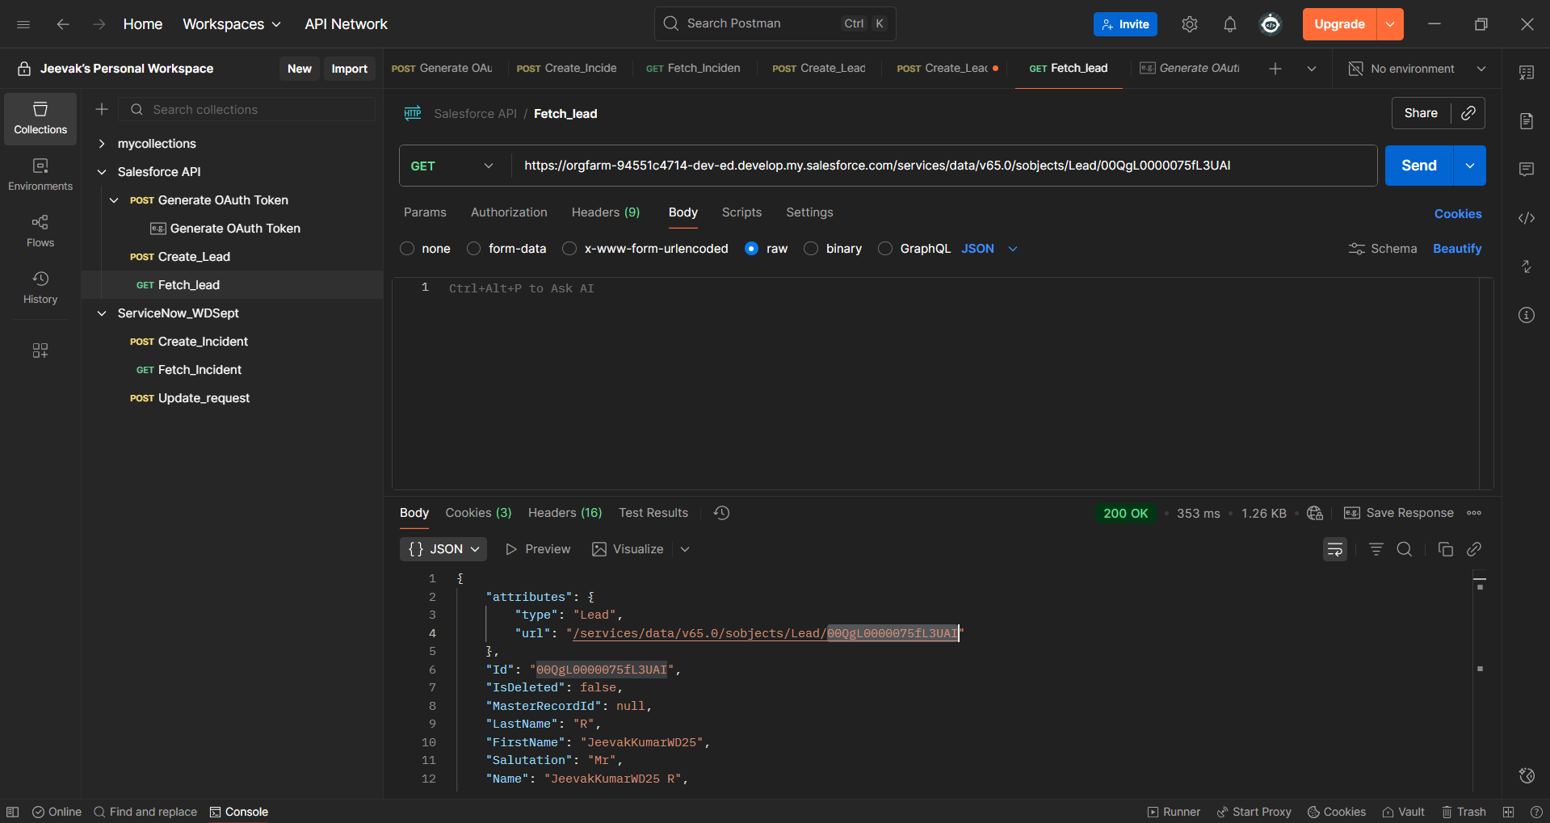

Step 3: Modify the “{
"Salutation":"Mr",
"FirstName":"JeevakKumarWD25",
"LastName":"R",
"Company":"TestleafTrainingSept2025"
}” using PATCH in Postman.
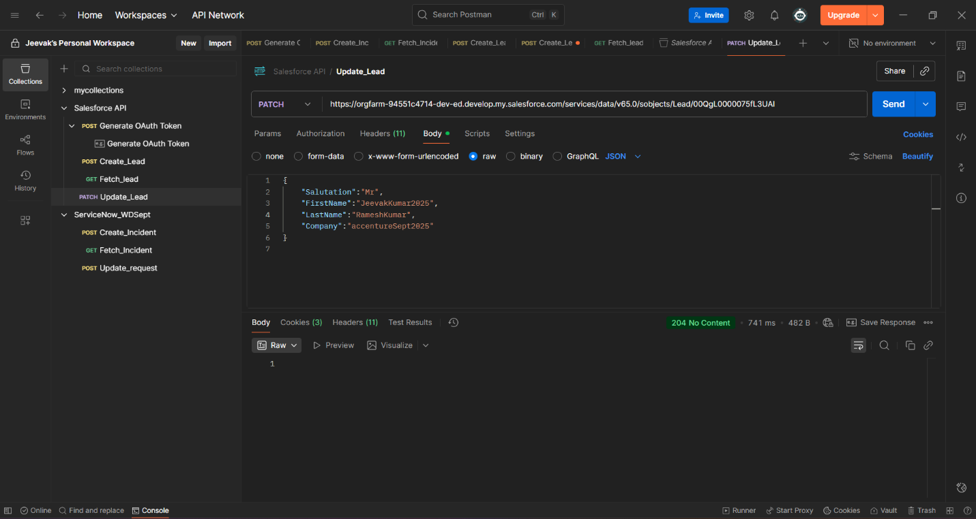
Check the same in salesforce whether Lead modification is done or not
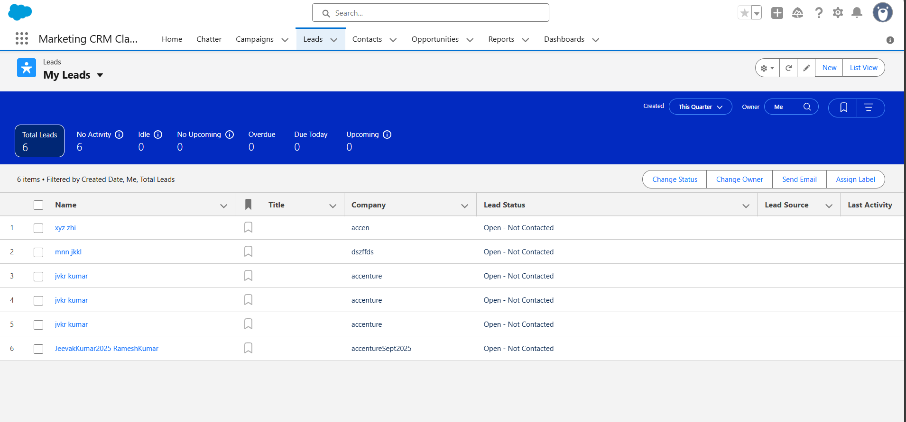
Step 4: Deletion of the Lead request created using DELETE in Postman.
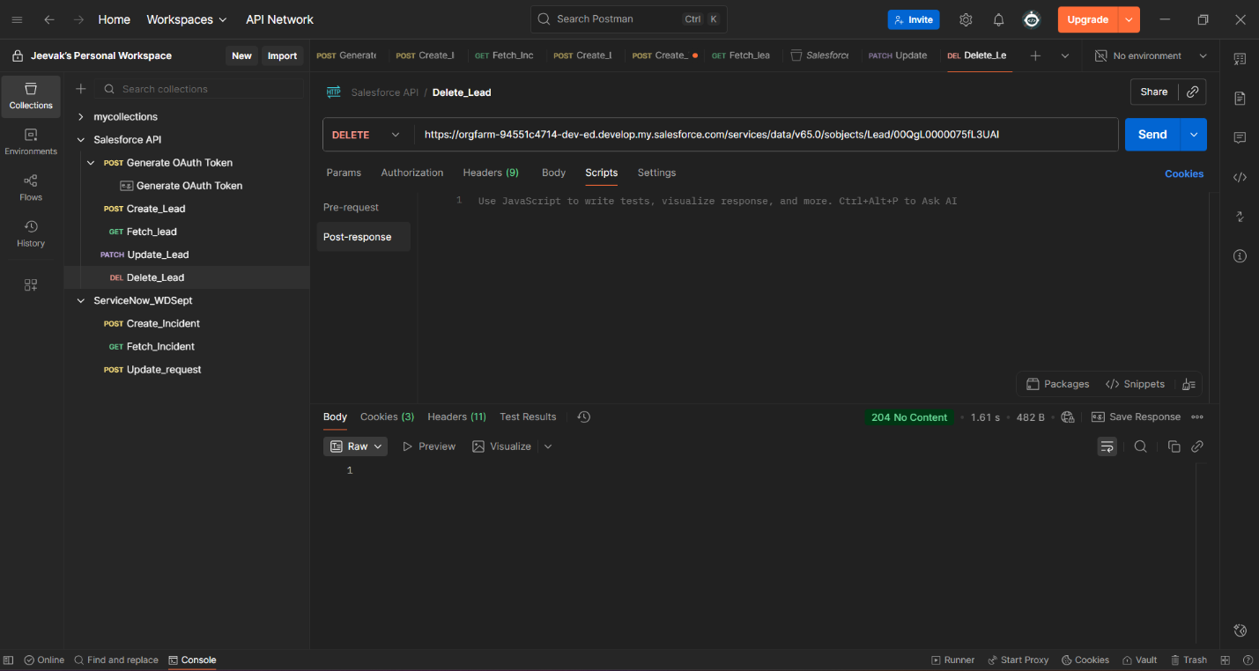
Check the same in salesforce whether Lead is deleted or not
