MICROSOFT
Microsoft Dynamics 365
D365 F&O User Onboarding Agent
Customer Testing Guide
Scenario: CreateADUser = 1 | Approval Required = Yes
Document Type  UAT / Functional Test Guide | Version  1.0 | April 2026
Product  UserOnboardingAgent | Platform  Microsoft Copilot Studio + Azure

CONFIDENTIAL — FOR CUSTOMER USE ONLY

1. Overview & Purpose
This guide walks you through the end-to-end test scenario for onboarding a new Microsoft 365 / Dynamics 365 Finance & Operations (D365 F&O) user using the UserOnboardingAgent. The scenario covered in this document tests:

- CreateADUser = 1 — The agent will check whether the user exists in Entra ID (formerly Azure Active Directory). If the user does not exist, the agent will automatically create the Entra ID account.
- Approval Required = Yes — Before provisioning proceeds, a Microsoft Teams Adaptive Card approval request is sent to a designated approver. Provisioning only continues after explicit approval.

When to use this guide
Use this guide during User Acceptance Testing (UAT) before go-live, or whenever you want to validate the full onboarding flow — from user input through Teams approval to Entra ID creation and D365 F&O role assignment.

1.1 What happens in this scenario?
The following sequence summarises the full onboarding flow you will test:

- An HR administrator or IT staff opens the Copilot Studio chat and types a prompt to onboard a new user.
- The agent presents an onboarding form requesting Identity Information, Job Details, and Region & Approval settings.
- The administrator fills in the form and sets Approval Required = Yes, then clicks Submit & Onboard.
- The agent checks Entra ID for the email address. Because CreateADUser = 1, if the user does not exist, the agent creates the account automatically.
- A Microsoft Teams Adaptive Card is sent to the configured Teams channel (FNOUserApprove) requesting approval.
- The approver reviews the card and clicks Approve or Reject.
- If approved, the agent completes the provisioning: D365 F&O roles are assigned and a confirmation email is sent to the user.
- The agent returns a status message confirming success.

2. Pre-Requisites
Before starting the test, ensure the following items are in place:

2.1 System Configuration (OnboardAgentConfig)
Verify the OnboardAgentConfig Dataverse table contains the following key-value pairs for UserOnboardingAgent. The highlighted row is the critical setting for this test scenario.

Config Key | Value (Test) | Description
CreateADUser | 1 | Set to 1 to enable automatic Entra ID account creation if user does not exist. This is the key setting for this test.
RoleDetermination | 2 | 2 = Hybrid mode (roles from both direct assignment and user groups)
TenantId | <your-tenant-id> | Your Microsoft 365 Tenant ID
TeamName | F&O User Provisioning | The Microsoft Teams team where approval cards are sent
ChannelName | FNOUserApprove | The Teams channel where the approval Adaptive Card appears
CCEmailList | <admin-email> | Email address(es) that receive the onboarding summary
SendConfirmationEmail | 1 | 1 = Send a welcome email to the new user after successful onboarding
Licensesku | {Commerce: [DYN365_RETAIL, ...]} | JSON map of commerce licences to F&O licence SKUs
graph-client-id | <app-registration-id> | Azure App Registration Client ID for Microsoft Graph API calls
graph-client-secret | <app-registration-secret> | Azure App Registration Secret (store securely in Key Vault)

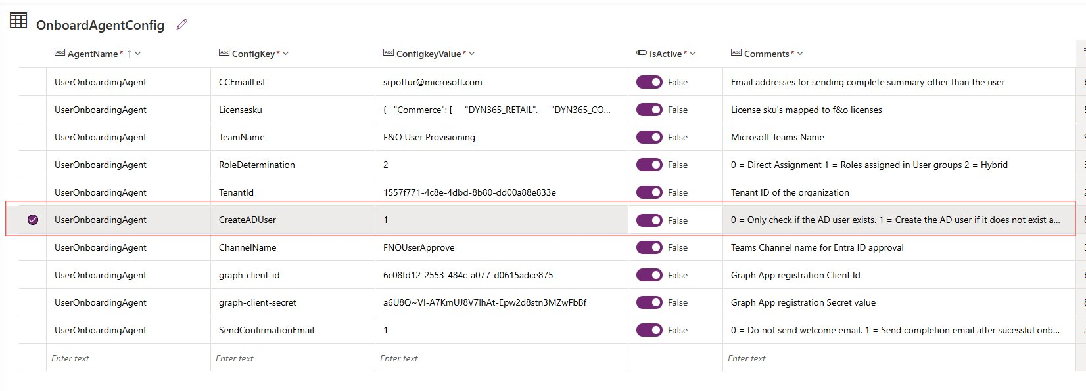
Figure 1 — OnboardAgentConfig table in Dataverse (CreateADUser highlighted)

Important — IsActive toggle
All configuration rows must have IsActive = True (toggle ON) for the agent to read them. If a row shows False, toggle it on before testing.

2.2 Access & Permissions Checklist

- You have access to the Copilot Studio bot (via webchat embed or direct Teams tab).
- Your account has permission to create users in Entra ID, or the Agent's App Registration has User.ReadWrite.All Graph API permission.
- The Teams channel FNOUserApprove exists and you have at least one designated approver in the channel.
- The App Registration (graph-client-id) has the following Microsoft Graph API permissions: User.ReadWrite.All, Directory.ReadWrite.All.
- D365 F&O environment is accessible and the role mappings are configured.
- You have a test email address ready (e.g., CAF.user@yourtenant.onmicrosoft.com) that does NOT yet exist in Entra ID.

3. Step-by-Step Test Execution
Follow these steps in order. Screenshots in each step correspond to the images captured during a live test run.

Step 1 | Launch the Onboarding Agent  Open the Copilot Studio bot in Microsoft Teams or the webchat interface. Type the prompt below to begin the onboarding workflow.

Trigger Prompt
Onboard a new user — First Name: CAF, Last Name: User, Email: CAF.user@pfecrmonline.onmicrosoft.com, Job Title: Finance Manager, Department: Finance, Country: US, Approval Required: Yes

The agent will parse your input and display the onboarding form pre-populated with the details you provided.

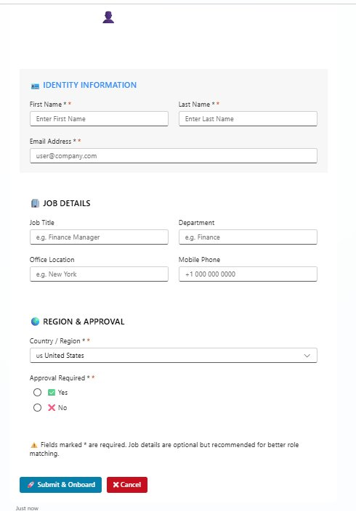
Figure 2 — Onboarding form as presented by the agent (blank state)

Step 2 | Review the Onboarding Form  The agent renders an interactive form with three sections: Identity Information, Job Details, and Region & Approval. Verify the fields are pre-filled correctly.

Form Fields Reference
Field | Sample Test Value | Required? | Notes
First Name | CAF | Yes * | Pre-filled from your prompt
Last Name | User | Yes * | Pre-filled from your prompt
Email Address | CAF.user@pfecrmonline.onmicrosoft.com | Yes * | Must be a valid UPN format
Job Title | Finance Manager | Optional | Improves role matching accuracy
Department | Finance | Optional | Used for role resolution
Office Location | (leave blank) | Optional | Can be left empty in test
Mobile Phone | (leave blank) | Optional | Can be left empty in test
Country / Region | us United States | Yes * | Select from dropdown
Approval Required | Yes (selected) | Yes * | MUST be Yes for this test scenario

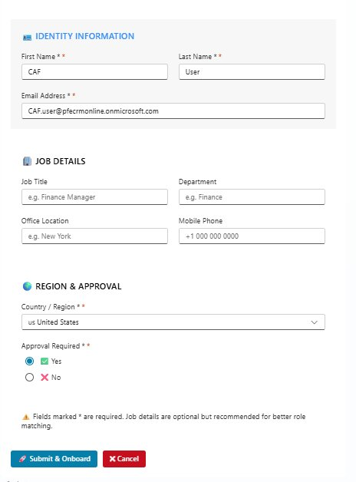
Figure 3 — Onboarding form filled with CAF User details (Approval Required = Yes selected)

Tip — Approval Required field
Make sure the 'Yes' radio button is selected under Approval Required. This is the trigger that routes the request through the Teams Adaptive Card approval workflow. If 'No' is selected, the user will be created directly without manager approval.

Step 3 | Submit the Form  Once you have reviewed all fields, click the Submit & Onboard button at the bottom of the form. The Cancel button will abort the process without saving.

After clicking Submit & Onboard, the agent will:
- Validate that all required fields (*) are filled in.
- Call the Entra ID check sub-agent to look up the email address.
- Because CreateADUser = 1 and the user does not exist, invoke the user creation flow via Microsoft Graph API.
- Trigger the Teams approval workflow and send an Adaptive Card to the FNOUserApprove channel.

Step 4 | Approve the Request in Microsoft Teams  The designated approver will receive an Adaptive Card in the FNOUserApprove Teams channel. The card displays all user details and provides Approve / Reject buttons.

Adaptive Card Contents
Field | Sample Test Value | Required? | Notes
First Name / Last Name | CAF / User | Display | Shown for approver review
Email Address | CAF.user@pfecrmonline.onmicrosoft.com | Display | The UPN that will be created in Entra ID
Job Title | <UNKNOWN> | Display | Shown as UNKNOWN if not provided
Department | <UNKNOWN> | Display | Shown as UNKNOWN if not provided
Country / Region | US | Display | Region selected in the form
Rejection Notes | (leave blank) | Conditional | Only required if clicking Reject

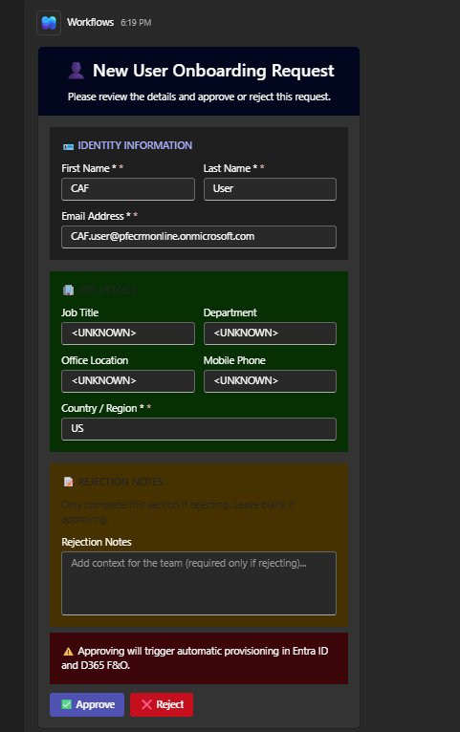
Figure 4 — Microsoft Teams Adaptive Card received by approver in FNOUserApprove channel

Warning — Approval is irreversible in this flow
Once the approver clicks Approve, the provisioning pipeline is triggered automatically. The agent will proceed to create the user in Entra ID and assign D365 F&O roles without further confirmation. Ensure the user details are correct before approving.

The approver should:
- Open the FNOUserApprove channel in Microsoft Teams.
- Locate the card titled 'New User Onboarding Request'.
- Review the Identity Information and Job Details sections.
- Leave the Rejection Notes field blank (it is only required when rejecting).
- Click the Approve button to proceed.

Step 5 | Verify the API Response & Success Message  After approval, the agent completes provisioning and returns the final status. You should see the following success response from the Entra ID creation workflow.

Expected API Response (isUserCreated = 1)
{
"statusCode": "200",
"body": {
"isusercreated": "1",
"statusmessage": "The User is created successfully"
}
}

A statusCode of 200 and isusercreated = 1 confirms that the Entra ID account was created successfully. The agent will now proceed with D365 F&O role assignment and send the welcome email.

4. Expected Results Checklist
Use the table below to validate each outcome of the test. Mark each item as Pass / Fail during your testing session.

Expected Result | Status | Notes
Onboarding form renders with correct sections (Identity, Job Details, Region & Approval) | Pass | Validated visually
Form pre-populates from natural language prompt | Pass | First/Last/Email filled automatically
Approval Required = Yes routes to Teams workflow | Pass | Teams card received in FNOUserApprove
Adaptive Card displays all user details correctly | Pass | CAF User / US / email shown
Approve button triggers provisioning pipeline | Pass | No manual intervention needed after click
Entra ID user created (CreateADUser = 1) | Pass | Verified in Azure Portal / Entra ID
API returns statusCode 200 and isusercreated = 1 | Pass | Confirmed in agent response
Success message displayed in Copilot Studio chat | Pass | "The User is created successfully"
Welcome email sent to new user | Pass | Check inbox of CAF.user@...
CC summary email sent to admin (CCEmailList) | Pass | Check configured admin mailbox

5. Troubleshooting Common Issues

5.1 Teams Adaptive Card not appearing
- Confirm TeamName and ChannelName in OnboardAgentConfig exactly match the Teams team and channel names (case-sensitive).
- Verify the Power Automate flow is published and not in a draft state.
- Check that the agent's service account has permission to post to the Teams channel.

5.2 isusercreated returns 0 instead of 1
- The user email already exists in Entra ID. This is the expected result (code 0 = user exists, was not re-created). Try a different test email.
- Verify CreateADUser = 1 is set in OnboardAgentConfig and the row IsActive toggle is ON.
- Check that the Graph App Registration has User.ReadWrite.All permission with admin consent granted.

5.3 Form does not render or shows blank fields
- Ensure the Copilot Studio bot is published and the latest version is deployed.
- Check the D365 F&O custom connector or Power Automate flow that drives the form rendering.
- Review Copilot Studio conversation transcripts for error nodes.

5.4 Agent times out during approval
- The Power Automate Teams approval workflow uses an asynchronous (decoupled) architecture to avoid the 2-minute Copilot Studio timeout. Verify both flows are active: the trigger flow and the completion callback flow.
- If you see a timeout error in the bot, check Power Automate run history for the approval flow.

6. Appendix — Configuration Reference

6.1 CreateADUser Flag Values

Value | Behaviour
0 | Validation only — The agent checks whether the Entra ID user exists. If the user does not exist, the process stops with an error. No account is created.
1 | Create if not exists — The agent checks Entra ID. If the user exists, onboarding continues with the existing account. If the user does NOT exist, the agent automatically creates the Entra ID account via Microsoft Graph API, then continues provisioning. This is the value used in this test guide.

6.2 Approval Required Flag

Value | Behaviour
No | Direct provisioning — User is created in Entra ID and D365 F&O immediately after form submission, with no manager approval step.
Yes | Approval-gated provisioning — A Teams Adaptive Card is sent to the FNOUserApprove channel. Provisioning only proceeds after the approver clicks Approve. This is the value used in this test guide.

6.3 Key Contacts

For questions about this testing guide or the UserOnboardingAgent product, contact:

Role | Contact
Microsoft Support | https://support.microsoft.com
Your Internal IT Admin | <Insert internal IT contact here>

