nileshv@nileshv-B85M-D3H:~$ git version

git version 2.25.1

nileshv@nileshv-B85M-D3H:~$ git config --global user.email "reachnileshvaity1@gmail.com"

nileshv@nileshv-B85M-D3H:~$ git config --global user.username "reachnileshvaity1"

nileshv@nileshv-B85M-D3H:~$ mkdir Lesson-02

nileshv@nileshv-B85M-D3H:~$ cd Lesson-02/

nileshv@nileshv-B85M-D3H:~/Lesson-02$ touch index.html Texts.txt C_Program.c HelloJava.java index.js styles.css typo.ts

nileshv@nileshv-B85M-D3H:~/Lesson-02$ ls -l

total 0

-rw-rw-r-- 1 nileshv nileshv 0 Dec 24 09:11 C_Program.c

-rw-rw-r-- 1 nileshv nileshv 0 Dec 24 09:11 HelloJava.java

-rw-rw-r-- 1 nileshv nileshv 0 Dec 24 09:11 index.html

-rw-rw-r-- 1 nileshv nileshv 0 Dec 24 09:11 index.js

-rw-rw-r-- 1 nileshv nileshv 0 Dec 24 09:11 styles.css

-rw-rw-r-- 1 nileshv nileshv 0 Dec 24 09:11 Texts.txt

-rw-rw-r-- 1 nileshv nileshv 0 Dec 24 09:11 typo.ts

nileshv@nileshv-B85M-D3H:~/Lesson-02$ sync

nileshv@nileshv-B85M-D3H:~/Lesson-02$ vi C_Program.c

nileshv@nileshv-B85M-D3H:~/Lesson-02$ vi HelloJava.java

nileshv@nileshv-B85M-D3H:~/Lesson-02$ vi index.html

nileshv@nileshv-B85M-D3H:~/Lesson-02$ vi index.js

nileshv@nileshv-B85M-D3H:~/Lesson-02$ git init

Initialized empty Git repository in /home/nileshv/Lesson-02/.git/

nileshv@nileshv-B85M-D3H:~/Lesson-02$ git add .

nileshv@nileshv-B85M-D3H:~/Lesson-02$ git commit . -m "I am pushing all the files to mu github"

[master (root-commit) a5da0d0] I am pushing all the files to mu github

8 files changed, 42 insertions(+)

create mode 100644 C_Program.c

create mode 100644 HelloJava.java

create mode 100644 Texts.txt

create mode 100644 index.html

create mode 100644 index.js

create mode 100644 steps_github.txt

create mode 100644 styles.css

create mode 100644 typo.ts

nileshv@nileshv-B85M-D3H:~/Lesson-02$ git status

On branch master

nothing to commit, working tree clean

nileshv@nileshv-B85M-D3H:~/Lesson-02$

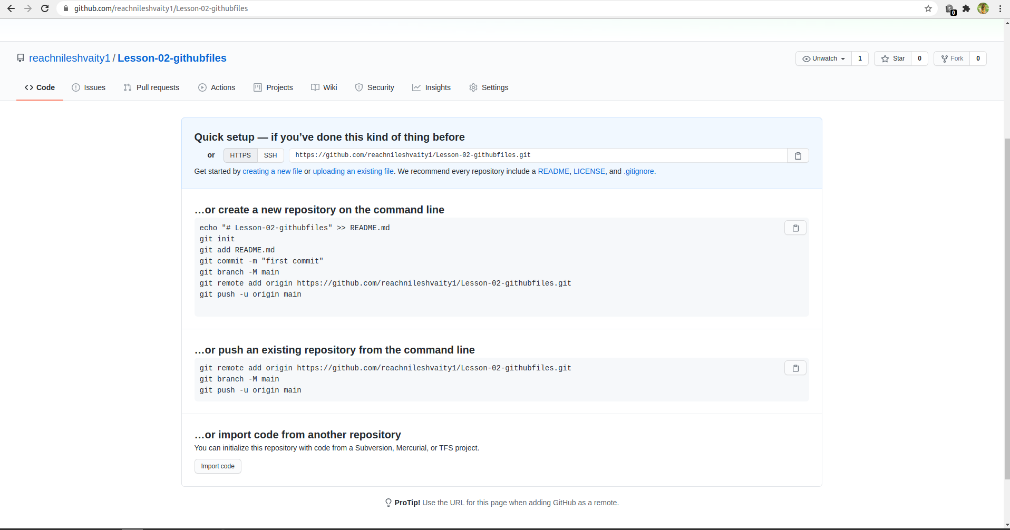nileshv@nileshv-B85M-D3H:~/Lesson-02$ git remote add origin git@github.com:reachnileshvaity1/Lesson-02-githubfiles.git

nileshv@nileshv-B85M-D3H:~/Lesson-02$ git push -u origin master

Warning: Permanently added the RSA host key for IP address '13.234.210.38' to the list of known hosts.

git@github.com: Permission denied (publickey).

fatal: Could not read from remote repository.

Please make sure you have the correct access rights

and the repository exists.

nileshv@nileshv-B85M-D3H:~/Lesson-02$ cat ~/.ssh/id_rsa.pub

ssh-rsa  nileshv@nileshv-B85M-D3H

nileshv@nileshv-B85M-D3H:~/Lesson-02$ git push -u origin master

Enumerating objects: 8, done.

Counting objects: 100% (8/8), done.

Delta compression using up to 4 threads

Compressing objects: 100% (7/7), done.

Writing objects: 100% (8/8), 1.14 KiB | 582.00 KiB/s, done.

Total 8 (delta 0), reused 0 (delta 0)

To github.com:reachnileshvaity1/Lesson-02-githubfiles.git

* [new branch] master -> master

Branch 'master' set up to track remote branch 'master' from 'origin'.

nileshv@nileshv-B85M-D3H:~/Lesson-02$