[**C调常用和弦指法图**](http://www.17jita.com/chord/c/)

* [**C**](http://www.17jita.com/chord/c/C.html) [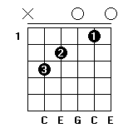](http://www.17jita.com/chord/c/C.html)
* [**Dm**](http://www.17jita.com/chord/c/Dm.html) [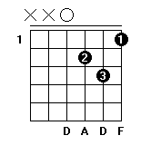](http://www.17jita.com/chord/c/Dm.html)
* [**Em**](http://www.17jita.com/chord/c/Em.html) [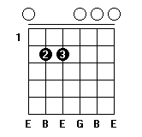](http://www.17jita.com/chord/c/Em.html)
* [**F**](http://www.17jita.com/chord/c/F.html) [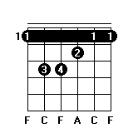](http://www.17jita.com/chord/c/F.html)
* [**G**](http://www.17jita.com/chord/c/G.html) [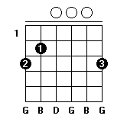](http://www.17jita.com/chord/c/G.html)
* [**Am**](http://www.17jita.com/chord/c/Am.html) [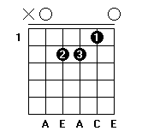](http://www.17jita.com/chord/c/Am.html)
* [**G7**](http://www.17jita.com/chord/c/G7.html) [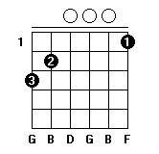](http://www.17jita.com/chord/c/G7.html)

[**D调常用和弦指法图**](http://www.17jita.com/chord/d/)

* [**D**](http://www.17jita.com/chord/d/D.html) [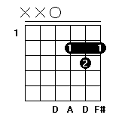](http://www.17jita.com/chord/d/D.html)
* [**Em**](http://www.17jita.com/chord/d/Em.html) [](http://www.17jita.com/chord/d/Em.html)
* [**#Fm**](http://www.17jita.com/chord/d/Fm1.html) [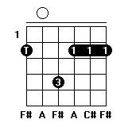](http://www.17jita.com/chord/d/Fm1.html)
* [**G**](http://www.17jita.com/chord/d/G.html) [](http://www.17jita.com/chord/d/G.html)
* [**A**](http://www.17jita.com/chord/d/A.html) [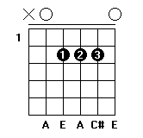](http://www.17jita.com/chord/d/A.html)
* [**Bm**](http://www.17jita.com/chord/d/Bm.html) [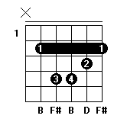](http://www.17jita.com/chord/d/Bm.html)
* [**A7**](http://www.17jita.com/chord/d/A7.html) [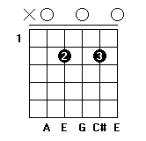](http://www.17jita.com/chord/d/A7.html)

[**E调常用和弦指法图**](http://www.17jita.com/chord/e/)

* [**E**](http://www.17jita.com/chord/e/E.html) [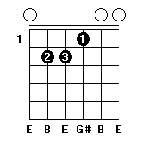](http://www.17jita.com/chord/e/E.html)
* [**#Fm**](http://www.17jita.com/chord/e/Fm1.html) [](http://www.17jita.com/chord/e/Fm1.html)
* [**#Gm**](http://www.17jita.com/chord/e/Gm1.html) [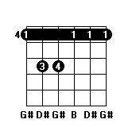](http://www.17jita.com/chord/e/Gm1.html)
* [**A**](http://www.17jita.com/chord/e/A.html) [](http://www.17jita.com/chord/e/A.html)
* [**B**](http://www.17jita.com/chord/e/B.html) [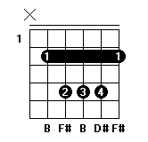](http://www.17jita.com/chord/e/B.html)
* [**#Cm**](http://www.17jita.com/chord/e/Cm1.html) [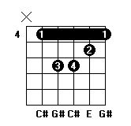](http://www.17jita.com/chord/e/Cm1.html)
* [**B7**](http://www.17jita.com/chord/e/B7.html) [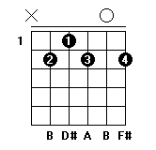](http://www.17jita.com/chord/e/B7.html)

[**F调常用和弦指法图**](http://www.17jita.com/chord/f/)

* [**F**](http://www.17jita.com/chord/f/F.html) [](http://www.17jita.com/chord/f/F.html)
* [**Gm**](http://www.17jita.com/chord/f/Gm.html) [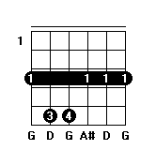](http://www.17jita.com/chord/f/Gm.html)
* [**Am**](http://www.17jita.com/chord/f/Am.html) [](http://www.17jita.com/chord/f/Am.html)
* [**bB**](http://www.17jita.com/chord/f/bB.html) [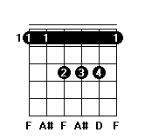](http://www.17jita.com/chord/f/bB.html)
* [**C**](http://www.17jita.com/chord/f/C.html) [](http://www.17jita.com/chord/f/C.html)
* [**Dm**](http://www.17jita.com/chord/f/Dm.html) [](http://www.17jita.com/chord/f/Dm.html)
* [**C7**](http://www.17jita.com/chord/f/C7.html) [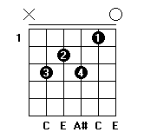](http://www.17jita.com/chord/f/C7.html)

[**G调常用和弦指法图**](http://www.17jita.com/chord/g/)

* [**G**](http://www.17jita.com/chord/g/G.html) [](http://www.17jita.com/chord/g/G.html)
* [**Am**](http://www.17jita.com/chord/g/Am.html) [](http://www.17jita.com/chord/g/Am.html)
* [**Bm**](http://www.17jita.com/chord/g/Bm.html) [](http://www.17jita.com/chord/g/Bm.html)
* [**C**](http://www.17jita.com/chord/g/C.html) [](http://www.17jita.com/chord/g/C.html)
* [**D**](http://www.17jita.com/chord/g/D.html) [](http://www.17jita.com/chord/g/D.html)
* [**Em**](http://www.17jita.com/chord/g/Em.html) [](http://www.17jita.com/chord/g/Em.html)
* [**D7**](http://www.17jita.com/chord/g/D7.html) [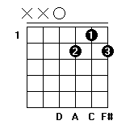](http://www.17jita.com/chord/g/D7.html)

[**A调常用和弦指法图**](http://www.17jita.com/chord/a/)

* [**A**](http://www.17jita.com/chord/a/A.html) [](http://www.17jita.com/chord/a/A.html)
* [**Bm**](http://www.17jita.com/chord/a/Bm.html) [](http://www.17jita.com/chord/a/Bm.html)
* [**#Cm**](http://www.17jita.com/chord/a/Cm1.html) [](http://www.17jita.com/chord/a/Cm1.html)
* [**D**](http://www.17jita.com/chord/a/D.html) [](http://www.17jita.com/chord/a/D.html)
* [**E**](http://www.17jita.com/chord/a/E.html) [](http://www.17jita.com/chord/a/E.html)
* [**#Fm**](http://www.17jita.com/chord/a/Fm1.html) [](http://www.17jita.com/chord/a/Fm1.html)
* [**E7**](http://www.17jita.com/chord/a/E7.html) [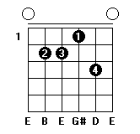](http://www.17jita.com/chord/a/E7.html)

[**B调常用和弦指法图**](http://www.17jita.com/chord/b/)

* [**B**](http://www.17jita.com/chord/b/B.html) [](http://www.17jita.com/chord/b/B.html)
* [**#Cm**](http://www.17jita.com/chord/b/Cm1.html) [](http://www.17jita.com/chord/b/Cm1.html)
* [**#Dm**](http://www.17jita.com/chord/b/Dm1.html) [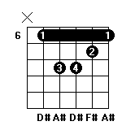](http://www.17jita.com/chord/b/Dm1.html)
* [**E**](http://www.17jita.com/chord/b/E.html) [](http://www.17jita.com/chord/b/E.html)
* [**#F**](http://www.17jita.com/chord/b/F.html) [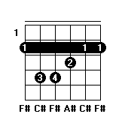](http://www.17jita.com/chord/b/F.html)
* [**#Gm**](http://www.17jita.com/chord/b/Gm1.html) [](http://www.17jita.com/chord/b/Gm1.html)
* [**#F7**](http://www.17jita.com/chord/b/F7.html) [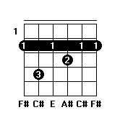](http://www.17jita.com/chord/b/F7.html)

**吉他和弦图的看法**

[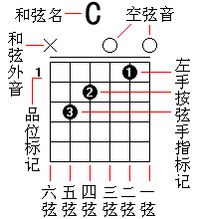](http://www.17jita.com/blog/hexian.html)

* [**吉他和弦图的看法详细介绍**](http://www.17jita.com/blog/hexian.html)
* [**吉他和弦以及和弦图的介绍**](http://www.17jita.com/hexian/3405.html)
* [**吉他谱怎么看**](http://www.17jita.com/zhuanti/4193.html)
* [吉他C和弦指法图大全](http://www.17jita.com/hexian/c/)
* [吉他D和弦指法图大全](http://www.17jita.com/hexian/d/)
* [吉他E和弦指法图大全](http://www.17jita.com/hexian/e/)
* [吉他F和弦指法图大全](http://www.17jita.com/hexian/f/)
* [吉他G和弦指法图大全](http://www.17jita.com/hexian/g/)
* [吉他A和弦指法图大全](http://www.17jita.com/hexian/a/)
* [吉他B和弦指法图大全](http://www.17jita.com/hexian/b/)