MLOPS COURSE END-TERM PROJECT - GROUP 53

Real-Time Credit Card Fraud Detection
  - An End-to-End MLOps Pipeline

Course | DA5402W - MLOps
Institution | IIT-M
Instructor | Dr. Alka Bhushan, Dr. Priyanka, Dr. Aishwarya  Jashaswimalya Acharjee  Sankalp Shrivastava
Team members | Gutti Ashok Kumar – DA25M567  K Afsar Ali – DA25M617  Mohammed Shujath – DA25M590  Sarita Jangra – DA25M617
Submission date | August 23rd, 2026
Repository | https://github.com/reachshujath/DA5402W_Project

Executive Summary
This project implements a reproducible, production-style machine-learning operations pipeline for real-time credit-card fraud detection. The solution integrates DVC, Apache Airflow, Apache Kafka, Apache Spark Structured Streaming, MLflow, FastAPI, Docker Compose, Prometheus, Grafana, and GitHub Actions. The emphasis is operational reliability, traceable data & model versions, automated training, guarded model promotion, streaming inference, observable deployment, and repeatable execution.
Verified outcome Random Forest was selected and promoted as model version 4. On the untouched test split it achieved PR-AUC 0.8253, recall 0.8776, precision 0.6056, and F1 0.7167 at a threshold of 0.17.

1. Problem Statement and Objectives
Fraud detection is a highly imbalanced binary-classification problem in which missed fraud is costly, while excessive false alarms impose operational friction. Accuracy is therefore misleading. The project optimizes validation PR-AUC subject to explicit recall and precision gates, tunes classification thresholds only on validation data, and reports final performance on an untouched test set.
- Automate validation, training, comparison, registration, deployment, and monitoring.
- Simulate transaction arrival through Kafka and perform inference with Spark.
- Provide reproducible data/model versions, observable APIs, and automated CI/CD checks.

2. Dataset and Data Processing
The project uses the public Credit Card Fraud Detection dataset published by the Machine Learning Group at Universite Libre de Bruxelles and distributed through Kaggle. It contains 284,807 transactions, 31 columns, and 492 fraud records (approximately 0.173%). Features V1-V28 are anonymized PCA components. Time and Amount remain numeric and Class is the binary target.
Stage | Implemented controls
Validation | Required columns, numeric types, missing values, binary labels, non-negative Amount
Splitting | Seeded stratified train/validation/test split
Preprocessing | Scale Time and Amount; pass through V1-V28
Imbalance | Balanced class weights plus threshold tuning
Versioning | DVC dataset pointer, parameterized stages, lock file, shared Google Drive remote

3. System Architecture and Data Pipeline
The architecture separates offline model lifecycle operations from online and streaming inference. Airflow orchestrates reproducible retraining, while Kafka and Spark represent event arrival and distributed processing. A promoted model artifact is shared by the API and streaming job. Operational and model behavior metrics are exported to Prometheus and visualized in Grafana.
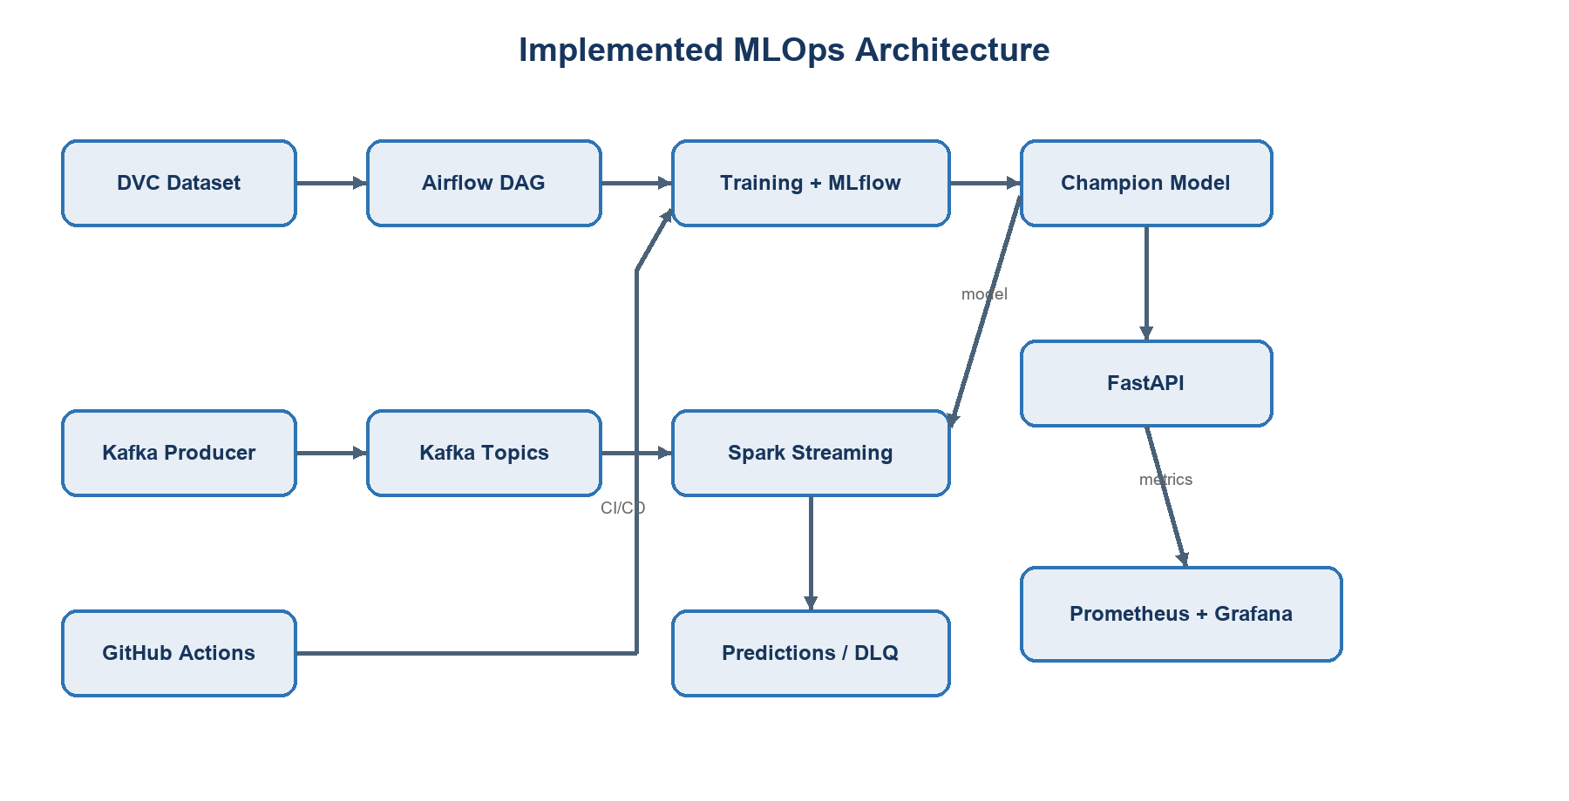
Figure 1. Implemented system architecture and principal data flows.
DVC restores the versioned source dataset and reproduces processed splits, model artifacts, metrics, and drift reference statistics. The Airflow DAG executes validation, candidate training/comparison, promotion evaluation, registry recording, and reference baseline verification. For online inference, FastAPI exposes health, metadata, prediction, drift, and Prometheus endpoints. For streaming inference, Kafka receives replayed transactions. Spark applies a strict schema, produces predictions, and routes malformed messages to a dead-letter topic.

4. Model Development and Results
Two balanced scikit-learn pipelines were compared: Logistic Regression as the interpretable linear baseline and Random Forest as the nonlinear alternative. Thresholds were selected using validation data subject to minimum recall 0.80 and precision 0.20. Eligible candidates were ranked by validation PR-AUC, then F1 and recall. The held-out test split was used only for final reporting.
Model | Threshold | Precision | Recall | F1 | ROC-AUC | PR-AUC
Logistic Regression | 0.95 | 0.3152 | 0.8878 | 0.4652 | 0.9736 | 0.7120
Random Forest (selected) | 0.17 | 0.6056 | 0.8776 | 0.7167 | 0.9738 | 0.8253
The selected Random Forest produced 86 true positives, 56,808 true negatives, 56 false positives, and 12 false negatives on the test split. Compared with Logistic Regression, it materially improved precision, F1, and PR-AUC while retaining high recall.

5. Experiment Tracking, Versioning, and Deployment
Each candidate run logs model parameters, thresholds, validation/test metrics, confusion matrices, dataset fingerprint, and artifacts to MLflow. The selection gate registered and promoted Random Forest as version 4 under the champion alias. The dataset fingerprint links the model to the exact input version, while DVC captures the reproducible pipeline graph and generated outputs.
Candidate experiment runs
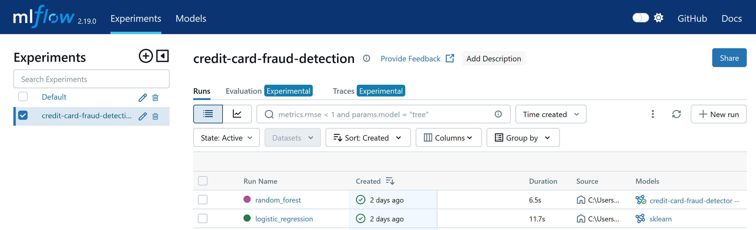
Promoted champion model
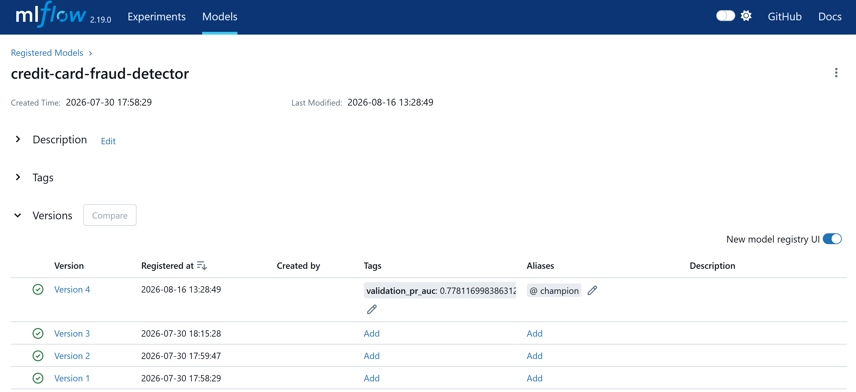
Figure 2. MLflow candidate runs and promoted champion model.
FastAPI loads the promoted local champion artifact and exposes GET /health, GET /model-info, POST /predict, GET /drift, and GET /metrics. Prediction responses include the probability, class, threshold, model metadata, and request ID. Structured logs avoid raw feature disclosure. Purpose-built images and Docker Compose provide consistent API, MLflow, Airflow, Spark, Kafka, Prometheus, and Grafana services.
Executed prediction request
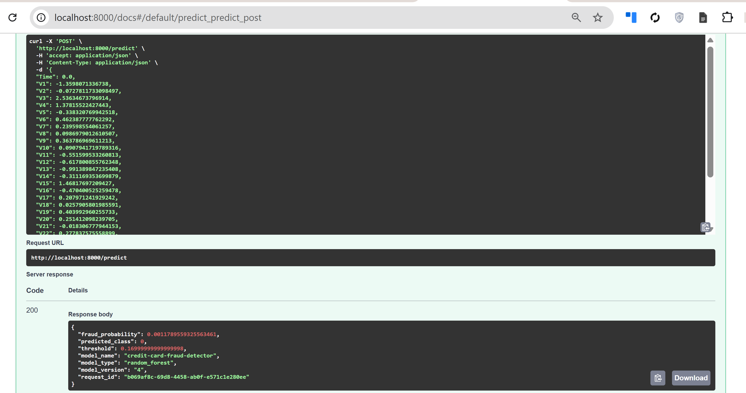
Figure 3. FastAPI prediction contract and traceable response.

6. Streaming and Workflow Orchestration
The Kafka producer replays historical records as JSON without the Class label. Spark Structured Streaming consumes credit card transactions, parses the fixed schema, applies the champion model, and writes probability, class, model version, and timestamp to fraud-predictions. Invalid messages are routed to fraud-invalid-transactions with a reason.
Spark Structured Streaming output
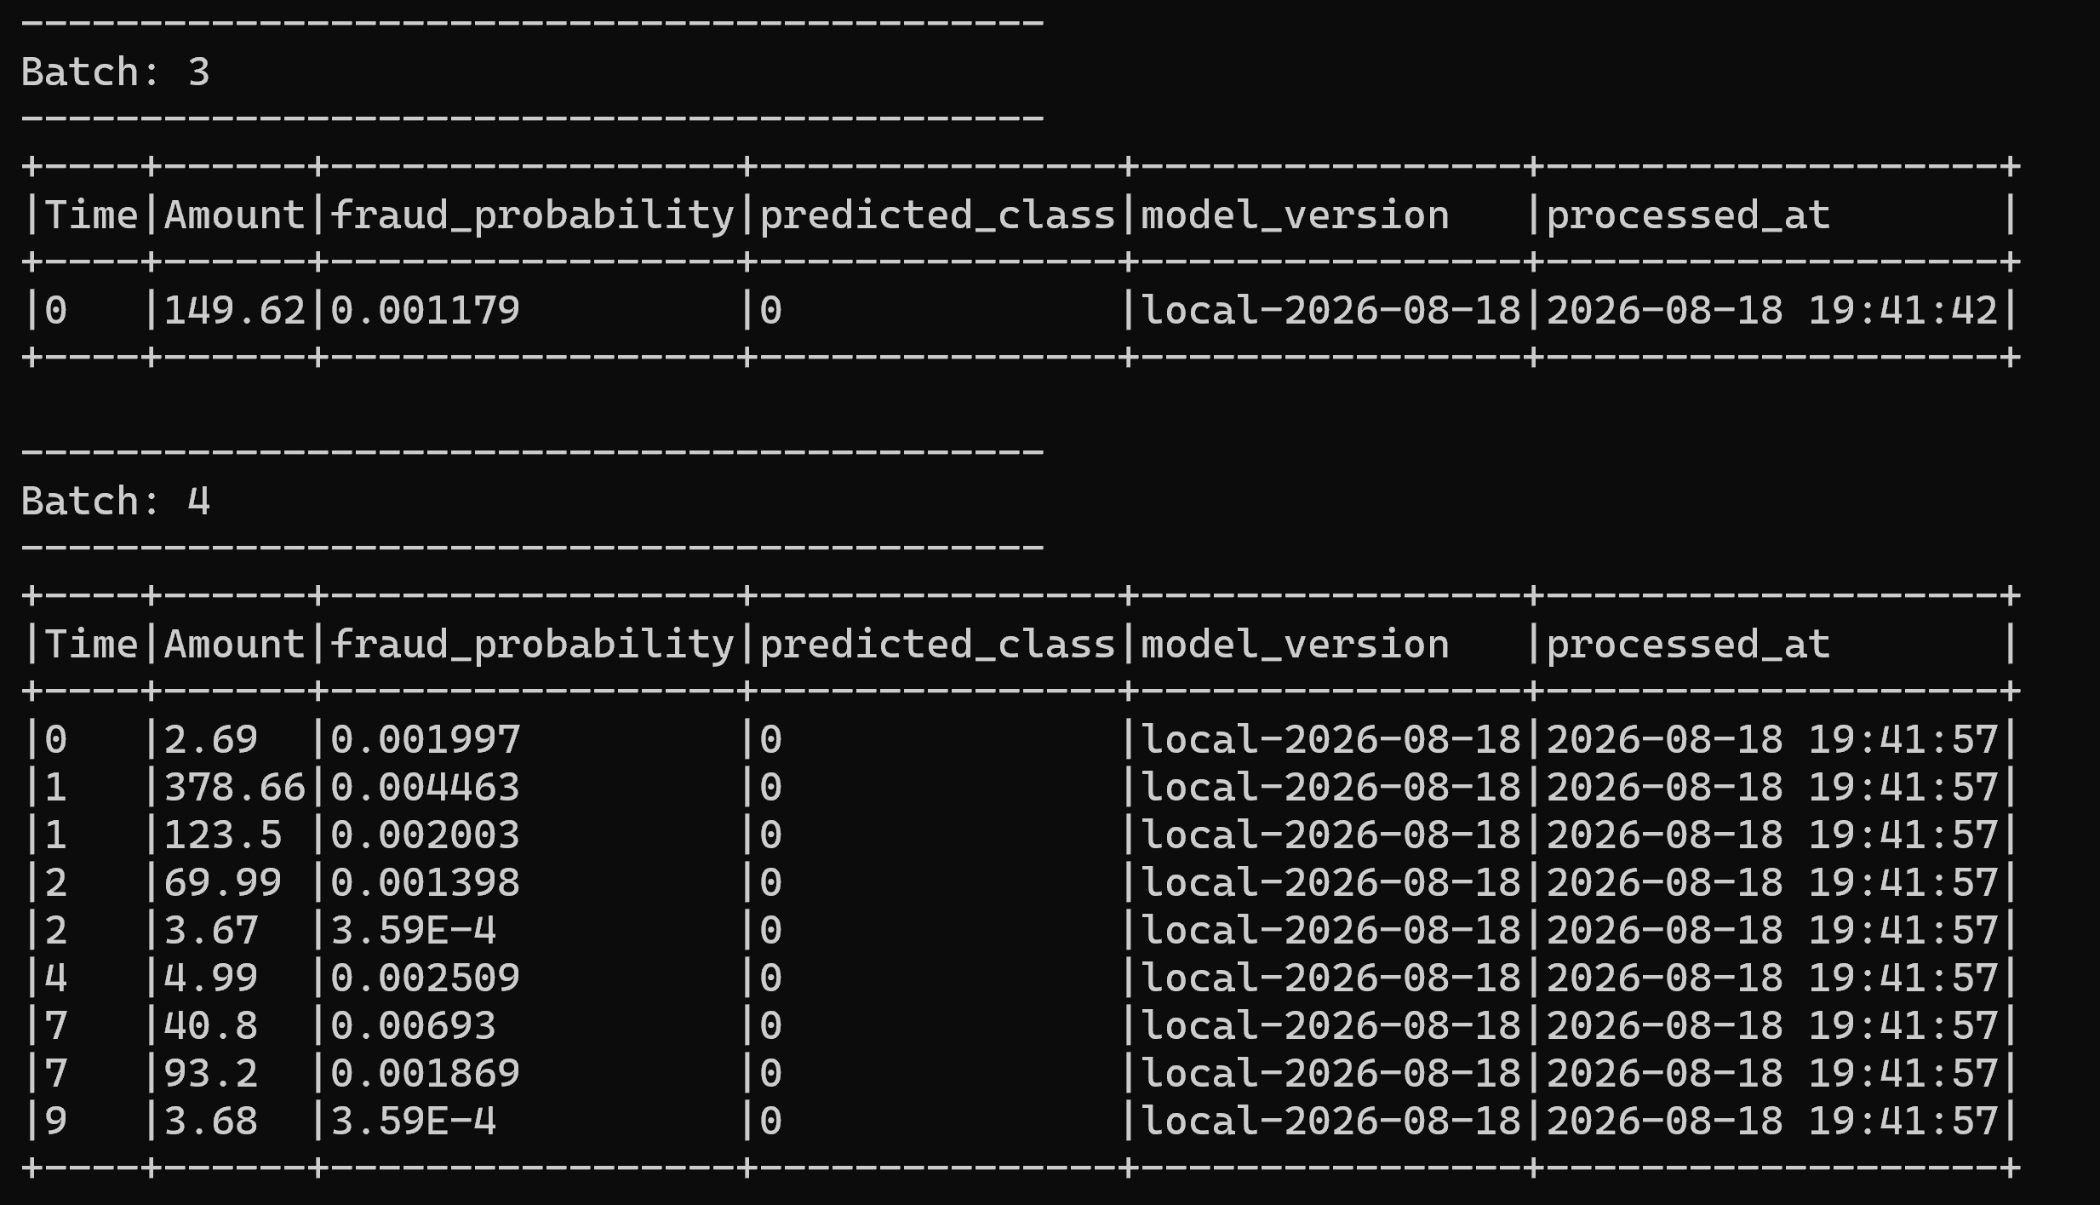
Kafka prediction messages
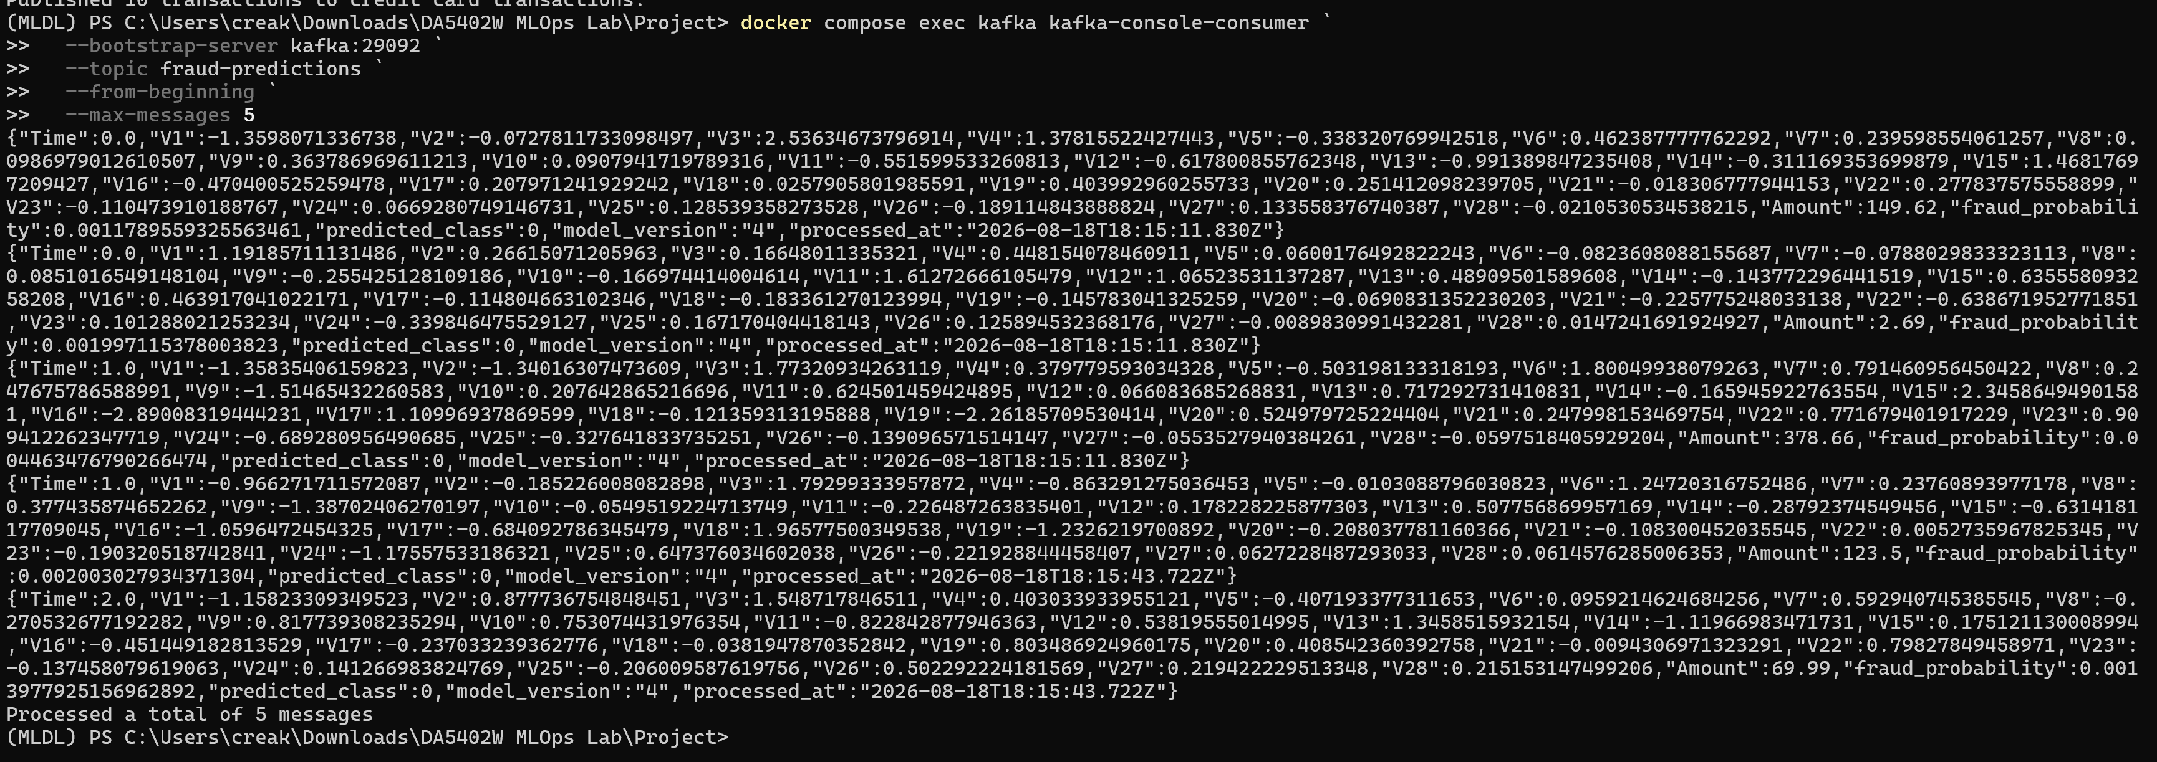
Figure 4. Spark Structured Streaming inference and Kafka prediction output.

7. Airflow Automation
The credit_card_fraud_retraining DAG makes the lifecycle explicit and repeatable. It validates data, trains and compares candidates, evaluates promotion conditions, records registry/promotion state, and verifies drift-baseline artifacts. Promotion requires recall of at least 0.80, precision of at least 0.20, and non-regressing validation PR-AUC relative to the current champion.
Successful retraining DAG
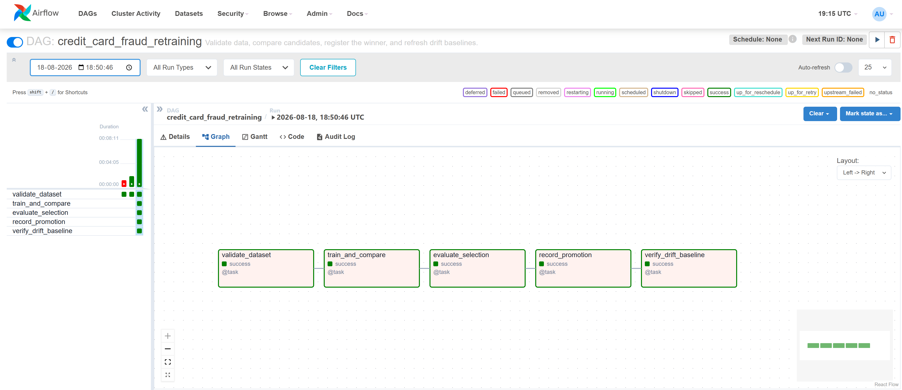
Figure 5. Successful Airflow retraining and promotion workflow.

8. Monitoring, Logging, and Drift
Prometheus scrapes the API for request/status counts, errors, prediction latency, fraud/legitimate outcomes, probability distribution, model readiness, and feature drift metrics. The API maintains a 500 record in-memory window and recalculates drift every 100 successful predictions for Amount, Time, and V1-V4. Grafana is provisioned with the Prometheus data source and fraud dashboard.
Operational and drift monitoring
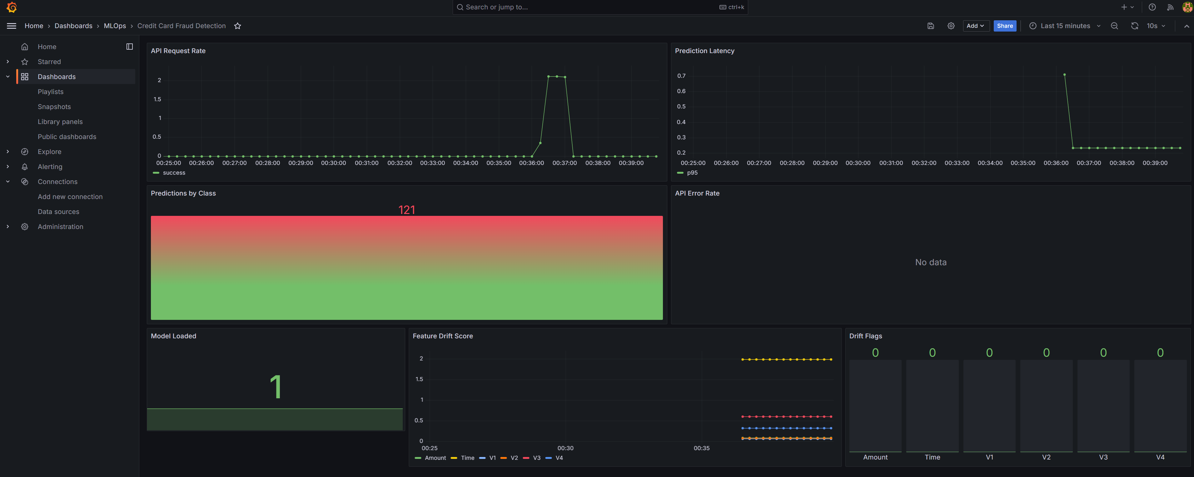
Figure 6. Provisioned Grafana operational and model monitoring dashboard.

9. CI/CD Implementation
GitHub Actions runs on pull requests and pushes to main. The quality job installs dependencies, performs Ruff checks, runs pytest with coverage, and validates the DVC graph. A deterministic synthetic data job executes a training smoke test. After both pass, the container job builds the API image and publishes it to GitHub Container Registry for pushes. The validation run for pull request #4 in the below instance completed successfully across quality, training-smoke, and container jobs before the fixes were merged into main.
Successful CI/CD validation
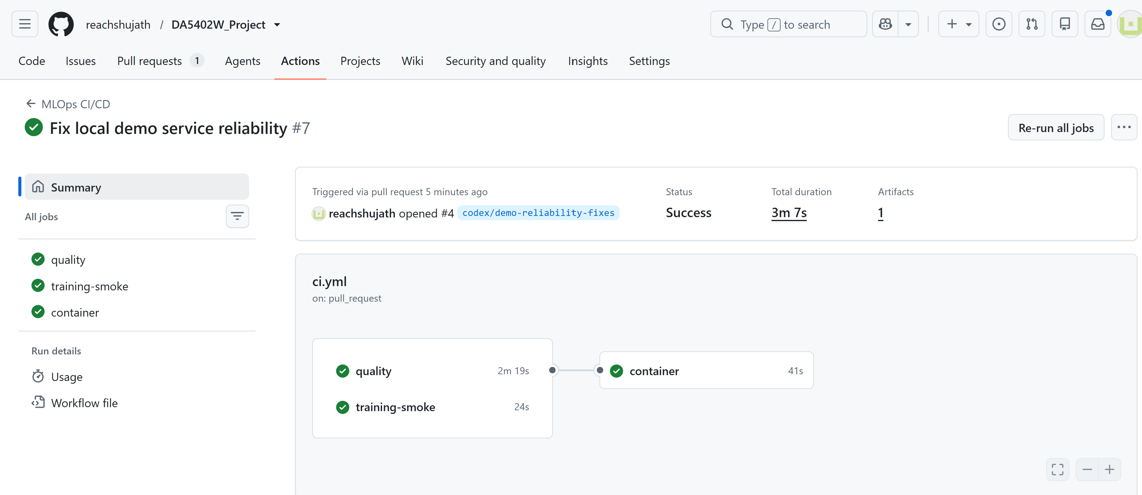
Figure 7. Successful GitHub Actions CI/CD validation for pull request #4 before merge into main.

10. Results and Discussion
The final model balances the competing objectives of fraud capture and alert quality. Recall of 0.8776 means most fraud cases were identified, while precision of 0.6056 is substantially stronger than the linear baseline. PR-AUC is the most informative aggregate metric under the extreme class imbalance and rose from 0.7120 for Logistic Regression to 0.8253 for Random Forest. The explicit threshold of 0.17 makes the operating point auditable rather than relying on a default 0.5 cutoff.
The implementation satisfies the scope mentioned in the project specfication. Airflow orchestration, Kafka and Spark data engineering, reproducible preprocessing, two-model comparison, MLflow tracking/registry, DVC versioning, Dockerized FastAPI deployment, monitoring/logging/drift, and GitHub Actions CI/CD. The architecture is deliberately local-first so it can be demonstrated and reproduced without paid cloud infrastructure.

11. Challenges and Limitations
- Extreme imbalance required stratified splitting, balanced estimators, PR-AUC, and threshold gates. Accuracy was intentionally excluded from selection.
- Combining Kafka, Spark, Airflow, MLflow, and monitoring creates startup-order and resource constraints; health checks and a terminal-by-terminal runbook mitigate this.
- PCA-anonymized features limit domain specific feature engineering and explainability.
- The drift window is in-memory and single-process. A production multi-replica deployment would use shared state and persistent monitoring storage.
- The demo uses replayed historical transactions and therefore does not represent live bank integration or delayed ground-truth evaluation.

12. Future Improvements
- Deploy to Kubernetes with autoscaling, secret management, persistent MLflow storage, and managed Kafka.
- Add SHAP-based explanations, richer distribution tests, alert routing, and delayed-label performance monitoring.
- Introduce a feature store, canary model rollout, rollback automation, and model-risk approval gates.
- Add load, resilience, end-to-end integration, and security tests to the CI/CD pipeline.

13. Conclusion
The project demonstrates the complete MLOps lifecycle around a realistic fraud-detection workload. Its main contribution is not model complexity but operational discipline including data lineage, reproducible training, evidence-based promotion, two inference paths, observable deployment, automated checks, and documented recovery procedures.

References
- MLOps Course End-Term Project Guidelines, 2026_MLOps_course_end_project.pdf.
- Credit Card Fraud Detection dataset:https://www.kaggle.com/datasets/mlg-ulb/creditcardfraud
- Project repository:https://github.com/reachshujath/DA5402W_Project
- Project documentation: README.md, ENVIRONMENT_SETUP.md, LIVE_DEMO_INSTRUCTIONS.md, and Implementation_Mapping.md.

