**ENSC-488: Introduction to Robotics**

**Simon Fraser UniversitySpring 2017**

**Final Report**

Group #7

Member 1: Andrew Nichol, 301178942,[amnichol@sfu.ca](mailto:amnichol@sfu.ca)

Member 2: Adrian Fettes, 301201391, [adfettes@sfu.ca](mailto:adfettes@sfu.ca)

Member 3: Monica Li, 301226320, [xmli@sfu.ca](mailto:xmli@sfu.ca)

# Part one:

## Frame assignment:

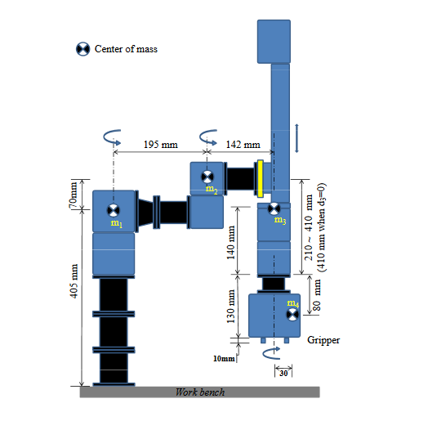

|  |  |  |  |  |
| --- | --- | --- | --- | --- |
| i | alphai-1 | ai-1 | di | thetai |
| 1 | 0 | 0 | L1 | θ1 |
| 2 | 0 | L3 | L2 | θ2 |
| 3 | 0 | L4 | -(Lmax+d3-L5) | 0 |
| 4 | 180 | 0 | L5+L6 | θ4 |
| 5 | 0 | 0 | (L7-L6+L8/2) | 0 |

|  |  |
| --- | --- |
| Label | Length(mm) |
| L1 | 405 |
| L2 | 70 |
| L3 | 195 |
| L4 | 142 |
| L5 | 140 |
| L6 | 80 |
| L7 | 130 |
| L8 | 10 |
| L9 | 30 |
| Lmax | 410 |

{5}

{4}

{3}

{2}

{0}

{1}

## Homogenous Matrix Transformations

$${}_{1}^{0}T=\left[\begin{matrix}cosθ1 & -sinθ1 & 0 & 0 \\ sinθ1 & cosθ1 & 0 & 0 \\ 0 & 0 & 1 & L1 \\ 0 & 0 & 0 & 1\end{matrix}\right]=\left[\begin{matrix}cosθ1 & -sinθ1 & 0 & 0 \\ sinθ1 & cosθ1 & 0 & 0 \\ 0 & 0 & 1 & 405 \\ 0 & 0 & 0 & 1\end{matrix}\right]$$

$${}_{2}^{1}T=\left[\begin{matrix}cosθ2 & -sinθ2 & 0 & L3 \\ sinθ2 & cosθ2 & 0 & 0 \\ 0 & 0 & 1 & L2 \\ 0 & 0 & 0 & 1\end{matrix}\right]=\left[\begin{matrix}cosθ2 & -sinθ2 & 0 & 195 \\ sinθ2 & cosθ2 & 0 & 0 \\ 0 & 0 & 1 & 70 \\ 0 & 0 & 0 & 1\end{matrix}\right]$$

$${}_{3}^{2}T=\left[\begin{matrix}1 & 0 & 0 & L4 \\ 0 & 1 & 0 & 0 \\ 0 & 0 & 1 & -(Lmax+d3-L5) \\ 0 & 0 & 0 & 1\end{matrix}\right]=\left[\begin{matrix}1 & 0 & 0 & 142 \\ 0 & 1 & 0 & 0 \\ 0 & 0 & 1 & -(270+d3) \\ 0 & 0 & 0 & 1\end{matrix}\right]$$

$${}_{4}^{3}T=\left[\begin{matrix}cosθ4 & -sinθ4 & 0 & 0 \\ -sinθ4 & -cosθ4 & 0 & 0 \\ 0 & 0 & -1 & -(L5+L6) \\ 0 & 0 & 0 & 1\end{matrix}\right]=\left[\begin{matrix}cosθ4 & -sinθ4 & 0 & 0 \\ -sinθ4 & -cosθ4 & 0 & 0 \\ 0 & 0 & -1 & -220 \\ 0 & 0 & 0 & 1\end{matrix}\right]$$

$${}_{5}^{4}T=\left[\begin{matrix}1 & 0 & 0 & 0 \\ 0 & 1 & 0 & 0 \\ 0 & 0 & 1 & (L7-L6+L8/2) \\ 0 & 0 & 0 & 1\end{matrix}\right]=\left[\begin{matrix}1 & 0 & 0 & 0 \\ 0 & 1 & 0 & 0 \\ 0 & 0 & 1 & 55 \\ 0 & 0 & 0 & 1\end{matrix}\right]$$

$${}_{5}^{0}T={}_{1}^{0}T*{}_{2}^{1}T*{}_{3}^{2}T*{}_{4}^{3}T*{}_{5}^{4}T$$

$$=\left[\begin{matrix}cosθ4cos\left(θ1+θ2\right)+sinθ4sin⁡(θ1+θ2) & cosθ4\sin\left(θ1+θ2\right)-sinθ4cos⁡(θ1+θ2) & 0 & L4\cos\left(θ1+θ2\right)+L3cosθ1 \\ cosθ4\sin\left(θ1+θ2\right)-sinθ4cos⁡(θ1+θ2) & -cosθ4\cos\left(θ1+θ2\right)-sinθ4sin⁡(θ1+θ2) & 0 & L4\sin\left(θ1+θ2\right)+L3sinθ1 \\ 0 & 0 & -1 & L1+L2-L7-\frac{L8}{2}-Lmax-d3 \\ 0 & 0 & 0 & 1\end{matrix}\right]$$

$$=\left[\begin{matrix}cos⁡(θ1+θ2-θ4) & sin⁡(θ1+θ2-θ4) & 0 & L4\cos\left(θ1+θ2\right)+L3cosθ1 \\ sin⁡(θ1+θ2-θ4) & -cos⁡(θ1+θ2-θ4) & 0 & L4\sin\left(θ1+θ2\right)+L3sinθ1 \\ 0 & 0 & -1 & L1+L2-L7-\frac{L8}{2}-Lmax-d3 \\ 0 & 0 & 0 & 1\end{matrix}\right]$$

## Position and Orientation of Tool Frame

$\left[\begin{matrix}x \\ y \\ z\end{matrix}\right] = \left[\begin{matrix}L4\cos\left(θ1+θ2\right)+L3cosθ1 \\ L4\sin\left(θ1+θ2\right)+L3sinθ1 \\ L1+L2-L7-\frac{L8}{2}-Lmax-d3\end{matrix}\right]$, φ = $θ1+θ2-θ4$

## Possible inverse kinematic solutions

Step 1: There are two results for $θ_{2}$

$$θ_{2}= ±arccos⁡((x^{2}+y^{2}-L_{3}^{2}-L_{4}^{2})/(2L_{3}L_{4})$$

Step 2: $θ_{1} and θ_{4}$ have 2 possible solutions because of $θ_{2}$

$$θ_{1}=atan2\left(y, x\right)-atan2(L_{4}* {sin⁡(θ}_{2}),\left(L_{3}+L_{4}\right)* cos⁡(θ_{2}))$$

$$θ_{4}= θ_{1}+ θ_{2}- θ_{d}$$

Step 3: d3 has one solution

$D_{3}=L_{1}+L_{2}-z-(Lmax+L_{7}+\frac{L_{8}}{2})$

# Part two:

# Part three:

# Plots:

# Observations and conclusion:

# Team Contributions:

## Andrew Nichol:

For the first section, Andrew worked on the demo script that added a menu to control the robot. He also worked on a library that allows for manipulation of the homogeneous matrix. On the second section Andrew developed the demo script to add new options to the control menu; he also added script to check the input from this menu. Also he wrote the underlying structure of the trajectory planner. For the third part of the project he was involved with adding more functionality to the demo script and the control menu. He also wrote a big part of the controller script and debugged the emulator script.

## Adrian Fettes:

## Monica Li:

## Methods of coordination:

To coordinate work effort we met often on Tuesday mornings and we kept in contact over the week on facebook. For sharing work we used github, if interested you can see more details on code work breakdown at https://github.com/reactabean/roboticProject