**ENSC-488: Introduction to Robotics**

**Simon Fraser University Spring 2017**

**Demo 1**

Group #7

Member 1: Andrew Nichol, 3012xxxxx,

Member 2: Adrian Fettes, 3012xxxxx,

Member 3: Monica Li, 301226320, [xmli@sfu.ca](mailto:xmli@sfu.ca)

# Frame assignment:

|  |  |
| --- | --- |
| Label | Length(mm) |
| L1 | 405 |
| L2 | 70 |
| L3 | 195 |
| L4 | 142 |
| L5 | 140 |
| L6 | 80 |
| L7 | 130 |
| L8 | 10 |
| Lmax | 410 |

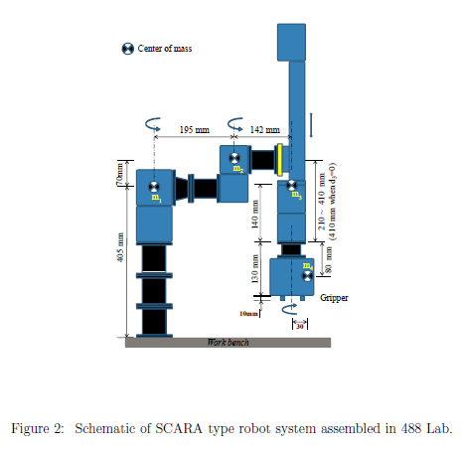

|  |  |  |  |  |
| --- | --- | --- | --- | --- |
| i | alphai-1 | ai-1 | di | thetai |
| 1 | 0 | 0 | L1 | θ1 |
| 2 | 0 | L3 | L2 | θ2 |
| 3 | 0 | L4 | -(Lmax+d3-L5) | 0 |
| 4 | 180 | 0 | L5+L6 | θ4 |
| 5 | 0 | 0 | (L7-L6+L8/2) | 0 |

# Homogenous Matrix Transformations

$${}_{1}^{0}T=\left[\begin{matrix}cosθ1 & -sinθ1 & 0 & 0 \\ sinθ1 & cosθ1 & 0 & 0 \\ 0 & 0 & 1 & L1 \\ 0 & 0 & 0 & 1\end{matrix}\right]=\left[\begin{matrix}cosθ1 & -sinθ1 & 0 & 0 \\ sinθ1 & cosθ1 & 0 & 0 \\ 0 & 0 & 1 & 405 \\ 0 & 0 & 0 & 1\end{matrix}\right]$$

$${}_{2}^{1}T=\left[\begin{matrix}cosθ2 & -sinθ2 & 0 & L3 \\ sinθ2 & cosθ2 & 0 & 0 \\ 0 & 0 & 1 & L2 \\ 0 & 0 & 0 & 1\end{matrix}\right]=\left[\begin{matrix}cosθ2 & -sinθ2 & 0 & 195 \\ sinθ2 & cosθ2 & 0 & 0 \\ 0 & 0 & 1 & 70 \\ 0 & 0 & 0 & 1\end{matrix}\right]$$

$${}_{3}^{2}T=\left[\begin{matrix}1 & 0 & 0 & L4 \\ 0 & 1 & 0 & 0 \\ 0 & 0 & 1 & -(Lmax+d3-L5) \\ 0 & 0 & 0 & 1\end{matrix}\right]=\left[\begin{matrix}1 & 0 & 0 & 142 \\ 0 & 1 & 0 & 0 \\ 0 & 0 & 1 & -(270+d3) \\ 0 & 0 & 0 & 1\end{matrix}\right]$$

$${}_{4}^{3}T=\left[\begin{matrix}cosθ4 & -sinθ4 & 0 & 0 \\ -sinθ4 & -cosθ4 & 0 & 0 \\ 0 & 0 & -1 & -(L5+L6) \\ 0 & 0 & 0 & 1\end{matrix}\right]=\left[\begin{matrix}cosθ4 & -sinθ4 & 0 & 0 \\ -sinθ4 & -cosθ4 & 0 & 0 \\ 0 & 0 & -1 & -220 \\ 0 & 0 & 0 & 1\end{matrix}\right]$$

$${}_{5}^{4}T=\left[\begin{matrix}1 & 0 & 0 & 0 \\ 0 & 1 & 0 & 0 \\ 0 & 0 & 1 & (L7-L6+L8/2) \\ 0 & 0 & 0 & 1\end{matrix}\right]=\left[\begin{matrix}1 & 0 & 0 & 0 \\ 0 & 1 & 0 & 0 \\ 0 & 0 & 1 & 55 \\ 0 & 0 & 0 & 1\end{matrix}\right]$$

$${}_{5}^{0}T={}_{1}^{0}T*{}_{2}^{1}T*{}_{3}^{2}T*{}_{4}^{3}T*{}_{5}^{4}T$$

$$=\left[\begin{matrix}cosθ4cos\left(θ1+θ2\right)+sinθ4sin⁡(θ1+θ2) & cosθ4\sin\left(θ1+θ2\right)-sinθ4cos⁡(θ1+θ2) & 0 & L4\cos\left(θ1+θ2\right)+L3cosθ1 \\ cosθ4\sin\left(θ1+θ2\right)-sinθ4cos⁡(θ1+θ2) & -cosθ4\cos\left(θ1+θ2\right)-sinθ4sin⁡(θ1+θ2) & 0 & L4\sin\left(θ1+θ2\right)+L3sinθ1 \\ 0 & 0 & -1 & L1+L2-L7-\frac{L8}{2}-Lmax-d3 \\ 0 & 0 & 0 & 1\end{matrix}\right]$$

$$=\left[\begin{matrix}cos⁡(θ1+θ2-θ4) & sin⁡(θ1+θ2-θ4) & 0 & L4\cos\left(θ1+θ2\right)+L3cosθ1 \\ sin⁡(θ1+θ2-θ4) & -cos⁡(θ1+θ2-θ4) & 0 & L4\sin\left(θ1+θ2\right)+L3sinθ1 \\ 0 & 0 & -1 & L1+L2-L7-\frac{L8}{2}-Lmax-d3 \\ 0 & 0 & 0 & 1\end{matrix}\right]$$

# Position and Orientation of Tool Frame

$\left[\begin{matrix}x \\ y \\ z\end{matrix}\right] = \left[\begin{matrix}L4\cos\left(θ1+θ2\right)+L3cosθ1 \\ L4\sin\left(θ1+θ2\right)+L3sinθ1 \\ L1+L2-L7-\frac{L8}{2}-Lmax-d3\end{matrix}\right]$, φ = $θ1+θ2-θ4$

# Possible inverse kinematic solutions