What is Express JS?

An Express server is a setup in Node.js (JavaScript runtime) that listens for and handles requests from clients, like a website or mobile app. It’s like a waiter in a restaurant, taking requests (like "get data" or "save this info") and responding back (with the data, or confirmation that info was saved).

Steps To create Express Server:

Step 1: install express package using below command as shown below screenshot.

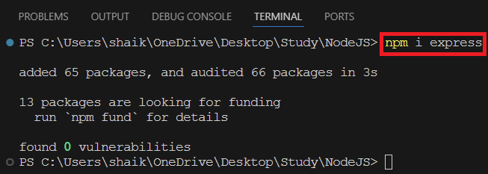

After installed express package you will find entry for express in package.json file this entry will indicate that it is mandatory to running application.

Step 2: to create express server for listening request & response we need to create new file with name app.js file in root folder of project which is entry point for our application.

Step 3: in app.js file write below code.

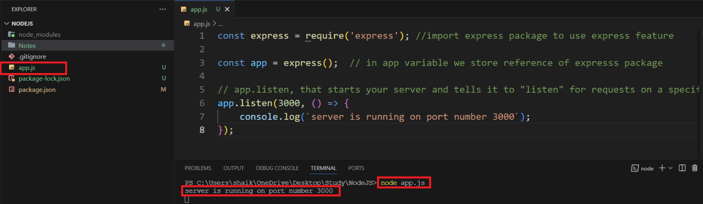

app.listen is a method in Express that starts your server and tells it to "listen" for requests on a specific port (like a door where requests come in).

When you call app.listen(3000), it means the server is now ready and waiting for requests on port 3000. Once it's listening, your Express app can start responding to incoming requests, like showing a webpage or saving data to a database.

In short, app.listen is like turning on your server so it can start handling requests.

Step 4: open browser and enter <http://localhost:3000> in browser. We will se cannot GET/ because we don’t create any route or pages.

