What is Nodemon?

Nodemon is a tool that helps you automatically restart your Node.js server whenever you make changes to your code. Normally, with a Node.js server, you'd have to stop and restart the server every time you change something to see the updates.

With Nodemon, you just run your app with nodemon instead of node, and it watches for changes in your files. When you save an update, Nodemon automatically restarts the server for you, so you don’t have to do it manually. This makes development faster and easier.

Installation Steps:

Step 1: install package using below command & after package installed add running command in package.json file in scripts section. This start command is special command that run using npm and run app.js file and continuously watching file changes.

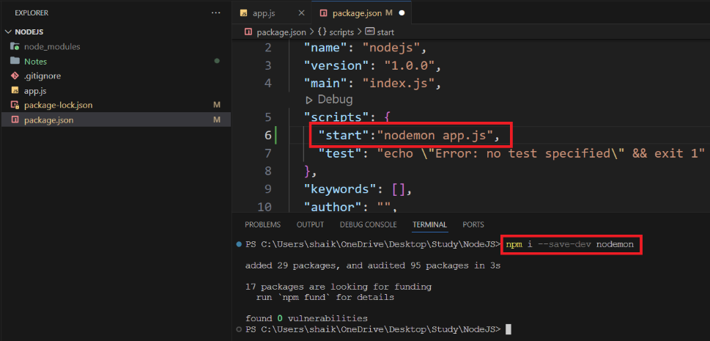

Step 2: change script in package.json file as given above and now try command npm start to run app.js file as shown in below screenshot.

