***Required Software for NodeJS Application***

Before working with any NodeJS application we need some software’s. so, we need NodeJS & NPM (Node Package Manager).

Before installation we need to run below command in command prompt to check that we already installed or not in our system.

*Check if node install or not in system if not installed then below highlighted error will show in command prompt, so we need to install from official website*[***https://nodejs.org/en***](https://nodejs.org/en)

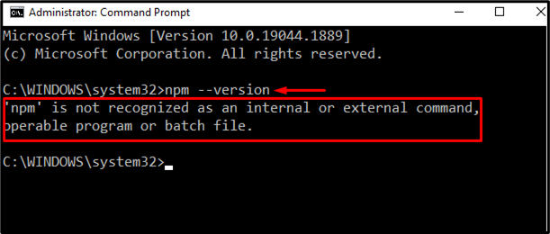

*If not install then visit* [*https://nodejs.org/en*](https://nodejs.org/en) *and install LTS version from given site and install with default setting once installation is successful then run above command again, now we will see Node & npm version.*

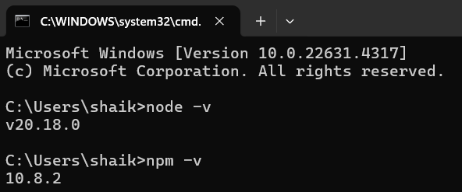

**Install IDE:**

We are using VS code if you don’t have, please visit <https://code.visualstudio.com/download> and download & install from here.