Supplemental data 9: 3’UTR conserved motifs in down regulated genes of metabolism and energy functional categories.

Motif1:

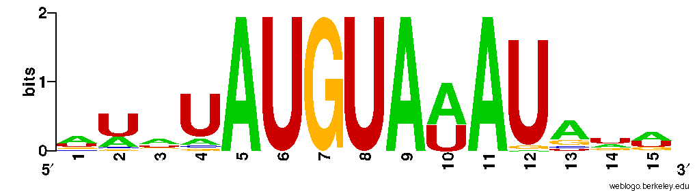

1 ACS1 >
acagTATGTAAAgaat
2 CAT5>
taatTATGTAAAtggg
3 COQ1>
tctaTATGTAAAtagt
4 FPS1>
catcTATGTAAAtata
5 GDB1>
aaaaTATGTAAAtata
6 GLG1>
tatcTATGTAAAgacc
7 GRR1>
tttaTATGTAAAtaag
8 HXK1>
agtaTATGTAAAtata
9 MAL32 >
tttaTATGTAAAtgat
10 MUC1>
aaaaTATGTAAAtgaa
11 NTH2 >
aacaTATGTAAAtaag
12 PIG2 >
tgtaTATGTAAAacaa
13 POX1>
tagaTATGTAAAtaga
14 SDH1>
acttTATGTAAAtgta
15 TPS2 >
tgtgTATGTAAAtctt
16 TTR1>
tataTATGTAAAtatt
17 ASP1>
gtvtATGTATATcagc
18 ATP15>
aaaATGTATATcagc
19 CRD1>
atatATGTATATatgc
20 EMI2 >
tattATGTATATagtt
21 FSP2>
gtatATGTATATgtat
22 GDB1>
atatATGTATATatag
23 GIP2>
atttATGTATATttac
24 GLG1>
ttgaATGTATATagaa
25 GLK1>
atgtATGTATATacac
26 GLK1>
atatATGTATATtttc
27 IDH2>
ttgtATGTATATatta
28 ISF1>
aactATGTATATtttc
29 MAL11>
aaaaATGTATATatat
30 PHO8 >
atatATGTATATatac
31 GRR1>
ttttATGTATATatgc
32 SDH1>
gtaaATGTATATtaat
33 SSH4>
aggaATGTATATattg
34 TSC11>
ataaATGTATATaftc
35 TSL1>
cattATGTATATgggt
36 XPT1>
ttgcATGTATATagat
37 YAL061W>
tatgATGTATATaaaa
38 ZWF1>
ttttATGTATATatat
39 CAT5>
aattATGTAAATgggg
40 COQ1>
ctatATGTAAATagtt
41 FPS1>
atctATGTAAATatat
42 GDB1>
aaatATGTAAATatat
43 GRR1>
ttatATGTAAATaagt
44 HXK1>
gtatATGTAAATatag
45 ISF1>
aataATGTAAATtaag
46 LEU5 >
tatgATGTAAATagta
47 MAL32>
ttatATGTAAATgatg
48 MUC1>
aaatATGTAAATgaat
49 NTH2>
acatATGTAAATaaga
50 POX1>
agatATGTAAATagat
51 PUT2 >
actcATGTAAATgtta
52 SDH1>
ctttATGTAAATgtat
53 SGA1>
tttgATGTAAATatct
54 TPS2>
gtgtATGTAAATcttc
55 TTR1>
atatATGTAAATatta
56 YTA12>
aaacATGTAAATatat

Motif 2

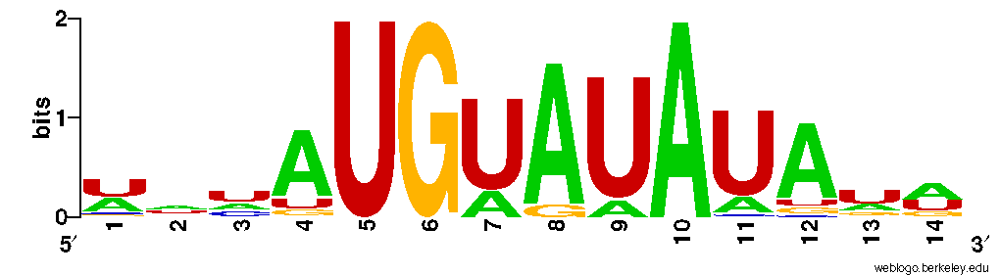

1 BCY1 >
uaCAUGUAUAguaa
2 CAT5 >
auCAUGUAUAaaau
3 EMI2 >
aaCAUGUAUAaagu
4 GLC8 >
uuCAUGUAUAaaau
5 GRR1 >
agCAUGUAUAcgcu
6 PXA2>
auCAUGUAUAaauu
7 SSH4 >
uuCAUGUAUAcuag
8 SUT1> cuCAUGUAUAaccc
9 THI11 >
agCAUGUAUAcaag
10 TSC11 >
cgCAUGUAUAaaug
11 XPT1>
ugCAUGUAUAuaga
12 YDR111C >
ugCAUGUAUAcuau
13 ZWF1 >
caCAUGUAUAcaau
14 CAT5 >
auuAUGUAAAUggg
15 COQ1 >
uauAUGUAAAUagu
16 FPS1>
ucuAUGUAAAUaua
17 GDB1>
aauAUGUAAAUaua
18 GRR1 >
uauAUGUAAAUaag
19 HXK1 >
uauAUGUAAAUaua
20 ISF1 >
auaAUGUAAAUuaa
21 LEU5 >
augAUGUAAAUagu
22 MAL32 >
uauAUGUAAAUgau
23 MUC1 >
aauAUGUAAAUgaa
24 NUH2 >
cauAUGUAAAUaag
25 POX1 >
gauAUGUAAAUaga
26 PUT2 >
cucAUGUAAAUguu
27 SDH1>
uuuAUGUAAAUgua
28 SGA1 >
uugAUGUAAAUauc
29 TPS2>
uguAUGUAAAUcuu
30 TTR1 >
uauAUGUAAAUauu
31 YTA12 >
aacAUGUAAAUaua
32 CAT8 >
uucAUGAAUAUuua
33 DBR1 >
cacAUGAAUAUaua
34 JEN1 >
aauAUGAAUAUaug
35 LSC1>
auaAUGAAUAUaua
36 MLS1 >
ggcAUGAAUAUauu
37 MUC1 >
uaaAUGAAUAUgua
38 NDE2 >
acaAUGAAUAUaua
39 PGM2 >
ucaAUGAAUAUuaa
40 PTM1 >
aauAUGAAUAUgaa
41 PTM1 >
aauAUGAAUAUaaa
42 PUT2 >
ucaAUGAAUAUuuu
43 SFC1>
guaAUGAAUAUcaa
44 STL1 >
uauAUGAAUAUuau
45 WSC2 >
gauAUGAAUAUgua
46 YGR043C>
uuaAUGAAUAUaua
47 YPC1 >
auuAUGAAUAUaua
48 ASP1 >
uvuAUGUAUAUcag
49 ATP15 >
aaaAUGUAUAUcag
50 CRD1 >
uauAUGUAUAUaug
51 EMI2 >
auuAUGUAUAUagu
52 FSP2 >
uauAUGUAUAUgua
53 GDB1 >
uauAUGUAUAUaua
54 GIP2 >
uuuAUGUAUAUuua
55 GLG1 >
ugaAUGUAUAUaga
56 GLK1>
uguAUGUAUAUaca
57 GLK1 >
uauAUGUAUAUuuu
58 IDH2 >
uguAUGUAUAUauu
59 ISF1 >
acuAUGUAUAUuuu
60 MAL11 >
aaaAUGUAUAUaua
61 PHO8 >
uauAUGUAUAUaua
62 RNR1 >
uuuAUGUAUAUaug
63 SDH1 >
uaaAUGUAUAUuaa
64 SSH4 >
ggaAUGUAUAUauu
65 TSC11 >
uaaAUGUAUAUafu
66 TSL1 >
auuAUGUAUAUggg
67 XPT1 >
ugcAUGUAUAUaga
68 YAL061W >
augAUGUAUAUaaa
69 ZWF1 >
uuuAUGUAUAUaua
70 ASP1 >
ucuaUGUAUAUAua
71 BAT2 >
acauUGUAUAUAug
72 COX14 >
aaccUGUAUAUAau
73 CRD1 >
uauaUGUAUAUAug
74 EMI2 >
auuaUGUAUAUAgu
75 GDB1 >
uauaUGUAUAUAua
76 GLG1 >
ugaaUGUAUAUAga
77 GLK1 >
uguaUGUAUAUAca
78 GLK1 >
ucagUGUAUAUAca
79 IDH2 >
uguaUGUAUAUAuu
80 KTR3 >
uaugUGUAUAUAga
81 LSC1>
ccuuUGUAUAUAuu
82 MAL11>
aaaaUGUAUAUAua
83 MAL32 >
agcgUGUAUAUAaa
84 MAL33 >
uaacUGUAUAUAga
85 MTH1 >
aguuUGUAUAUAua
86 PHO8 >
uauaUGUAUAUAua
87 RNR1 >
uuuaUGUAUAUAug
88 SDH1 >
uuaaUGUAUAUAua
89 SPS19 >
ucauUGUAUAUAaa
90 SSH4 >
ggaaUGUAUAUAuu
91 THI4 >
auugUGUAUAUAgc
92 TSC11 >
uaaaUGUAUAUAgu
93 UGP1 >
aaugUGUAUAUAuu
94 XPT1 >
ugcaUGUAUAUAga
95 YAL061W >
augaUGUAUAUAaa
96 ZWF1 >
uuuaUGUAUAUAua
97 CAT5 >
aucaUGUAUAAAau
98 EMI2 >
aacaUGUAUAAAgu
99 FSP2 >
uauaUGUAUAAAaa
100 GAL4 >
acgaUGUAUAAAug
101 GDH2 >
guuuUGUAUAAAuu
102 GLC8 >
uucaUGUAUAAAau
103 GRE3 >
uaugUGUAUAAAuu
104 HXK2 >
auauUGUAUAAAcu
105 PLB2 >
uaaaUGUAUAAAaa
106 PXA2 >
aucaUGUAUAAAuu
107 PXA2 >
uuuuUGUAUAAAua
108 TGL1 >
auugUGUAUAAAac
109 THI4 >
agcgUGUAUAAAaa
110 TSC11 >
cgcaUGUAUAAAug
111 YLR345W >
auauUGUAUAAAag
112 YTA12 >
uacgUGUAUAAAug
113 ADH5 >
uugaUGAAUAUAuu
114 CAT8 >
guuuUGAAUAUAuu
115 DBR1 >
cacaUGAAUAUAua
116 JEN1 >
aauaUGAAUAUAug
117 LEU5 >
auauUGAAUAUAga
118 LSC1 >
uaaaUGAAUAUAua
119 MLS1 >
ggcaUGAAUAUAuu
120 NCA2 >
auauUGAAUAUAuu
121 NDE2 >
acaaUGAAUAUAua
122 PHO8 >
uuauUGAAUAUAua
123 PTM1 >
aauaUGAAUAUAaa
124 PTM1 >
aauaUGAAUAUAaa
125 YGR043C >
uuaaUGAAUAUAua
126 YLR345W >
auuuUGAAUAUAga
127 YMR118C >
uuauUGAAUAUAac
128 YPC1 >
auuaUGAAUAUAua
129 ALD6 >
auuuUGUGUAUAug
130 FAA2 >
ucacUGUGUAUAau
131 GRE3 >
uauaUGUGUAUAaa
132 HXK1 >
uuuuUGUGUAUAau
133 KTR3 >
auuaUGUGUAUAua
134 RGT1 >
cuagUGUGUAUAgu
135 SGA1 >
cacuUGUGUAUAcu
136 SUT1 >
auugUGUGUAUAga
137 TGL1 >
uuauUGUGUAUAaa
138 THI4 >
aaauUGUGUAUAua
139 UGP1 >
uaaaUGUGUAUAua
140 CYB2 >
uauaUGUGUAUAug

Motif 3:

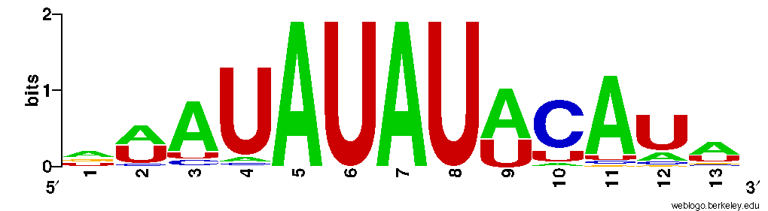

1ALG9 >
aAAUAUAUAuaua
2 ATH1 >
aAAUAUAUAuccu
3 CYB2 >
uAAUAUAUAugua
4 CYB2 >
aAAUAUAUAugug
5 DBR1 >
gAAUAUAUAuaua
6 DBR1 >
aAAUAUAUAuaua
7 DBR1 >
aAAUAUAUAaaaa
8 DLD1 >
uAAUAUAUAuagu
9 DLD1 >
uAAUAUAUAucac
10FBP1 >
aAAUAUAUAuaua
11 FPS1>
uAAUAUAUAuaua
12 FPS1>
aAAUAUAUAuaua
13 FUN34 >
gAAUAUAUAauag
14GDB1 >
aAAUAUAUAuaua
15 HXK1 >
aAAUAUAUAuaua
16 IDH2 >
uAAUAUAUAcaua
17 KTR5 >
uAAUAUAUAuagu
18 LSC1>
gAAUAUAUAcaaa
19 MDH2 >
gAAUAUAUAuaua
20 NDE2 >
gAAUAUAUAaaac
21 NDI1 >
gAAUAUAUAaaua
22 PDX1 >
gAAUAUAUAacau
23 PHO8 >
gAAUAUAUAuaua
24 SDH3 >
aAAUAUAUAuaua
25 SGA1 >
aAAUAUAUAuaua
26 SSH4 >
cAAUAUAUAcauu
27 SSH4 >
aAAUAUAUAuaua
28 TES1 >
gAAUAUAUAugua
29 THI4 >
aAAUAUAUAaauc
30 UGP1 >
uAAUAUAUAcaca
31 UGP1 >
aAAUAUAUAacau
32 YGR043C >
aAAUAUAUAuaua
33 YGR043C > gAAUAUAUAaguc
34 YJL132W >
gAAUAUAUAuagc
35 YNL274C >
uAAUAUAUAgaaa
36 YPC1>
uAAUAUAUAuuca
37 YPC1>
gAAUAUAUAuuau
38 YTA12 >
aAAUAUAUAuacg
39 YTP1>
aAAUAUAUAaaaa
40 ZWF1 >
aAAUAUAUAuaca
41 ADH5 >
aaAUAUAUUCauc
42 CAT8 >
uaAUAUAUUCaaa
43 DBR1 >
auAUAUAUUCaug
44 FUN34 >
uuAUAUAUUCuua
45 JEN1 >
acAUAUAUUCaua
46 LSC1>
guAUAUAUUCauu
47 MDH2 >
auAUAUAUUCuac
48 MLS1 >
aaAUAUAUUCaug
49 NCA2 >
gaAUAUAUUCuua
50 NCA2 >
gaAUAUAUUCaau
51 NDE2 >
uuAUAUAUUCauu
52 NDI1 >
uuAUAUAUUCcca
53 OSM1 >
agAUAUAUUCuuc
54 PDX1 >
uuuAUAUAUUCug
55 PHO8 >
auAUAUAUUCaaa
56 TES1 >
auAUAUAUUCuua
57YGR043C >
uuAUAUAUUCauu
58 YJL132W >
auAUAUAUUCuga
59 YPC1 >
auAUAUAUUCaua
60 ASP1 >
auaUAUAUACAua
61 BAT2 >
ucaUAUAUACAau
62 COX14 >
uauUAUAUACAgg
63 CRD1 >
gcaUAUAUACAua
64 EMI2 >
aacUAUAUACAua
65 GDB1 >
cuaUAUAUACAua
66 GLG1 >
uucUAUAUACAuu
67 GLK1 >
gugUAUAUACAua
68 GLK1 >
augUAUAUACAcu
69 IDH2 >
uaaUAUAUACAua
70 KTR3 >
aucUAUAUACAca
71 LSC1>
gaaUAUAUACAaa
72 MAL11>
auaUAUAUACAuu
73 MAL32 >
auuUAUAUACAcg
74 MAL33 >
uucUAUAUACAgu
75 MTH1 >
uuaUAUAUACAaa
76 PHO8 >
guaUAUAUACAua
77 RNR1 >
gcaUAUAUACAua
78 SDH1 >
guaUAUAUACAaa
79 SPS19 >
uuuUAUAUACAau
80 SSH4 >
caaUAUAUACAuu
81 THI4 >
cgcUAUAUACAca
82 TSC11 >
gacUAUAUACAuu
83 UGP1 >
uaaUAUAUACAca
84 XPT1 >
aucUAUAUACAug
85 YAL061W >
uuuUAUAUACAuc
86 ZWF1 >
auaUAUAUACAua
87 ADH5 >
aaaUAUAUUCAuc
88 CAT8 >
uaaUAUAUUCAaa
89 DBR1 >
auaUAUAUUCAug
90 JEN1 >
acaUAUAUUCAua
91 LEU5 >
aucUAUAUUCAau
92 LSC1 >
guaUAUAUUCAuu
93 MLS1 >
aaaUAUAUUCAug
94 NCA2 >
gaaUAUAUUCAau
95 NDE2 >
uuaUAUAUUCAuu
96 PHO8 >
auaUAUAUUCAaa
97 PTM1 >
auuUAUAUUCAua
98 PTM1 >
auuUAUAUUCAua
99 YGR043C >
cuaUAUAUUCAuu
100 YLR345W >
aucUAUAUUCAaa
101 YMR118C >
uguUAUAUUCAau
102 YPC1 >
auaUAUAUUCAua
103 ADH5 >
aaauAUAUUCAUc
104 CAU8 >
cuaaAUAUUCAUg
105 DBR1>
auauAUAUUCAUg
106 JEN1>
acauAUAUUCAUa
107 LSC1 >
guauAUAUUCAUu
108 MLS1 >
aaauAUAUUCAUg
109 MUC1 >
auacAUAUUCAUu
110 NDE2 >
uuauAUAUUCAUu
111 PGM2 >
guuaAUAUUCAUu
112 PUM1 >
auucAUAUUCAUa
113 PUM1 >
auuuAUAUUCAUa
114 PUT2 >
aaaaAUAUUCAUu
115 SFC1 >
uuugAUAUUCAUu
116 SUL1 >
aauaAUAUUCAUa
117 WSC2 >
cuacAUAUUCAUa
118 YGR043C >
uuauAUAUUCAUu
119 ASP1 >
auauAUAUACAUa
120 ATP15 >
gcugAUAUACAUu
121 CRD1>
gcauAUAUACAUa
122 EMI2 >
aacuAUAUACAUa
123 FSP2 >
auacAUAUACAUa
124 GDB1 >
cuauAUAUACAUa
125 GIP2 >
guaaAUAUACAUa
126 GLG1 >
uucuAUAUACAUu
127 GLK1 >
guguAUAUACAUa
128 GLK1 >
gaaaAUAUACAUa
129 IDH2 >
uaauAUAUACAUa
130 ISF1>
gaaaAUAUACAUa
131 MAL11 >
auauAUAUACAUu
132 PHO8 >
guauAUAUACAUa
133 RNR1 >
gcauAUAUACAUa
134 SDH1 >
auuaAUAUACAUu
135 SSH4 >
caauAUAUACAUu
136 TSC11 >
gacuAUAUACAUu
137 TSL1 >
acccAUAUACAUa
138 XPT1 >
aucuAUAUACAUg
139 YAL061W >
uuuuAUAUACAUc
140 ZWF1 >
auauAUAUACAUa

Motif 4:

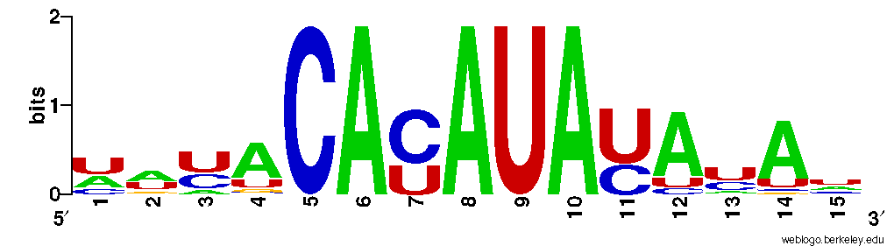

1 HXK1>
uuuACAUAUACuaga
2 LEU3 >
ugaACAUAUACcuaa
3 NDE2 >
aucACAUAUACaaau
4 PIG2 >
uuuACAUAUACaaaa
5 RGT1 >
uacACAUAUACacac
6 TTR1 >
aucACAUAUACcuac
7 WSC2 >
auuACAUAUACuuaa
8 YGR043C >
ugcACAUAUACucaa
9 CYB2 >
uauaCACAUAUAuau
10 FBP1 >
cauaCACAUAUAuau
11 GRE3 >
uauaCACAUAUAcag
12 GSY2 >
auucCACAUAUAuuu
13 HXK1 >
cacaCACAUAUAuau
14 JEN1 >
auuuCACAUAUAuuc
15 MDH2 >
cacaCACAUAUAuau
16 MLS1 >
uguaCACAUAUAuaa
17 NDE2 >
ucauCACAUAUAcaa
18 OYE3 >
aacuCACAUAUAgau
19 RGT1 >
cuuaCACAUAUAcac
20 TRR2 >
uacgCACAUAUAuau
21 TTR1 >
aaauCACAUAUAccu
22 YGR043C >
uaugCACAUAUAcuc
23 YLR164W >
aauaCACAUAUAuaa

