LSAS: A Practical, Auditable Safety-Orchestration Architecture for Generative AI Outputs in Regulated Healthcare and MedTech

Author: Matt Vegas, Principal AI Consultant @ Inference-Stack.com
Version: v1.2 (Enterprise and Academic Edition)
Date: January 23, 2026

Origin note: The term "LSAS" (Layered Safety and Accuracy System) was coined by Matt Vegas during Soluna AI Platform systems design work (April 2025).

Disclaimer: This paper is for engineering and research purposes only. It does not constitute legal advice, compliance advice, or clinical advice. Regulated entities should consult qualified counsel, compliance leadership, and clinical safety governance for final determinations.

Abstract
Generative AI is increasingly embedded into healthcare and medtech workflows, including requirements discovery, clinical workflow design, documentation, and live code generation inside developer tools. Yet raw model outputs are unsafe by default in regulated environments due to predictable failure modes: unsupported assertions, overconfident compliance language, privacy leakage, insecure code generation, prompt injection, insecure output handling, and drift in standards and regulation.

This paper introduces LSAS (Layered Safety and Accuracy System): a practical safety-orchestration architecture that treats all AI outputs (text and code) as untrusted intermediate artifacts until they are grounded, validated, and governed through deterministic controls with auditable evidence. LSAS composes five layers: (1) intent and risk classification; (2) authoritative knowledge grounding with optional live retrieval; (3) real-time validation and filtering for accuracy, compliance posture, security, and accessibility; (4) escalation protocols for uncertainty or high-risk domains; and (5) continuous learning through policy versioning, feedback loops, regression harnesses, and a regulatory watcher.

LSAS is designed to align with HIPAA privacy and security realities, NIST implementation guidance for HIPAA safeguards, and healthcare accessibility requirements, while remaining extensible through policy packs for adjacent regimes such as PCI DSS, SOC 2, HITRUST CSF, and medical device lifecycle governance. This document is written as a build guide: it includes reference architectures, validator catalogs, operational checklists, and concrete implementation instructions intended for enterprise adoption and academic scrutiny.

Keywords
Healthcare AI, MedTech AI, HIPAA, SaMD, CDS, AI governance, validation pipeline, grounded generation, output governance, LLM security, auditability, accessibility

Executive Summary
Healthcare and medtech organizations do not fail with AI because models are incapable; they fail because outputs are treated as authoritative without governance. LSAS is an engineering answer: it turns "AI output" into a governed pipeline with evidence, validation, and escalation.

If you are a health system, payer, digital health company, research institution, or medical device manufacturer, LSAS is designed to satisfy expectations already applied to production systems:
- Safety is enforced by architecture, not training alone.
- High-risk claims are grounded to authoritative sources and are auditable.
- Outputs are validated across privacy, security, accessibility, and regulated design patterns.
- Controls evolve with standards and threats through versioned policy packs and regression testing.

This paper provides an implementable blueprint and a common vocabulary. It aims to reduce ambiguity and enable reproducible safety posture across teams, vendors, and institutions.

How to Use This Paper
- If you are deciding whether LSAS is relevant: read Sections 1 to 3 and the capability gating table.
- If you are implementing LSAS: read Sections 6 to 12 and Appendix B (policy pack example).
- If you are evaluating LSAS for enterprise or medtech compliance: read Sections 2, 4, 12, 14, 15, and Appendix D (threat mapping).

Table of Contents
Abstract 2
Keywords 2
Executive Summary 3
How to Use This Paper 3
Table of Contents 4
1. Introduction 7
2. Enterprise and Academic Review: Likely Objections and Hardening Decisions 7
2.1 "This is just guardrails or a rules engine" 7
2.2 "Where does this live in our HIPAA program, audits, and incident response?" 8
2.3 "What about cloud providers, BAAs, and vendor risk?" 8
2.4 "How do you prevent PHI leakage through prompts, logs, embeddings, and citations?" 8
2.5 "How do we prove this works, and how do we keep it working after changes?" 9
2.6 "How does this integrate with medtech quality systems and device lifecycle expectations?" 9
2.7 "Transparency expectations: how will we explain what the system did?" 10
2.8 "Where is the governance model and accountability boundary?" 10
3. Regulatory and Assurance Baseline (Healthcare-First, MedTech-Ready) 11
3.1 HIPAA privacy, minimum necessary, and data handling 11
3.2 HIPAA security, safeguards, and implementation guidance 11
3.3 HIPAA cloud computing guidance and business associate status 11
3.4 De-identification and synthetic data posture 12
3.5 NIST CSF, AI RMF, and the Generative AI Profile 12
3.6 FDA digital health and medtech expectations 12
3.7 ONC HTI-1 transparency for decision support interventions 13
4. System Boundary and Data Lifecycle: Preventing "PHI by Accident" 13
4.1 Data artifacts governed by LSAS 13
4.2 Data retention philosophy (default posture) 13
4.3 Data boundary reference diagram (conceptual) 14
4.4 Observability and analytics guardrails 14
5. LSAS Definition and Design Goals 15
5.1 Core design goals 15
6. LSAS Reference Architectures 16
6.1 End-to-end pipeline 16
6.2 Control plane vs data plane (enterprise requirement) 17
6.3 IDE code generation integration pattern 18
7. Layer 1: Risk Classification and Capability Gating 18
7.1 Practical risk taxonomy (baseline) 18
7.2 Capability gating matrix (baseline) 18
7.3 Reference classification object 19
7.4 Conservative tie-breaking and failure philosophy 20
8. Layer 2: Knowledge Grounding and Evidence Contracts 20
8.1 Trusted-source allowlist (control plane) 20
8.2 Live retrieval option (staleness mitigation) 20
8.3 Evidence contract (citation gating) 21
8.4 Retrieval poisoning and corpus governance 21
9. Layer 3: Validator Architecture (Practical Engineering) 21
9.1 Validator design principles 21
9.2 Validator interface (reference) 21
9.3 Validator catalog (enterprise baseline) 22
9.4 Latency budgets and deterministic fallbacks 23
9.5 Validators for information outputs (text) 23
9.6 Validators for code outputs (IDE) 23
9.7 Implementation guidance: enforce the pipeline 24
10. Layer 4: Escalation Protocols (Safe Behavior Under Uncertainty) 24
10.1 Escalation actions 24
10.2 Soft qualifiers for high-risk topics 24
11. Layer 5: Continuous Learning, Policy Versioning, and the Regulatory Watcher 25
11.1 Policy as code lifecycle 25
11.2 Regulatory watcher design 25
12. MedTech Alignment: QMS, Risk Management, and Device Lifecycle 25
12.1 QMSR and controlled records 25
12.2 Cybersecurity guidance and premarket documentation posture 26
12.3 AI-enabled device change management and PCCPs 26
12.4 CDS scope boundaries 26
13. Healthcare-Specific Design Patterns LSAS Should Enforce 26
13.1 Minimum necessary by default 26
13.2 Audit trails as a product design primitive 27
13.3 Telehealth: consent, audit, and secure transport notes 27
13.4 EHR-integrated workflows: retrieval boundaries 27
14. Evaluation Methodology: How to Prove LSAS Works 27
14.1 Core metrics (recommended baseline) 27
14.2 Testing strategy 28
14.3 Reproducibility in academic settings 28
15. Operationalization: Governance, SDLC Integration, and Deployment 28
15.1 Deployment models 29
15.2 Multi-tenant controls 29
15.3 Governance roles and approval paths 29
15.4 CI/CD and SDLC integration 30
15.5 Incident response integration 30
16. Extensions: PCI DSS, SOC 2, HITRUST CSF 30
16.1 PCI DSS (payments) 30
16.2 SOC 2 and Trust Services Criteria 30
16.3 HITRUST CSF 31
17. Common Anti-Patterns and How LSAS Prevents Them 31
18. Conclusion 31
Appendix A: LSAS Safety Report (Audit Artifact) 32
A.1 Schema goals 32
A.2 Example JSON (illustrative) 32
Appendix B: Policy Pack Example (YAML Skeleton) 33
Appendix C: Implementation Checklist (MVP to Production) 34
Appendix D: OWASP LLM Risk Mapping (Condensed) 35
References 37

1. Introduction
Healthcare product teams increasingly use generative AI for two categories of work:
- Information outputs: strategic guidance, requirements, product design analysis, clinical workflow reasoning, and compliance-sensitive documentation.
- Code outputs: live code generation inside an IDE (front-end components, API routes, infrastructure snippets, and supporting utilities).

Both output types must meet strict standards for privacy, security, accessibility, and regulatory posture. The dominant operational risk is not that an AI assistant "gets something wrong." It is that teams unknowingly ship incorrect guidance, insecure code, or unsafe workflows because model output was accepted without validation.

LSAS establishes a repeatable contract: no response or code snippet is treated as final until it is classified, grounded, validated, and logged with an audit artifact. This transforms AI assistance from a probabilistic tool into an enforceable system boundary.

2. Enterprise and Academic Review: Likely Objections and Hardening Decisions
This section probes LSAS through the lens of top healthcare organizations and medtech manufacturers. It enumerates common objections and the hardening decisions required for adoption at scale. The goal is implementation credibility.

2.1 "This is just guardrails or a rules engine"
Objection: Large organizations already have policies, prompt guidelines, and retrieval-augmented generation (RAG). They will dismiss LSAS if it appears to be a generic rule set.

Hardening decision: LSAS is positioned as a safety-orchestration system with:
- Separation of control plane (policy and governance) from data plane (runtime execution).
- Policy packs as versioned, testable artifacts ("policy as code").
- A deterministic validator pipeline with explicit evidence contracts.
- A standard audit artifact (the LSAS Safety Report) that makes behavior traceable and reproducible.

2.2 "Where does this live in our HIPAA program, audits, and incident response?"
Objection: HIPAA programs require safeguards and documentation. Systems must support audit readiness and breach investigations without increasing exposure.

Hardening decision: LSAS treats audit evidence as a first-class product output. It enforces minimum-necessary principles for prompts, logs, and audit artifacts, consistent with HIPAA privacy guidance and the minimum necessary standard [2][3]. LSAS can be aligned to HIPAA implementation guidance via NIST SP 800-66 Rev. 2 [7].

2.3 "What about cloud providers, BAAs, and vendor risk?"
Objection: Many AI deployments are blocked or delayed due to uncertainty about whether cloud services are business associates and whether "no-view" encrypted storage changes BAA obligations.

Hardening decision: LSAS explicitly models vendor boundaries and requires BAA posture when a cloud service provider creates, receives, maintains, or transmits ePHI, including "no-view" services where the provider lacks the decryption key [4].

2.4 "How do you prevent PHI leakage through prompts, logs, embeddings, and citations?"
Objection: The most common AI governance failure in healthcare is accidental PHI exposure in prompts, logs, observability tooling, or vector stores.

Hardening decision: LSAS includes explicit data boundary controls:
- Prompt minimization and deterministic redaction prior to model invocation.
- Prohibition (by default) on embedding PHI into vector stores without a documented justification, compensating controls, and access boundaries.
- Safety Reports designed to support investigation with hashes and metadata rather than raw PHI retention.
- Use of HIPAA de-identification methods and guidance for synthetic or properly de-identified data [5].

2.5 "How do we prove this works, and how do we keep it working after changes?"
Objection: Frameworks are not systems. Enterprises demand measurable outcomes and regression safety.

Hardening decision: LSAS includes an evaluation and change-control model:
- Golden prompt suites and adversarial prompt sets mapped to OWASP LLM risks [17][18].
- Metrics for evidence coverage, validator failure rates, false-positive cost, latency budgets, and defect reduction.
- Policy pack versioning and regression harnesses as release gates.

2.6 "How does this integrate with medtech quality systems and device lifecycle expectations?"
Objection: Medtech manufacturers operate within quality system expectations and device lifecycle processes. If LSAS is not compatible with design controls, risk management, cybersecurity guidance, and post-market monitoring, it will not be adopted for regulated workflows.

Hardening decision: LSAS is structured to integrate with medtech artifacts and workflows:
- Cybersecurity guidance for premarket submissions and quality system considerations [13].
- Quality Management System Regulation (QMSR) transition incorporating ISO 13485 with enforcement beginning February 2, 2026 [12].
- AI-enabled device change management concepts such as Predetermined Change Control Plans (PCCPs) [15].
- Clear boundaries for Clinical Decision Support (CDS) software guidance scope and what constitutes non-device CDS [14].

2.7 "Transparency expectations: how will we explain what the system did?"
Objection: Healthcare increasingly expects algorithmic transparency, including requirements for predictive decision support interventions in certified health IT contexts.

Hardening decision: LSAS produces explainable artifacts by design: it stores evidence ledgers, validator findings, and policy versions for each output. This aligns with transparency expectations reflected in ONC's HTI-1 final rule focus on algorithm transparency and decision support intervention documentation [16].

2.8 "Where is the governance model and accountability boundary?"
Objection: Enterprise and academic reviewers will ask who owns policy changes, who approves high-risk behaviors, and how accountability is enforced across teams and vendors.

Hardening decision: LSAS explicitly separates runtime enforcement (data plane) from policy ownership and approval (control plane). Section 15 defines recommended roles, approval paths, and change control gates. The Safety Report enables accountability by recording policy versions and validator results for each output.

3. Regulatory and Assurance Baseline (Healthcare-First, MedTech-Ready)
This paper is healthcare-first. It emphasizes U.S. regulatory baselines that frequently anchor enterprise requirements, while enabling extension to other regimes through policy packs.

3.1 HIPAA privacy, minimum necessary, and data handling
HIPAA privacy guidance emphasizes that protected health information should not be used or disclosed when not necessary, and that regulated entities should make reasonable efforts to limit PHI to the minimum necessary to accomplish intended purposes [3]. LSAS enforces minimum-necessary by design for prompts, outputs, logs, and audit artifacts.

3.2 HIPAA security, safeguards, and implementation guidance
The HIPAA Security Rule requires administrative, physical, and technical safeguards to protect ePHI [1]. NIST SP 800-66 Rev. 2 provides practical guidance and resources for regulated entities to implement HIPAA safeguards [7]. LSAS is designed to support these expectations through documented policies, deterministic validation, and evidence capture.

HHS has published technical safeguard guidance that highlights addressable encryption flexibility under the current rule while requiring reasonable and appropriate measures [6]. In addition, HHS has published a HIPAA Security Rule Notice of Proposed Rulemaking (NPRM) to strengthen cybersecurity expectations for ePHI, underscoring that requirements and enforcement posture may become more prescriptive over time [10][11].

3.3 HIPAA cloud computing guidance and business associate status
HHS guidance clarifies that a cloud service provider that maintains ePHI is a business associate even if the provider does not have access to the decryption key ("no-view services") [4]. This is a common enterprise gating item for AI deployments, and LSAS explicitly models vendor boundaries and required agreements.

3.4 De-identification and synthetic data posture
HHS provides guidance regarding methods for de-identification of PHI under the HIPAA Privacy Rule, including Expert Determination and Safe Harbor approaches [5]. LSAS treats de-identification and synthetic data as first-line options for examples, test sets, and demonstrations.

3.5 NIST CSF, AI RMF, and the Generative AI Profile
NIST CSF 2.0 provides a cybersecurity risk management taxonomy used broadly across regulated sectors [8]. NIST AI RMF 1.0 provides a risk management framework for AI systems [9]. NIST AI 600-1 provides a generative AI profile that can be used as a companion resource for GenAI risk management [20]. LSAS can be mapped to these frameworks to support governance alignment and executive reporting.

3.6 FDA digital health and medtech expectations
For medtech contexts, FDA has published guidance on cybersecurity in medical devices addressing quality system considerations and premarket submission content [13]. FDA has also issued guidance related to Clinical Decision Support (CDS) software scope and non-device criteria [14]. For AI-enabled device software functions, FDA has provided recommendations for Predetermined Change Control Plans (PCCPs) to support iterative improvements while maintaining assurance of safety and effectiveness [15].

FDA's QMSR final rule incorporates ISO 13485 by reference and is enforceable beginning February 2, 2026, affecting how medtech manufacturers manage controlled documents, records, and design controls [12].

3.7 ONC HTI-1 transparency for decision support interventions
ONC's HTI-1 final rule advances algorithm transparency requirements for predictive algorithms included in certified health IT [16]. Even outside certification contexts, this rule influences how major healthcare organizations think about documentation, transparency, and explainability for decision support tools.

4. System Boundary and Data Lifecycle: Preventing "PHI by Accident"
Many GenAI programs fail because they treat the model call boundary as the only boundary. In healthcare, the real boundary is the full data lifecycle: prompts, retrieved context, logs, embeddings, analytics, and audit artifacts. LSAS makes this explicit.

4.1 Data artifacts governed by LSAS
- Input prompt and context
- Retrieved sources (regulatory documents, internal policies, knowledge bases)
- Model draft output (untrusted artifact)
- Validator findings and transformations (redactions, downgrades, remediations)
- Final output and citations
- Safety Report (audit artifact)
- Telemetry and metrics

4.2 Data retention philosophy (default posture)
- Do not store raw PHI in Safety Reports by default.
- Prefer hashes, metadata, and evidence pointers.
- Store only what is needed for investigation, reproducibility, and audit readiness.
- Enforce role-based access and encryption for audit artifacts and sensitive evidence.

Artifact | Default PHI posture | Retention recommendation | Primary purpose
Raw prompt | May contain PHI | Do not store by default; store hash | Replay pointer only
Redacted prompt | PHI minimized | Store short-term with RBAC if needed | Investigation and QA
Retrieved passages | Usually non-PHI | Store hashes and source IDs | Evidence ledger
Embeddings / vector entries | Avoid PHI by default | No PHI unless justified + bounded | Retrieval performance
Untrusted model draft | May contain PHI | Do not store by default | Intermediate artifact
Final output | May contain PHI | Prefer hash; store only if required | User-facing response
LSAS Safety Report | Should be PHI-minimal | Store with RBAC + encryption; long-term | Auditability and traceability
Telemetry metrics | Non-PHI only | Store aggregated | Monitoring and drift detection

4.3 Data boundary reference diagram (conceptual)

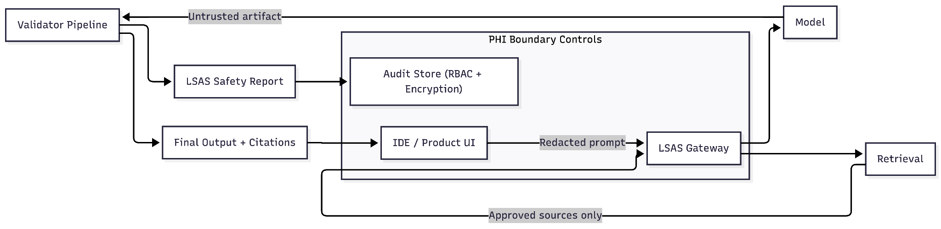

4.4 Observability and analytics guardrails
Enterprises routinely leak sensitive data through logs and analytics events. LSAS enforces:
- No PHI in telemetry by default.
- Sanitization of error logs and traces.
- Aggregated metrics rather than raw payload retention.
- Explicit "debug mode" policies restricted to non-production or de-identified datasets.

5. LSAS Definition and Design Goals
LSAS governs AI-generated text and code through five layers: 1) Input understanding: intent classification and risk tagging. 2) Knowledge grounding: authoritative sources, curated corpora, optional live retrieval. 3) Real-time validation: validators for accuracy, compliance posture, security, and accessibility. 4) Escalation: deterministic safe behavior under uncertainty and high-risk conditions. 5) Continuous learning: policy versioning, feedback loops, regression harnesses, and regulatory watchers.

Layer | Purpose | Key enforcement behaviors | Primary artifacts
1. Input understanding | Classify intent and risk | Capability gating; conservative tie-breaks | Risk tags; capability decision
2. Knowledge grounding | Anchor to authoritative sources | Allowlist; evidence contract; live retrieval when required | Evidence ledger; citation map
3. Real-time validation | Validate text and code | Accuracy, compliance posture, security, a11y; transform or fail | Findings; transforms; evidence
4. Escalation | Safe behavior under uncertainty | Clarify; degrade; HITL; remediation checklists | Escalation record; rationale
5. Continuous learning | Keep controls current | Policy versioning; regression harness; watcher alerts | Releases; tests; telemetry

5.1 Core design goals
- Output is untrusted until validated.
- High-risk claims require evidence and citations.
- Controls are policy-driven, versioned, and testable (policy as code).
- Minimal sensitive retention with maximum auditability.
- Pluggable validators and policy packs.
- Practical latency budgets with safe fallbacks.
- Explicit alignment with healthcare and medtech lifecycle realities.

6. LSAS Reference Architectures

6.1 End-to-end pipeline

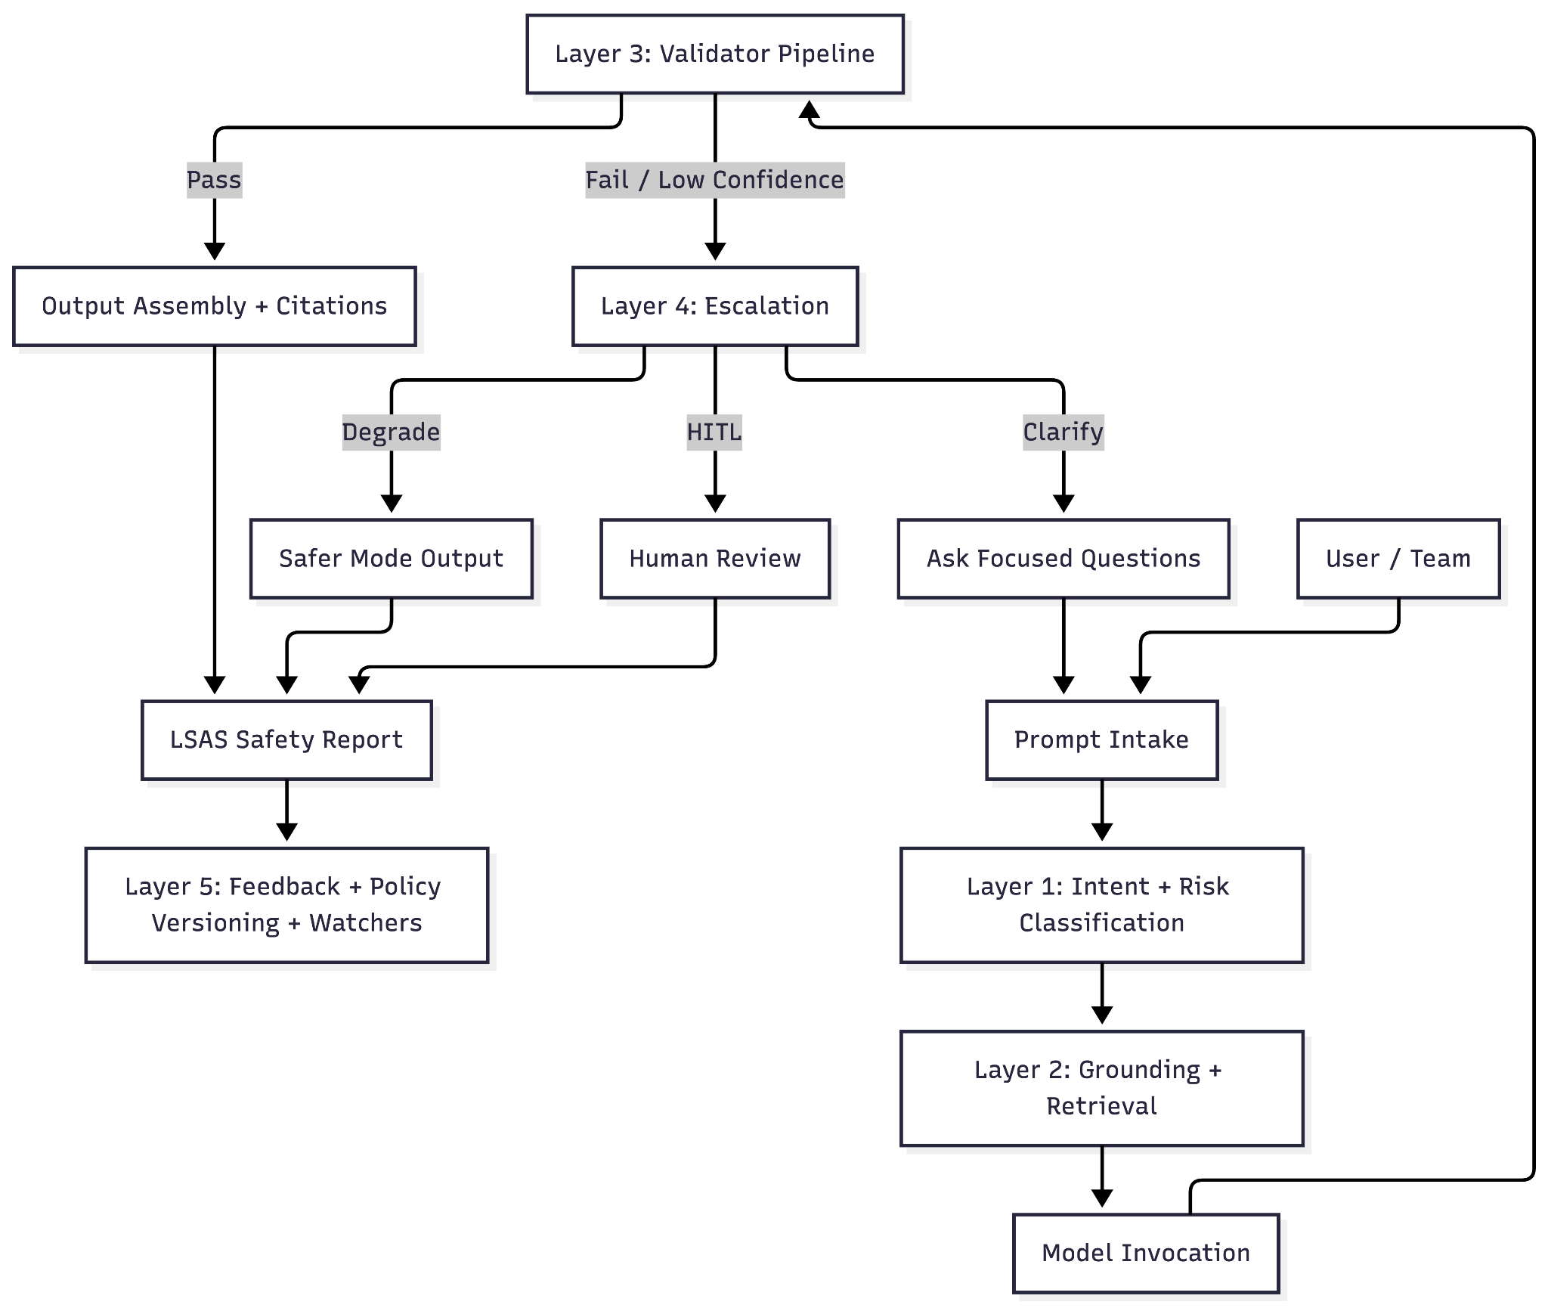

6.2 Control plane vs data plane (enterprise requirement)

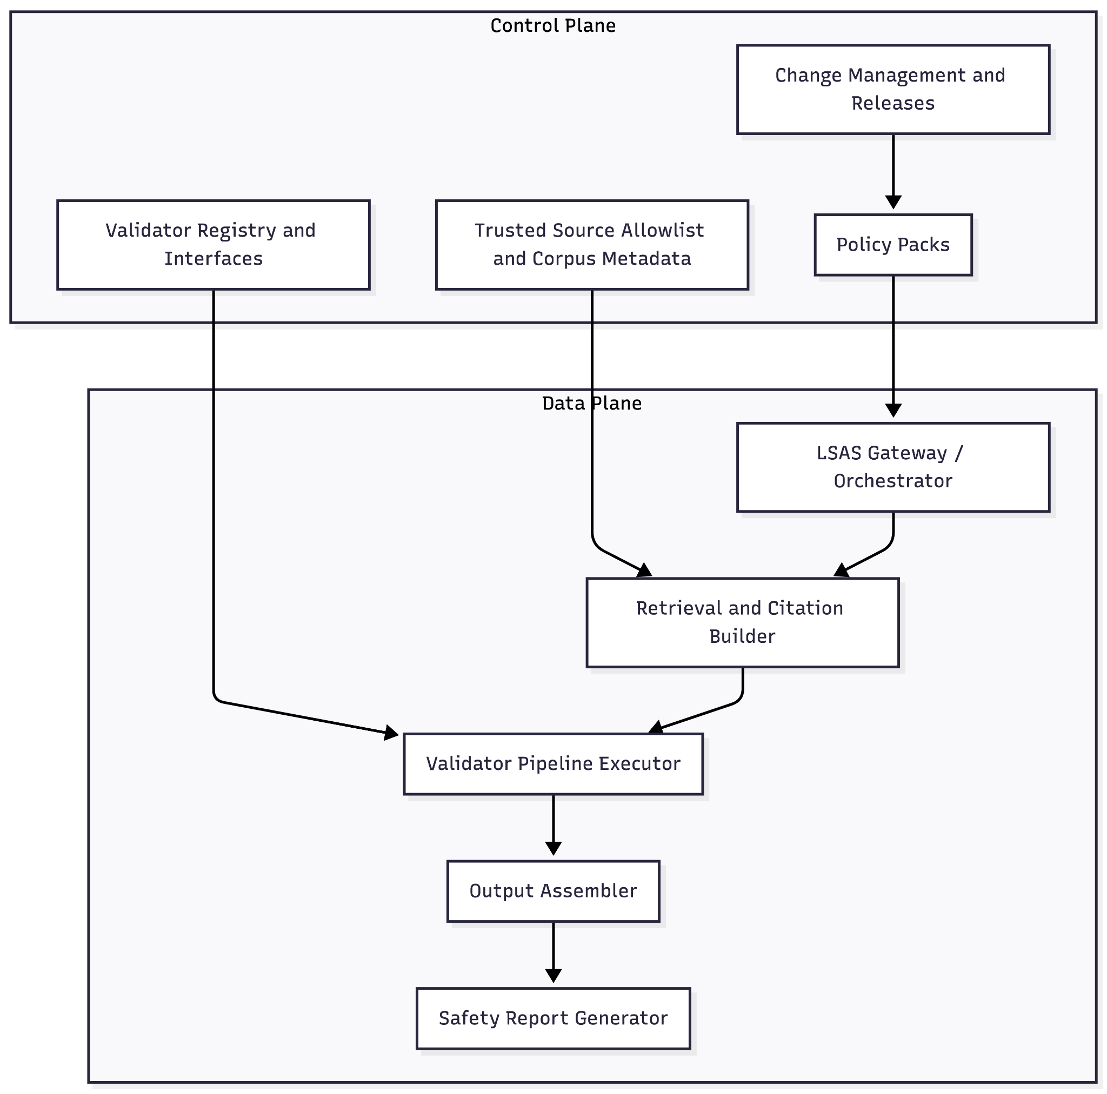

6.3 IDE code generation integration pattern

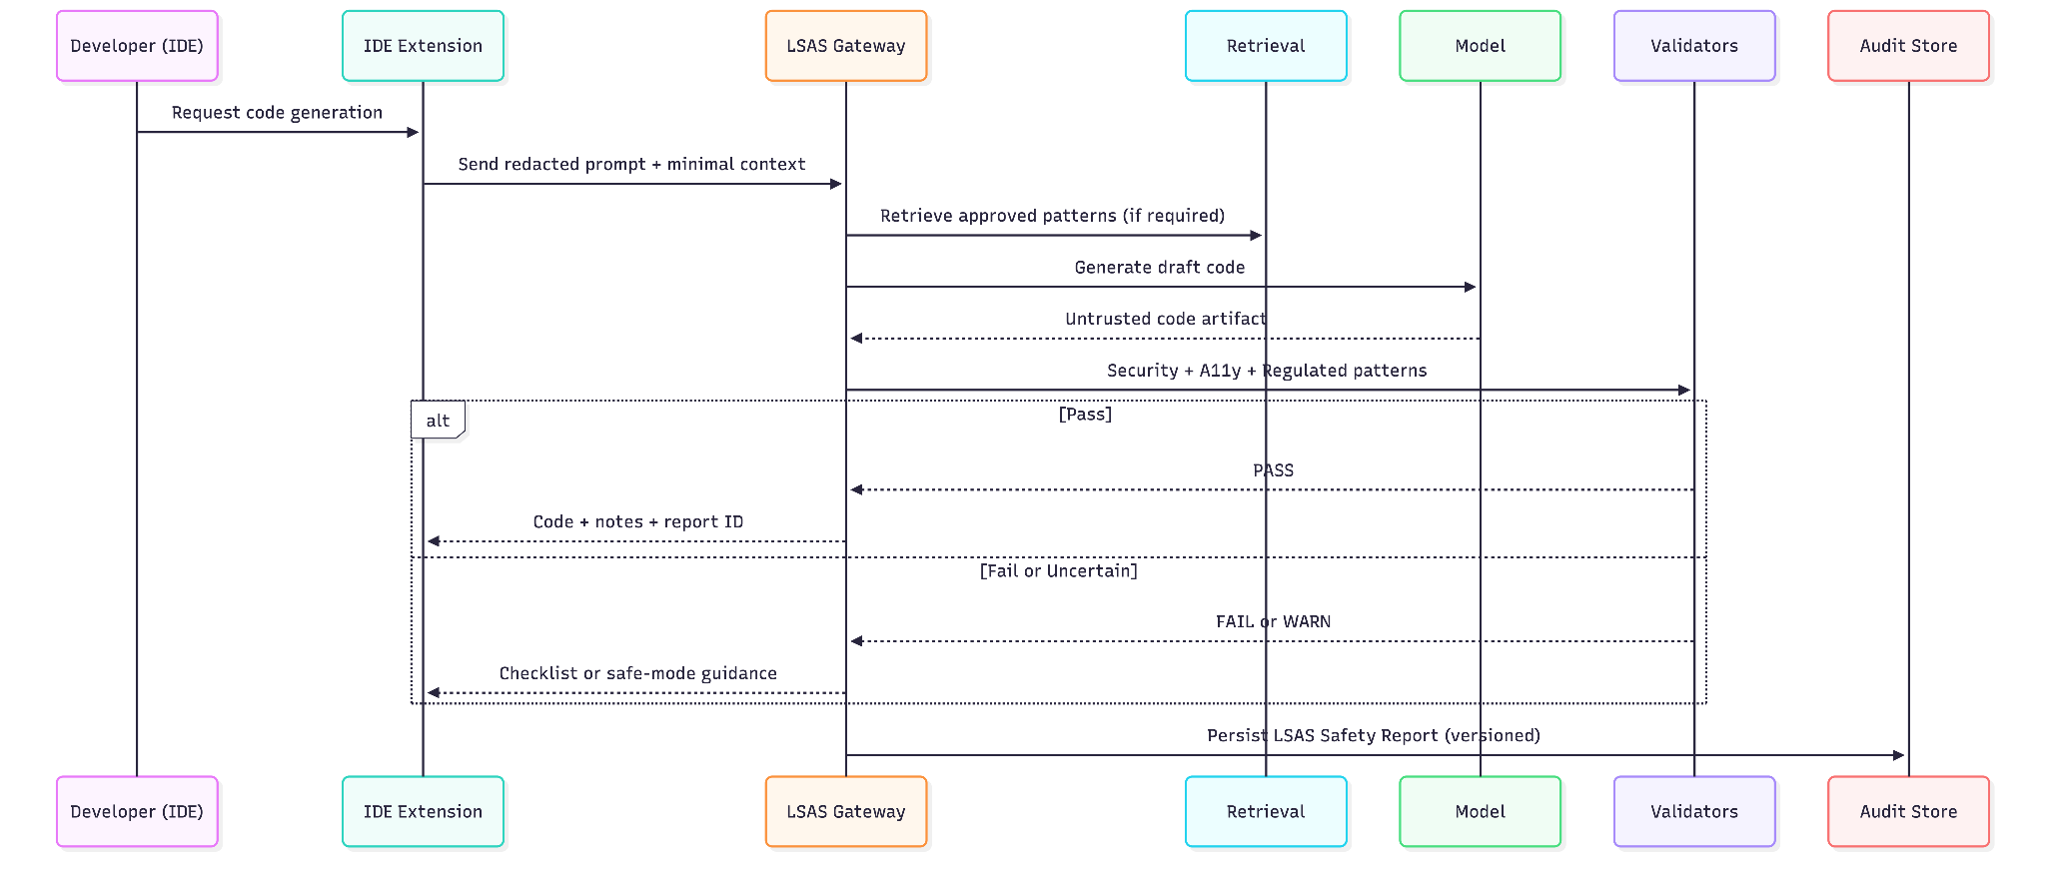

7. Layer 1: Risk Classification and Capability Gating
In large organizations, risk must translate into deterministic system behavior. LSAS uses risk tags to control capabilities and validation requirements.

7.1 Practical risk taxonomy (baseline)
- Low risk: general engineering guidance, non-sensitive refactoring, generic UI patterns, no PHI, no clinical advice.
- Medium risk: security-sensitive guidance, authentication patterns, billing flows, accessibility recommendations, standards interpretation with citations.
- High risk: PHI handling, HIPAA interpretation, clinical workflow guidance that may influence care decisions, regulated device functions, production security posture, tool use against patient data.

7.2 Capability gating matrix (baseline)
Capability | Low risk | Medium risk | High risk
Citations required | Optional | Required for key claims | Required for all critical claims
Live retrieval | Optional | When standards may be current-sensitive | Required for regulatory claims unless pre-approved corpus
Code generation | Allowed | Allowed with security/a11y validators | Allowed only with full validators; may degrade to checklist
Tool use / external actions | Allowlisted only | Restricted; allowlist + evidence required | Disabled by default; HITL to enable
PHI in prompts | Disallowed | Disallowed; synthetic/de-identified only | Disallowed; strict redaction + minimum necessary
Store raw outputs | Per policy | Prefer hashed storage | Disallowed by default; store hashes + evidence metadata
Human review | Optional | Recommended for certain domains | Default for clinical/regulatory interpretation and patient-impact decisions

7.3 Reference classification object
Code block:
{
"risk_level": "high",
"domains": ["hipaa", "security", "accessibility"],
"required_policy_packs": ["hipaa", "security", "a11y"],
"capabilities": {
"citations_required": true,
"live_retrieval": "required_for_regulatory_claims",
"code_generation": "allowed_with_full_validators",
"tool_use": "disabled_by_default",
"store_raw_content": false
}
}

7.4 Conservative tie-breaking and failure philosophy
If classification uncertainty exists, LSAS must bias upward (more restrictive). This reduces the probability of unsafe behavior at the cost of occasional friction, which is an acceptable trade in healthcare and medtech.

8. Layer 2: Knowledge Grounding and Evidence Contracts
Grounding is not optional for high-risk claims. It is the mechanism that converts probabilistic output into defensible output.

8.1 Trusted-source allowlist (control plane)
The allowlist should store:
- Publisher authority (HHS, FDA, NIST, W3C, etc.)
- Document version and date
- Applicability and jurisdiction
- Stability expectations (fast-changing vs stable)
- Access restrictions (public vs internal policies)

8.2 Live retrieval option (staleness mitigation)
When regulatory or standard currency matters, LSAS can enforce "live retrieval required" before finalizing an answer. This is relevant for:
- HIPAA Security Rule NPRM updates [10][11]
- FDA cybersecurity guidance updates [13]
- FDA PCCP guidance and AI-enabled device change management [15]
- Accessibility standards updates, including WCAG 2.2 [19]

8.3 Evidence contract (citation gating)
For high-risk topics:
- Every critical claim must be tied to an authoritative citation.
- Unsupported claims must be downgraded or escalated.
- The Safety Report must store a citation map and evidence ledger (URL, retrieval timestamp, hash).

8.4 Retrieval poisoning and corpus governance
Large organizations will ask how LSAS prevents malicious or low-quality sources from steering output:
- Use allowlists, not open-web browsing by default.
- Treat retrieval content as untrusted until validated for provenance and integrity.
- Hash and version authoritative documents in the corpus to prevent silent drift.
- Monitor for corpus changes through the watcher and approval workflow.

9. Layer 3: Validator Architecture (Practical Engineering)
Validators are the practical core of LSAS. They must be composable, testable, and explainable.

9.1 Validator design principles
- Validators emit structured findings, not prose.
- Validators can transform artifacts (redaction, downgrading language, producing checklists).
- Policy packs decide which validators run and thresholds.
- Validators run with explicit budgets and fail-safe fallbacks.

9.2 Validator interface (reference)
Code block:
Validator.execute(artifact, context) -> result

artifact: { type: "text"|"code", content, citations?, metadata }
context: { riskLevel, domains, policyPackVersions, tenant, environment, budgets }
result: { status: PASS|FAIL|WARN, findings[], transformedArtifact?, evidence[] }

9.3 Validator catalog (enterprise baseline)
Output | Validator | Trigger | Failure behavior | Evidence captured
Text | Evidence / citation gate | Regulatory or standards claims | Downgrade language or escalate | Citation map; evidence ledger
Text | Compliance posture (tone) | High-risk domains | Transform language; escalate on ambiguity | Findings with rule IDs
Text | PHI/PII detector + redaction | All prompts/outputs | Redact; fail closed for high risk | Redaction record; hashes
Text | Scope gate (clinical advice) | Patient-impact / clinical requests | Escalate to HITL; refuse patient-specific advice | Escalation record
Code | SAST / insecure patterns scan | Medium/high risk code gen | Fail or require remediation | Findings (CWE/OWASP tags)
Code | Secret scanning | All code artifacts | Fail closed | Secret detector findings
Code | Dependency/SCA check | When dependencies suggested | Fail or block high CVEs | CVE list; SBOM pointers
Code | A11y baseline (WCAG) | UI code generation | Warn + checklist; block severe issues | A11y findings; checklist
Both | Insecure output handling gate | Tool use or execution paths | Block privileged use; require sanitization | Gate decision record
Both | Prompt injection heuristics | Untrusted user input | Strip instructions; constrain tool use | Injection flags; sanitized prompt hash

9.4 Latency budgets and deterministic fallbacks
Healthcare workflows require predictable interaction. LSAS should define time budgets per layer (example):
- Classification: 50 to 150 ms
- Retrieval: 200 to 800 ms (cacheable)
- Fast validators: 500 to 1500 ms
- Deep validators: 2 to 10 s (use only when required by policy)
If deep validation exceeds budget, LSAS should degrade output (checklist, clarifying questions, or HITL) rather than silently skipping controls.

9.5 Validators for information outputs (text)
Minimum practical validators:
- Evidence validator: require citations for regulatory and standards claims.
- Compliance posture validator: disallow overconfident language without authority; enforce scoped language.
- PHI/PII detector: redact or block leakage; enforce minimum necessary [3].
- Scope validator: block patient-specific advice and clinical recommendations unless explicitly permitted and routed through clinical governance.

9.6 Validators for code outputs (IDE)
Minimum practical validators:
- Security scan: detect OWASP-class issues, secret leakage, auth mistakes, insecure defaults.
- Insecure output handling gate: prevent generated output from being executed or used as privileged tool input without sanitization [18].
- Accessibility baseline checks: ARIA and semantic structure, keyboard navigation, focus management, error prevention patterns aligned to WCAG 2.2 [19].
- Regulated design pattern validator: enforce inclusion of audit trail hooks, consent capture points, and secure transport notes for PHI workflows.

9.7 Implementation guidance: enforce the pipeline
LSAS does not require inventing new scanners. It requires enforcing a pipeline contract:
- SAST and code scanning can be integrated into IDE and CI workflows.
- Accessibility checks can be automated and complemented by human review for complex UI flows.
- Privacy detection should be deterministic; do not "guess" what might be sensitive.
- Prefer providing remediation checklists over auto-repair in high-risk contexts unless changes are fully attributable and reviewable.

10. Layer 4: Escalation Protocols (Safe Behavior Under Uncertainty)
Escalation is deterministic behavior, not defensive disclaimers.

10.1 Escalation actions
- Ask focused clarifying questions when essential context is missing.
- Degrade to safe mode (general guidance only, no code, no PHI, no tool use).
- Provide remediation checklists instead of executable code.
- Route to human review (security, compliance, clinical) when required by policy.

10.2 Soft qualifiers for high-risk topics
High-risk outputs should include scoped qualifiers tied to evidence:
- "Based on the cited sources, here are preliminary guidelines. Confirm final interpretations with your compliance team."
Avoid blanket disclaimers. Tie uncertainty to the specific claim or missing context.

11. Layer 5: Continuous Learning, Policy Versioning, and the Regulatory Watcher
Healthcare safety posture drifts if policies are not versioned and tested.

11.1 Policy as code lifecycle
- Policy pack changes require review and approval.
- Each release is tested against golden suites and adversarial prompts.
- Releases are versioned with changelogs.
- Safety Reports capture the policy versions used for each output.

11.2 Regulatory watcher design
The watcher monitors authoritative sources and triggers review:
- HHS HIPAA guidance changes and NPRM developments [10][11]
- FDA cybersecurity and PCCP guidance updates [13][15]
- FDA CDS guidance updates [14]
- NIST updates (CSF, AI RMF) [8][9][20]
- OWASP LLM risk updates [17][18]
- WCAG updates and related accessibility guidance [19]
Watcher output should trigger review workflows, not silently change runtime behavior without approval.

12. MedTech Alignment: QMS, Risk Management, and Device Lifecycle
For medtech, LSAS is valuable only if it integrates with real quality system practices.

12.1 QMSR and controlled records
FDA's QMSR final rule incorporates ISO 13485 by reference and is enforceable on February 2, 2026 [12]. LSAS artifacts can be designed as controlled records:
- Policy packs as controlled documents (document control and approvals).
- Safety Reports as controlled records supporting validation evidence.
- Regression harness results as verification artifacts.
- CAPA hooks based on repeated validator failures.

12.2 Cybersecurity guidance and premarket documentation posture
FDA cybersecurity guidance emphasizes secure design, labeling, and documentation expected in premarket submissions for devices with cybersecurity risk [13]. LSAS contributes by gating insecure generated code and producing evidence that cybersecurity validation controls are consistently applied.

12.3 AI-enabled device change management and PCCPs
FDA provides recommendations for PCCPs to support iterative improvements to AI-enabled device software functions while maintaining safety and effectiveness [15]. LSAS supports PCCP-ready posture by versioning policy packs and validator configurations and maintaining regression harnesses that demonstrate continued safety after changes.

12.4 CDS scope boundaries
FDA CDS guidance clarifies which CDS functions may be excluded from device regulation under non-device criteria and what functions remain within device scope [14]. LSAS provides a governance boundary so that outputs related to CDS are escalated and controlled.

13. Healthcare-Specific Design Patterns LSAS Should Enforce
This section identifies practical patterns that are repeatedly missed in real products.

13.1 Minimum necessary by default
When users request patient examples or realistic datasets, LSAS should:
- recommend synthetic or properly de-identified data [5]
- block inclusion of PHI in prompts and logs
- enforce redaction in Safety Reports

13.2 Audit trails as a product design primitive
LSAS should:
- identify audit trail events in generated designs ("consent captured," "record accessed," "order submitted")
- produce audit event templates as part of output
- ensure the Safety Report captures evidence for audit readiness

13.3 Telehealth: consent, audit, and secure transport notes
For telehealth workflows, LSAS should ensure outputs include consent capture points, audit event templates, secure transport notes, and secure storage considerations for recordings and transcripts.

13.4 EHR-integrated workflows: retrieval boundaries
For EHR-integrated tools:
- tool calls must be permissioned and logged
- retrieval must be scoped to minimum necessary
- outputs must not echo sensitive fields unless explicitly required and permitted
- Safety Reports should store hashes and metadata rather than raw PHI

14. Evaluation Methodology: How to Prove LSAS Works
Top institutions will not accept "it seems safer." LSAS must be measurable.

14.1 Core metrics (recommended baseline)
Metric | Definition | Why it matters
Evidence coverage rate | % of high-risk claims with authoritative citations | Reduces unsupported assertions; improves auditability
Unsafe output rate | % outputs failing validators or requiring escalation | Measures safety posture and policy effectiveness
False positive cost | Time/blocks introduced by validators | Ensures usability remains viable for teams
Latency overhead | Added time per validator set | Controls operational cost and developer experience
Security defect rate | Findings per generated code artifact | Reduces breach and exploit risk
Accessibility defect rate | A11y findings per generated UI artifact | Reduces legal risk and improves patient access
Policy drift indicators | Changes in failure modes over time | Detects emerging risks and regressions

14.2 Testing strategy
- Golden prompts by risk category.
- Red-team prompts mapped to OWASP LLM risks [17][18].
- Regression tests per policy pack version.
- Before/after comparisons for evidence coverage, unsafe output rate, and code defect rate.

14.3 Reproducibility in academic settings
To support university-grade credibility:
- publish the LSAS specification and Safety Report schema
- publish representative (non-sensitive) test suites
- disclose assumptions and limits
- version all artifacts to enable reproducible evaluation

15. Operationalization: Governance, SDLC Integration, and Deployment
LSAS is designed to be deployed as a reusable platform boundary.

15.1 Deployment models
- Central gateway (recommended): enforce LSAS across product UIs and IDE workflows.
- Embedded library: for disconnected, offline, or constrained environments.
- Hybrid: local redaction and classification plus centralized validation and evidence storage.

15.2 Multi-tenant controls
- Tenant-scoped policy packs and allowlists.
- Data residency and logging controls by tenant.
- Per-tenant audit artifacts and access controls.
- Separation of dev, test, and prod policy packs and corpora.

15.3 Governance roles and approval paths
Role | Responsibilities | Approval scope | Typical participants
LSAS Platform Owner | Owns gateway runtime, SLOs, deployments, incident response | Runtime changes; infra controls | Platform engineering, SRE
Policy Pack Owner | Owns policy pack content and versioning | Policy releases; thresholds; allowlists | Security lead, privacy lead
Security Lead | Security validators; tool boundaries; vuln policy | Security validator updates; exceptions | AppSec, security engineering
Privacy/Compliance Lead | Minimum necessary rules; PHI handling; audit retention | PHI-related policies; retention | Privacy officer, compliance
Clinical Safety Governance | Clinical boundary decisions; HITL criteria | Clinical escalation policies | Clinician reviewers, safety committee
Product/Engineering Leads | Adoption, workflow integration, training | Project-level usage and rollout | Product, engineering managers

15.4 CI/CD and SDLC integration
LSAS becomes strongest when it is enforced as part of the development lifecycle:
- Policy pack changes are treated as code changes: reviewed, tested, and released.
- Validator pipelines run in CI to prevent regression and drift.
- IDE integrations provide early feedback while CI provides enforcement gates.
- Security and accessibility scans are treated as required quality gates for high-risk code outputs.

15.5 Incident response integration
Safety Reports should support incident investigation without amplifying exposure:
- minimal sensitive retention by default
- replay pointers and evidence hashes
- alignment with breach readiness workflows [1][4]

16. Extensions: PCI DSS, SOC 2, HITRUST CSF
LSAS is healthcare-first but should integrate cleanly into enterprise assurance demands.

16.1 PCI DSS (payments)
PCI DSS provides a baseline of technical and operational requirements designed to protect payment account data [22]. LSAS can extend via a payments policy pack to prevent account data from entering prompts/logs and to apply stricter security validators to payment flows.

16.2 SOC 2 and Trust Services Criteria
SOC 2 reports evaluate controls relevant to security, availability, processing integrity, confidentiality, and privacy [23]. LSAS provides evidence artifacts that can support such evaluations. The Trust Services Criteria provide the underlying control categories and points of focus [24].

16.3 HITRUST CSF
HITRUST CSF harmonizes multiple regulations and frameworks into a certifiable control set used widely in healthcare [21]. LSAS policy packs can map validator evidence to HITRUST-aligned controls when an organization pursues certification.

17. Common Anti-Patterns and How LSAS Prevents Them
- "Copy-paste AI code into production": LSAS enforces security and accessibility validators before code is accepted.
- "RAG as compliance": LSAS requires evidence contracts and escalates when citations are missing.
- "Logging everything": LSAS treats minimum necessary as a system property and discourages raw PHI retention.
- "Tool use without boundaries": LSAS gates tool use, requires allowlists, and logs tool actions in Safety Reports.
- "Silent drift": LSAS versions policies, runs regressions, and uses a watcher to trigger reviews.

18. Conclusion
LSAS reframes generative AI in healthcare and medtech as a governed output pipeline rather than a raw generative feature. By separating control plane policy/versioning from runtime execution, enforcing grounding and validation before finalization, and producing audit artifacts per interaction, LSAS provides a practical path for adopting GenAI without relying on informal prompt etiquette.

The next step for organizations is not to debate whether models are safe. It is to implement enforceable system boundaries that make safety measurable and repeatable. LSAS is one such boundary, designed for production.

Appendix A: LSAS Safety Report (Audit Artifact)
The Safety Report is the primary artifact that enables auditability and reproducibility while minimizing sensitive retention.

A.1 Schema goals
- Replayability: sufficient metadata to reproduce decisions without storing PHI.
- Traceability: policy versions, validator results, evidence ledger.
- Audit readiness: consistent structure across outputs.

A.2 Example JSON (illustrative)
{
"lsas_version": "1.2",
"request": {
"id": "req_...",
"timestamp_utc": "2026-01-23T17:02:11Z",
"tenant_id": "tenant_...",
"environment": "prod",
"output_type": "code"
},
"classification": {
"risk_level": "high",
"domains": ["hipaa", "security", "accessibility"],
"policy_packs": {"hipaa": "1.3.0", "security": "1.2.1", "a11y": "1.0.4"},
"capabilities": {
"code_generation": "allowed_with_validators",
"tool_use": "disabled_by_default",
"live_retrieval": "required_for_regulatory_claims",
"store_raw_content": false
}
},
"grounding": {
"sources": [
{"title": "HHS HIPAA Cloud Computing Guidance", "url": "https://www.hhs.gov/hipaa/for-professionals/special-topics/health-information-technology/cloud-computing/index.html", "retrieved_utc": "2026-01-23T17:01:55Z", "hash": "sha256:..."},
{"title": "WCAG 2.2", "url": "https://www.w3.org/TR/WCAG22/", "retrieved_utc": "2026-01-23T17:01:56Z", "hash": "sha256:..."}
],
"citations_required": true
},
"validators": [
{"name": "security_sast", "status": "PASS", "findings": []},
{"name": "a11y_baseline", "status": "WARN", "findings": ["Missing focus management in modal."]},
{"name": "insecure_output_handling_gate", "status": "PASS", "findings": []}
],
"escalation": {
"action": "remediation_checklist",
"reason": "a11y_warn",
"notes": "Provided checklist instead of auto-fixing high-risk UI behavior."
},
"output": {
"artifact_hash": "sha256:...",
"contains_phi": false
}
}

Appendix B: Policy Pack Example (YAML Skeleton)
id: hipaa
version: 1.0.0
description: HIPAA-oriented governance for ePHI and PHI-sensitive outputs.
applicability:
domains: ["hipaa", "privacy", "security"]
source_allowlist:
- title: "HHS HIPAA Security Rule"
url: "https://www.hhs.gov/hipaa/for-professionals/security/index.html"
- title: "NIST SP 800-66 Rev. 2"
url: "https://nvlpubs.nist.gov/nistpubs/SpecialPublications/NIST.SP.800-66r2.pdf"
validators:
- name: "phi_pii_detector"
mode: "fail_closed"
- name: "evidence_citation_gate"
mode: "required_for_high_risk"
- name: "compliance_posture_tone"
mode: "transform_or_escalate"
thresholds:
high_risk_requires_live_retrieval: true
escalation:
high_risk_default: "clarify_or_hitl"
logging:
store_raw_prompts: false
store_raw_outputs: false
store_hashes_and_metadata: true

Appendix C: Implementation Checklist (MVP to Production)
MVP (2-4 weeks):
- LSAS gateway/orchestrator.
- Risk classifier and capability gating.
- Trusted source allowlist and retrieval.
- Evidence gate and PHI detector.
- Security validator for obvious hazards.
- Safety Report generation.

Production (8-16 weeks):
- Policy as code lifecycle with approvals and releases.
- Regression harness and adversarial prompt suite.
- Full validator pipeline (security, accessibility, compliance posture).
- Multi-tenant enforcement and data residency controls.
- Incident response integration and audit readiness.
- Regulatory watcher and review workflow.

Appendix D: OWASP LLM Risk Mapping (Condensed)
OWASP LLM risk | Primary LSAS layers | Mitigation pattern | Test case example
LLM01 Prompt Injection | L1, L3, L4 | Input delimiting; tool allowlists; injection heuristics; escalation | Injected instructions to exfiltrate data
LLM02 Insecure Output Handling | L3, L4 | Sanitize output before execution; block privileged tool use | Model output used as a shell command
LLM03 Training Data Poisoning | L2, L5 | Trusted corpus allowlists; integrity hashes; watcher alerts | Poisoned internal doc steering output
LLM04 Model DoS | L1, L3 | Budgeting; rate limits; degrade behavior | Long prompts causing validator overload
LLM05 Supply Chain Vulnerabilities | L3, L5 | Dependency scanning; SBOM; block risky packages | Suggested dependency with known CVE
LLM06 Sensitive Info Disclosure | L1, L3, L4 | PHI detection; minimum necessary; redaction; no raw retention | Prompt containing PHI echoed in output
LLM07 Insecure Plugin Design | L1, L3, L4 | Tool allowlists; scoped permissions; audit tool calls | Tool used to fetch unauthorized records
LLM08 Excessive Agency | L1, L4 | Disable tool use by default; HITL for actions | Model attempts to change configs
LLM09 Overreliance | L4, L5 | Escalation and evidence artifacts; require citations | User accepts unsupported claim as policy
LLM10 Model Theft | Outside LSAS core | Infra and access controls; rate limits; monitoring | Repeated probing of system prompts

References
[1] HHS. The Security Rule. https://www.hhs.gov/hipaa/for-professionals/security/index.html (accessed 2026-01-23)

[2] HHS. HIPAA Privacy Rule. https://www.hhs.gov/hipaa/for-professionals/privacy/index.html (accessed 2026-01-23)

[3] HHS. Minimum Necessary Requirement. https://www.hhs.gov/hipaa/for-professionals/privacy/guidance/minimum-necessary-requirement/index.html (accessed 2026-01-23)

[4] HHS. Guidance on HIPAA and Cloud Computing. https://www.hhs.gov/hipaa/for-professionals/special-topics/health-information-technology/cloud-computing/index.html (accessed 2026-01-23)

[5] HHS. Guidance Regarding Methods for De-identification of PHI. https://www.hhs.gov/hipaa/for-professionals/special-topics/de-identification/index.html (accessed 2026-01-23)

[6] HHS. HIPAA Security Series: Technical Safeguards (PDF). https://www.hhs.gov/sites/default/files/ocr/privacy/hipaa/administrative/securityrule/techsafeguards.pdf (accessed 2026-01-23)

[7] NIST. SP 800-66 Rev. 2 (PDF). https://nvlpubs.nist.gov/nistpubs/SpecialPublications/NIST.SP.800-66r2.pdf (accessed 2026-01-23)

[8] NIST. Cybersecurity Framework (CSF) 2.0 (PDF). https://nvlpubs.nist.gov/nistpubs/CSWP/NIST.CSWP.29.pdf (accessed 2026-01-23)

[9] NIST. AI RMF 1.0 (PDF). https://nvlpubs.nist.gov/nistpubs/ai/nist.ai.100-1.pdf (accessed 2026-01-23)

[10] HHS. HIPAA Security Rule NPRM landing page. https://www.hhs.gov/hipaa/for-professionals/security/hipaa-security-rule-nprm/index.html (accessed 2026-01-23)

[11] Federal Register. HIPAA Security Rule NPRM (Jan 6, 2025). https://www.federalregister.gov/documents/2025/01/06/2024-30983/hipaa-security-rule-to-strengthen-the-cybersecurity-of-electronic-protected-health-information (accessed 2026-01-23)

[12] FDA. QMSR Final Rule FAQ. https://www.fda.gov/medical-devices/quality-system-qs-regulationmedical-device-current-good-manufacturing-practices-cgmp/quality-management-system-regulation-final-rule-amending-quality-system-regulation-frequently-asked (accessed 2026-01-23)

[13] FDA. Cybersecurity in Medical Devices Guidance (PDF). https://www.fda.gov/media/119933/download (accessed 2026-01-23)

[14] FDA. Clinical Decision Support Software Guidance (Jan 2026 revision). https://www.fda.gov/regulatory-information/search-fda-guidance-documents/clinical-decision-support-software (accessed 2026-01-23)

[15] FDA. PCCP Guidance (PDF). https://www.fda.gov/media/166704/download (accessed 2026-01-23)

[16] ASTP/ONC. HTI-1 Final Rule. https://healthit.gov/regulations/hti-rules/hti-1-final-rule/ (accessed 2026-01-23)

[17] OWASP. Top 10 for Large Language Model Applications. https://owasp.org/www-project-top-10-for-large-language-model-applications/ (accessed 2026-01-23)

[18] OWASP. LLM02: Insecure Output Handling. https://genai.owasp.org/llmrisk2023-24/llm02-insecure-output-handling/ (accessed 2026-01-23)

[19] W3C. WCAG 2.2. https://www.w3.org/TR/WCAG22/ (accessed 2026-01-23)

[20] NIST. AI 600-1: Generative AI Profile (PDF). https://nvlpubs.nist.gov/nistpubs/ai/NIST.AI.600-1.pdf (accessed 2026-01-23)

[21] HITRUST. HITRUST CSF Framework overview. https://hitrustalliance.net/hitrust-framework (accessed 2026-01-23)

[22] PCI SSC. PCI DSS Document Library. https://www.pcisecuritystandards.org/document_library/ (accessed 2026-01-23)

[23] AICPA. SOC 2 overview. https://www.aicpa-cima.com/topic/audit-assurance/audit-and-assurance-greater-than-soc-2 (accessed 2026-01-23)

[24] AICPA. Trust Services Criteria (2022 points of focus). https://www.aicpa-cima.com/resources/download/2017-trust-services-criteria-with-revised-points-of-focus-2022 (accessed 2026-01-23)

