
ReactOS Build Environment
Version 1.5.1.1 for Windows NT based operating systems

Introduction
The ReactOS Build Environment (“RosBE”) is a complete environment for building ReactOS. It also optionally includes SVN to make it possible to load and update the Source Code. The Current version is based on GCC 4.4.3/MinGW32 and GCC 4.4.3/MinGW-w64.

Installation
While installing the ReactOS Build Environment you are asked to provide the directory where your ReactOS sources are located or should be checked out to later (defaults to USERPROFILE\reactos\). If you did not checkout a Source tree yet, start RosBE and type “ssvn create” (for this feature you need to have installed the Subversion Tools during installation).

Basic Usage
The ReactOS Build Environment prompt is shown here:

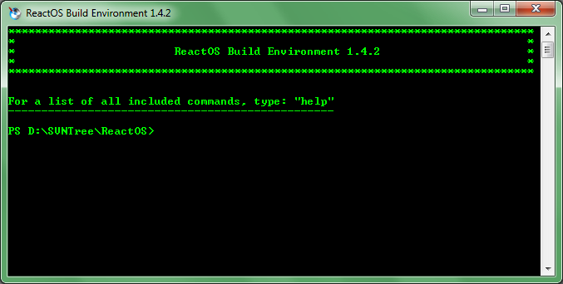
This prompt provides a complete environment for building ReactOS as well as many helpful commands. You can get a full list of available commands and their descriptions by typing 'help' at the prompt. For additional help for a specific Command, type 'help COMMAND'.

Version Information
The ReactOS Build Environment v1.5.1 contains the following packages:

- GNU Binutils (64 Bit) v2.20.51.20091209 (snapshot)
- GCC (64 Bit), The GNU Compiler Collection v4.4.3-20091023 (snapshot)
- GNU Binutils v2.20.51.20091222 (snapshot)
- GCC, The GNU Compiler Collection v4.4.3
patched with:
  - http://gcc.gnu.org/bugzilla/attachment.cgi?id=18882&action=view (committed in GCC r153606)
- MinGW
  - mingw32-make-3.81-2.tar.gz
  - mingw-runtime-3.17.tar.gz
  - w32api-3.14.tar.gz
- NASM, The Netwide assembler v2.08.01
- The Yasm Modular Assembler Project v1.0.0
- GDB, The GNU Project Debugger v6.8-3
- ccache, Compiler Cache v2.4
- Subversion v1.6.11
- GNU Bison v2.4.1 from GnuWin32
- Flex v2.5.4a-1 from GnuWin32
- Patch v2.5.9-7 from GnuWin32
- wget 1.11.4 from GnuWin32
- 7-Zip 4.65

Tested Operating Systems
The ReactOS Build Environment is designed to work on all Windows NT based operating systems, known working systems are as follows:
- Windows 2000
- Windows XP SP2 / SP3 (32 Bit / 64 Bit)
- Windows 2003 SP2
- Windows Vista SP1/SP2 (32 Bit / 64 Bit)
- Windows 7 RC/Final (32 Bit / 64 Bit)
- ReactOS 0.3.11

Websites
7-Zip
http://www.7-zip.org
MinGW, Minimalist GNU for Windows
http://www.mingw.org
GNU Binutils, The Binary Tools Collection
http://www.gnu.org/software/binutils
GCC, the GNU Compiler Collection
http://www.gcc.org
GDB, The GNU Project Debugger
http://www.gnu.org/software/gdb
GNU Make, The Makefile processor
http://www.gnu.org/software/make
GnuWin32, The GnuWin32 Project
http://gnuwin32.sourceforge.net/
NASM, The Netwide Assembler
http://nasm.sourceforge.net
The Yasm Modular Assembler Project
http://www.tortall.net/projects/yasm/
NSIS (Nullsoft Scriptable Install System)
http://nsis.sourceforge.net
Subversion Client
http://subversion.tigris.org
ccache, Compiler Cache
http://ccache.samba.org
Cygwin
http://www.cygwin.com

Credits
Daniel Reimer (reimer.daniel@freenet.de) (active)
Peter Ward (dralnix@gmail.com) (inactive)
Colin Finck (colin@reactos.org) (active)
Pierre Schweitzer (heis_spiter@hotmail.com) (active)
Thanks to ROSFan, who created the nice ReactOS Build Environment Logo.
Thanks also goes out to all those who provide so much help by testing the new versions. Without them RosBE would not be what it is today.
Credits to Gregor Anich who created the original ReactOS Build Environment.
This product includes software developed by the University of California, Berkeley and its contributors. (Flex)

