Basic Shell Browser Architecture
Chee Chew – 9/12/96

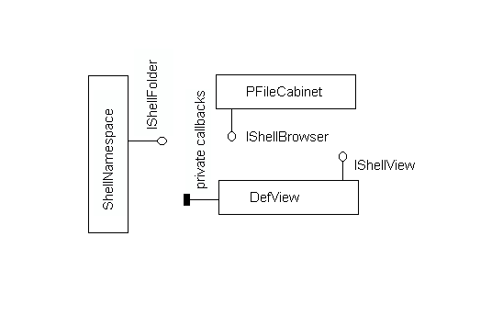

Figure 1. In Win95 we created this architecture for viewing and navigating through the shell namespace. The namespace is created by a heirarchy of IShellFolders. The main shell browser in win95 implements IShellBrowser in explorer.exe. The class implementation was a C implementation of PFileCabinet (C structure name).

IShellBrowser provides the UI for navigating through the shell namespace. It implements the menus, toolbar, status bar and (in Explore mode) the tree pane. It provides mechanisms by which the content view can merge in menus and toolbar buttons and add text and fields to the status bar.

When IShellBrowser wants to present an IShellFolder, it asks for the IShellFolder’s IShellView (via IShellFolder::CreateViewObject). In Win95, we had one main implementation of IShellView, DefView, which serves all of the Win95 Shell team implemented IShellFolders.

Navigating through the Web is not much different (or should not be) from navigating through the Win95 shell namespace. The Internet should be considered just another namespace. And should eventually (IE4) be considered part of the Shell namespace. If we write an IShellFolder (and family) implementation that represents the Internet, then we could view it using the Win95 shell.

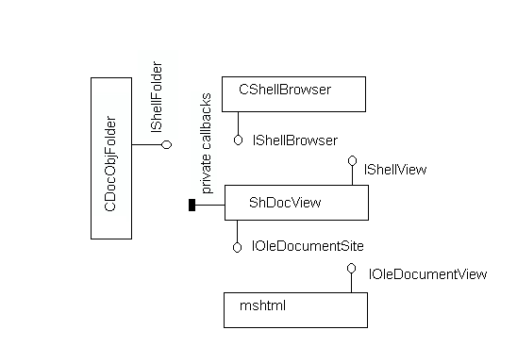

Figure 2. This is the initial architecture of IE3. Mshtml is the dll form of the IE2 monolithic iexplore.exe. Instead of turning it directly into an IShellView, we wrapped the HTML parsing and viewing components and wrapped it in an ActiveDocument interface (IOleDocumentView). The implementation class is HTMLObj. In shdocvw.dll, we implemented a ActiveDocument host (IOleDocumentSite) to host mshtml and exposed an IShellView interface up to the IShellBrowser. This was called CDocObjectView. We implemented CDocObjectFolder which is the IShellFolder for CDocObjectView.

Because we have the middle layer of CDocObjectView implemented separately from HTMLObj, we can use it to view any ActiveDocument.
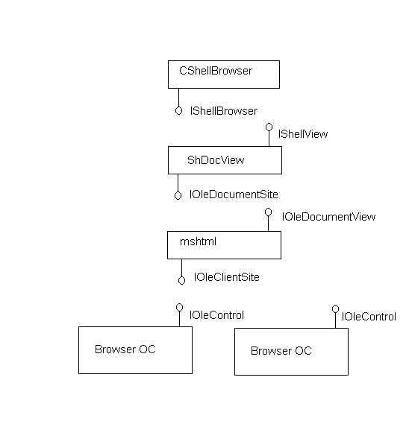

Figure 3. As part of the ActiveX story, IE3 had to host ActiveX controls. So mshtml implemented IOleClientSite to hosts OCs in its pages.

In thinking about framesets, we realized each frame in a frameset is a full web browsers (minus the frame decorations). MSHTML already hosts OCs, so if we could have a web browser that is an OC then we could implement frames relatively easily.

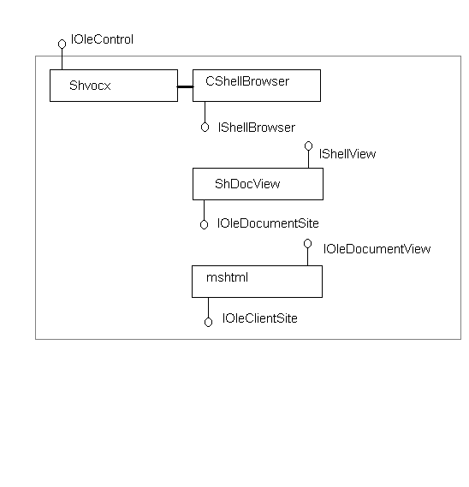
Figure 4. CWebBrowserOC wraps our top level browser and exposes IOleControl so that mshtml can host it. In CWebBrowserOC’s implementation we have a CWebBrowserSB contained class. CWebBrowserSB is derived from our top level ShellBrowser, that overrides a few functions as needed by the OC. CWebBrowserOC inherits from our generic IOleControl class (CShellOcx) and provides the glue to tie CShellOcx to CWebBrowserSB.

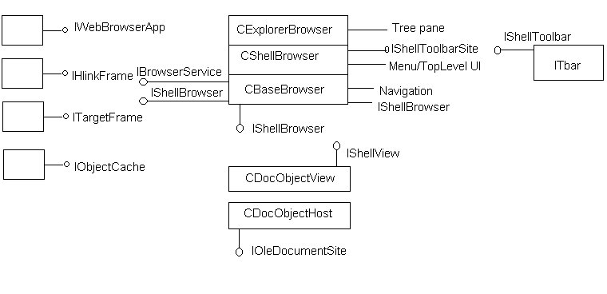
Figure 5. Implementation details.

In IE4, the top level browser is implemented in 3 classes:
- CBaseBrowser: implements the core IShellBrowser, and handles navigation.
- CShellBrowser: derived from CBaseBrowser. This implements top level UI Frame decorations and implements IShellToolbarSite.
- CExplorerBrowser: derived from CShellBrowser. This implements the tree pane for Explore mode.

The toolbars (the explorer tree pane and the internet toolbar) of CShellBrowser and CExplorerBrowser interact with the browser via IShellToolbar. The IShellToolbar/IShellToolbarSite interfaces primarily serve to negotiate window realestate.

The IShellView implementation for the internet (and docobj) namespace are implemented in two classes:
- CDocObjectView: implements the IShellView interface for being hosted by IShellBrowser
- CDocObjectHost: implements the IOleDocumentSite interface for hosting ActiveDocuments. This includes the new async binding model.

We split this view into two classes for a couple reasons. We had hopes of isolating all the doc hosting code so that we could use it in pageview, but that has not yet been done. Second, for abstraction of tasks. Third, each object implements an IOleCommandTarget. The COM identity of the two command targets indicate the direction that the Exec() should follow. Commands received by CDocObjectView propagate downward. Commands received by CDocObjectHost propagate upward.

Services of the ShellBrowser are:
- IWebBrowserApp/IWebBrowser2: an IDispatch derived interface.
- IHlinkFrame: for async hyperlink binding/navigation.
- ITargetFrame: This is private.used for frame naming. hopefully going away
- IObjectCache: for ole object caching as we move from site to site.

These interfaces are conceptually unrelated, but implemented as one object for memory/performance reasons.

The WebBrowser OC aggregates the above object and exposes its interfaces in addition to the OCs IWebBrowser and IWebBrowser2 interfaces.

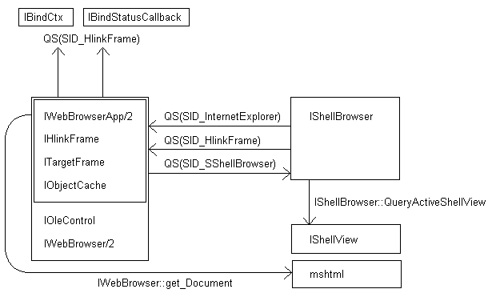
Figure 6. The road map. This diagram tries to illustrate how to get from one object to the next.
QS(sid) means IServiceProvider::QueryService(ServiceID, interface type)

