**Table of Contents**

**Introduction** 2

**Getting Started** 2

**Components** 2

**Steps** 2

**Test Plan** 2

# **Introduction**

Match Engine is a system that takes an order and order book as input parameter. Later on gives back a list of trades plus all the remaining orders. The remaining orders will be stored in the resting book for the next order received by the matching engine.

# **Getting Started**

## **Components**

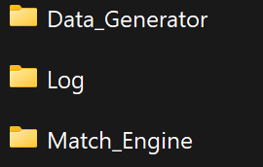

There’re folder including in the zip file.

1. Match_Engine : The engine for matching order.
2. Data_Generator : Generater a number of orders.
3. Log : A file contains several orders.

**Steps**

1. Place the Log file in C drive.
2. Build and run both Match_Engine and Data_Generator solution.
3. Result stored in the Logs folder save inside the Match_Engine folder.

## **Test Plan**

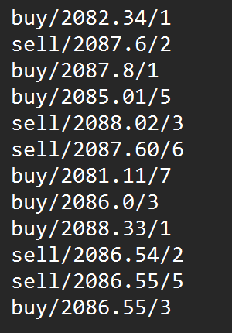

Here are orders stored in the order.txt from Log folder.