# Update Data Connection String

After the database has been moved to the new server, the Data Connection Strings on each of the VI servers will need to be changed to reflect the new database location.

1. Open the Registry Editor
2. Navigate to HKEY_LOCAL_MACHINE\SOFTWARE\WOW6432Node\Video Insight\IP Server Ent
3. Double click on the “DataConnectionString” entry

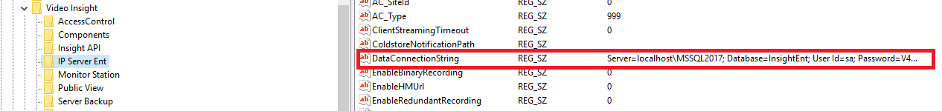

1. Delete the existing value
2. Enter the new value
3. Click OK to accept the new value
4. Close the Registry Editor
5. Open IP Server Manager
6. Right-click on the IP Server Manager icon in the system tray
7. Click Start IP Server