# Database Migration

1. On the Microsoft SQL Server 2017 server, open Microsoft SQL Server Management Studio
2. Log into the SQL Server 2017 instance
3. Click the “New Query” button (will open a blank query tab)
4. Enter the following query to create an empty InsightEnt database

CREATE DATABASE InsightEnt;

1. Click the “Execute” button or press F5 to execute the query
   * Successful response will be “Commands completed successfully.”
2. In the left tree, click the minus sign (-) to the left of Databases to collapse the database folder
3. Click the blue circle arrow button in Object Explorer toolbar to refresh database listing
4. In the left tree, click the plus sign (+) to the left of Databases to expand the database folder
5. Right-click on the InsightEnt database
6. Mouse over Tasks
7. Click “Import Data…” (will open SQL Server Import and Export Wizard”

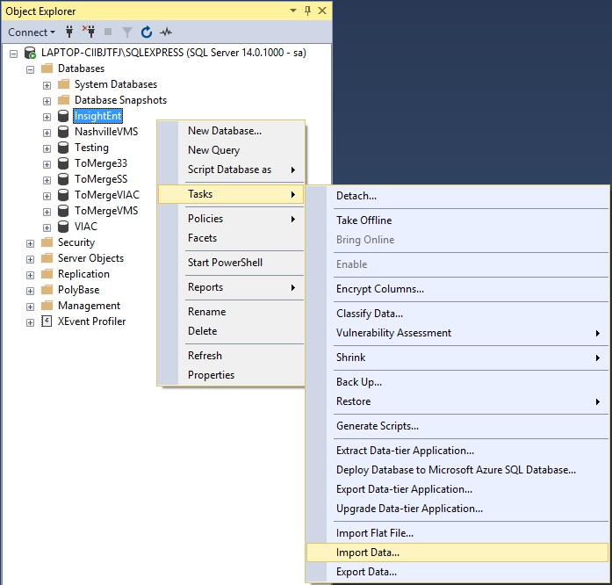

1. If welcome screen appears, click next
2. In the “Choose a Data Source” window set the following values:
   * Data Source: SQL Server Native Client 11.0
   * Server Name: Server Name / IP Address and Instance name of old SQL Server
     1. USE SQL Server Authentication; Enter Username and Password
   * Database: InsightEnt

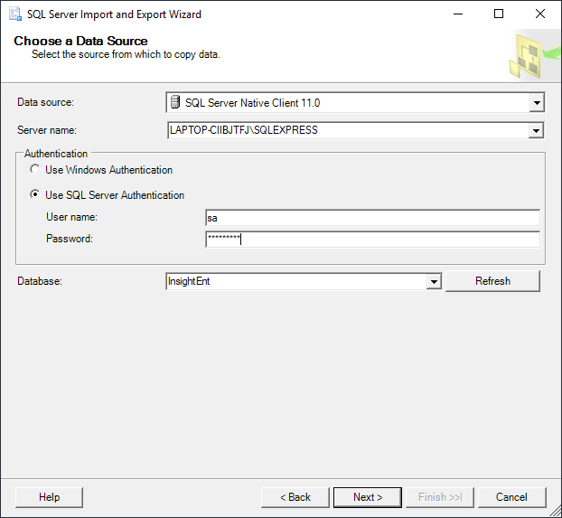

1. Click Next
2. In the “Choose a Destination” window set the following values:
   * Data Source: SQL Server Native Client 11.0
   * Server Name: Should be prepopulated, if not enter gaining SQL Server Instance
     1. USE SQL Server Authentication; Enter Username and Password
   * Database: InsightEnt (should be prepopulated)

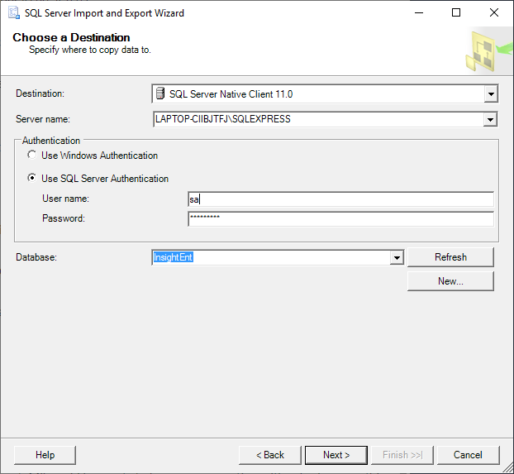

1. Click Next
2. In the “Specify Table Copy or Query” window, click the radio button next to “Copy data from one or more tables or views”
3. Click Next
4. In the “Select Source Tables and Views” window:
   * Click the empty checkbox in the header bar to select all tables

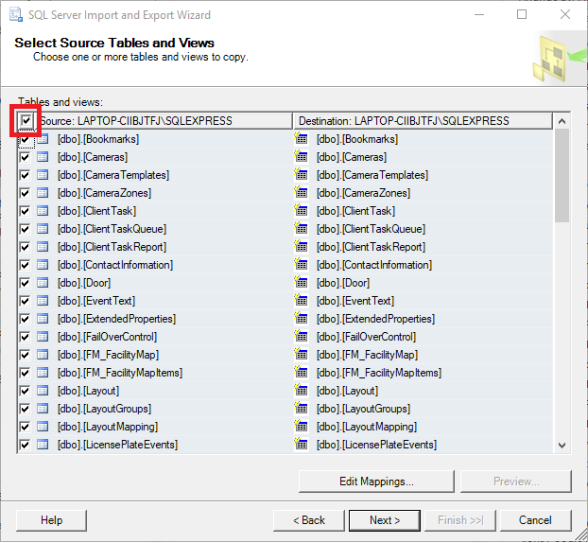

1. Click Next
2. Click Finish in the “Save and Run Package” window
3. Click Finish in the “Complete the Wizard” window
4. The “Performing Operation” window will appear and display the progress of each table and the number of rows copied per table

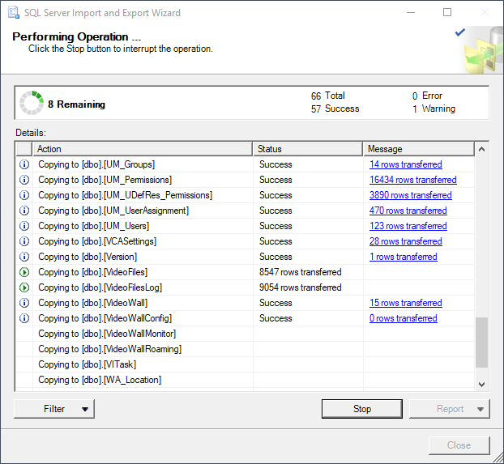

1. Once complete the Close button becomes active, click Close to close the window
2. Expand the InsightEnt database in the Object Explorer to verify that tables have been imported