Summary of Models

# BADS Generalised Linear Mixed Model with Gaussian distribution and log link

Table : BADS Generalised Linear Mixed Model with Gaussian distribution and log link

| Parameter | Estimate | Est.Error | l-95% CI | u-95% CI | Rhat | Bulk_ESS | Tail_ESS |
| --- | --- | --- | --- | --- | --- | --- | --- |
| **Group-Level Effects:** | | | | | | | |
| fkClientID (Number of levels: 1060) |  |  |  |  |  |  |  |
| sd(Intercept) | 0.15 | 0.01 | 0.13 | 0.16 | 1.00 | 842 | 1 956 |
| **Population-Level Effects:** | | | | | | | |
| Intercept | -1.23 | 0.02 | -1.27 | -1.18 | 1.00 | 3 154 | 4 846 |
| BADS_baseline | 0.91 | 0.03 | 0.86 | 0.96 | 1.00 | 2 806 | 4 751 |
| BADS_change | 0.54 | 0.03 | 0.48 | 0.60 | 1.00 | 2 403 | 4 808 |
| **Family Specific Parameters:** | | | | | | | |
| sigma | 0.10 | 0.00 | 0.09 | 0.11 | 1.00 | 998 | 2 397 |
| Formula: aqol6d_total_w ~ BADS_baseline + BADS_change + (1 | fkClientID) | | | | | | | |
| Family: gaussian Links: mu = log; sigma = identity Data: data_tb (Number of observations: 1696) Samples: 4 chains, each with iter = 4000; warmup = 2000; thin = 1; total post-warmup samples = 8000 | | | | | | | |
| Samples were drawn using sample(hmc). For each parameter, Bulk_ESS and Tail_ESS are effective sample size measures, and Rhat is the potential scale reduction factor on split chains (at convergence, Rhat = 1). | | | | | | | |

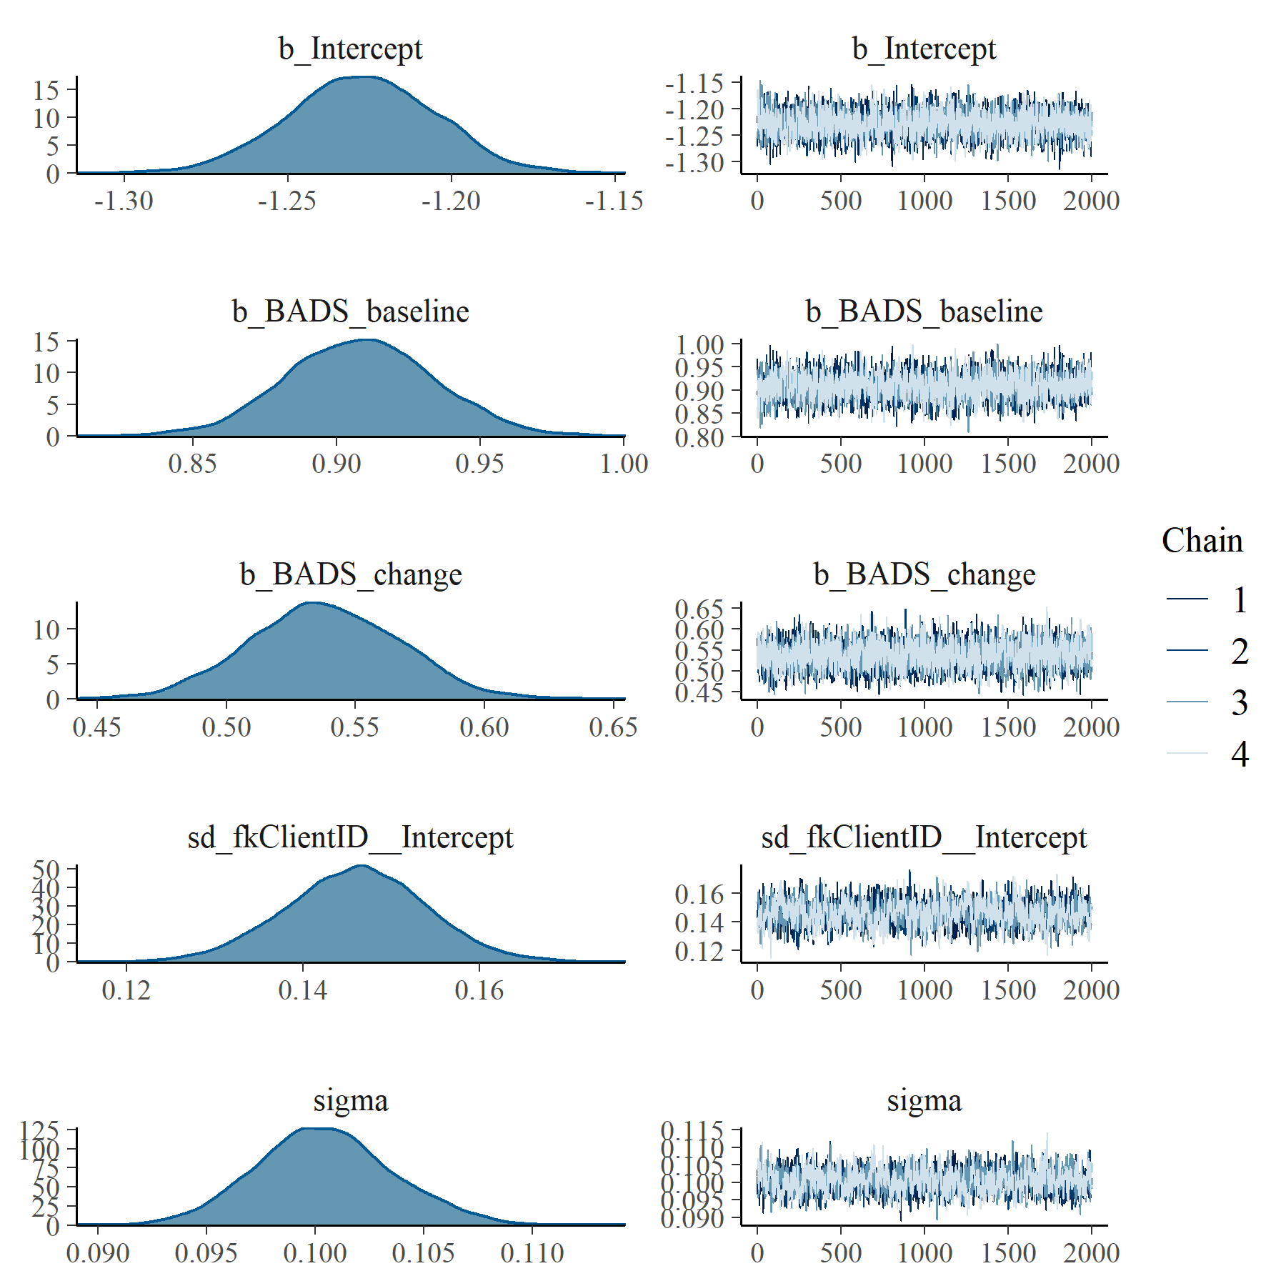

Figure : BADS Generalised Linear Mixed Model with Gaussian distribution and log link population and group level effects

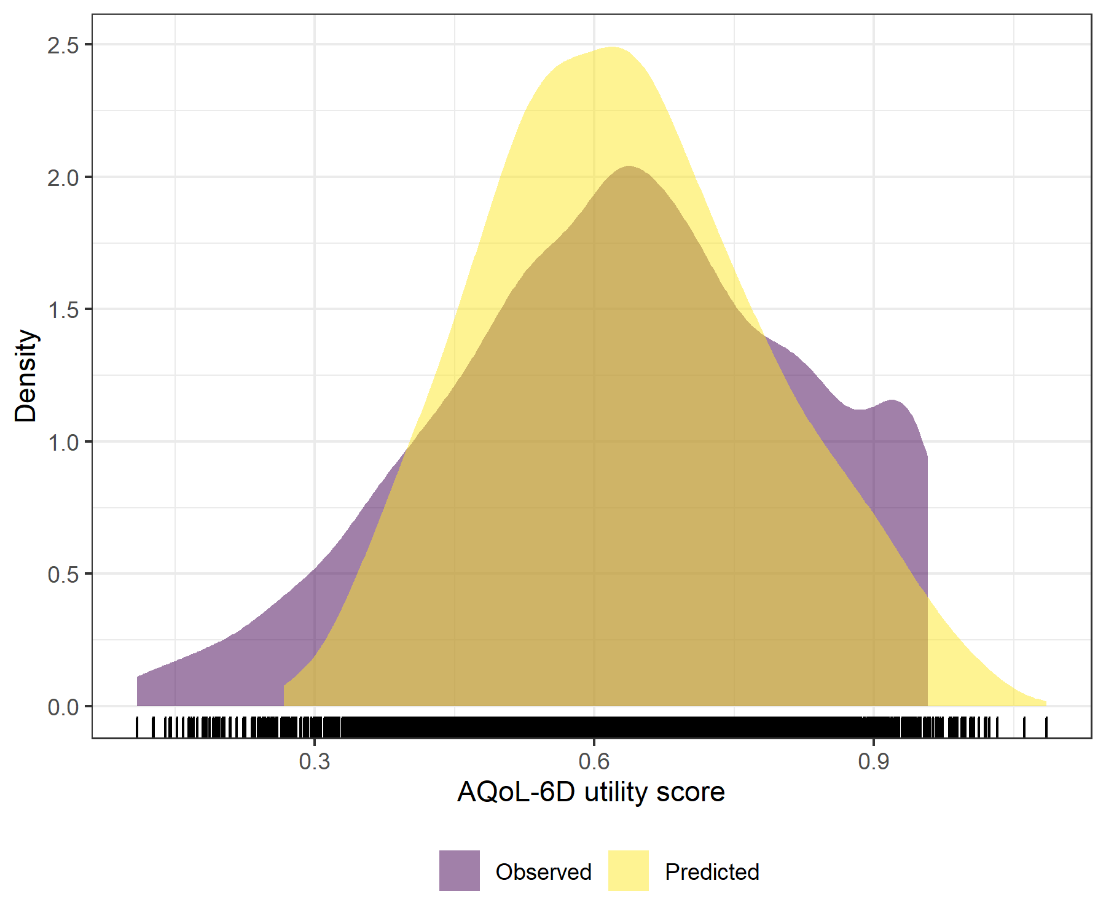

Figure : BADS Generalised Linear Mixed Model with Gaussian distribution and log link comparative densities of observed and predicted data

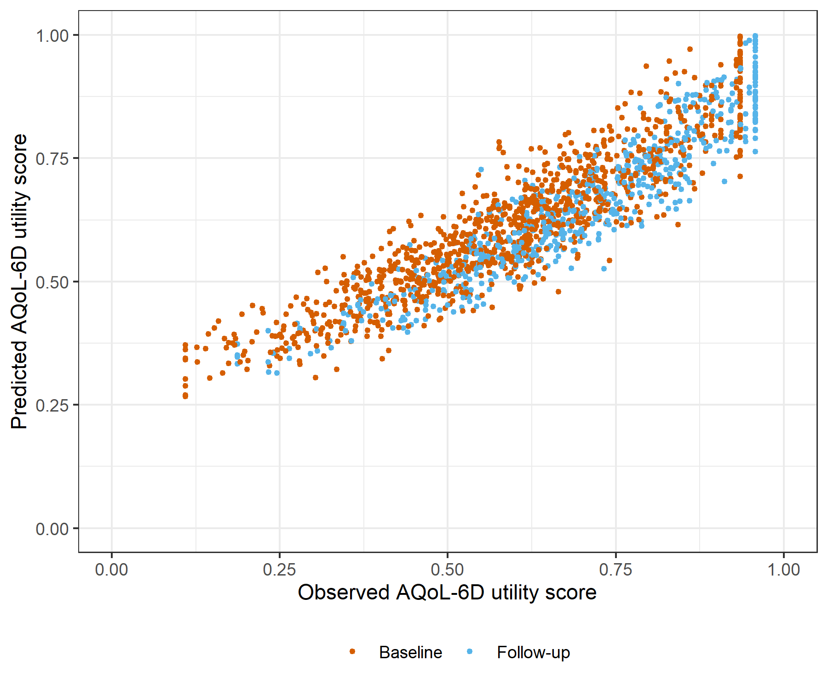

Figure : BADS Generalised Linear Mixed Model with Gaussian distribution and log link comparative scatter plot of obsereved and predicted data

# BADS Linear Mixed Model with clog-log transformation

Table : BADS Linear Mixed Model with clog-log transformation

| Parameter | Estimate | Est.Error | l-95% CI | u-95% CI | Rhat | Bulk_ESS | Tail_ESS |
| --- | --- | --- | --- | --- | --- | --- | --- |
| **Group-Level Effects:** | | | | | | | |
| fkClientID (Number of levels: 1060) |  |  |  |  |  |  |  |
| sd(Intercept) | 0.31 | 0.01 | 0.29 | 0.34 | 1.00 | 1 471 | 3 211 |
| **Population-Level Effects:** | | | | | | | |
| Intercept | -1.51 | 0.04 | -1.59 | -1.43 | 1.00 | 2 768 | 4 352 |
| BADS_baseline | 1.86 | 0.05 | 1.76 | 1.96 | 1.00 | 2 730 | 4 042 |
| BADS_change | 1.11 | 0.05 | 1.01 | 1.22 | 1.00 | 4 707 | 5 812 |
| **Family Specific Parameters:** | | | | | | | |
| sigma | 0.28 | 0.01 | 0.27 | 0.30 | 1.00 | 1 641 | 3 392 |
| Formula: aqol6d_total_w_cloglog ~ BADS_baseline + BADS_change + (1 | fkClientID) | | | | | | | |
| Family: gaussian Links: mu = identity; sigma = identity Data: data_tb (Number of observations: 1696) Samples: 4 chains, each with iter = 4000; warmup = 2000; thin = 1; total post-warmup samples = 8000 | | | | | | | |
| Samples were drawn using sample(hmc). For each parameter, Bulk_ESS and Tail_ESS are effective sample size measures, and Rhat is the potential scale reduction factor on split chains (at convergence, Rhat = 1). | | | | | | | |

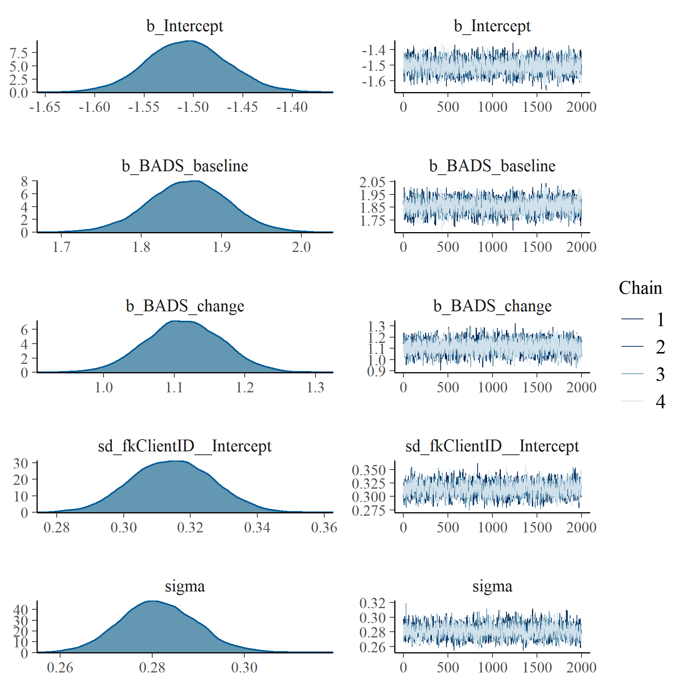

Figure : BADS Linear Mixed Model with clog-log transformation population and group level effects

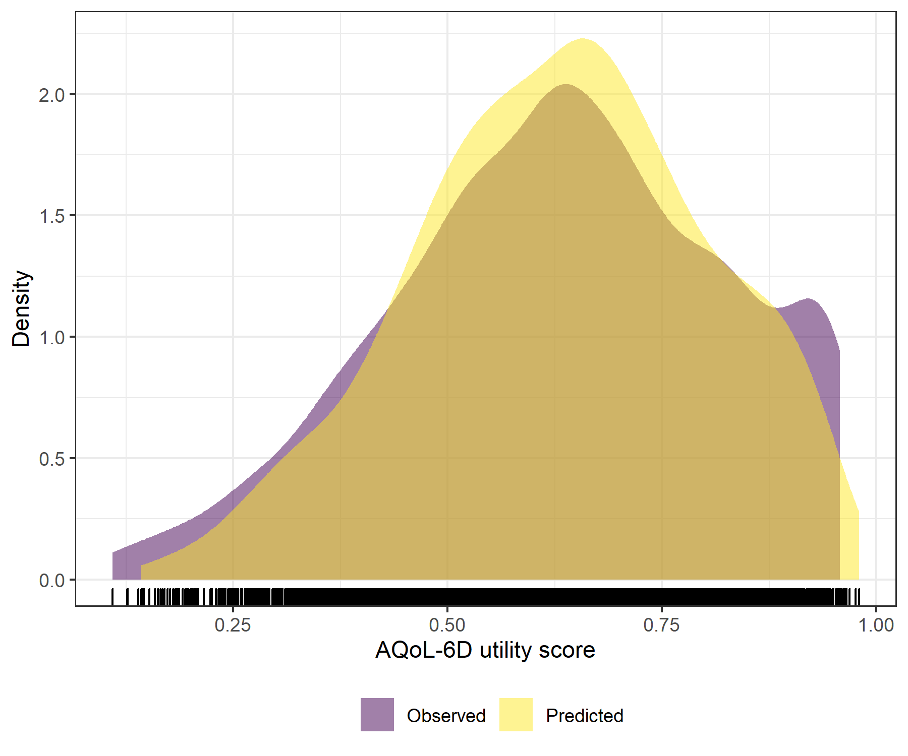

Figure : BADS Linear Mixed Model with clog-log transformation comparative densities of observed and predicted data

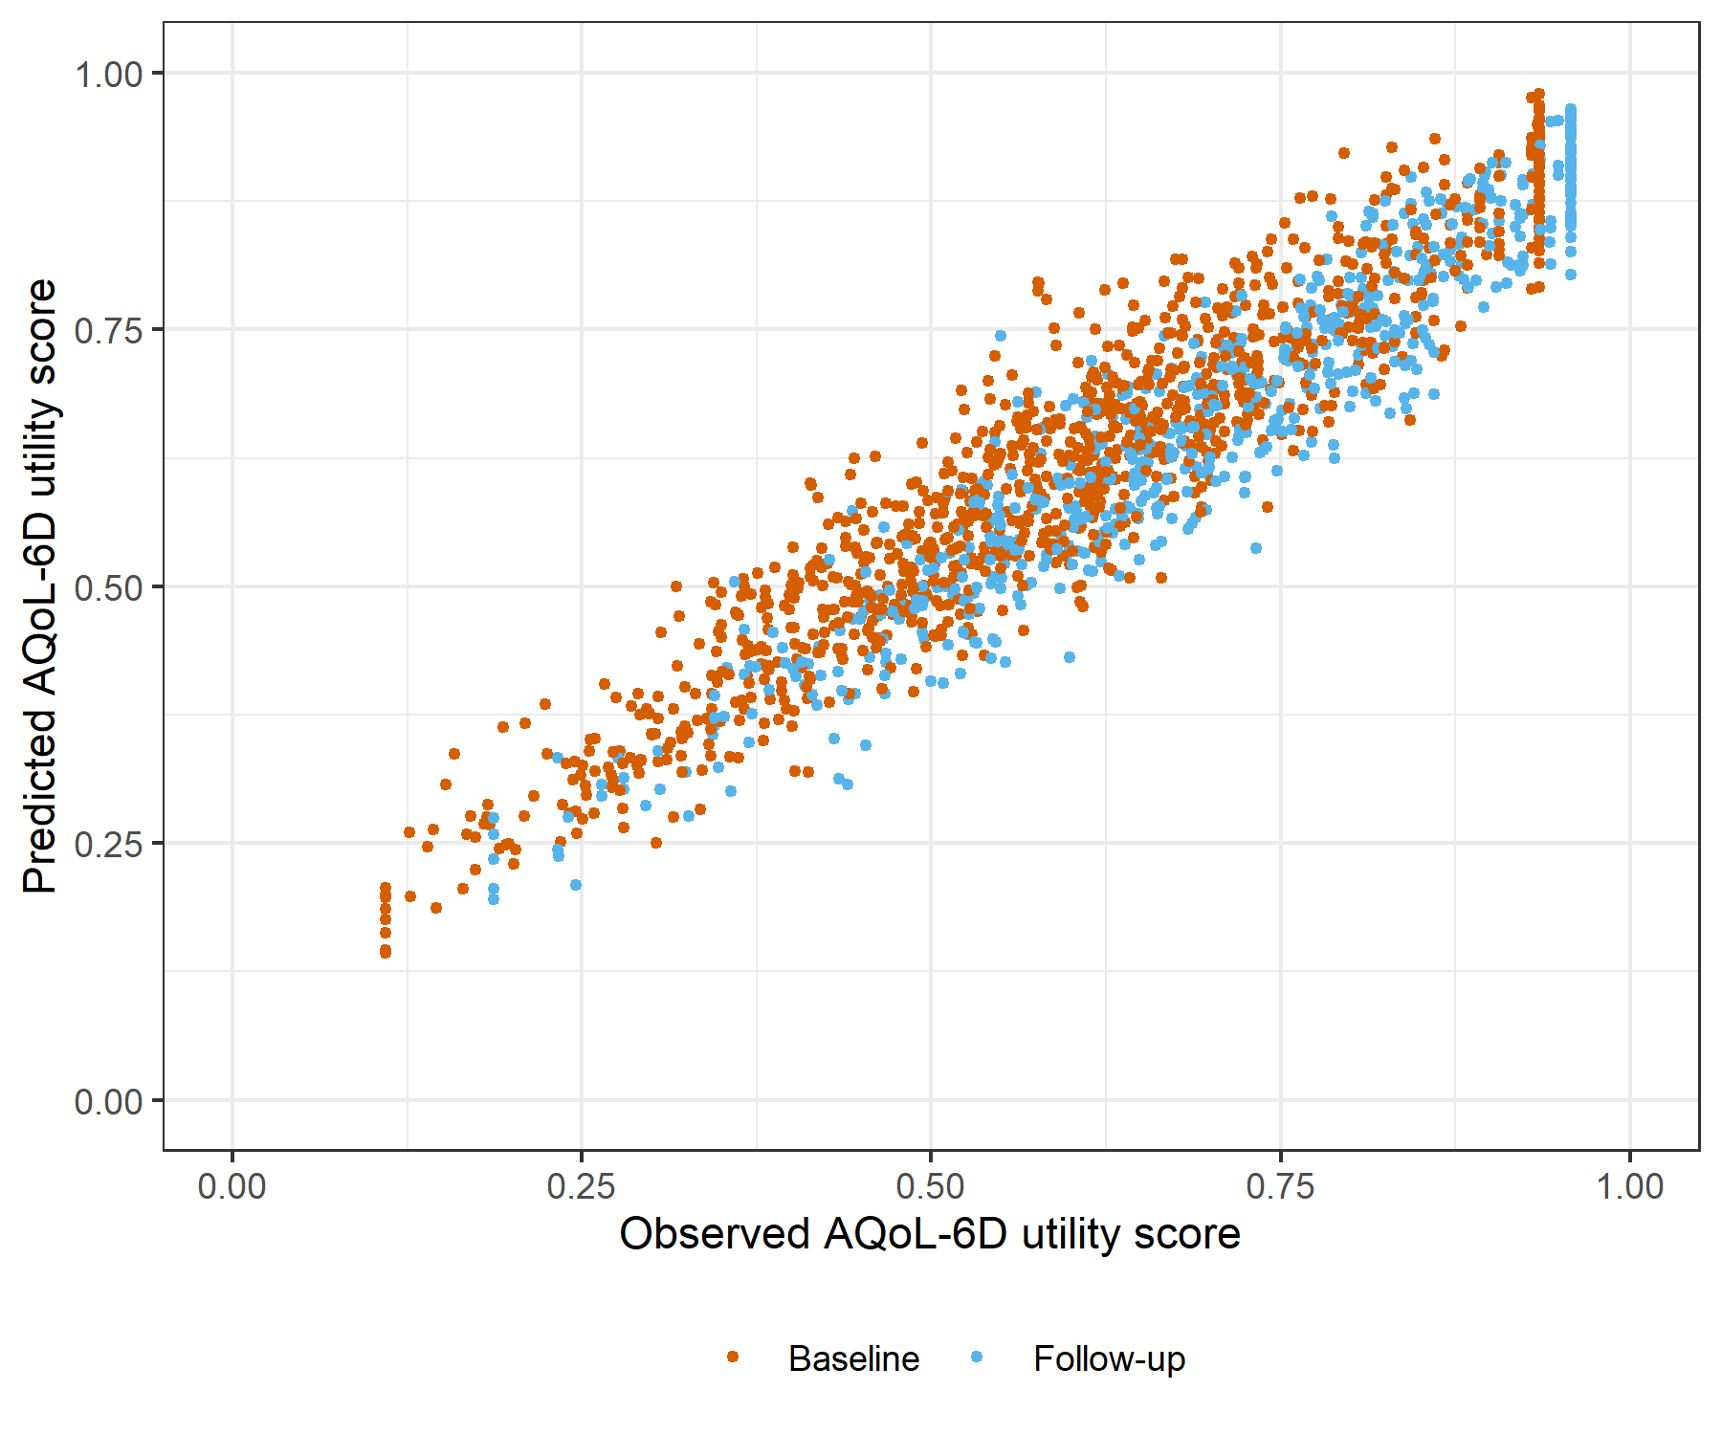

Figure : BADS Linear Mixed Model with clog-log transformation comparative scatter plot of obsereved and predicted data

# GAD7 Generalised Linear Mixed Model with Gaussian distribution and log link

Table : GAD7 Generalised Linear Mixed Model with Gaussian distribution and log link

| Parameter | Estimate | Est.Error | l-95% CI | u-95% CI | Rhat | Bulk_ESS | Tail_ESS |
| --- | --- | --- | --- | --- | --- | --- | --- |
| **Group-Level Effects:** | | | | | | | |
| fkClientID (Number of levels: 1062) |  |  |  |  |  |  |  |
| sd(Intercept) | 0.17 | 0.01 | 0.15 | 0.18 | 1.01 | 1 028 | 2 485 |
| **Population-Level Effects:** | | | | | | | |
| Intercept | -0.11 | 0.01 | -0.14 | -0.08 | 1.00 | 2 592 | 4 100 |
| GAD7_baseline | -3.90 | 0.13 | -4.15 | -3.66 | 1.00 | 2 902 | 4 244 |
| GAD7_change | -2.34 | 0.13 | -2.60 | -2.08 | 1.00 | 3 139 | 4 779 |
| **Family Specific Parameters:** | | | | | | | |
| sigma | 0.10 | 0.00 | 0.09 | 0.11 | 1.01 | 1 088 | 2 496 |
| Formula: aqol6d_total_w ~ GAD7_baseline + GAD7_change + (1 | fkClientID) | | | | | | | |
| Family: gaussian Links: mu = log; sigma = identity Data: data_tb (Number of observations: 1696) Samples: 4 chains, each with iter = 4000; warmup = 2000; thin = 1; total post-warmup samples = 8000 | | | | | | | |
| Samples were drawn using sample(hmc). For each parameter, Bulk_ESS and Tail_ESS are effective sample size measures, and Rhat is the potential scale reduction factor on split chains (at convergence, Rhat = 1). | | | | | | | |

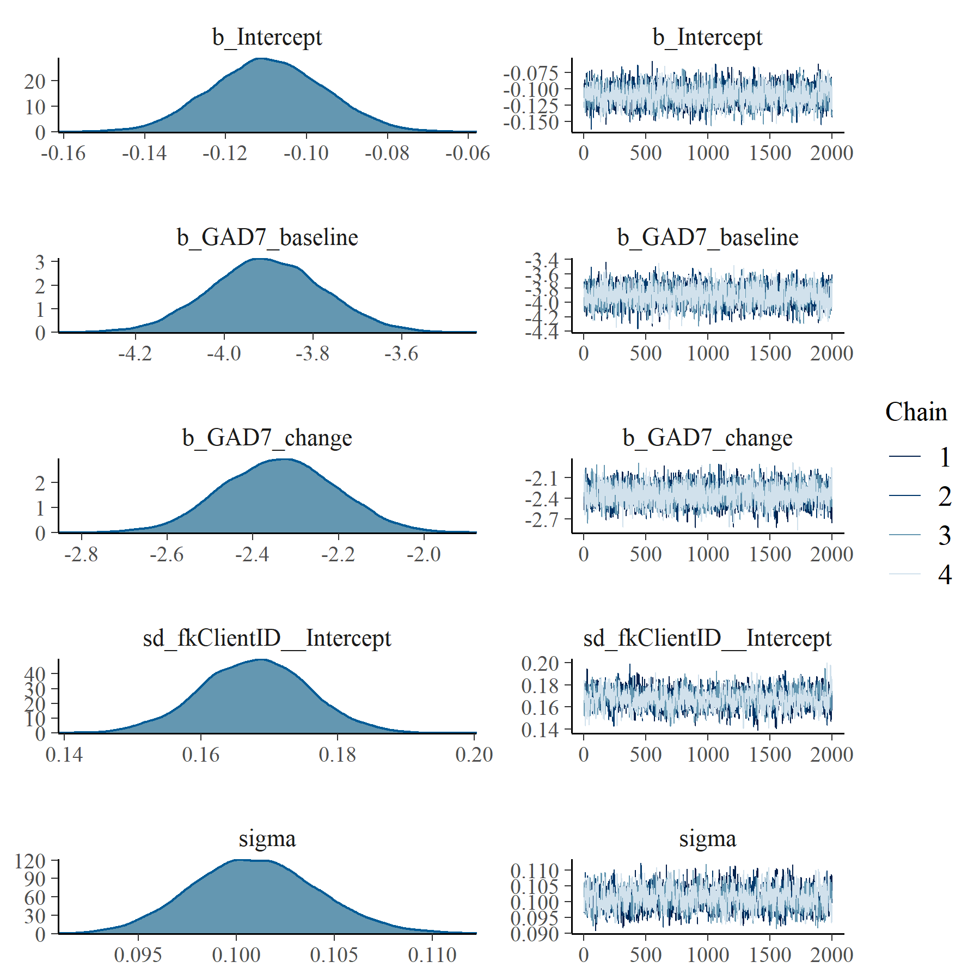

Figure : GAD7 Generalised Linear Mixed Model with Gaussian distribution and log link population and group level effects

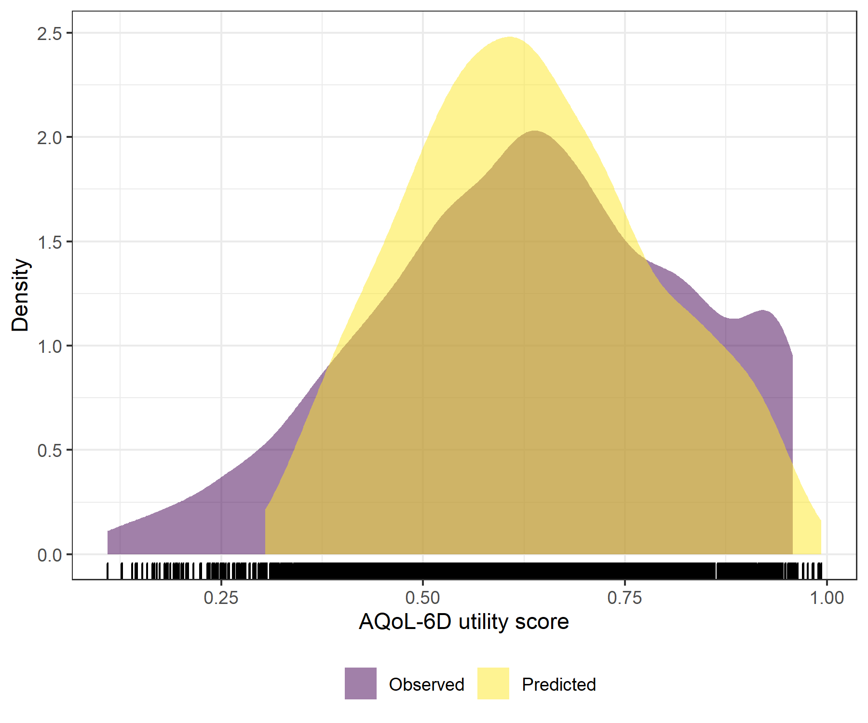

Figure : GAD7 Generalised Linear Mixed Model with Gaussian distribution and log link comparative densities of observed and predicted data

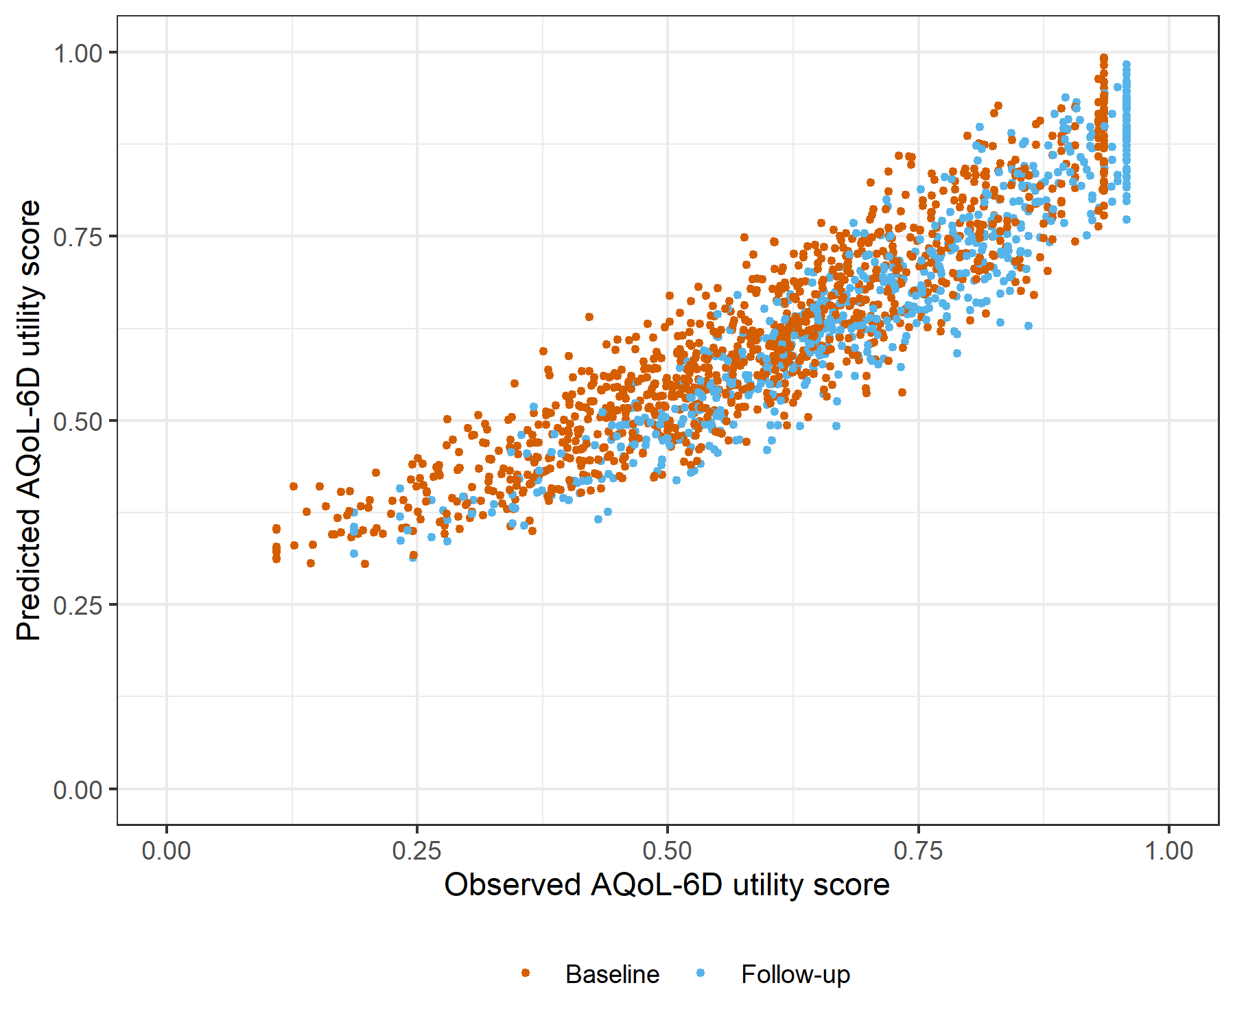

Figure : GAD7 Generalised Linear Mixed Model with Gaussian distribution and log link comparative scatter plot of obsereved and predicted data

# GAD7 Linear Mixed Model with clog-log transformation

Table : GAD7 Linear Mixed Model with clog-log transformation

| Parameter | Estimate | Est.Error | l-95% CI | u-95% CI | Rhat | Bulk_ESS | Tail_ESS |
| --- | --- | --- | --- | --- | --- | --- | --- |
| **Group-Level Effects:** | | | | | | | |
| fkClientID (Number of levels: 1062) |  |  |  |  |  |  |  |
| sd(Intercept) | 0.36 | 0.01 | 0.33 | 0.38 | 1.00 | 1 480 | 3 070 |
| **Population-Level Effects:** | | | | | | | |
| Intercept | 0.77 | 0.03 | 0.71 | 0.83 | 1.00 | 2 015 | 3 565 |
| GAD7_baseline | -7.84 | 0.25 | -8.34 | -7.34 | 1.00 | 2 054 | 3 418 |
| GAD7_change | -4.50 | 0.24 | -4.98 | -4.02 | 1.00 | 4 253 | 5 084 |
| **Family Specific Parameters:** | | | | | | | |
| sigma | 0.29 | 0.01 | 0.27 | 0.31 | 1.00 | 1 483 | 3 347 |
| Formula: aqol6d_total_w_cloglog ~ GAD7_baseline + GAD7_change + (1 | fkClientID) | | | | | | | |
| Family: gaussian Links: mu = identity; sigma = identity Data: data_tb (Number of observations: 1696) Samples: 4 chains, each with iter = 4000; warmup = 2000; thin = 1; total post-warmup samples = 8000 | | | | | | | |
| Samples were drawn using sample(hmc). For each parameter, Bulk_ESS and Tail_ESS are effective sample size measures, and Rhat is the potential scale reduction factor on split chains (at convergence, Rhat = 1). | | | | | | | |

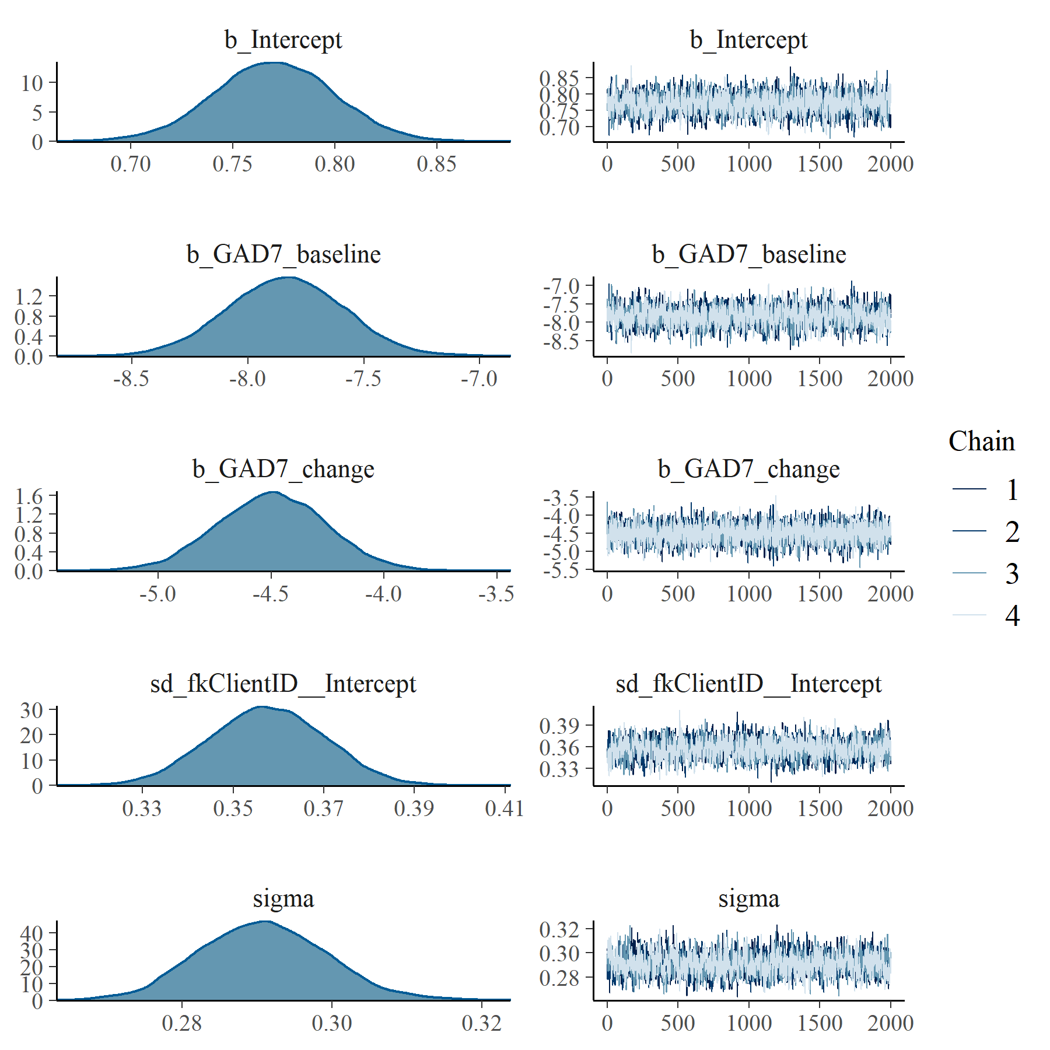

Figure : GAD7 Linear Mixed Model with clog-log transformation population and group level effects

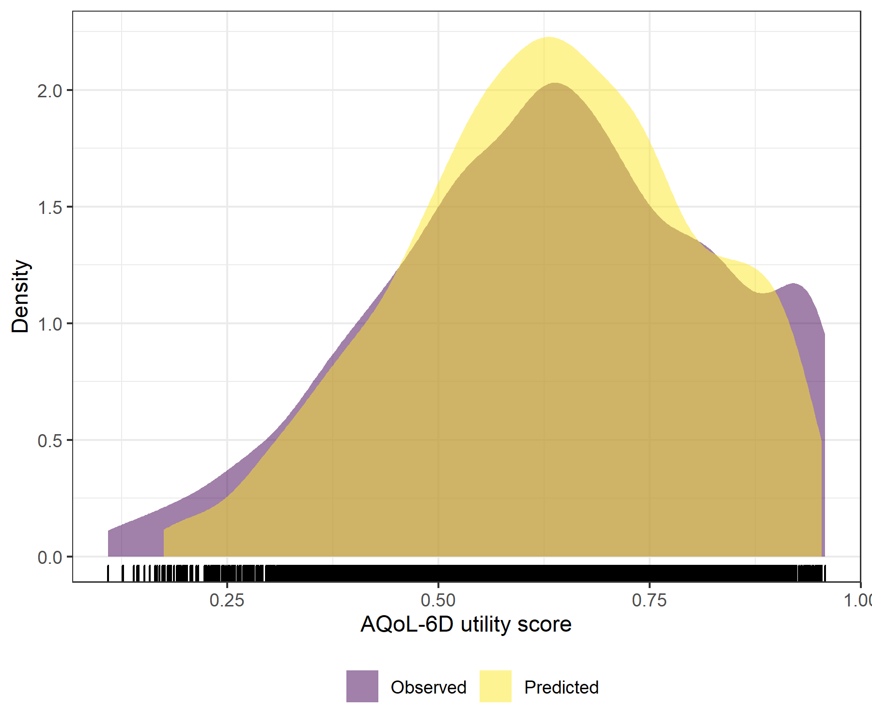

Figure : GAD7 Linear Mixed Model with clog-log transformation comparative densities of observed and predicted data

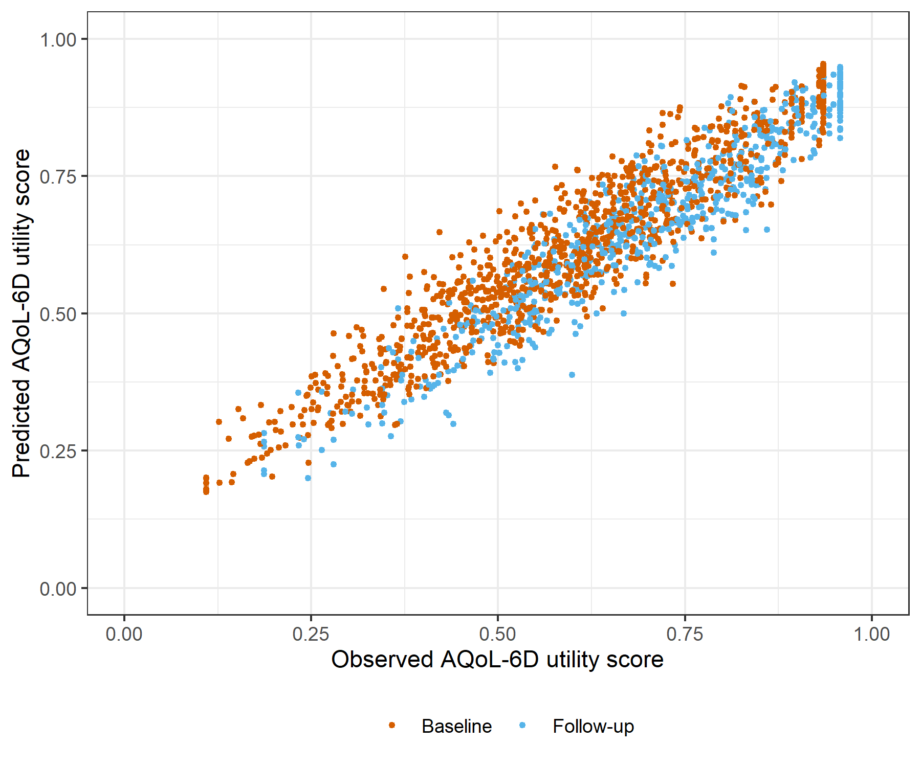

Figure : GAD7 Linear Mixed Model with clog-log transformation comparative scatter plot of obsereved and predicted data

# K6 Generalised Linear Mixed Model with Gaussian distribution and log link

Table : K6 Generalised Linear Mixed Model with Gaussian distribution and log link

| Parameter | Estimate | Est.Error | l-95% CI | u-95% CI | Rhat | Bulk_ESS | Tail_ESS |
| --- | --- | --- | --- | --- | --- | --- | --- |
| **Group-Level Effects:** | | | | | | | |
| fkClientID (Number of levels: 1062) |  |  |  |  |  |  |  |
| sd(Intercept) | 0.16 | 0.01 | 0.15 | 0.18 | 1.01 | 1 063 | 2 546 |
| **Population-Level Effects:** | | | | | | | |
| Intercept | -0.04 | 0.02 | -0.07 | -0.01 | 1.00 | 2 992 | 4 010 |
| K6_baseline | -3.88 | 0.12 | -4.12 | -3.64 | 1.00 | 3 286 | 4 241 |
| K6_change | -2.21 | 0.13 | -2.46 | -1.97 | 1.00 | 3 448 | 5 810 |
| **Family Specific Parameters:** | | | | | | | |
| sigma | 0.10 | 0.00 | 0.09 | 0.11 | 1.00 | 1 110 | 3 241 |
| Formula: aqol6d_total_w ~ K6_baseline + K6_change + (1 | fkClientID) | | | | | | | |
| Family: gaussian Links: mu = log; sigma = identity Data: data_tb (Number of observations: 1697) Samples: 4 chains, each with iter = 4000; warmup = 2000; thin = 1; total post-warmup samples = 8000 | | | | | | | |
| Samples were drawn using sample(hmc). For each parameter, Bulk_ESS and Tail_ESS are effective sample size measures, and Rhat is the potential scale reduction factor on split chains (at convergence, Rhat = 1). | | | | | | | |

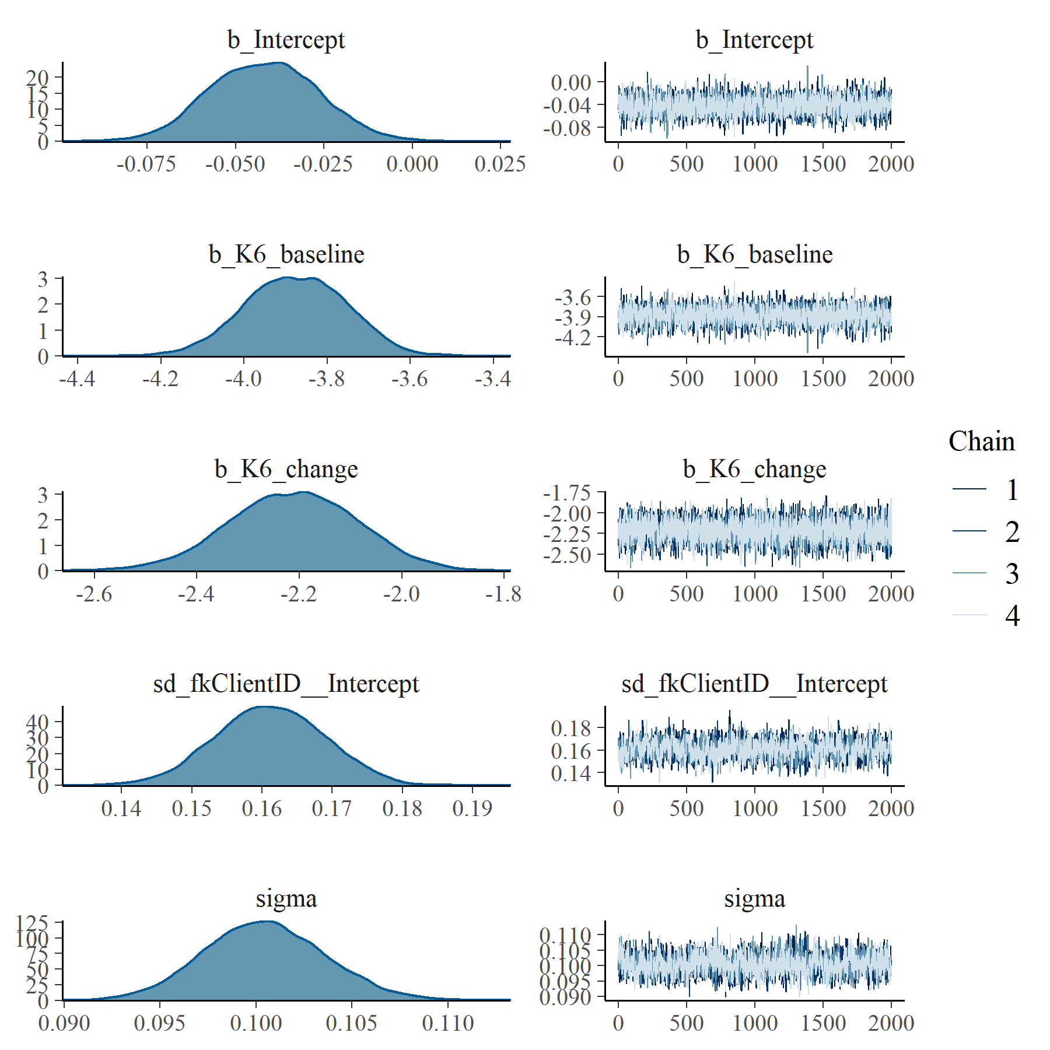

Figure : K6 Generalised Linear Mixed Model with Gaussian distribution and log link population and group level effects

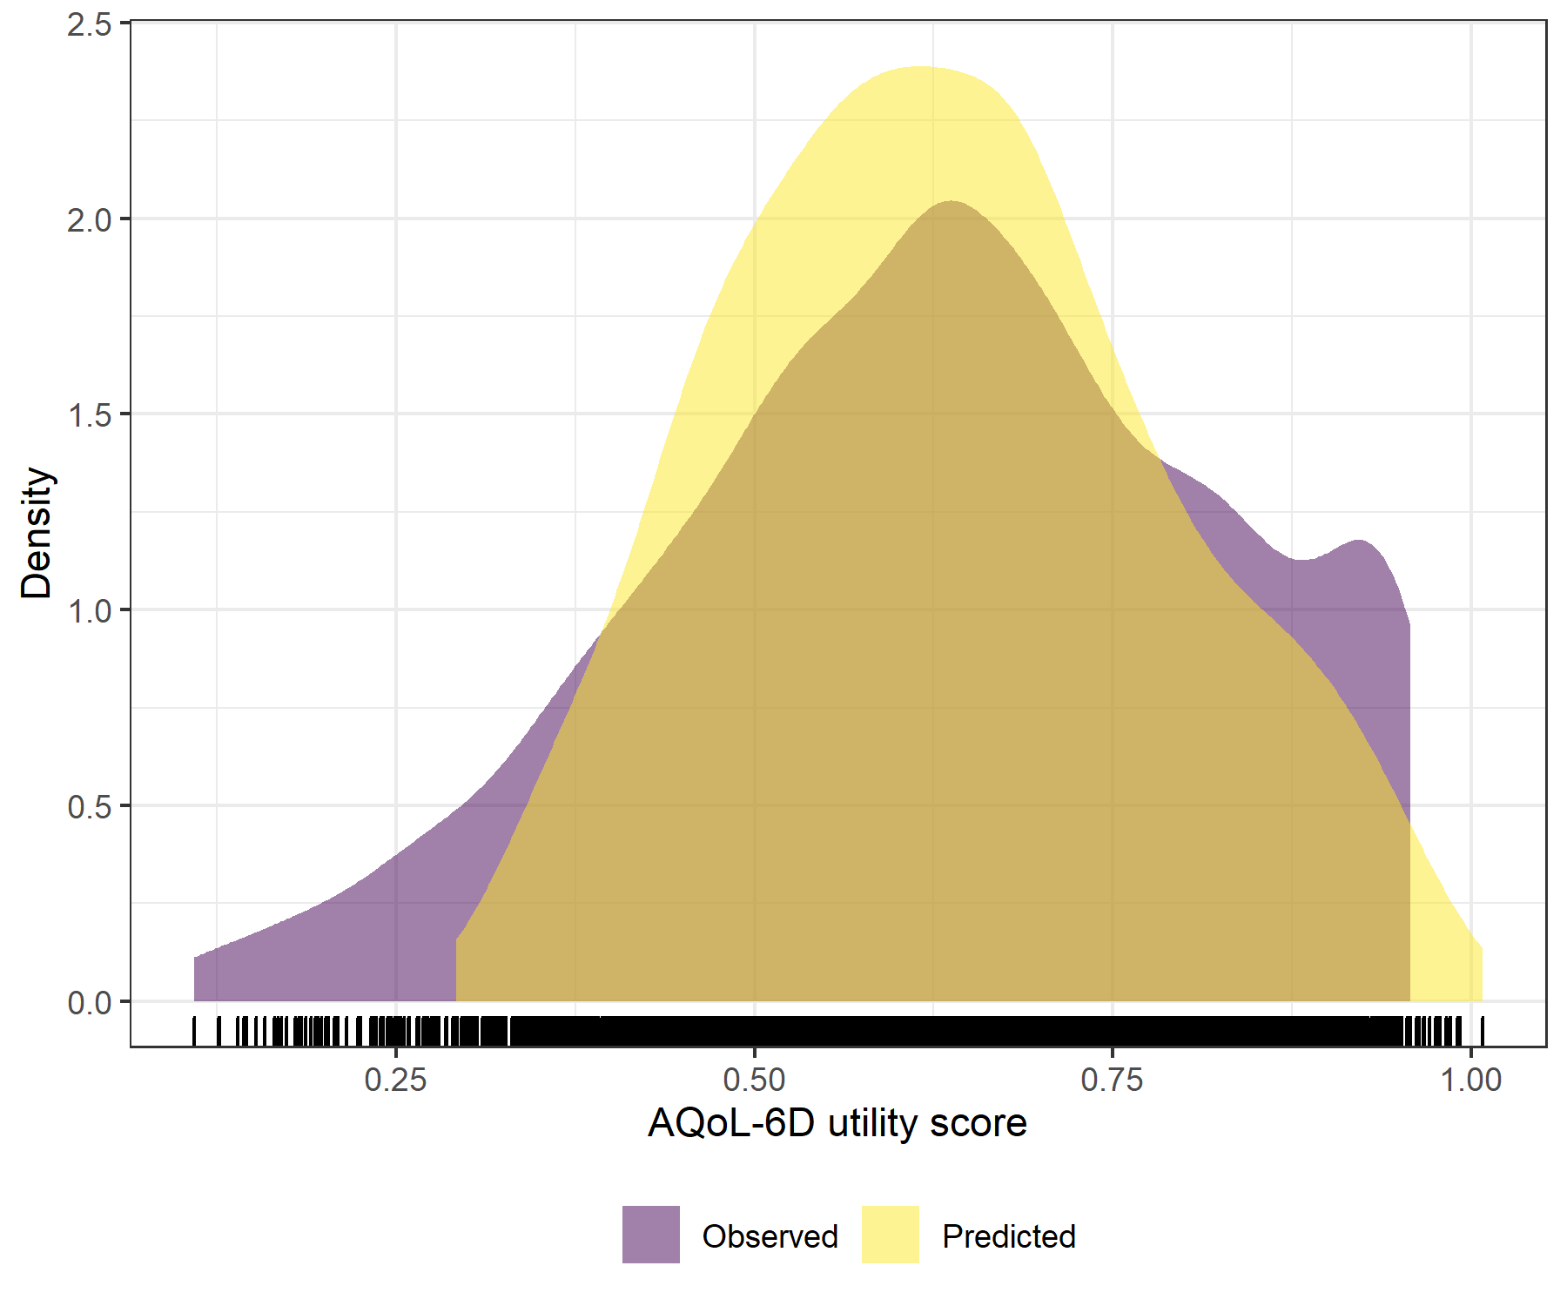

Figure : K6 Generalised Linear Mixed Model with Gaussian distribution and log link comparative densities of observed and predicted data

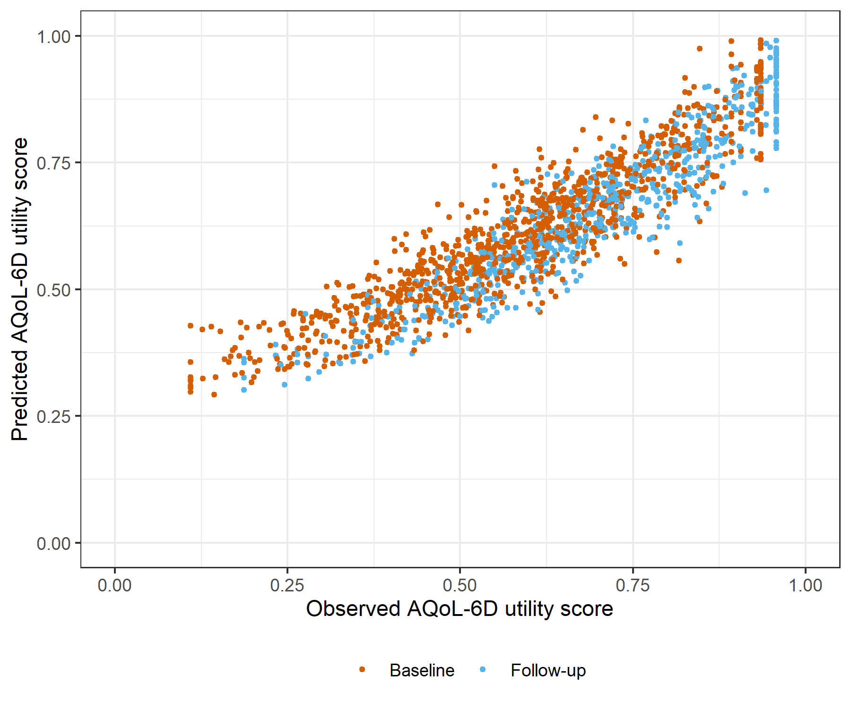

Figure : K6 Generalised Linear Mixed Model with Gaussian distribution and log link comparative scatter plot of obsereved and predicted data

# K6 Linear Mixed Model with clog-log transformation

Table : K6 Linear Mixed Model with clog-log transformation

| Parameter | Estimate | Est.Error | l-95% CI | u-95% CI | Rhat | Bulk_ESS | Tail_ESS |
| --- | --- | --- | --- | --- | --- | --- | --- |
| **Group-Level Effects:** | | | | | | | |
| fkClientID (Number of levels: 1062) |  |  |  |  |  |  |  |
| sd(Intercept) | 0.35 | 0.01 | 0.32 | 0.37 | 1.00 | 1 641 | 2 998 |
| **Population-Level Effects:** | | | | | | | |
| Intercept | 0.90 | 0.03 | 0.84 | 0.97 | 1.00 | 2 836 | 4 171 |
| K6_baseline | -7.78 | 0.23 | -8.23 | -7.33 | 1.00 | 2 817 | 4 705 |
| K6_change | -4.31 | 0.23 | -4.77 | -3.85 | 1.00 | 4 665 | 5 434 |
| **Family Specific Parameters:** | | | | | | | |
| sigma | 0.29 | 0.01 | 0.27 | 0.31 | 1.00 | 1 782 | 3 064 |
| Formula: aqol6d_total_w_cloglog ~ K6_baseline + K6_change + (1 | fkClientID) | | | | | | | |
| Family: gaussian Links: mu = identity; sigma = identity Data: data_tb (Number of observations: 1697) Samples: 4 chains, each with iter = 4000; warmup = 2000; thin = 1; total post-warmup samples = 8000 | | | | | | | |
| Samples were drawn using sample(hmc). For each parameter, Bulk_ESS and Tail_ESS are effective sample size measures, and Rhat is the potential scale reduction factor on split chains (at convergence, Rhat = 1). | | | | | | | |

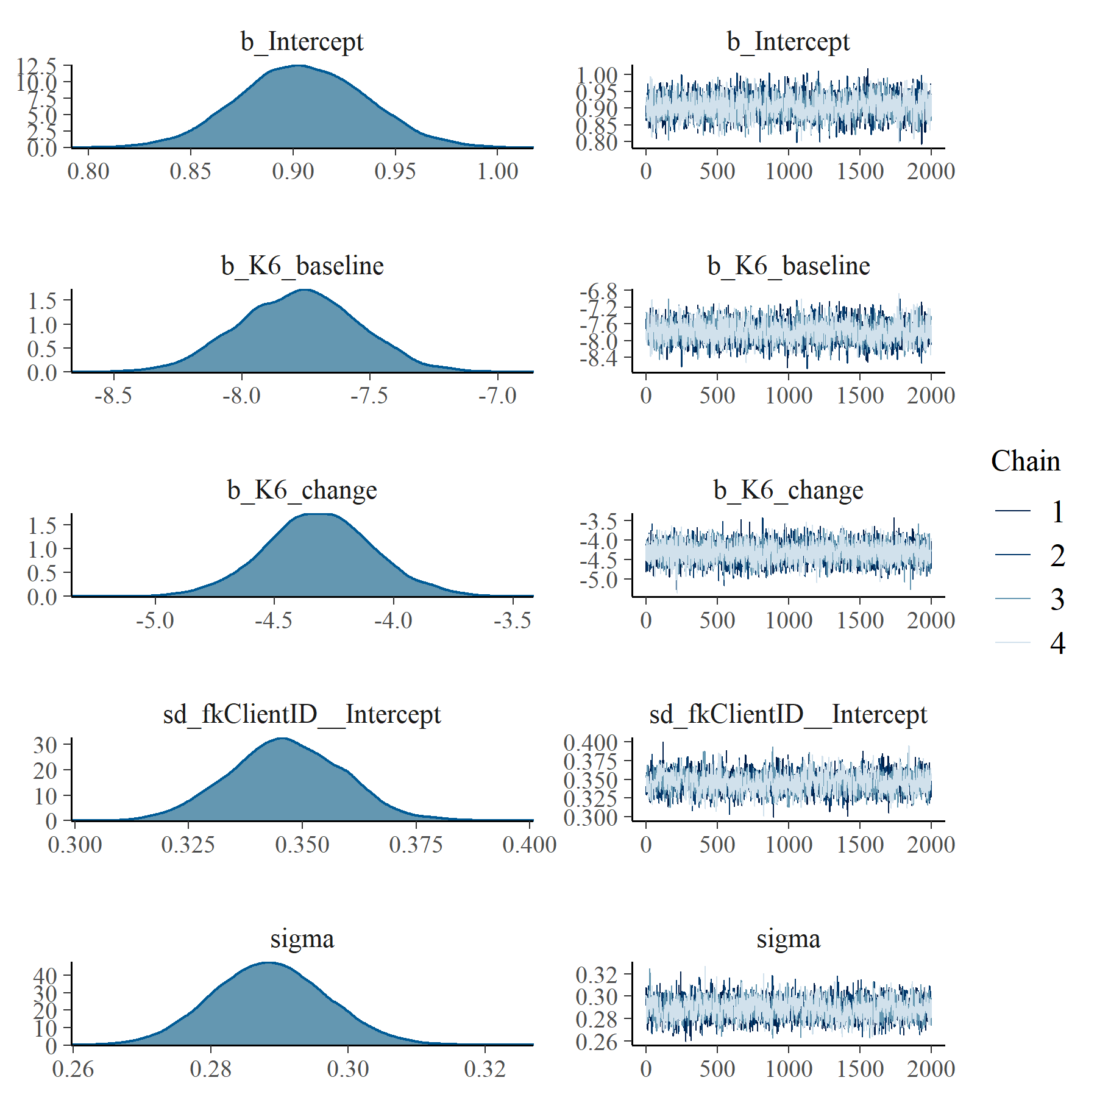

Figure : K6 Linear Mixed Model with clog-log transformation population and group level effects

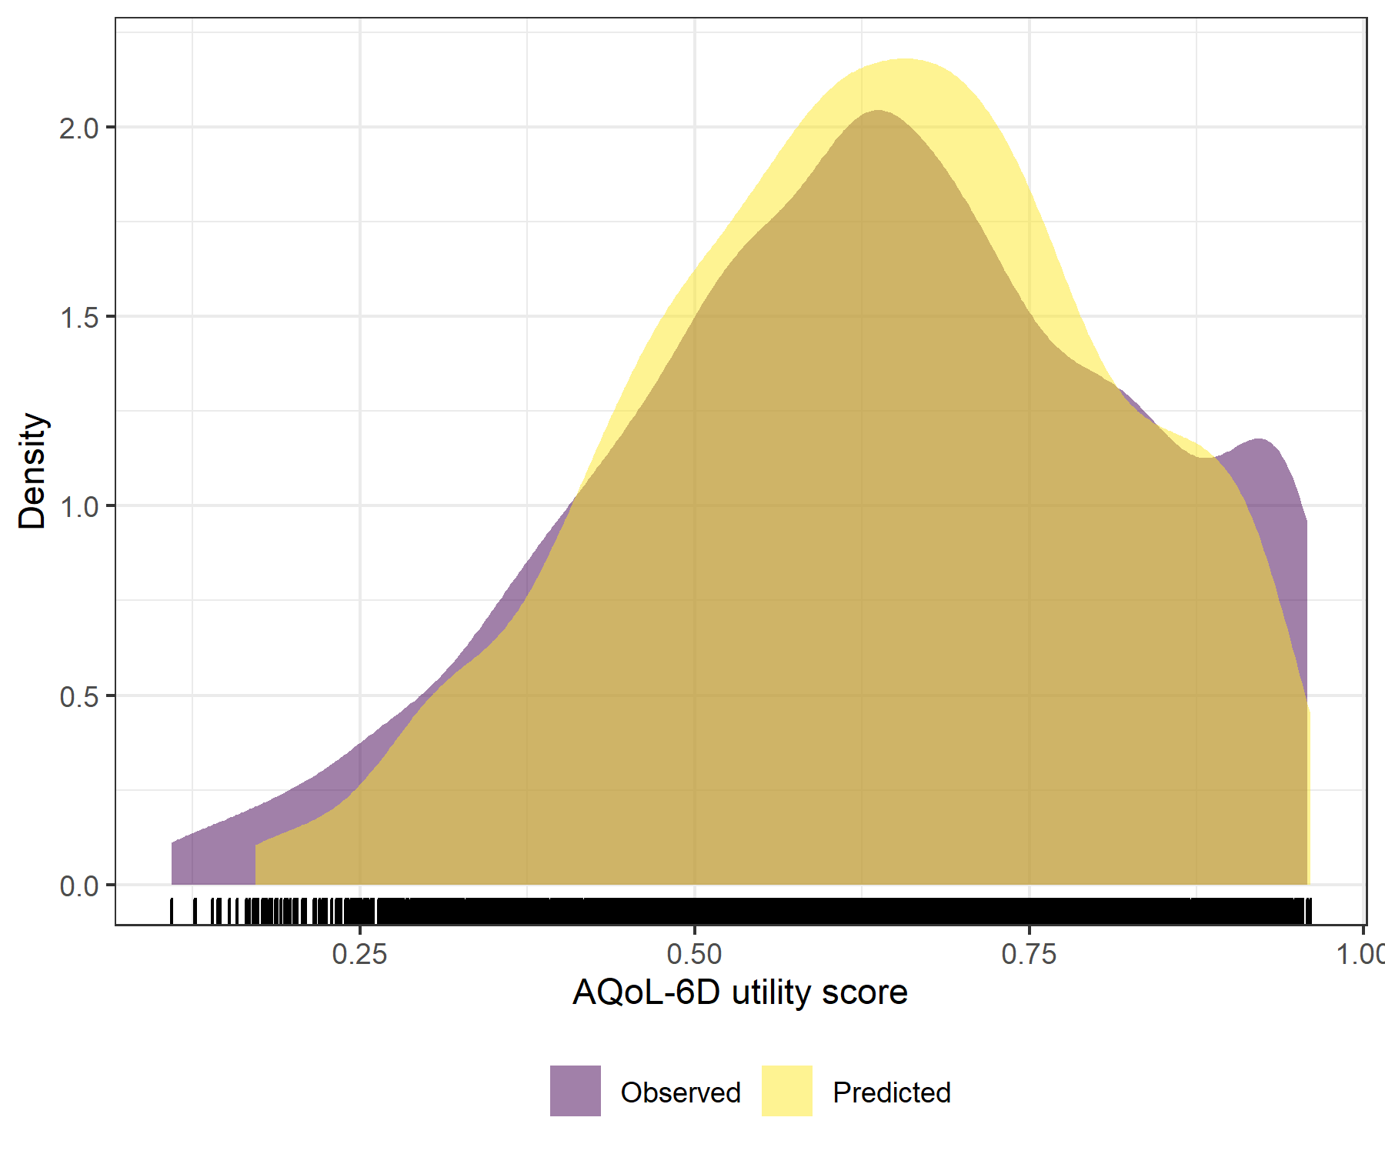

Figure : K6 Linear Mixed Model with clog-log transformation comparative densities of observed and predicted data

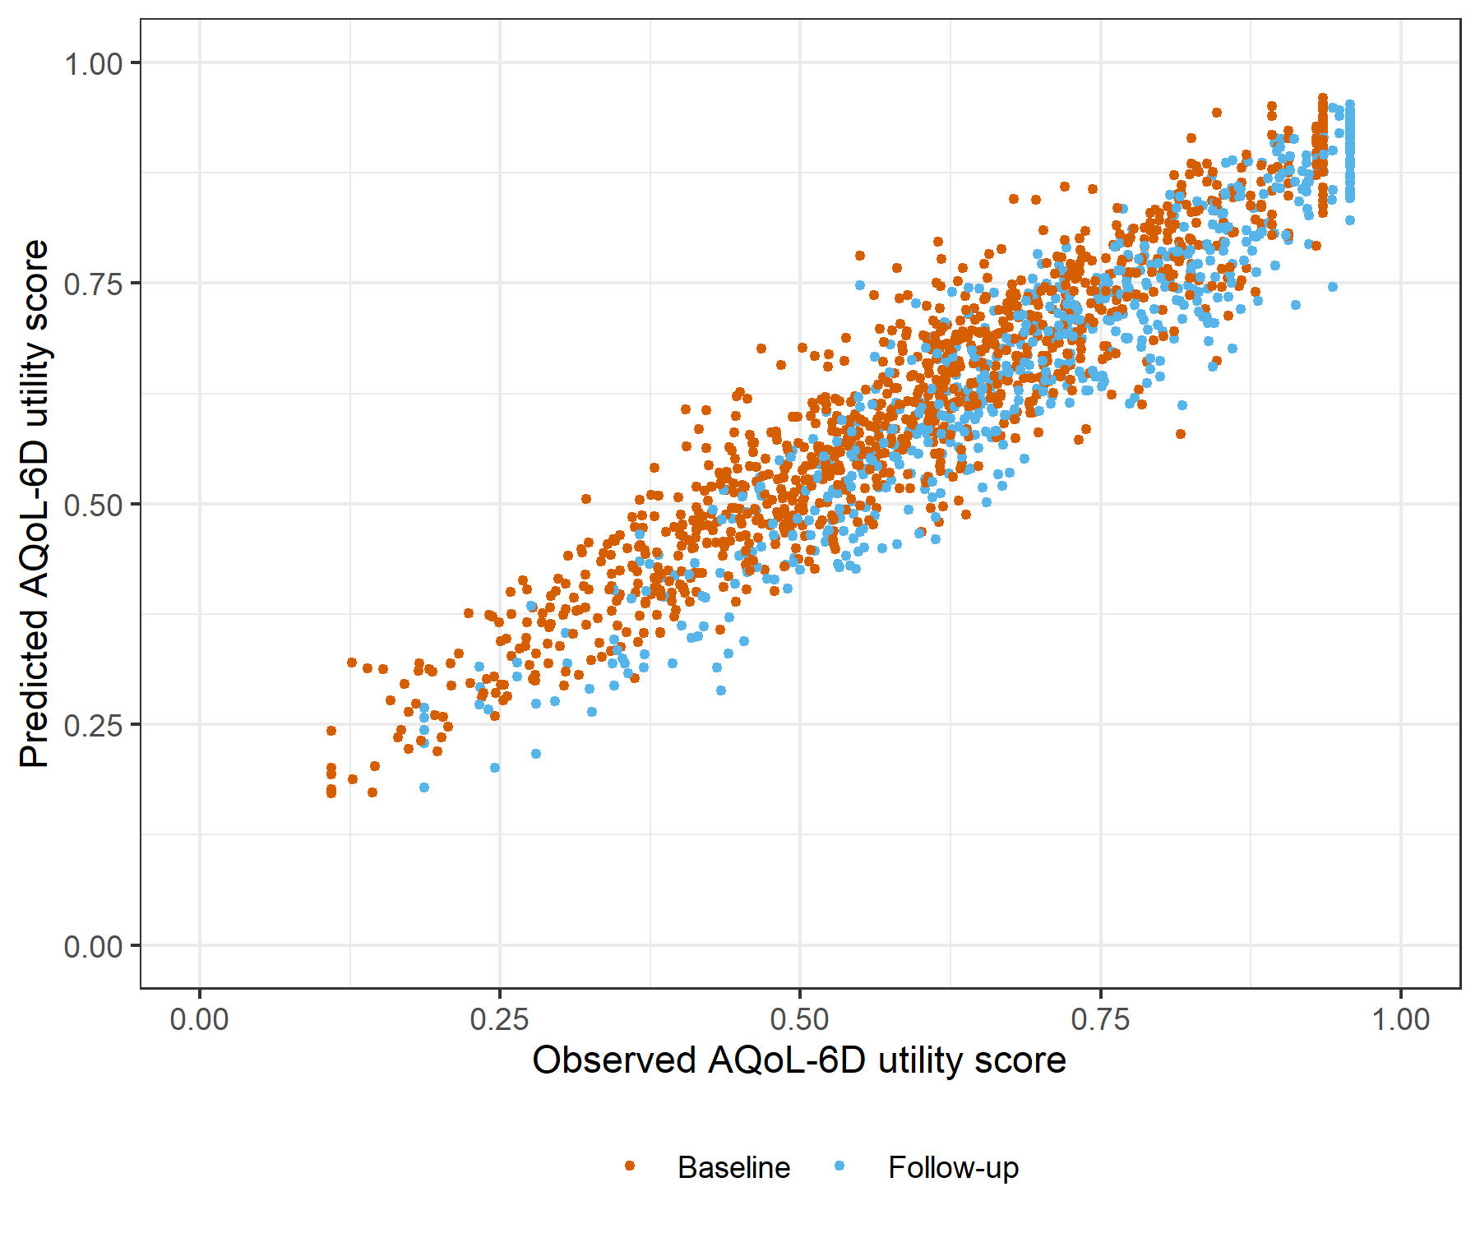

Figure : K6 Linear Mixed Model with clog-log transformation comparative scatter plot of obsereved and predicted data

# OASIS Generalised Linear Mixed Model with Gaussian distribution and log link

Table : OASIS Generalised Linear Mixed Model with Gaussian distribution and log link

| Parameter | Estimate | Est.Error | l-95% CI | u-95% CI | Rhat | Bulk_ESS | Tail_ESS |
| --- | --- | --- | --- | --- | --- | --- | --- |
| **Group-Level Effects:** | | | | | | | |
| fkClientID (Number of levels: 1057) |  |  |  |  |  |  |  |
| sd(Intercept) | 0.15 | 0.01 | 0.13 | 0.16 | 1.00 | 1 030 | 2 431 |
| **Population-Level Effects:** | | | | | | | |
| Intercept | -0.10 | 0.01 | -0.12 | -0.07 | 1.00 | 2 607 | 4 034 |
| OASIS_baseline | -5.11 | 0.15 | -5.41 | -4.82 | 1.00 | 2 958 | 4 669 |
| OASIS_change | -3.04 | 0.17 | -3.38 | -2.70 | 1.00 | 2 922 | 5 213 |
| **Family Specific Parameters:** | | | | | | | |
| sigma | 0.10 | 0.00 | 0.09 | 0.11 | 1.00 | 1 065 | 2 084 |
| Formula: aqol6d_total_w ~ OASIS_baseline + OASIS_change + (1 | fkClientID) | | | | | | | |
| Family: gaussian Links: mu = log; sigma = identity Data: data_tb (Number of observations: 1693) Samples: 4 chains, each with iter = 4000; warmup = 2000; thin = 1; total post-warmup samples = 8000 | | | | | | | |
| Samples were drawn using sample(hmc). For each parameter, Bulk_ESS and Tail_ESS are effective sample size measures, and Rhat is the potential scale reduction factor on split chains (at convergence, Rhat = 1). | | | | | | | |

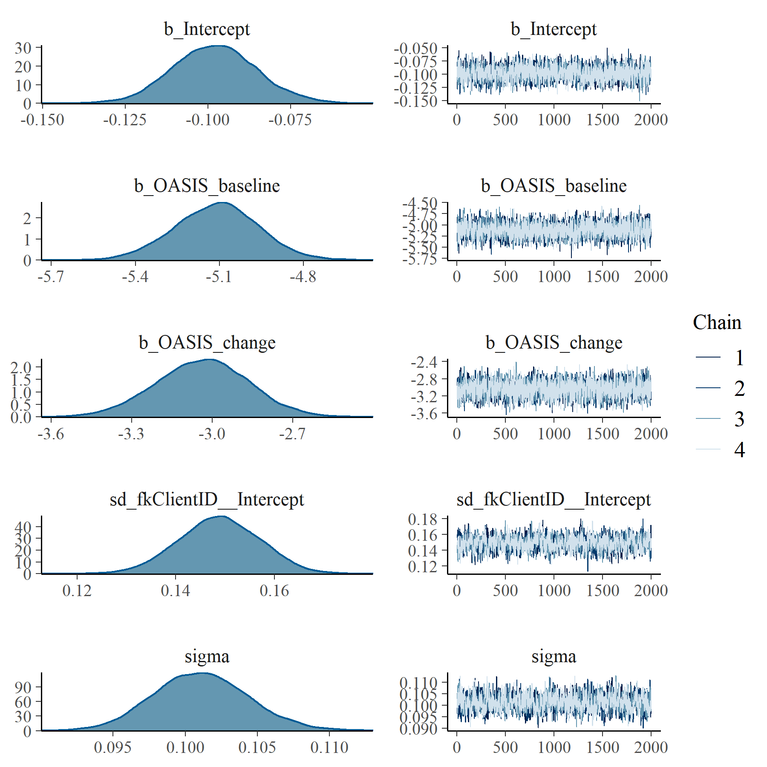

Figure : OASIS Generalised Linear Mixed Model with Gaussian distribution and log link population and group level effects

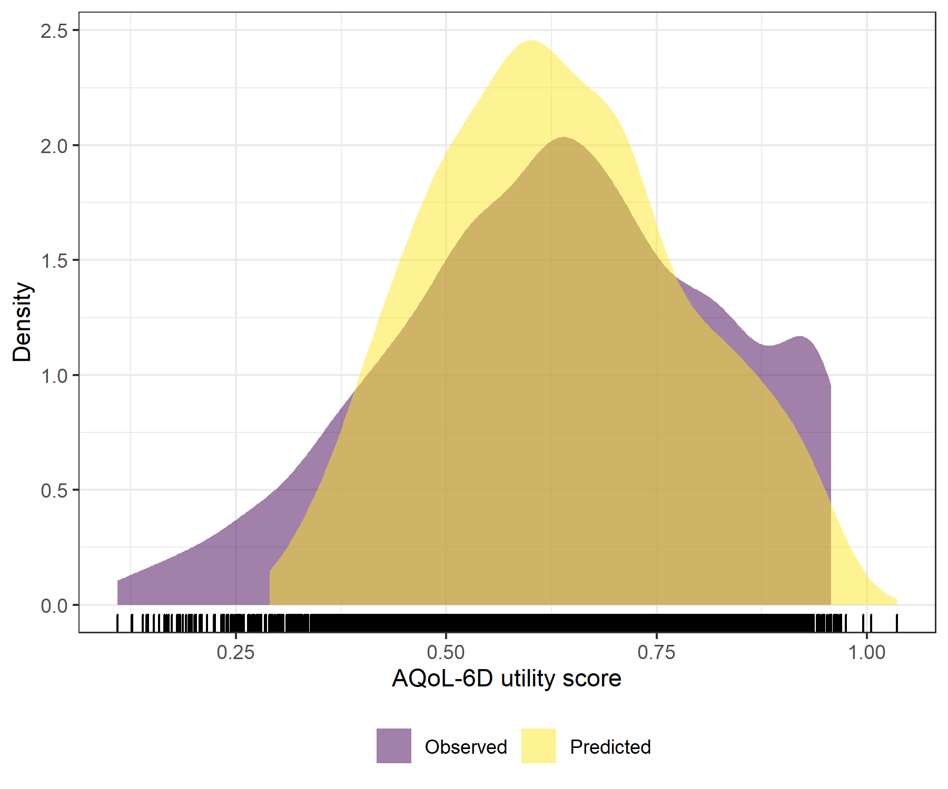

Figure : OASIS Generalised Linear Mixed Model with Gaussian distribution and log link comparative densities of observed and predicted data

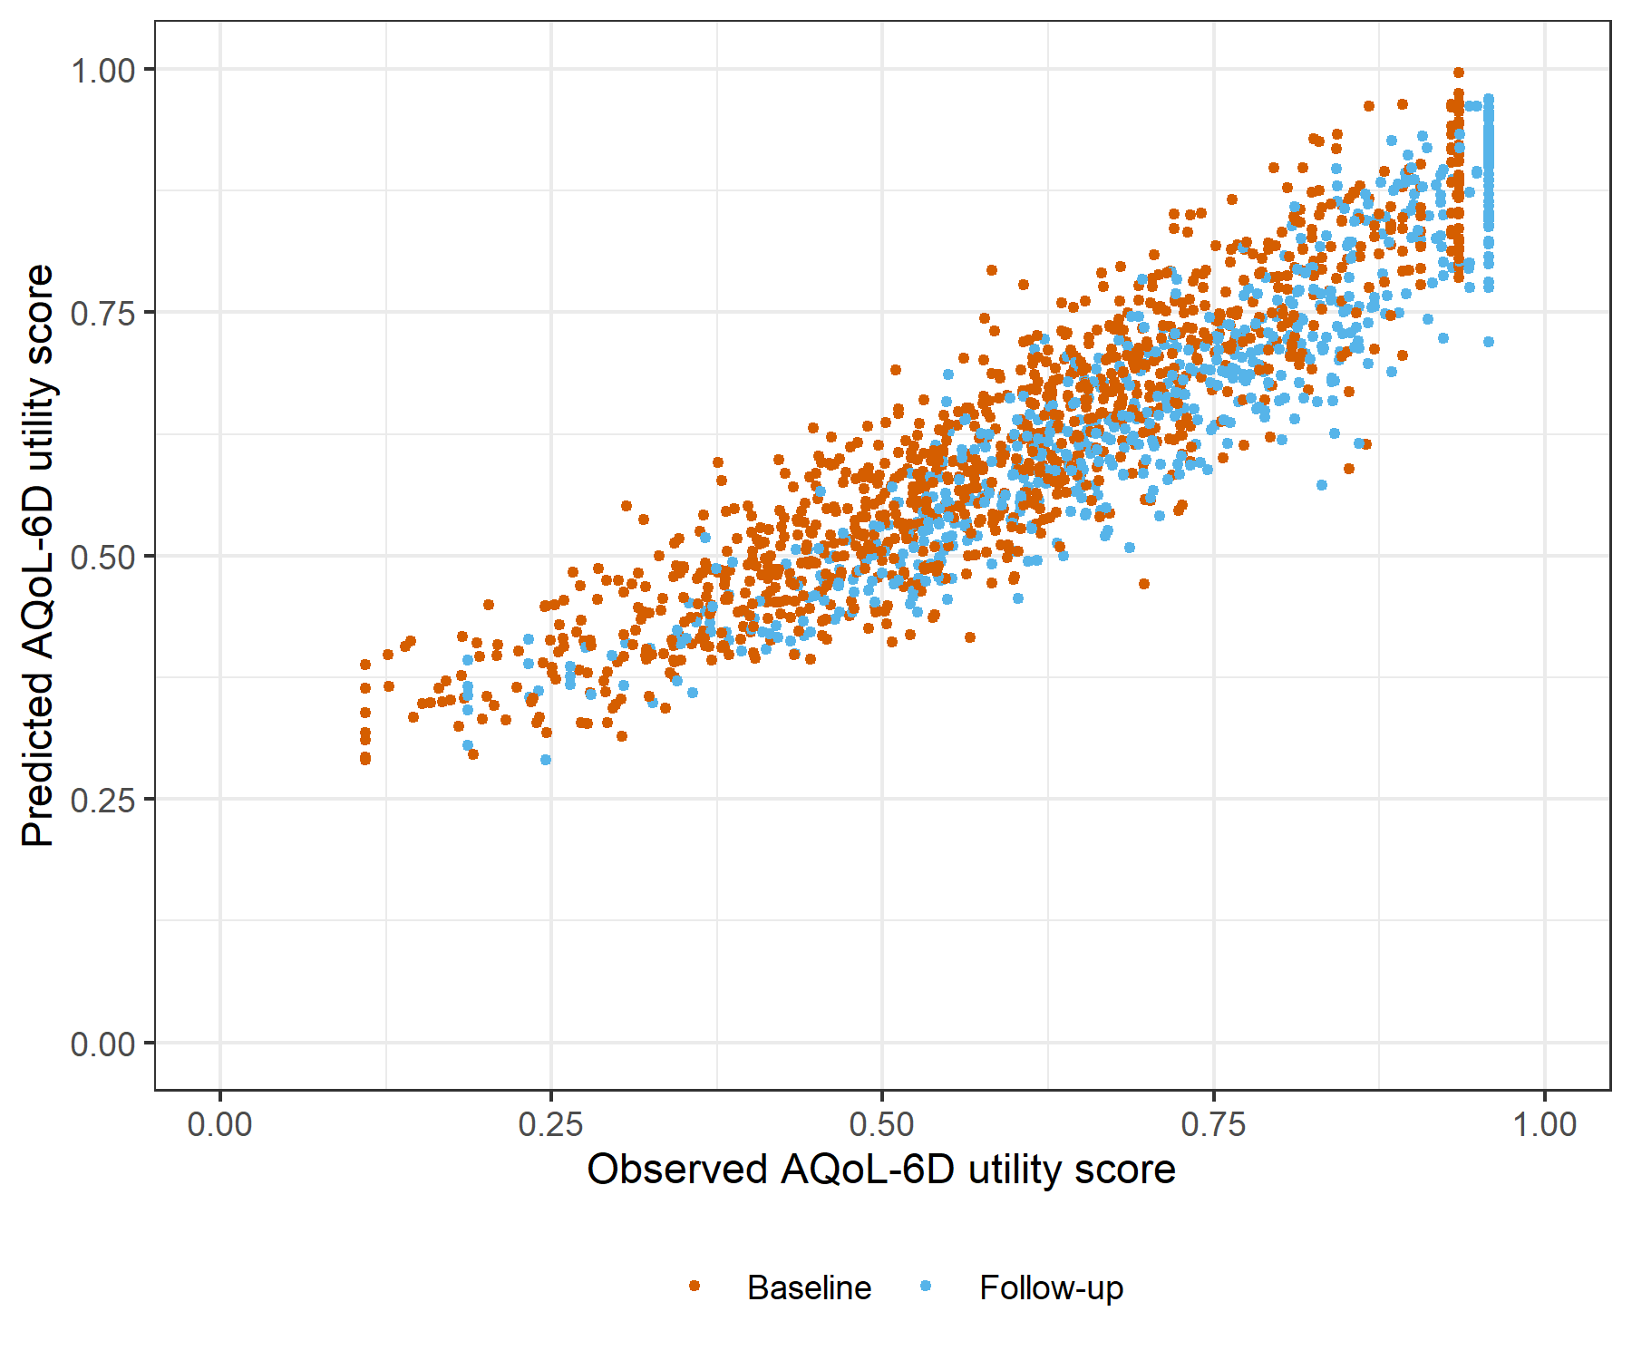

Figure : OASIS Generalised Linear Mixed Model with Gaussian distribution and log link comparative scatter plot of obsereved and predicted data

# OASIS Linear Mixed Model with clog-log transformation

Table : OASIS Linear Mixed Model with clog-log transformation

| Parameter | Estimate | Est.Error | l-95% CI | u-95% CI | Rhat | Bulk_ESS | Tail_ESS |
| --- | --- | --- | --- | --- | --- | --- | --- |
| **Group-Level Effects:** | | | | | | | |
| fkClientID (Number of levels: 1057) |  |  |  |  |  |  |  |
| sd(Intercept) | 0.33 | 0.01 | 0.31 | 0.36 | 1.00 | 1 482 | 3 087 |
| **Population-Level Effects:** | | | | | | | |
| Intercept | 0.78 | 0.03 | 0.73 | 0.83 | 1.00 | 3 528 | 4 531 |
| OASIS_baseline | -10.16 | 0.28 | -10.70 | -9.60 | 1.00 | 3 681 | 4 439 |
| OASIS_change | -5.76 | 0.29 | -6.35 | -5.20 | 1.00 | 5 429 | 6 425 |
| **Family Specific Parameters:** | | | | | | | |
| sigma | 0.28 | 0.01 | 0.27 | 0.30 | 1.00 | 1 663 | 3 490 |
| Formula: aqol6d_total_w_cloglog ~ OASIS_baseline + OASIS_change + (1 | fkClientID) | | | | | | | |
| Family: gaussian Links: mu = identity; sigma = identity Data: data_tb (Number of observations: 1693) Samples: 4 chains, each with iter = 4000; warmup = 2000; thin = 1; total post-warmup samples = 8000 | | | | | | | |
| Samples were drawn using sample(hmc). For each parameter, Bulk_ESS and Tail_ESS are effective sample size measures, and Rhat is the potential scale reduction factor on split chains (at convergence, Rhat = 1). | | | | | | | |

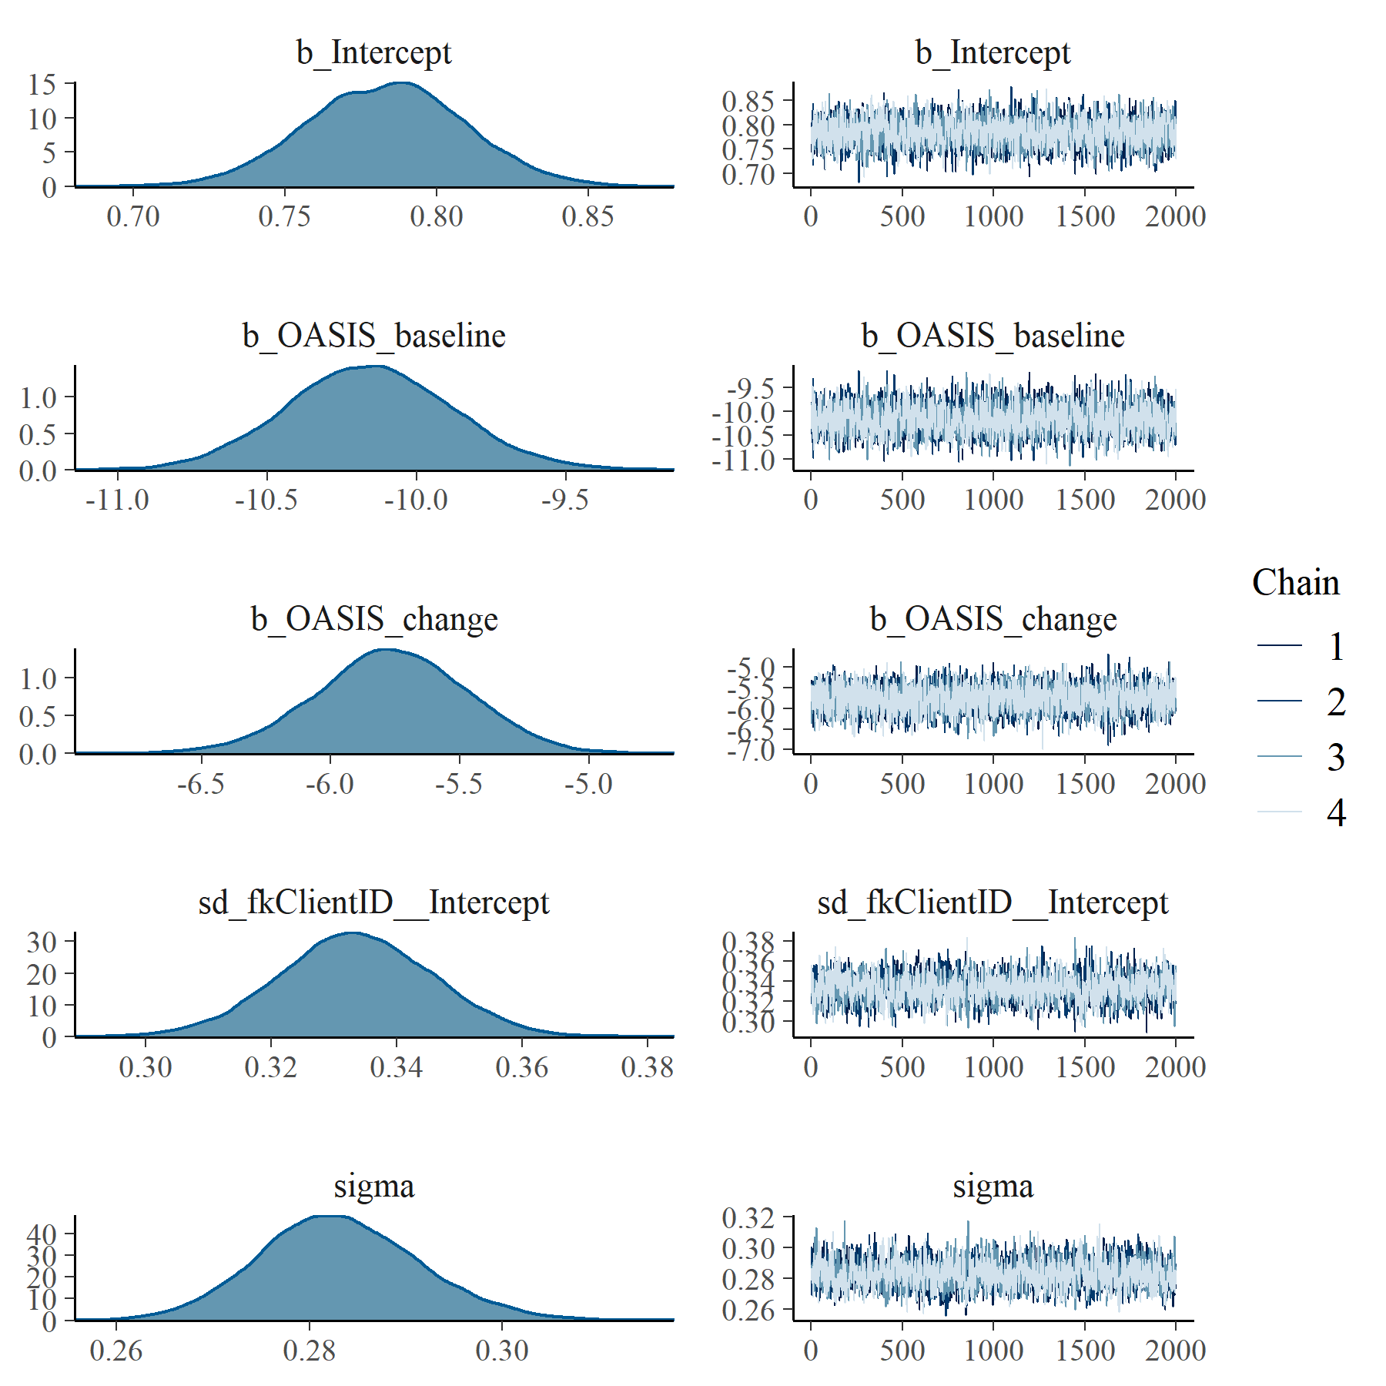

Figure : OASIS Linear Mixed Model with clog-log transformation population and group level effects

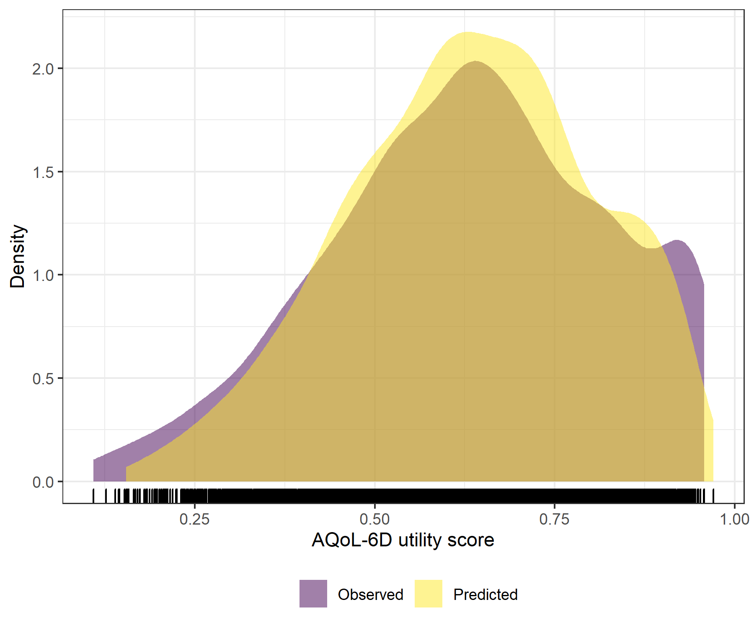

Figure : OASIS Linear Mixed Model with clog-log transformation comparative densities of observed and predicted data

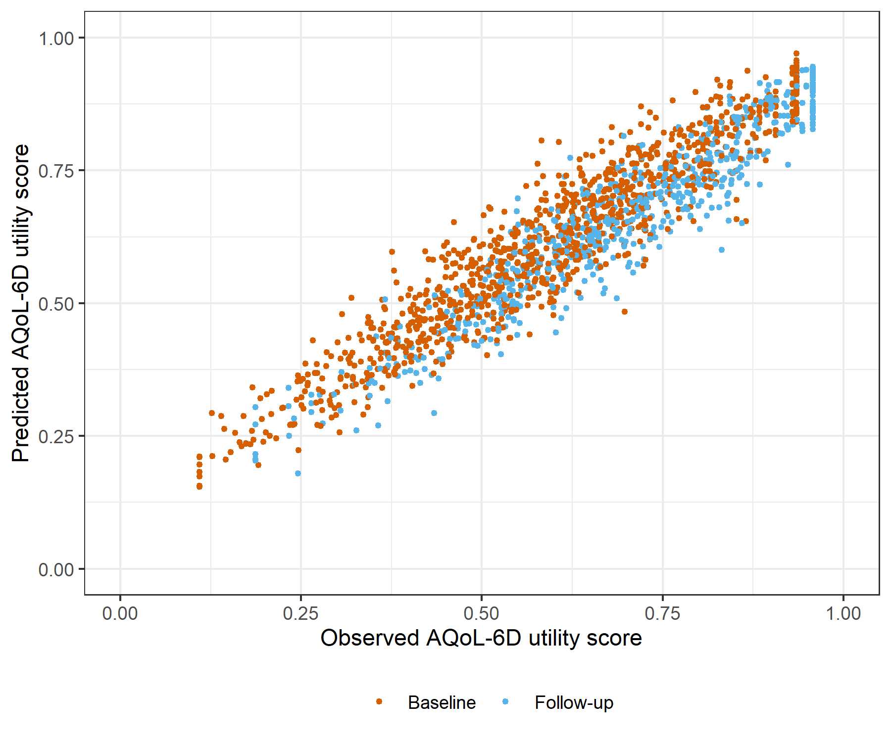

Figure : OASIS Linear Mixed Model with clog-log transformation comparative scatter plot of obsereved and predicted data

# PHQ9 Generalised Linear Mixed Model with Gaussian distribution and log link

Table : PHQ9 Generalised Linear Mixed Model with Gaussian distribution and log link

| Parameter | Estimate | Est.Error | l-95% CI | u-95% CI | Rhat | Bulk_ESS | Tail_ESS |
| --- | --- | --- | --- | --- | --- | --- | --- |
| **Group-Level Effects:** | | | | | | | |
| fkClientID (Number of levels: 1064) |  |  |  |  |  |  |  |
| sd(Intercept) | 0.10 | 0.01 | 0.07 | 0.11 | 1.00 | 542 | 1 042 |
| **Population-Level Effects:** | | | | | | | |
| Intercept | -0.02 | 0.01 | -0.04 | 0.00 | 1.00 | 5 119 | 4 968 |
| PHQ9_baseline | -3.89 | 0.08 | -4.05 | -3.72 | 1.00 | 5 367 | 5 238 |
| PHQ9_change | -2.73 | 0.12 | -2.98 | -2.50 | 1.00 | 1 651 | 3 500 |
| **Family Specific Parameters:** | | | | | | | |
| sigma | 0.10 | 0.00 | 0.09 | 0.11 | 1.00 | 663 | 1 325 |
| Formula: aqol6d_total_w ~ PHQ9_baseline + PHQ9_change + (1 | fkClientID) | | | | | | | |
| Family: gaussian Links: mu = log; sigma = identity Data: data_tb (Number of observations: 1699) Samples: 4 chains, each with iter = 4000; warmup = 2000; thin = 1; total post-warmup samples = 8000 | | | | | | | |
| Samples were drawn using sample(hmc). For each parameter, Bulk_ESS and Tail_ESS are effective sample size measures, and Rhat is the potential scale reduction factor on split chains (at convergence, Rhat = 1). | | | | | | | |

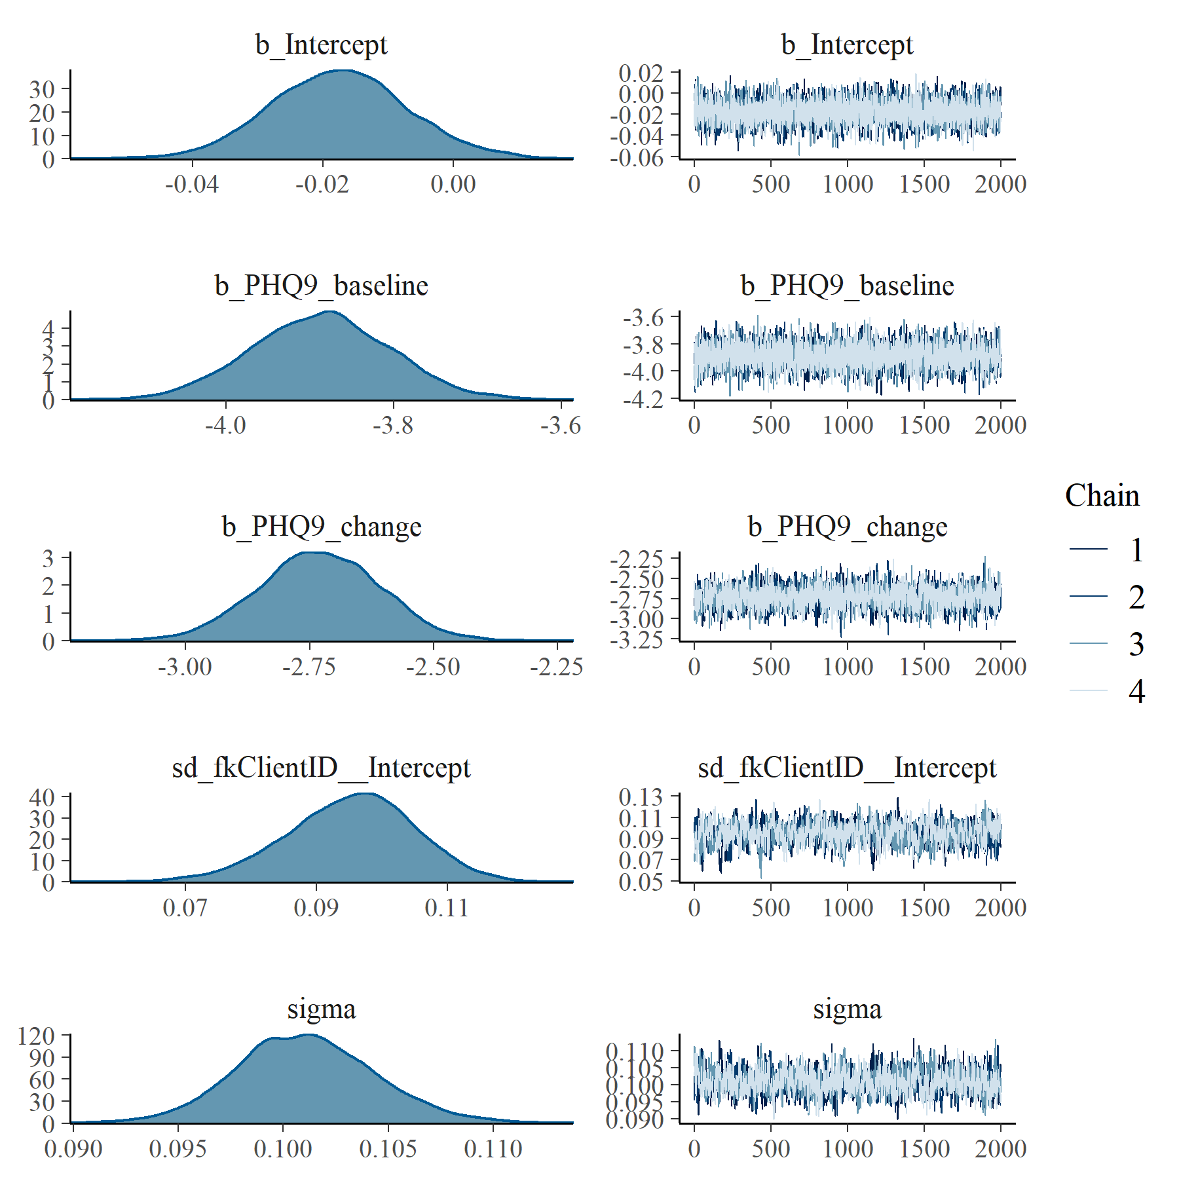

Figure : PHQ9 Generalised Linear Mixed Model with Gaussian distribution and log link population and group level effects

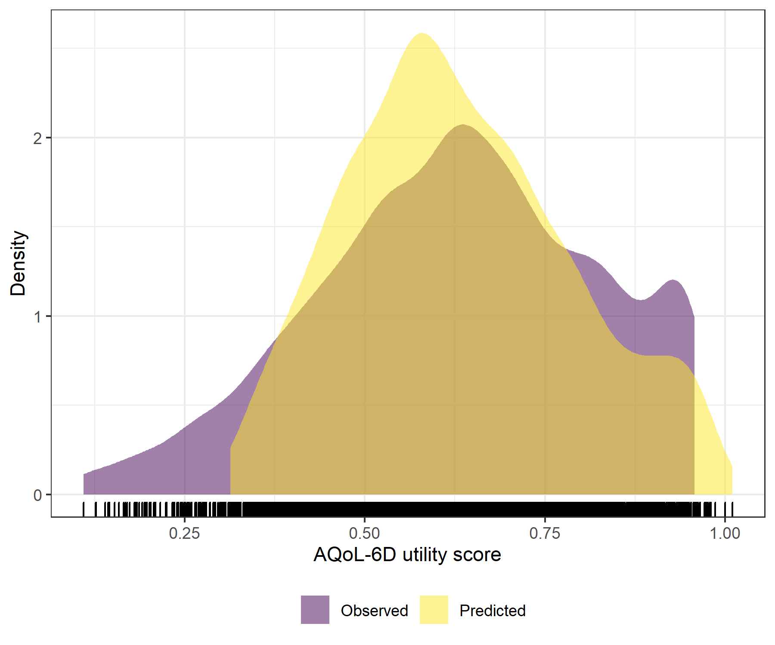

Figure : PHQ9 Generalised Linear Mixed Model with Gaussian distribution and log link comparative densities of observed and predicted data

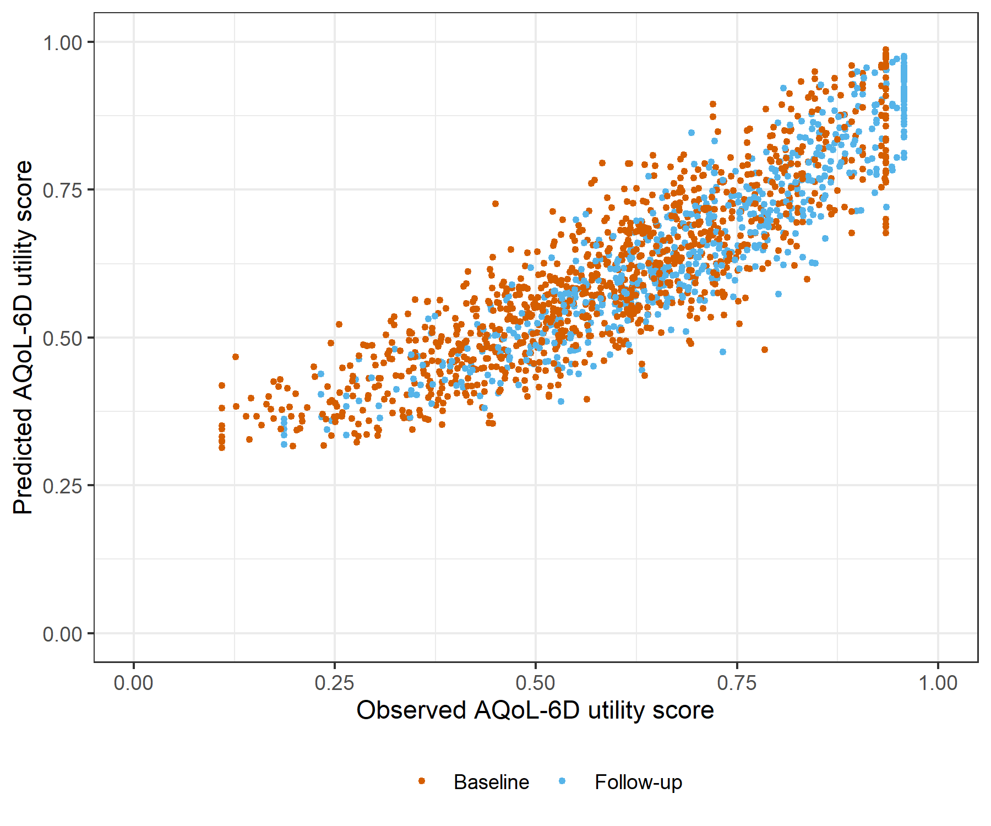

Figure : PHQ9 Generalised Linear Mixed Model with Gaussian distribution and log link comparative scatter plot of obsereved and predicted data

# PHQ9 Linear Mixed Model with clog-log transformation

Table : PHQ9 Linear Mixed Model with clog-log transformation

| Parameter | Estimate | Est.Error | l-95% CI | u-95% CI | Rhat | Bulk_ESS | Tail_ESS |
| --- | --- | --- | --- | --- | --- | --- | --- |
| **Group-Level Effects:** | | | | | | | |
| fkClientID (Number of levels: 1064) |  |  |  |  |  |  |  |
| sd(Intercept) | 0.26 | 0.01 | 0.23 | 0.28 | 1.00 | 1 187 | 3 399 |
| **Population-Level Effects:** | | | | | | | |
| Intercept | 0.96 | 0.02 | 0.91 | 1.00 | 1.00 | 3 286 | 4 717 |
| PHQ9_baseline | -7.83 | 0.17 | -8.14 | -7.51 | 1.00 | 3 347 | 4 794 |
| PHQ9_change | -5.10 | 0.21 | -5.52 | -4.70 | 1.00 | 3 829 | 5 409 |
| **Family Specific Parameters:** | | | | | | | |
| sigma | 0.27 | 0.01 | 0.26 | 0.29 | 1.00 | 1 409 | 3 462 |
| Formula: aqol6d_total_w_cloglog ~ PHQ9_baseline + PHQ9_change + (1 | fkClientID) | | | | | | | |
| Family: gaussian Links: mu = identity; sigma = identity Data: data_tb (Number of observations: 1699) Samples: 4 chains, each with iter = 4000; warmup = 2000; thin = 1; total post-warmup samples = 8000 | | | | | | | |
| Samples were drawn using sample(hmc). For each parameter, Bulk_ESS and Tail_ESS are effective sample size measures, and Rhat is the potential scale reduction factor on split chains (at convergence, Rhat = 1). | | | | | | | |

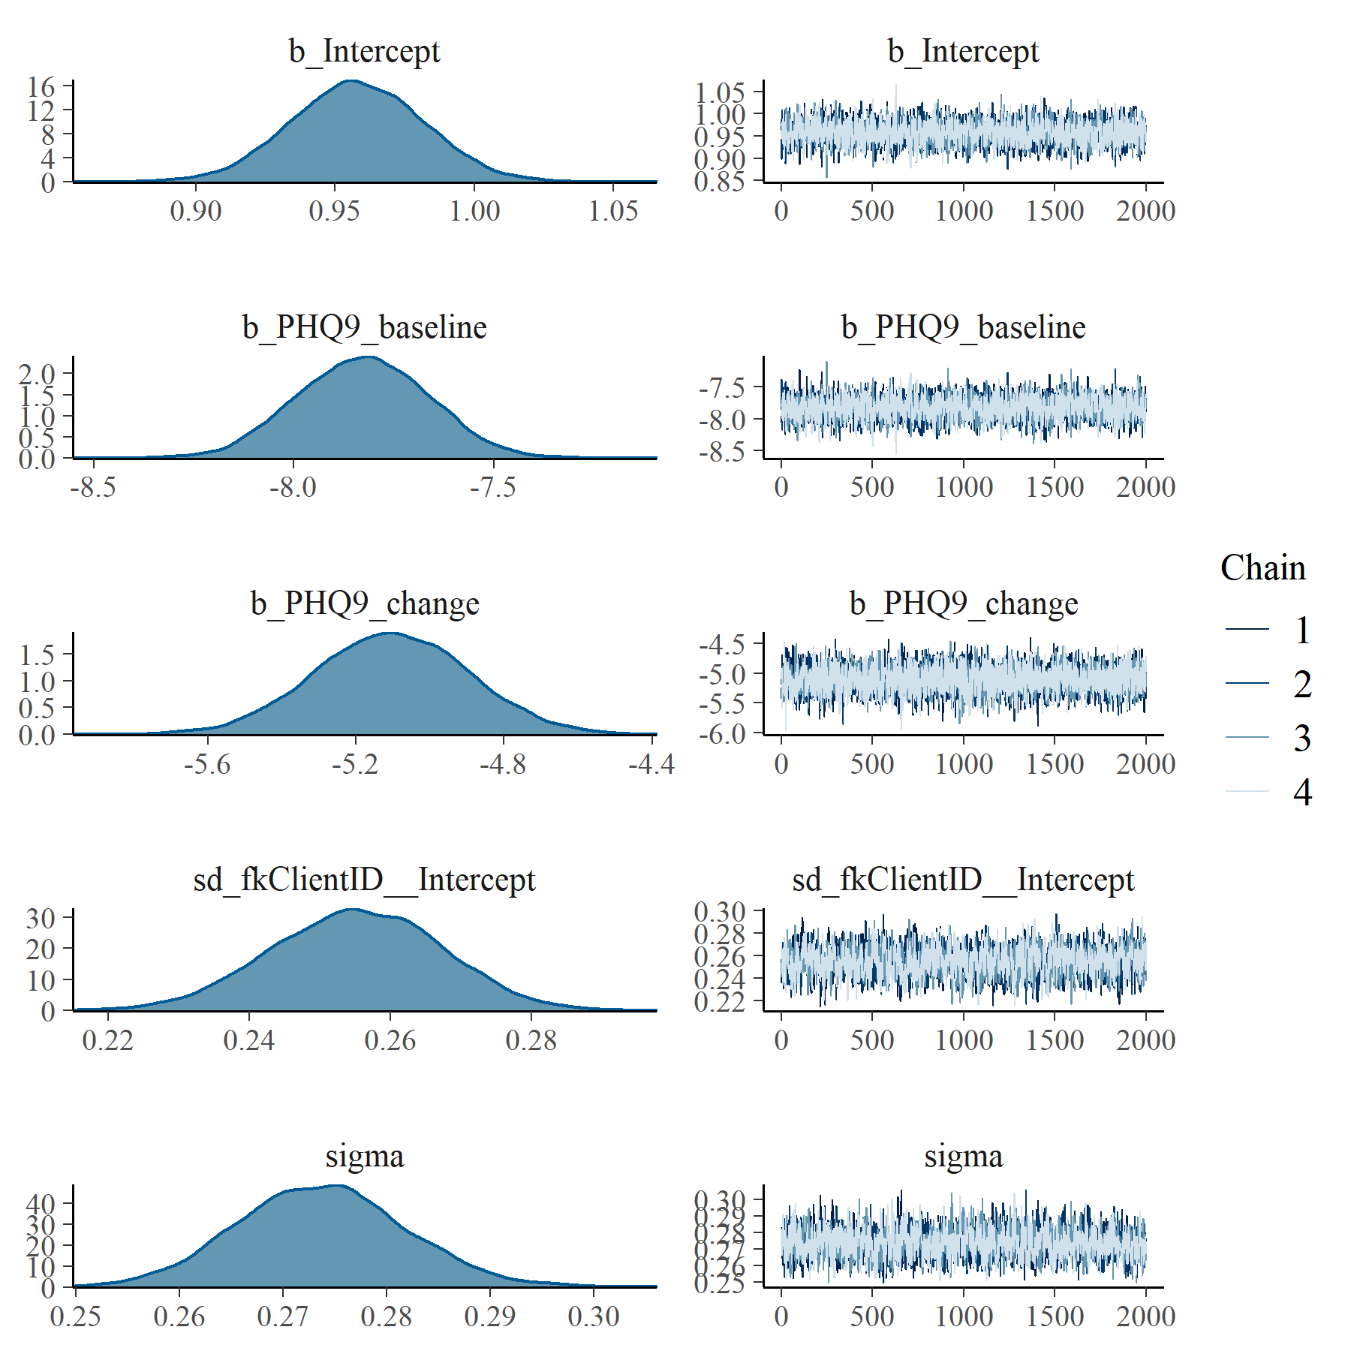

Figure : PHQ9 Linear Mixed Model with clog-log transformation population and group level effects

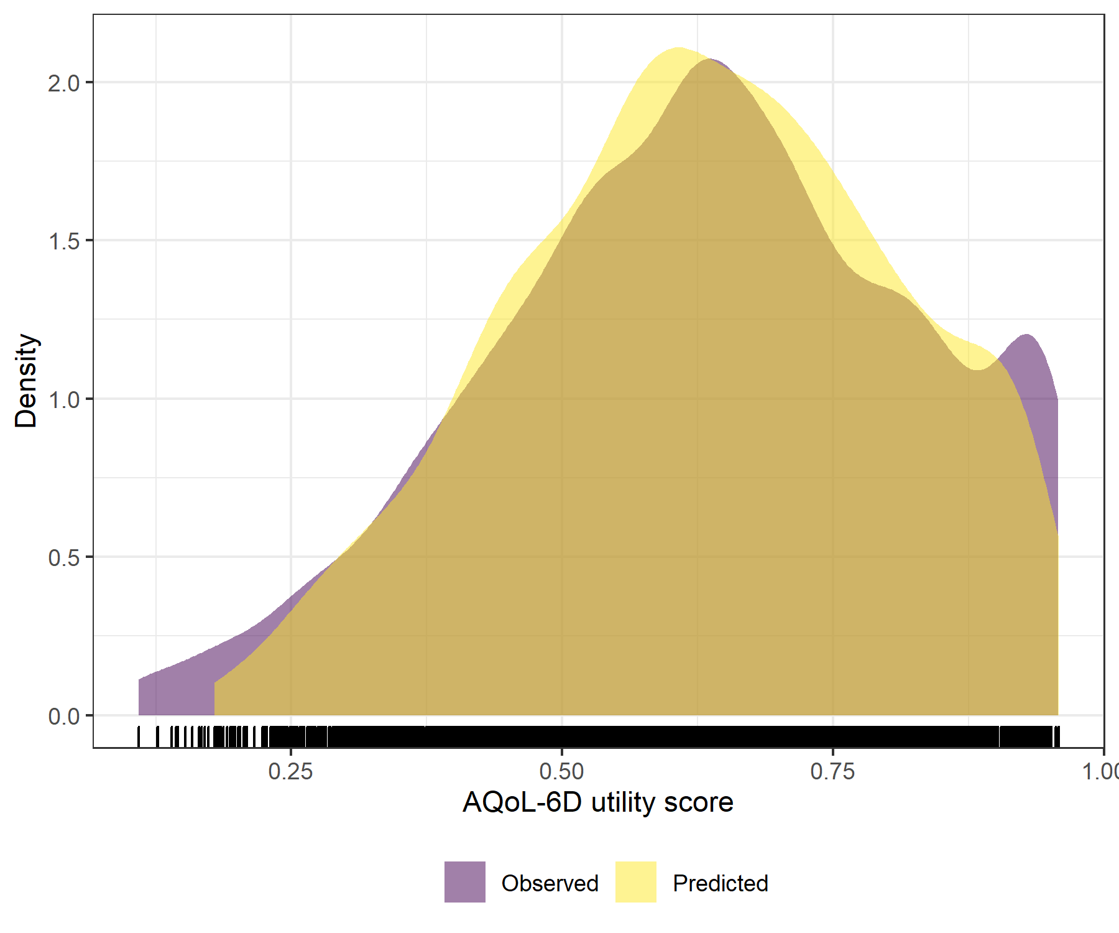

Figure : PHQ9 Linear Mixed Model with clog-log transformation comparative densities of observed and predicted data

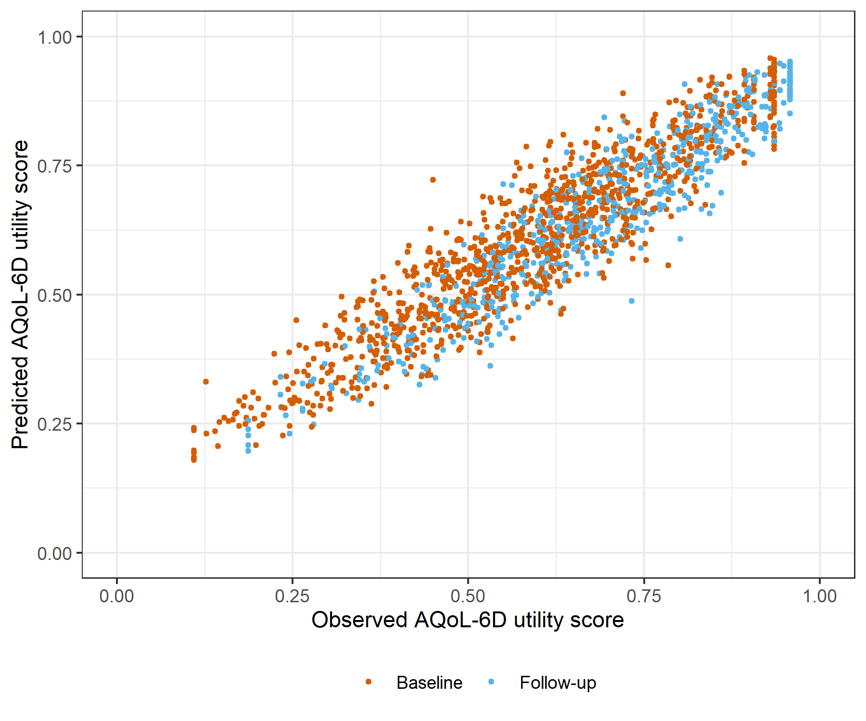

Figure : PHQ9 Linear Mixed Model with clog-log transformation comparative scatter plot of obsereved and predicted data

# SCARED Generalised Linear Mixed Model with Gaussian distribution and log link

Table : SCARED Generalised Linear Mixed Model with Gaussian distribution and log link

| Parameter | Estimate | Est.Error | l-95% CI | u-95% CI | Rhat | Bulk_ESS | Tail_ESS |
| --- | --- | --- | --- | --- | --- | --- | --- |
| **Group-Level Effects:** | | | | | | | |
| fkClientID (Number of levels: 1062) |  |  |  |  |  |  |  |
| sd(Intercept) | 0.18 | 0.01 | 0.16 | 0.19 | 1.00 | 1 009 | 2 446 |
| **Population-Level Effects:** | | | | | | | |
| Intercept | -0.11 | 0.02 | -0.14 | -0.08 | 1.00 | 2 591 | 4 174 |
| SCARED_baseline | -1.15 | 0.04 | -1.23 | -1.07 | 1.00 | 2 741 | 4 129 |
| SCARED_change | -0.60 | 0.04 | -0.69 | -0.52 | 1.00 | 3 788 | 5 296 |
| **Family Specific Parameters:** | | | | | | | |
| sigma | 0.10 | 0.00 | 0.10 | 0.11 | 1.00 | 1 101 | 2 456 |
| Formula: aqol6d_total_w ~ SCARED_baseline + SCARED_change + (1 | fkClientID) | | | | | | | |
| Family: gaussian Links: mu = log; sigma = identity Data: data_tb (Number of observations: 1698) Samples: 4 chains, each with iter = 4000; warmup = 2000; thin = 1; total post-warmup samples = 8000 | | | | | | | |
| Samples were drawn using sample(hmc). For each parameter, Bulk_ESS and Tail_ESS are effective sample size measures, and Rhat is the potential scale reduction factor on split chains (at convergence, Rhat = 1). | | | | | | | |

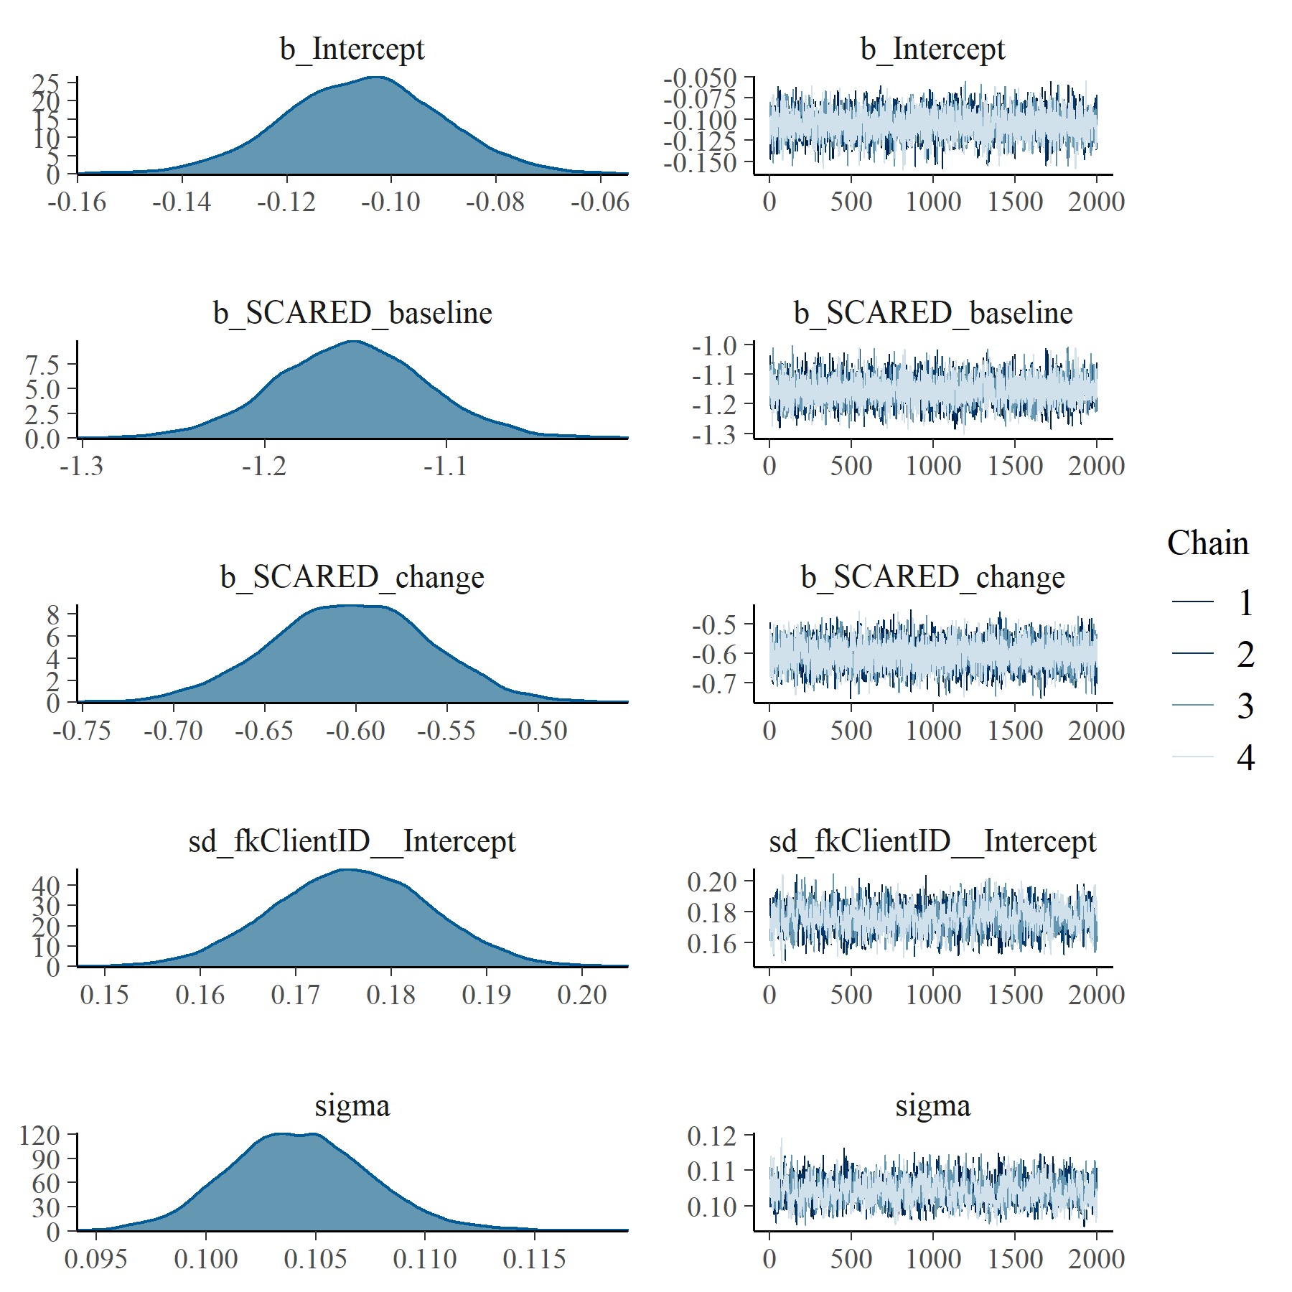

Figure : SCARED Generalised Linear Mixed Model with Gaussian distribution and log link population and group level effects

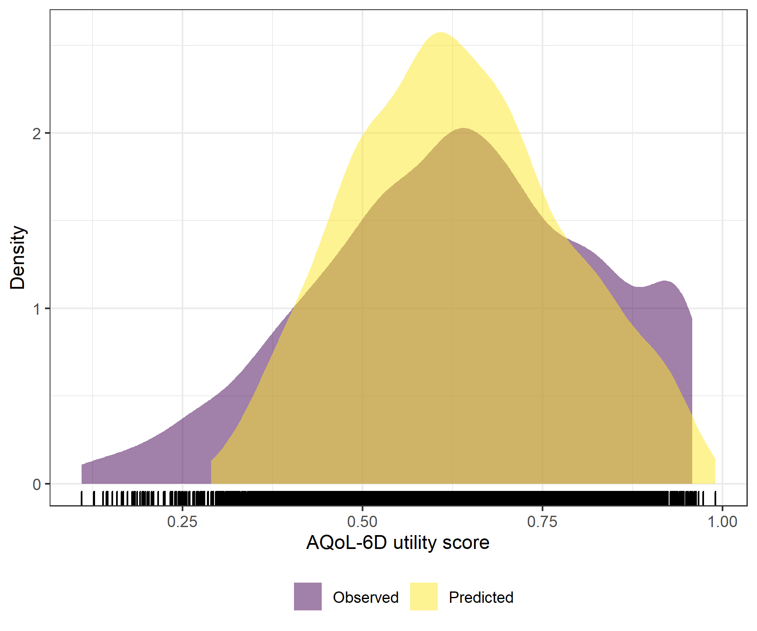

Figure : SCARED Generalised Linear Mixed Model with Gaussian distribution and log link comparative densities of observed and predicted data

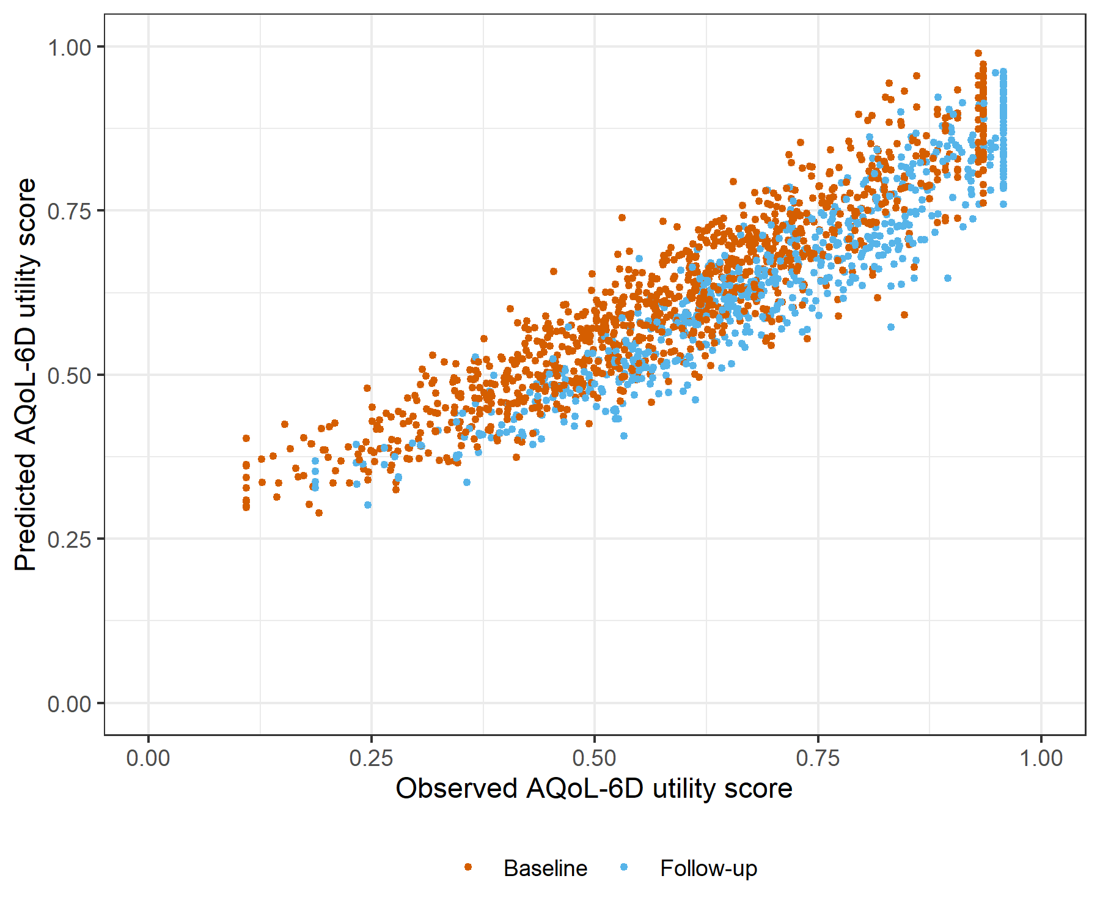

Figure : SCARED Generalised Linear Mixed Model with Gaussian distribution and log link comparative scatter plot of obsereved and predicted data

# SCARED Linear Mixed Model with clog-log transformation

Table : SCARED Linear Mixed Model with clog-log transformation

| Parameter | Estimate | Est.Error | l-95% CI | u-95% CI | Rhat | Bulk_ESS | Tail_ESS |
| --- | --- | --- | --- | --- | --- | --- | --- |
| **Group-Level Effects:** | | | | | | | |
| fkClientID (Number of levels: 1062) |  |  |  |  |  |  |  |
| sd(Intercept) | 0.37 | 0.01 | 0.35 | 0.40 | 1.00 | 1 508 | 2 840 |
| **Population-Level Effects:** | | | | | | | |
| Intercept | 0.77 | 0.03 | 0.71 | 0.84 | 1.00 | 2 045 | 3 667 |
| SCARED_baseline | -2.31 | 0.08 | -2.47 | -2.16 | 1.00 | 1 954 | 3 781 |
| SCARED_change | -1.21 | 0.08 | -1.36 | -1.05 | 1.00 | 4 261 | 5 448 |
| **Family Specific Parameters:** | | | | | | | |
| sigma | 0.30 | 0.01 | 0.29 | 0.32 | 1.00 | 1 451 | 3 057 |
| Formula: aqol6d_total_w_cloglog ~ SCARED_baseline + SCARED_change + (1 | fkClientID) | | | | | | | |
| Family: gaussian Links: mu = identity; sigma = identity Data: data_tb (Number of observations: 1698) Samples: 4 chains, each with iter = 4000; warmup = 2000; thin = 1; total post-warmup samples = 8000 | | | | | | | |
| Samples were drawn using sample(hmc). For each parameter, Bulk_ESS and Tail_ESS are effective sample size measures, and Rhat is the potential scale reduction factor on split chains (at convergence, Rhat = 1). | | | | | | | |

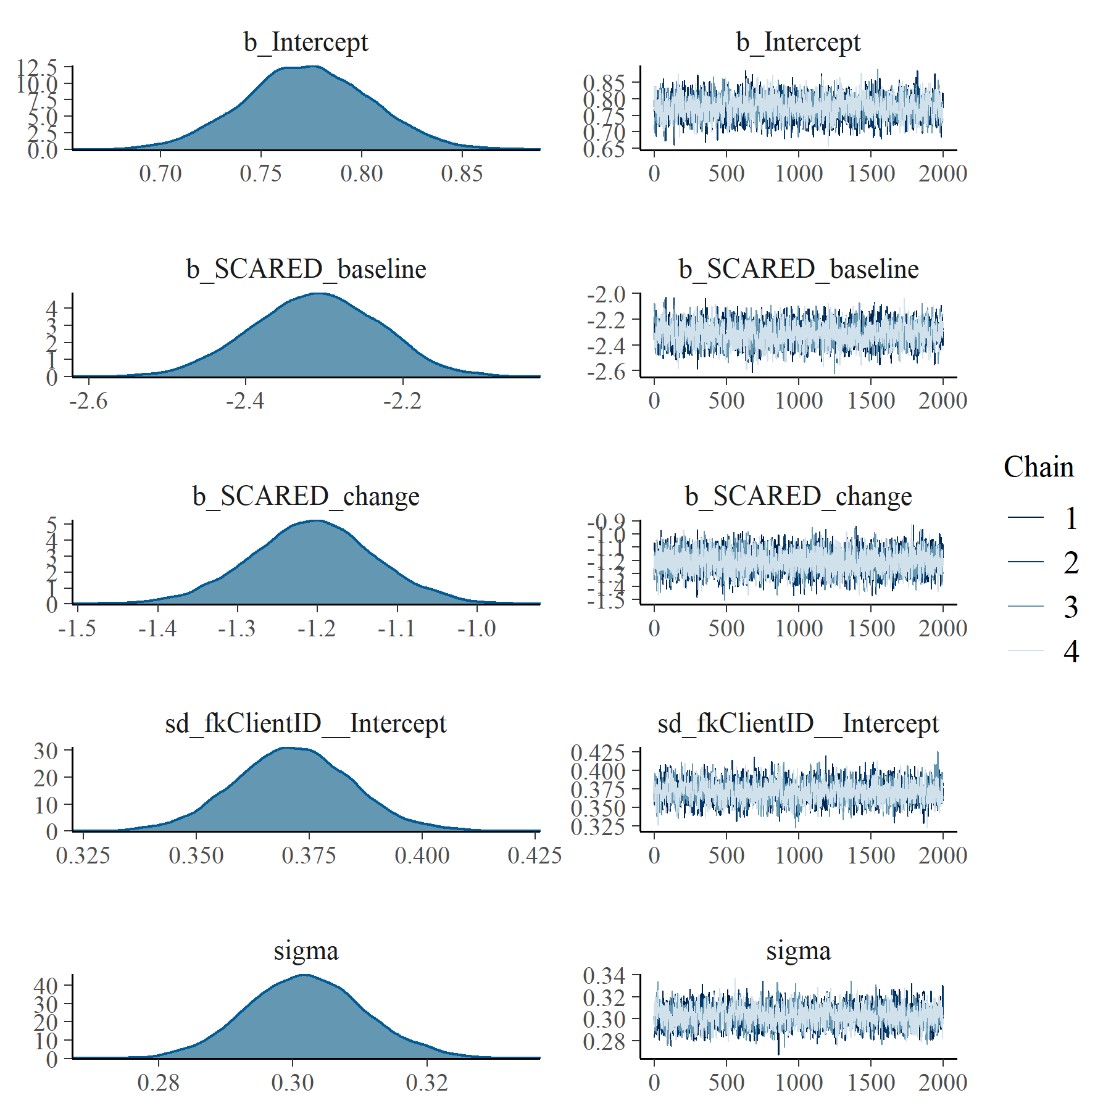

Figure : SCARED Linear Mixed Model with clog-log transformation population and group level effects

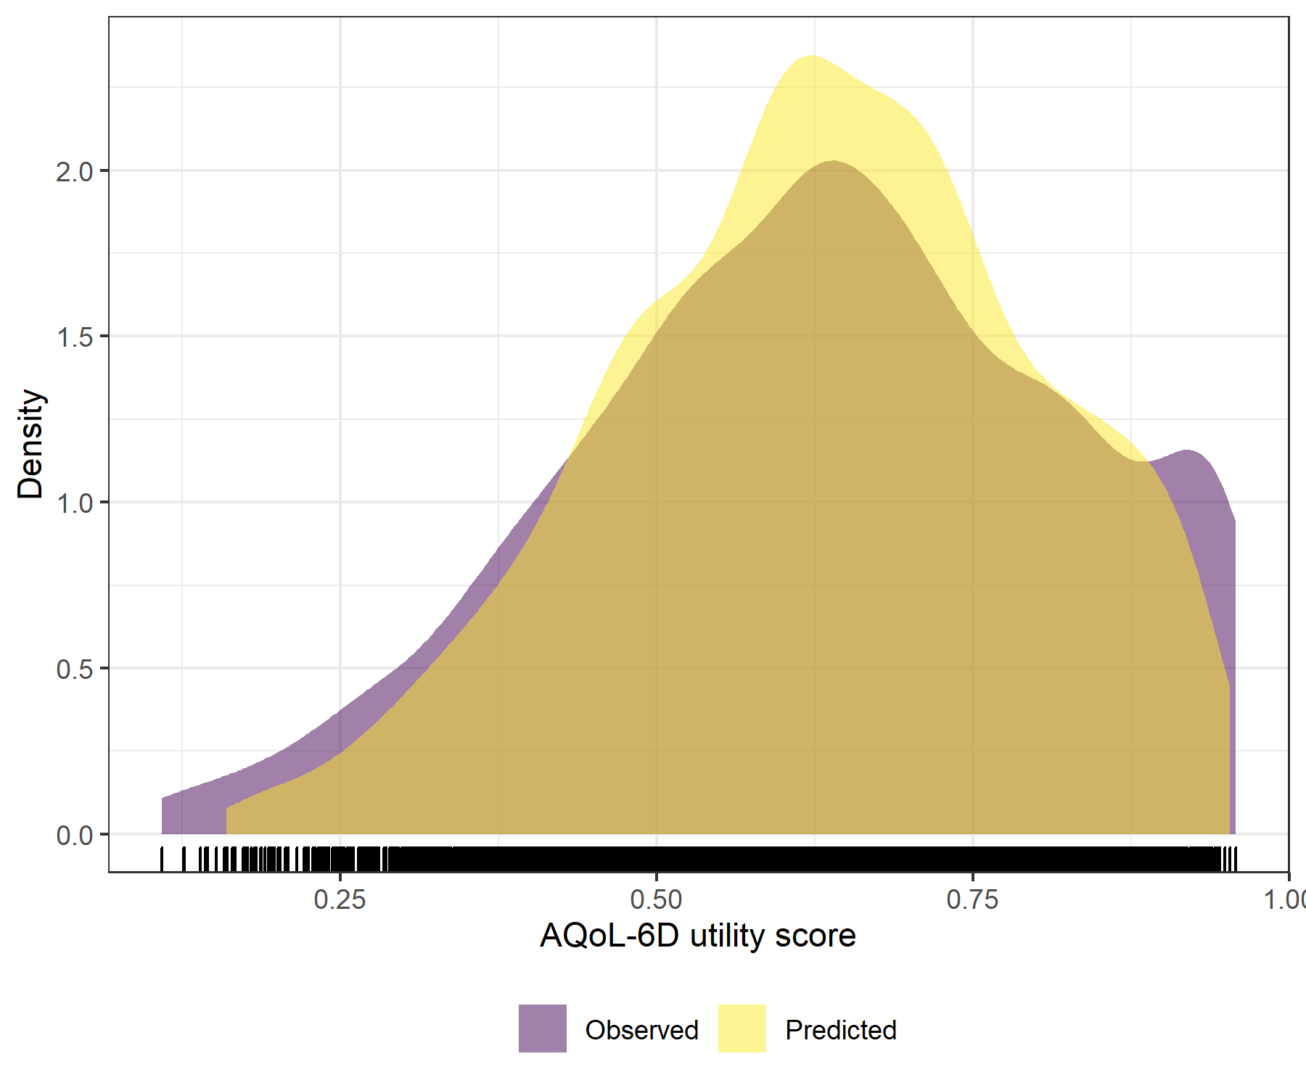

Figure : SCARED Linear Mixed Model with clog-log transformation comparative densities of observed and predicted data

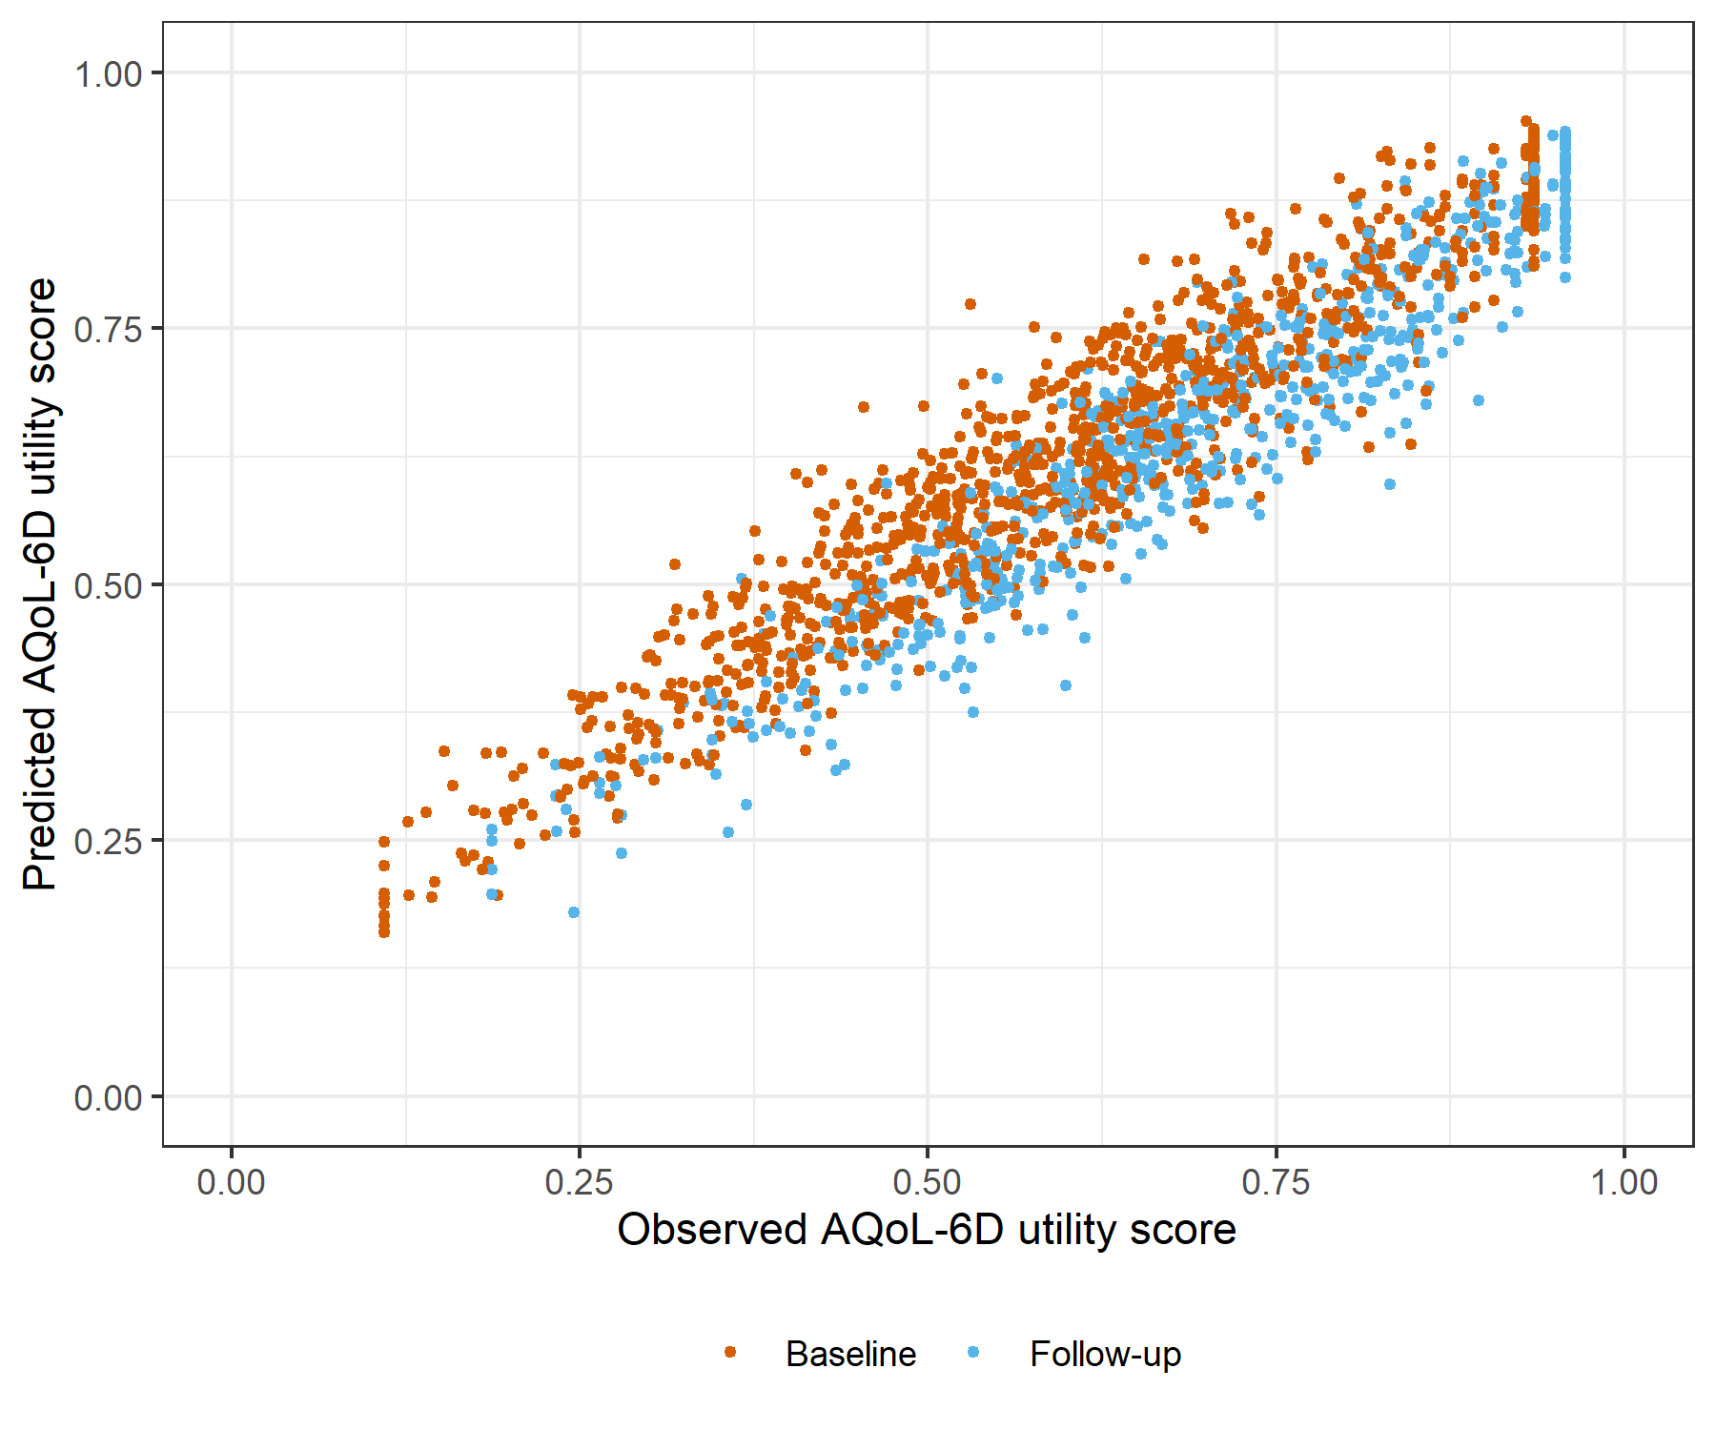

Figure : SCARED Linear Mixed Model with clog-log transformation comparative scatter plot of obsereved and predicted data

# BADS with SOFAS Generalised Linear Mixed Model with Gaussian distribution and log link

Table : BADS with SOFAS Generalised Linear Mixed Model with Gaussian distribution and log link

| Parameter | Estimate | Est.Error | l-95% CI | u-95% CI | Rhat | Bulk_ESS | Tail_ESS |
| --- | --- | --- | --- | --- | --- | --- | --- |
| **Group-Level Effects:** | | | | | | | |
| fkClientID (Number of levels: 1031) |  |  |  |  |  |  |  |
| sd(Intercept) | 0.16 | 0.01 | 0.14 | 0.17 | 1.00 | 745 | 1 979 |
| **Population-Level Effects:** | | | | | | | |
| Intercept | -1.22 | 0.05 | -1.33 | -1.12 | 1.00 | 3 085 | 4 705 |
| BADS_baseline | 0.90 | 0.03 | 0.85 | 0.95 | 1.00 | 2 565 | 4 719 |
| BADS_change | 0.46 | 0.03 | 0.40 | 0.52 | 1.00 | 3 069 | 5 351 |
| SOFAS_baseline | -0.02 | 0.07 | -0.15 | 0.12 | 1.00 | 3 142 | 4 870 |
| SOFAS_change | 0.56 | 0.07 | 0.42 | 0.70 | 1.00 | 5 889 | 6 038 |
| **Family Specific Parameters:** | | | | | | | |
| sigma | 0.09 | 0.00 | 0.09 | 0.10 | 1.00 | 819 | 2 030 |
| Formula: aqol6d_total_w ~ BADS_baseline + BADS_change + SOFAS_baseline + SOFAS_change + (1 | fkClientID) | | | | | | | |
| Family: gaussian Links: mu = log; sigma = identity Data: data_tb (Number of observations: 1650) Samples: 4 chains, each with iter = 4000; warmup = 2000; thin = 1; total post-warmup samples = 8000 | | | | | | | |
| Samples were drawn using sample(hmc). For each parameter, Bulk_ESS and Tail_ESS are effective sample size measures, and Rhat is the potential scale reduction factor on split chains (at convergence, Rhat = 1). | | | | | | | |

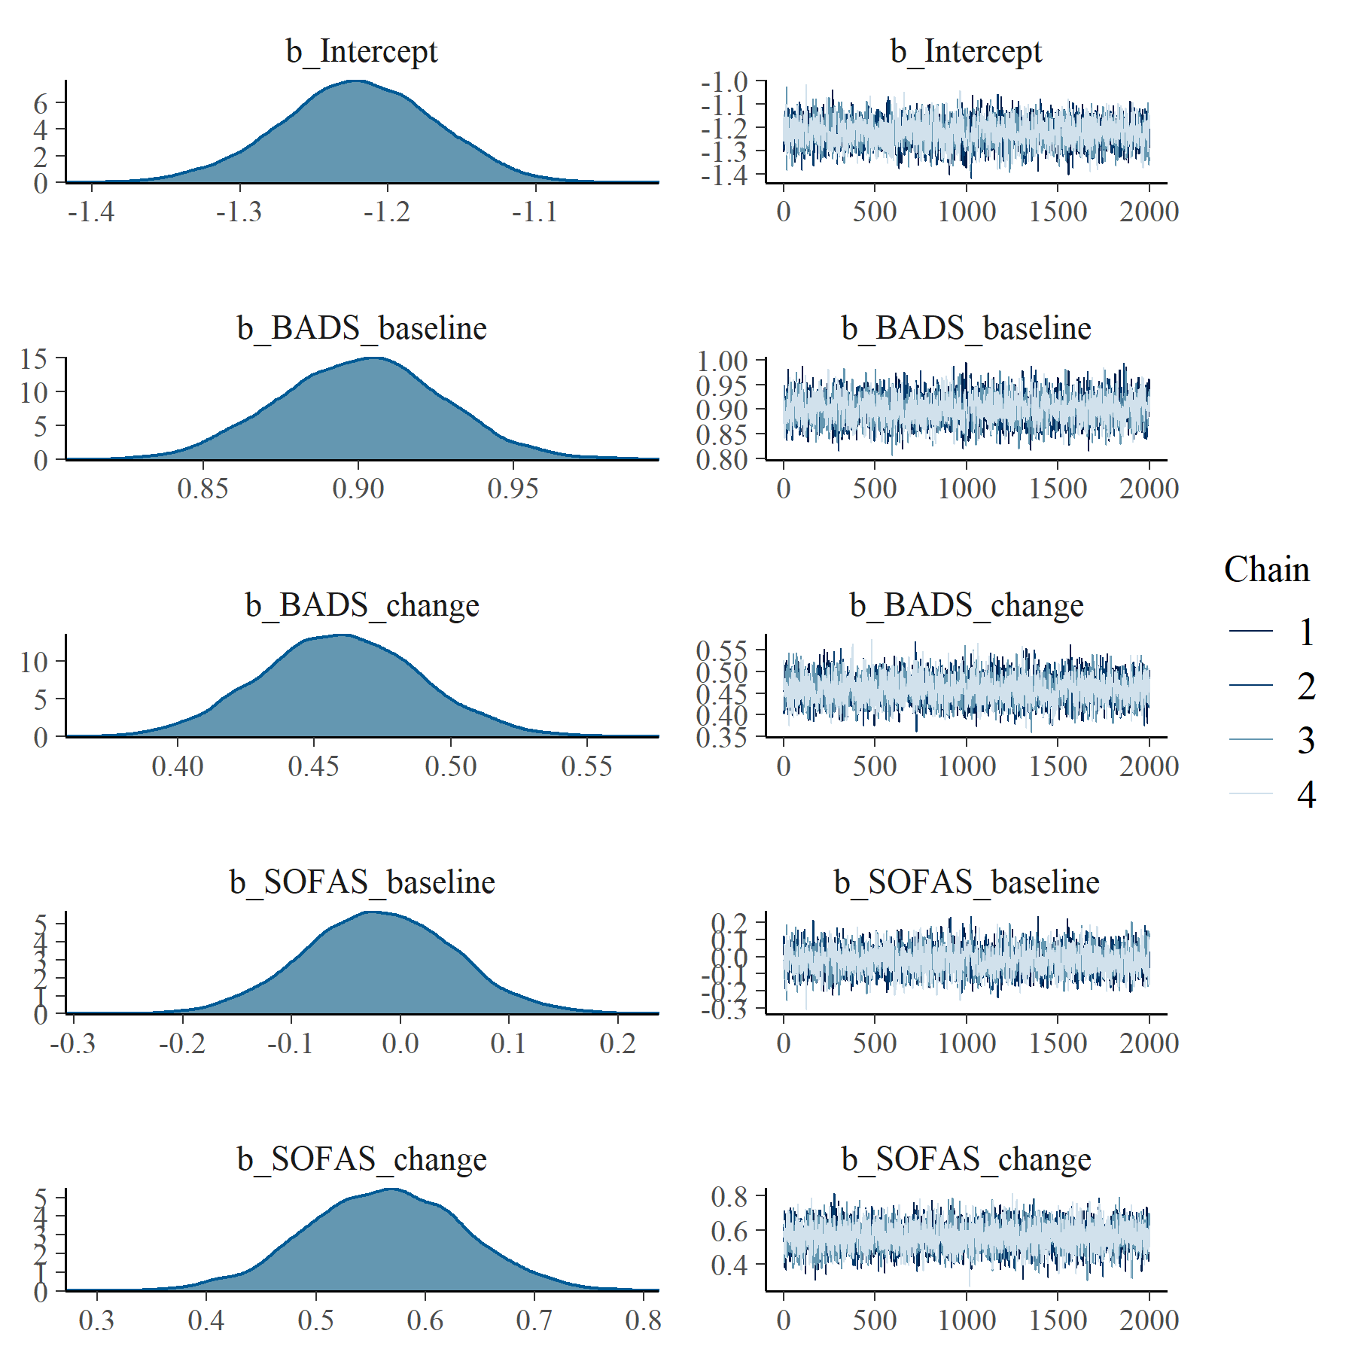

Figure : BADS with SOFAS Generalised Linear Mixed Model with Gaussian distribution and log link population level effects

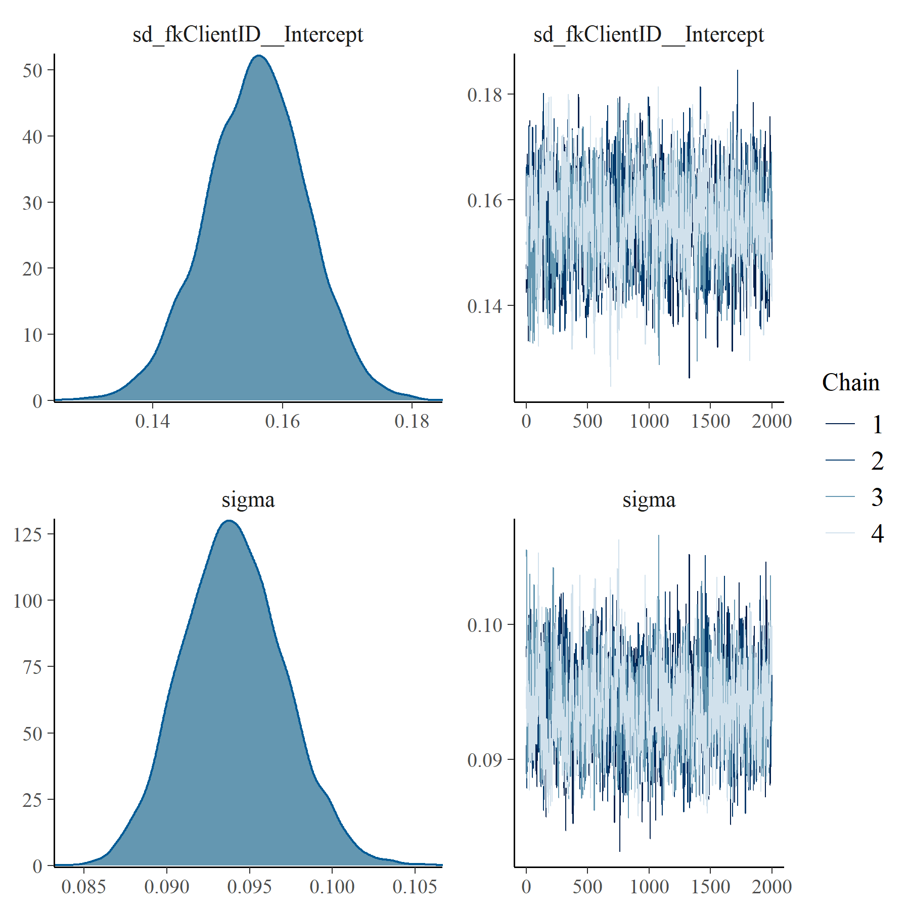

Figure : BADS with SOFAS Generalised Linear Mixed Model with Gaussian distribution and log link group level effects

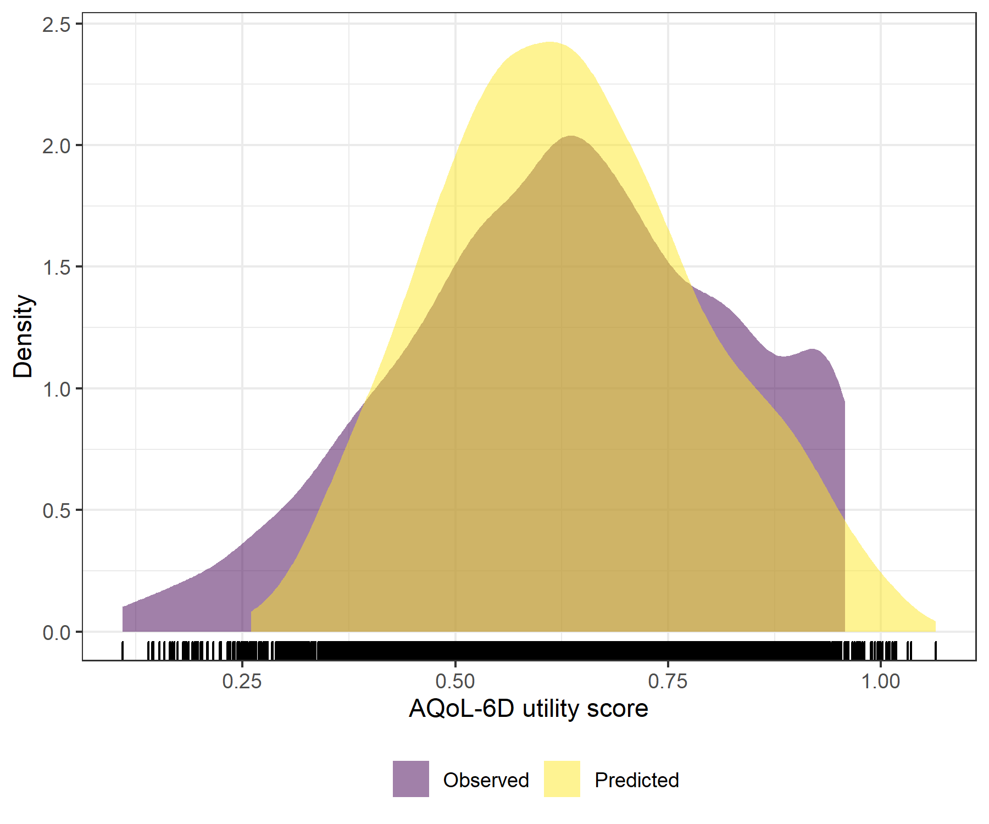

Figure : BADS with SOFAS Generalised Linear Mixed Model with Gaussian distribution and log link comparative densities of observed and predicted data

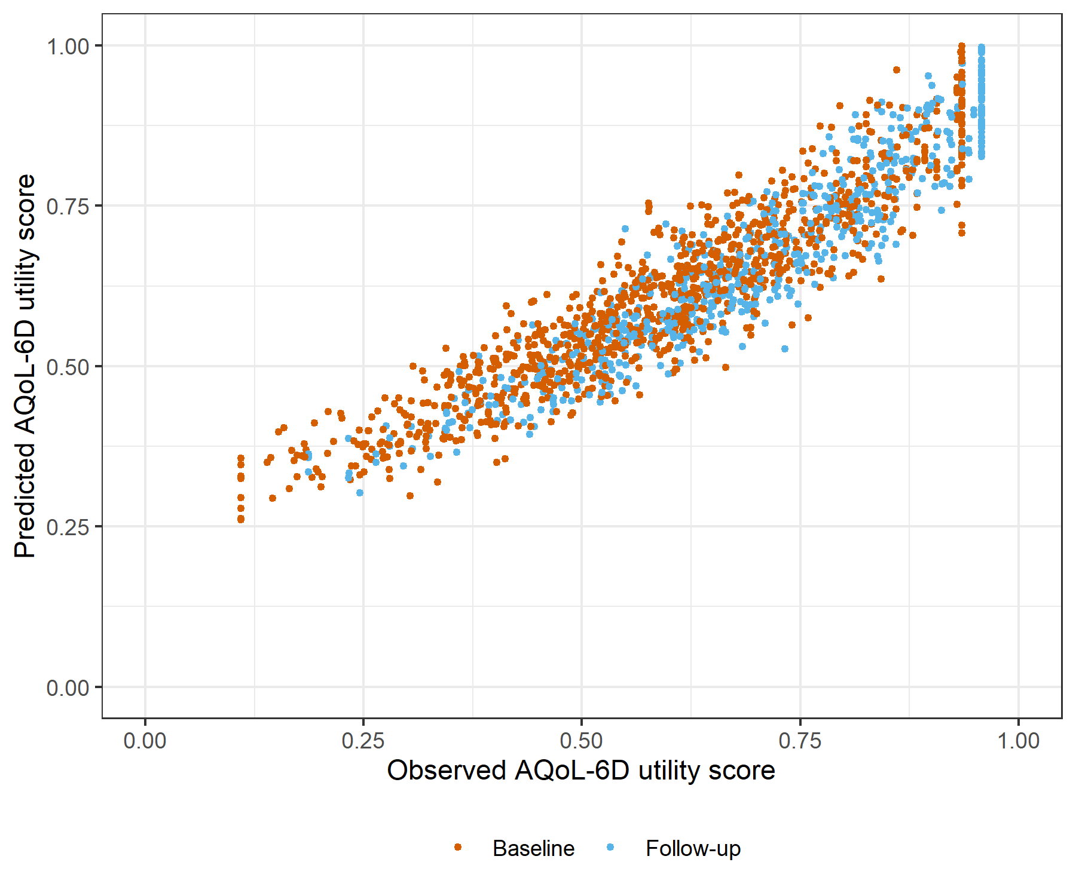

Figure : BADS with SOFAS Generalised Linear Mixed Model with Gaussian distribution and log link comparative scatter plot of obsereved and predicted data

# BADS with SOFAS Linear Mixed Model with clog-log transformation

Table : BADS with SOFAS Linear Mixed Model with clog-log transformation

| Parameter | Estimate | Est.Error | l-95% CI | u-95% CI | Rhat | Bulk_ESS | Tail_ESS |
| --- | --- | --- | --- | --- | --- | --- | --- |
| **Group-Level Effects:** | | | | | | | |
| fkClientID (Number of levels: 1031) |  |  |  |  |  |  |  |
| sd(Intercept) | 0.33 | 0.01 | 0.31 | 0.35 | 1.00 | 1 690 | 3 734 |
| **Population-Level Effects:** | | | | | | | |
| Intercept | -1.48 | 0.10 | -1.68 | -1.29 | 1.00 | 2 624 | 4 363 |
| BADS_baseline | 1.81 | 0.05 | 1.71 | 1.91 | 1.00 | 2 310 | 4 166 |
| BADS_change | 0.95 | 0.05 | 0.85 | 1.06 | 1.00 | 4 732 | 5 306 |
| SOFAS_baseline | -0.01 | 0.14 | -0.28 | 0.25 | 1.00 | 2 551 | 4 078 |
| SOFAS_change | 1.27 | 0.14 | 1.00 | 1.54 | 1.00 | 5 850 | 5 858 |
| **Family Specific Parameters:** | | | | | | | |
| sigma | 0.26 | 0.01 | 0.24 | 0.27 | 1.00 | 1 734 | 3 379 |
| Formula: aqol6d_total_w_cloglog ~ BADS_baseline + BADS_change + SOFAS_baseline + SOFAS_change + (1 | fkClientID) | | | | | | | |
| Family: gaussian Links: mu = identity; sigma = identity Data: data_tb (Number of observations: 1650) Samples: 4 chains, each with iter = 4000; warmup = 2000; thin = 1; total post-warmup samples = 8000 | | | | | | | |
| Samples were drawn using sample(hmc). For each parameter, Bulk_ESS and Tail_ESS are effective sample size measures, and Rhat is the potential scale reduction factor on split chains (at convergence, Rhat = 1). | | | | | | | |

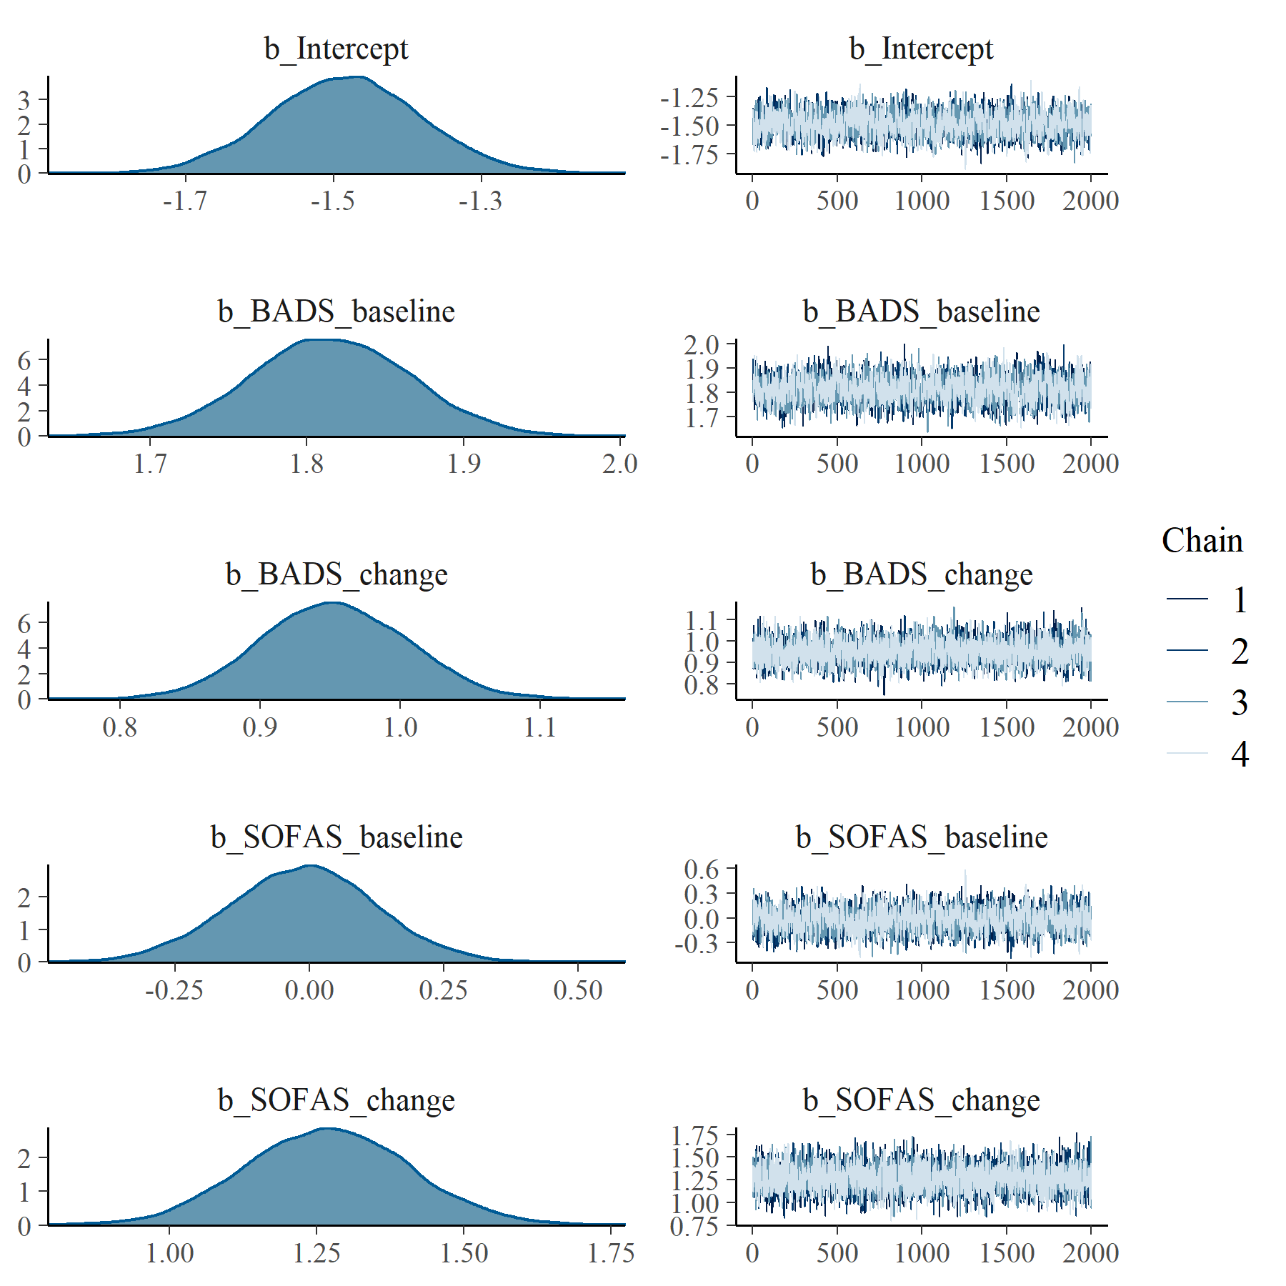

Figure : BADS with SOFAS Linear Mixed Model with clog-log transformation population level effects

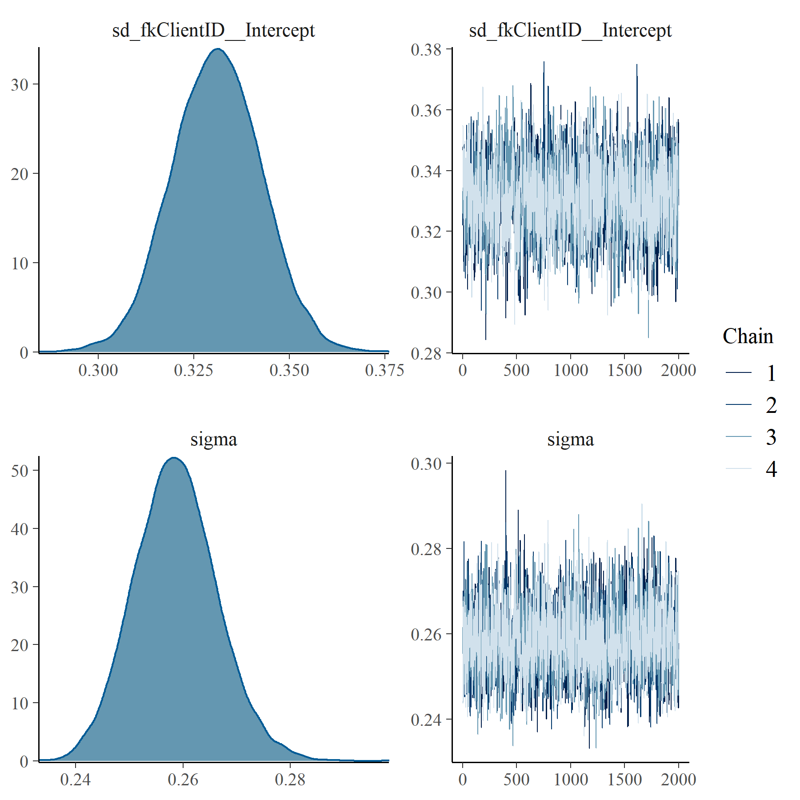

Figure : BADS with SOFAS Linear Mixed Model with clog-log transformation group level effects

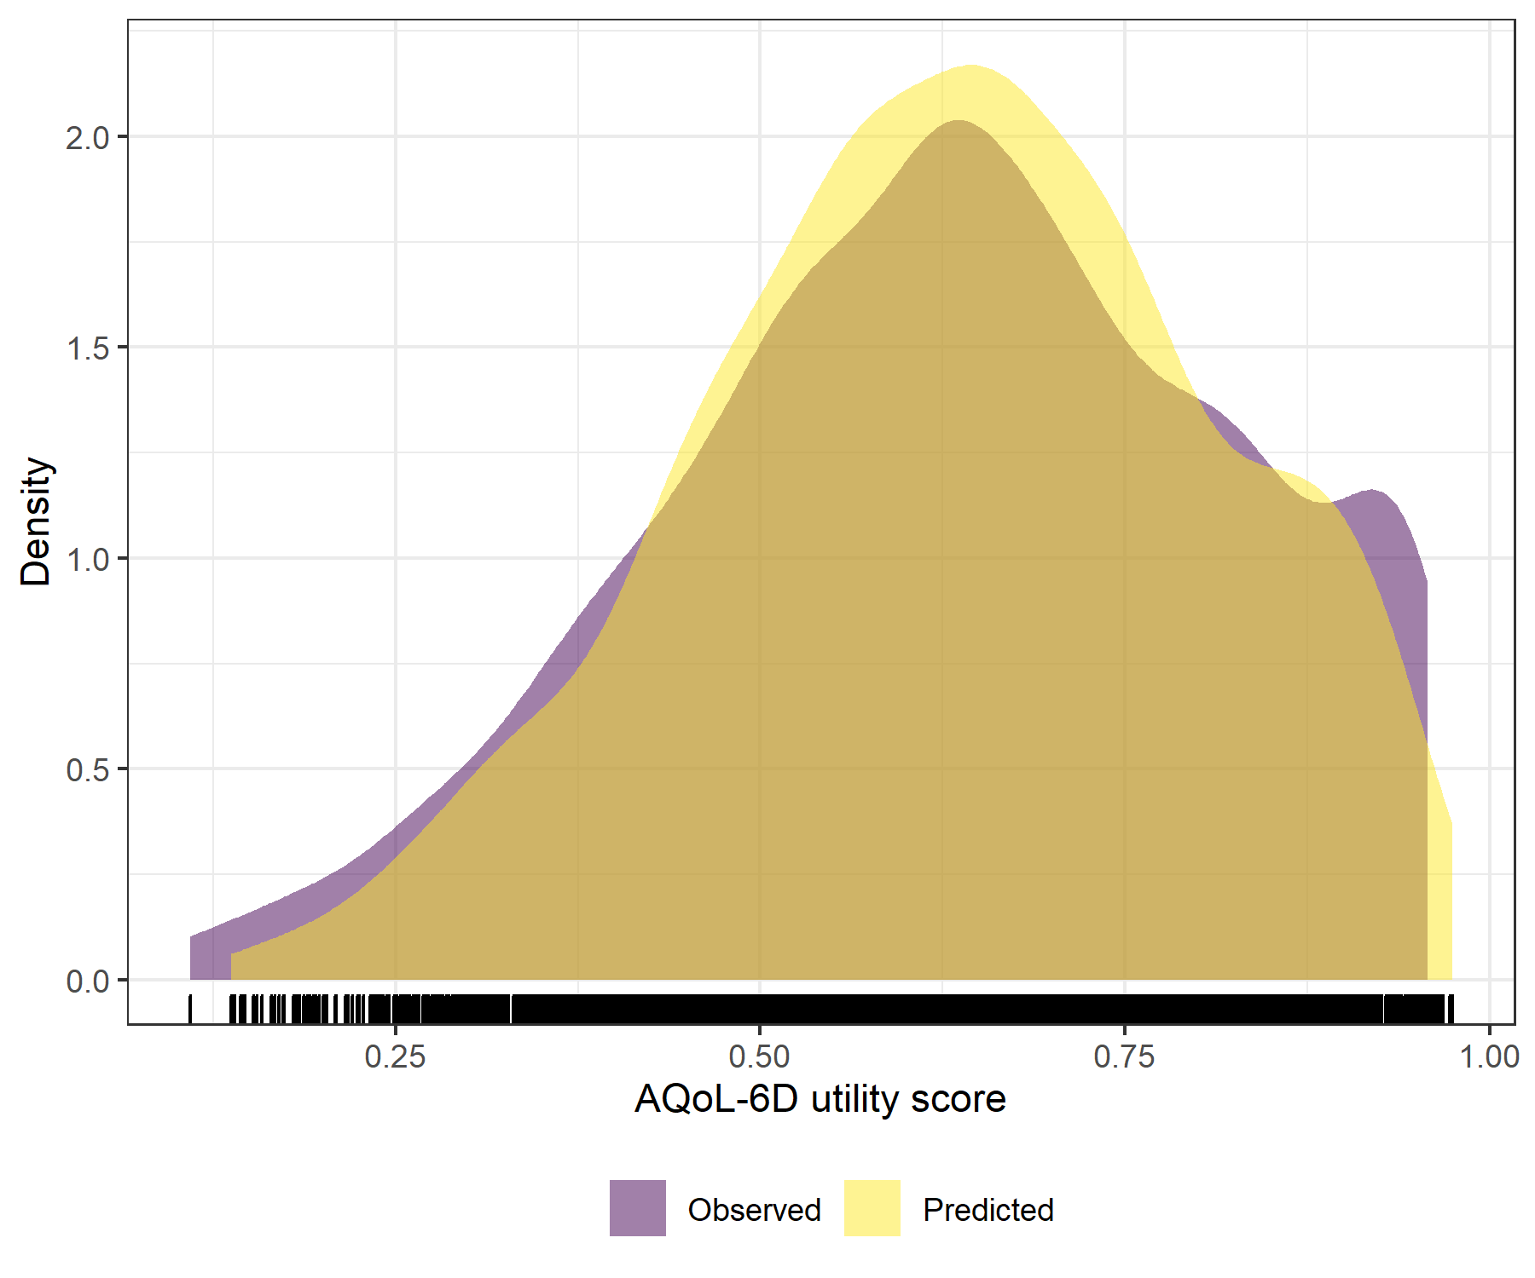

Figure : BADS with SOFAS Linear Mixed Model with clog-log transformation comparative densities of observed and predicted data

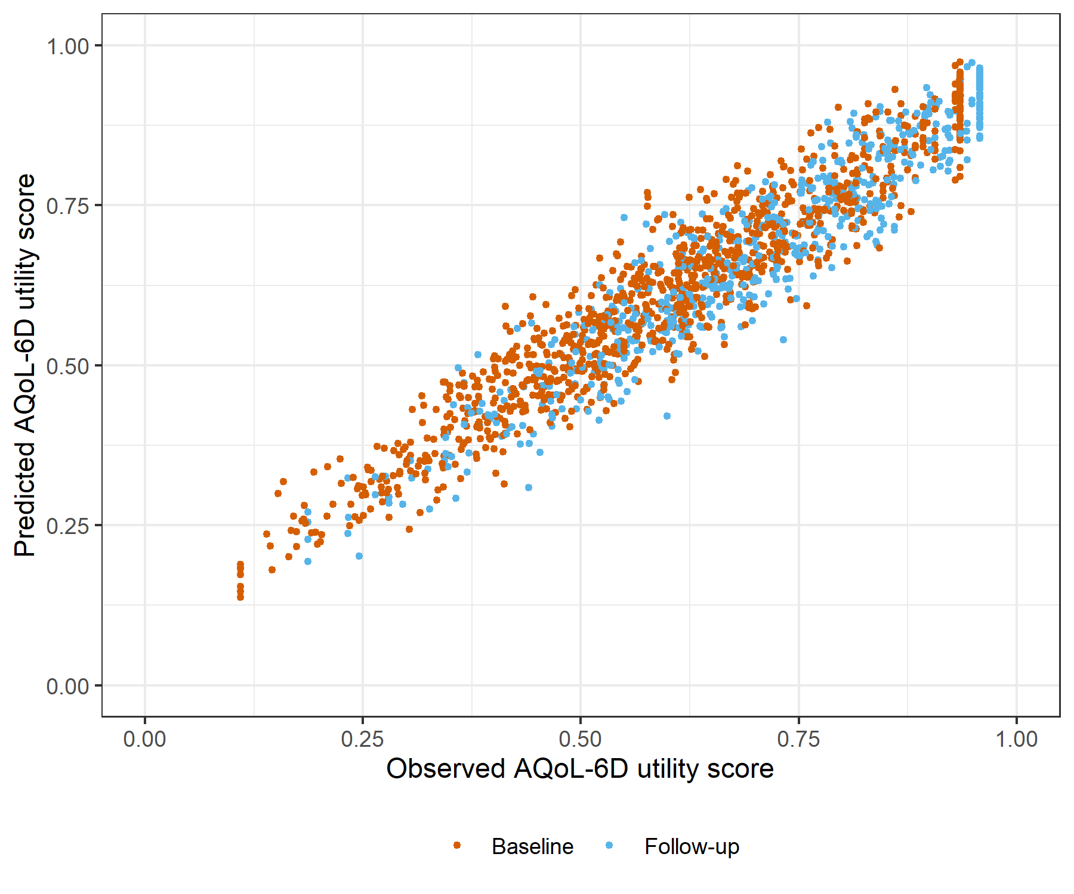

Figure : BADS with SOFAS Linear Mixed Model with clog-log transformation comparative scatter plot of obsereved and predicted data

# GAD7 with SOFAS Generalised Linear Mixed Model with Gaussian distribution and log link

Table : GAD7 with SOFAS Generalised Linear Mixed Model with Gaussian distribution and log link

| Parameter | Estimate | Est.Error | l-95% CI | u-95% CI | Rhat | Bulk_ESS | Tail_ESS |
| --- | --- | --- | --- | --- | --- | --- | --- |
| **Group-Level Effects:** | | | | | | | |
| fkClientID (Number of levels: 1032) |  |  |  |  |  |  |  |
| sd(Intercept) | 0.18 | 0.01 | 0.16 | 0.19 | 1.00 | 882 | 1 878 |
| **Population-Level Effects:** | | | | | | | |
| Intercept | -0.11 | 0.05 | -0.20 | -0.00 | 1.00 | 2 159 | 3 840 |
| GAD7_baseline | -3.87 | 0.13 | -4.13 | -3.60 | 1.00 | 2 431 | 4 564 |
| GAD7_change | -2.02 | 0.13 | -2.29 | -1.77 | 1.00 | 3 130 | 5 008 |
| SOFAS_baseline | -0.03 | 0.08 | -0.18 | 0.12 | 1.00 | 2 042 | 3 873 |
| SOFAS_change | 0.58 | 0.07 | 0.43 | 0.72 | 1.00 | 4 900 | 5 548 |
| **Family Specific Parameters:** | | | | | | | |
| sigma | 0.09 | 0.00 | 0.09 | 0.10 | 1.00 | 976 | 1 855 |
| Formula: aqol6d_total_w ~ GAD7_baseline + GAD7_change + SOFAS_baseline + SOFAS_change + (1 | fkClientID) | | | | | | | |
| Family: gaussian Links: mu = log; sigma = identity Data: data_tb (Number of observations: 1649) Samples: 4 chains, each with iter = 4000; warmup = 2000; thin = 1; total post-warmup samples = 8000 | | | | | | | |
| Samples were drawn using sample(hmc). For each parameter, Bulk_ESS and Tail_ESS are effective sample size measures, and Rhat is the potential scale reduction factor on split chains (at convergence, Rhat = 1). | | | | | | | |

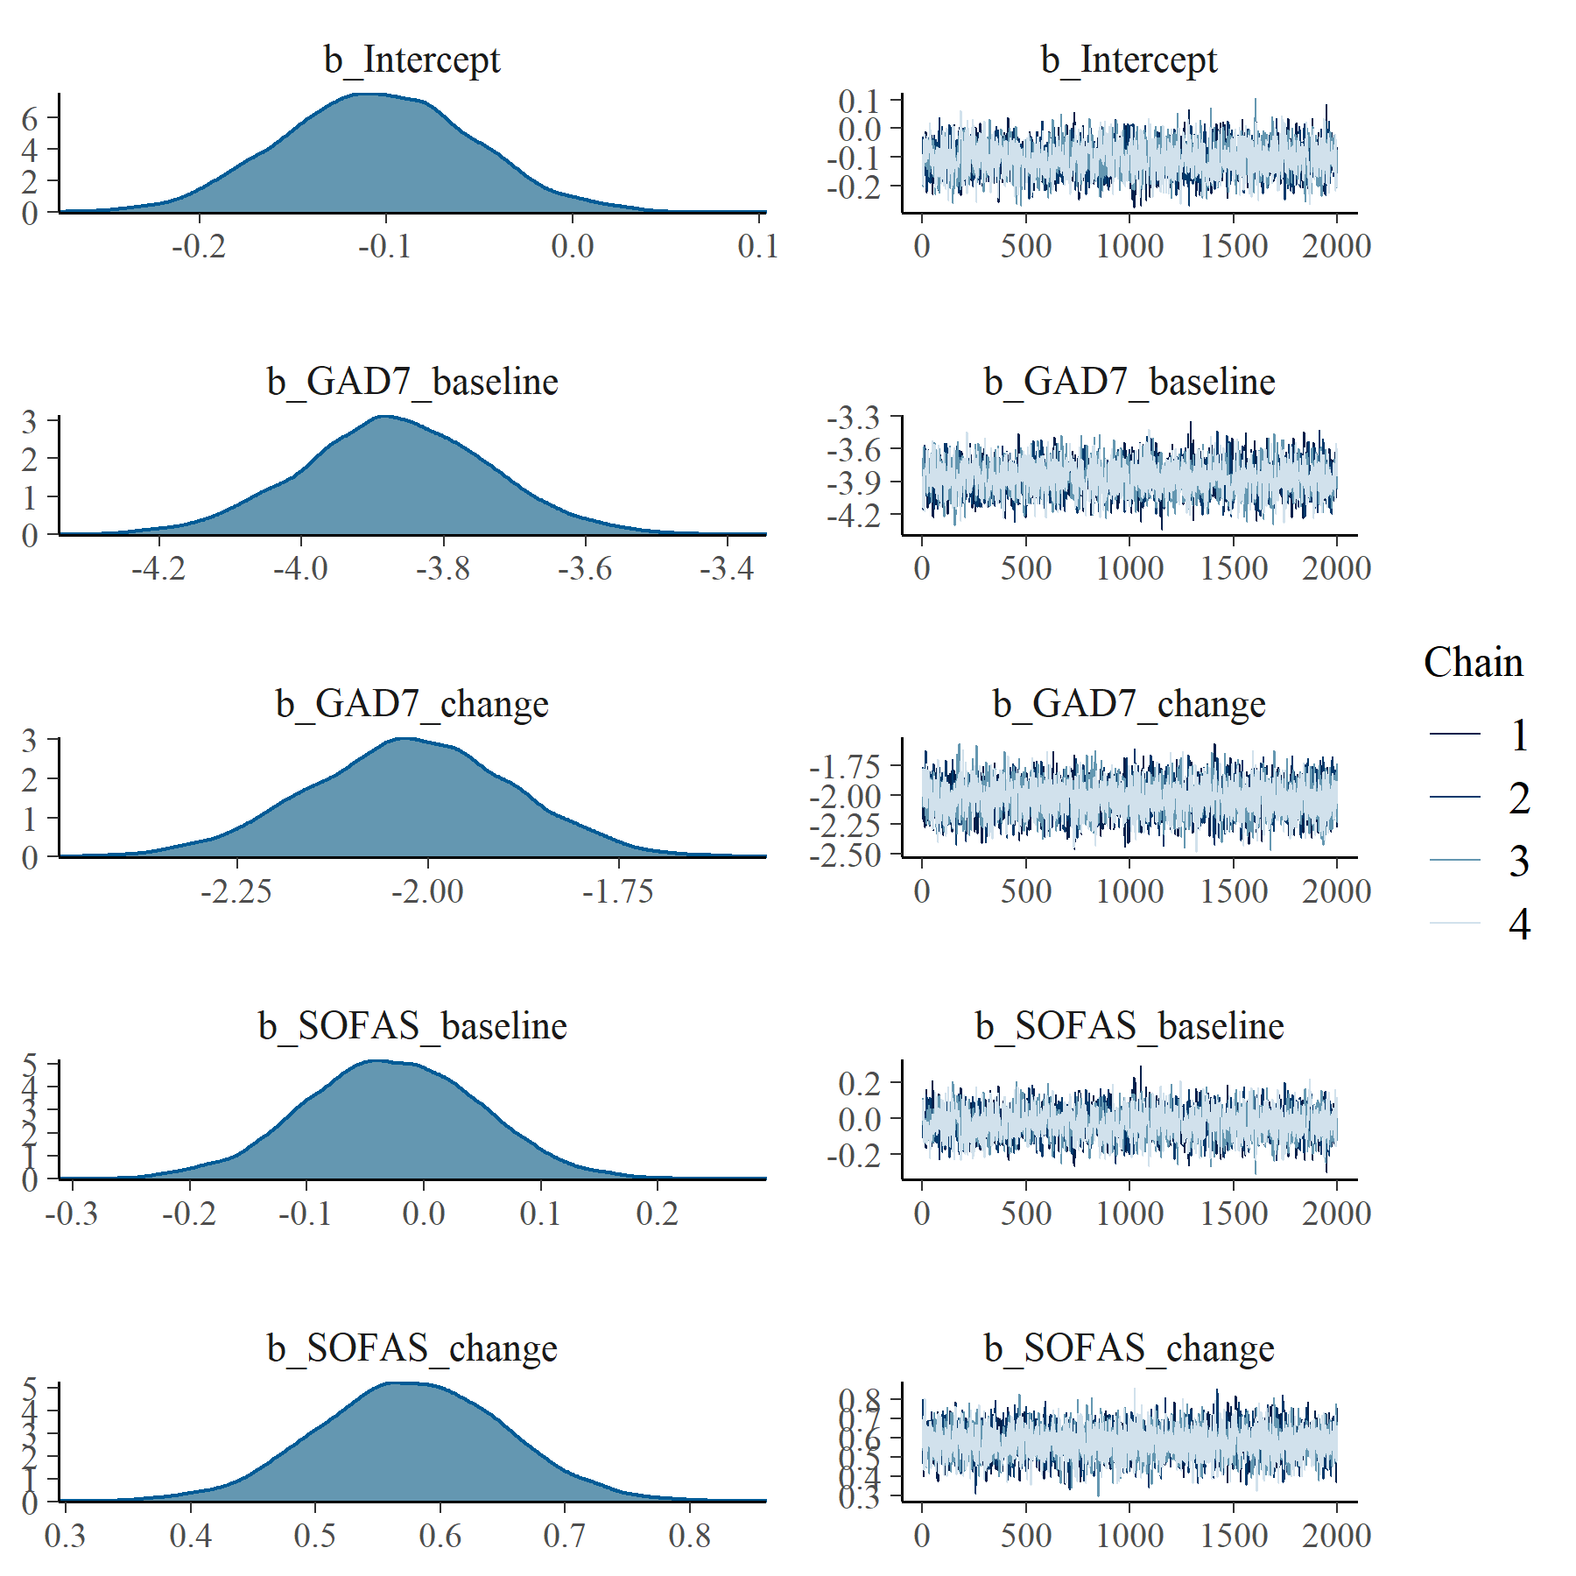

Figure : GAD7 with SOFAS Generalised Linear Mixed Model with Gaussian distribution and log link population level effects

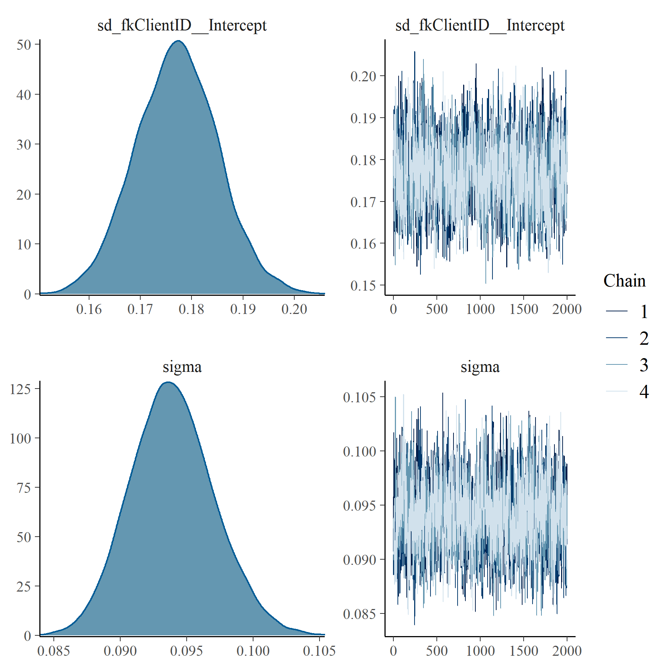

Figure : GAD7 with SOFAS Generalised Linear Mixed Model with Gaussian distribution and log link group level effects

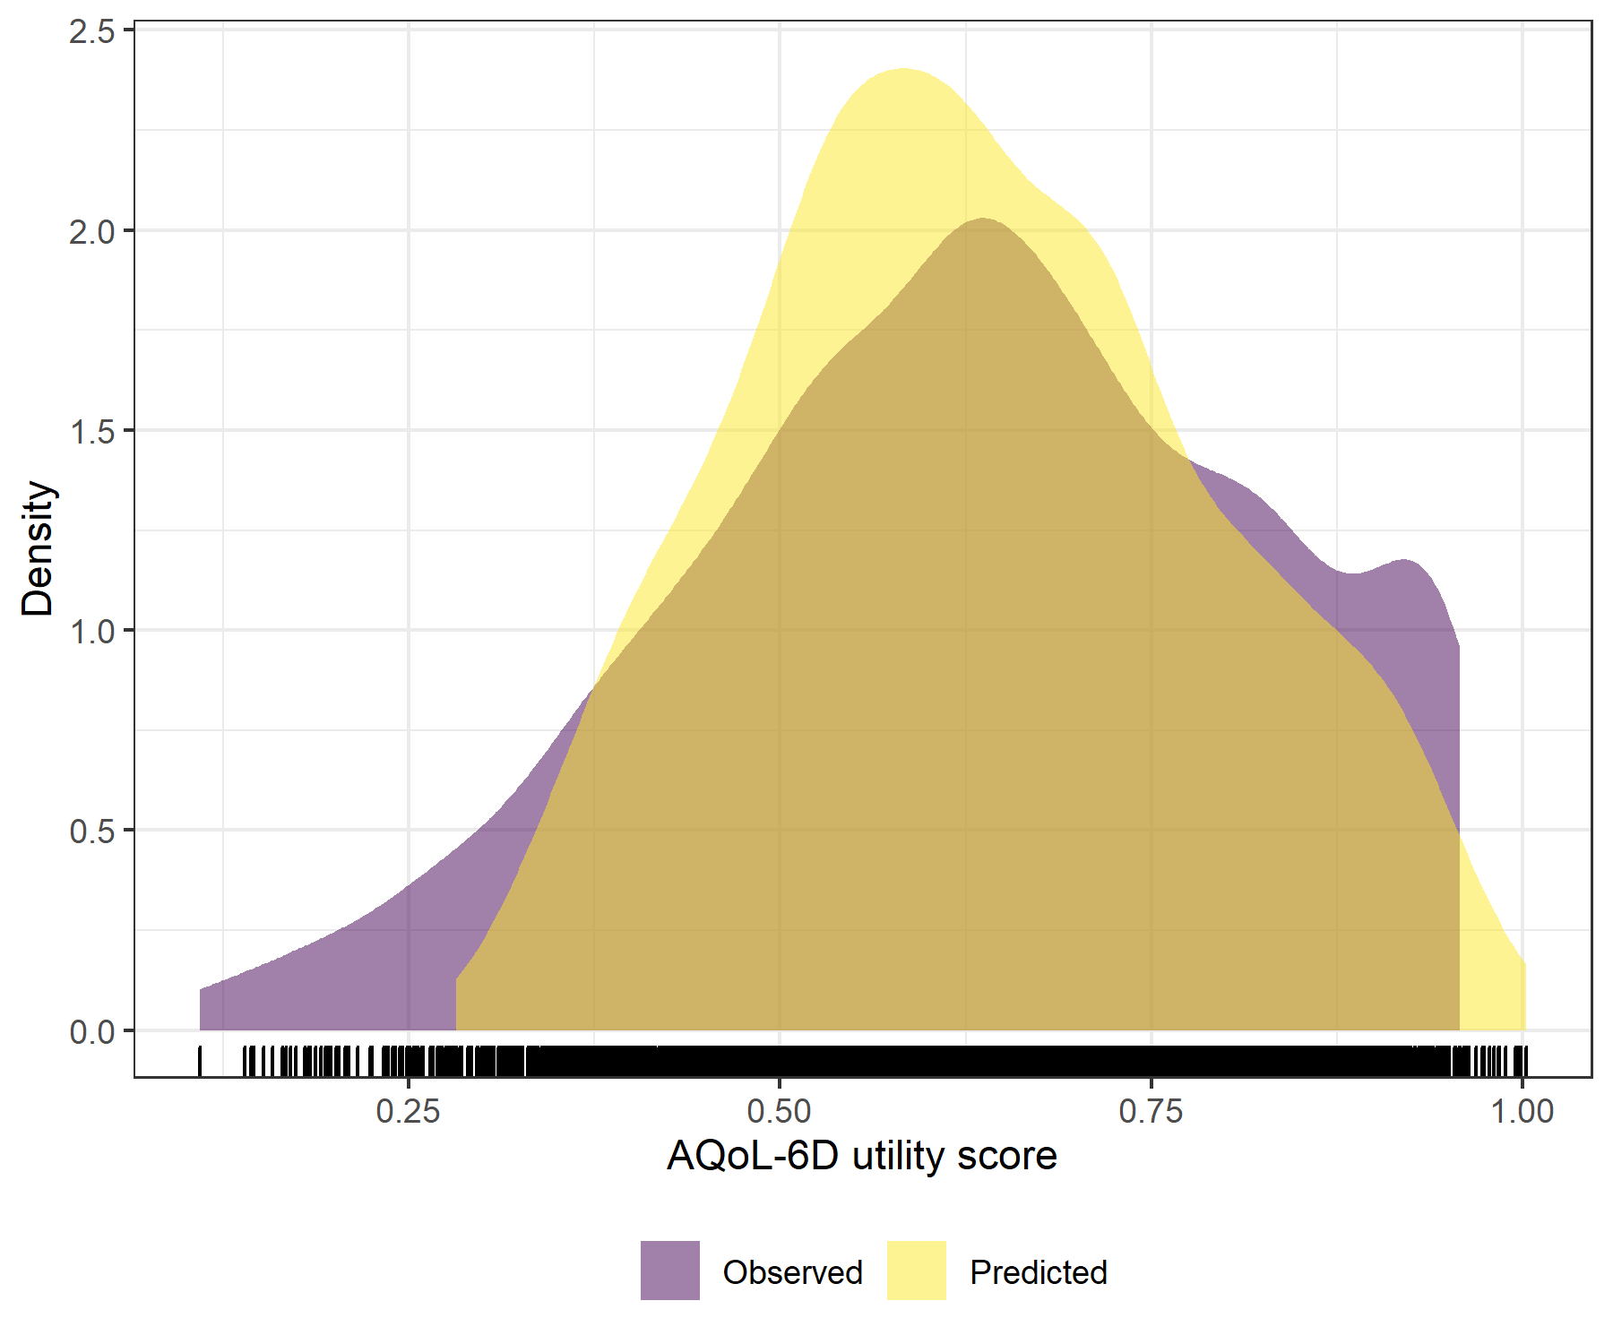

Figure : GAD7 with SOFAS Generalised Linear Mixed Model with Gaussian distribution and log link comparative densities of observed and predicted data

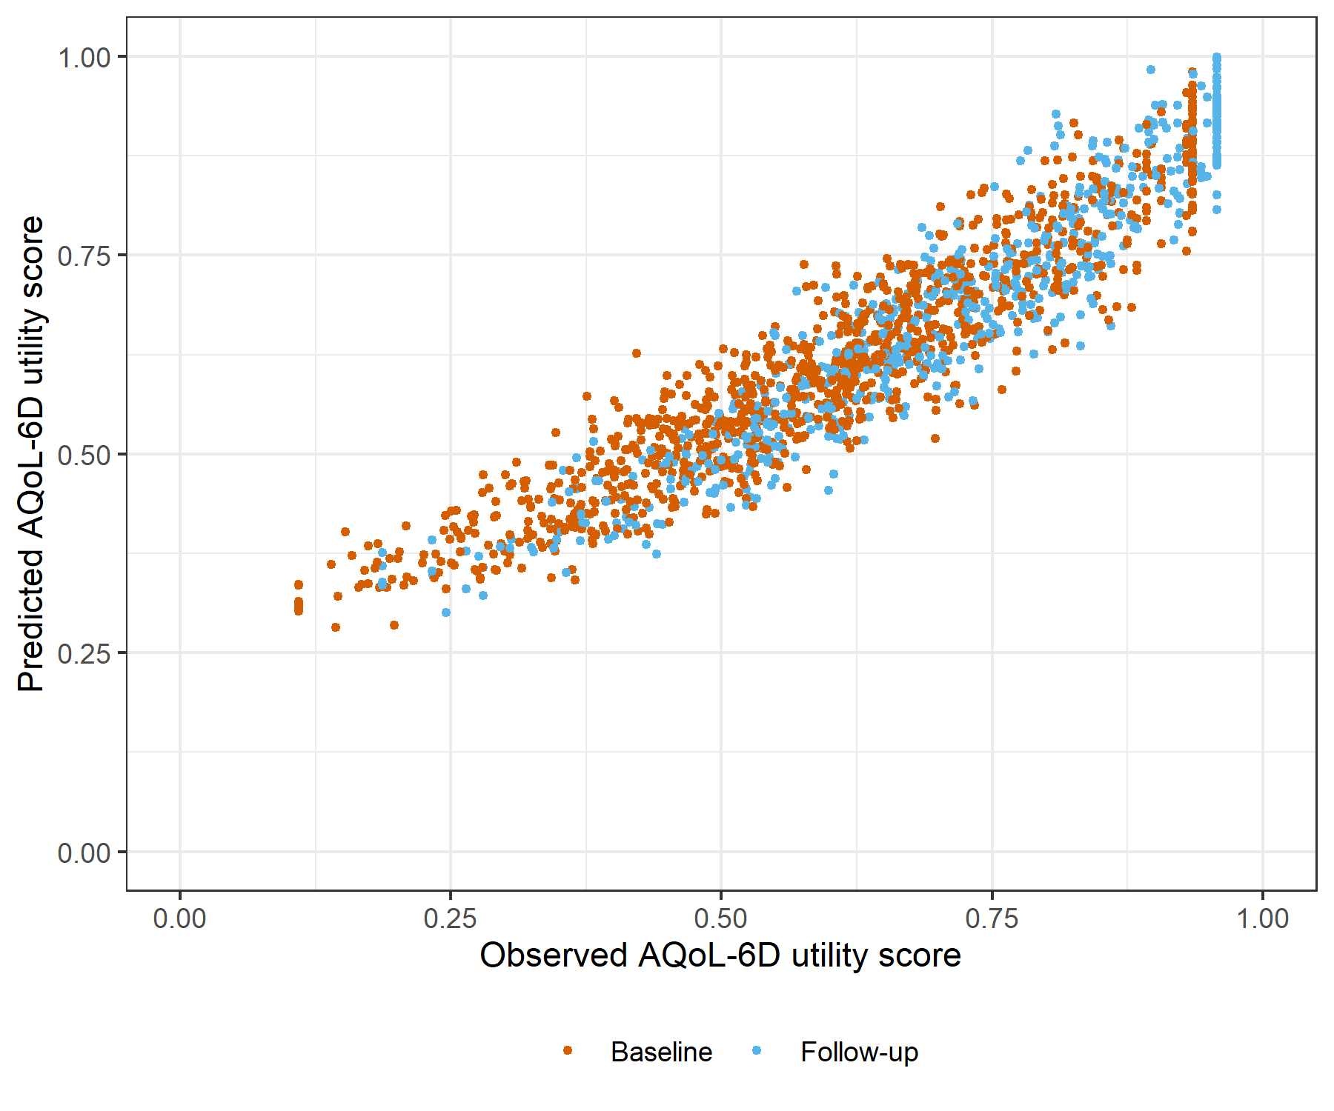

Figure : GAD7 with SOFAS Generalised Linear Mixed Model with Gaussian distribution and log link comparative scatter plot of obsereved and predicted data

# GAD7 with SOFAS Linear Mixed Model with clog-log transformation

Table : GAD7 with SOFAS Linear Mixed Model with clog-log transformation

| Parameter | Estimate | Est.Error | l-95% CI | u-95% CI | Rhat | Bulk_ESS | Tail_ESS |
| --- | --- | --- | --- | --- | --- | --- | --- |
| **Group-Level Effects:** | | | | | | | |
| fkClientID (Number of levels: 1032) |  |  |  |  |  |  |  |
| sd(Intercept) | 0.37 | 0.01 | 0.35 | 0.40 | 1.00 | 1 366 | 2 779 |
| **Population-Level Effects:** | | | | | | | |
| Intercept | 0.76 | 0.10 | 0.56 | 0.96 | 1.00 | 1 957 | 3 395 |
| GAD7_baseline | -7.67 | 0.26 | -8.16 | -7.16 | 1.00 | 1 699 | 3 553 |
| GAD7_change | -3.82 | 0.23 | -4.29 | -3.37 | 1.00 | 4 145 | 5 190 |
| SOFAS_baseline | -0.04 | 0.15 | -0.34 | 0.25 | 1.00 | 1 907 | 3 392 |
| SOFAS_change | 1.38 | 0.14 | 1.09 | 1.65 | 1.00 | 5 872 | 5 582 |
| **Family Specific Parameters:** | | | | | | | |
| sigma | 0.26 | 0.01 | 0.25 | 0.28 | 1.00 | 1 552 | 3 586 |
| Formula: aqol6d_total_w_cloglog ~ GAD7_baseline + GAD7_change + SOFAS_baseline + SOFAS_change + (1 | fkClientID) | | | | | | | |
| Family: gaussian Links: mu = identity; sigma = identity Data: data_tb (Number of observations: 1649) Samples: 4 chains, each with iter = 4000; warmup = 2000; thin = 1; total post-warmup samples = 8000 | | | | | | | |
| Samples were drawn using sample(hmc). For each parameter, Bulk_ESS and Tail_ESS are effective sample size measures, and Rhat is the potential scale reduction factor on split chains (at convergence, Rhat = 1). | | | | | | | |

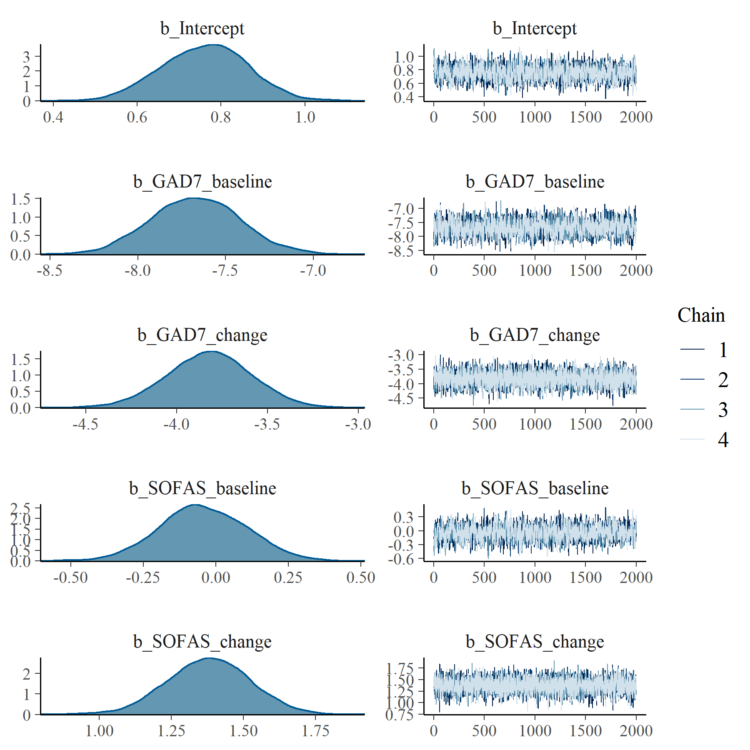

Figure : GAD7 with SOFAS Linear Mixed Model with clog-log transformation population level effects

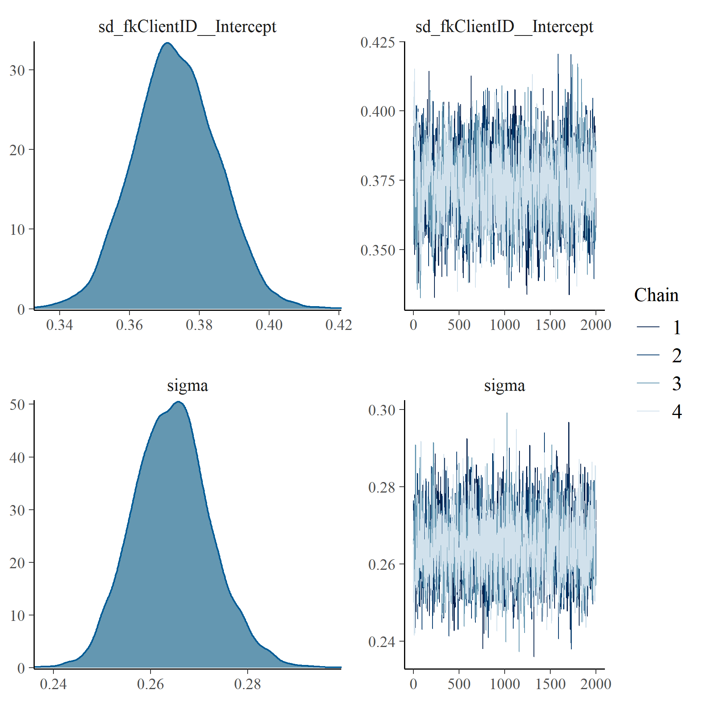

Figure : GAD7 with SOFAS Linear Mixed Model with clog-log transformation group level effects

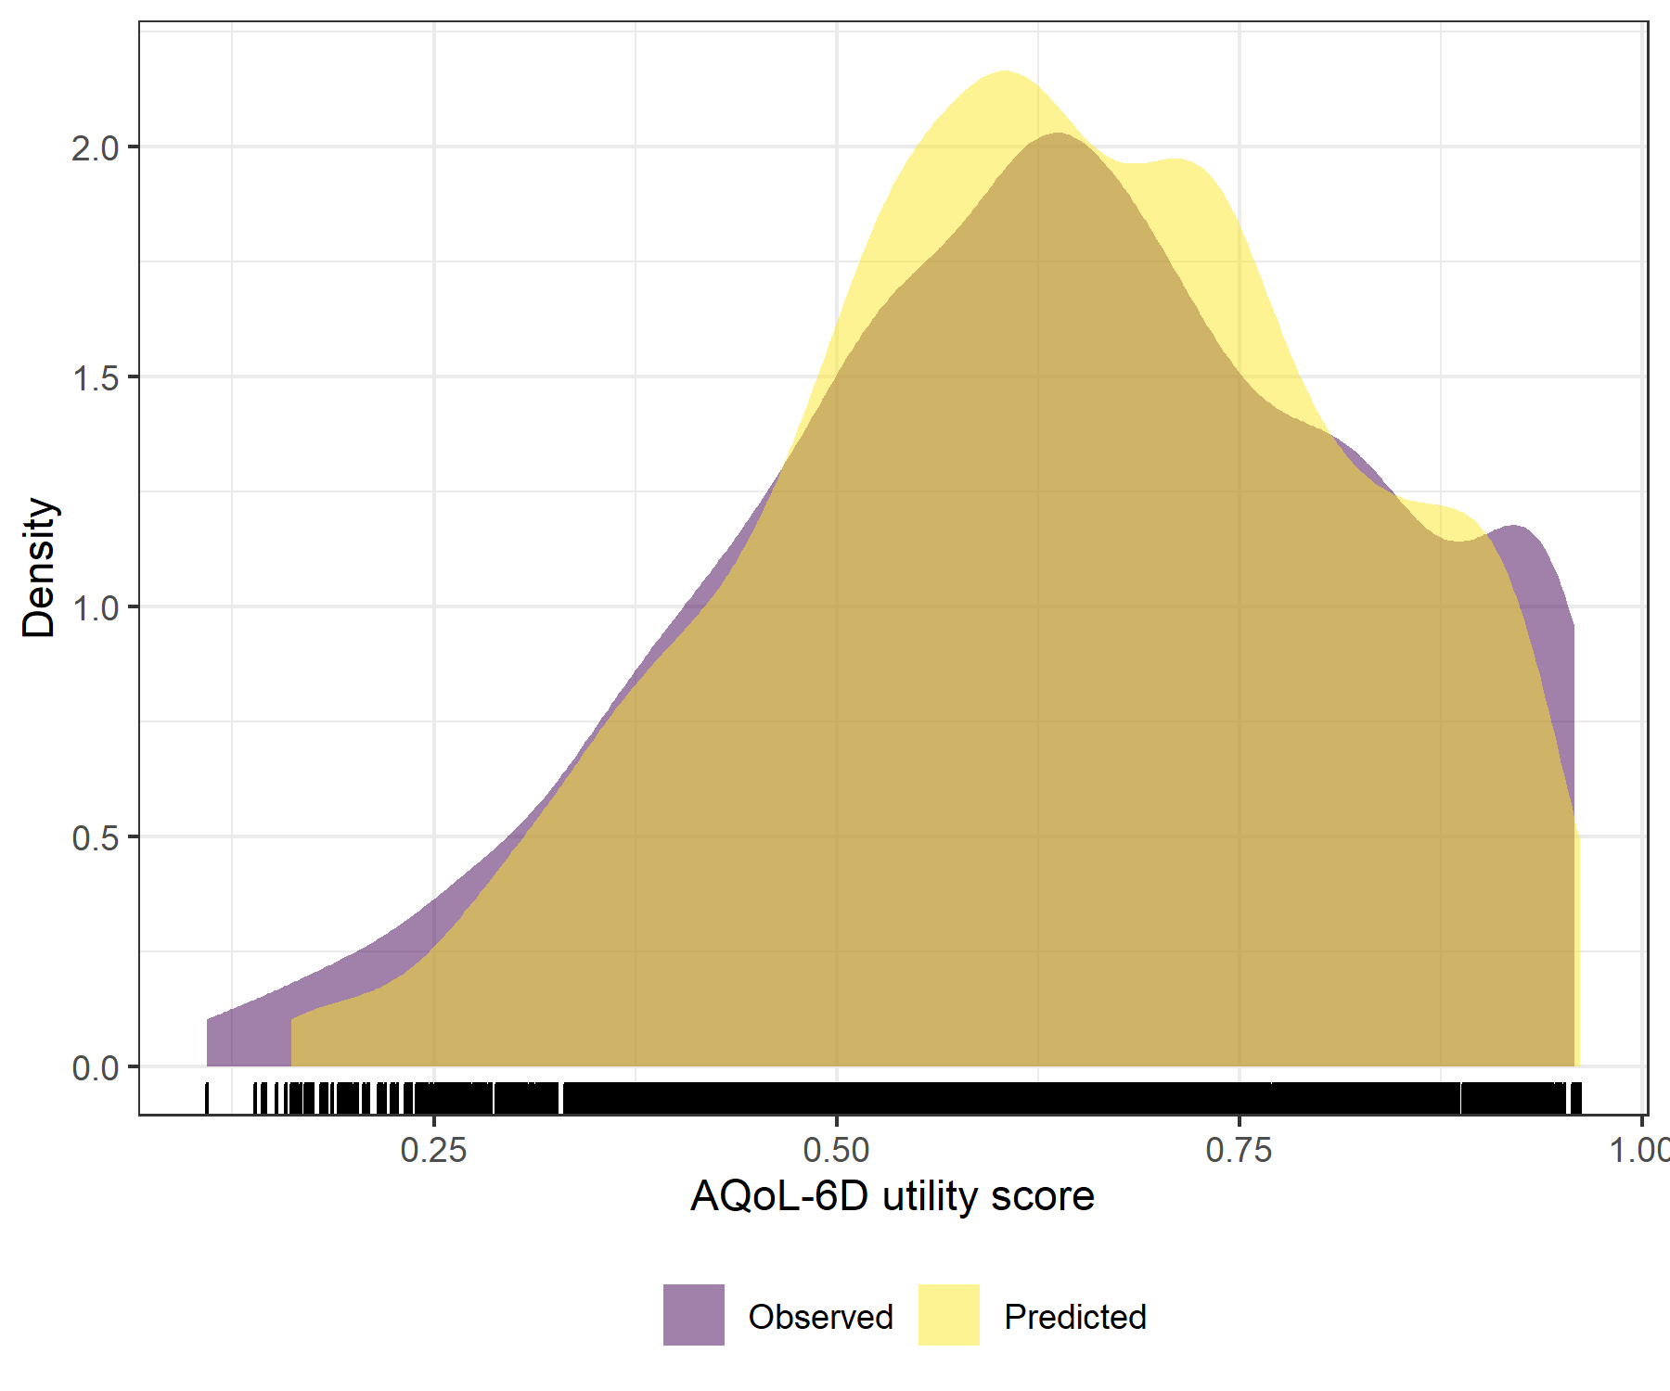

Figure : GAD7 with SOFAS Linear Mixed Model with clog-log transformation comparative densities of observed and predicted data

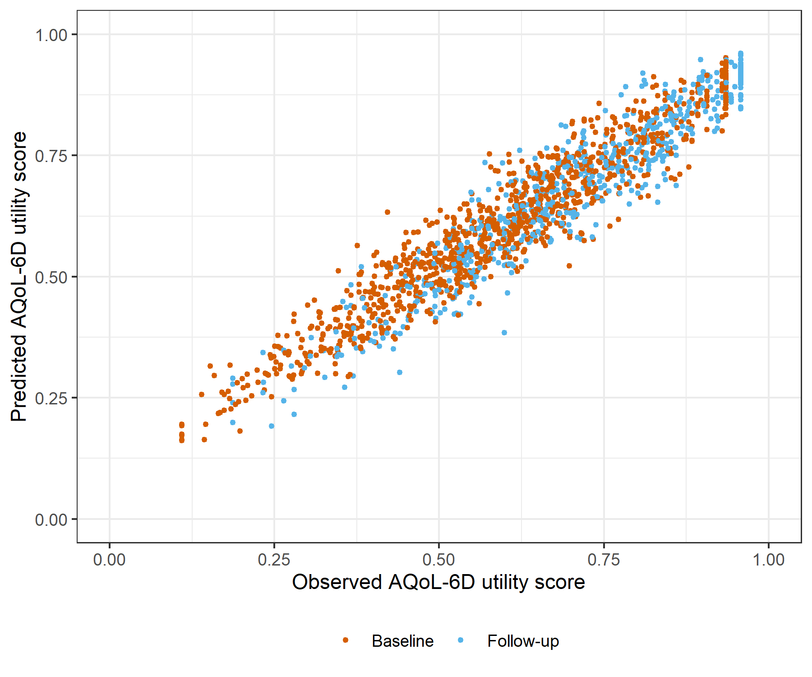

Figure : GAD7 with SOFAS Linear Mixed Model with clog-log transformation comparative scatter plot of obsereved and predicted data

# K6 with SOFAS Generalised Linear Mixed Model with Gaussian distribution and log link

Table : K6 with SOFAS Generalised Linear Mixed Model with Gaussian distribution and log link

| Parameter | Estimate | Est.Error | l-95% CI | u-95% CI | Rhat | Bulk_ESS | Tail_ESS |
| --- | --- | --- | --- | --- | --- | --- | --- |
| **Group-Level Effects:** | | | | | | | |
| fkClientID (Number of levels: 1032) |  |  |  |  |  |  |  |
| sd(Intercept) | 0.17 | 0.01 | 0.15 | 0.18 | 1.00 | 1 023 | 2 084 |
| **Population-Level Effects:** | | | | | | | |
| Intercept | -0.05 | 0.05 | -0.14 | 0.05 | 1.00 | 1 888 | 3 659 |
| K6_baseline | -3.86 | 0.12 | -4.10 | -3.62 | 1.00 | 2 364 | 3 445 |
| K6_change | -1.87 | 0.13 | -2.12 | -1.63 | 1.00 | 2 670 | 4 576 |
| SOFAS_baseline | -0.01 | 0.07 | -0.15 | 0.13 | 1.00 | 1 847 | 3 478 |
| SOFAS_change | 0.61 | 0.07 | 0.47 | 0.76 | 1.00 | 4 543 | 5 634 |
| **Family Specific Parameters:** | | | | | | | |
| sigma | 0.09 | 0.00 | 0.09 | 0.10 | 1.00 | 1 092 | 2 159 |
| Formula: aqol6d_total_w ~ K6_baseline + K6_change + SOFAS_baseline + SOFAS_change + (1 | fkClientID) | | | | | | | |
| Family: gaussian Links: mu = log; sigma = identity Data: data_tb (Number of observations: 1650) Samples: 4 chains, each with iter = 4000; warmup = 2000; thin = 1; total post-warmup samples = 8000 | | | | | | | |
| Samples were drawn using sample(hmc). For each parameter, Bulk_ESS and Tail_ESS are effective sample size measures, and Rhat is the potential scale reduction factor on split chains (at convergence, Rhat = 1). | | | | | | | |

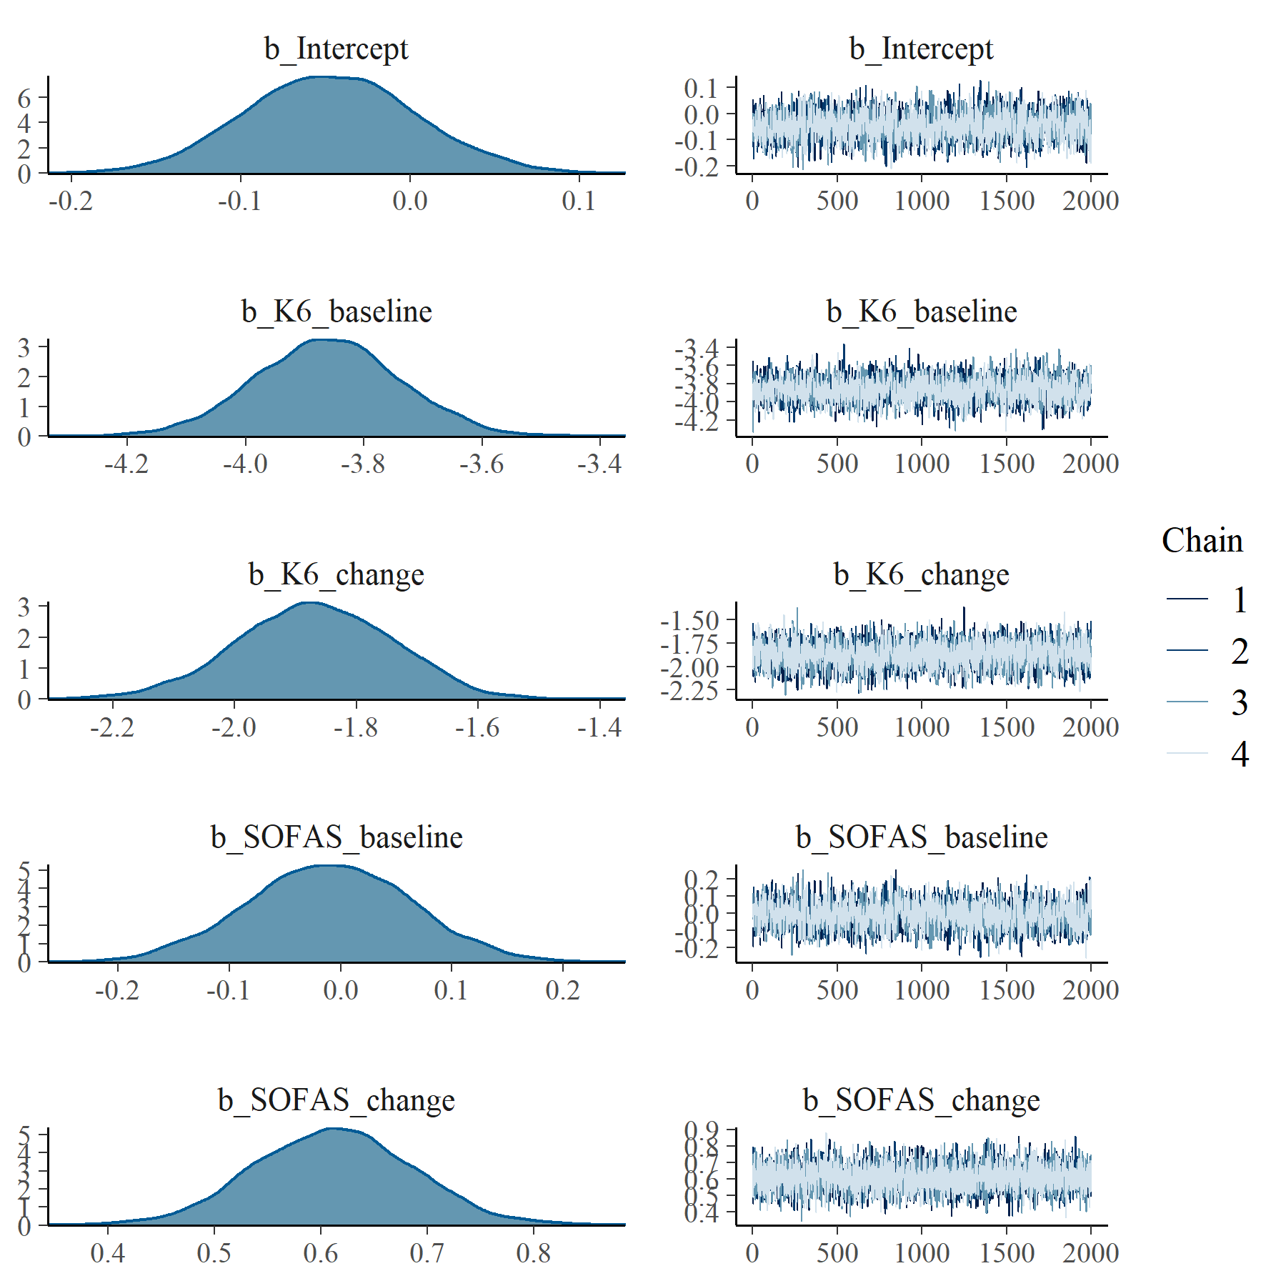

Figure : K6 with SOFAS Generalised Linear Mixed Model with Gaussian distribution and log link population level effects

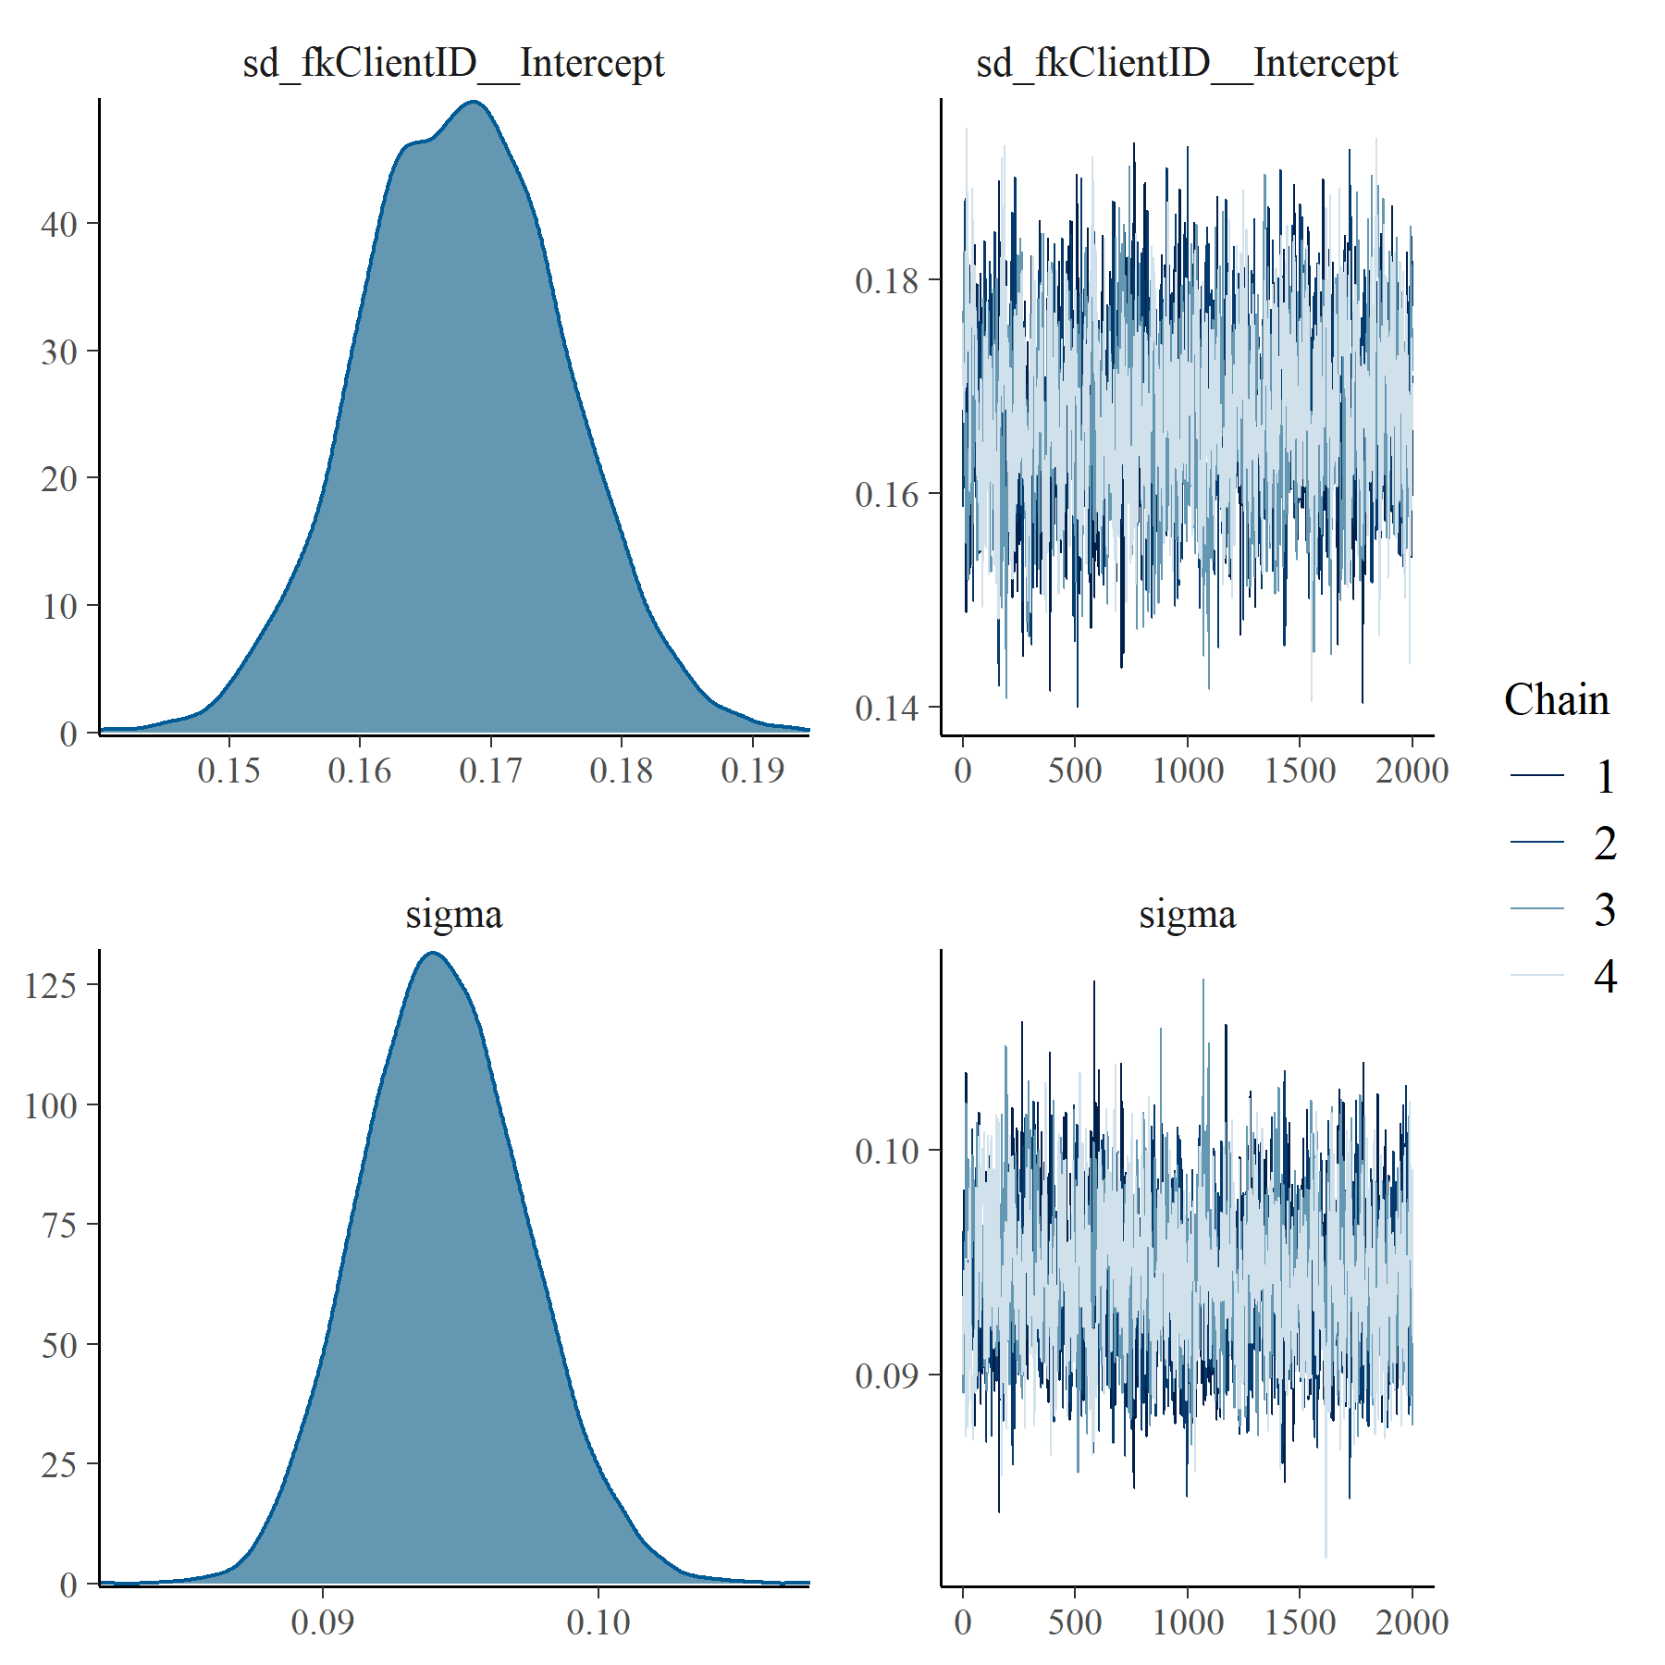

Figure : K6 with SOFAS Generalised Linear Mixed Model with Gaussian distribution and log link group level effects

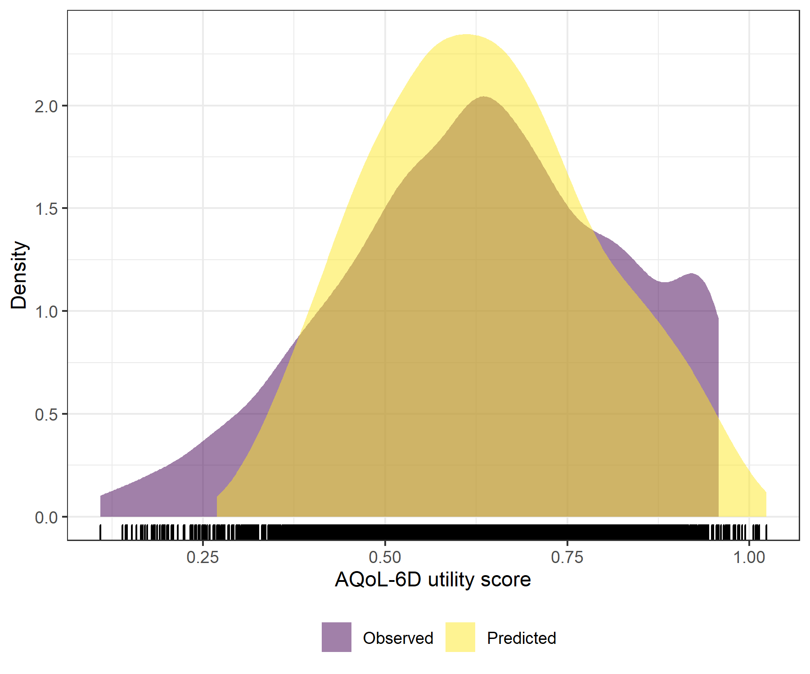

Figure : K6 with SOFAS Generalised Linear Mixed Model with Gaussian distribution and log link comparative densities of observed and predicted data

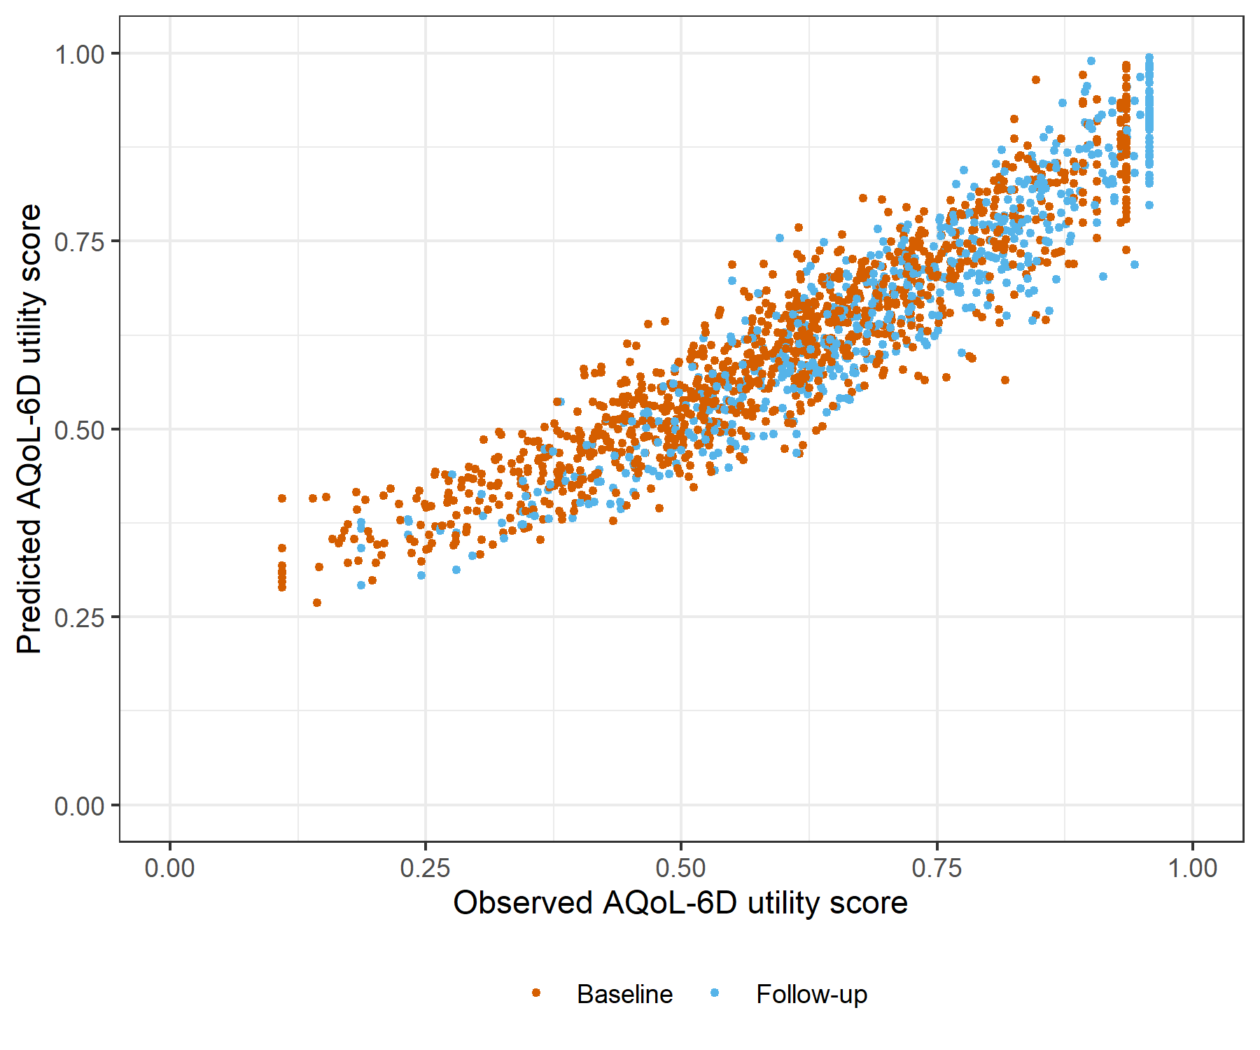

Figure : K6 with SOFAS Generalised Linear Mixed Model with Gaussian distribution and log link comparative scatter plot of obsereved and predicted data

# K6 with SOFAS Linear Mixed Model with clog-log transformation

Table : K6 with SOFAS Linear Mixed Model with clog-log transformation

| Parameter | Estimate | Est.Error | l-95% CI | u-95% CI | Rhat | Bulk_ESS | Tail_ESS |
| --- | --- | --- | --- | --- | --- | --- | --- |
| **Group-Level Effects:** | | | | | | | |
| fkClientID (Number of levels: 1032) |  |  |  |  |  |  |  |
| sd(Intercept) | 0.36 | 0.01 | 0.34 | 0.38 | 1.00 | 1 769 | 2 923 |
| **Population-Level Effects:** | | | | | | | |
| Intercept | 0.87 | 0.10 | 0.67 | 1.06 | 1.00 | 1 657 | 3 237 |
| K6_baseline | -7.67 | 0.24 | -8.15 | -7.20 | 1.00 | 1 349 | 3 148 |
| K6_change | -3.61 | 0.22 | -4.04 | -3.18 | 1.00 | 4 251 | 5 863 |
| SOFAS_baseline | 0.01 | 0.14 | -0.27 | 0.29 | 1.00 | 1 624 | 3 099 |
| SOFAS_change | 1.41 | 0.14 | 1.13 | 1.69 | 1.00 | 4 878 | 5 586 |
| **Family Specific Parameters:** | | | | | | | |
| sigma | 0.26 | 0.01 | 0.25 | 0.28 | 1.00 | 1 903 | 3 457 |
| Formula: aqol6d_total_w_cloglog ~ K6_baseline + K6_change + SOFAS_baseline + SOFAS_change + (1 | fkClientID) | | | | | | | |
| Family: gaussian Links: mu = identity; sigma = identity Data: data_tb (Number of observations: 1650) Samples: 4 chains, each with iter = 4000; warmup = 2000; thin = 1; total post-warmup samples = 8000 | | | | | | | |
| Samples were drawn using sample(hmc). For each parameter, Bulk_ESS and Tail_ESS are effective sample size measures, and Rhat is the potential scale reduction factor on split chains (at convergence, Rhat = 1). | | | | | | | |

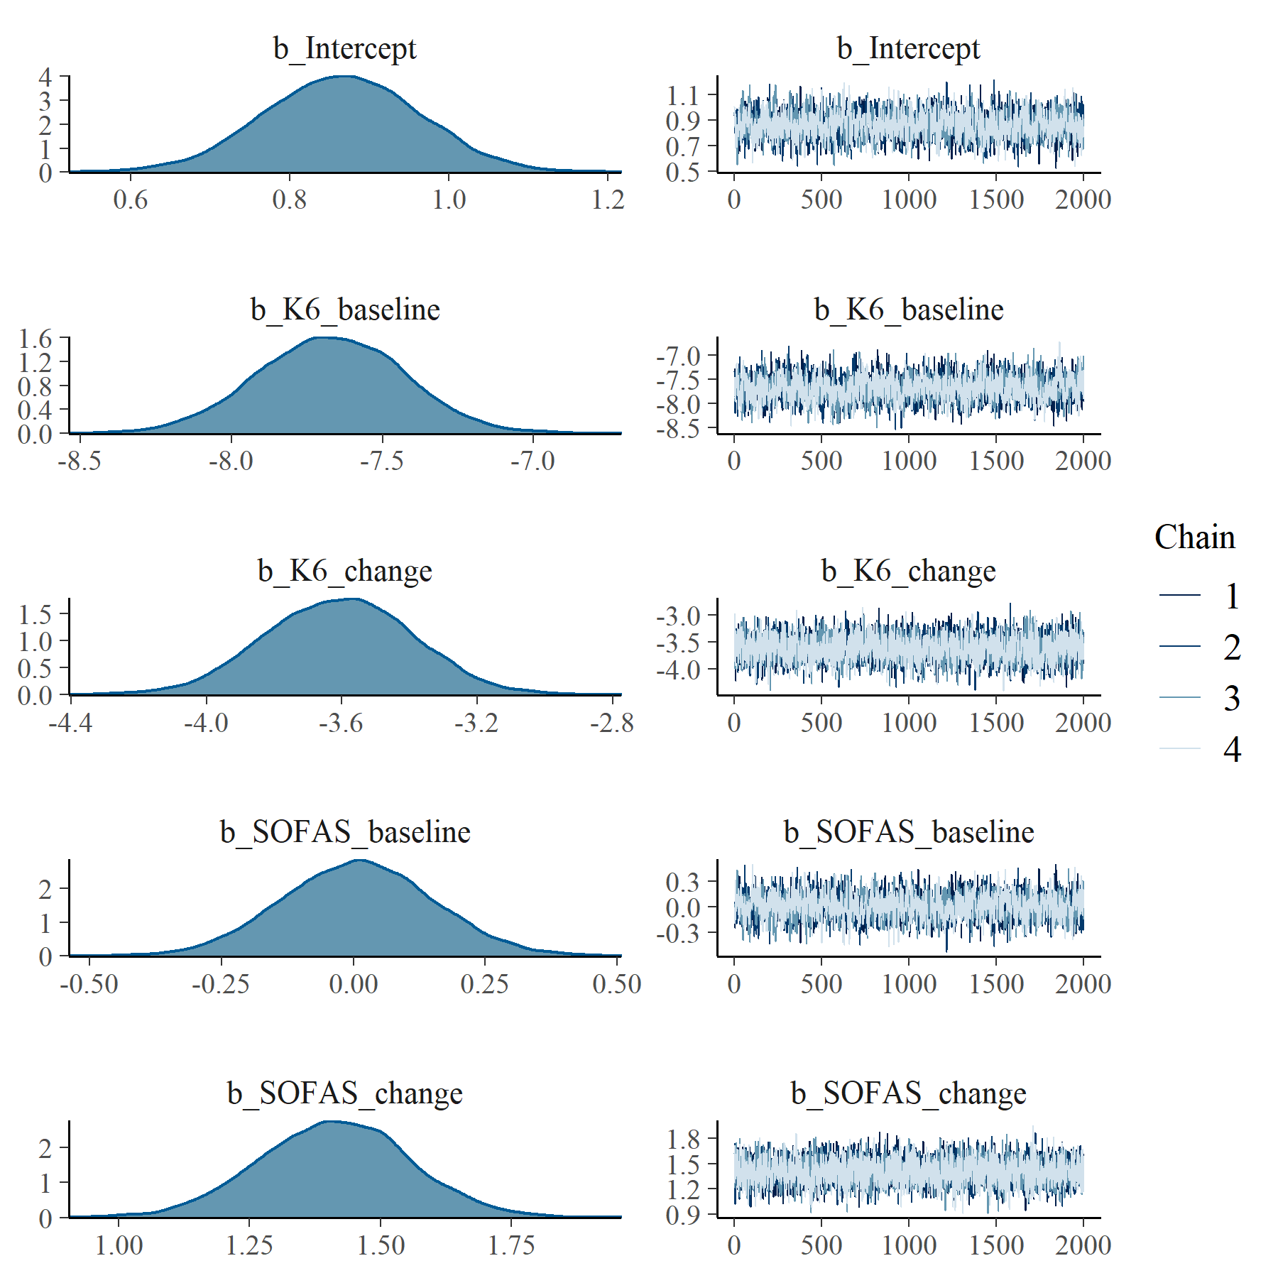

Figure : K6 with SOFAS Linear Mixed Model with clog-log transformation population level effects

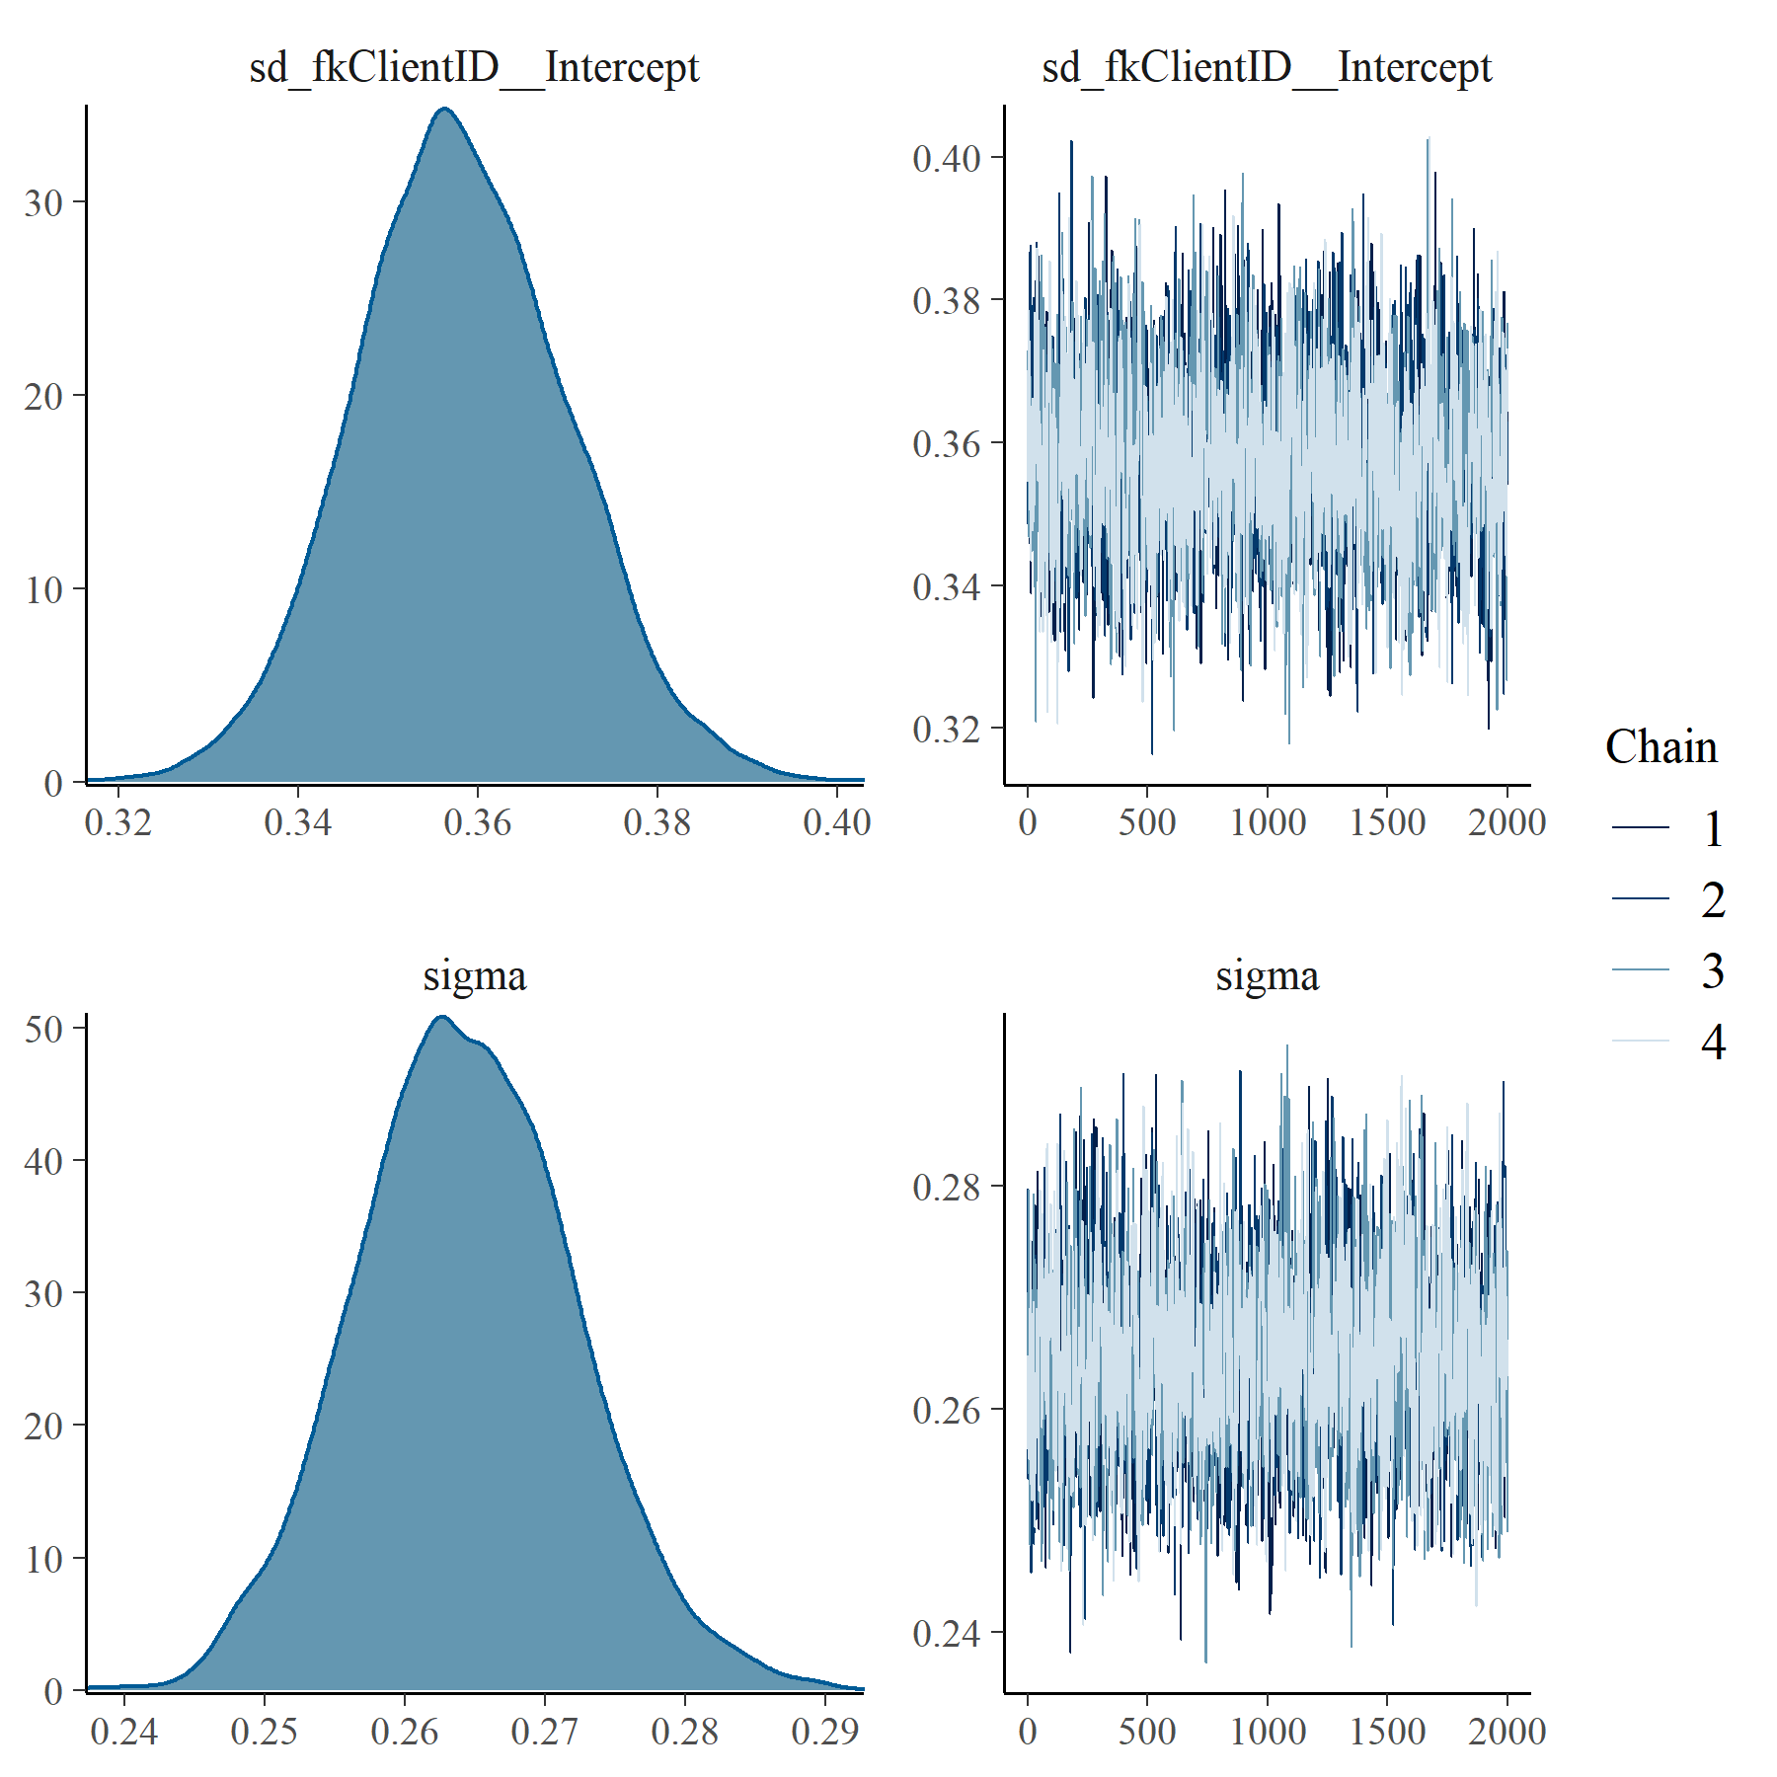

Figure : K6 with SOFAS Linear Mixed Model with clog-log transformation group level effects

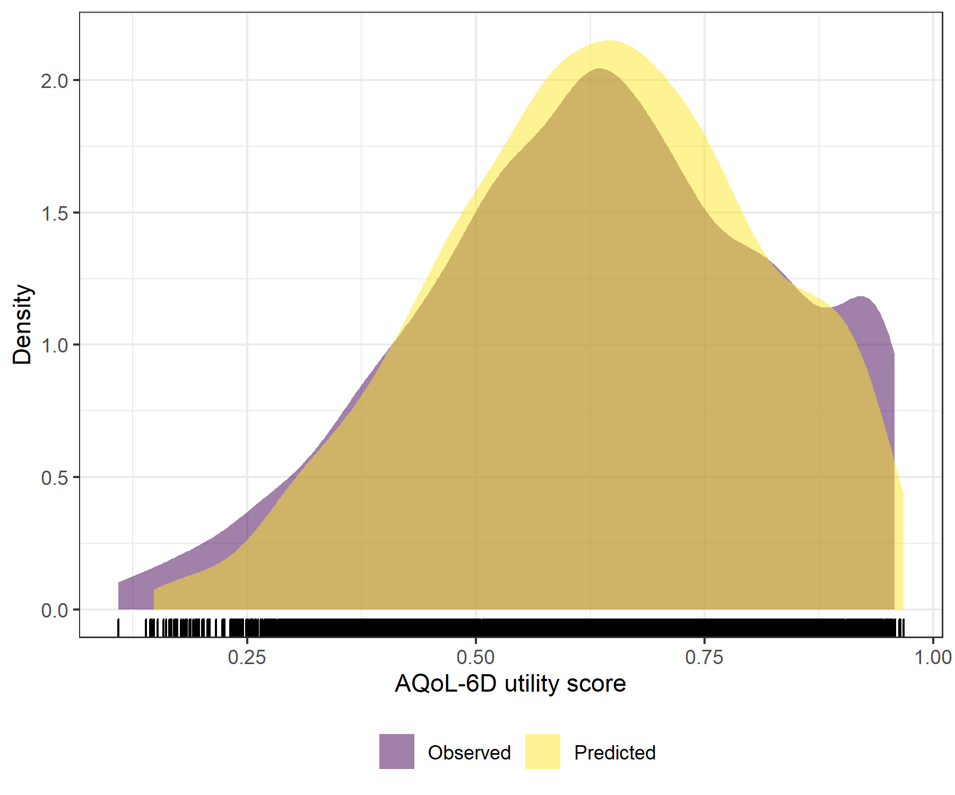

Figure : K6 with SOFAS Linear Mixed Model with clog-log transformation comparative densities of observed and predicted data

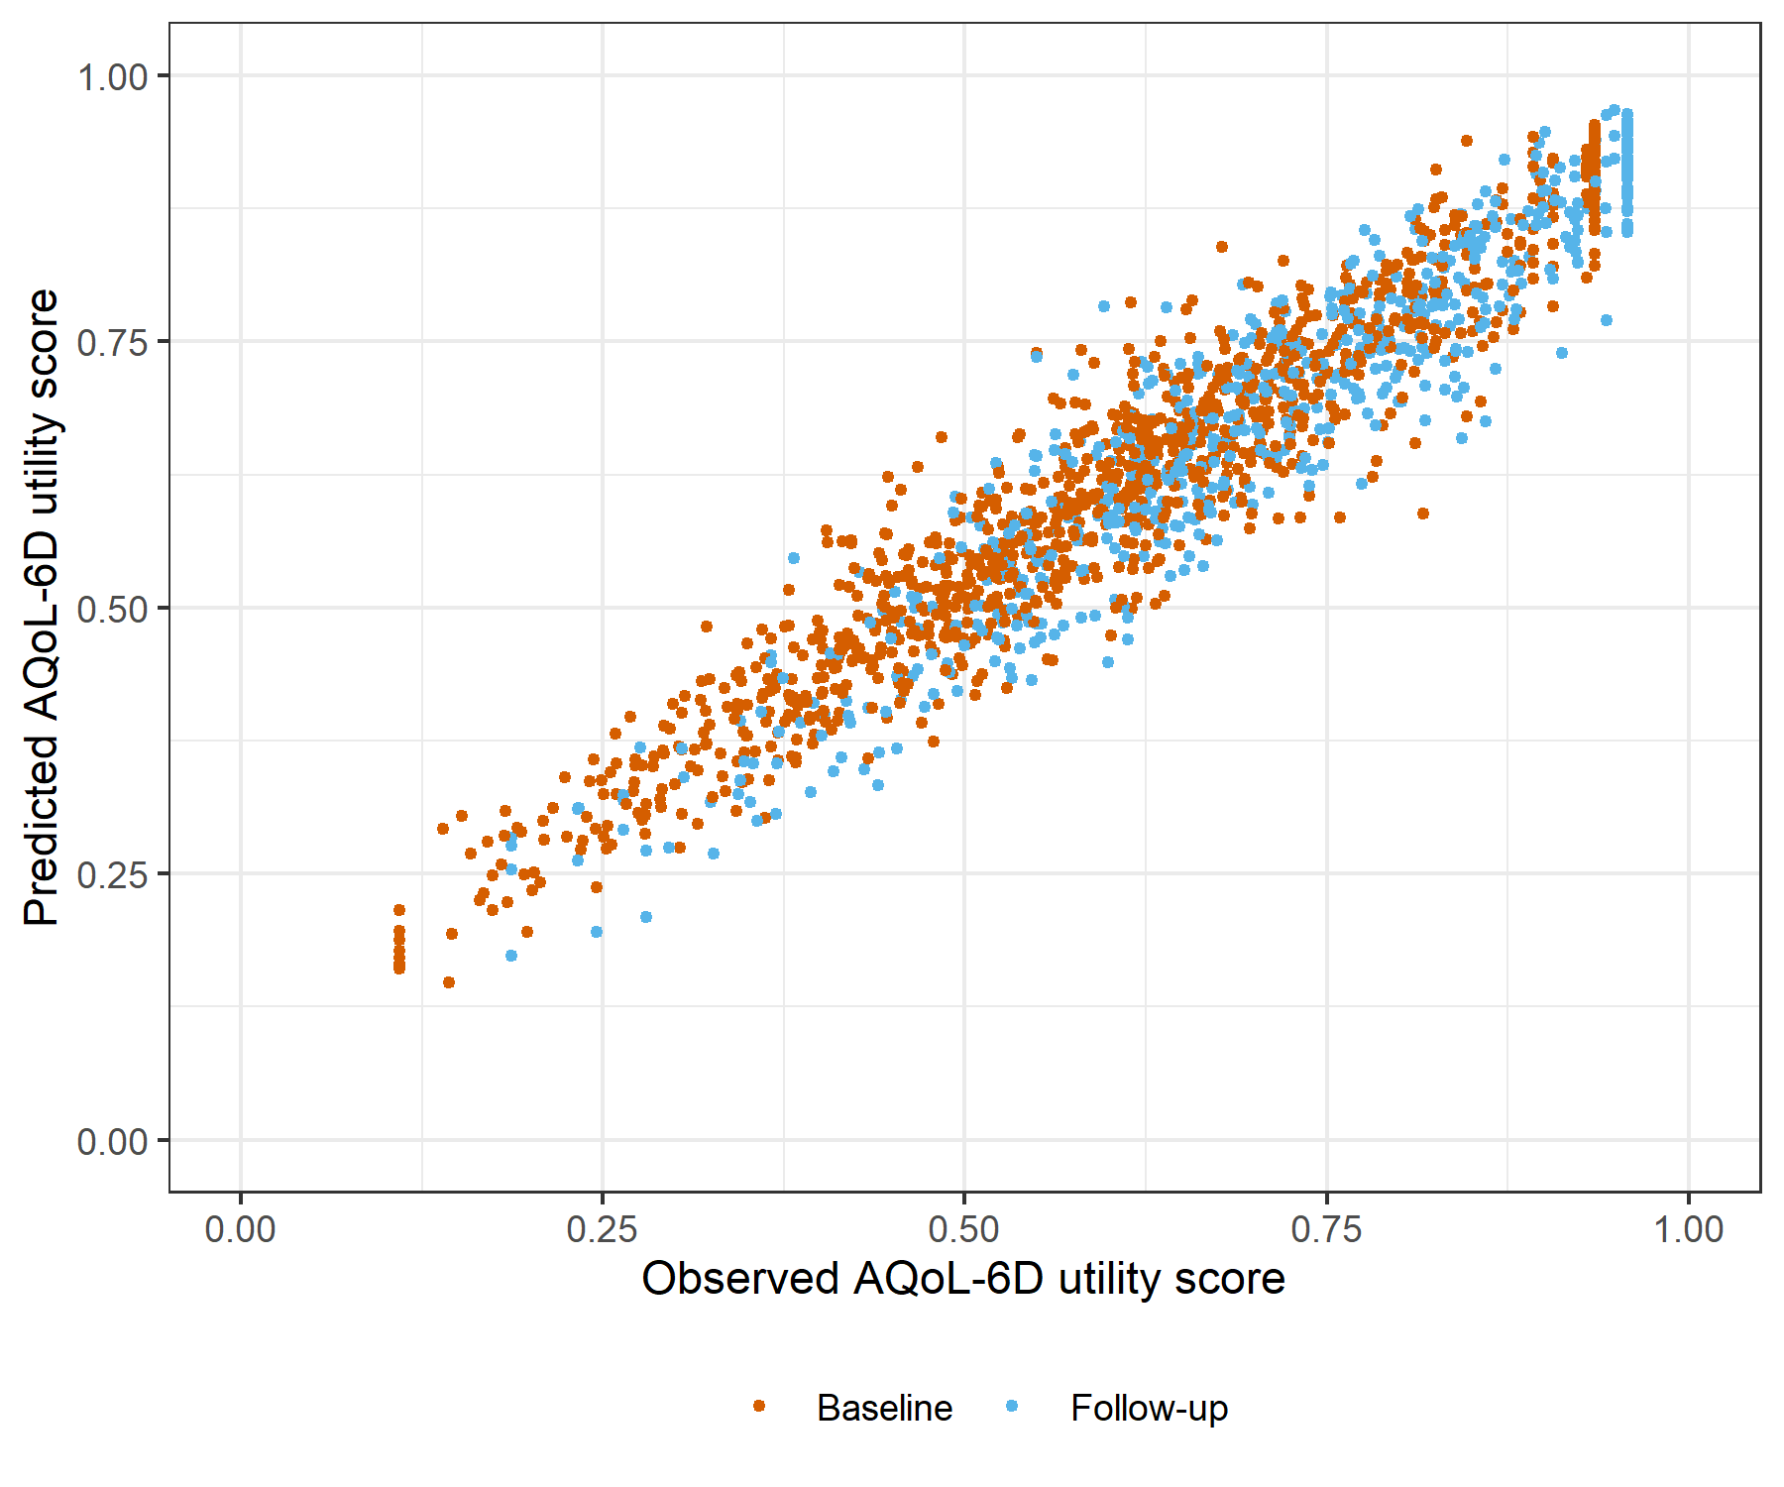

Figure : K6 with SOFAS Linear Mixed Model with clog-log transformation comparative scatter plot of obsereved and predicted data

# OASIS with SOFAS Generalised Linear Mixed Model with Gaussian distribution and log link

Table : OASIS with SOFAS Generalised Linear Mixed Model with Gaussian distribution and log link

| Parameter | Estimate | Est.Error | l-95% CI | u-95% CI | Rhat | Bulk_ESS | Tail_ESS |
| --- | --- | --- | --- | --- | --- | --- | --- |
| **Group-Level Effects:** | | | | | | | |
| fkClientID (Number of levels: 1027) |  |  |  |  |  |  |  |
| sd(Intercept) | 0.16 | 0.01 | 0.15 | 0.18 | 1.01 | 803 | 2 091 |
| **Population-Level Effects:** | | | | | | | |
| Intercept | -0.14 | 0.05 | -0.23 | -0.04 | 1.00 | 2 641 | 4 124 |
| OASIS_baseline | -5.03 | 0.15 | -5.33 | -4.74 | 1.00 | 2 699 | 4 071 |
| OASIS_change | -2.60 | 0.17 | -2.95 | -2.27 | 1.00 | 2 603 | 4 337 |
| SOFAS_baseline | 0.03 | 0.07 | -0.11 | 0.17 | 1.00 | 2 607 | 4 003 |
| SOFAS_change | 0.59 | 0.07 | 0.44 | 0.73 | 1.00 | 5 421 | 5 812 |
| **Family Specific Parameters:** | | | | | | | |
| sigma | 0.09 | 0.00 | 0.09 | 0.10 | 1.01 | 831 | 2 296 |
| Formula: aqol6d_total_w ~ OASIS_baseline + OASIS_change + SOFAS_baseline + SOFAS_change + (1 | fkClientID) | | | | | | | |
| Family: gaussian Links: mu = log; sigma = identity Data: data_tb (Number of observations: 1645) Samples: 4 chains, each with iter = 4000; warmup = 2000; thin = 1; total post-warmup samples = 8000 | | | | | | | |
| Samples were drawn using sample(hmc). For each parameter, Bulk_ESS and Tail_ESS are effective sample size measures, and Rhat is the potential scale reduction factor on split chains (at convergence, Rhat = 1). | | | | | | | |

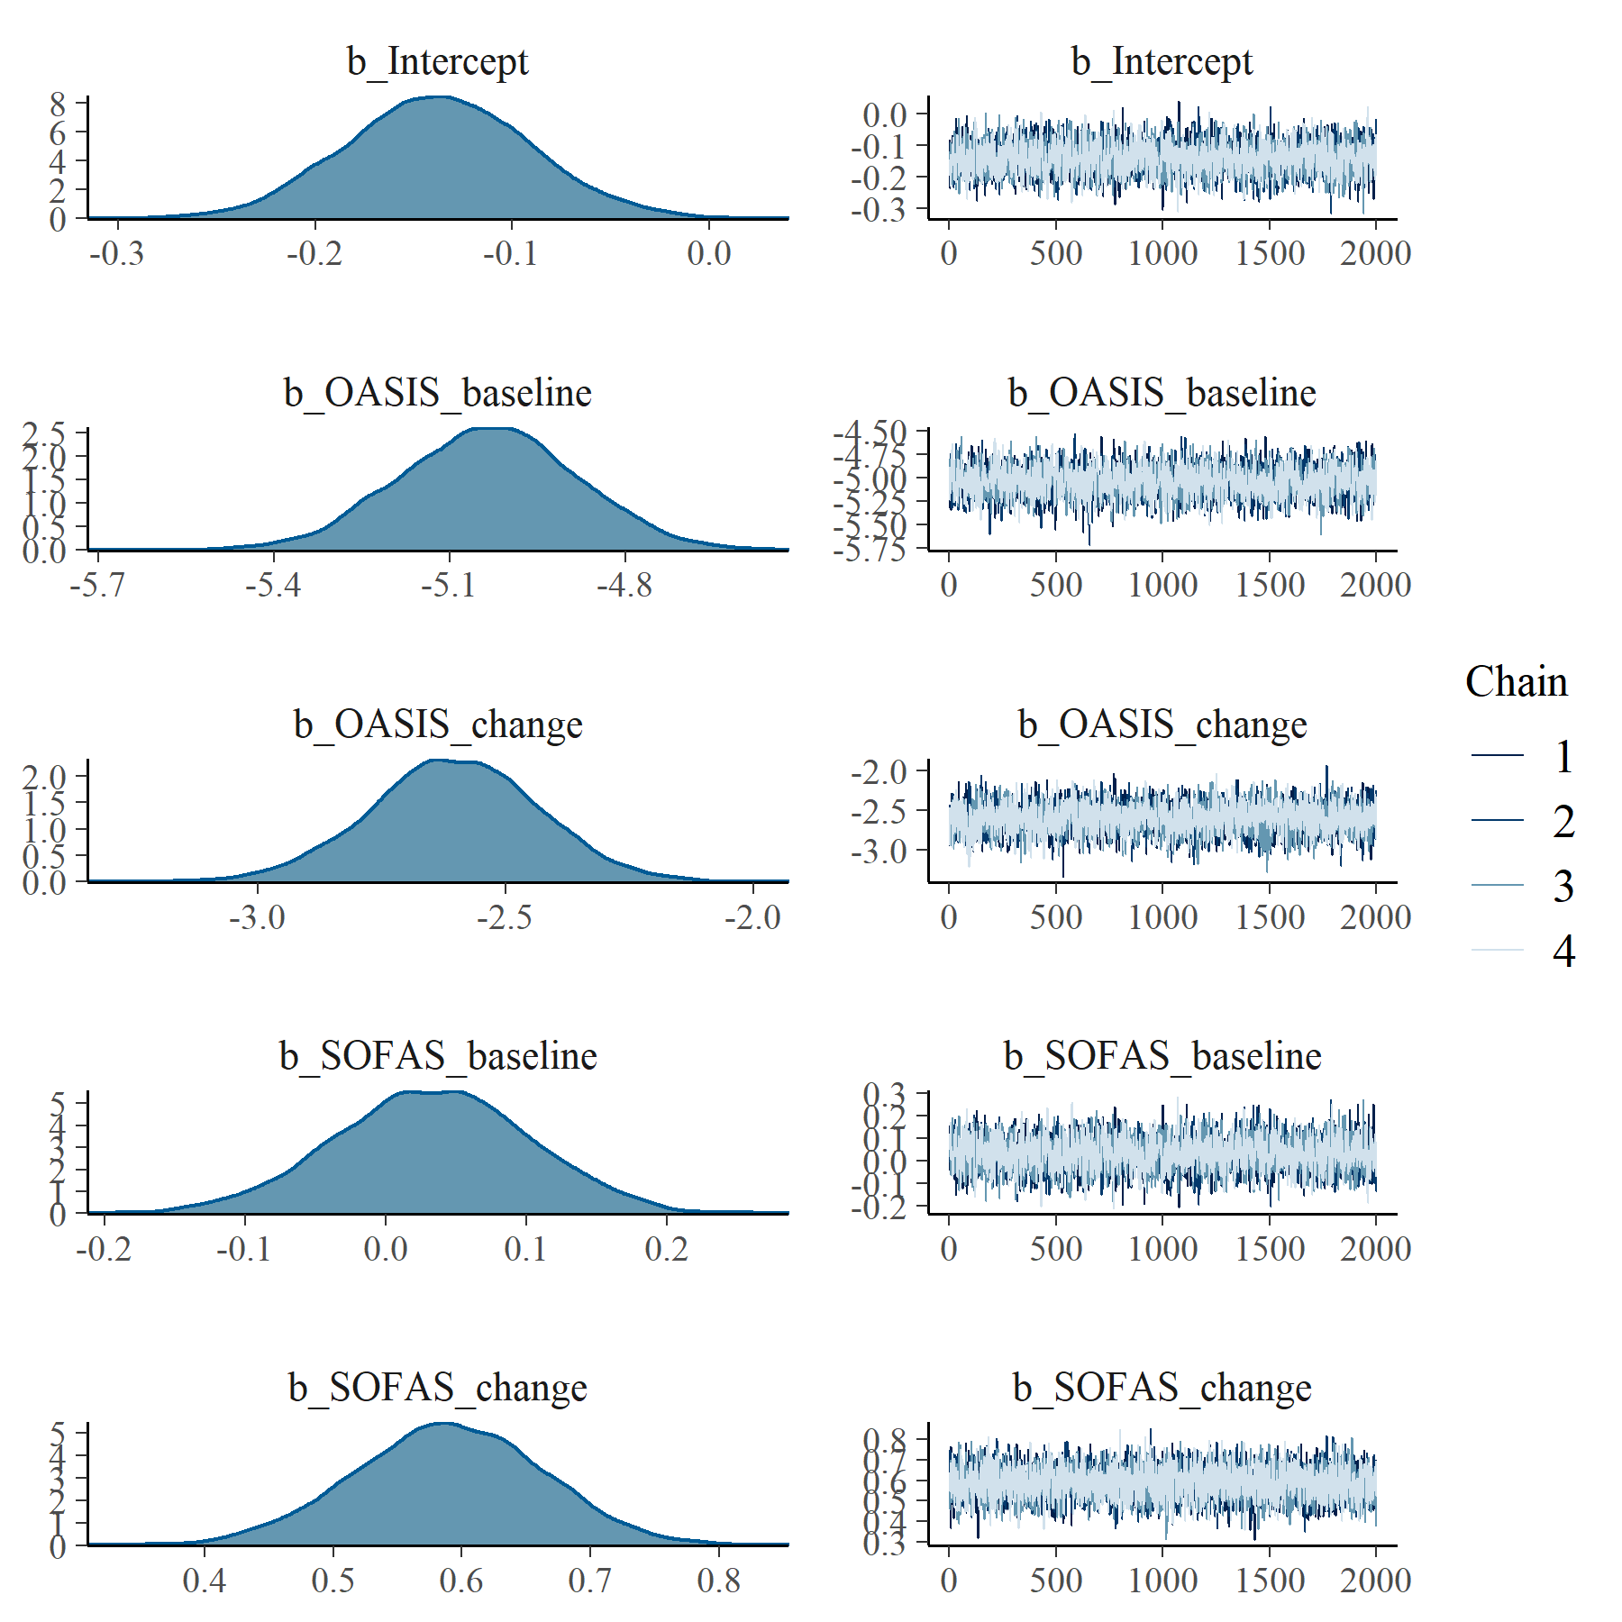

Figure : OASIS with SOFAS Generalised Linear Mixed Model with Gaussian distribution and log link population level effects

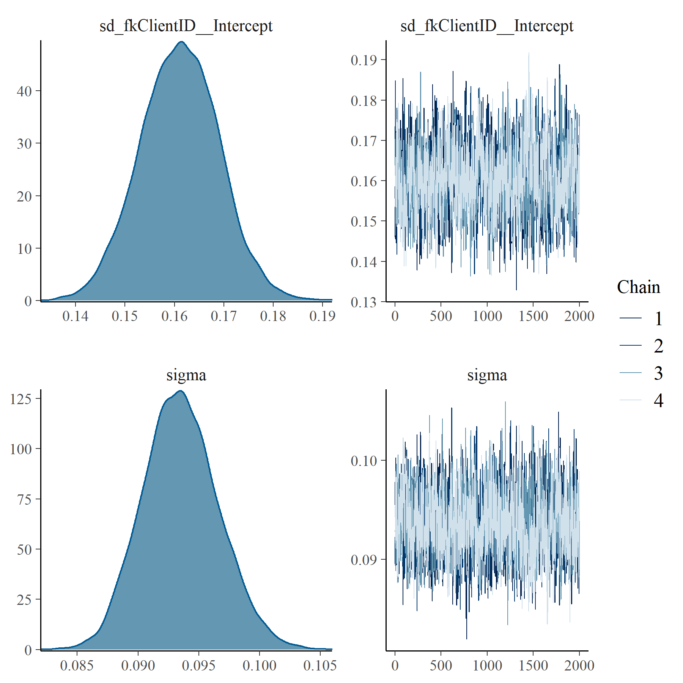

Figure : OASIS with SOFAS Generalised Linear Mixed Model with Gaussian distribution and log link group level effects

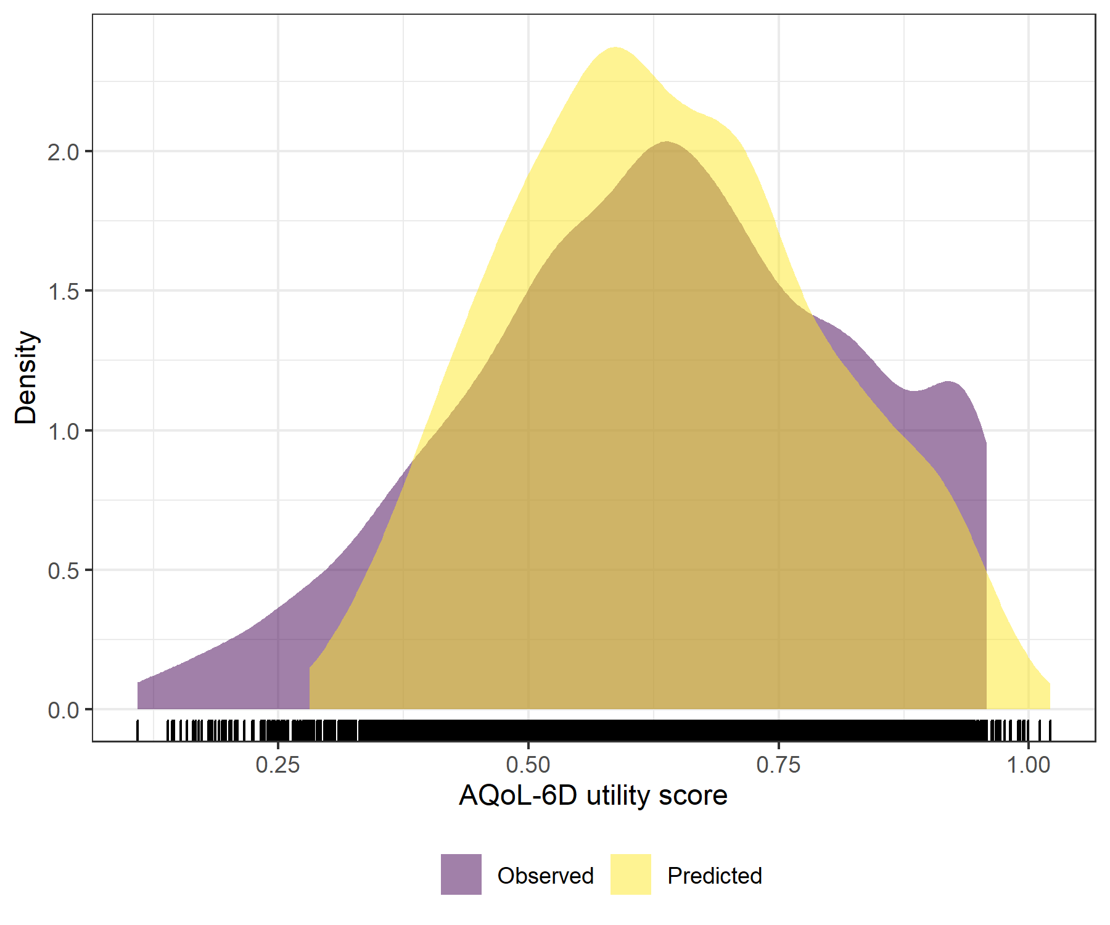

Figure : OASIS with SOFAS Generalised Linear Mixed Model with Gaussian distribution and log link comparative densities of observed and predicted data

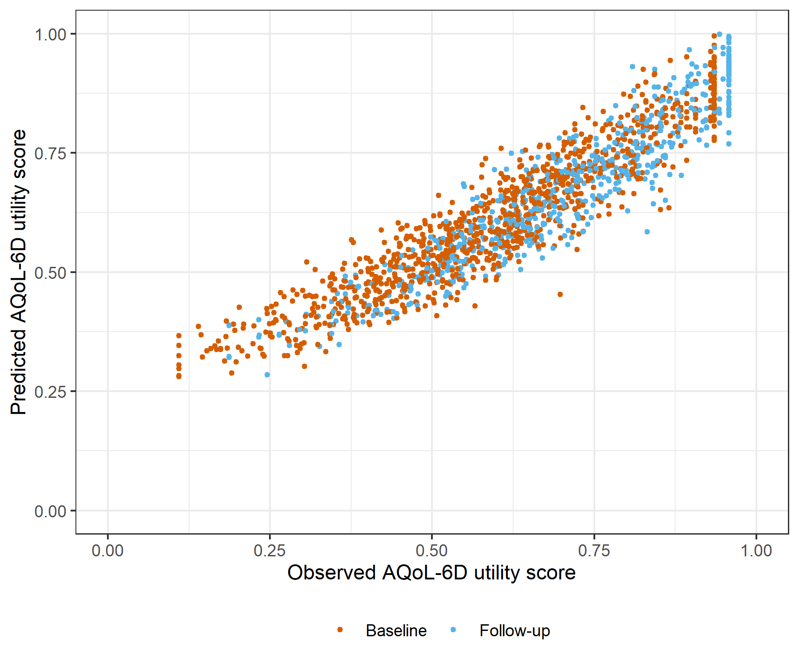

Figure : OASIS with SOFAS Generalised Linear Mixed Model with Gaussian distribution and log link comparative scatter plot of obsereved and predicted data

# OASIS with SOFAS Linear Mixed Model with clog-log transformation

Table : OASIS with SOFAS Linear Mixed Model with clog-log transformation

| Parameter | Estimate | Est.Error | l-95% CI | u-95% CI | Rhat | Bulk_ESS | Tail_ESS |
| --- | --- | --- | --- | --- | --- | --- | --- |
| **Group-Level Effects:** | | | | | | | |
| fkClientID (Number of levels: 1027) |  |  |  |  |  |  |  |
| sd(Intercept) | 0.35 | 0.01 | 0.33 | 0.37 | 1.01 | 1 286 | 2 665 |
| **Population-Level Effects:** | | | | | | | |
| Intercept | 0.68 | 0.10 | 0.49 | 0.86 | 1.00 | 2 083 | 3 824 |
| OASIS_baseline | -9.91 | 0.29 | -10.48 | -9.33 | 1.01 | 2 157 | 3 886 |
| OASIS_change | -4.88 | 0.28 | -5.44 | -4.34 | 1.00 | 5 099 | 5 623 |
| SOFAS_baseline | 0.09 | 0.14 | -0.18 | 0.38 | 1.00 | 2 108 | 3 510 |
| SOFAS_change | 1.34 | 0.14 | 1.07 | 1.61 | 1.00 | 6 722 | 6 051 |
| **Family Specific Parameters:** | | | | | | | |
| sigma | 0.26 | 0.01 | 0.24 | 0.27 | 1.00 | 1 550 | 2 844 |
| Formula: aqol6d_total_w_cloglog ~ OASIS_baseline + OASIS_change + SOFAS_baseline + SOFAS_change + (1 | fkClientID) | | | | | | | |
| Family: gaussian Links: mu = identity; sigma = identity Data: data_tb (Number of observations: 1645) Samples: 4 chains, each with iter = 4000; warmup = 2000; thin = 1; total post-warmup samples = 8000 | | | | | | | |
| Samples were drawn using sample(hmc). For each parameter, Bulk_ESS and Tail_ESS are effective sample size measures, and Rhat is the potential scale reduction factor on split chains (at convergence, Rhat = 1). | | | | | | | |

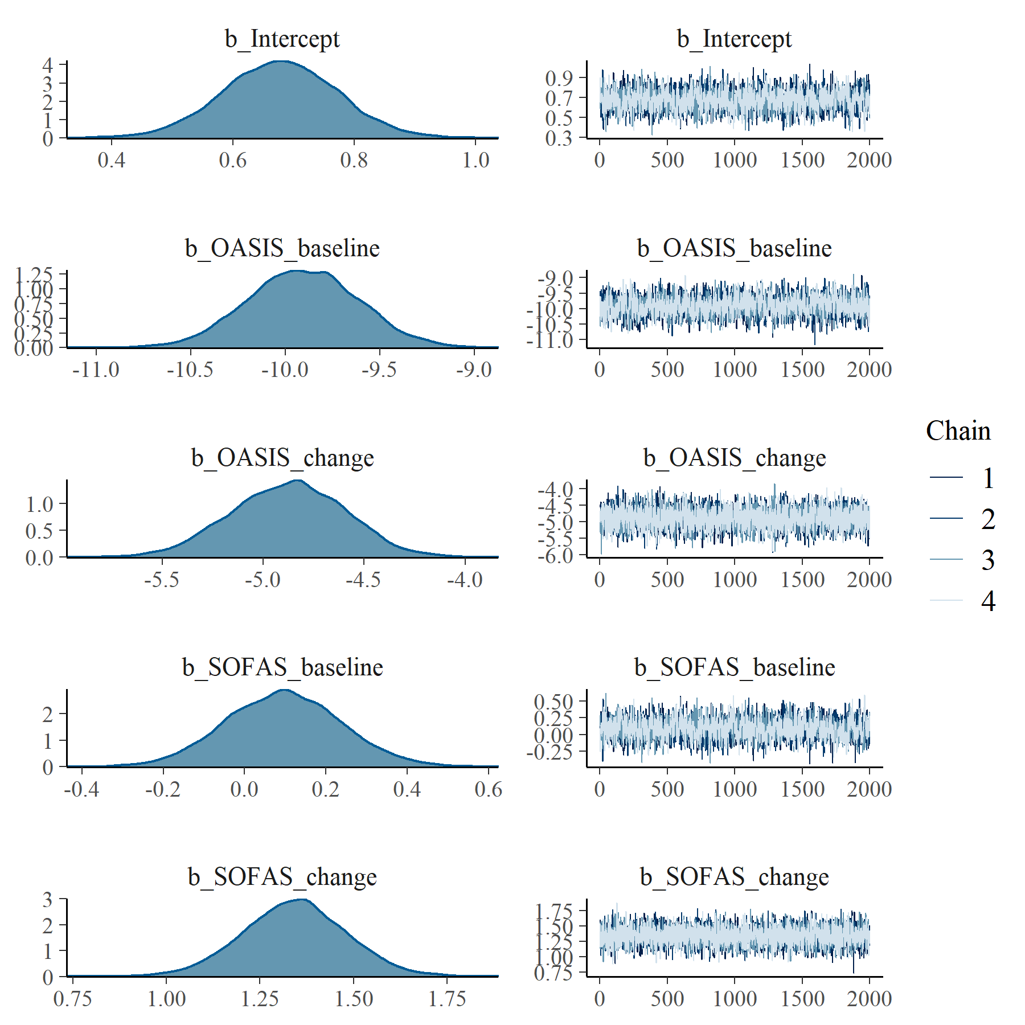

Figure : OASIS with SOFAS Linear Mixed Model with clog-log transformation population level effects

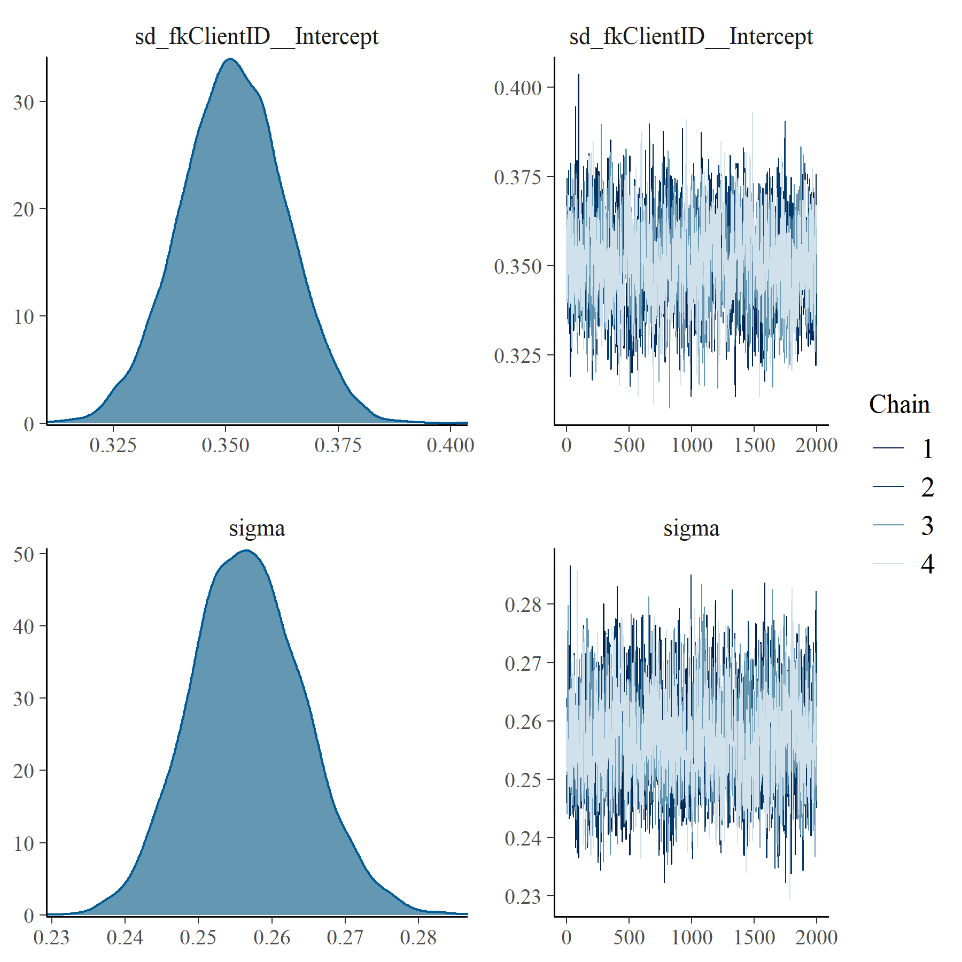

Figure : OASIS with SOFAS Linear Mixed Model with clog-log transformation group level effects

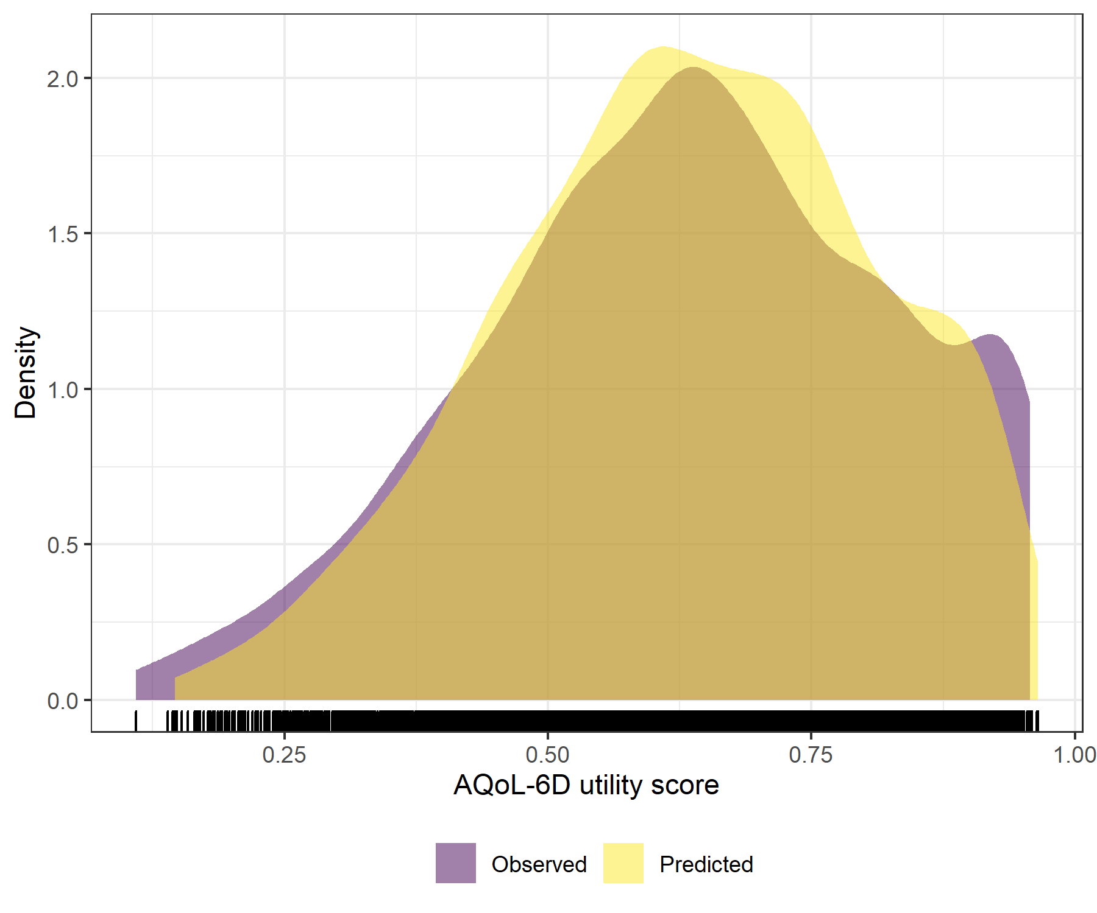

Figure : OASIS with SOFAS Linear Mixed Model with clog-log transformation comparative densities of observed and predicted data

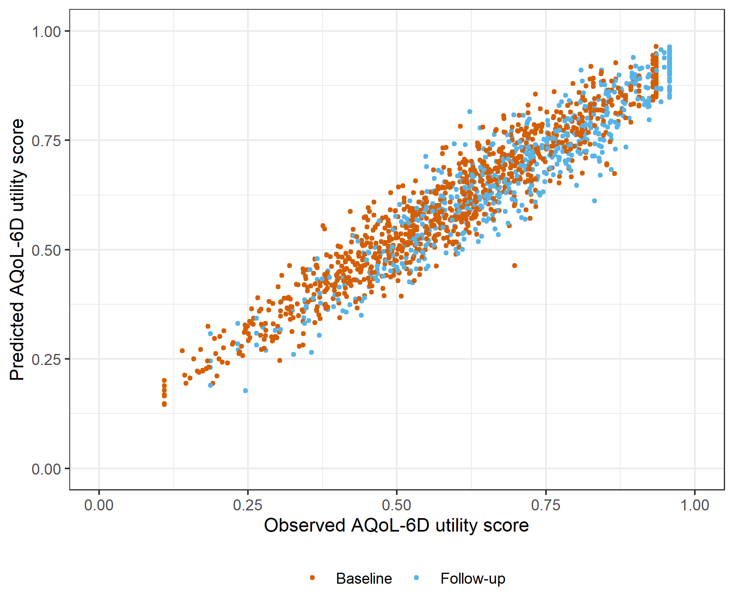

Figure : OASIS with SOFAS Linear Mixed Model with clog-log transformation comparative scatter plot of obsereved and predicted data

# PHQ9 with SOFAS Generalised Linear Mixed Model with Gaussian distribution and log link

Table : PHQ9 with SOFAS Generalised Linear Mixed Model with Gaussian distribution and log link

| Parameter | Estimate | Est.Error | l-95% CI | u-95% CI | Rhat | Bulk_ESS | Tail_ESS |
| --- | --- | --- | --- | --- | --- | --- | --- |
| **Group-Level Effects:** | | | | | | | |
| fkClientID (Number of levels: 1034) |  |  |  |  |  |  |  |
| sd(Intercept) | 0.10 | 0.01 | 0.08 | 0.12 | 1.00 | 727 | 1 982 |
| **Population-Level Effects:** | | | | | | | |
| Intercept | -0.03 | 0.04 | -0.11 | 0.04 | 1.00 | 4 680 | 4 906 |
| PHQ9_baseline | -3.86 | 0.09 | -4.03 | -3.69 | 1.00 | 4 745 | 5 332 |
| PHQ9_change | -2.45 | 0.13 | -2.71 | -2.20 | 1.00 | 1 647 | 3 721 |
| SOFAS_baseline | 0.01 | 0.06 | -0.10 | 0.12 | 1.00 | 4 782 | 5 302 |
| SOFAS_change | 0.41 | 0.07 | 0.27 | 0.55 | 1.00 | 6 274 | 5 861 |
| **Family Specific Parameters:** | | | | | | | |
| sigma | 0.10 | 0.00 | 0.09 | 0.10 | 1.00 | 859 | 2 215 |
| Formula: aqol6d_total_w ~ PHQ9_baseline + PHQ9_change + SOFAS_baseline + SOFAS_change + (1 | fkClientID) | | | | | | | |
| Family: gaussian Links: mu = log; sigma = identity Data: data_tb (Number of observations: 1651) Samples: 4 chains, each with iter = 4000; warmup = 2000; thin = 1; total post-warmup samples = 8000 | | | | | | | |
| Samples were drawn using sample(hmc). For each parameter, Bulk_ESS and Tail_ESS are effective sample size measures, and Rhat is the potential scale reduction factor on split chains (at convergence, Rhat = 1). | | | | | | | |

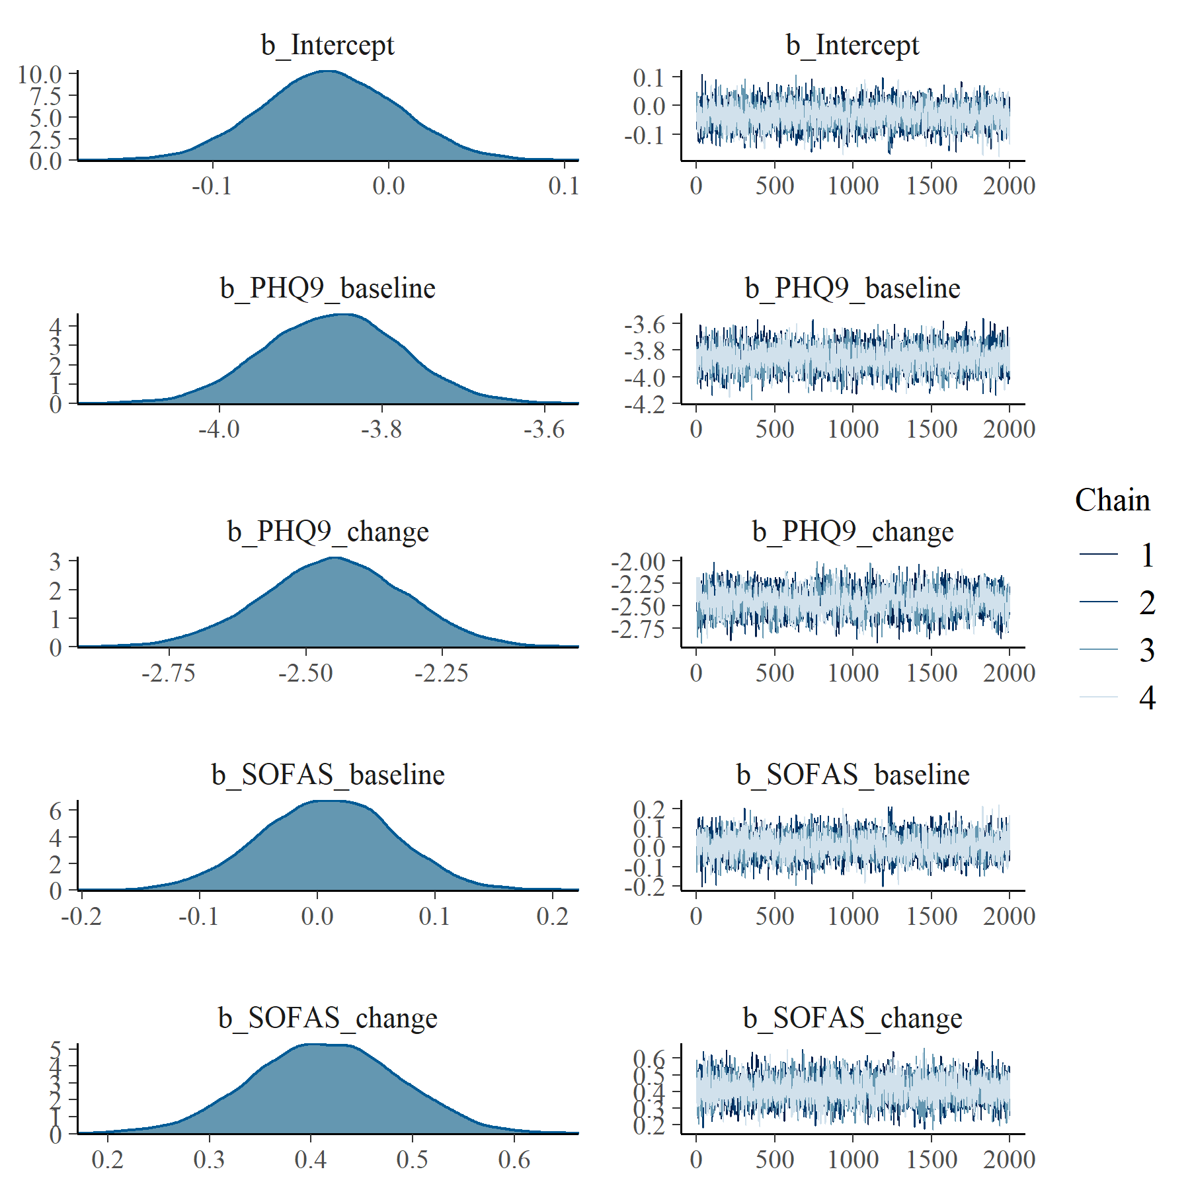

Figure : PHQ9 with SOFAS Generalised Linear Mixed Model with Gaussian distribution and log link population level effects

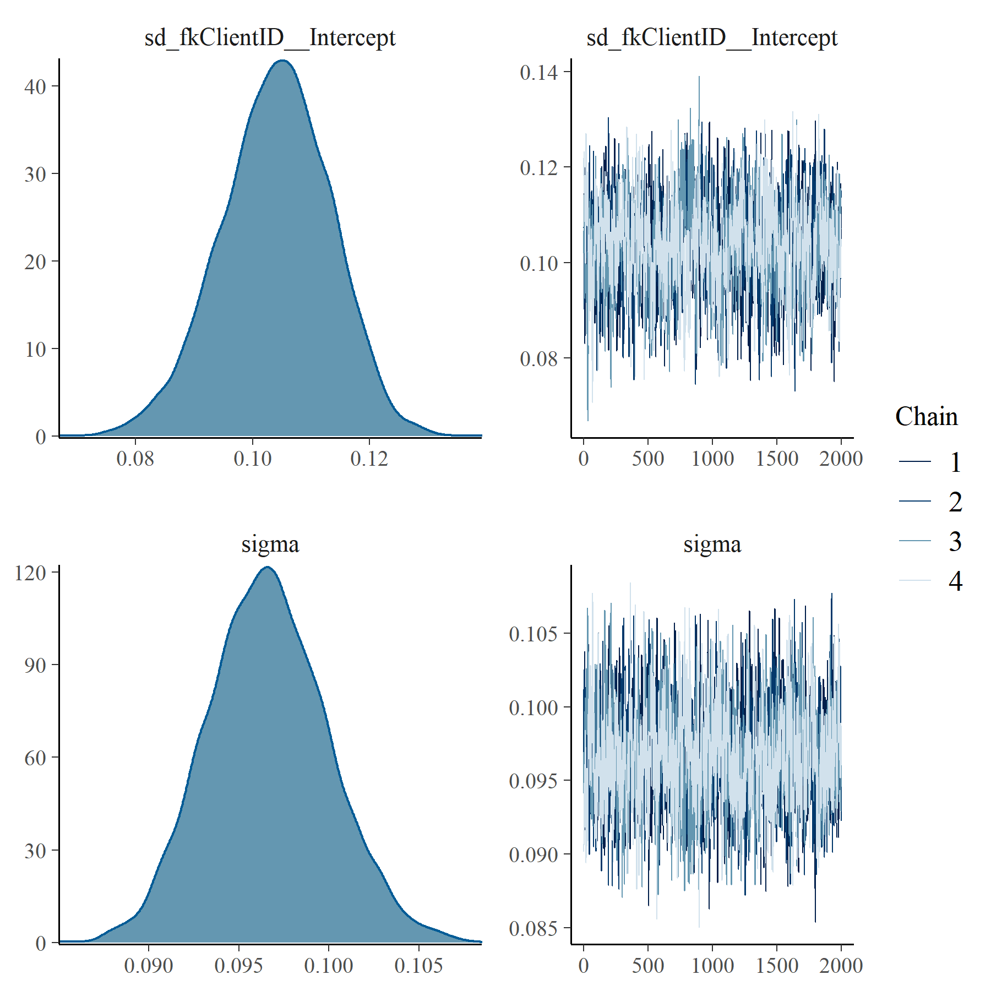

Figure : PHQ9 with SOFAS Generalised Linear Mixed Model with Gaussian distribution and log link group level effects

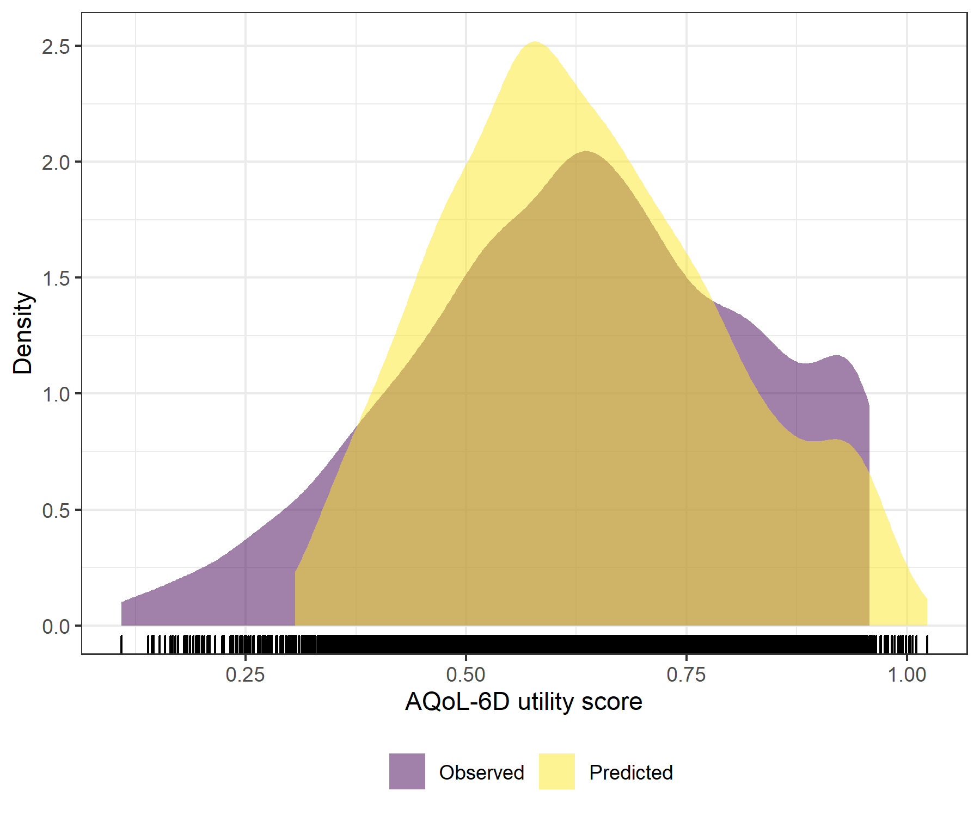

Figure : PHQ9 with SOFAS Generalised Linear Mixed Model with Gaussian distribution and log link comparative densities of observed and predicted data

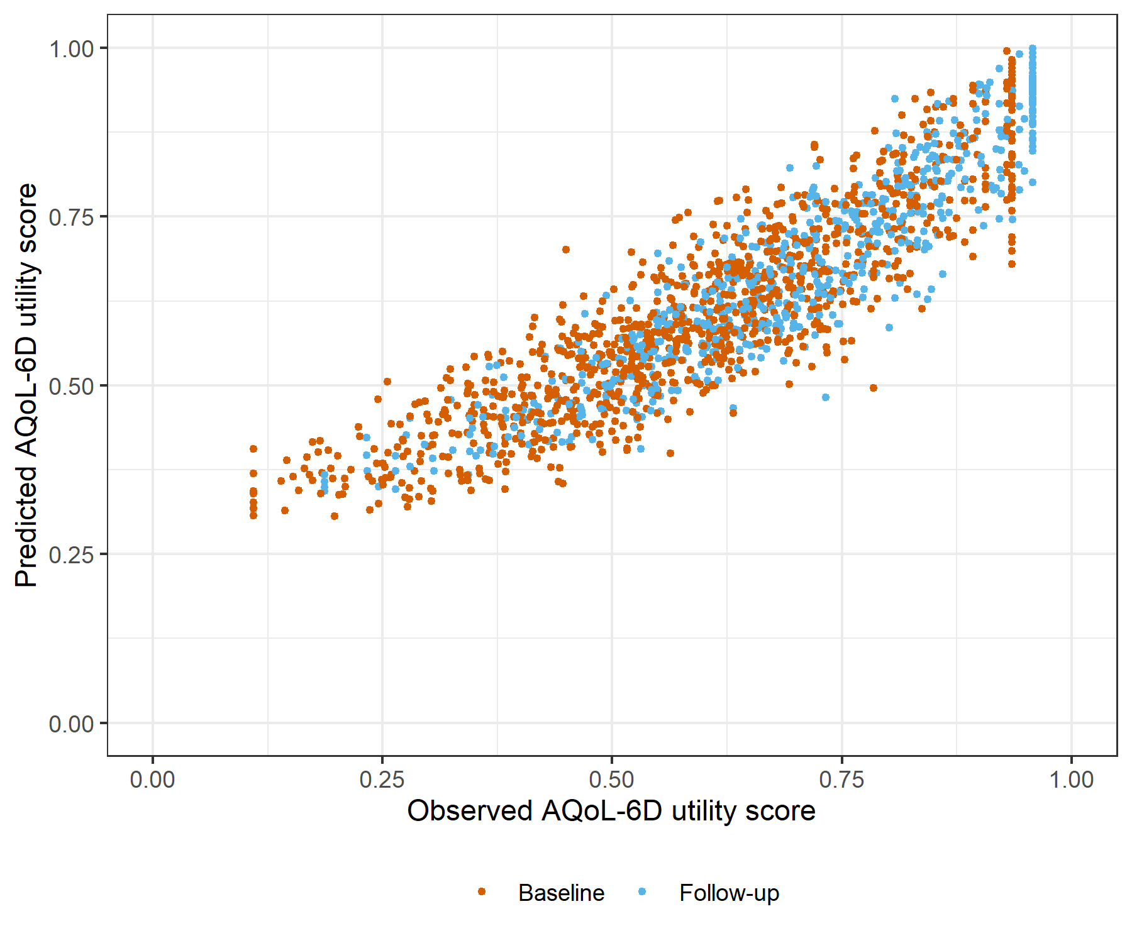

Figure : PHQ9 with SOFAS Generalised Linear Mixed Model with Gaussian distribution and log link comparative scatter plot of obsereved and predicted data

# PHQ9 with SOFAS Linear Mixed Model with clog-log transformation

Table : PHQ9 with SOFAS Linear Mixed Model with clog-log transformation

| Parameter | Estimate | Est.Error | l-95% CI | u-95% CI | Rhat | Bulk_ESS | Tail_ESS |
| --- | --- | --- | --- | --- | --- | --- | --- |
| **Group-Level Effects:** | | | | | | | |
| fkClientID (Number of levels: 1034) |  |  |  |  |  |  |  |
| sd(Intercept) | 0.27 | 0.01 | 0.25 | 0.29 | 1.00 | 1 153 | 2 585 |
| **Population-Level Effects:** | | | | | | | |
| Intercept | 0.91 | 0.08 | 0.76 | 1.07 | 1.00 | 2 663 | 4 105 |
| PHQ9_baseline | -7.73 | 0.17 | -8.06 | -7.40 | 1.00 | 2 660 | 4 091 |
| PHQ9_change | -4.47 | 0.22 | -4.91 | -4.06 | 1.00 | 3 216 | 4 894 |
| SOFAS_baseline | 0.03 | 0.12 | -0.20 | 0.25 | 1.00 | 2 587 | 4 159 |
| SOFAS_change | 1.04 | 0.14 | 0.77 | 1.31 | 1.00 | 4 758 | 5 727 |
| **Family Specific Parameters:** | | | | | | | |
| sigma | 0.26 | 0.01 | 0.24 | 0.27 | 1.00 | 1 406 | 3 026 |
| Formula: aqol6d_total_w_cloglog ~ PHQ9_baseline + PHQ9_change + SOFAS_baseline + SOFAS_change + (1 | fkClientID) | | | | | | | |
| Family: gaussian Links: mu = identity; sigma = identity Data: data_tb (Number of observations: 1651) Samples: 4 chains, each with iter = 4000; warmup = 2000; thin = 1; total post-warmup samples = 8000 | | | | | | | |
| Samples were drawn using sample(hmc). For each parameter, Bulk_ESS and Tail_ESS are effective sample size measures, and Rhat is the potential scale reduction factor on split chains (at convergence, Rhat = 1). | | | | | | | |

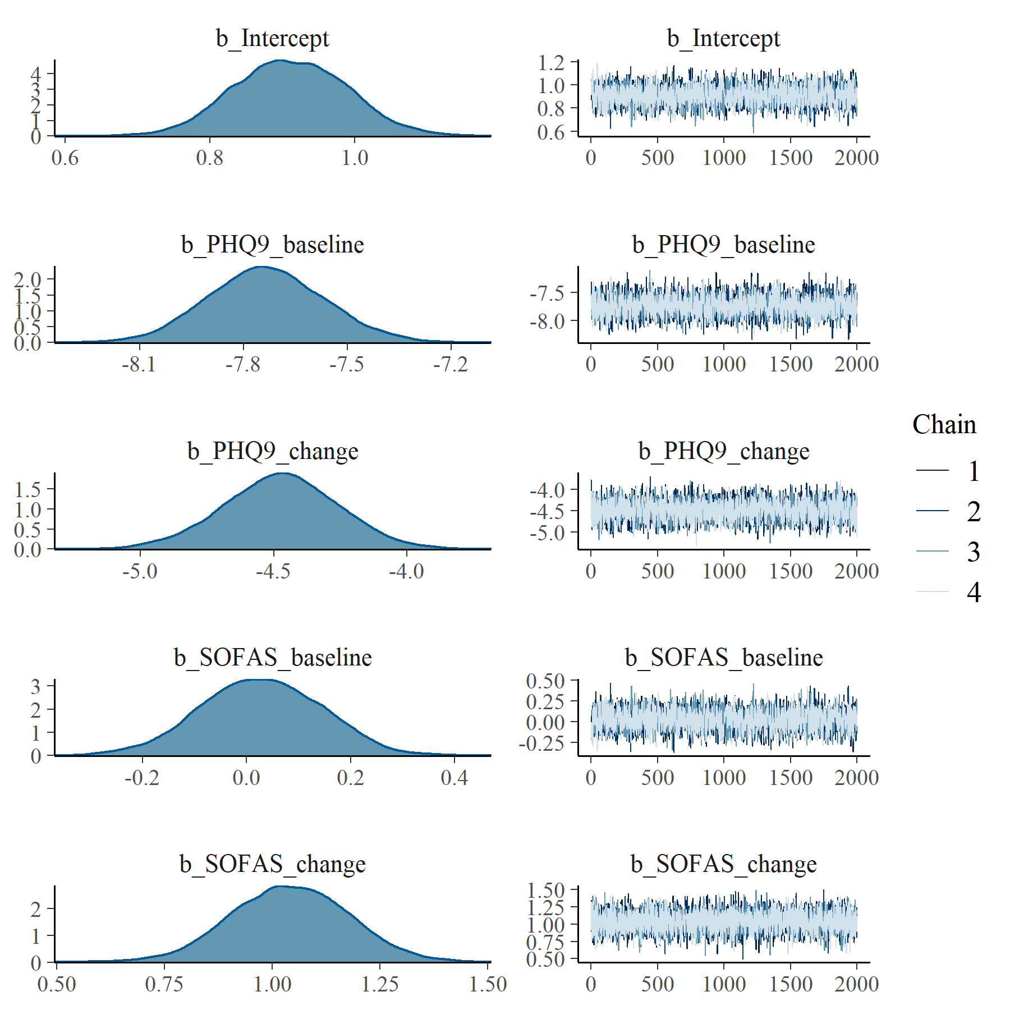

Figure : PHQ9 with SOFAS Linear Mixed Model with clog-log transformation population level effects

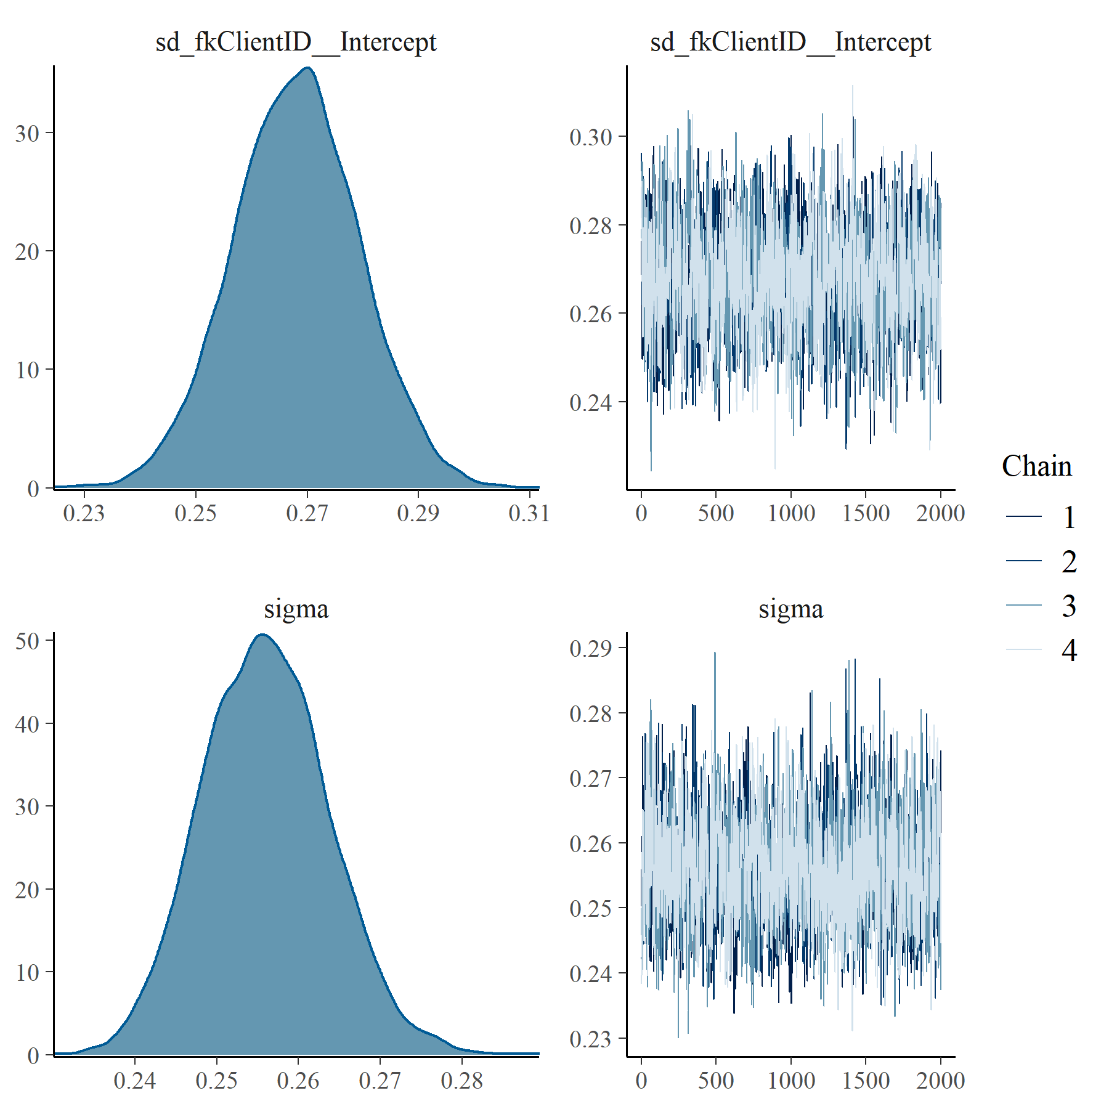

Figure : PHQ9 with SOFAS Linear Mixed Model with clog-log transformation group level effects

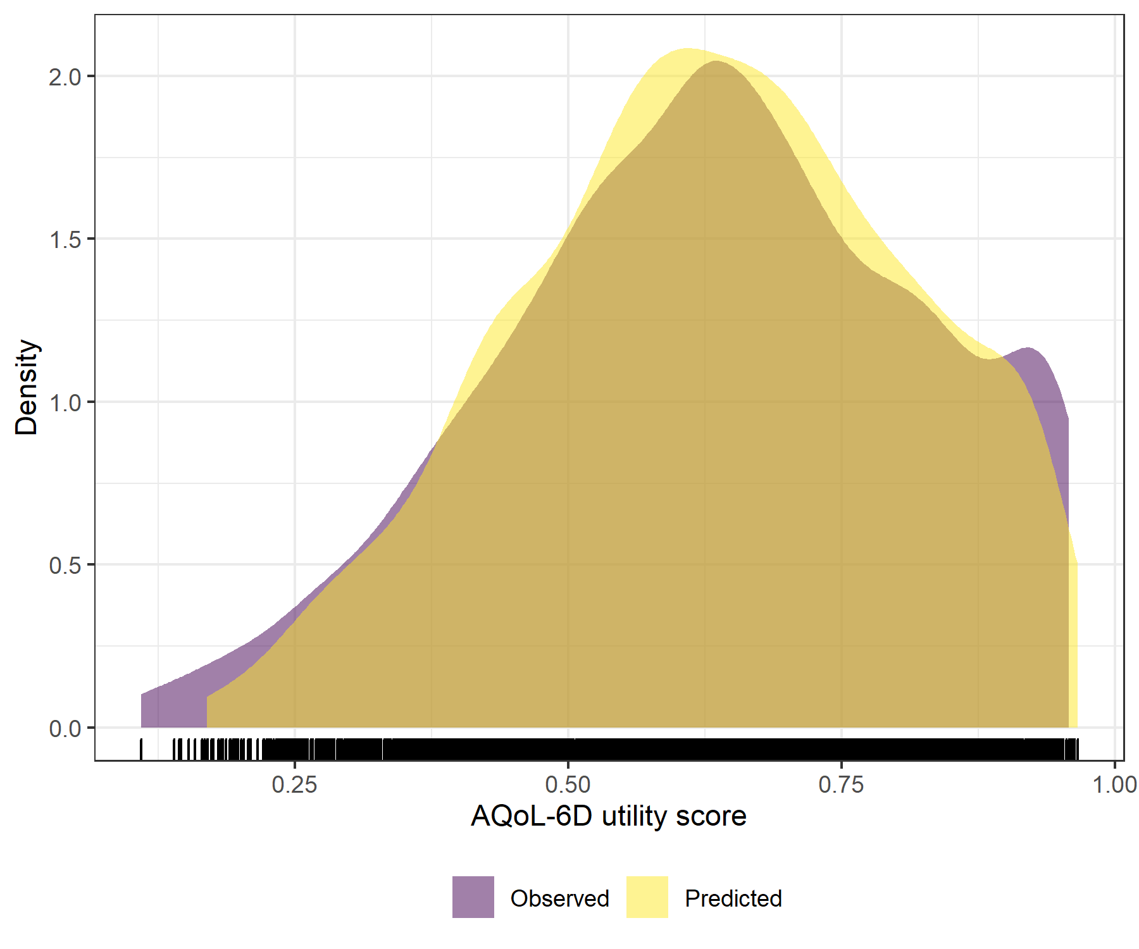

Figure : PHQ9 with SOFAS Linear Mixed Model with clog-log transformation comparative densities of observed and predicted data

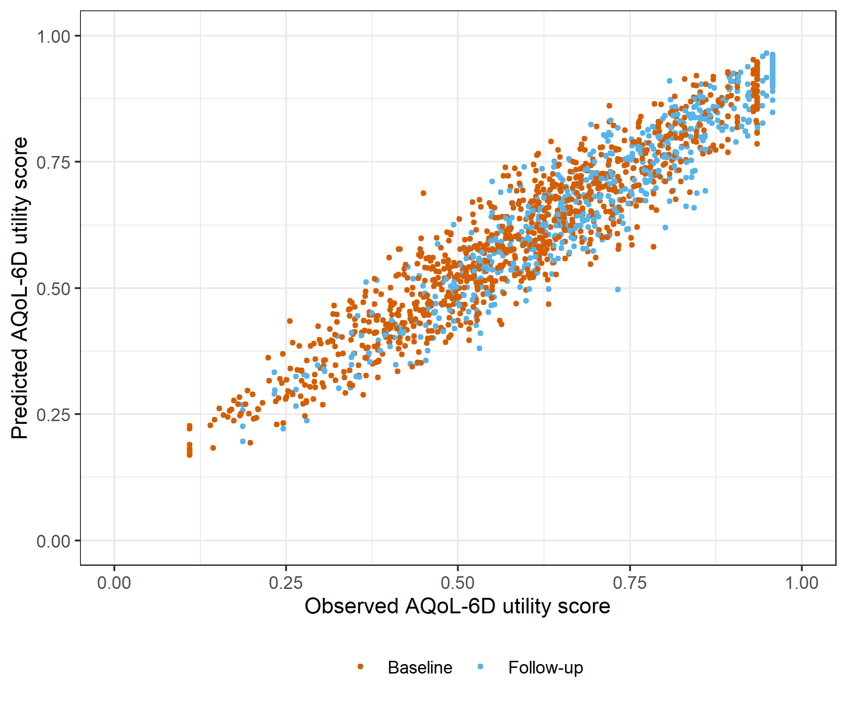

Figure : PHQ9 with SOFAS Linear Mixed Model with clog-log transformation comparative scatter plot of obsereved and predicted data

# SCARED with SOFAS Generalised Linear Mixed Model with Gaussian distribution and log link

Table : SCARED with SOFAS Generalised Linear Mixed Model with Gaussian distribution and log link

| Parameter | Estimate | Est.Error | l-95% CI | u-95% CI | Rhat | Bulk_ESS | Tail_ESS |
| --- | --- | --- | --- | --- | --- | --- | --- |
| **Group-Level Effects:** | | | | | | | |
| fkClientID (Number of levels: 1033) |  |  |  |  |  |  |  |
| sd(Intercept) | 0.19 | 0.01 | 0.17 | 0.20 | 1.01 | 1 013 | 2 320 |
| **Population-Level Effects:** | | | | | | | |
| Intercept | -0.15 | 0.05 | -0.25 | -0.05 | 1.00 | 2 808 | 4 276 |
| SCARED_baseline | -1.14 | 0.04 | -1.23 | -1.06 | 1.00 | 2 378 | 3 953 |
| SCARED_change | -0.52 | 0.04 | -0.60 | -0.44 | 1.00 | 3 612 | 5 099 |
| SOFAS_baseline | 0.04 | 0.08 | -0.12 | 0.19 | 1.00 | 2 885 | 4 560 |
| SOFAS_change | 0.75 | 0.07 | 0.60 | 0.89 | 1.00 | 5 993 | 5 505 |
| **Family Specific Parameters:** | | | | | | | |
| sigma | 0.09 | 0.00 | 0.09 | 0.10 | 1.00 | 1 210 | 2 922 |
| Formula: aqol6d_total_w ~ SCARED_baseline + SCARED_change + SOFAS_baseline + SOFAS_change + (1 | fkClientID) | | | | | | | |
| Family: gaussian Links: mu = log; sigma = identity Data: data_tb (Number of observations: 1651) Samples: 4 chains, each with iter = 4000; warmup = 2000; thin = 1; total post-warmup samples = 8000 | | | | | | | |
| Samples were drawn using sample(hmc). For each parameter, Bulk_ESS and Tail_ESS are effective sample size measures, and Rhat is the potential scale reduction factor on split chains (at convergence, Rhat = 1). | | | | | | | |

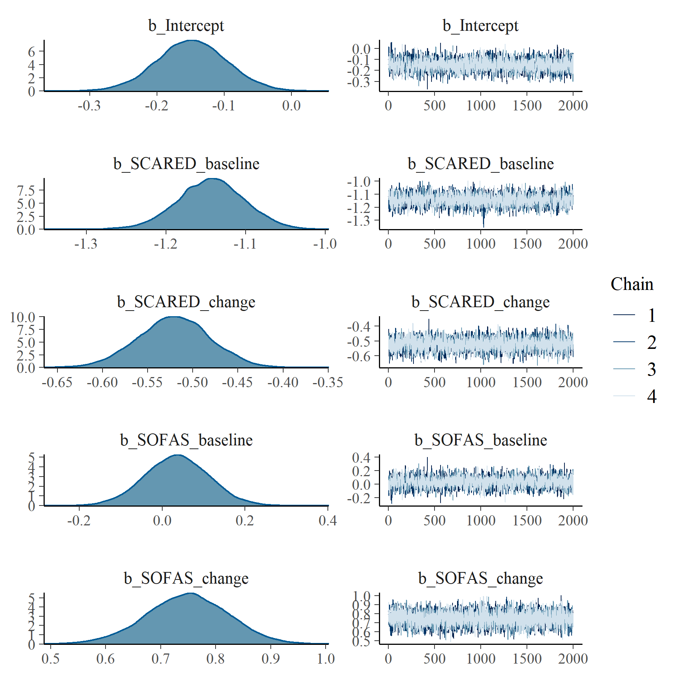

Figure : SCARED with SOFAS Generalised Linear Mixed Model with Gaussian distribution and log link population level effects

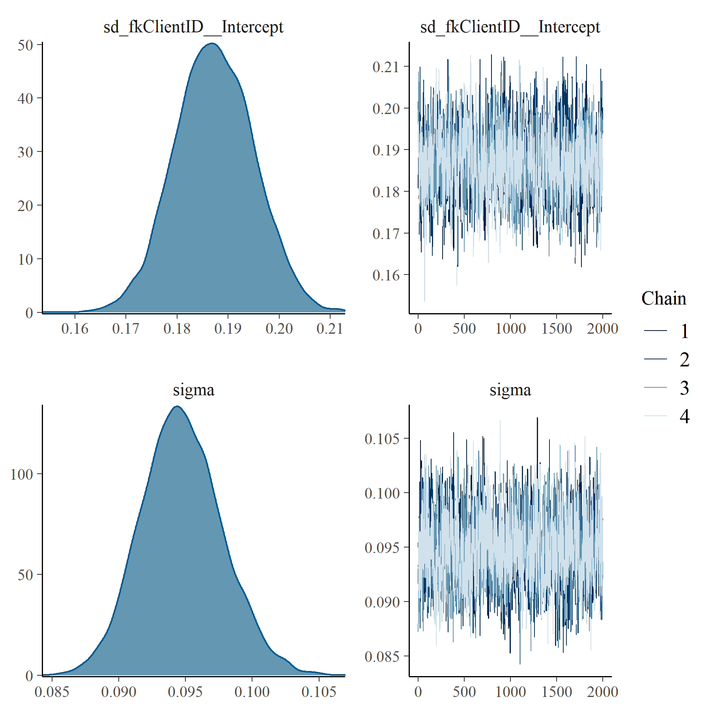

Figure : SCARED with SOFAS Generalised Linear Mixed Model with Gaussian distribution and log link group level effects

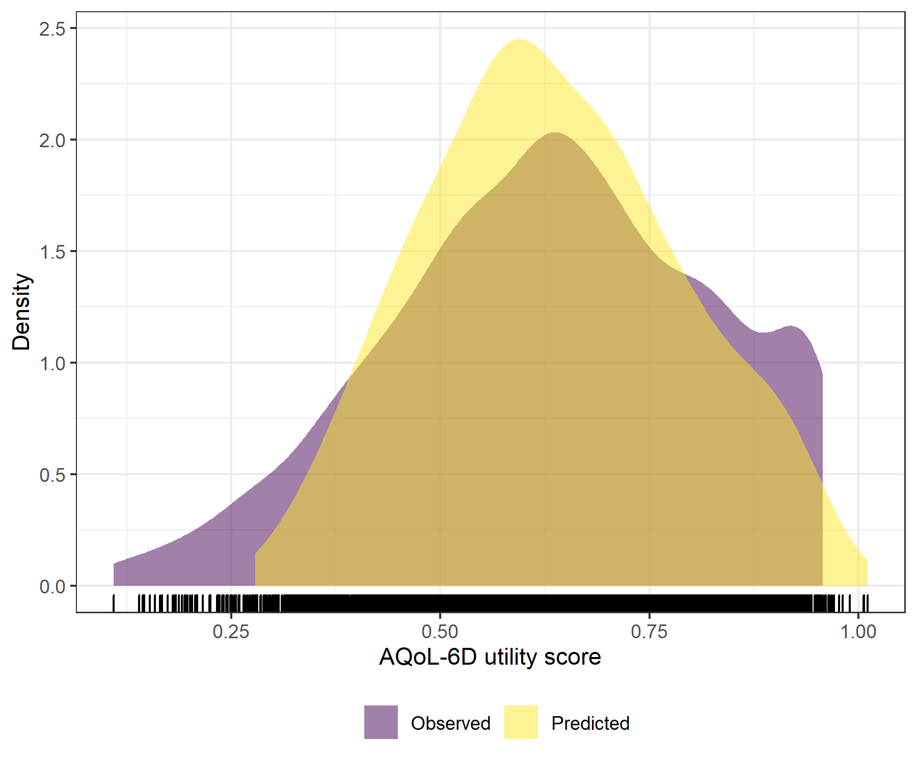

Figure : SCARED with SOFAS Generalised Linear Mixed Model with Gaussian distribution and log link comparative densities of observed and predicted data

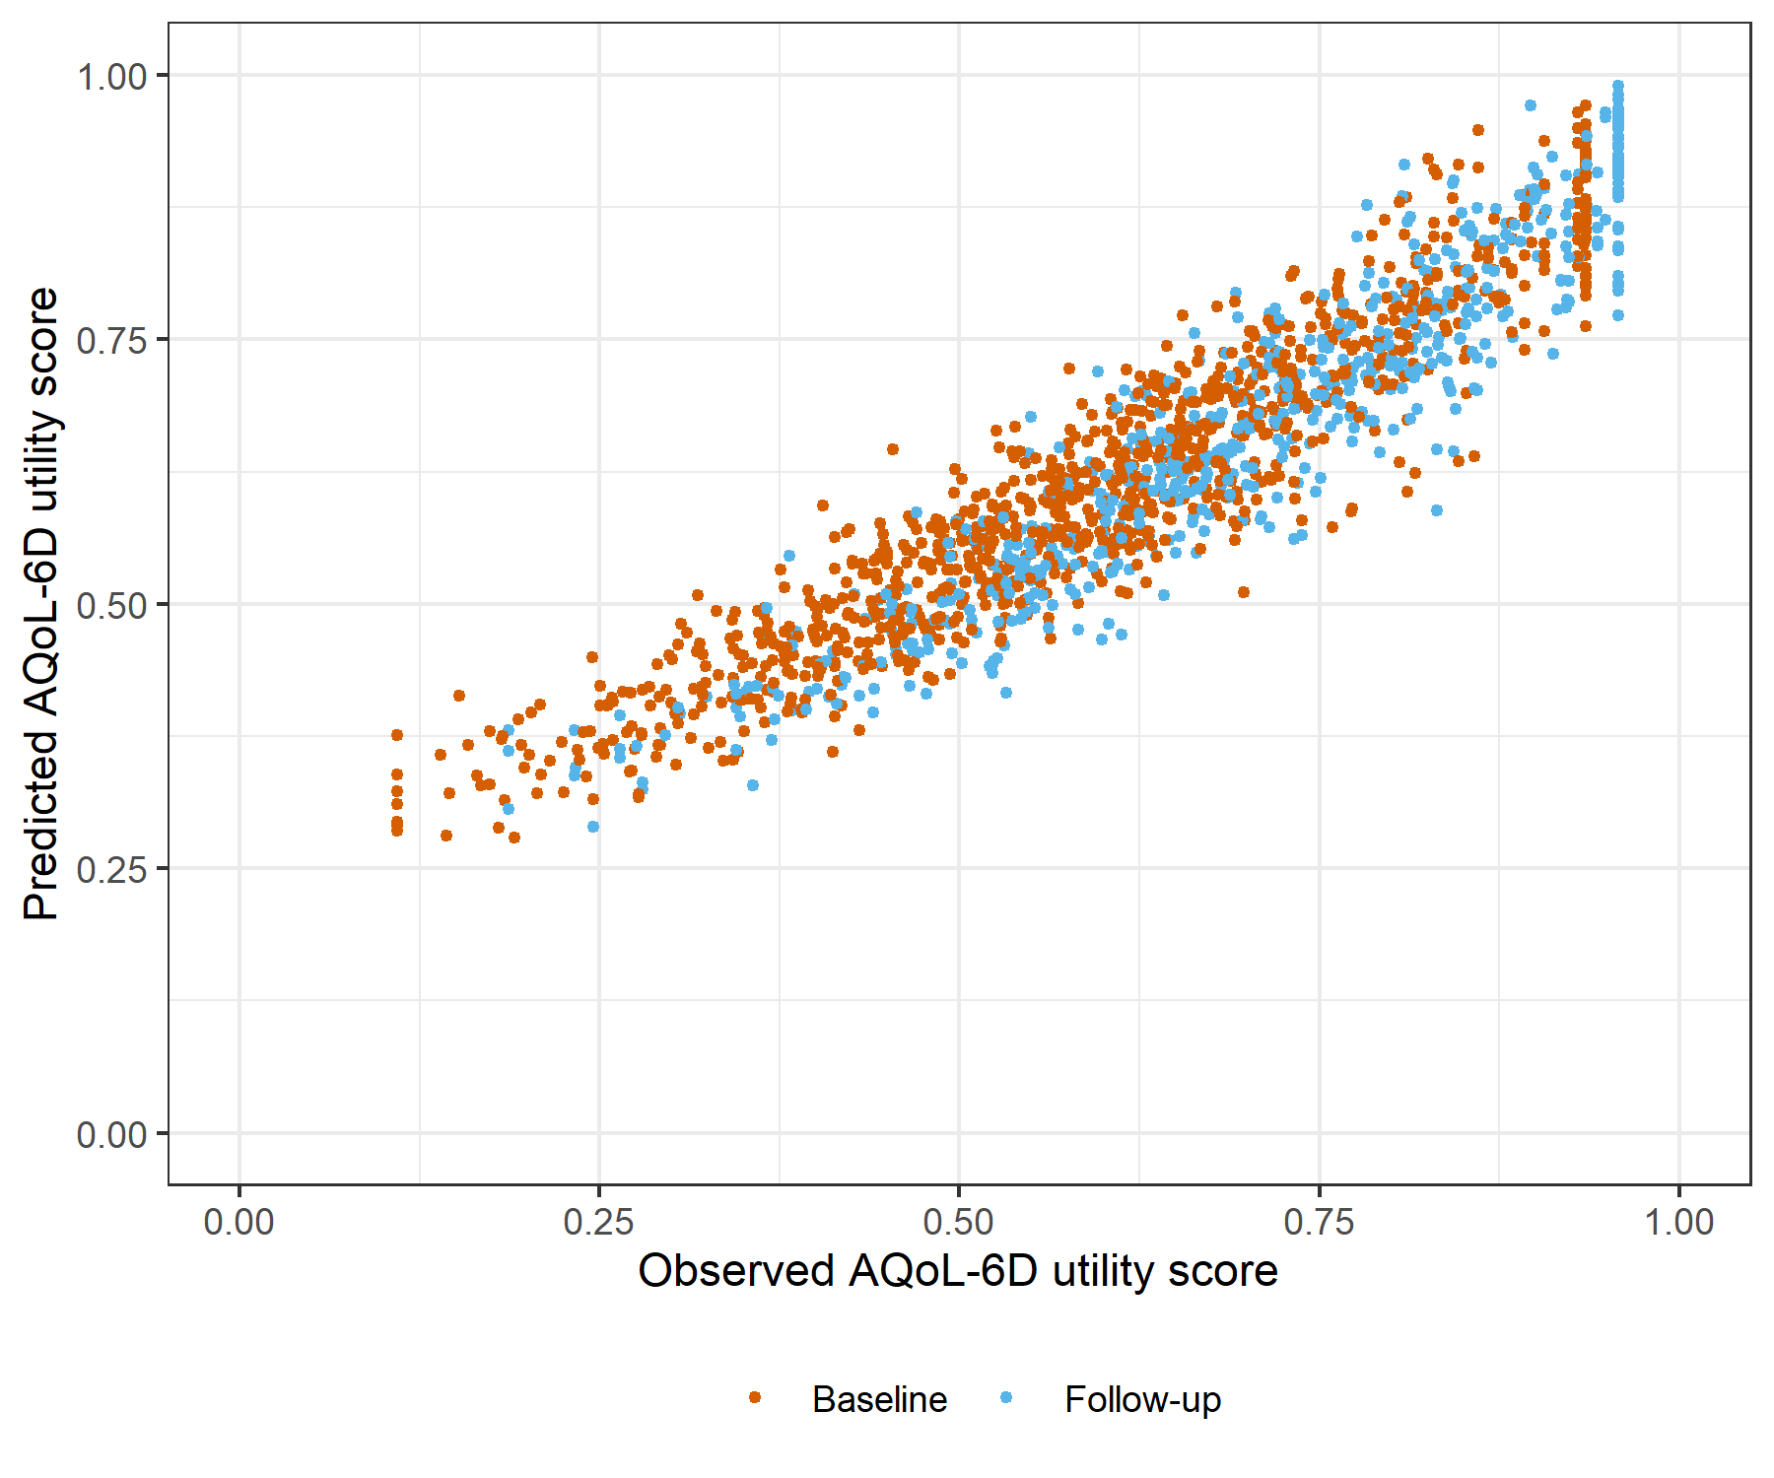

Figure : SCARED with SOFAS Generalised Linear Mixed Model with Gaussian distribution and log link comparative scatter plot of obsereved and predicted data

# SCARED with SOFAS Linear Mixed Model with clog-log transformation

Table : SCARED with SOFAS Linear Mixed Model with clog-log transformation

| Parameter | Estimate | Est.Error | l-95% CI | u-95% CI | Rhat | Bulk_ESS | Tail_ESS |
| --- | --- | --- | --- | --- | --- | --- | --- |
| **Group-Level Effects:** | | | | | | | |
| fkClientID (Number of levels: 1033) |  |  |  |  |  |  |  |
| sd(Intercept) | 0.39 | 0.01 | 0.36 | 0.41 | 1.00 | 1 309 | 3 307 |
| **Population-Level Effects:** | | | | | | | |
| Intercept | 0.66 | 0.10 | 0.46 | 0.87 | 1.00 | 2 020 | 3 533 |
| SCARED_baseline | -2.25 | 0.08 | -2.41 | -2.10 | 1.00 | 1 747 | 3 555 |
| SCARED_change | -1.02 | 0.07 | -1.17 | -0.88 | 1.00 | 4 914 | 5 278 |
| SOFAS_baseline | 0.09 | 0.16 | -0.21 | 0.39 | 1.00 | 2 001 | 3 153 |
| SOFAS_change | 1.65 | 0.14 | 1.38 | 1.92 | 1.00 | 6 223 | 5 811 |
| **Family Specific Parameters:** | | | | | | | |
| sigma | 0.27 | 0.01 | 0.25 | 0.29 | 1.00 | 1 479 | 3 337 |
| Formula: aqol6d_total_w_cloglog ~ SCARED_baseline + SCARED_change + SOFAS_baseline + SOFAS_change + (1 | fkClientID) | | | | | | | |
| Family: gaussian Links: mu = identity; sigma = identity Data: data_tb (Number of observations: 1651) Samples: 4 chains, each with iter = 4000; warmup = 2000; thin = 1; total post-warmup samples = 8000 | | | | | | | |
| Samples were drawn using sample(hmc). For each parameter, Bulk_ESS and Tail_ESS are effective sample size measures, and Rhat is the potential scale reduction factor on split chains (at convergence, Rhat = 1). | | | | | | | |

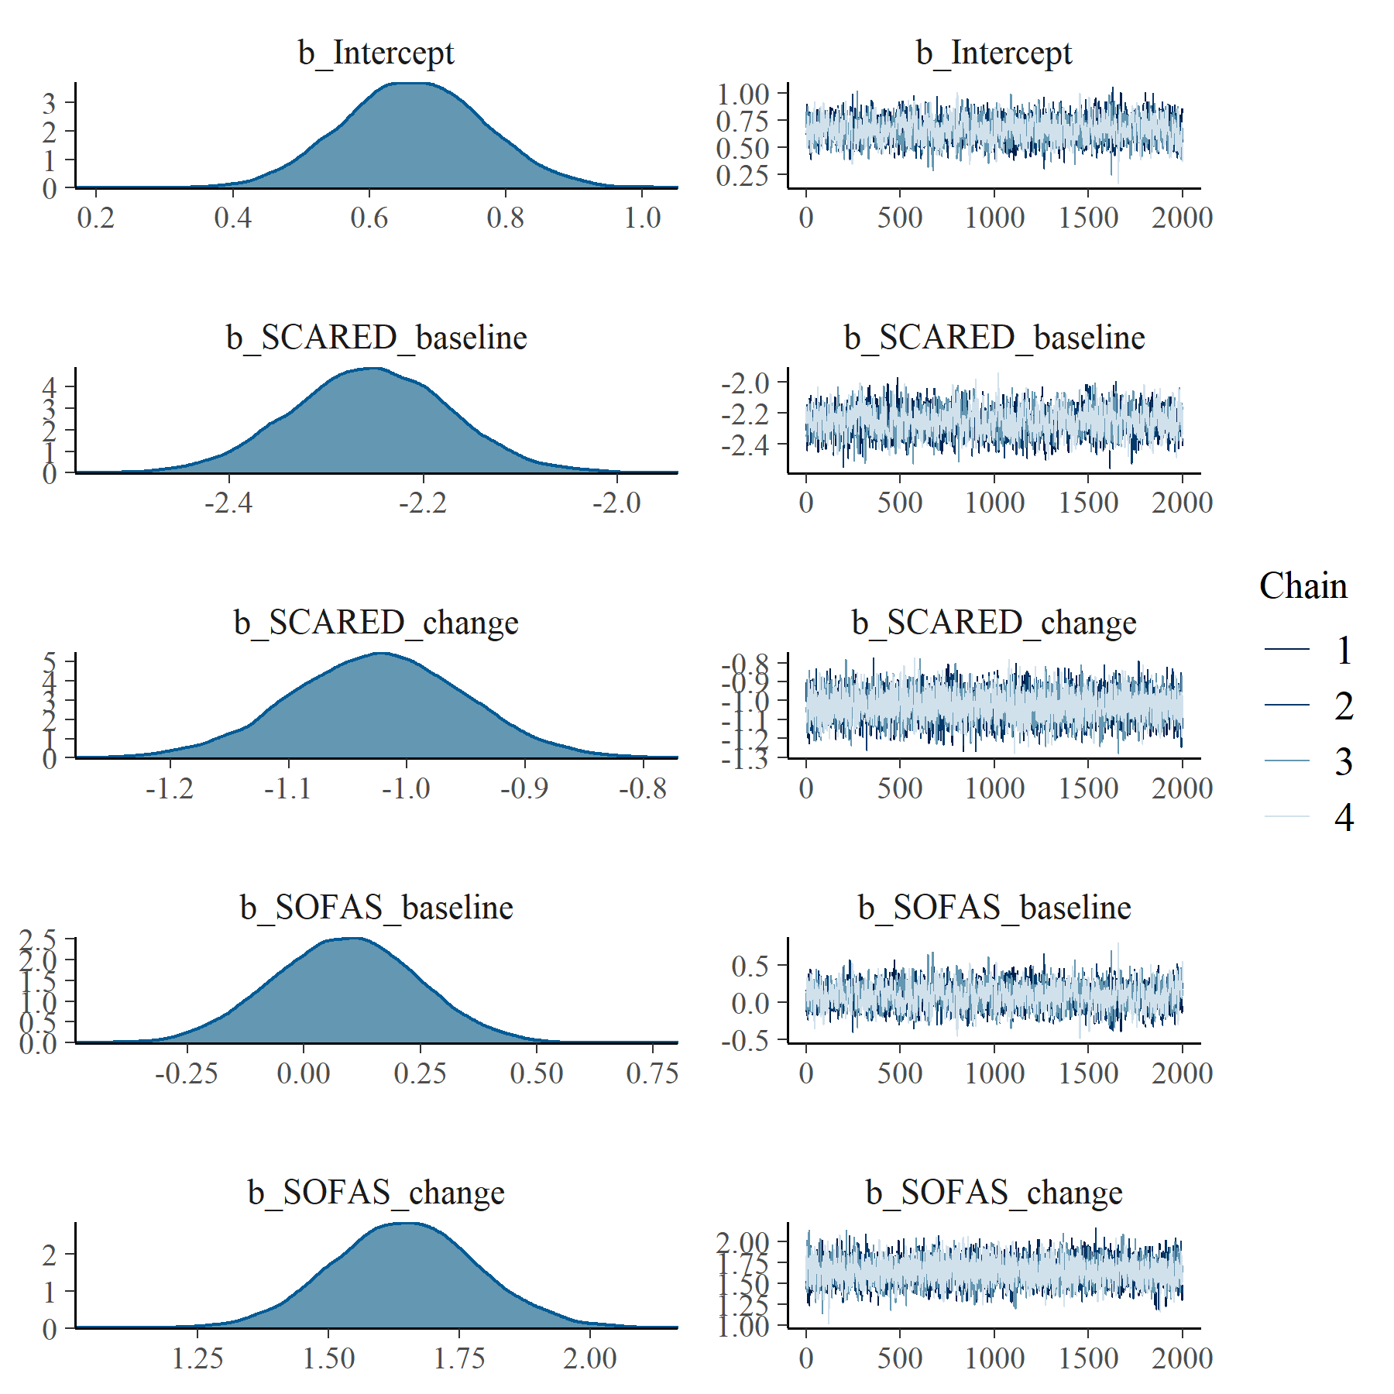

Figure : SCARED with SOFAS Linear Mixed Model with clog-log transformation population level effects

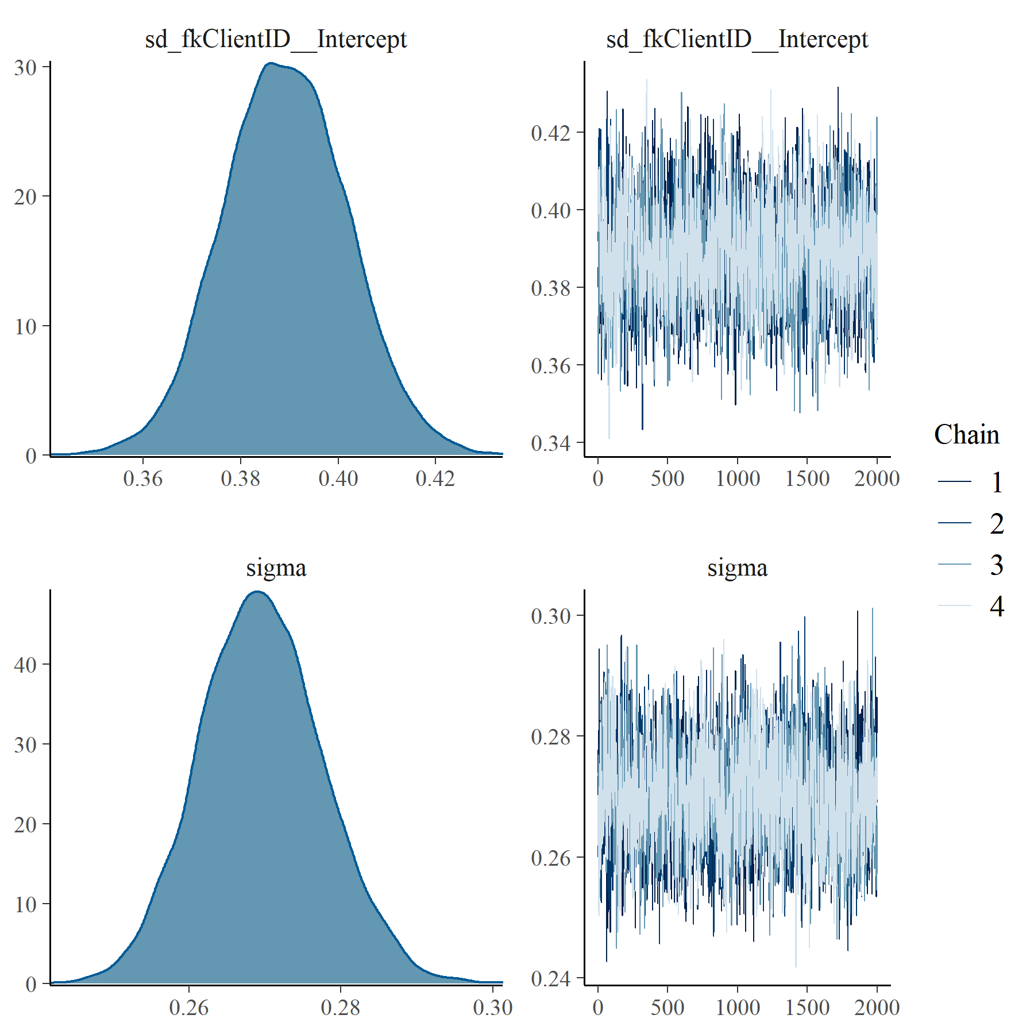

Figure : SCARED with SOFAS Linear Mixed Model with clog-log transformation group level effects

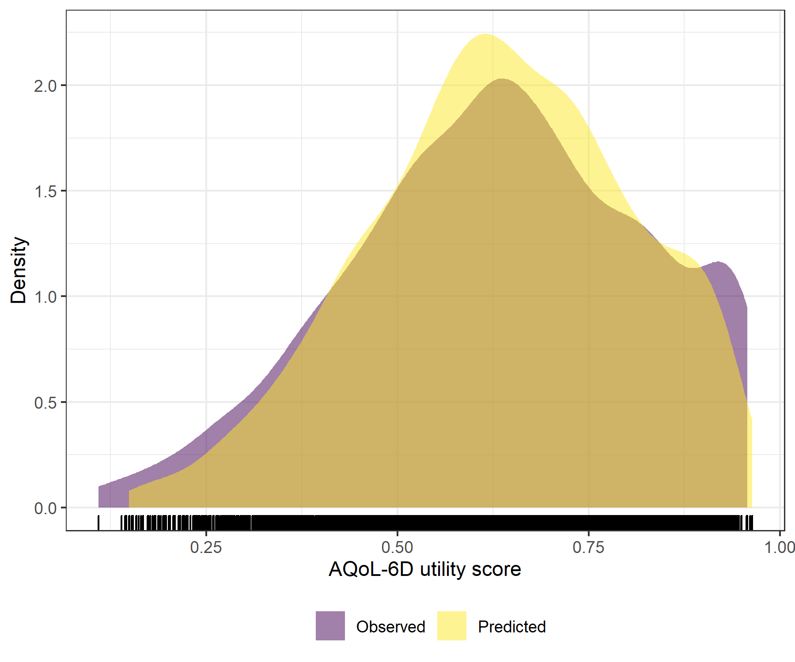

Figure : SCARED with SOFAS Linear Mixed Model with clog-log transformation comparative densities of observed and predicted data

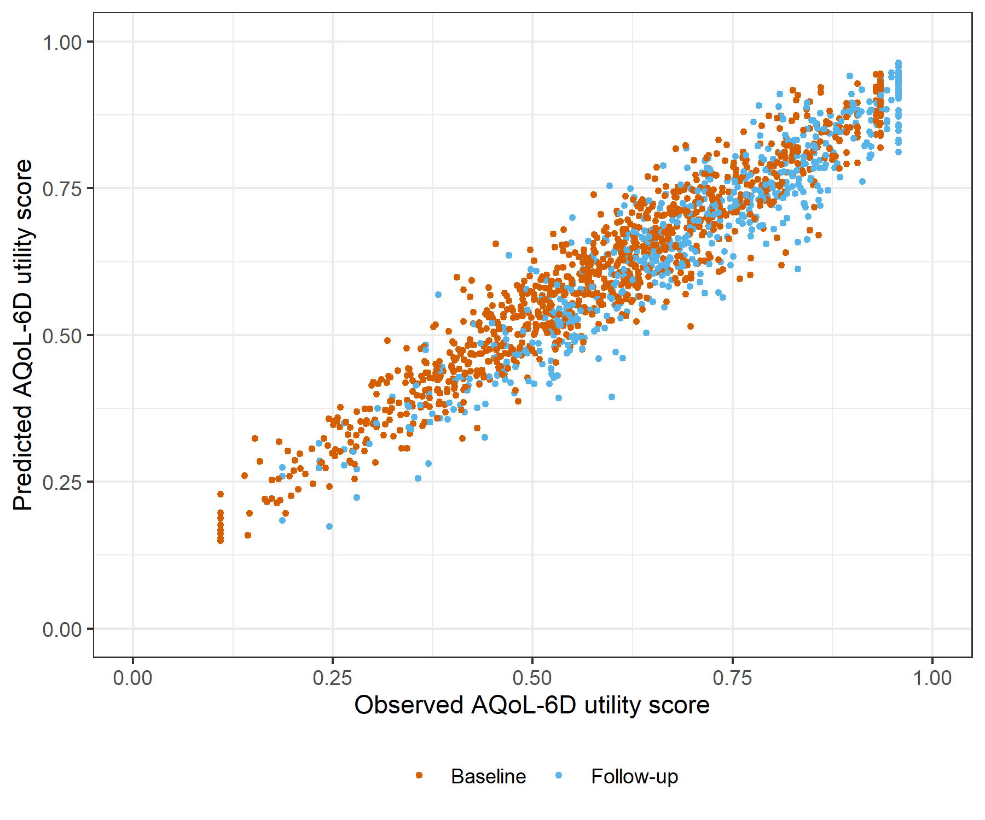

Figure : SCARED with SOFAS Linear Mixed Model with clog-log transformation comparative scatter plot of obsereved and predicted data