TEST

Matthew Hamilton

06/08/2020

# 1 PHQ9 with SOFAS Generalised Linear Mixed Model with Gaussian distribution and log link

Table : PHQ9 with SOFAS Generalised Linear Mixed Model with Gaussian distribution and log link

| Parameter | Estimate | Est.Error | l-95% CI | u-95% CI | Rhat | Bulk_ESS | Tail_ESS |
| --- | --- | --- | --- | --- | --- | --- | --- |
| **Group-Level Effects:** | | | | | | | |
| fkClientID (Number of levels: 1034) |  |  |  |  |  |  |  |
| sd(Intercept) | 0.10 | 0.01 | 0.08 | 0.12 | 1.00 | 599 | 1 106 |
| **Population-Level Effects:** | | | | | | | |
| Intercept | -0.03 | 0.04 | -0.11 | 0.04 | 1.00 | 4 700 | 5 335 |
| PHQ9_baseline | -3.86 | 0.08 | -4.03 | -3.70 | 1.00 | 3 647 | 4 904 |
| PHQ9_change | -2.45 | 0.13 | -2.70 | -2.20 | 1.00 | 1 342 | 3 300 |
| SOFAS_baseline | 0.01 | 0.06 | -0.10 | 0.12 | 1.00 | 4 767 | 5 393 |
| SOFAS_change | 0.41 | 0.07 | 0.27 | 0.55 | 1.00 | 6 621 | 6 049 |
| **Family Specific Parameters:** | | | | | | | |
| sigma | 0.10 | 0.00 | 0.09 | 0.10 | 1.01 | 661 | 1 473 |
| Formula: aqol6d_total_w ~ PHQ9_baseline + PHQ9_change + SOFAS_baseline + SOFAS_change + (1 | fkClientID) | | | | | | | |
| Family: gaussian Links: mu = log; sigma = identity Data: data_tb (Number of observations: 1651) Samples: 4 chains, each with iter = 4000; warmup = 2000; thin = 1; total post-warmup samples = 8000 | | | | | | | |
| Samples were drawn using sampling(NUTS). For each parameter, Bulk_ESS and Tail_ESS are effective sample size measures, and Rhat is the potential scale reduction factor on split chains (at convergence, Rhat = 1). | | | | | | | |

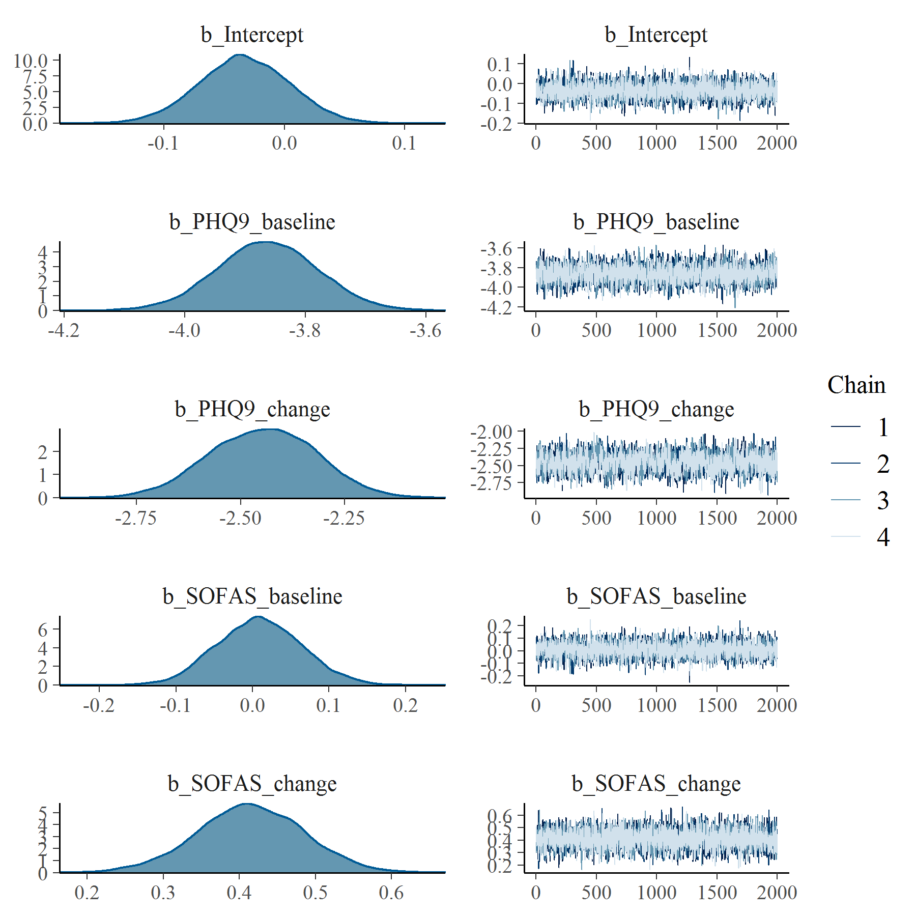

Figure : PHQ9 with SOFAS Generalised Linear Mixed Model with Gaussian distribution and log link population level effects

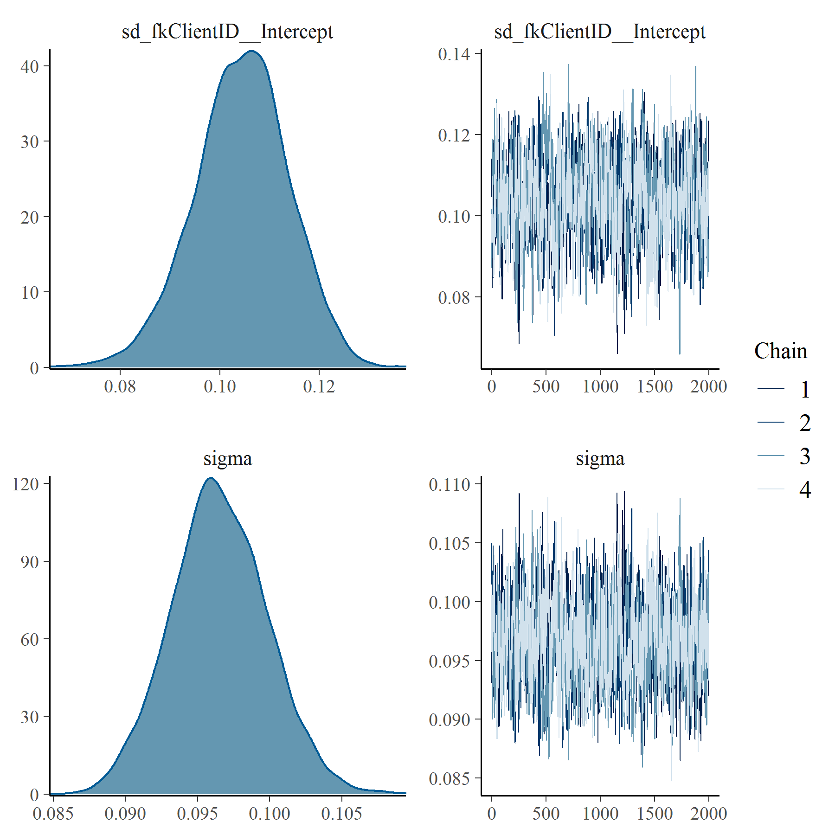

Figure : PHQ9 with SOFAS Generalised Linear Mixed Model with Gaussian distribution and log link group level effects

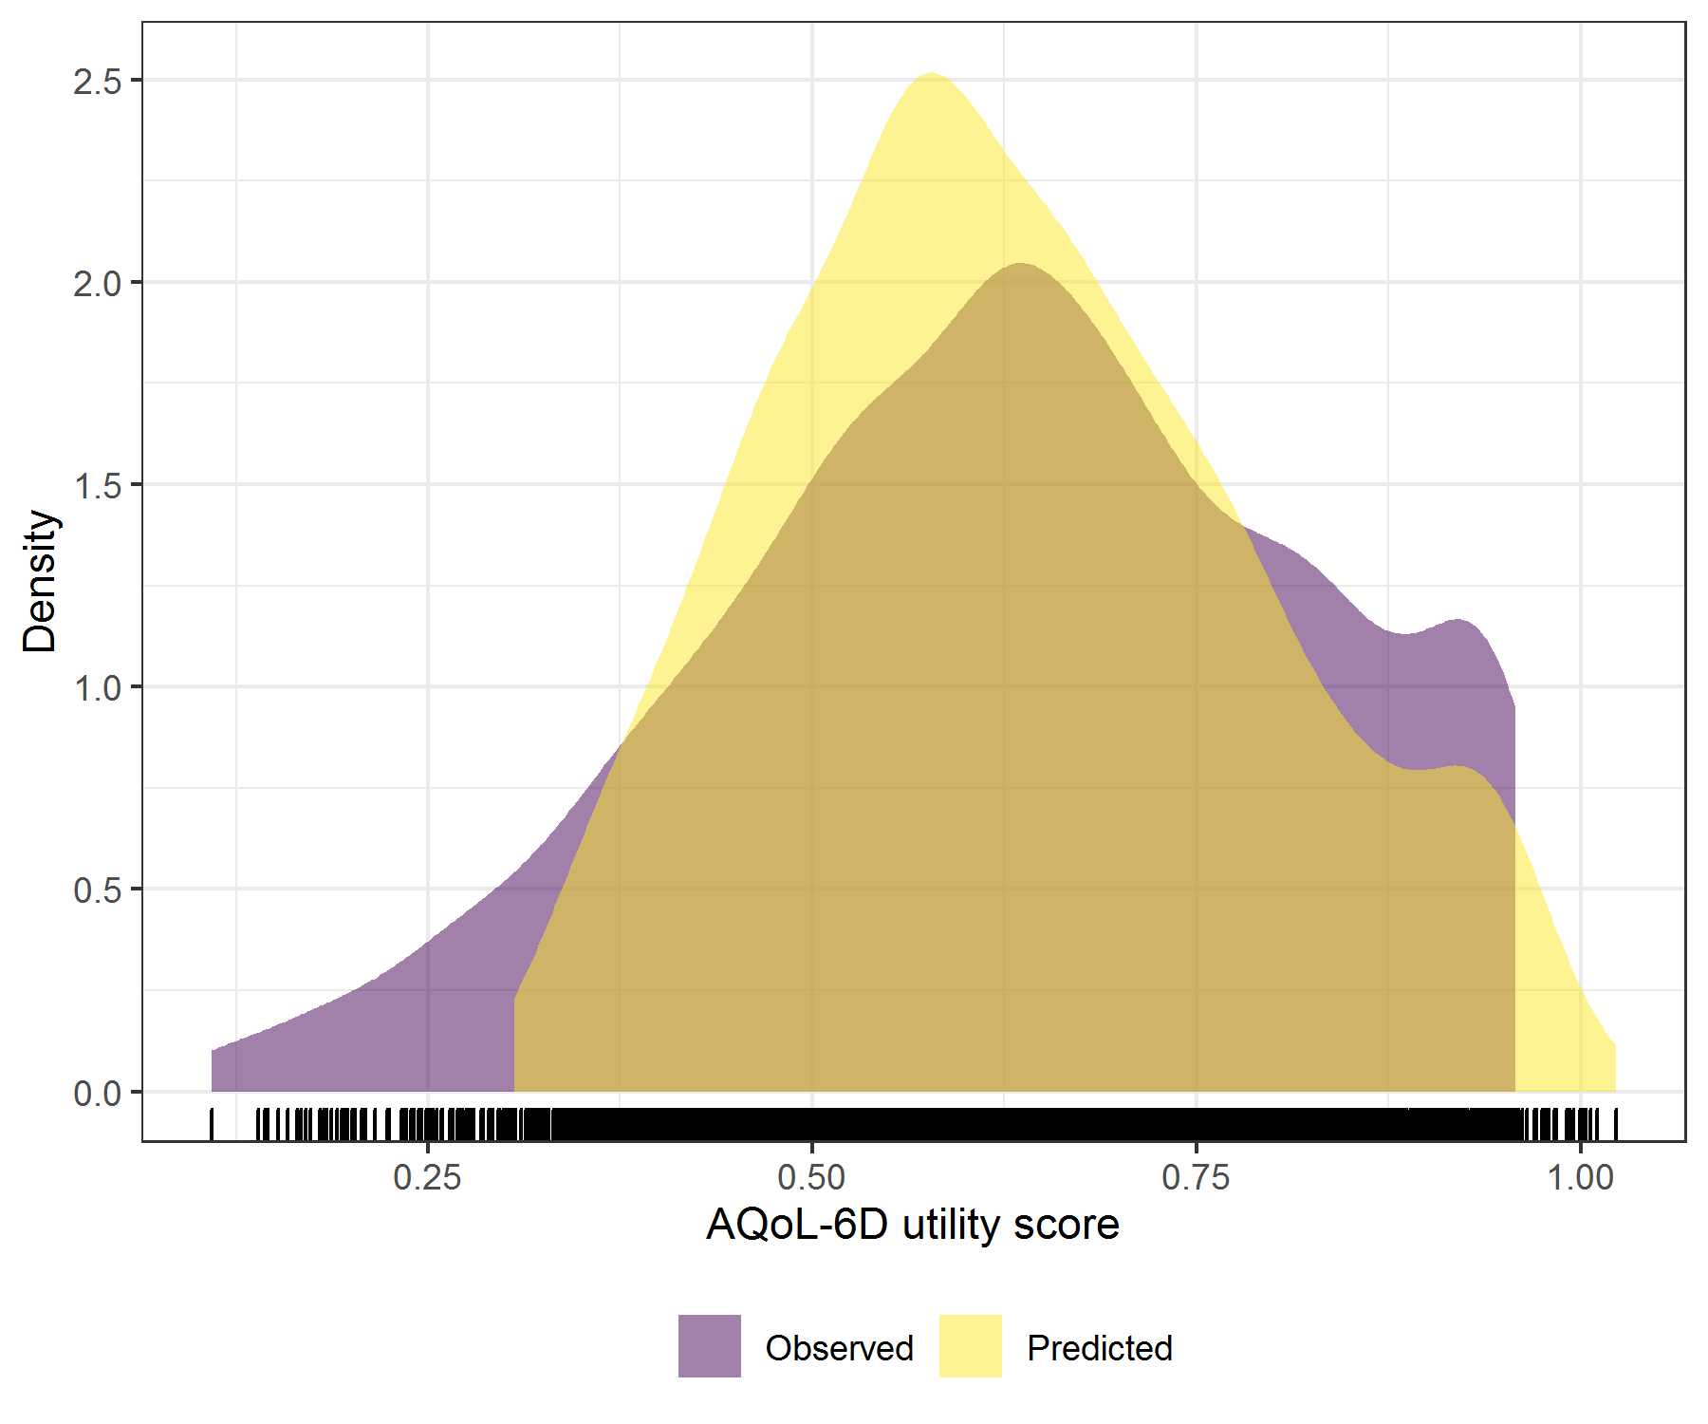

Figure : PHQ9 with SOFAS Generalised Linear Mixed Model with Gaussian distribution and log link comparative densities of observed and predicted data

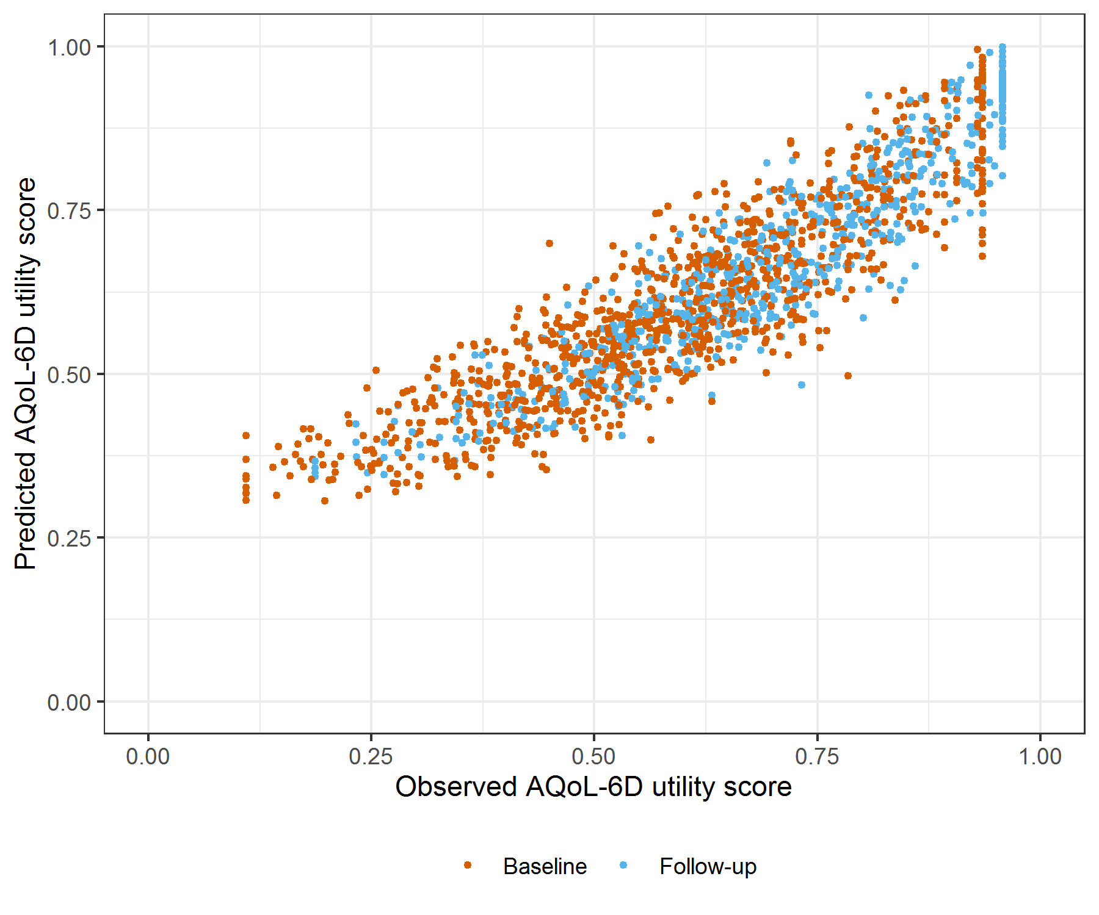

Figure : PHQ9 with SOFAS Generalised Linear Mixed Model with Gaussian distribution and log link comparative scatter plot of obsereved and predicted data

# 2 PHQ9 with SOFAS Linear Mixed Model with clog-log transformation

Table : PHQ9 with SOFAS Linear Mixed Model with clog-log transformation

| Parameter | Estimate | Est.Error | l-95% CI | u-95% CI | Rhat | Bulk_ESS | Tail_ESS |
| --- | --- | --- | --- | --- | --- | --- | --- |
| **Group-Level Effects:** | | | | | | | |
| fkClientID (Number of levels: 1034) |  |  |  |  |  |  |  |
| sd(Intercept) | 0.27 | 0.01 | 0.25 | 0.29 | 1.01 | 1 218 | 2 564 |
| **Population-Level Effects:** | | | | | | | |
| Intercept | 0.91 | 0.08 | 0.76 | 1.07 | 1.00 | 2 860 | 4 477 |
| PHQ9_baseline | -7.73 | 0.17 | -8.06 | -7.38 | 1.00 | 2 643 | 4 098 |
| PHQ9_change | -4.48 | 0.22 | -4.90 | -4.05 | 1.00 | 2 872 | 5 188 |
| SOFAS_baseline | 0.02 | 0.12 | -0.20 | 0.25 | 1.00 | 2 874 | 4 790 |
| SOFAS_change | 1.04 | 0.14 | 0.77 | 1.31 | 1.00 | 4 486 | 5 491 |
| **Family Specific Parameters:** | | | | | | | |
| sigma | 0.26 | 0.01 | 0.24 | 0.27 | 1.00 | 1 317 | 3 036 |
| Formula: aqol6d_total_w_cloglog ~ PHQ9_baseline + PHQ9_change + SOFAS_baseline + SOFAS_change + (1 | fkClientID) | | | | | | | |
| Family: gaussian Links: mu = identity; sigma = identity Data: data_tb (Number of observations: 1651) Samples: 4 chains, each with iter = 4000; warmup = 2000; thin = 1; total post-warmup samples = 8000 | | | | | | | |
| Samples were drawn using sampling(NUTS). For each parameter, Bulk_ESS and Tail_ESS are effective sample size measures, and Rhat is the potential scale reduction factor on split chains (at convergence, Rhat = 1). | | | | | | | |

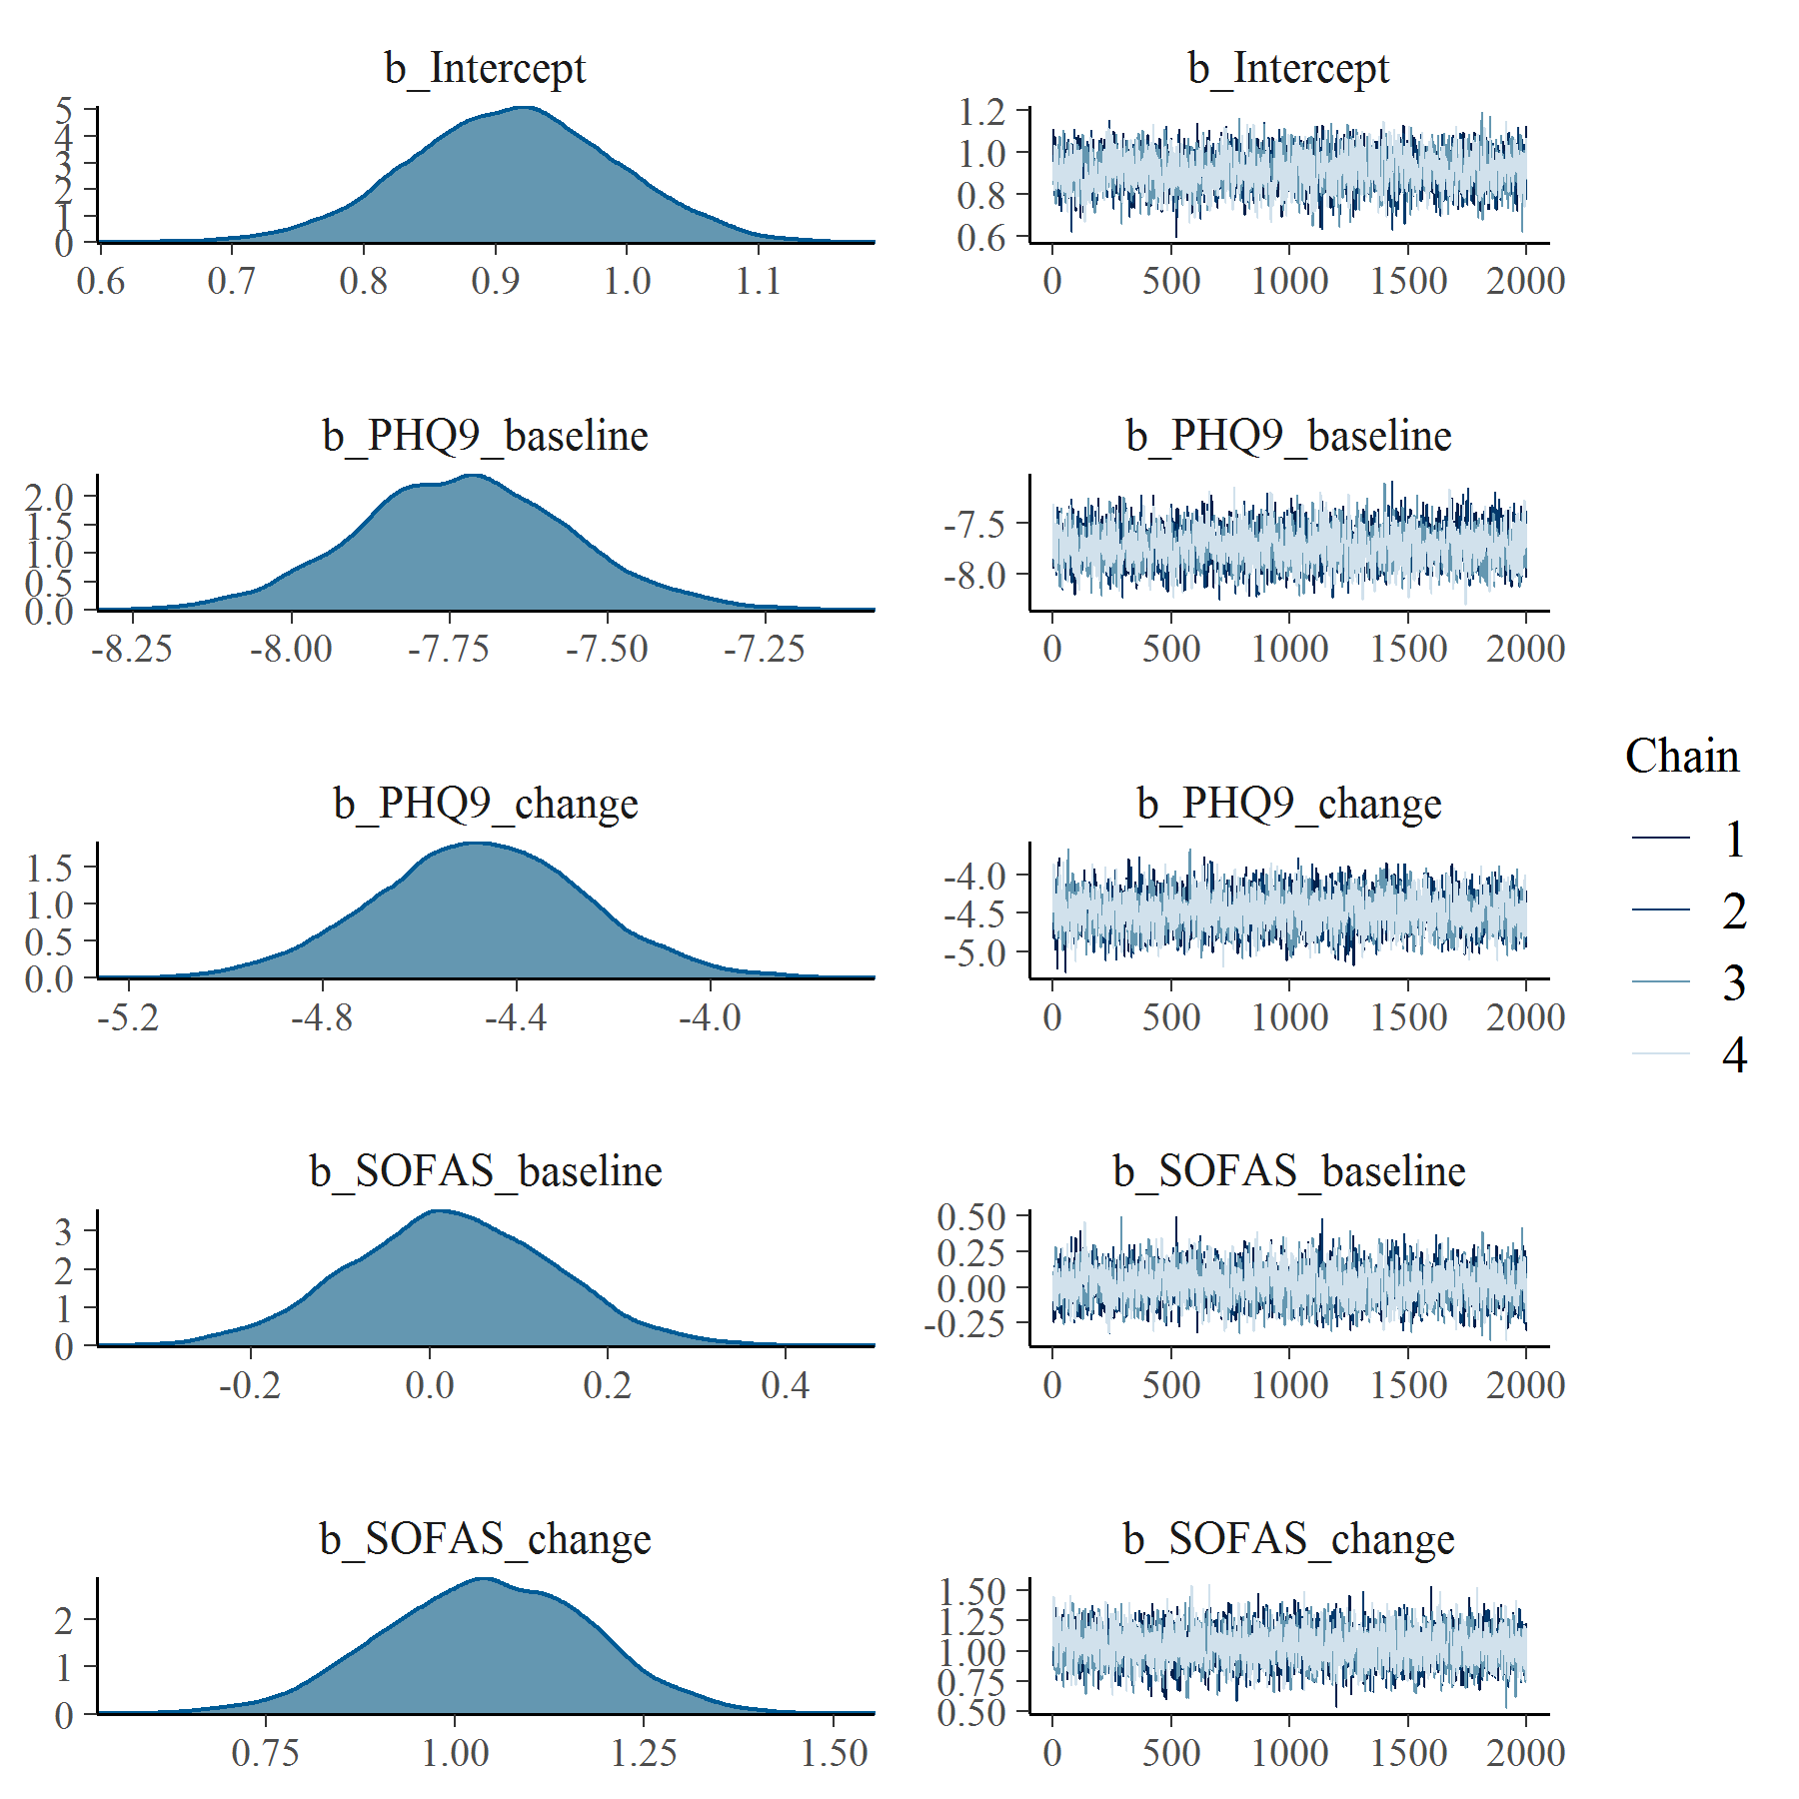

Figure : PHQ9 with SOFAS Linear Mixed Model with clog-log transformation population level effects

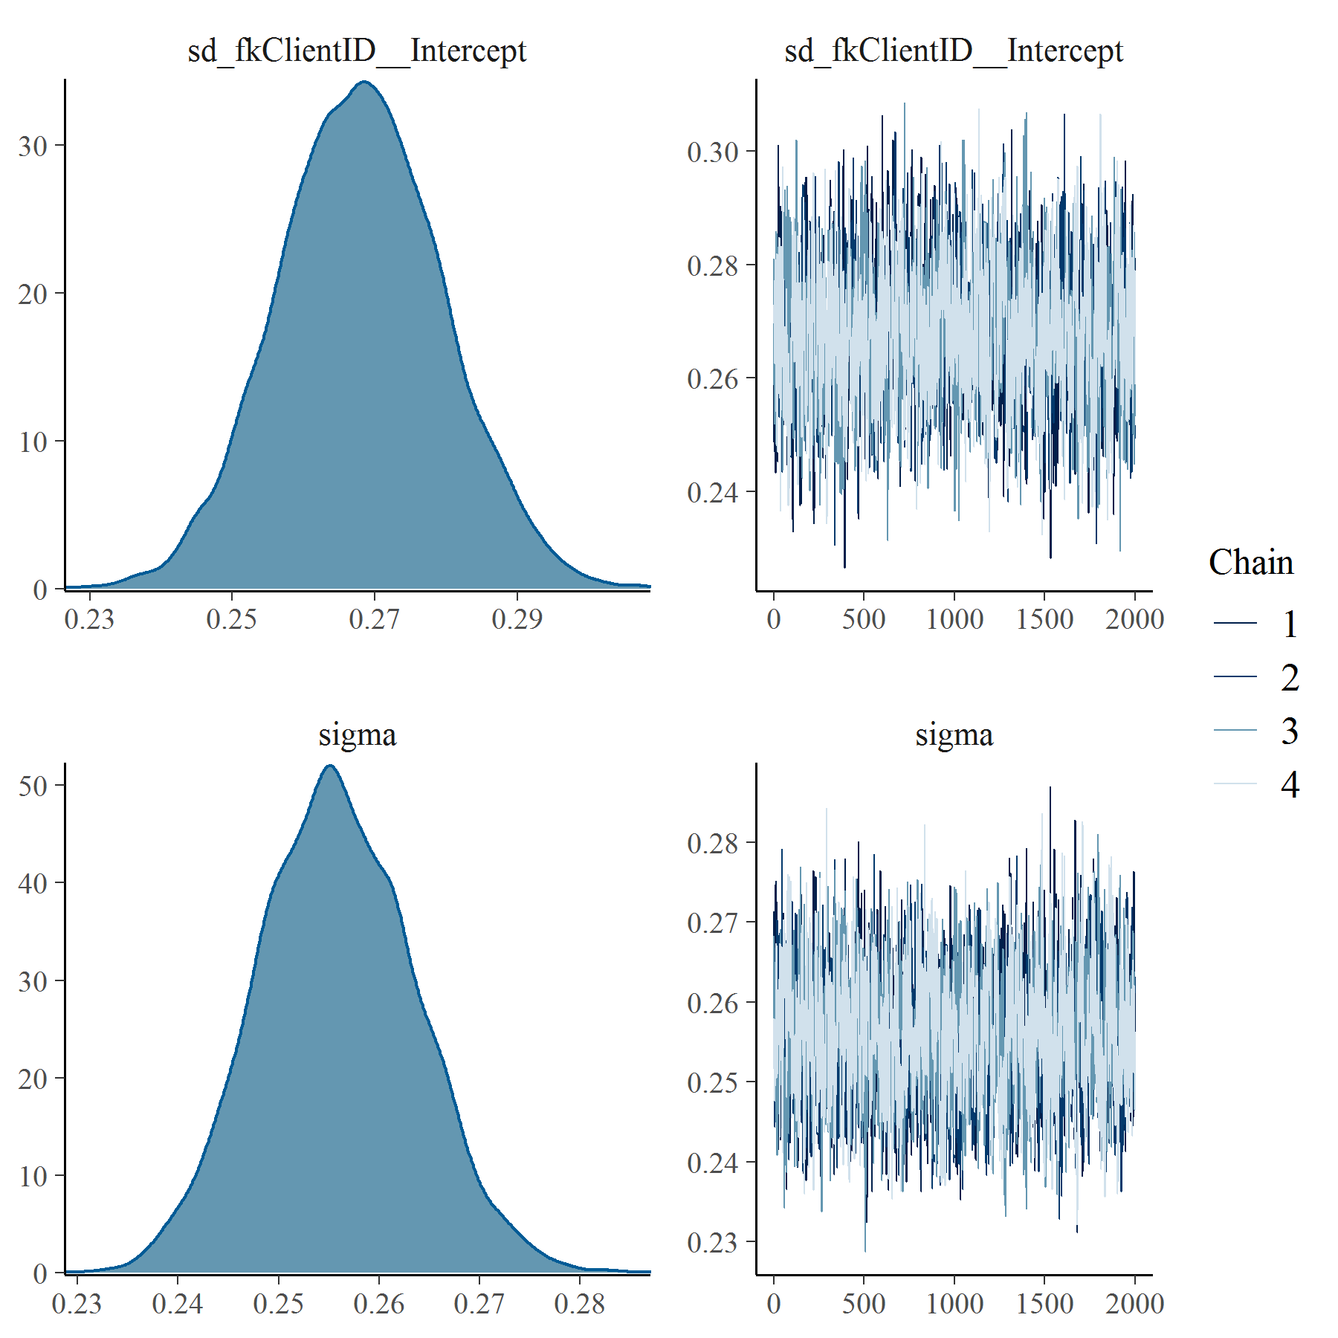

Figure : PHQ9 with SOFAS Linear Mixed Model with clog-log transformation group level effects

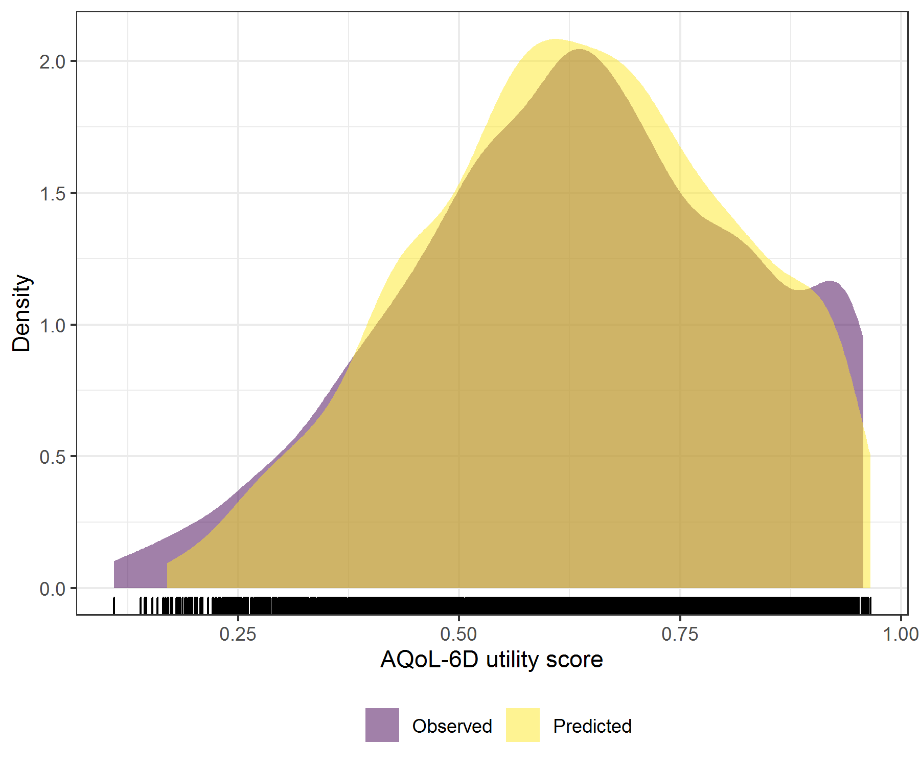

Figure : PHQ9 with SOFAS Linear Mixed Model with clog-log transformation comparative densities of observed and predicted data

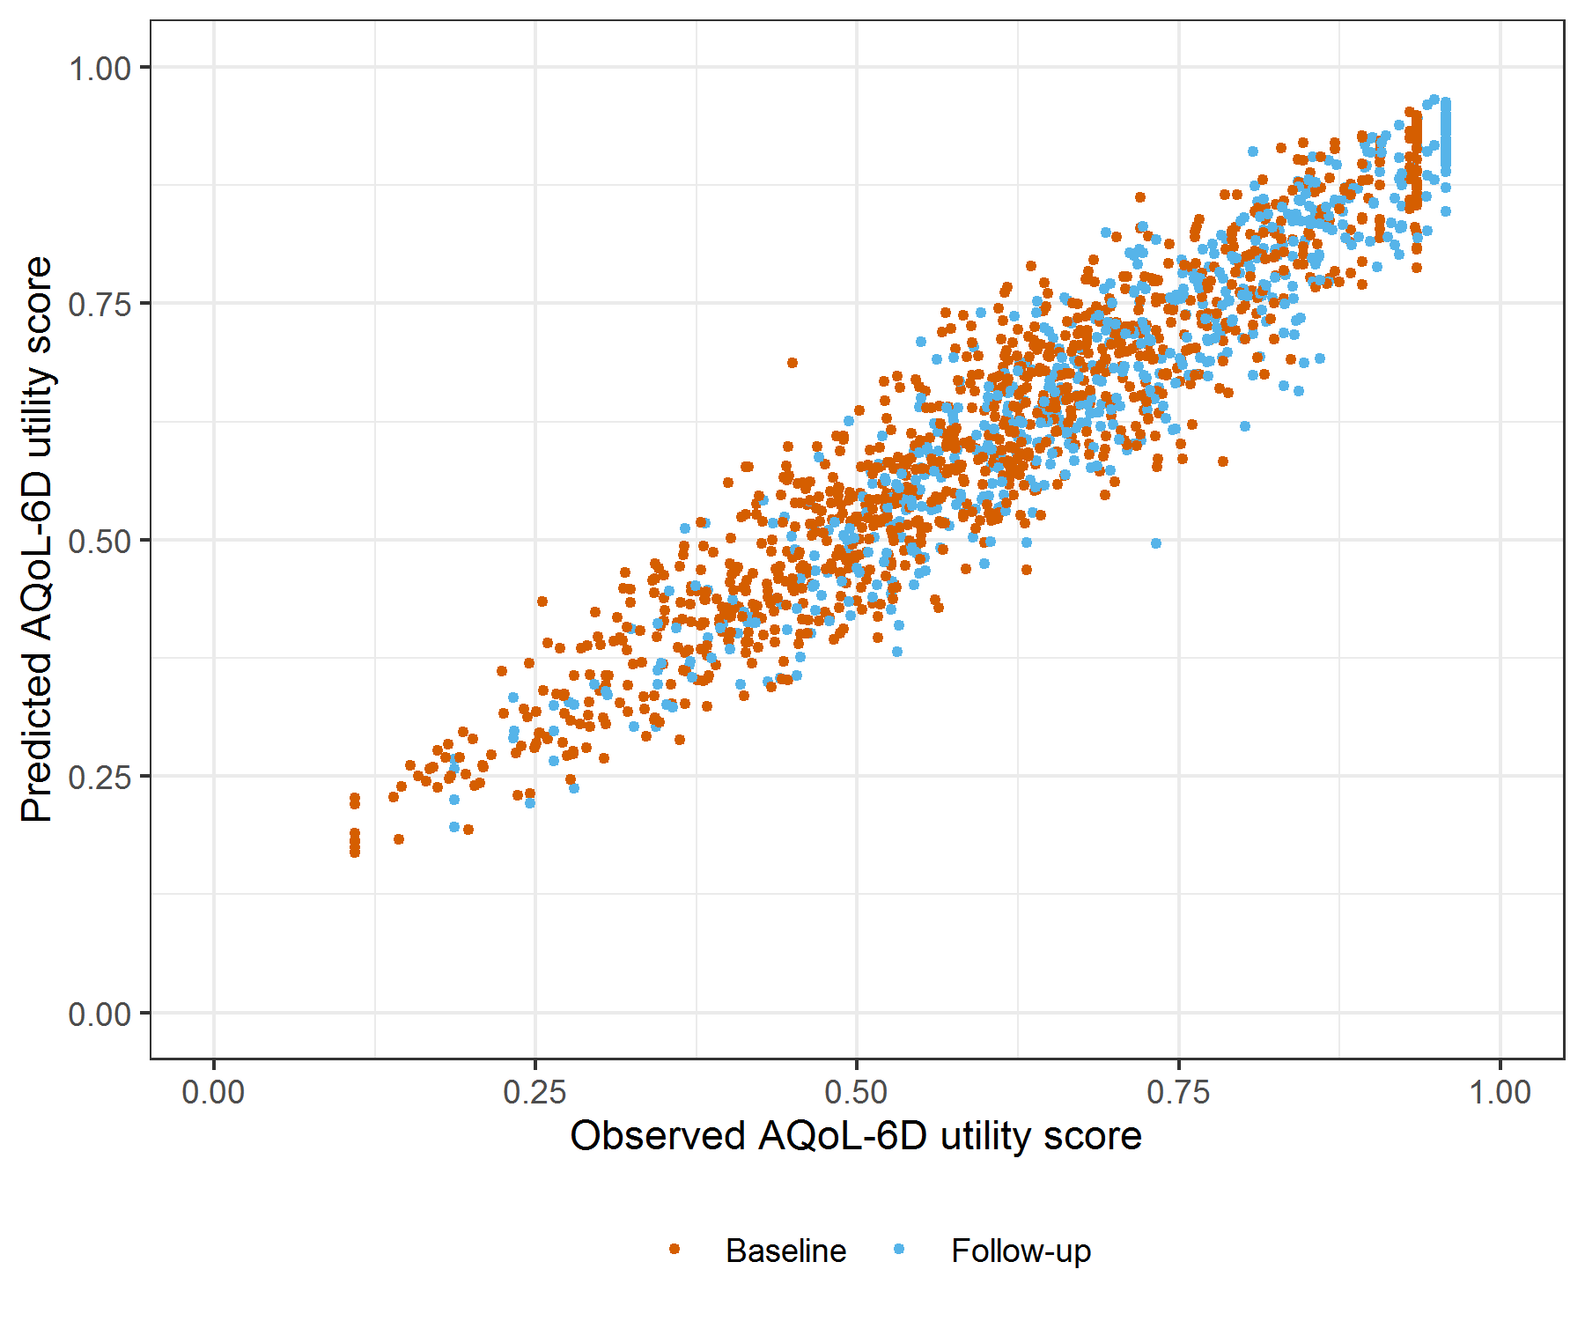

Figure : PHQ9 with SOFAS Linear Mixed Model with clog-log transformation comparative scatter plot of obsereved and predicted data