文档末尾
-----------------------------------------------------------
August 16, 2004
- FIFO采用双向格雷码来解决毛刺现象。
- 时钟约束。如果fan out太大，要采用时钟线。一个时钟线可以驱动400多个时钟信号。如果用普通的i/o线，如果输出太多，则延时过大。
- Try to change formula like 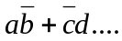 into 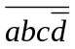+…., this change will provide a significant improvement in SPEED!
- 将一个需要20ns的任务分成两步做，可能每步只需要3ns。
- What is GPIO? GPIO is a flexible parallel interface that allows a variety of custom connections. Although GPIO typically requires more time to configure than HP-IB (GPIB), its speed and versatility make it the perfect choice for many tasks.
- What is UART. (universal asynchronous receiver transmitter)
- DMA is Direct Memory Access
- AMBA is Advanced Microcontroller Bus Architecture.
- SSP interface is Synchronous Serial Port, which includes SPI, MicroWire, T.I. protocols

-----------------------------------------------------------
VHDL Attribute Syntax –attribute
Syntax: attribute AttributeName: Type;
Example: attribute RLOC: string;
The attribute type defines the type of the attribute value. The only allowed type for XST is string. An attribute can be declared in an entity or architecture. If declared in the entity, it is visible both in the entity and the architecture body. If the attribute is declared in the architecture, it cannot be used in the entity declaration.
Once declared a VHDL attribute can be specified as follows:
Syntax: attribute AttributeName of ObjectList : ObjectType is AttributeValue ;
Examples: attribute RLOC of u123 : label is R11C1.S0 ;
attribute bufg of my_signal : signal is sr;
The object list is a comma separated list of identifiers. Accepted object types are entity, component, label, signal, variable and type.
-----------------------------------------------------------

Verilog Meta Comment Syntax
Constraints can be specified as follows in Verilog code:
// synthesis attribute AttributeName [of] ObjectName [is] AttributeValue
Example:
// synthesis attribute RLOC of u123 is R11C1.S0
// synthesis attribute HU_SET u1 MY_SET
// synthesis attribute bufg of my_clock is “clk”;
-----------------------------------------------------------

Add I/O Buffers –iobuf {yes|no}
When the yes value is selected, IBUF and OBUF primitives are generated. IBUF/OBUF primitives are connected to I/O ports of the top-level module. When XST is called to synthesize an internal module which will be instantiated later in a larger design, you must select no for this option. If I/O buffers are added to a design, this design cannot be used as a submodule of another design.
-----------------------------------------------------------

The flaws of TD-SCDMA
1. Considering the incertitude states of the 5 timeslot in a sub-frame, i.e. from timeslot 2 to timeslot 6 with both downlink and uplink states, incredible interference can be caused if one time slot is used as uplink by one UE, and downlink by another simultaneously, when the two UE are close by each other compared with the BS. The receiver probably receive the signal which transmitted by another UE. And this results in a severe BER/BLER.
The solution to the problem above is to force the certain district to use the same like time slot states, i.e. all UE nearby use the same uplink timeslot and downlink timeslot.
2. The BATON HAND OVER scheme still need a further touch up in order to gain an advantage over 2G’s hard handover, even better than soft handover .
3. Since TD-SCDMA is a low chip rate CDMA, the whole timeslots, except timeslot 1, have to be all configured as downlink timeslots if the 2Mbps is the aim, as well the channel modulation must be 8 PSK, instead of QPSK.
-----------------------------------------------------------

Power control for fast fading and slow fading
In the fast fading, if the UE is moving with a speed of 30 kilometers/second, the power control does no take any effects. Because when the TPC comes to the UE, the network condition is completely different with the former, even if it was only 5 ms ago.
-----------------------------------------------------------

Something about Joint Detection and Power Control
Because of the limitation of TD-SCDMA, the system can’t provide a fast Power Control. Because the Tx and Rx are separated by timeslots, not like FDD which you can Rx and Tx at the same time in different frequency band, the TPC has to be transmitted at next DW or UL timeslot.
The solution is Joint Detection which can relieve the drawback to some extent.
-----------------------------------------------------------

How to generate a Gray Code from Binary Code
proc3: process (read_clock, nrst) --Generate Binary Code
begin
if (nrst = '0') then
read_addr <= "00000";
elsif (read_clock'event and read_clock = '1') then 7
if (read_allow = '1') then
read_addr <= read_addr + 1;
end if;
end if;
end process proc3;

proc4: process (read_clock, nrst) --Generate Gray Code from Binary Code
begin
if (nrst = '0') then
read_nextgray <= "10000";
elsif (read_clock'event and read_clock = '1') then
if (read_allow = '1') then
read_nextgray(4) <= read_addr(4);
read_nextgray(3) <= read_addr(4) xor read_addr(3);
read_nextgray(2) <= read_addr(3) xor read_addr(2);
read_nextgray(1) <= read_addr(2) xor read_addr(1);
read_nextgray(0) <= read_addr(1) xor read_addr(0);
end if;
end if;
end process proc4;
-----------------------------------------------------------

Black box declaration in XST
-- Synplicity black box declaration
attribute syn_black_box : boolean;
attribute syn_black_box of MUXCY_L: component is true;
attribute syn_black_box of RF_CTRL_RAM: component is true;
-- XST black box declaration
attribute box_type : string;
attribute box_type of MUXCY_L: component is "black_box";
attribute box_type of RF_CTRL_RAM: component is "black_box";
If the BOX_TYPE attribute:
♦ primitive, or black_box, XST tries to interpret this module as a Virtex™ primitive and use its parameters, for instance, in critical path estimation.
♦ user_black_box, XST processes it as a regular user black box. If the name of the user black box is the same as that of a Virtex™ primitive, XST renames it to a unique name and generates a warning message with the reason for the warning.
-----------------------------------------------------------

Why use Gray Code as the address code for Asynchronous FIFO
Grey-code addresses are used so that the registered Full and Empty flags are always clean, and never in an unknown state due to the asynchronous relationship of the Read and Write clocks. In the worst case scenario, Full and Empty would simply stay active one cycle longer, but it would not generate an error or give false values.
-----------------------------------------------------------

Why Asynchronous FIFO
多时钟域带来的一个问题就是，如何设计异步时钟之间的接口电路。异步FIFO（First In First Out）是解决这个问题一种简便、快捷的解决方案。使用异步FIFO可以在两个不同时钟系统之间快速而方便地传输实时数据。在网络接口、图像处理等方面，异步FIFO得到了广泛的应用。
-----------------------------------------------------------

FIFO的空满标志产生
空/满标志的产生FIFO的核心部分。如何正确设计此部分的逻辑，直接影响到FIFO的性能。`
空/满标志产生的原则是：写满不溢出，读空不多读。即无论在什么进修，都不应出现读写地址同时对一个存储器地址操作的情况。在读写地址相等或相差一个或多个地址的时候，满标志应该有效，表示此时FIFO已满，外部电路应对FIFO发数据。在满信号有效时写数据，应根据设计的要求，或保持、或抛弃重发。同理，空标志的产生也是如此，即：
空标志<=(|写地址-读地址|<=预定值)AND（写地址超前读地址）
满标志<=（|写地址-读地址|<=预定值）AND(读地址超前写地址)
最直接的做法是，采用读写地址相比较来产生空满标志。当读写地址的差值等于一个预设值的时候，空/满信号被置位。这种实现方法逻辑简单，但它是减法器形成的一个比较大的组合逻辑，因而限制了FIFO的速度。所以，一般只采用相等不相等的比较逻辑，避免使用减法器。
-----------------------------------------------------------

How to use 1-bit high-speed carry propagate function in Xilinx FPGA
MUXCY_L is used to implement a 1-bit high-speed carry propagate function. One such function can be implemented per logic cell (LC), for a total of 4-bits per configurable logic block (CLB). The direct input (DI) of an LC is connected to the DI input of the MUXCY_L. The carry in (CI) input of an LC is connected to the CI input of the MUXCY_L. The select input (S) of the MUXCY_L is driven by the output of the lookup table (LUT) and configured as an XOR function. The carry out (LO) of the MUXCY_L reflects the state of the selected input and implements the carry out function of each LC. When Low, S selects DI; when High, S selects CI. See also “MUXCY” and “MUXCY_D”
-----------------------------------------------------------

Problem: ST100 can’t start-up.
Solution: Delete C:\Documents and Settings\User(on your computer)\.jext folder
-----------------------------------------------------------

Rx Cut2.2 FIFO ERROR
The FIFO interrupt signal runs short of 1 interrupt signal, which will terminate the DSP’s DMA process. Without the last and important 1 interrupt, the DMA process will wait endlessly. To solve this problem, we extend the AD_ON signal. So that the fifo can generate the enough number of interrupt.
Notes: the fifo is quit strange in its timing. So when you are dealing with the fifo, you must pay attention to its timing. Maybe the fifo will eat you fist data, or it will need a further clk to output the last data.
-----------------------------------------------------------

Modelsim se中创建altera的仿真库
1．取消modelsim的安装目录中e:\modelsim_57 中modelsim.ini文件中的只读属性（右键->属性）。
2．启动modelsim se仿真工具，在主窗口选择【file】→【change directory】，将工作目录改变到你想存放仿真库的目录，点击OK。一般放在e:\modelsim_57。
3．在生窗口中选择【file】→【new】→【library】命令,在弹出的【create a new library】窗口中将选项【create】设置为【a new library and a logical mapping to it】,在【libryr name】和【library library】窗口中将选项【create】设置为【a new library and a logical mapping to it】,在【libryr name】和【library physical name】中键入所要创建库名字,如altera_library, ,此时在主窗口中已多了一个altera_library(empty)项。注：这个过程实质上想当于在modelsim主窗口中的脚本区域中输入了vlib和vmap命令。
4．在workspace中的library中选中你健入的库名altera_library(empty),在主菜单中选【compile】→【compile…】命令;在弹出窗口compile source file窗口中的【libaray】下拉菜单中选中你的库名,在【查找范围】中选择quarturs安装目录\quarturs\eda\sim_lib文件夹下,对它下面的8个文件进行编译,一要编译两次或分两次编译,方法一:先选8个文件,点击【compile】,这次有错出象,完成后再点击【compile】, 编译成功, 点击【done】;方法二:先编译220pack,再编译altera_mf_componenta.vhd,然后编译其它6个文件，然后点击DONE.
5．配制modelsim 将modelsim根目录下的配制文件modelsim.ini的属性只读改为可写,这可使软件记录仿真库的路径以及映射关系,以后每次启动modelsim时,就会根据ini文件中的本身寻找仿真库,并且形成映射关系, 注:如果启动时出象”仿真库名(unavailable)”可选中它,点右键选择【edit】指定路径; 到些仿真库已创建,以后对altera设计仿真都不需要做库处理了。
6．后仿真配制 如果要做后仿真;就要把你用的系列库和quartursii生成文件一起编译即可,例如你用的是altera的max 7000比利时列,就要加quartursii安装目录\quarturs\eda\sim_lib下的max_atoms;vmax_atoms.vhd; max_components.vhd加这三个文件同时选中，然后一起编译; 注:在做仿真前建project时,在项目窗口default library name项中键入quartursii生成仿真文件的默认名,如max7000系列默认名max。
7．然后将e:\modelsim_57目录下的modelsim.ini的属性重新改为只读。
8．另外：如果你的库没有变成默认的，可以通过编辑e:\modelsim_57目录下modelsim.ini文件来实现。首先取消只读属性，然后用ultraedit打开，按照以下格式编辑
Altera_Library = $MODEL_TECH/../Altera_Library
cyclone = $MODEL_TECH/../cyclone
XilinxCorelib=$MODEL_TECH/../XilinxCoreLib
XilinxCoreLib_ver=$MODEL_TECH/../xilinxCoreLib_ver
cpld=$MODEL_TECH/../cpld
cpld_ver=$MODEL_TECH/../cpld_ver
ieeepure=$MODEL_TECH/../ieeepure
simprim=$MODEL_TECH/../simprim
uni9000_ver=$MODEL_TECH/../uni9000_ver
然后保存modelsim.int, 然后修改属性为只读，这样你的altera库就可以添加进去了。
-----------------------------------------------------------

在Modelsim se中创建xilinx的仿真库
1．在modelsim se的控制台中，输入命令：‘cd ..’回到硬盘的根目录e：。
2．取消modelsim的安装目录中e:\modelsim_57 中modelsim.ini文件中的只读属性（右键->属性）。（这一步很关键，我没有做这一步，结果后面除了一些问题，我猜想可能是这方面的原因。但我没有试过）。
3．运行：compxlib -s mti_se -f all -l all -o Modeltech_57
安装目录在e:\modeltech_57下。
-----------------------------------------------------------

Modelsim se使用教程
- File/Change Directory 选择你的工作目录
- File/New/New project 新建你的工作目录，
- 在project的workspace下，右键点击，选择Add to project/ Existing files，选择你的文件。
- 右键单击文件，选择compile all
- 选择work目录内的文件，双击进入sim模式。
- 在命令空间内输入：view *
- 在工作区内编辑wave.do文件
restart -f
force A 0 20,1 40 -r 40
force B 0 0, 1 100 -r 100
force Cin 1 0, 0 150 -r 150
run 2000
- 在命令空间输入：add wave *
- 在命令空间输入：do wave.do
- 退出sim模式：quit -sim
- 退去modelsim模式：exit
-----------------------------------------------------------

关于inout的设计。
读ARM读FPGA数据时，可以采用：
D<= data_reg0 WHEN nrd='0' AND ncs2='0' AND nwr0='1' AND A="000000000" ELSE
data_reg1 WHEN nrd='0' AND ncs2='0' AND nwr0='1' AND A="000000001" ELSE
(OTHERS=>'Z');
这样的格式。当nrd电平为低时，寄存器数据输出；其他情况输出为(OTHERS=>'Z');
当ARM写FPGA数据时，具体格式无所谓，可以采用电平触发，也可以采用写信号的上跳沿触发。例如：
data_reg0<=D WHEN A="000000000" AND nwr0='0' AND ncs2='0' AND nrd='1';
data_reg1<=D WHEN A="000000001" AND nwr0='0' AND ncs2='0' AND nrd='1';
data_reg2<=D WHEN A="000000010" AND nwr0='0' AND ncs2='0' AND nrd='1';
data_reg3<=D WHEN A="000000011" AND nwr0='0' AND ncs2='0' AND nrd='1';
data_reg4<=D WHEN A="000000100" AND nwr0='0' AND ncs2='0' AND nrd='1';
data_reg5<=D WHEN A="000000101" AND nwr0='0' AND ncs2='0' AND nrd='1';
--------------------------------------------------------------
低电平触发等效于上跳沿触发（条件是上跳沿时数据是稳定的）
--------------------------------------------------------------

QuartusII中fifo的讨论
- 只有当rdclk运行5个cycle后，fifo才开始工作！
- 当fifo开始后果后，可以使rdreq置为高，当每次rdclk的上跳沿，fifo输出一个数据。
--------------------------------------------------------------

关于fifo的实现：
经过测试，发现按照rdreq＝1，rdclk=NOT nrd这种方法实现的fifo还有很大问题，因为rdclk比较混乱，fifo数据总是被误读出。
经过考虑，决定采用pipeline的方式，延迟一个周期，在下一个周期读当前值，当rd信号来的时候，将上次锁存的值送出，然后在rd的上跳沿将fifo值锁定。第一次读输出无效的0。
The hold-time of high level of ‘rdreq’ shall be at least 10ns, less than 10ns will cause the fifo read operation unworks. Now we divided the sys_clk by 2, and hence a 100MHz clock to act as rdclk.
After the post simulation of FPGA, this kind of fifo satisfy the 60MHz data transimission speed, which means only after 7.5ns of the down edge of NRD, the data from fifo are ready on the data bus. The further improvement will depend on the FPGA structure, and how to synthesize the VHDL. What I want to do next is to make sure that how fast the FPGA can run, and what is the limitation.
2005-1-17

About the Clock…
The speed grade of EP1C6 is -8, which is the slowest one. So it is unable to work in 200MHz, whose the maximal frequency is 171MHz. Hereby we change the system clock to 150MHz, instead of 200MHz.
--------------------------------------------------------------

About the FPGA ‘inout’ pins
The structure of FPGA ‘inout’ pin is shown as follows:
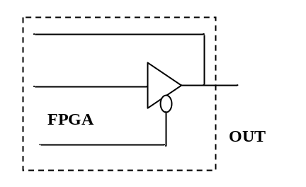

The ‘out data’ can always go into to FPGA at any time. When the FPGA has data to transmit to outside, it just transmit; else if the FPGA don’t want to transmit data, it output ‘Z’, which is high impedence.
--------------------------------------------------------------

About the QuartusII 仿真问题
Quartus的仿真界面中，当修改信号的属性，比如把in修改成inout，必须重新load一下管脚才可以使修改生效，得出正确的仿真结果。如果不重新load，仿真结果就会出错。
--------------------------------------------------------------

关于信号
在vhdl中，有时候的某些信号需要赋值给一个输出管脚，这样信号才稳定。有一个正确的逻辑。
--------------------------------------------------------------

Uboot下调试dma_transceiver中的sram_interface模块中的sram2arm and arm2sram
命令：
1．写sram_A模块
Mw.w 30000060 0003
Mw.w 30000062 0100
Mw.w 30000064 0000
Mw.w 30000066 000f
Mw.w 30000068 0055
Mw.w 30000180 5555 300
需要注意修改sram_interface中关于的ch_select语句。
2．从sram_A读刚才写入的数据
Mw.w 30000060 0003
Mw.w 30000062 0100
Mw.w 30000064 0000
Mw.w 30000066 000f
Mw.w 30000068 00AA
Md.w 30000180 300
结果：输出结果基本正确。但是D14位的值恒为1。当存储数据1234时，输出为5234；存储数据0055时，输出为4055。
-----------------------------------------------------------
2005-2-21

组合电路与时序电路的区别
组合电路的输出结果只和当前的输入有关，与其他时刻的输入输出无关；时序电路的输出既与当前输入有关，又与以前时刻的输入有关。
-----------------------------------------------------------

PLD和FPGA的区别
PLD: 基于乘积项结构，包括Macrocell, PIA 和I/O 单元
FPGA: 基于lut。xinlix包括CLB, PIA, I/O, RAM; 一个CLB包括两个slice，每个slice包含2个lut；
Alitera包括LAB,PIA,I/O,RAM；每个LAB包含8个LE，每个LE包含一个lut和一个D触发器。
-----------------------------------------------------------

建立时间Tsetup和保持时间Tholdtime
建立时间：在触发器时钟上跳沿之前数据必须提前到达的时间；
保持时间：在触发器时钟上跳沿之后数据必须保持的时间。
只有满足了建立时间和保持时间，输出才能被锁入到D触发器中。
-----------------------------------------------------------

消除毛刺的方法
- 采用gray码计数代替二进制计数。
- 输出信号加一个D触发器锁存，只要在毛刺不出现在时钟的沿口并且不满足数据的建立和保持时间，就不会对系统造成危害。
- 修改逻辑
-----------------------------------------------------------

关于消除时钟毛刺的方法
- 全局时钟 在PLD/FPGA设计中最好的时钟方案是：由专用的全局时钟输入引脚驱动的单个主时钟去钟控设计项目中的每一个触发器。只要可能就应尽量在设计项目中采用全局时钟。全局时钟提供器件中最短的时钟到输出的延时。全局时钟应遵守建立时间和保持时间的约束条件。建立和保持时间的数值在PLD数据手册中给出，也可用软件的定时分析器计算出来。如果在应用中不能满足建立和保持时间的要求，则必须用时钟同步输入信号。
- 门控时钟 在许多应用中，整个设计项目都采用外部的全局时钟是不可能或不实际的。PLD具有乘积项逻辑阵列时钟（即时钟是由逻辑产生的），允许任意函数单独地钟控各个触发器。然而，当你用阵列时钟时，应仔细地分析时钟函数，以避免毛刺。通常用阵列时钟构成门控时钟。门控时钟常常同微处理器接口有关，用地址线去控制写脉冲。然而，每当用组合函数钟控触发器时，通常都存在着门控时钟。如果符合下述条件，门控时钟可以象全局时钟一样可靠地工作：a. 驱动时钟的逻辑必须只包含一个“与”门或一个“或”门。如果采用任何附加逻在某些工作状态下，会出现竞争产生的毛刺。b. 逻辑门的一个输入作为实际的时钟，而该逻辑门的所有其它输入必须当成地址或控制线，它们遵守相对于时钟的建立和保持时间的约束。
- 采用带使能端的D触发器

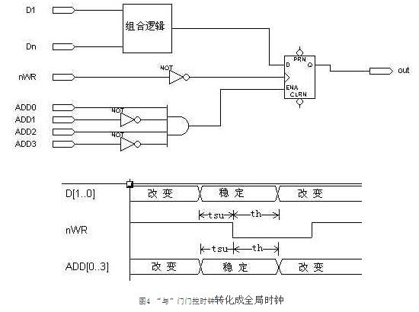
我们往往可以将门控时钟转换成全局时钟以改善设计项目的可靠性。地址线在控制D触发器的使能输入，许多PLD设计软件，如MAX+PLUSII软件都提供这种带使能端的D触发器。当ENA为高电平时，D输入端的值被钟控到触发器中：当ENA为低电平时，维持现在的状态。
这种电路的定时波形表明地址线不需要在nWR有效的整个期间内保持稳定；而只要求它们和数据引脚一样符合同样的建立和保持时间，这样对地址线的要求就少很多。

- 多级逻辑时钟 图7 给出一个含有险象的多级时钟的例子。时钟是由SEL引脚控制的多路选择器输出的。多路选择器的输入是时钟(CLK)和该时钟的2分频(DIV2)。由图7 的定时波形图看出，在两个时钟均为逻辑1的情况下，当SEL线的状态改变时，存在静态险象。险象的程度取决于工作的条件。 多级逻辑的险象是可以去除的。例如，你可以插入“冗余逻辑”到设计项目中。然而，PLD/FPGA编译器在逻辑综合时会去掉这些冗余逻辑，使得验证险象是否真正被去除变得困难了。为此，必须应寻求其它方法来实现电路的功能。

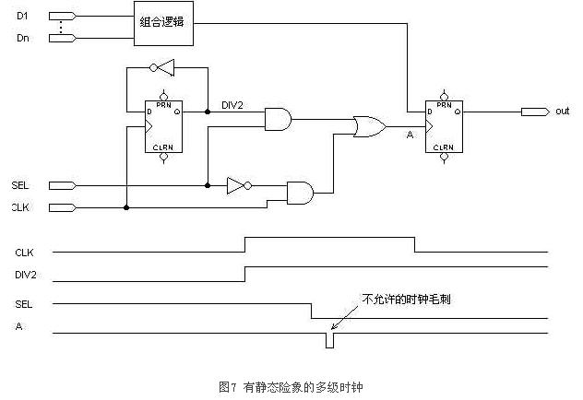
图8 给出 图7 电路的一种单级时钟的替代方案。图中SEL引脚和DIV2信号用于使能D触发器的使能输入端，而不是用于该触发器的时钟引脚。采用这个电路并不需要附加PLD的逻辑单元，工作却可靠多了。 不同的系统需要采用不同的方法去除多级时钟，并没有固定的模式。

- 多时钟系统
-----------------------------------------------------------

高速同步电路的设计
一、同步电路中数据传递的一个基本模型：如下图
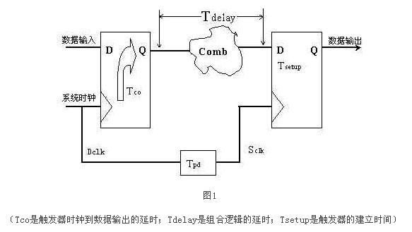
Tpd ,即时钟的延时参数，我们在刚才做时间分析的时候，没有提这个参数，（如果使用PLD的全局时钟型号，Tpd可以为0，如果是普通时钟，则不为0）。所以如果考虑到时钟的延时，精确的公式应该是T=Tco+Tdelay+Tsetup-Tpd。当然以上全部分析的都是器件内部的运行速度，如果考虑芯片I/O管脚延时对系统速度的影响，那么还需要加一些修正。

由于Tco、Tsetup是由具体的器件和工艺决定的，我们设计电路时只可以改变Tdelay。所以缩短触发器间组合逻辑的延时是提高同步电路速度的关键。由于一般同步电路都不止一级锁存（如图3），而要使电路稳定工作，时钟周期必须满足最大延时要求，缩短最长延时路径，才可提高电路的工作频率。

二、分割组合逻辑 如图2所示：我们可以将较大的组合逻辑分解为较小的几块，中间插入触发器，这样可以提高电路的工作频率。这也是所谓“流水线”（pipelining）技术的基本原理。
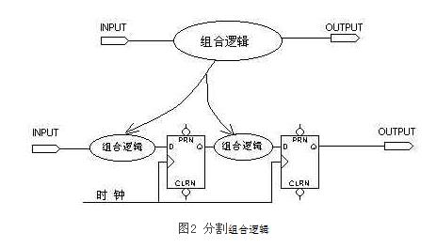
三、 转移组合逻辑 对于图3的上半部分，它时钟频率受制于第二个较大的组合逻辑的延时，通过适当的方法平均分配组合逻辑，可以避免在两个触发器之间出现过大的延时，消除速度瓶颈。
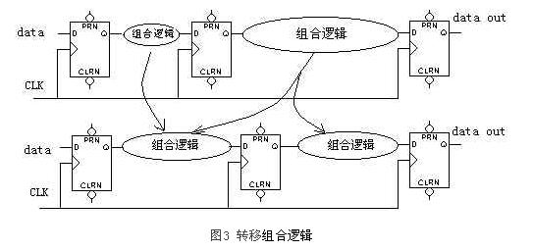
四、 修改PLD开发软件的设置 PLD开发软件中也有一些设置，通过修改这些设置，可以提高编译后系统速度，但这种速度的提高是很有限的，我们只有理解系统速度的基本原理，认真的优化设计方案，才能从根本上提高系统的运行速度。
--------------------------------------------------------------

About FPGA Retiming

Why not use retiming ago?
- Retiming tends to increase area utilization, which was very costly in early ASIC and programmable logic.
- Bandwidth has not always been an urgent need for implementing a typical design.
- Limitation of applying retiming algorithm due to different type of registers with complex control signals.

What can retiming do?
The current retiming algorithms developed by today’s FPGA synthesis tools are working towards solving and enhancing these limitations to obtain a much better timing performance.

In what case that retiming is disqualified?
In general, registers with different clock enable (CE) lines, registers with uncommon set/reset signals or registers with complex control signals are disqualified for retiming.
--------------------------------------------------------------

How to solve the ‘metastable’ state of synchronizer?
The accepted solution at that time was to concatenate an additional flip-flop after the original synchronizer stage (Figure 4). This added flip-flop does not totally remove the problem but does improve reliability. This same solution is still in wide use today.

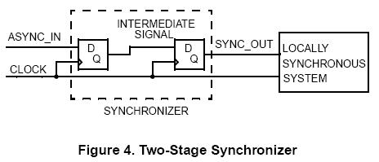
This type of synchronizer does have the drawback of adding one clock cycle of latency, which might be unacceptable in some systems.
So far, no known method totally eliminates the possibility of metastability. However, while you cannot eliminate metastability, you can employ design techniques that make its probability relatively small compared with other failure modes.
--------------------------------------------------------------
2005-2-23

Ten commandments of excellent design
Why use synchronous logic at all? Wouldn’t asynchronous logic be faster?
- Synchronous designs eliminate the problem associated with speed variations through different paths of logic. By sampling signal at well-defined time intervals, fast paths and slow paths can be handled in a simple manner.
- Synchronous designs work well under variations of temperature, voltage and process. This stability is key for high volume manufacturing.
- Many designs must be portable. The deterministic behavior of synchronous designs makes them much more straightforward to move to a new technology.
- Interfacing between two blocks of logic is simplified by defining standardized synchronous behavior. Asynchronous interfaces demand elaborate handshaking or token passing to ensure integrity of information.

Clock Distribution
- Skew Minimization
- Clock fidelity Techniques used to guarantee consistent clock behavior include transmission line termination, ground-bounce minimization, and the use of identical clock drivers.

Good state machine design
Moore Machines: The output is a function only of the current state of the machine.
Mealy Machines: The output of mealy machine is a function of the current state of the machine plus the inputs.
--------------------------------------------------------------
2005-2-24

同步异步系统方法
如图：
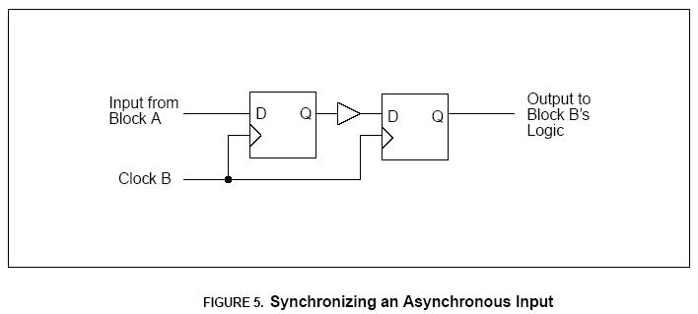
采用clockB采样用两个D触发器来缓冲block A的异步数据。可以是metastable的状态降到较低（但是不能绝对避免metastable状态）。在极少数情况下，如果对数据要求较高，则需要3个D触发器进行缓冲。
另外，如果你的FPGA中有metastable-hardened flip-flop, 可以用来做第一级的D触发器。Metastable-Hardened flip-flop 的特点是不论输入的数据与flip-flop的上升沿多接近，经过一段maximum time都可以产生一个输出。
However, this method of information interchange has one drawback. If the strobe has the form of a pulse, which its pulse width is less than the destination block’s clock (sampling) frequency. In consequence, the pulse from A could not be detected by B.

--------------------------------------------------------------

Using toggle signals to cross clock system to avoid signal metastability.

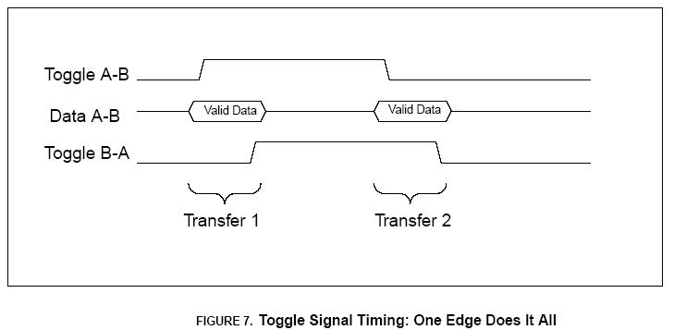
It may be seen that each transfer is complete with only two events: a toggle of each of the two toggle strobes.
--------------------------------------------------------------

Why latches?
A single bit register implemented with a latch may use just 60% of the gates that a conventional D-type flip-flop requires.
--------------------------------------------------------------

Why Registers?
Register-based designs suffer from none of the disadvantages listed above. Race conditions are rare to non-existent, glitches on the control or D signals are unlikely to cause harm, and signals can be reliably latched in one clock period.
--------------------------------------------------------------

Fast pass to disaster
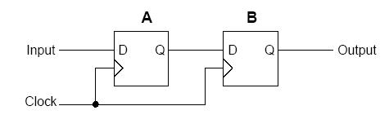
This is a classic example of a race condition; the transition as the output of the first flip-flop changes might well violate the hold time on the D input of the second flip-flop. This situation can be worsened if there is skew between the clocks to each of the two flip-flops.
The solution is add a delay element.
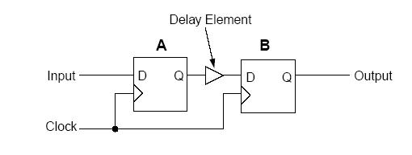
Some synthesizer tools have a “fix hold” option which claims to take care of this situation.
--------------------------------------------------------------

Peter’s Provocative Pontifications—The ten commandments for successful design
- All state machine outputs shall always be registered
- Use register, never latches
- The State machine inputs, including resets, shall be synchronous
- Beware fast paths
- Minimize skew of clock
- Cross clock domains with the greatest of caution. Synchronize your signals.
- Have no dead states in you state machine.
- Have no logic with unbroken asynchronous feedback
- All decode logic must be crafted carefully.
- Trust not your simulator.
--------------------------------------------------------------

Some comment about the LATCH
Advantages:
- Smaller than D-type flip-flops
- Provide anticipation of the data
- Lower power, compared with continuously clocked flip-flop
Drawbacks:
  - Thus, latch-based design is inherently not reusable.
Attention:
- A glitch-free enable
- Data input hold time
--------------------------------------------------------------
IF-Then-Else
Improper use of the Nested If statement can result in an increase in area and longer delays in a design. Each If keyword specifies a priority-encoded logic whereas the Case statement generally creates balanced logic.
Rule - To avoid long path delays, do not use extremely long Nested If constructs. In general, use the Case statement for complex decoding and use the If statement for speed-critical paths.
Guideline
    - In general, If-Else constructs are much slower unless the intention is to build a priority encoder. The If-Else statements are appropriate to use for priority encoders. In this case assign the highest priority to a late arriving critical signal.
    - the nested If was modified to use If-Case
--------------------------------------------------------------

Critical Path Optimization
A common technique that is used to speed-up a critical path is to reduce the number of logic levels on the critical path by giving the late arriving signal the highest priority.
Example: assign out = (((in0&in1) & ~critical) | ~in2) & ~in3;
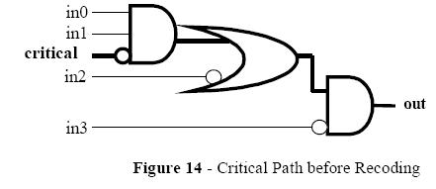
Here, in3 has the highest priority.
--------------------------------------------------------------
2005-2-28

设计异步多时钟系统的综合及描述技巧
Static Timing Analysis
Performing static timing analysis is the process of verifying that every signal path in a design meets required clock-cycle timing, whether or not all of the signal paths are even possible.
Dynamic timing verification.
In theory, timing verification could be accomplished by running exhaustive gate level simulations with SDF back annotation of actual timing values after a design is placed and routed.
Advantages that a static timing analysis has over the Dynamic timing verification.
- 静态时延验证每一个具有顺序结构的信号路径。
- 不需要测试向量
- 速度快
--------------------------------------------------------------

时钟命名规则
每个时钟的命名应该明确指出该时钟来自于哪个时钟源（可以使用一个前缀）。Any signal that was
clocked by the uClk would have a u-prefix in the signal name, such as uaddr, udata, uwrite, etc.
Design Partitioning
Guideline: Only allow one clock per module.
Reason: Static timing analysis and creating synthesis scripts is more easily accomplished on
single-clock modules or groups of single-clock modules.
Guideline: Create a synchronizer module for each set of signals that pass from just one clock
domain into another clock domain.
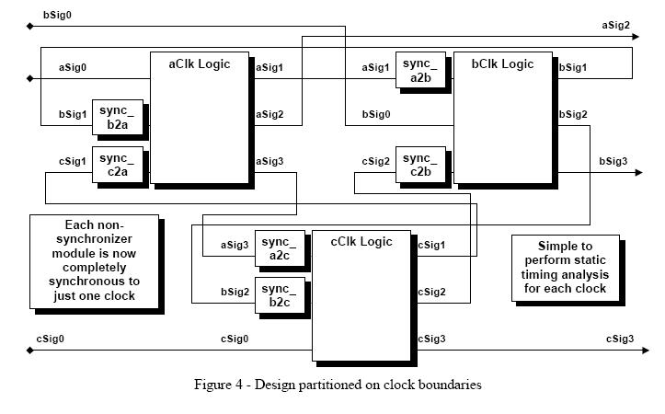
After repartitioning the design, many of the timing analysis and synthesis tasks became trivial.

--------------------------------------------------------------

静态时序的分析工具
DesignTime , PrimeTime
--------------------------------------------------------------

Synchronizing Fast Signals Into Slow Clock Domains
解决方法一：把快速时钟系统的信号延长多个时钟周期，保证慢速系统能够采到。
解决方法二：采用反馈，应答的方法。
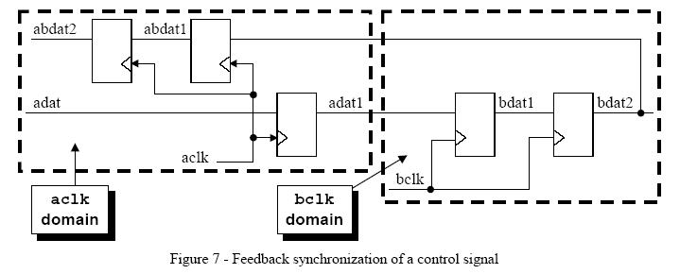
--------------------------------------------------------------

在异步系统中传输 数据和时钟 同步的方法(Passing Data between clock domains)
- 采用握手信号
The biggest disadvantage to using handshaking is the latency required to pass and recognize all of the handshaking signals for each data word that is transferred.

- 使用FIFO
Use Gray-code counters
--------------------------------------------------------------

Pessimistic full and empty flags of FIFOS
A pessimistic full flag is a full signal that is asserted immediately when a FIFO becomes full but
is de-asserted late (it is not de-asserted until a few read-clock cycles later).
--------------------------------------------------------------

结论
- Partitioning non-synchronizer blocks so that there is only one clock per module permits easy verification of correct timing by creating clock-domain sub-blocks that can be more easily verified with static timing analysis tools.
- Partitioning synchronizer blocks to permit inputs from one and only one clock domain and clocking the signals with only one asynchronous clock creates manageable synchronizer sub-blocks that can also be easily timed.
- A clock-oriented naming convention can be useful to help identify signals that need to be timed within the different asynchronous clock domains.
- Multiple control signals crossing clock domains require special attention to ensure that all control signals are properly sequenced into a new clock domain.
--------------------------------------------------------------
2005-3-1

同步复位与异步复位

Advantages of synchronous resets
- Synchronous reset will synthesize to smaller flip-flops, particularly if the reset is gated with the logic generating the d-input. (which is not so important that the die size is not an critical issue) .
- Synchronous reset can be much easier to work with when using cycle based simulators.
- Synchronous resets generally insure that the circuit is 100% synchronous.
- Synchronous resets insure that reset can only occur at an active clock edge.
- In some designs, the reset must be generated by a set of internal conditions. A synchronous reset is recommended for these types of designs because it will filter the logic equation glitches between clocks.
- By using synchronous resets and a number of clocks as part of the reset process, flip-flops can be used within the reset buffer tree to help the timing of the buffer tree keep within a clock period.
--------------------------------------------------------------

Disadvantages of synchronous resets
- Synchronous resets may need a pulse stretcher to guarantee a reset pulse width wide enough to ensure reset is present during an active edge of the clock
- A designer must work with pessimistic vs. optimistic simulators.
--------------------------------------------------------------

Advantages of asynchronous resets
- The biggest advantage to using asynchronous resets is that, as long as the vendor library has asynchronously resetable flip-flops, the data path is guaranteed to be clean.
- Another advantage favoring asynchronous resets is that the circuit can be reset with or without a clock present.
--------------------------------------------------------------

Disadvantages of asynchronous resets
- For DFT, if the asynchronous reset is not directly driven from an I/O pin, then the reset net from the reset driver must be disabled for DFT scanning and testing.
- If the asynchronous reset is released at or near the active clock edge of a flip-flop, the output of the flip-flop could go metastable and thus the reset state of the ASIC could be lost.
- Spurious resets due to noise or glitches on the board or system reset.
--------------------------------------------------------------

Asynchronous reset problem
异步reset无效时，如果正好是clk的上升沿，那么触发器的状态就会进入不定态。
An asynchronous reset signal will be de-asserted asynchronous to the clock signal. There are two potential problems with this scenario: (1) violation of reset recovery time and, (2) reset removal happening in different clock cycles for different sequential elements.
--------------------------------------------------------------

Reset synchronizer
Guideline: EVERY ASIC USING AN ASYNCHRONOUS RESET SHOULD INCLUDE A RESET SYNCHRONIZER CIRCUIT!!
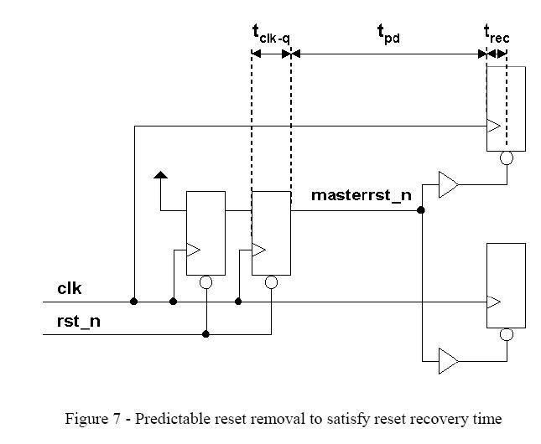
module async_resetFFstyle2 (rst_n, clk, asyncrst_n);
output rst_n;
input clk, asyncrst_n;
reg rst_n, rff1;
always @(posedge clk or negedge asyncrst_n)
if (!asyncrst_n) {rst_n,rff1} <= 2'b0;
else {rst_n,rff1} <= {rff1,1'b1};
endmodule
Example 8a - Properly coded reset synchronizer using Verilog
library ieee;
use ieee.std_logic_1164.all;
entity asyncresetFFstyle is
port (
clk : in std_logic;
asyncrst_n : in std_logic;
rst_n : out std_logic);
end asyncresetFFstyle;
architecture rtl of asyncresetFFstyle is
signal rff1 : std_logic;
begin
process (clk, asyncrst_n)
begin
if (asyncrst_n = '0') then
rff1 <= '0';
rst_n <= '0';
elsif (clk'event and clk = '1') then
rff1 <= '1';
rst_n <= rff1;
end if;
end process;
end rtl;
--------------------------------------------------------------

Reset-glitch filtering
If the reset line is subject to glitching, this can be a real problem. This solution requires that a digital delay (meaning the delay will vary with temperature, voltage and process) to filter out small glitches.
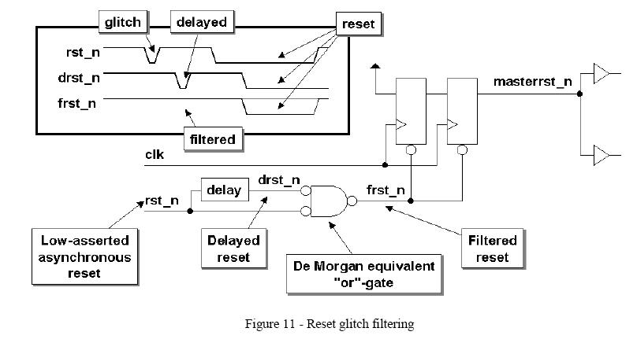
In order to add the delay, some vendors provide a delay hard macro that can be hand instantiated. If such a delay macro is not available, the designer could manually instantiate the delay into the synthesized design after optimization – remember not to optimize this block after the delay has been inserted or it will be removed.
--------------------------------------------------------------

Multi-clock reset issues
Depending on the constraints of the design, there are two techniques that could be employed:
(1) non-coordinatedreset removal
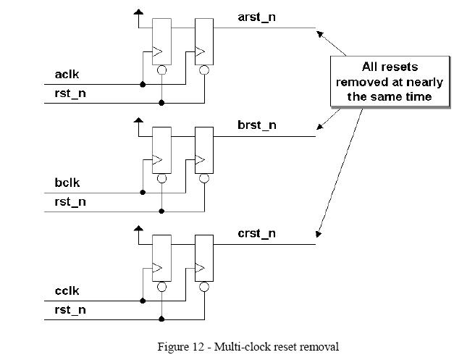
For this type of design, creating separate asynchronous reset synchronizers as shown in Figure 12 is sufficient,

(2) sequenced coordination of reset removal.
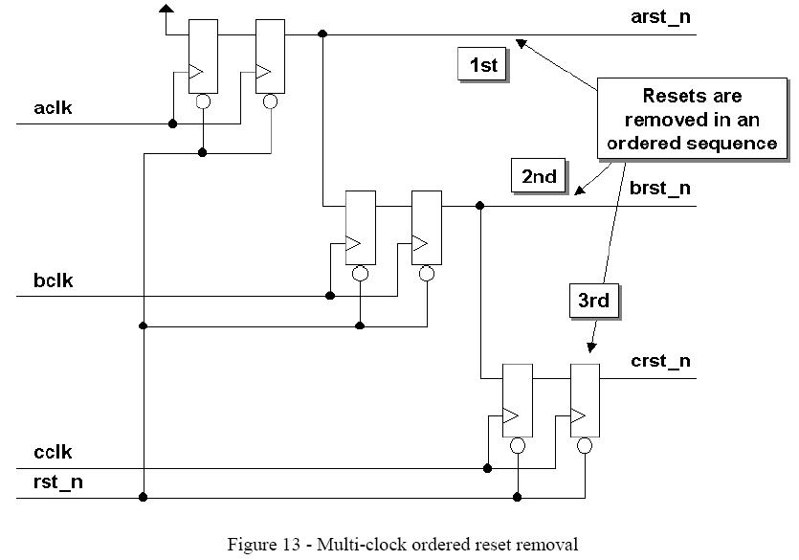

--------------------------------------------------------------

Multi-ASIC reset synchronization
First, for very high-speed designs, the relative board trace length of reset signals to the four ASICs would have to be held to a very tight tolerance; hence, board layout is an issue.
Second, process variations within or between batches of manufactured ASICs can create delays that exceed the ultra short ASIC clock periods.
--------------------------------------------------------------

多点综合技术
(top-down综合需要把代码分成小于100K的子模块进行综合。)
多点综合技术采取不是完全的自顶向下也不是纯粹的自底向上的方法。作为一个可替代的方法，把自顶向下方法的易使用、高的综合质量结果与自底向上的方法的高效率、低的内存使用结合起来。多点综合技术在大型的设计中利用了层次化的方法。
--------------------------------------------------------------

采用CPU来配置FPGA
可以实现现场可编程，降低成本。但是需要CPU提供5根IO线，另外CPU的boot应该不依赖FPGA。对于Altera的FPGA，配置方法可分为：专用的EPROM （Configuration EPROM）、PS（Passive serial 无源串行）、PPS（Passive parallel synchronous 无源同步并行）、PPA（Passive parallel asynchronous 无源异步并行）、JTAG（不是所有器件都支持）。
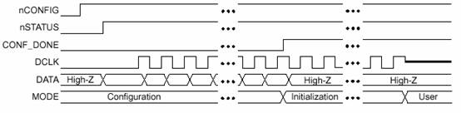

时序图
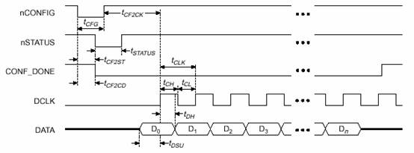
Tcfg>2us Tcf2st<1us Tcf2ck>5us

Tdclk

型号 | DCLK最高频率
ACEX1K、FLEX10KE、APEX20K | 33MHz
FLEX10K | 16MHz
APEXII、APEX20KE、APEX20KC | 57MHz
Mercury | 50MHz

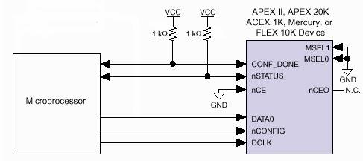
--------------------------------------------------------------

安全的状态机
在VHDL中，when others语句有时候并不能保证一个安全的状态机。
例如在系统上电过程中，可能会进入一个非预期的状态，也许会使系统的状态机瘫痪。可以通过设置综合工具的选项，使其不要综合掉一些看似‘无用’的状态，这样我们就可以产生一个‘安全’的状态机。
“Safe” State Machines If the number of states (N) is a power of 2, and you use a binary or gray-code encoding algorithm, the state machine is “safe”. This ensures that you have M number of registers where N = 2M. Because all of the possible state values (or register statuses) are reachable, the design is “safe.”
“Unsafe” State Machines If the number of states is not a power of 2, or if you do not use binary or gray-code encoding algorithm, e.g. one-hot, the state machine is “unsafe.”
综合工具设置方法：在menu: State Machine Properities->Generation中的More Options中选择recovery state（复原状态），在Menu: state machine properties->Encoding中Scheme选择Hard， Mode选择auto（由工具指定状态的编码长度）。

--------------------------------------------------------------
高速系统的问题

关于Rocket IO的差分走线（LVDS）
- 差分线对内两条线间的距离应尽量小于两倍线宽，即S<2W；
- PCB板材厚度应大于差分线对内两条线之间的距离，即B>S；
- 相邻差分对之间的距离应大于两倍的差分线对的距离，即D>2S。
- 差分走线一定要等线长
- 设计中要注意耦合电容选用75-500nF的无极性电容，尽量选择体积、ESR和ESL小的贴片封装方式，并且应放置在差分线靠近接收器一侧邻近位置上，同时布线要保证差分线对间不能交错

出于对信号线的屏蔽的考虑，设计的线型选用带状线
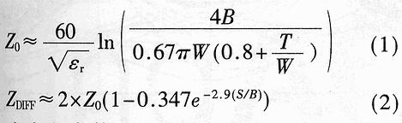

当介电常数εr=4.3、T=1mil、W=6mil、S=10mil、B=20mil时，由（1）式得Z0≈54.4Ω。由（2）式得差分线阻抗ZDIFF≈100Ω，以适配Rocket I/O模块设定的50Ω差分输入阻抗。PCB布线时应注意以下几点：
- 差分线对内的长度相互匹配以减少信号扭曲。为使设计传输速率达到2．5Gbaud，在差分线对内部每个走线区间内的实际布线公差应控制在5mil内。
- 差分线对内两条线之间的距离应尽可能小，以使外部干扰为共模特征。差分线对间的距离应尽可能保持一致，以降低差分阻抗分布的不连续性。
- 采用电源层作为差分线的信号回路，因为电源平面有最小的传输阻抗，从而减小噪声。
- 由于每个过孔可带来0．5～1．0dB的损耗，应尽量减少过孔数目。过孔的通孔和焊盘应有尽量小的物理尺寸，并且在通孔穿越的未连接层不加焊盘。差分对内的过孔不仅在数量上要匹配，而且在放置的位置上也要接近，以使阻抗分布尽量一致。
- 避免导致阻抗不连续的90°走线，而要用圆弧或45°折线来代替。走线时应使向左、向右折角的数量接近，这样可减少信号经差分线传输引起的扭曲。
--------------------------------------------------------------
2005-3-29

怎样调整FPGA管脚以方便布线
- 将FPGA相应的bank单独画一张原理图，将该bank的所有pins都连接起来。
- 在allegro中设置颜色，显示pin_number，然后选择该net为高亮，即可方便就可以重新制定FPGA的管脚以方便布线。
--------------------------------------------------------------

NIOS-II FPGA嵌入式软处理器研究
功能：
把Nios II嵌入到Altera的所有FPGA中，例如StratixII、Stratix、CycloneII, Cyclone、APEX, ACEX和HardCopy系列器件中，用户可以获得超过200 DMIPS的性能，用户可以从三种处理器以及超过60个的IP核中选择所需要的，Nios II系统为用户提供了最基本的多功能性，设计师可以以此来创建一个最适合他们需求的嵌入式系统。
优点和性能：
使用Nios II处理器的用户可以根据他们的需要来调整嵌入式系统的特性、性能以及成本，快速使得产品推向市场，扩展产品的生命周期，并且避免处理器的更新换代。

提高系统性能
* 一系列的处理器核可供选择，其中包括了超过200 DMIPS性能的核
* 实现任何数量的处理器或将不同的处理器核组和在一起
* 增加了已有的处理器，在FPGA中添加一个或更多的Nios II软核处理器

更低的系统成本
* 通过将处理器、外设、存储器和I/O接口集成到一个单一的FPGA中，从而降低了系统成本、复杂性和功耗
* 通过将Nios II处理器嵌入到低成本的FPGA中只需花费35美分或者更低（编者：对大多数用户而言，NiosII所占逻辑资源的成本大约是10－20元人民币，具体取决于所选FPGA的类型和NiosII的配置）

应对产品的生命周期
* 提供易用的设计工具从而快速将产品推向市场。
* 提供永久的，免费的许可从而使基于Nios II处理器的产品避免了处理器的更新换代而带来的损失。

功能强大、易用的开发工具
* 通过使用Nios II集成开发环境（IDE），从而加速了软件的开发
* 利用Altera的强大的SOPC Builder系统开发工具和Quartus II设计软件可以在几分钟内设计一个系统

使用完全功能的开发包
* 使用易用的Nios II 开发包开始一个设计
* 使用易用的Nios II开发包开始设计
* 可以选择具有低成本特性的Cyclone FPGA开发套件，或高性能的Stratix FPGA开发套件
一．软件安装
- 安装QuartusII4.2 （一定要装这个版本或者更高版本的）
- 安装NiosII IDE 用于软件开发
- 安装ModelSim6.0。 用于系统仿真
二．

--------------------------------------------------------------

Quartus4.2 中管脚绑定
在当前工作目录下建立一个name为Setup.tcl的file，其内容如下：

#Setup.tcl
# Setup pin setting
set_global_assignment -name RESERVE_ALL_UNUSED_PINS "AS OUTPUT DRIVING GROUND"
set_global_assignment -name ENABLE_INIT_DONE_OUTPUT OFF
set_location_assignment PIN_16 -to clk
set_location_assignment PIN_37 -to led\[0\]
set_location_assignment PIN_39 -to led\[1\]
set_location_assignment PIN_1 -to led\[2\]
set_location_assignment PIN_41 -to led\[3\]
set_location_assignment PIN_42 -to led\[4\]
set_location_assignment PIN_49 -to led\[5\]
set_location_assignment PIN_50 -to led\[6\]
set_location_assignment PIN_51 -to led\[7\]

其中具体的管脚修改PIN_**为所需要的即可。这样十分方便再次assign管脚。
--------------------------------------------------------------

Xilinx嵌入式开发简介
EDK - 嵌入式开发套件(Embedded Development Kit)和平台工作室（Platform Studio）
嵌入式开发套件(EDK)是用于设计嵌入式可编程系统的全面的解决方案。这一预配置套件包含获奖的平台工作室（Platform Studio）工具套件，以及您在利用嵌入式IBM PowerPC™硬处理器核和/或Xilinx MicroBlaze™软处理器核进行Xilinx平台FPGA设计时所需的技术文档和IP。
--------------------------------------------------------------

ASIC设计中两个模块传送数据的同步问题：
两个模块之间要传送数据，有两种办法可以解决同步问题：
- 在两个模块分别加上使能端strobe，依靠strobe取得同步。
- 在两个模块间加fifo或dpram。
--------------------------------------------------------------

Xilinx EDK 中download.cmd 文件中的设置：
setMode -bscan
setCable -p auto
identify
assignfile -p 3 -file implementation/download.bit
program -p 3
quit

其中3，代表fpga在scan chain中是第三个器件。需要根据实际情况修改。
--------------------------------------------------------------
2005-5-16

Xilinx下载prom文件生成
- 双击Generate PROM.ACE or JTAG File
- PROM File
- Xilinx Serial PROM
- MCS
- PROM File Name: my_prom
- Location:Browse->确定
- xc18v, xc18v04, add, add(加两个)
- Next, Next
- add File ->xilinx****.bit
- No
- Finish->Yes
--------------------------------------------------------------
2005-5-20

Xilinx EDK 使用经验
在使用中，如果reset是 active high, 那么一定要把reset置成GND，才会工作。
--------------------------------------------------------------
2005-5-23

Xilinx soft core MicroBlaze 使用分析
- 一个MicroBlaze softcore 在xc2v2000上占用资源为
Device utilization summary:
Number of External IOBs 10 out of 408 2%
Number of LOCed External IOBs 0 out of 10 0%
Number of MULT18X18s 3 out of 56 5%
Number of RAMB16s 8 out of 56 14%
Number of SLICEs 1072 out of 10752 9%
Number of BSCANs 1 out of 1 100%
Number of BUFGMUXs 2 out of 16 12%

- 在XC2V2000上，最高内核时钟为100MHz。
- 3s1000可以满足要求
Device utilization summary:
Number of External IOBs 45 out of 221 20%
Number of LOCed External IOBs 0 out of 45 0%
Number of MULT18X18s 3 out of 24 12%
Number of RAMB16s 16 out of 24 66%
Number of Slices 1241 out of 7680 16%
Number of SLICEMs 316 out of 3840 8%
Number of BUFGMUXs 8 out of 8 100%
Number of DCMs 2 out of 4 50%

- 3s400估计也可以实现
--------------------------------------------------------------

在ISE中，怎样才能将SRAM综合成BLOCK RAM，而不是分布式RAM
错误程序：
type memtype is array(0 to 1023）of std_logic_vector((31 downto 0) ;
signal mem0 : memtype;
signal mem1 : memtype;
process(clk,we)
begin
if rising_edge(clk) then
if we= '1' then
mem(conv_integer(memaddr)) <= mux_data
end if;
end if;
end process;
dout_mem <= mem(conv_integer(memaddr));
综合时提示用的是分布式RAM，那么该如何修改程序才能使用BLOCK RAM ？
问题出在dout_mem <= mem(conv_integer(memaddr));部分，block ram需要输入、输出都在clk的驱动下进行，也就是需要同步设计，像这种异步的，综合结果就是错误的。
--------------------------------------------------------------

如何使用“面积复制换速度提高”？
举一个路由器设计的一个例子。假设输入数据流的速率是350Mb/s，而在FPGA上设计的数据处理模块的处理速度最大为150Mb/s，由于处理模块的数据吞吐量满足不了要求，看起来直接在FPGA上实现是一个“impossible mission”。这种情况下，就应该利用“面积换速度”的思想，至少复制3个处理模块，首先将输入数据进行串并转换，然后利用这三个模块并行处理分配的数据，然后将处理结果“并串变换”，就完成数据速率的要求。我们在整个处理模块的两端看，数据速率是350Mb/s，而在FPGA的内部看，每个子模块处理的数据速率是150Mb/s，其实整个数据的吞吐量的保障是依赖于3个子模块并行处理完成的，也就是说利用了占用更多的芯片面积，实现了高速处理，通过“面积的复制换取处理速度的提高”的思想实现了设计。
--------------------------------------------------------------

verilog的层次结构，以及与C语言的差别。
比较重要的层次有：系统级(System)、算法级(Algorithm)、寄存器传输级(RTL)、逻辑级(Logic)、门级(Gate)、电路开关级(Switch)设计等。系统级和算法级与C语言更相似，可用的语法和表现形式也更丰富。自RTL级以后，HDL语言的功能就越来越侧重于硬件电路的描述，可用的语法和表现形式的局限性也越大。相比之下C语言与系统级和算法级Verilog描述更相近一些，而与RTL级，Gate级、Switch级描述从描述目标和表现形式上都有较大的差异。
--------------------------------------------------------------

For语句在HDL中的使用
在我们工作中，除了描述仿真测试激励（testbench）时，使用for循环语句外，极少在RTL级编码中使用for循环。其原因是for循环会被综合器展开为所有变量情况的执行语句，每个变量独立占用寄存器资源，每条执行语句并不能有效的复用硬件逻辑资源，造成巨大的资源浪费。在RTL硬件描述中，遇到类似算法，推荐的方式是先搞清楚设计的时序要求，做一个reg型计数器，在每个时钟沿累加，并在每个时钟沿判断计数器情况，做相应的处理，如果能复用的处理模块，尽量复用，即使所有操作都不能复用，也采用case语句展开处理。如下所示：
--------------------------------------------------------------

case语句和if/else嵌套描述结构的区别
在Verilog语法中， if…else语句是有优先级的，一般来说第一个if的优先级最高，最后一个else的优先级最低。如果描述一个编码器，在Xilinx的XST综合参数就有一个关于优先级编码器硬件原语的选项Priority Encoder Extraction。而case语句是“平行”的结构，所有的case的条件和执行都没有“优先级”。而建立优先级结构（优先级树）会消耗大量的组合逻辑，所以如果能够使用case语句的地方，尽量用case替换if...else结构。 关于这点简单的引申两点：第一，也可以用if...; if…;的结构描述出不带优先级的“平行”条件判断语。第二，随着现在综合工具的优化能力越来越强，大多数情况下可以将不必要的优先级树优化掉。
--------------------------------------------------------------

FPGA/CPLD分析和论述
一般来说实时性要求高、频率快的功能模块适合使用FPGA/CPLD实现。而FPGA和CPLD相比，更适合实现规模较大、频率较高、寄存器资源使用较多的设计。使用FPGA/CPLD设计时，应该对芯片内部的各种底层硬件资源，和可用的设计资源有一个较深刻的认识。比如FPGA一般触发器资源比较丰富，而CPLD组合逻辑资源更丰富一些，这点直接影响着两者使用的编码风格。FPGA/CPLD一般是由底层可编程硬件单元、Block RAM资源、布线资源(PIA)、可配置IO单元、时钟资源等构成。底层可编程硬件单元一般由触发器（FF）和查找表（LUT）组成，Xilinx的底层可编程硬件资源叫SLICE，由2个FF和2个LUT组成，Altera的底层可编程硬件资源叫LE，由1个FF和1个LUT组成，评估两者芯片的可编程资源时需要注意这个区别。可配置IO单元，是FPGA/CPLD内部的一个重要单元，通过在实现中配置相应选项，可用使IO单元适配不同的IO接口标准，不同的器件可支持的IO标准不同，一些高端器件可以支持：LVTTL、LVCMOS、PCI、GTL、GTLP、HSTL、SSTL、LDT、LVDS、LVDSEXT、BLVDS、ULVDS、LVPECL、LVDCI等多种IO标准，在通信领域应用是否便捷。布线资源用以连接不同硬件单元，根据用途不同，布线资源的工艺、速度、驱动能力都不同。有全铜层的全局时钟布线资源，也有速度较快，抖动时延很小的长线资源，普通的布线资源也分很多种。时钟资源主要指片内集成的一些DLL或者PLL，用于完成时钟的高精度、低抖动的倍频、分频、移相等操作。目前，Xilinx芯片主要集成的是DLL，而Altera芯片集成的是PLL，他们各有优缺点，时钟控制的功能复杂，而精度却非常高，一般在ps的数量级。Block RAM是FPGA的一个重要资源，在片内集成RAM是FPGA的优势之一，高端FPGA的片内RAM规模越来越大，应用也越来越广泛，是SOPC（可编程片上系统）的有力硬件支持。使用片内RAM可以实现单口RAM、双口RAM、同步/异步FIFO、ROM、CAM等常用单元模块。目前FPGA的两个重要发展与突破是，大多数厂商在其高端器件上都提供了片上的处理器（如CPU、DSP）等硬核（Hard Core）或固化核（Fixed Core）。比如Xilinx的Virtex II Pro芯片可以提供Power PC，而Altera的Stratix系列芯片可以提供Nios和Arm模块。在FPGA上集成微处理器，使SOPC设计更加便利与强大。另一个发展是在不同器件商推出的高端芯片上大都集成了高速串行收发器，一般能够达到3.125Gb/s的数据处理能力，在Xilinx、Altera、Lattice都有相应的器件型号提供该功能。这个新功能使FPGA的数据吞吐能力大幅度增强。
--------------------------------------------------------------
2005-06-13

EDK XPS中PowerPC中代码存放位置
ppc405是直接做在V2p内部的硬核，只要在xps种调用即可，使用C语言编写的代码在编译程二进制文件后，经过xilinx的工具转换，与hdl代码得到的比特流文件最终合成在一起，根据这个合并后的比特流文件生成mcs（烧入pROM的一种最常用的文件格式）文件，只要把这个mcs文件烧入prom即可。系统加电后配置fpga后，编译的软件代码被放到bram中，确切的说是你为ppc系统配置的内存中。一个prom不够，可以多加几个就是，也可以使用外部的prom或eprom，只是需要有引导代码能够把这段代码读到存储器中运行才行
--------------------------------------------------------------

RS(255,239)编解码需要的FPGA门数
要看你们对数据速率的要求了，要求高的话，以ACEX1K系列FPGA为例，编码大概用到8000门，译码用到3万门，RS(255,239)码
我刚做了一个(63,47)的编码用170个slices，(255,223)的500个slices。我做的对速度要求不是很高。。我做的gf域的乘法器的工作周期是六个钟。如果改为一个钟，那速度上去了，面积也上去了
--------------------------------------------------------------
2006-01-20

消抖与滤波
- 串联电阻：在同一块电路板上，由于信号线的走线过长而产生的高频毛刺我们可以通过在接近输入端串联一个100欧左右的电阻来滤除。
- 但是对于板外信号，或者板内其他干扰造成较大的抖动时只好采用积分电路来滤波，即串一个电阻还要并一个电容接地。
- 同样在VHDL中我们可以采用类似的办法，对于小于触发器建立时间的毛刺可以用时钟打一下实现滤波。
- 但对于开关或按键抖动等较大的干扰，我们可以采用延时比较法或积分法，或者二者并用。
- 比较法：这个方法很好理解，就是若干个时钟周期读取的数据相同时我们认为收到了一个稳定的数据，否则认为是过渡态。即采用若干位的移位寄存器，当寄存器是全'1'或全'0'时才开始读数。这种方法的缺点是，当干扰脉冲较宽时我们必须等比地扩大移位寄存器的比特，消耗较大资源。
- 积分法：用一个增减计数器，当输入信号为'1'时计数器递增计数直到计数器全'1'停止计数、否则计数器递减计数直到全'0'停止计数。那么计数器的MSB即为输入信号的去抖信号。你也可以用时钟再加上一个速度较慢的使能来对输入信号计数。显然计数器的位数要求与要去抖的抖动脉冲宽度的对数关系。
当然也可以二者结合，前端用几个比特的移位寄存器实现比较，比较结果作为计数使能来控制接下来的增减计数器的计数。
--------------------------------------------------------------

Verilog触发器和锁存器
触发器：边沿触发； 锁存器：电平触发。在verilog中，net被映射成硬件的连线，reg被尽量映射成触发器或者锁存器。
--------------------------------------------------------------

Verilog非常量下标的使用
module verilogt1 (data, index, dout);
input [0:3] data;
input [0:1] index;
output dout;
assign dout=data[index];
endmodule
应重视非常量下标的使用，可产生多种译码，选择，编码等电路。
--------------------------------------------------------------

Verilog中Case语句使用
在verilog中如果case语句的分支很多的话，会导致综合出来的if语句嵌套很深；所以，如果可能的话，尽量使用parallel_case来生成译码电路。如下：
casex (Toggle) //synthesis parallel_case
3’bxx1: NexToggle = 3’b010;
3’bx1x: NexToggle = 3’b110;
default: NexToggle = 3’b000;
endcase
--------------------------------------------------------------

台湾芯片代工格局
TMSC: 台积电，张忠谋, 28nm
SMIC: 中芯国际
SMC:
--------------------------------------------------------------

--------------------------------------------------------------

--------------------------------------------------------------

--------------------------------------------------------------

--------------------------------------------------------------

--------------------------------------------------------------

--------------------------------------------------------------

--------------------------------------------------------------

文档末尾

