Task 1: Quantifying Uncertainty in Predictions with a Bayesian Neural Network

# Dilirici Mihai, Group 411

# 1. Introduction

In a Bayesian Neural Network (BNN), uncertainty in predictions can be quantified to help make more informed decisions about model predictions. This uncertainty can arise due to two main sources: aleatoric uncertainty (inherent noise in data) and epistemic uncertainty (due to the model's parameters). The goal is to propose methods to quantify this uncertainty and to use it to guide predictions.

# 2. Method 1: Prediction Variance

Prediction variance can be used to quantify uncertainty arising from the model itself (epistemic uncertainty). In Bayesian inference, predictions are made using posterior distributions over model parameters. By generating multiple predictions based on these posterior samples, we can estimate the spread of the predictions, which helps us quantify uncertainty.

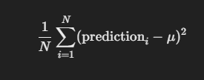Method:   
- Use the posterior predictive distribution to generate multiple predictions.  
- Compute the mean and variance (or standard deviation) of the predictions for each data point.  
- The variance (or standard deviation) of the predicted values can be calculated using the formula:

Variance of prediction =

,where prediction_i are the posterior predictions for each sample, and mean is the average of these predictions.

Interpretation:   
- Low variance indicates high confidence in the prediction.  
- High variance indicates high uncertainty in the prediction.

# 3. Method 2: Entropy of the Posterior Predictive Distribution

Entropy measures the uncertainty in the model's predictions, reflecting how much unpredictability exists in the predicted probabilities. In classification tasks, it is particularly useful for understanding how confident the model is in its predicted class.

Method:   
- Compute the entropy of the predicted probabilities for each data point using the Shannon entropy formula:  
  
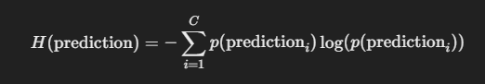

,where p(prediction_i) is the predicted probability of the i-th class, and C is the number of classes.

Interpretation:   
- Low entropy indicates high confidence in the predicted class (i.e., one class has high probability).  
- High entropy indicates uncertainty in the prediction (i.e., multiple classes have similar probabilities).

# 4. Combining Prediction Variance and Entropy

Both prediction variance and entropy provide useful insights into uncertainty. Prediction variance quantifies model uncertainty, while entropy reflects the overall uncertainty in the predicted class probabilities (for classification). Combining these two metrics gives a fuller picture of the model's confidence and uncertainty.

For regression tasks, variance can provide a confidence interval around the predicted mean, while for classification tasks, entropy can be used alongside maximum class probabilities to assess model confidence.