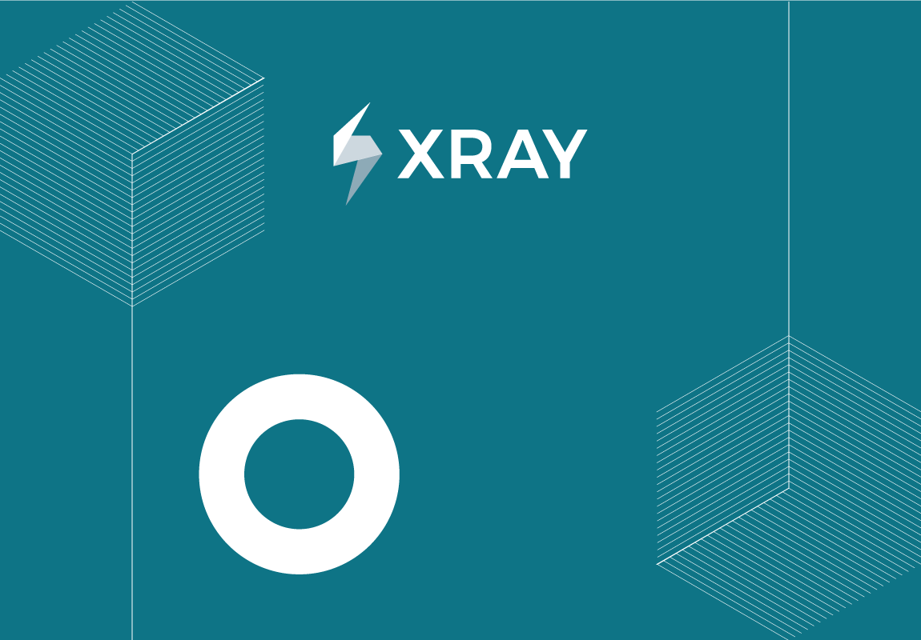

TEST REPORT

&{for issues|filter=%{${BulkIssueIndex} == 0}}

Project Name: ${Project.Name}

Prepared by: ${fullname:Username}

 CONFIDENTIAL

&{end}

Document Date: %{(new Date()).getDate() + "/" + ((new Date()).getMonth()+1) + "/" + (new Date()).getFullYear()}

**TABLE OF CONTENTS**

1. Introduction 3

1.1. Document Overview 3

2. Manual Tests 4

2.1. Manual Test ${Key} - ${Summary} 4

2.1.1. Status of the Last Execution 4

2.1.2. Pre Conditions 4

2.1.3. Requirements 4

2.1.4. Description 4

2.1.5. Test Procedure 5

2.1.6. Test Sets 5

2.1.7. Test Plans 5

3. Automated Tests 7

3.1. Automated Test ${Key} - ${Summary} 7

3.1.1. Status of the Last Execution 7

3.1.2. Pre Conditions 7

3.1.3. Requirements 7

3.1.4. Description 7

3.1.5. Test Procedure 8

3.1.6. Test Sets 8

3.1.7. Test Plans 8

4. Appendix A: Test Report Approval 9

# Introduction

## Document Overview

This Test Report provides a summary of the results of test performed as outlined within this document. This document has been generated automatically from the test management platform.

# Manual Tests

&{for issues|filter=%{'${IssueTypeName}'.equals('Test') && '${Test Type}'.equals('Manual')}}

## Manual Test ${Key} - ${Summary}

### Status of the Last Execution

${TestRunStatus}

### Pre Conditions

#{if (%{'${PreConditionsCount}'.equals('0')})}

*None*

#{end}

#{if (%{!'${PreConditionsCount}'.equals('0')})}

|  |  |  |
| --- | --- | --- |
| Key | Summary | Condition |

#{for preconditions}

|  |  |  |
| --- | --- | --- |
| ${PreConditions[n].Key} | ${PreConditions[n].Summary} | ${PreConditions[n].Conditions} |

#{end}

#{end}

### Requirements

#{if (%{'${jqlcount: key in testRequirements('${Key}')}'.equals('0')})}

*None*

#{end}

#{if (%{!'${jqlcount: key in testRequirements('${Key}')}'.equals('0')})}

|  |  |
| --- | --- |
| Requirement Key | Requirement Summary |

#{for z=JQLIssuesCount|clause= key in testRequirements('${Key}')}

|  |  |
| --- | --- |
| ${JQLIssues[z].Key} | ${JQLIssues[z].Summary} |

#{end}

#{end}

### Description

#{if (%{'${Description}'.equals('')})}

*None*

#{end}

#{if (%{!'${Description}'.equals('')})}

${wiki:Description}

#{end}

### Test Procedure

|  |  |  |  |
| --- | --- | --- | --- |
| Step Number | Step | Data | Expected Result |

#{for m=TestStepsCount}

|  |  |  |  |
| --- | --- | --- | --- |
| ${TestSteps[m].StepNumber} | ${wiki:TestSteps[m].Action} | ${wiki:TestSteps[m].Data} | ${wiki:TestSteps[m].ExpectedResult} |

#{end}

### Test Sets

#{if (%{'${jqlcount:issuetype = 'Test Set' and key in testTestSet('${Key}')}'.equals('0')})}

*None*

#{end}

#{if (%{!'${jqlcount:issuetype = 'Test Set' and key in testTestSet('${Key}')}'.equals('0')})}

|  |  |  |
| --- | --- | --- |
| Key | Summary | Test Count |

#{for y=JQLIssuesCount|clause= issuetype = 'Test Set' and key in testTestSet('${Key}')}

|  |  |  |
| --- | --- | --- |
| ${JQLIssues[y].Key} | ${JQLIssues[y].Summary} | ${jqlcount: issuetype = 'Test' and key in testSetTests('${JQLIssues[y].Key}')} |

#{end}

#{end}

### Test Plans

#{if (%{'${jqlcount: issuetype = 'Test Plan' and key in testTestPlan('${Key}')}'.equals('0')})}

*None*

#{end}

#{if (%{!'${jqlcount: issuetype = 'Test Plan' and key in testTestPlan('${Key}')}'.equals('0')})}

|  |  |
| --- | --- |
| Key | Summary |

#{for x=JQLIssuesCount|clause= issuetype = 'Test Plan' and key in testTestPlan('${Key}')}

|  |  |
| --- | --- |
| ${JQLIssues[x].Key} | ${JQLIssues[x].Summary} |

#{end}

#{end}

&{end}

# Automated Tests

&{for issues|filter=%{'${IssueTypeName}'.equals('Test') && '${Test Type}'.equals('Cucumber')}}

## Automated Test ${Key} - ${Summary}

### Status of the Last Execution

${TestRunStatus}

### Pre Conditions

#{if (%{'${PreConditionsCount}'.equals('0')})}

*None*

#{end}

#{if (%{!'${PreConditionsCount}'.equals('0')})}

|  |  |  |
| --- | --- | --- |
| Key | Summary | Condition |

#{for preconditions}

|  |  |  |
| --- | --- | --- |
| ${PreConditions[n].Key} | ${PreConditions[n].Summary} | ${PreConditions[n].Conditions} |

#{end}

#{end}

### Requirements

#{if (%{'${jqlcount: key in testRequirements('${Key}')}'.equals('0')})}

*None*

#{end}

#{if (%{!'${jqlcount: key in testRequirements('${Key}')}'.equals('0')})}

|  |  |
| --- | --- |
| Requirement Key | Requirement Summary |

#{for z=JQLIssuesCount|clause= key in testRequirements('${Key}')}

|  |  |
| --- | --- |
| ${JQLIssues[z].Key} | ${JQLIssues[z].Summary} |

#{end}

#{end}

### Description

#{if (%{'${Description}'.equals('')})}

*None*

#{end}

#{if (%{!'${Description}'.equals('')})}

${wiki:Description}

#{end}

### Test Procedure

${Cucumber Test Type}

${Cucumber Scenario}

### Test Sets

#{if (%{'${jqlcount:issuetype = 'Test Set' and key in testTestSet('${Key}')}'.equals('0')})}

*None*

#{end}

#{if (%{!'${jqlcount:issuetype = 'Test Set' and key in testTestSet('${Key}')}'.equals('0')})}

|  |  |  |
| --- | --- | --- |
| Key | Summary | Test Count |

#{for y=JQLIssuesCount|clause= issuetype = 'Test Set' and key in testTestSet('${Key}')}

|  |  |  |
| --- | --- | --- |
| ${JQLIssues[y].Key} | ${JQLIssues[y].Summary} | ${jqlcount: issuetype = 'Test' and key in testSetTests('${JQLIssues[y].Key}')} |

#{end}

#{end}

### Test Plans

#{if (%{'${jqlcount: issuetype = 'Test Plan' and key in testTestPlan('${Key}')}'.equals('0')})}

*None*

#{end}

#{if (%{!'${jqlcount: issuetype = 'Test Plan' and key in testTestPlan('${Key}')}'.equals('0')})}

|  |  |
| --- | --- |
| Key | Summary |

#{for x=JQLIssuesCount|clause= issuetype = 'Test Plan' and key in testTestPlan('${Key}')}

|  |  |
| --- | --- |
| ${JQLIssues[x].Key} | ${JQLIssues[x].Summary} |

#{end}

#{end}

&{end}

# Appendix A: Test Report Approval

The undersigned acknowledge they have reviewed the **Test Report** and agree with the approach it presents. Changes to this **Test Report** will be coordinated with and approved by the undersigned or their designated representatives.

|  |  |  |  |
| --- | --- | --- | --- |
| *Signature:* |  | *Date:* |  |
| *Print Name:* |  |  |  |
| *Title:* |  |  |  |
| *Role:* |  |  |  |