
CHAPTER I

INTRODUCTION

1.1 Rationale of the Study
Seagrass species play a crucial role in coastal areas by providing habitat for marine organisms, stabilizing sediments, and serving as nursery grounds for fish and other aquatic species (Green & Short, 2003). In the coastal waters of Mati City, nine seagrass species have been documented across areas such as Lawigan, Taitaidaga, Manguihay, and Pujada Island (Angsinco-Jimenez et al., 2003). However, the ability of students, tourists, and local communities to correctly distinguish one seagrass species from another remains limited, since most available learning materials present these species in ways that are difficult for non-expert users to interpret.
Traditional methods such as printed field guides, photographs, and expert explanations are often ineffective for beginners because seagrass structures are difficult to fully understand using only two-dimensional images (Jerald, 2015). This lack of interactive educational tools contributes to low public awareness regarding marine biodiversity and conservation (Radianti et al., 2020; Short et al., 2011).
Recent studies show that interactive visualization technologies improve learning engagement and understanding. According to Radianti et al. (2020), immersive visualization systems help users better understand digital representations through interactive exploration. Jerald (2015) also explained that 3D visualization technologies provide a more realistic understanding of object structures compared to static images and text-based materials.
This gap between the ecological importance of seagrass species and the public's limited ability to recognize them points to the need for a learning tool that is both localized to Mati City and interactive enough to hold users' attention.
To address the limited availability of accessible, localized learning tools for seagrass species in Mati City, the researchers propose MarineSee, a Mobile-Based Seagrass Educational and Interactive 3D Visualization System for Mati City. By pairing manipulable 3D species models and organized species profiles with an SVM-based image recognition feature, MarineSee gives users a way to both identify and learn about the seagrass species found in their own coastal waters, supporting marine environmental awareness and seagrass conservation efforts in Mati City.
1.2 Purpose and Project Description
The purpose of this project is to develop MarineSee, a mobile-based educational platform that uses interactive 3D visualization technology and Support Vector Machine (SVM)-based image recognition to help users learn about the seagrass species found in Mati City. The system is designed primarily for students, tourists, coastal communities, and local researchers who need accessible and engaging educational resources about marine biodiversity.
The system provides users with a digital library containing interactive 3D models of the nine documented seagrass species native to the coastal waters of Mati City. Users can rotate, zoom, and inspect each 3D model to better understand the physical appearance and structural characteristics of every species. Alongside the 3D visualization, the platform also displays educational information such as scientific names, common names, botanical characteristics, ecological roles, conservation status, and geographic distribution. The system also integrates an SVM-based image recognition model that allows users to identify seagrass species by capturing or uploading images through the mobile application.
The innovation of MarineSee lies in its use of localized interactive 3D visualization and SVM-based image recognition specifically tailored to the seagrass biodiversity of Mati City. Unlike traditional field guides and general biodiversity websites that rely mainly on photographs and text descriptions, MarineSee provides a more immersive and engaging learning experience through manipulable digital models and automated species identification. This makes the system more accessible to non-expert users who may struggle to understand complex marine biology concepts using conventional educational materials.
As Mati City continues to grow as a coastal tourism and environmental research destination, the need for modern digital educational tools also increases. MarineSee addresses this need by transforming scientific information into an interactive learning experience that promotes awareness, appreciation, and conservation of local marine ecosystems through mobile technology.
1.3 Objectives of the Study
The main objective of this study is to develop MarineSee, a mobile-based educational platform utilizing interactive 3D visualization to enhance marine environmental awareness and understanding of seagrass species in Mati City, integrated with a Support Vector Machine (SVM)-based image recognition system to support species identification.
To systematically achieve the general objective, the project aims:
- To integrate an SVM-based image recognition system and interactive 3D models for the nine (9) documented seagrass species found in the coastal areas of Mati City (Cymodocea rotundata, Cymodocea serrulata, Enhalus acoroides, Halodule pinifolia, Halodule uninervis, Halophila minor, Halophila ovalis, Syringodium isoetifolium, and Thalassia hemprichii).
- To construct a centralized digital library containing localized species profiles, including scientific names, common names, botanical characteristics, ecological roles, conservation status, and growth processes.
- To design a responsive mobile application interface that provides interactive 3D viewing controls, allowing users to rotate, zoom, and inspect seagrass structural models.
- To develop and train a Support Vector Machine (SVM) classification model using extracted color, texture, and shape features to achieve a species identification accuracy of at least 85%.
- To evaluate the software quality and acceptability of the MarineSee application among students, tourists, local researchers, and coastal community members based on the ISO/IEC 25010 software quality standards across functional suitability, usability, performance efficiency, reliability, compatibility, and portability.

User Evaluation (Based on ISO/IEC 25010 Standards)
The user evaluation will be conducted using ISO/IEC 25010 software quality standards to assess the overall quality and performance of the MarineSee system. The evaluation focuses on software quality characteristics such as functional suitability, usability, reliability, performance efficiency, compatibility, and portability. The purpose of this evaluation is to determine how effectively the system supports interactive seagrass education and visualization for users.
Students, tourists, researchers, and coastal community members will evaluate the system through surveys, questionnaires, and actual system usage testing. Respondents will provide feedback regarding the ease of use, responsiveness, accessibility, educational effectiveness, and overall user experience of the MarineSee application. The results of the evaluation will be used to determine the acceptability and quality performance of the proposed system.
1.4 Significance of the Study
The development of MarineSee provides significant benefits to various sectors by promoting marine environmental awareness through interactive digital technology. For students and educators, the system serves as an engaging learning tool that simplifies the study of marine biology and coastal ecosystems; through interactive 3D visualization and SVM-based image recognition, students can better understand and identify the physical structure and characteristics of seagrass species compared to traditional textbook illustrations and static photographs. For tourists, visitors to Mati City can use the platform to learn about the marine ecosystems surrounding the beaches and coastal waters they visit, while the SVM-based identification feature allows them to recognize seagrass species through captured images, promoting responsible tourism and appreciation for local biodiversity. For coastal communities and fisherfolk, MarineSee helps residents better recognize the ecological importance of seagrass ecosystems that support fisheries and marine life; through the system's educational content, 3D visualization, and image recognition capabilities, users can more easily identify local seagrass species and build the awareness that may encourage participation in conservation activities. For local researchers, the system provides a centralized and localized educational reference containing digital 3D representations, SVM-assisted species identification, and organized species information that may assist in marine environmental studies and awareness campaigns. Finally, for future researchers and developers, this study serves as a reference for those interested in combining SVM-based image recognition and 3D visualization technology with environmental education and biodiversity conservation systems.

1.5 Scope and Limitations

Scope of the Study
- The project is focused on the development and implementation of MarineSee, a mobile-based educational platform designed to provide interactive 3D visualization, SVM-based image recognition, and educational learning resources for seagrass species found in the coastal areas of Mati City, Davao Oriental.
- The MarineSee system is designed as a mobile-based application that requires an active internet connection to access the interactive 3D visualization features, educational content, and digital learning resources within the application. Internet connectivity is necessary to ensure proper loading of 3D assets, educational information, and other system resources during application usage.
- The system will feature a centralized Digital Library containing educational information about the nine (9) seagrass species native to the coastal waters of Mati City. These species include (1) Cymodocea rotundata, (2) Cymodocea serrulata, (3) Enhalus acoroides, (4) Halodule pinifolia, (5) Halodule uninervis, (6) Halophila minor, (7) Halophila ovalis, (8) Syringodium isoetifolium, and (9) Thalassia hemprichii. Each species profile will provide organized and accessible information including scientific names, common names, botanical characteristics, ecological roles, conservation status, and development growth processes within the coastal waters of Mati City.
- The primary feature of the system is the Interactive 3D Visualization Module, which allows users to explore realistic three-dimensional representations of the nine (9) seagrass species through a mobile application interface.
- The system will also implement an SVM-based image recognition module using extracted color, texture, and shape features for automated seagrass species identification. Users may capture or upload seagrass images through the mobile application, and the SVM model will classify the detected species based on trained image datasets of the nine (9) documented seagrass species found in Mati City. The image recognition module aims to provide fast and accessible species identification for students, tourists, researchers, and coastal communities.

Limitations of the Study
The following factors are constraints or boundaries beyond the researchers’ control that define the limits of the project.
- The system is limited only to the nine (9) documented seagrass species found in the coastal waters of Mati City. Other marine plants, coral species, algae, or seagrass species from other regions are not included within the platform.
- The accuracy and realism of the 3D visualization models are dependent on the quality of the available reference images, scientific illustrations, and modeling resources used during development. Certain microscopic or highly detailed biological structures may not be fully represented within the 3D models.
- The system does not include real-time geographic tracking, GPS-based navigation, or advanced geographic information system (GIS) analysis. Any species distribution information presented in the platform is limited only to educational reference purposes and is not intended for precise scientific mapping or navigation.
- The project focuses primarily on visualization and educational learning rather than scientific field analysis. The system does not perform automated species recognition, underwater scanning, or real-time environmental monitoring.
- The system is designed as a standalone mobile application and may have limited compatibility with non-Android devices or older smartphone models.
- The project does not include advanced virtual reality (VR) or augmented reality (AR) integration. Visualization is limited to standard interactive 3D viewing within a mobile application environment.
- The educational content and interface of the system are presented only in the English language. The platform currently does not support Filipino, Bisaya, or other regional language translations.
- The system does not directly measure ecological parameters such as water quality, species population density, or habitat degradation. The platform serves only as an educational and visualization tool intended to improve awareness and understanding of seagrass ecosystems in Mati City.
- The performance and responsiveness of the 3D visualization module may vary depending on the user’s device specifications, mobile operating system compatibility, graphics capability, and internet speed. Older mobile devices may experience reduced rendering performance when displaying complex 3D assets.
- For optimal performance and smooth 3D visualization rendering, the application requires Android mobile devices running at least Android 8.0 (Oreo) or higher, with a minimum of 3GB RAM, 32GB internal storage, and an octa-core or equivalent processor capable of handling interactive 3D graphics. The recommended screen resolution is at least 720 × 1600 pixels to properly display the user interface and visualization controls. Devices with lower specifications may experience slower loading times, reduced rendering quality, or limited responsiveness when interacting with 3D seagrass models.

1.6 Conceptual Framework
The study uses the Input-Process-Output (IPO) model to illustrate how MarineSee transforms educational content and digital assets into an interactive 3D learning experience for users.
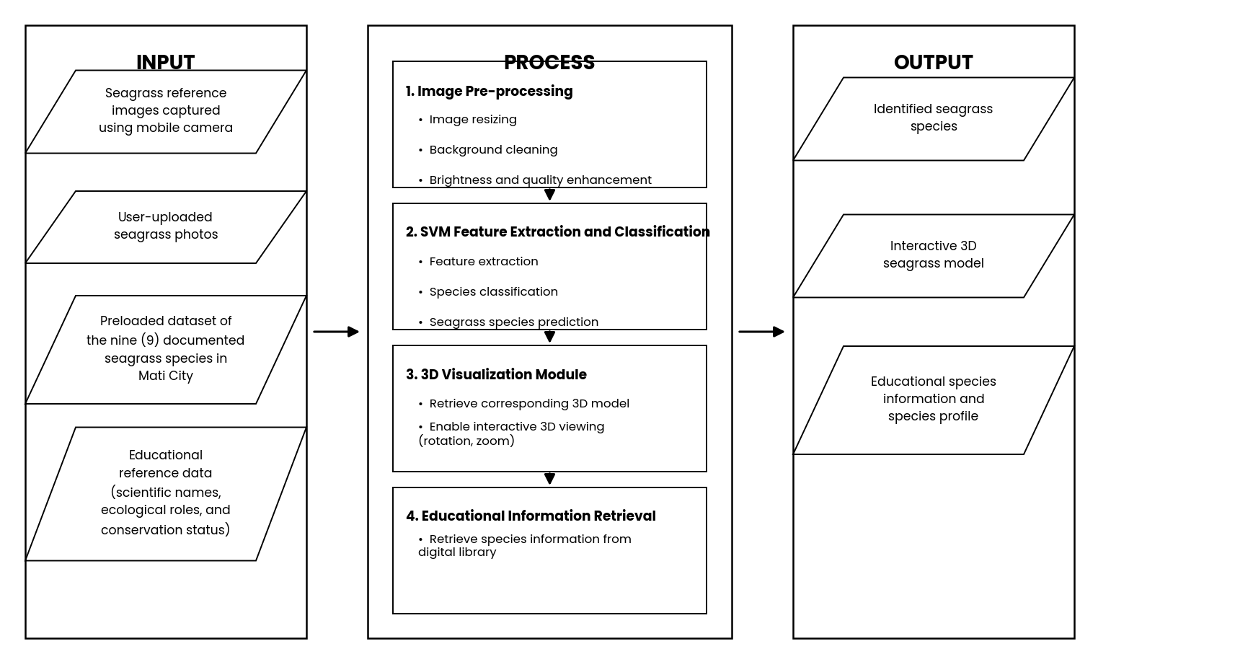
Figure 1. Conceptual Diagram of the Study
The study uses the Input-Process-Output (IPO) framework to illustrate how MarineSee transforms seagrass reference images and educational resources into a mobile-based educational and SVM-powered image recognition system. The framework demonstrates the overall flow of the system from the collection of seagrass image datasets and educational references, through the application of image pre-processing, SVM-based feature extraction and classification, interactive 3D visualization, and educational information retrieval, up to the delivery of educational outputs that improve user understanding regarding seagrass ecosystems in Mati City as shown in Figure 1.
The Input stage identifies the resources and materials required to develop the system. The primary inputs include seagrass reference images captured using mobile cameras, user-uploaded seagrass photos, and preloaded datasets containing the nine (9) documented seagrass species found in Mati City. Educational reference data regarding the scientific names, botanical characteristics, ecological roles, conservation status, and habitat information of each seagrass species are also included as part of the system inputs. These resources serve as the foundation for training the SVM model and providing educational content within the application.
The Process stage represents the core processes and technologies used in the system. The first process component is Image Pre-processing, where uploaded seagrass images undergo image resizing, background cleaning, and brightness or quality enhancement to improve image consistency and prepare the images for SVM analysis. This process helps ensure better classification accuracy and improves the quality of image inputs used by the model.
The second process component is the SVM Feature Extraction and Classification Model. In this stage, the system extracts visual features such as leaf shape, texture, and color from the uploaded image and classifies them using a trained Support Vector Machine (SVM) model to identify the seagrass species. This approach relies on carefully engineered image features rather than automatic deep feature learning, which keeps the model lightweight and well suited to the study's limited, localized dataset. After classification, the model identifies the uploaded image as one of the nine (9) documented seagrass species.
The third process component is the 3D Visualization Module. After species identification, the system retrieves the corresponding interactive 3D seagrass model and allows users to explore the species through rotation and zooming controls. This interactive visualization enhances learning by enabling users to examine the physical structure and appearance of the seagrass species in a more engaging and realistic way compared to traditional text-based or static image materials.
The fourth process component is Educational Information Retrieval, where the system retrieves the appropriate species profile and educational information from the digital library. Users can access organized information including scientific names, botanical descriptions, ecological roles, and conservation information while interacting with the application.
The Output stage delivers the final services and educational results of the system to the users. The first output is the identified seagrass species generated by the SVM-based image recognition system. The second output is the interactive 3D seagrass model that allows users to visualize and inspect the identified species through the mobile application. The third output is the educational species information and profile that provide users with organized learning materials regarding the identified seagrass species.

Definition of Terms

3D Visualization A digital presentation technique used in the system to create realistic and interactive three-dimensional representations of seagrass species for educational and learning purposes within the mobile application.

Support Vector Machine (SVM) A supervised machine learning algorithm used in MarineSee to classify user-captured or uploaded seagrass images, based on extracted visual features, for automated species identification.
Image Recognition The automated process used by the system to identify the specific species of a seagrass plant from a user-uploaded photograph.

Digital Library A searchable archive within the system that organizes and manages localized educational resources, species information, reference images, and conservation data related to seagrass ecosystems in Mati City.

Seagrass The primary biological subject of the study; underwater flowering plants native to the coastal waters of Mati City that serve as important habitats for marine organisms and contribute to coastal ecosystem stability.

Three-Dimensional (3D) Model A digitally created object with height, width, and depth that visually represents the physical structure and appearance of seagrass species within the interactive mobile-based educational platform.
Conservation Status | The level of protection and environmental condition of a seagrass species based on its population, habitat stability, and ecological threats. Conservation status provides users with information regarding whether a seagrass species is stable, vulnerable, threatened, or in need of conservation efforts within marine ecosystems.


CHAPTER II
REVIEW OF RELATED LITERATURE

2.1 Literature Map
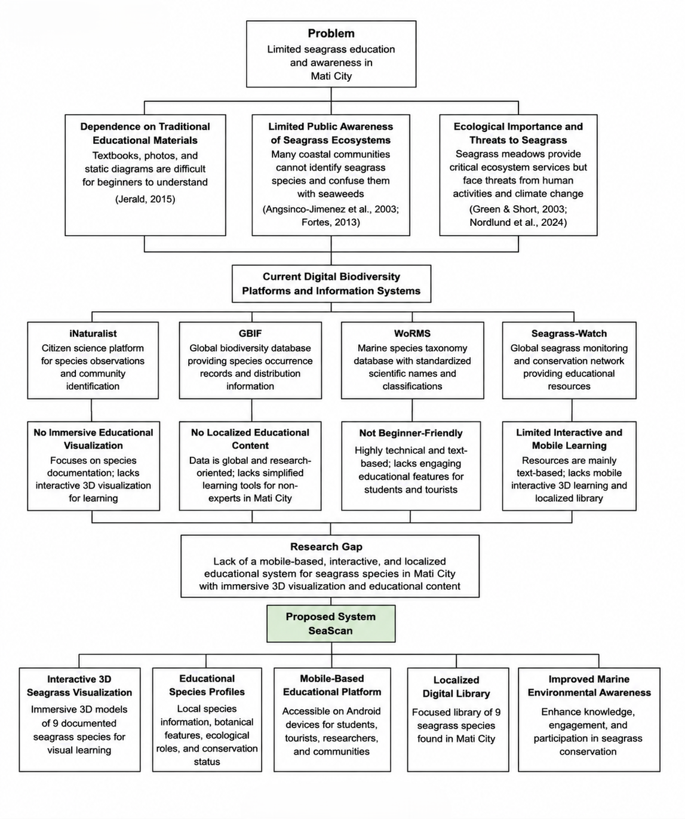
Figure 2. Literature Map
Figure 2 presents the literature map of the study entitled “MarineSee: A Mobile-Based Seagrass Species Identification System for Mati City Using Image Recognition and Interactive 3D Visualization.” The diagram illustrates the relationship between the identified problem, supporting literature, existing educational platforms, research gaps, and the proposed system developed by the researchers.
2.2 Related Literature

Seagrass Education and Awareness as a Central Problem
Seagrass meadows are among the most ecologically important coastal ecosystems because they provide habitat for marine organisms, stabilize sediments, protect shorelines from erosion, and support fisheries and biodiversity (Green & Short, 2003). Despite their ecological importance, public awareness and understanding of seagrass ecosystems remain limited, particularly among students, tourists, and coastal communities. Short et al. (2011) explained that scientific information regarding seagrass species is often highly technical and primarily available through academic publications and institutional databases, making it difficult for non-expert users to understand and appreciate marine biodiversity.
In the Philippines, the problem of limited seagrass awareness is especially significant because many coastal communities depend directly on marine ecosystems for livelihood and environmental sustainability. Fortes (2013) emphasized that although the Philippines contains one of the richest seagrasses biodiversities within the Coral Triangle, public education and conservation awareness programs remain inadequate. Angsinco-Jimenez et al. (2003) observed that many coastal residents could not properly identify seagrass species and often confused them with seaweeds or other aquatic plants. This lack of understanding weakens community participation in marine conservation efforts and reduces appreciation for the ecological importance of seagrass habitats.
In Mati City, Davao Oriental, several seagrass species have been documented across coastal areas such as Lawigan, Taitaidaga, Manguihay, and Pujada Bay (Angsinco-Jimenez et al., 2003; Sanchez-Delute et al., 2025). However, despite the ecological significance of these habitats, there are still limited educational tools specifically designed to introduce local communities and visitors to the seagrass species found within the area. Traditional learning resources remain dependent on printed field guides, scientific illustrations, and text-heavy materials that are often difficult for beginners to interpret and visualize.
Localized educational systems are important because they allow users to better relate scientific information to ecosystems present within their own communities, increasing environmental relevance, familiarity, and engagement. Without localized educational references, users may find it difficult to connect scientific concepts with the actual marine ecosystems found within their surroundings.

Basis for the Inclusion of the Nine Seagrass Species
The inclusion of the nine (9) seagrass species in this study is based on documented coastal assessments and marine biodiversity studies conducted within the coastal waters of Mati City, Davao Oriental. These species were identified through verified environmental surveys and scientific references, which confirmed their presence within seagrass meadows located in areas such as Pujada Bay, Lawigan, Taitaidaga, and Manguihay. (Angsinco-Jimenez et al., 2003; Sanchez-Delute et al., 2025). According to Fortes (2013), the Philippines is one of the countries with the highest seagrass diversity within the Coral Triangle region, and Mati City contains ecologically important seagrass habitats that support marine biodiversity and coastal productivity.
The selected species namely Cymodocea rotundata, Cymodocea serrulata, Enhalus acoroides, Halodule pinifolia, Halodule uninervis, Halophila minor, Halophila ovalis, Syringodium isoetifolium, and Thalassia hemprichii were included because they represent the documented seagrass composition commonly found within the coastal ecosystems of Mati City (Fortes, 2013; Sanchez-Delute et al., 2025). These species possess distinct botanical characteristics, ecological functions, and habitat adaptations that make them important subjects for marine environmental education and visualization. Each species contributes differently to sediment stabilization, nursery habitat formation, nutrient cycling, shoreline protection, and biodiversity support within coastal ecosystems (Green & Short, 2003).
The inclusion of these species also supports the localized educational objective of the study. Rather than presenting generalized global marine content, the system focuses specifically on seagrass species that users are most likely to encounter within the coastal waters of Mati City. Localized educational systems improve environmental relevance and user familiarity because learners can directly connect digital educational content with actual ecosystems present within their own communities (Short et al., 2011). This localized approach strengthens marine environmental awareness and promotes greater appreciation for the conservation of local seagrass habitats.
Furthermore, the nine (9) seagrass species were selected because sufficient scientific references, photographic resources, and botanical information are available to support the development of accurate 3D visualization models and educational species profiles within the MarineSee system. The availability of verified scientific data ensures that the educational content presented in the application remains reliable, organized, and scientifically grounded for students, tourists, researchers, and coastal communities using the platform (Fortes, 2013; Green & Short, 2003).

Limitations of Traditional Educational Materials
Traditional educational approaches used in marine biology and environmental education rely heavily on textbooks, photographs, and static diagrams. While these materials provide scientific information, they often fail to fully represent the actual physical structures and spatial appearance of marine organisms. Jason Jerald (2015) explained that static visual materials limit user engagement because learners cannot interact with the objects being studied or observe them from different perspectives.
For seagrass education specifically, understanding structures such as leaf morphology, rhizome systems, sheath formation, and reproductive organs can be difficult when presented only through two-dimensional illustrations. Students and non-expert users may struggle to imagine the actual shape, size, and arrangement of these structures in real environments. As a result, learning retention and engagement become limited.
Jaziar Radianti et al. (2020) emphasized that immersive visualization technologies improve user engagement and comprehension by allowing learners to actively interact with digital objects and environments. Their study found that immersive educational systems provide more effective learning experiences compared to passive reading-based approaches. These findings suggest that environmental education platforms using interactive digital visualization may significantly improve public understanding of marine ecosystems and biodiversity conservation.

Mobile-Based Learning in Environmental Education
Mobile learning platforms have become increasingly important in modern education because they provide flexible and accessible learning opportunities through smartphones and portable devices. Helen Crompton and Diane Burke (2018) explained that mobile learning improves learner engagement, accessibility, and educational flexibility by allowing users to access learning materials anytime and anywhere.
In environmental education, mobile-based systems are particularly beneficial because users can access educational content directly within coastal and field environments. This allows students, tourists, and community members to interact with educational materials while observing actual ecosystems. Mobile educational platforms also encourage self-paced learning and increase public participation in environmental awareness activities.
The growing accessibility of Android devices further supports the development of mobile educational systems for biodiversity awareness and conservation. Through mobile accessibility, educational platforms can reach wider audiences and provide convenient learning experiences for users with varying levels of scientific knowledge.

Existing Digital Biodiversity Platforms
Several biodiversity platforms and marine information systems currently exist to support species documentation and environmental awareness. Platforms such as iNaturalist, GBIF, and WoRMS provide biodiversity information, species records, and taxonomic references through online platforms. These systems help researchers and users access scientific names, classifications, occurrence records, and species documentation from different regions worldwide (iNaturalist, 2026; GBIF, 2026; WoRMS Editorial Board, 2026).
Citizen science platforms such as iNaturalist encourage public participation in biodiversity monitoring by allowing users to upload observations, photographs, and other information about organisms. These observations can contribute to biodiversity research and conservation efforts (iNaturalist, 2026). GBIF (Global Biodiversity Information Facility) serves as an international network and data infrastructure that provides open access to biodiversity data, including information about where and when species have been recorded from different sources and institutions (GBIF, 2026). WoRMS (World Register of Marine Species) serves as an authoritative marine taxonomic database, providing a comprehensive list of marine organism names, including valid names and synonyms, with its content maintained and reviewed by taxonomic experts (WoRMS Editorial Board, 2026).
Although these platforms are valuable for biodiversity documentation and research, they primarily focus on species records and textual information rather than immersive educational interaction. Most of these systems do not provide localized 3D educational visualization specifically tailored to the seagrass species found in Mati City. Furthermore, many biodiversity databases are designed mainly for researchers and trained users, making them less accessible and less engaging for students, tourists, and community members with limited scientific background.

Suitability of SVM for MarineSee
Support Vector Machine (SVM) models have become effective tools for image recognition and species identification because they can accurately classify extracted visual patterns such as shape, texture, and color from images (LeCun et al., 2015). Using extracted image features such as color, texture, and shape, SVM models can achieve accurate classification while remaining efficient to train on smaller, localized datasets (Cortes & Vapnik, 1995). Wäldchen and Mäder (2022) similarly found that feature-based machine learning approaches remain a practical choice for image-based species identification, particularly for research contexts working with limited image collections rather than the large-scale datasets typically used in deep learning. Using mobile-based image recognition built on this approach, users can identify seagrass species by simply capturing or uploading images.
Although MarineSee is primarily designed as a mobile-based educational and interactive 3D visualization system, the researchers also considered the importance of providing an efficient, lightweight, and reliable species recognition method that could run smoothly on mobile devices with limited processing power. Among the different image classification approaches available, the Support Vector Machine (SVM) algorithm was selected as the most suitable model for the seagrass image recognition module of the system.
Deep learning models such as Convolutional Neural Networks (CNN) generally require large volumes of labeled training images and considerable computational resources, including GPU acceleration, to reach their highest classification accuracy. Because MarineSee relies on a localized, self-collected dataset limited to the nine (9) documented seagrass species of Mati City, the number of available training images is comparatively small, which increases the risk of overfitting when deep, many-layered models are trained on limited data.
In contrast, SVM performs particularly well on small to medium-sized datasets because its decision boundary is defined by a limited number of critical training samples known as support vectors, rather than by the entire dataset. This characteristic allows SVM to maintain strong generalization performance and reduce the risk of overfitting even when the number of training images per species is limited, which better fits the scale of the seagrass image dataset gathered for this study.
SVM also requires significantly less computational power than CNN during both training and inference because it does not depend on the many-layered architecture and large number of parameters used by deep neural networks. This lower computational demand makes SVM more practical for deployment within a mobile-based Android application, where processing power, memory, and battery consumption are more limited than in desktop or server-based environments.
To further support this decision, the researchers reviewed benchmark results from comparative studies evaluating SVM, Artificial Neural Network (ANN), and CNN models for image-based species classification. Table 1 summarizes these findings and presents the basis for the algorithm selection of MarineSee.

Table 1. Benchmark Comparison of Image Classification Models for Species Recognition
Classification Model | Reported Accuracy* | Training Data Requirement | Computational Demand | Suitability for MarineSee
Support Vector Machine (SVM) | 91% | Performs well on small to medium datasets; suited to the study's limited, localized seagrass image set | Low — no GPU required; runs efficiently on mobile hardware | Selected — best fit for the dataset size and mobile-only deployment of the system
Artificial Neural Network (ANN) | 94% | Requires moderately large, well-labeled training data | Moderate — noticeably heavier than SVM | Not selected — data and processing requirements exceed the scope of the study
Convolutional Neural Network (CNN) | 99% | Requires large volumes of labeled training images to reach peak accuracy | High — typically GPU-dependent | Not selected — highest computational cost and greatest overfitting risk given the limited dataset

As shown in Table 1, CNN generally achieves the highest reported classification accuracy when trained on large, extensively labeled datasets; however, this advantage requires data volumes and computational resources beyond the scope of this capstone project. Considering the limited size of the localized seagrass dataset, the mobile-only deployment environment of MarineSee, and the need to minimize overfitting, the researchers determined that SVM offers the most practical balance of accuracy, efficiency, and feasibility for the system's image recognition module.
Because of these advantages, SVM was selected as the image recognition approach for MarineSee. The system extracts relevant visual features, such as color histograms, texture descriptors, and shape characteristics, from captured or uploaded seagrass images, which are then classified by the trained SVM model into one of the nine (9) documented seagrass species.

Conservation Threats and the Need for Awareness-Building Tools
Beyond the difficulty of learning to distinguish seagrass species, seagrass ecosystems themselves face mounting environmental pressure. Nordlund et al. (2024) reported that seagrass meadows worldwide continue to decline due to coastal development, pollution, and climate-related stressors, and argued that closing the gap in public awareness is a necessary step toward more effective, community-supported conservation action. This reinforces the rationale for MarineSee: an accessible, localized tool that helps students, tourists, and coastal residents recognize and learn about the specific seagrass species around them is a practical starting point for building the awareness that conservation efforts depend on.

Gaps in Existing Educational and Visualization Systems
Despite the availability of biodiversity databases and online educational materials, several important gaps remain. One major limitation is the absence of localized educational platforms dedicated to the seagrass ecosystems of Mati City. Existing systems provide global information but lack geographically focused content that highlights the species documented specifically within the coastal waters of Mati City and Pujada Bay.
Another limitation is the lack of immersive visualization features within existing marine educational resources. Most systems rely mainly on photographs, diagrams, and text descriptions, which are insufficient for helping users fully understand the physical structure and morphology of seagrass species. Jerald (2015) explained that interactive 3D educational visualization allows users to inspect and manipulate digital objects, improving comprehension of complex structures and spatial relationships.
Existing platforms also provide limited engagement for mobile users seeking accessible educational content in field or coastal environments. While many biodiversity websites are accessible online, they are not specifically optimized as mobile-based educational systems that combine 3D visualization, educational profiles, and localized educational content into a single platform.
Another critical gap is the absence of localized digital libraries dedicated specifically to the seagrass species of Mati City. Sanchez-Delute et al. (2025) emphasized the importance of localized coastal data and species inventories for environmental education and community-based conservation efforts. Without localized references, users may struggle to connect scientific information with the actual marine ecosystems present within their own communities.
Gaps Addressed by the Proposed System
The identified gaps from previous studies served as the foundation for the development of the proposed system. The reviewed literature demonstrates that while biodiversity databases and marine educational resources already exist, there remains a significant lack of localized, interactive, and mobile-accessible educational systems focused on seagrass ecosystems in Mati City. Traditional learning materials remain static and difficult for beginners to understand, while existing digital platforms provide limited immersive interaction and localized educational content.
To address these gaps, the researchers propose MarineSee, a mobile-based interactive 3D visualization and educational system for seagrass species in Mati City. Unlike traditional educational materials and global biodiversity databases, MarineSee focuses specifically on the nine (9) documented seagrass species found within the coastal waters of Mati City.
The system integrates immersive 3D educational visualization technology that allows users to rotate, zoom, and inspect realistic digital models of seagrass species through Android mobile devices. This directly addresses the limitations of static educational materials identified by Jerald (2015) and Radianti et al. (2020). MarineSee also incorporates localized educational profiles containing scientific names, botanical characteristics, ecological roles, conservation status, and habitat information relevant to Mati City.
Additionally, the system includes a localized digital library containing verified educational references and species information specific to Mati City. This localized educational resource helps students, tourists, researchers, and coastal communities better understand the marine biodiversity present within their own environment. Through the integration of mobile accessibility, immersive visualization, localized educational resources, and SVM-supported image recognition, MarineSee aims to improve marine environmental awareness and encourage greater participation in seagrass conservation activities.

Synthesis
The review of related literature highlights the growing importance of seagrass ecosystems and the challenges associated with public awareness and environmental education. Existing studies emphasize that seagrasses provide critical ecological functions, yet many coastal communities and non-expert users remain unfamiliar with the species found within their local waters. Traditional educational methods based on textbooks, photographs, and scientific descriptions are often insufficient for effectively teaching users about marine biodiversity and seagrass morphology.
The literature also shows that although digital biodiversity systems and online databases already exist, most platforms focus primarily on taxonomic records and scientific documentation rather than immersive educational interaction. Existing systems lack localized educational content, immersive 3D visualization, mobile-focused learning tools, and region-specific educational resources specifically designed for the seagrass species found in Mati City.
The review further established that image classification models trained on extracted visual features, such as Support Vector Machine (SVM), remain effective for image-based species recognition, particularly when working with smaller, localized datasets that are typical of capstone-scale research. Previous studies demonstrated that feature-based classification systems are effective for recognizing plant and marine species, especially when trained using localized image datasets with a limited number of samples per class.
These findings guided the development of MarineSee, which aims to address the identified gaps by providing a mobile-based interactive educational platform tailored to the marine ecosystems of Mati City. Through immersive 3D visualization, localized species profiles, digital educational resources, and SVM-supported species recognition, the proposed system seeks to improve environmental literacy, enhance user engagement, and promote awareness and conservation of seagrass ecosystems among students, tourists, researchers, and coastal communities.

2.3 Related System
Several image recognition and image processing systems currently exist that support species and object identification through photographs, but most of them are designed for broad, general-purpose recognition rather than specialized, localized marine species education. Existing platforms also provide limited support for seagrass-specific classification and lack an interactive 3D visualization component integrated with the recognition process, particularly for species found in Mati City

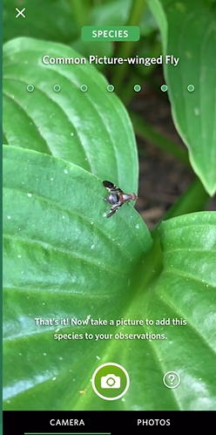

Figure 3. Seek by iNaturalist (iNaturalist, 2023)

As shown in Figure 3, Seek is a mobile application that uses an on-device convolutional neural network (CNN) to identify plants, animals, and fungi in real time through the smartphone camera, without requiring an internet connection (iNaturalist, 2023). Its strengths include instant camera-based recognition, a large pre-trained global species model, and gamified badges that encourage repeated use. In comparison to Seek, MarineSee differs by using a Support Vector Machine (SVM) model trained specifically on the nine seagrass species found in Mati City rather than a broad, general-purpose CNN covering thousands of unrelated species worldwide. While Seek prioritizes breadth and real-time recognition across many taxonomic groups, MarineSee prioritizes depth and localized accuracy, pairing its recognition output with interactive 3D visualization and locally relevant botanical information not available in Seek.
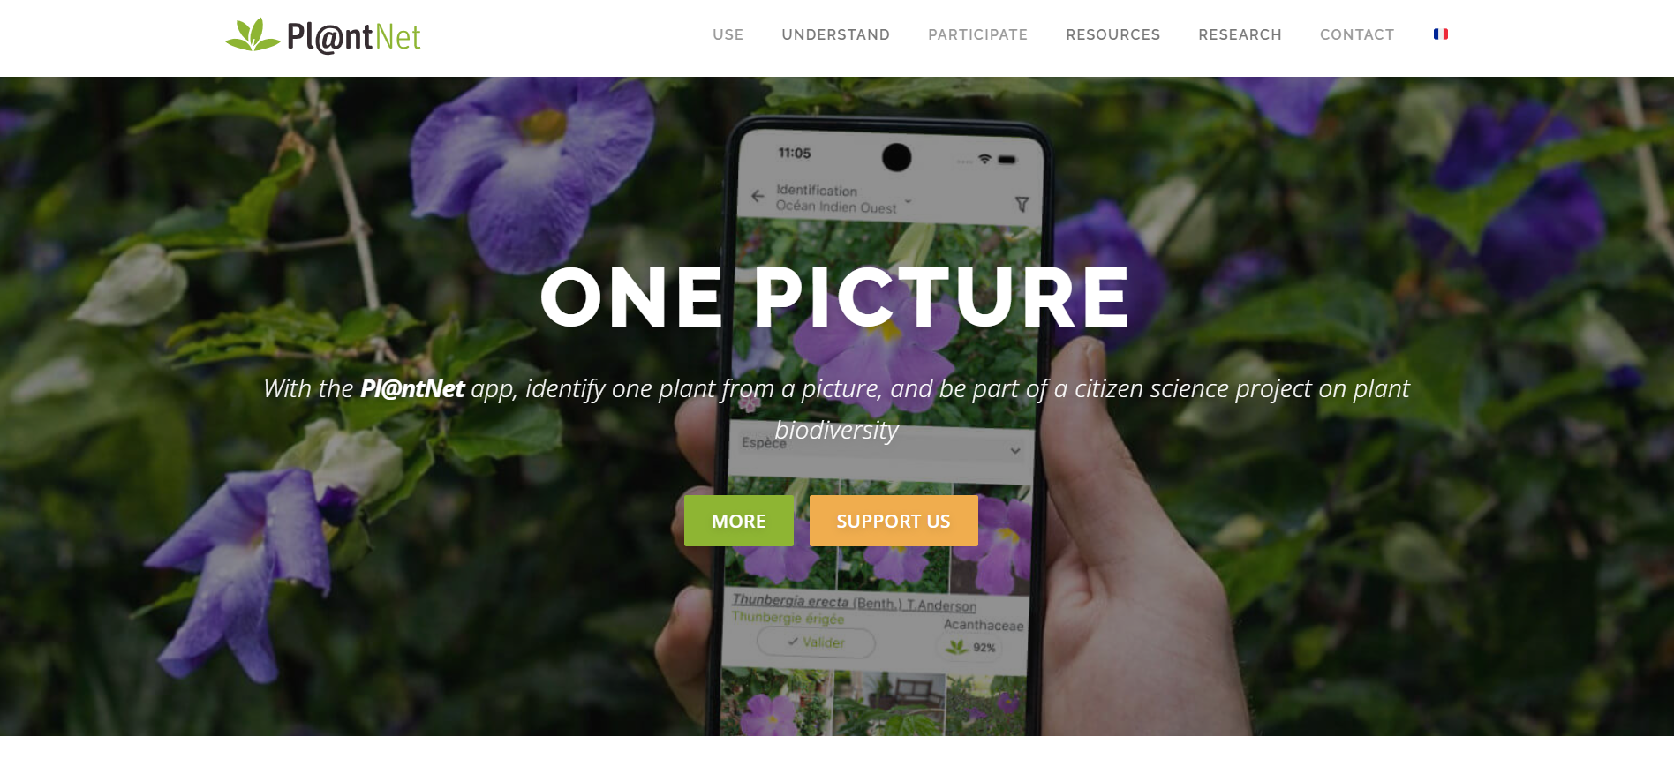
Figure 4. PlantNet (PlantNet, 2023)

As shown in Figure 4, PlantNet is an image-based plant identification platform that applies deep learning to match user-submitted photographs against a large botanical reference database, returning a ranked list of probable species (PlantNet, 2023). Its strengths include a large citizen-contributed image dataset, multi-organ photo submission (leaf, flower, fruit, bark), and continuous model retraining from community contributions. Compared to PlantNet, MarineSee is built around a narrower and more controlled dataset consisting solely of Mati City's documented seagrass species, resulting in a lighter, purpose-built SVM model rather than a large-scale deep learning system reliant on continuous crowd-sourced data. PlantNet also has no marine or seagrass-specific focus and offers no supplementary visualization, whereas MarineSee integrates recognition directly with 3D species models and localized educational content.
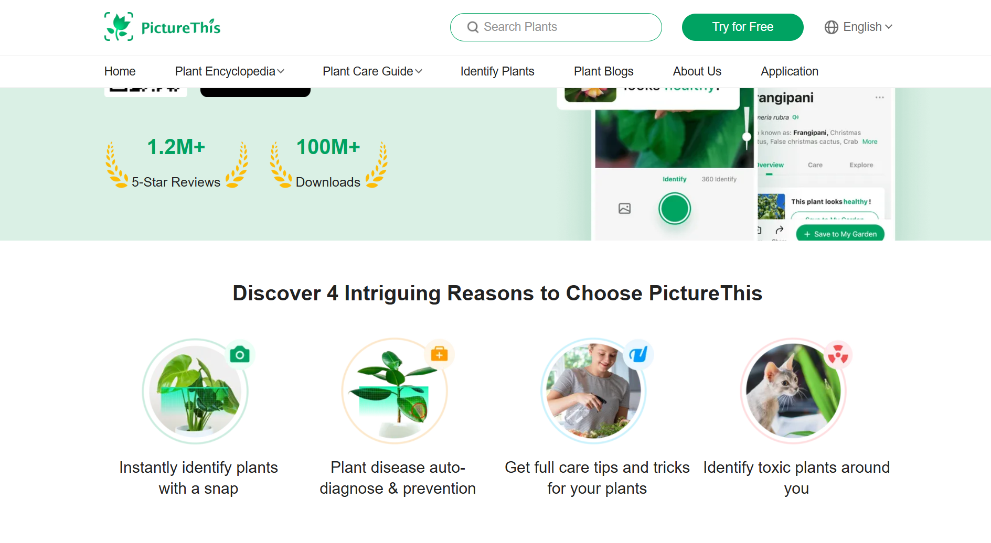
Figure 5. PictureThis (PictureThis, 2023)

As shown in Figure 5, PictureThis is a commercial AI-powered plant identification application that uses image recognition to identify plant species and provide care instructions, disease diagnosis, and gardening tips (PictureThis, 2023). Its strengths include a polished user interface, fast recognition speed, and an extensive plant-care content library. Unlike PictureThis, which is a subscription-based, general consumer gardening tool, MarineSee is a free, education-focused system designed specifically for students, tourists, and coastal communities in Mati City. PictureThis has no marine species coverage at all, while MarineSee directly addresses this gap through an SVM model trained exclusively on local seagrass species, paired with 3D visualization absent from PictureThis.
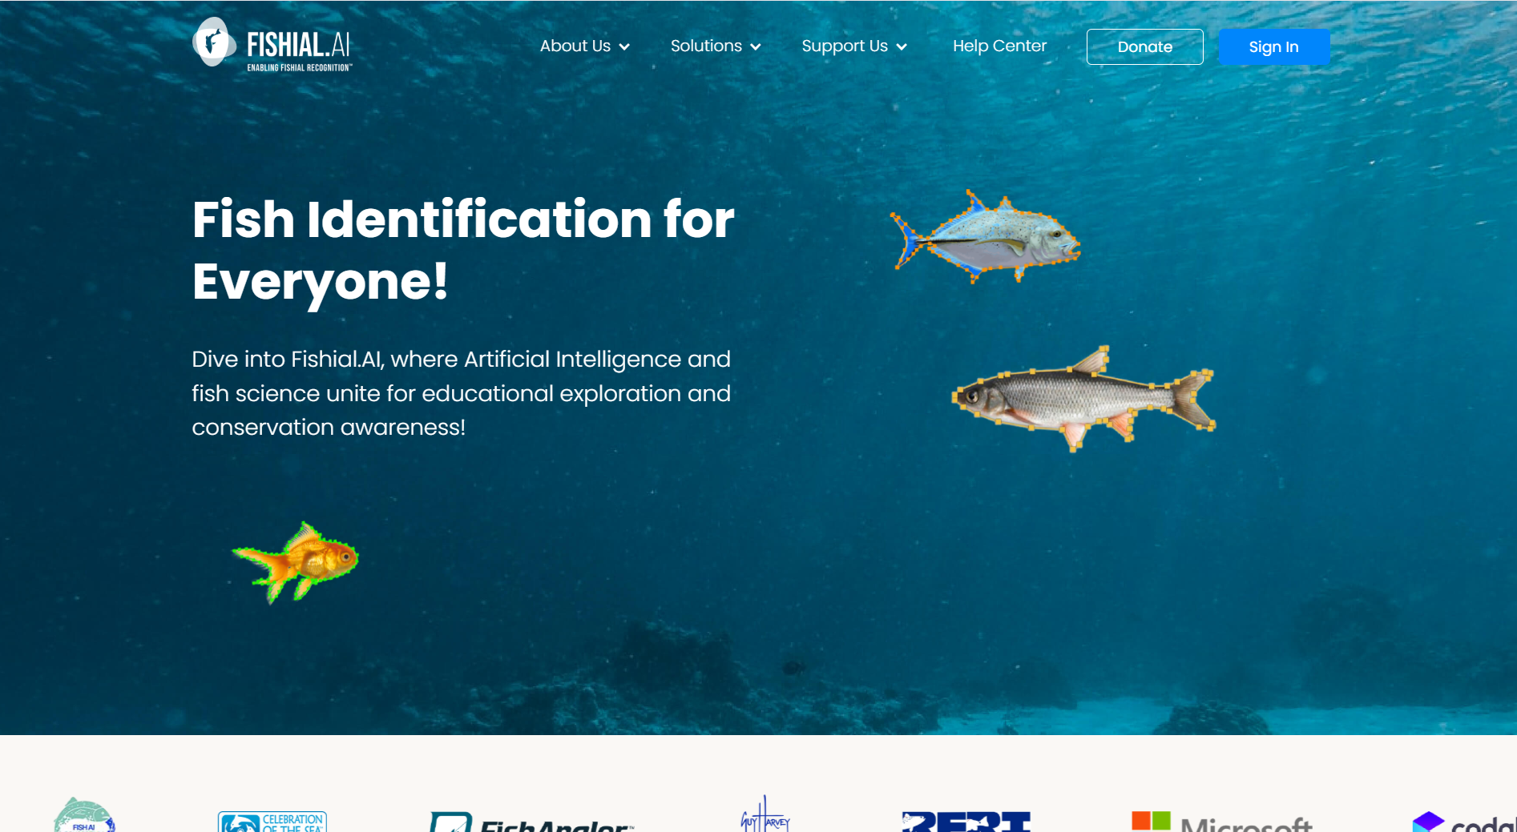
Figure 6. Fishial.ai (Fishial.ai, 2023)

As shown in Figure 6, Fishial.ai is an AI-based image recognition platform that identifies fish species from user-submitted photographs using a deep learning model trained on a global fish image dataset (Fishial.ai, 2023). Its strengths include high recognition accuracy for supported species and an API that other platforms can integrate for automated species tagging. In comparison to Fishial.ai, MarineSee targets a different taxonomic focus (seagrass rather than fish) and a much smaller, localized geographic scope. While Fishial.ai demonstrates that image-recognition-based marine species identification is technically viable, it does not address seagrass at all; MarineSee fills this specific gap while additionally offering interactive 3D visualization, which Fishial.ai does not provide.
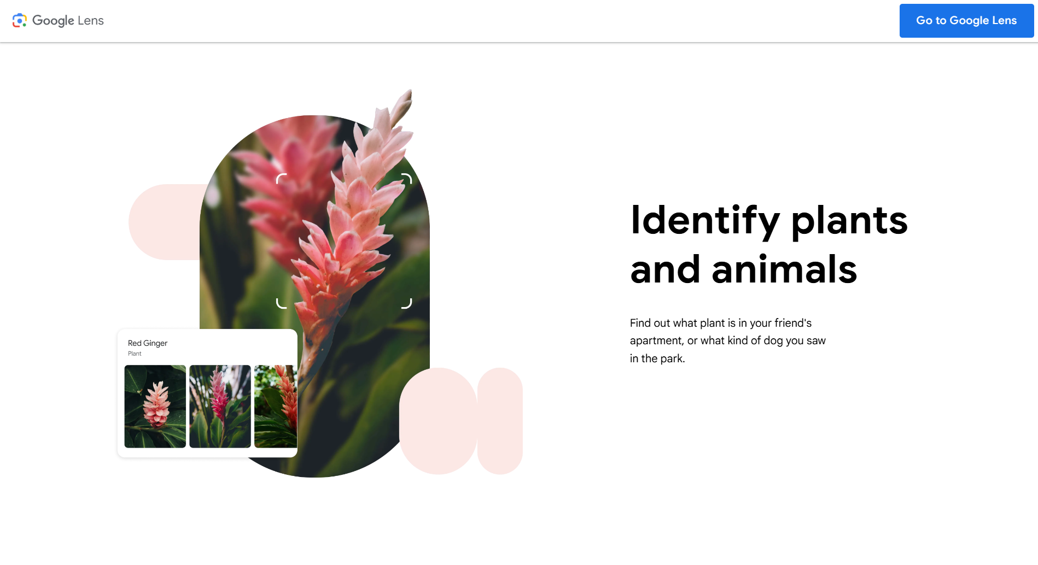
Figure 7. Google Lens (Google, 2023)

As shown in Figure 7, Google Lens is a general-purpose visual recognition tool that allows users to identify objects, plants, animals, text, and landmarks by pointing a smartphone camera at them, using Google's large-scale image recognition infrastructure (Google, 2023). Its strengths include near-universal object coverage, fast cloud-based processing, and integration with the broader Google ecosystem. Compared to Google Lens, MarineSee sacrifices general-purpose coverage for specialized accuracy: its SVM model is trained only on the nine seagrass species of Mati City, allowing more precise identification within that narrow domain than a generalist tool designed to recognize virtually anything. Google Lens also provides no dedicated educational content, species profiles, or 3D visualization for seagrass, all of which MarineSee offers.

Gaps of Related Systems
Taken together, the related image recognition systems reviewed above share several limitations when weighed against the needs of localized seagrass education in Mati City. Seek, PlantNet, PictureThis, and Google Lens are built for broad, general-purpose recognition across many species or object types rather than focused, high-accuracy identification of a specific local species set, and none of them provide interactive 3D models or content specific to Mati City. Fishial.ai demonstrates that image-recognition-based marine species identification is feasible, but it is limited to fish and does not cover seagrass at all. Across all five systems, none combine a locally trained recognition model, interactive 3D visualization, mobile accessibility, and localized educational profiles into a single platform focused specifically on Mati City’s seagrass species.

Introduction of the Proposed System
MarineSee was developed to address these gaps. The system integrates interactive 3D visualization, localized species profiles, and SVM-based image recognition into a single mobile-based platform focused specifically on the nine documented seagrass species of Mati City. Where existing image recognition systems such as Seek, PlantNet, PictureThis, Fishial.ai, and Google Lens prioritize broad, general-purpose recognition across thousands of unrelated species or objects, MarineSee narrows its focus to achieve higher accuracy within a specific local domain, bringing identification, 3D visualization, and localized learning content together in one accessible tool. This gives students, tourists, researchers, and coastal communities a way to engage directly with the seagrass species found in their own coastal waters.

Feature | Seek  (iNaturalist) | PlantNet | PictureThis | Fishial.ai | Google Lens | MarineSee (Our System)
SVM-based photo identification | X (CNN, general) | X (Deep learning) | X (Deep learning) | X (Deep learning) | X (Cloud CNN) | ✓  Local SVM model
Localized to Mati City species | X | X | X | X | X | ✓  Localized to Mati City
Botanical feature profiles | Partial (basic info) | Partial | (care info) | X (fish only) | Partial | ✓ Comprehensive
Species richness documentation | Partial (global) | (global) | Partial | Partial (fish) | X | ✓  Localized Documentation
Evaluation matrix per species class | X | X | X | X | X | ✓  Assessment System
Designed for non-expert users | X | X | X | Partial | X | ✓  User Friendly inter-face
Interactive 3D visualization | X | X | X | X | X | ✓  3D models & visualization
Mobile-based application | ✓  Mobile app | ✓  Mobile app | ✓  Mobile app | Partial (Web access) | ✓  Mobile app | ✓  Andriod Mobile app
Table 2. Matrix Comparison of Related Systems

Table 2 presents the matrix comparison of related image recognition systems and the proposed system, MarineSee. The comparison evaluates the existing platforms based on several important features relevant to image-based species identification, localization, visualization, and accessibility. The selected related systems include Seek by iNaturalist, PlantNet, PictureThis, Fishial.ai, and Google Lens, which are all widely used image recognition platforms. Although these systems demonstrate strong general-purpose or domain-specific recognition capabilities, the matrix shows that none offer the combination of local SVM-based recognition, seagrass-specific documentation, and interactive 3D visualization that MarineSee provides.

CHAPTER III
MATERIALS AND METHODS

3.1 Software Development
This study will utilize the Developmental Research Design using the Waterfall Software Development Life Cycle (SDLC) Model in developing MarineSee: A Mobile-Based Seagrass Species Identification System for Mati City Using Image Recognition and Interactive 3D Visualization. The study will focus on the design, development, implementation, testing, and evaluation of a mobile-based educational application intended to improve awareness and understanding of seagrass species found in Mati City.
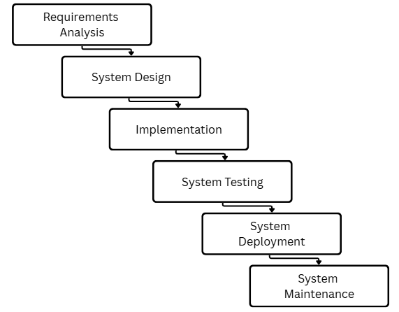
Figure 8. Waterfall Software Development Life Cycle Model (Bassil, 2012)
This study will adopts the Waterfall Model as shown in Figure 8. The Waterfall Model organizes the development process into a sequence of distinct, non-overlapping phases, where each phase must be completed and formally reviewed before the next phase begins. This structured and linear approach was selected because it aligns with the fixed scope, well-defined requirements, and formal panel-reviewed milestones required of the capstone project, and it provides clear documentation and traceability at every stage of development. The Waterfall Model includes six sequential phases: Requirements Analysis, System Design, Implementation, Testing, Deployment, and Maintenance. These phases ensure a systematic, well-documented, and quality-controlled development process for MarineSee (Bassil, 2012).

3.2 Requirements Analysis
In this phase, the researchers will gather and define all the features, functionalities, and deliverables required for MarineSee. This will include the interactive 3D seagrass visualization module, the SVM-based image recognition module, the species information digital library, the Android mobile interface, and the user interaction controls. Requirements will be consolidated based on related literature, related systems, and consultations with the project adviser and panel, and will be documented as a formal Software Requirements Specification that will serve as the reference for all subsequent phases.

3.3 System Design
Based on the finalized requirements, the researchers will design the overall system architecture, database structure, user interface layout, and the workflow of the SVM-based image recognition process. Design activities in this phase will include the conceptual framework, use case diagrams, the Business Process Model and Notation (BPMN), the mock-up interface designs, and the technical specifications for integrating the 3D visualization module with the mobile application. This phase will produce a complete system design blueprint before any implementation work begins, allowing the adviser and panel to review and approve the design prior to development.

Implementation
During this phase, the researchers translated the finalized design into working system components. Development tasks included building the Android mobile interface, integrating the 3D seagrass models, developing and training the SVM-based image recognition model using the extracted image features of the nine (9) documented seagrass species, and setting up the digital library database. Because the Waterfall Model requires that design be finalized beforehand, implementation proceeded in a structured and sequential manner, with each module developed strictly according to the approved System Design specifications.

Model Building Process
Building the SVM-based image recognition module of MarineSee involved a sequence of data preparation and feature-engineering steps carried out before the classifier itself could be trained. Because the model relies on extracted visual features rather than automatic deep feature learning, the quality, consistency, and organization of the seagrass image dataset directly affect the reliability of the resulting classifications. This section describes how the dataset was gathered and prepared for the nine (9) documented seagrass species of Mati City.
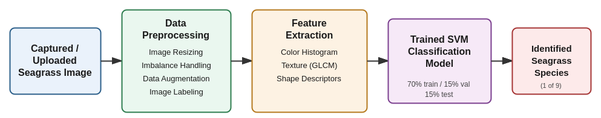
Figure 9. Data Preprocessing and Model Building Pipeline of MarineSee's SVM-Based Image Recognition Module
Figure 9 shows the overall pipeline followed to build the SVM-based image recognition module. A captured or uploaded seagrass image first passes through data preprocessing, where it is resized, checked for class imbalance, augmented, and labeled according to its species. Color, texture, and shape features are then extracted from the preprocessed image and used to train and evaluate the SVM classification model, which outputs the identified seagrass species as one of the nine (9) documented species.

Data Preprocessing
For this capstone project, the researchers collected seagrass leaf and canopy images from the documented coastal areas of Mati City, Davao Oriental, specifically Lawigan, Taitaidaga, Manguihay, and Pujada Bay, where the nine (9) documented seagrass species are found. The researchers gathered a total of [INSERT NUMBER] images, consisting of images distributed across each of the nine (9) species: Cymodocea rotundata, Cymodocea serrulata, Enhalus acoroides, Halodule pinifolia, Halodule uninervis, Halophila minor, Halophila ovalis, Syringodium isoetifolium, and Thalassia hemprichii. The dataset was divided into a training set, a validation set, and a testing set, following a 70% training, 15% validation, and 15% testing split.
Through data preprocessing, the researchers ensured the quality, diversity, and reliability of the seagrass image dataset used to train the SVM classification model. The steps followed for data preprocessing are outlined below.
Image Resizing. The researchers selected images that clearly showed the visual characteristics of each seagrass species, such as leaf shape, blade width, and coloration, to ensure that the dataset remained relevant to the objectives of the study. To address inconsistent image resolutions collected from different devices and field conditions, the researchers performed image resizing on all captured and uploaded photos. A fixed image size was applied to ensure uniformity across the dataset and to preserve the visual details required for accurate feature extraction.
Data Imbalance. During data collection, the researchers observed data imbalance in the dataset, which may occur when certain seagrass species have more available sample images than others due to differences in accessibility, seasonal presence, or field conditions at the collection sites. To address this, the researchers monitored the number of images collected per species and applied data augmentation to underrepresented classes to reduce the effects of imbalance on the SVM model's classification performance.
Data Augmentation. To increase the number and variety of training images and to improve the generalization of the SVM model, the researchers applied data augmentation techniques such as random flipping, rotation, and zoom to the collected seagrass images. These augmentation techniques allowed the dataset to better represent the natural variation in leaf orientation, angle, and framing that occurs when users capture seagrass images in real coastal field conditions.
Image Labeling. Each preprocessed image was labeled according to its corresponding seagrass species by organizing the dataset into species-specific folders verified against the documented botanical references used in this study. This labeling process ensured that every image used during feature extraction and SVM training was correctly associated with one of the nine (9) documented seagrass species, forming the ground truth used to evaluate the classification accuracy of the model.

Feature Extraction and Model Training
After preprocessing, the researchers extracted color, texture, and shape features from each labeled image to represent the visual characteristics that distinguish one seagrass species from another. Color features were derived from color histograms, texture features were derived using descriptors such as the Gray-Level Co-occurrence Matrix (GLCM), and shape features were derived from the contour and blade characteristics of each leaf. These extracted feature vectors, rather than the raw pixel data, were used as the input to train the Support Vector Machine (SVM) classification model, consistent with the lightweight, feature-based approach discussed in Chapter II. The trained SVM model was then evaluated using the validation and testing sets described above to assess its classification accuracy across the nine (9) documented seagrass species.

Testing
Once implementation was completed, the researchers conducted unit testing, integration testing, and system testing to verify that MarineSee met the functional and non-functional requirements defined in the Requirements Analysis phase. Testing activities included evaluating the accuracy of the SVM-based species classification, verifying the responsiveness of the 3D visualization module, checking the stability of the mobile interface, and identifying and resolving defects. User acceptance testing was also conducted with students, tourists, researchers, and coastal community members to evaluate the system based on ISO/IEC 25010 software quality standards.

Deployment
After testing confirmed that the system met the required quality standards, MarineSee was prepared and released for use by its intended users. This phase involved final packaging of the Android application, configuration of the production digital library and image recognition components, and orientation of end users on how to operate the system. Deployment marked the transition of MarineSee from a development project into a functional educational tool available for students, tourists, researchers, and coastal communities in Mati City.

Maintenance
Following deployment, the researchers identified the activities necessary to sustain and improve MarineSee over time. This includes correcting any defects discovered after deployment, updating the digital library with additional species information as it becomes available, refining the SVM classification model as more seagrass images are collected, and enhancing the mobile interface based on user feedback. Because the Waterfall Model treats maintenance as a distinct final phase, all post-deployment changes are documented and evaluated separately from the original development cycle to preserve traceability.
3.4 System Planning
The project was conceptualized after identifying the limited availability of interactive educational tools focused on seagrass species awareness and marine environmental education within Mati City. Traditional educational resources related to marine biodiversity primarily rely on textbooks, printed materials, lectures, and static images, which may not fully engage modern learners and mobile technology users. Additionally, the lack of accessible digital systems for seagrass identification and visualization created a need for an interactive educational platform that combines mobile technology, image recognition, and 3D visualization. As a response, the researchers proposed the development of MarineSee, a mobile-based educational application that integrates interactive 3D visualization and image recognition technologies to improve awareness, accessibility, and understanding of seagrass species within Mati City.

Feasibility Study
The proposed system, MarineSee: A Mobile-Based Seagrass Species Identification System for Mati City Using Image Recognition and Interactive 3D Visualization, is considered feasible in terms of operational, technical, and economic aspects. The project aims to provide an interactive educational platform that combines image recognition technology, 3D visualization, and mobile accessibility. The system is expected to benefit students, tourists, researchers, environmental advocates, and coastal communities by providing accessible marine biodiversity information through Android mobile devices. The proposed system is operationally feasible because it is designed to be user-friendly, accessible, and educational. Technically, the project can be successfully developed using existing software tools and mobile technologies capable of supporting 3D rendering and database integration. Economically, the system is cost-effective because it primarily utilizes open-source development tools and existing mobile hardware resources.

Operational Feasibility
The proposed system is considered operationally feasible because it is designed to function effectively for students, tourists, researchers, and Android mobile users interested in marine biodiversity education. The application utilizes intuitive mobile controls, interactive 3D models, educational content, and image recognition features that are compatible with current mobile technology trends. The integration of interactive visualization and mobile learning enhances user engagement, accessibility, and educational effectiveness. Unlike traditional educational methods that rely heavily on textbooks and static references, MarineSee provides a more immersive and interactive learning experience through mobile technology and real-time species interaction. The system can also support educational institutions and environmental awareness programs by providing accessible marine biodiversity resources without requiring expensive infrastructure or specialized equipment.

Technical Feasibility
The proposed system is technically feasible because the necessary hardware, software, and development technologies required for the development of MarineSee are readily available and accessible. The researchers utilized Android Studio for mobile application development, Blender for creating interactive 3D seagrass models, and Firebase/MySQL for database management and data storage. These technologies are capable of supporting the major functionalities of the system, including interactive 3D visualization, SVM-based image classification, database integration, and mobile responsiveness. Through the use of these modern and accessible development tools, the researchers can effectively develop and implement the proposed system for Android mobile devices.

Economic Feasibility
The project is considered economically feasible because it relies primarily on open-source tools, existing development resources, and Android mobile devices. The development process does not require expensive proprietary software or high-cost infrastructure. The use of freely available development frameworks and existing hardware resources minimizes project expenses while maintaining system quality and functionality.
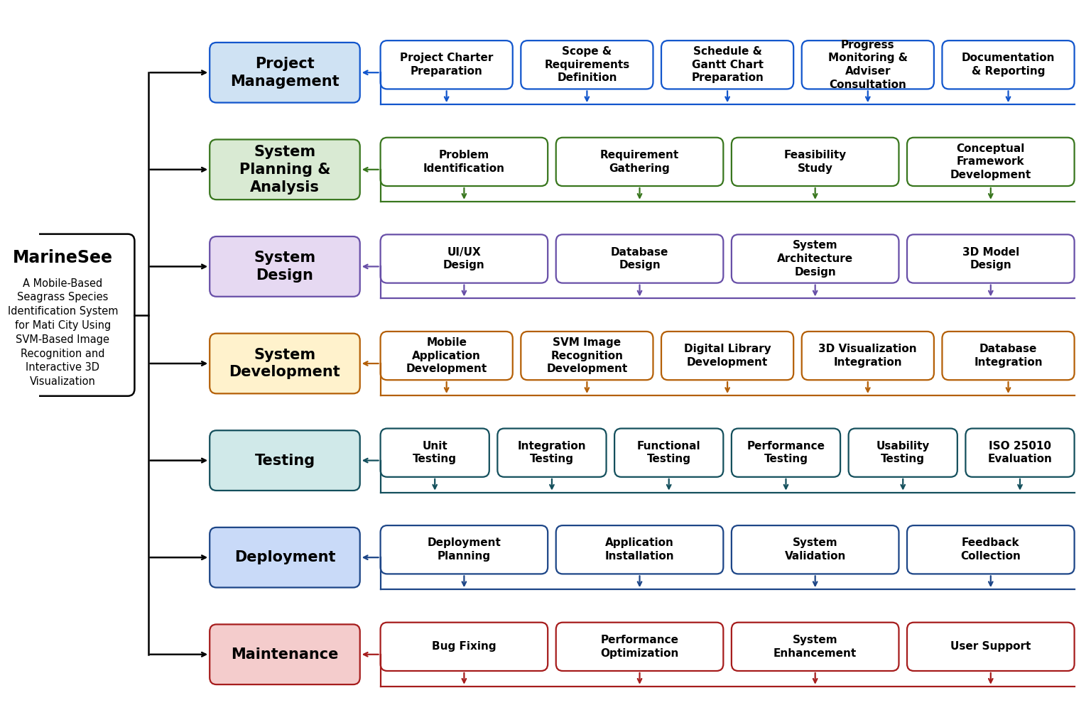
Work Breakdown Structure (WBS)
Figure 10. Work Breakdown Structure
As shown in Figure 10, The Work Breakdown Structure (WBS) presents the major phases and tasks involved in developing the MarineSee: A Mobile-Based Seagrass Species Identification System for Mati City Using Image Recognition and Interactive 3D Visualization. It serves as a guide for organizing, managing, and monitoring the development process of the proposed system.
The Work Breakdown Structure (WBS) presented in Figure 9 illustrates the current process involved in identifying and learning seagrass species before the implementation of the proposed MarineSee system. The process begins when users attempt to identify or learn about seagrass species using available resources such as books, printed references, photographs, and static educational materials. Users then manually compare the physical characteristics of seagrass species based on the information they gathered. However, due to the limited use of interactive visualization and digital learning tools, users often experience difficulty understanding the structure and characteristics of seagrass species. As a result, users rely on experts or researchers to verify species identification, which contributes to limited awareness and understanding of seagrass ecosystems. This current process highlights the need for a more accessible, interactive, and technology-driven educational platform that can improve seagrass identification and learning experiences.

Gantt Chart
The Gantt chart is used as a project management tool to present the timeline and progression of the development of MarineSee: A Mobile-Based Seagrass Species Identification System for Mati City Using Image Recognition and Interactive 3D Visualization. It visually outlines the major phases of the project, including planning, analysis, design, implementation, testing, evaluation and feedback, and deployment.
Each task is assigned a specific duration to ensure that the project remains organized and is completed efficiently within the proposed schedule. The chart helps the researchers monitor development progress, manage workloads, and identify possible delays or technical issues during the implementation process. It also shows the sequence of activities to ensure that all tasks are completed in the proper order.
The Gantt chart serves as a guide for tracking project milestones, evaluating the completion of each phase, and managing time and resources effectively throughout the system development process. Through proper scheduling and monitoring, the researchers can ensure continuous progress and timely completion of the proposed system.
Overall, the Gantt chart provides a structured, organized, and systematic approach to the development of the MarineSee system.
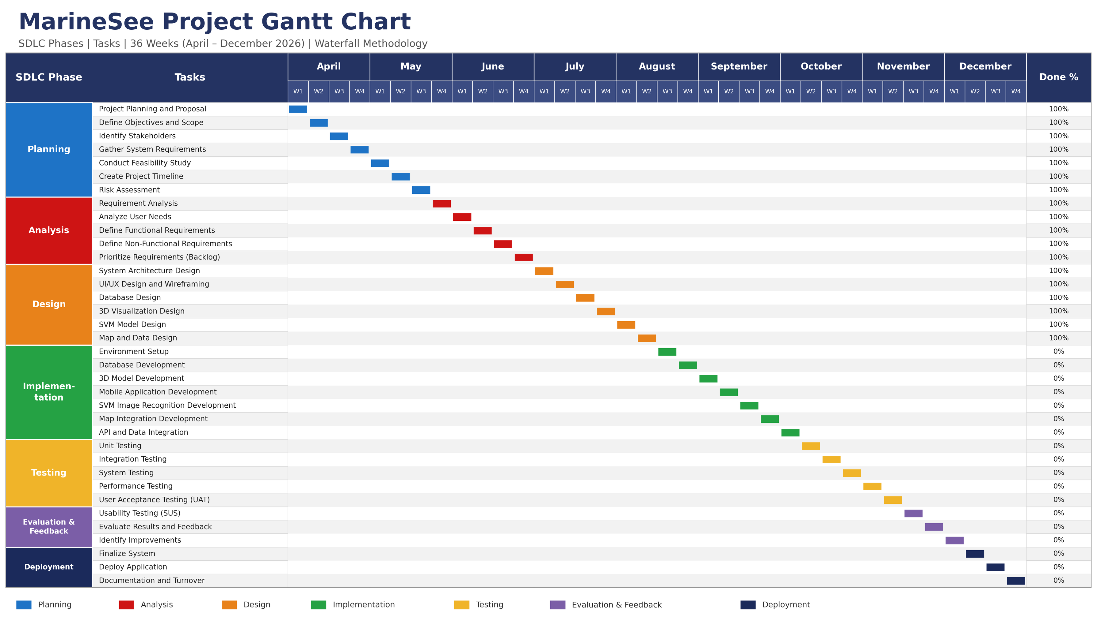
Figure 11. Gantt Chart
System Analysis
Currently, there is no existing digital or technology-assisted system for identifying seagrass species in Mati City, Davao Oriental. The identification and learning process for seagrass species primarily relies on traditional and manual methods such as books, printed references, photographs, and static educational materials. Students, tourists, local community members, and researchers manually observe and compare the physical characteristics of seagrass species based on the information available to them.

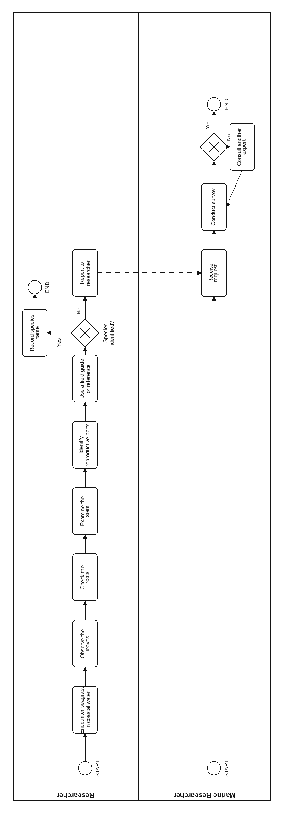
However, due to the limited availability of interactive educational tools and digital visualization technologies, users often experience difficulty understanding and accurately identifying different seagrass species. In cases where users cannot verify the species independently, they usually seek assistance from marine researchers or experts for confirmation. This manual process contributes to limited public awareness and understanding of seagrass ecosystems, highlighting the need for a more accessible and interactive technology-based learning system.

BPMN of the current system
Figure 12. BPMN diagram of the current manual seagrass identification process
Requirements Specification
This section defines the specific features and qualities that MarineSee must possess to effectively address the identified problems in seagrass species identification and marine environmental education in Mati City.

Functional Requirements
Functional requirements describe the specific operations and services that the MarineSee system must perform.
- The system shall allow users to upload or capture seagrass images using an Android mobile device camera.
- The system shall automatically identify seagrass species using an SVM-based image recognition model.
- The system shall display the identified seagrass species together with its scientific name, common name, botanical characteristics, ecological role, conservation status, and habitat information.
- The system shall provide interactive 3D visualization that allows users to rotate, zoom, and inspect seagrass models.
- The system shall provide a digital library containing information about the nine (9) localized seagrass species found in Mati City.
- The system shall provide educational content and conservation awareness information related to seagrass ecosystems.
- The system shall support user interaction controls and mobile navigation features.
- The system shall display a confidence score for every SVM-based identification result.
- The system shall recommend retaking the image when the confidence score is low.
- The system shall store and retrieve species information through database integration.
- The system shall allow administrators to manage educational content and species information.
- The system shall support user-friendly navigation and accessibility features for mobile users.

Non-Functional Requirements
Non-functional requirements define the quality attributes, standards, and constraints of the MarineSee system.

A. Performance
The system shall process image identification requests within five seconds. It shall also maintain smooth and responsive 3D rendering performance on Android devices and support fast loading of educational content and species information.

B. Reliability
The SVM-based identification system shall achieve at least 85% identification accuracy under normal conditions. The system shall remain functional and accessible during normal usage conditions, and it shall perform regular backups to prevent data loss.

C. Usability
The system shall provide a user-friendly and responsive mobile interface that is easy to use for students, tourists, researchers, and coastal community users. It shall provide clear instructions and easy navigation for non-technical users and shall achieve an acceptable usability rating during system evaluation.

D. Compatibility
The system shall be compatible with Android mobile devices, supporting different screen sizes and resolutions, and shall function properly on commonly used Android versions.

E. Security
The system shall protect uploaded images and user information from unauthorized access. It shall implement role-based access control for administrators and users and shall securely store species and user data within the database.

F. Scalability
The system shall support future expansion of educational content and additional species information, as well as increasing numbers of users without major performance degradation.

G. Maintainability
The system shall allow easy updating of educational content and species records, and shall support future system enhancements and feature improvements.

Proposed Solution
To address the limitations of the current manual process in seagrass identification and marine environmental education, the researchers proposed the development of MarineSee: A Mobile-Based Seagrass Species Identification System for Mati City Using Image Recognition and Interactive 3D Visualization. The proposed system aims to provide a more accessible, interactive, and technology-driven platform that can assist users in identifying and learning about seagrass species found in Mati City.
The proposed system integrates SVM-based image recognition, interactive 3D visualization, educational content, and mobile accessibility into a single Android-based application. Through the system, users can upload or capture images of seagrass species using a mobile device camera, and the application will automatically identify the species and display relevant information such as scientific name, botanical characteristics, ecological role, conservation status, and habitat details. The system also includes interactive 3D models that allow users to rotate, zoom, and inspect the seagrass structure for better understanding and learning.
Additionally, MarineSee provides a digital library containing localized information about the nine (9) documented seagrass species found in Mati City. The proposed solution is expected to improve user engagement, simplify the identification process, enhance environmental awareness, and support marine biodiversity education among students, tourists, researchers, and coastal communities through the use of modern mobile technologies.
Project Phases and Estimated Duration
The development of MarineSee: A Mobile-Based Seagrass Species Identification System for Mati City Using Image Recognition and Interactive 3D Visualization follows the Waterfall Software Development Life Cycle Model and is divided into several sequential project phases. Each phase is assigned an estimated duration to ensure proper project management and timely completion of the system.
Table 3.1 Project Phases and Estimated Duration of MarineSee Implementation
Project Phase | Activities Included | Estimated Duration
Analysis | Requirement gathering, feasibility study, project proposal, risk assessment | April – May
Design | User analysis, functional and non-functional requirements, backlog prioritization | May – June
Implementation | System architecture, UI/UX design, database design, SVM model and 3D visualization design | October – November

Table 3.2 Project Phases and Estimated Duration of MarineSee Implementation
Testing | Unit testing, integration testing, system testing, usability and performance testing | November – December
Evaluation and Feedback | Collecting user feedback and identifying improvements | November – December
Deployment | Finalization, deployment, documentation, and turnover | December

LITERATURES CITED

Angsinco-Jimenez, F., Nañola, C. L., Fortes, M. D., & Campos, W. L. (2003). Seagrass resources of the Philippines. Marine Science Institute, University of the Philippines.

CMS Dugong MOU Secretariat. (2022). Dugong and seagrass conservation project. https://www.dugongconservation.org

Crompton, H., & Burke, D. (2018). The use of mobile learning in higher education: A systematic review. Computers & Education, 123, 53–64. https://doi.org/10.1016/j.compedu.2018.04.007

Fortes, M. D. (2013). Seagrass ecosystems of the Philippines: Status, problems, and management directions. Coastal Marine Science, 36(1), 1–7.

GBIF Secretariat. (2024). Global Biodiversity Information Facility. https://www.gbif.org
Goëau, H., Bonnet, P., Joly, A., & Molino, J. F. (2025). Improving tropical plant identification through regionalized deep learning datasets. Ecological Informatics, 85, 102114. https://doi.org/10.1016/j.ecoinf.2024.102114

Green, E. P., & Short, F. T. (2003). World atlas of seagrasses. University of California Press.

iNaturalist. (2023). iNaturalist biodiversity observation platform. https://www.inaturalist.org
Jerald, J. (2015). The VR book: Human-centered design for virtual reality. Morgan & Claypool Publishers.

Nordlund, L. M., Unsworth, R. K. F., Gullström, M., & Cullen-Unsworth, L. C. (2024). Global threats and conservation challenges facing seagrass ecosystems. Marine Pollution Bulletin, 198, 115825. https://doi.org/10.1016/j.marpolbul.2023.115825

Radianti, J., Majchrzak, T. A., Fromm, J., & Wohlgenannt, I. (2020). A systematic review of immersive virtual reality applications for higher education: Design elements, lessons learned, and research agenda. Computers & Education, 147, 103778. https://doi.org/10.1016/j.compedu.2019.103778

Sanchez-Delute, J. C., Nañola, C. L., & Fortes, M. D. (2025). Community-based seagrass assessment in Pujada Bay, Davao Oriental. Philippine Journal of Science, 154(1), 45–59.

Seagrass-Watch. (2023). Seagrass-Watch global seagrass monitoring program. https://www.seagrasswatch.org

Short, F. T., Polidoro, B., Livingstone, S. R., Carpenter, K. E., Bandeira, S., Bujang, J. S., Calumpong, H. P., Carruthers, T. J. B., Coles, R. G., Dennison, W. C., Erftemeijer, P. L. A., Fortes, M. D., Freeman, A. S., Jagtap, T. G., Kamal, A. H. M., Kendrick, G. A., Kenworthy, W. J., La Nafie, Y. A., Nasution, I. M., … Zieman, J. C. (2011). Extinction risk assessment of the world's seagrass species. Biological Conservation, 144(7), 1961–1971. https://doi.org/10.1016/j.biocon.2011.04.010

Wäldchen, J., & Mäder, P. (2022). Machine learning for image-based species identification. Methods in Ecology and Evolution, 13(4), 845–860. https://doi.org/10.1111/2041-210X.13809

WoRMS Editorial Board. (2024). World Register of Marine Species. https://www.marinespecies.org

