The provided mazes and solutions, as well as four additional maze-solution pairs are displayed below. Additionally, the code and supplemental information includes the intermediary images and animated .gif files that loop through each solution set for each maze.

The final system is mostly contained in a single ANA\* search class, which handles the search solution, drawing intermediary and final solutions, generating the animated gif, and writing out a text file with the number of solution loops and the number of internal loops for each solution.

The search handled small scale mazes very well, and only used one or two solution loops to reach a final conclusion. The much larger maps took quite a bit longer to run, and did not generate additional solution loops. The heuristics that were used in these solutions was a direct distance from each grid point to the solution, which might have thrown out additional search options based on being considered “too costly”.



Trivial Maze and Solution

Solution 0 took 197 loops to solve

Solution 1 took 3 loops to solve

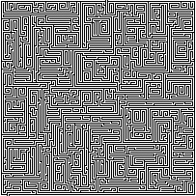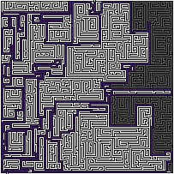

Medium Maze and Solution

Solution 0 took 16552 loops to solve

Solution 1 took 3448 loops to solve

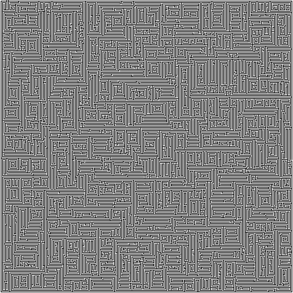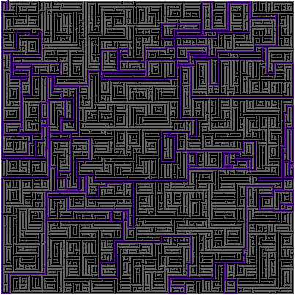

Hard Maze and Solution

Solution 0 took 80001 loops to solve

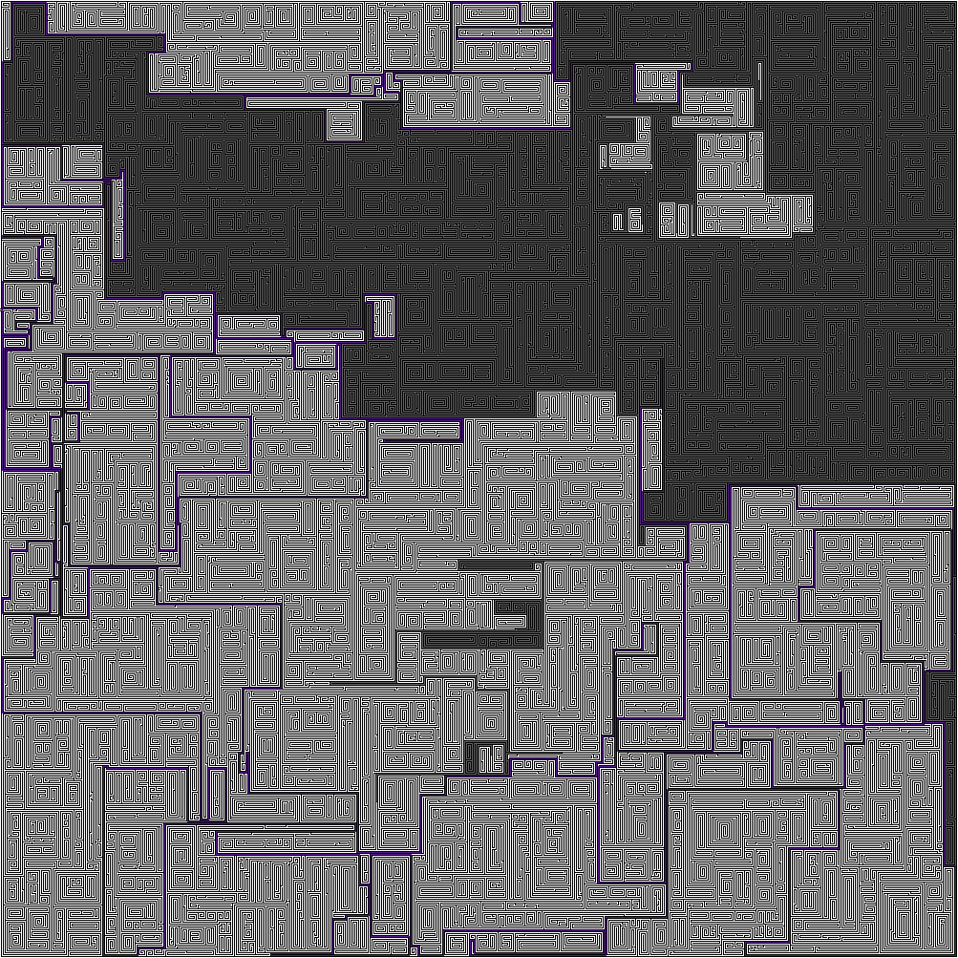

Very Hard Maze and Solution

Solution 0 took 249449 loops to solve

Solution 1 took 164594 loops to solve

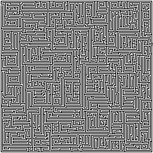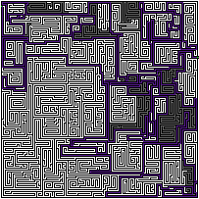

Maze Test 1 and Solution

Solution 0 took 16204 loops to solve

Solution 1 took 1939 loops to solve



Maze Test 2 and Solution

Solution 0 took 801 loops to solve

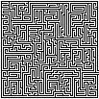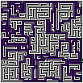

Maze Test 3 and Solution

Solution 0 took 5000 loops to solve

Solution 1 took 0 loops to solve

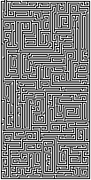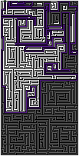

Maze Test 4 and Solution

Solution 0 took 4640 loops to solve

Solution 1 took 4635 loops to solve