COMPUTER NETWORKS
Muhammad Bilal Khan BCSF24A032
Muhammad Hassan Farooq
BCSF24A025


CENTIPEDE
Packet Sniffer

Table of Contents
1. INTRODUCTION: 3
1.1. What is a packet sniffer? 3
1.1.1 Uses 3
1.1.2. Misuses 3
1.2. Our project 4
2. OUR CODE LOGIC 4
2.1. Backend code logic: 4
2.1.1. Libraries used:- 4
2.1.2. Library Linking and Macro Definition 5
2.1.3. Protocol Header Structures 7
2.1.4. IP Address Conversion Function 8
2.1.5. IP Address Conversion to Hexadecimal 9
2.1.6. 32-bit value to hexadecimal conversion: 9
2.1.7. TCP checksum verification: 10
2.1.8. UDP checksum verification: 11
2.1.9. IPV4 header checksum verification: 12
2.1.10. Escape a string for json 12
2.1.11. Hex payload building function 13
2.2.12 Main function: 14
2.2. Enivronment framework: 20
2.2.1. Functionality: 21
2.2.2. Code: 21
2.2.3. Integration logic: 21
2.3. Frontend Code Logic: 22
2.3. Frontend Code Logic (interface.html) 22
2.3.1. User Interface (UI) Layout and Styling 22
2.3.2. WebSocket Communication 22
2.3.3. Data Ingestion and State Management 23
2.3.4. Real-Time UI Updating and Statistics 23
2.3.5. Packet Filtering Engine 23
2.3.6. Dynamic Table Rendering 23
2.3.7. Deep Packet Inspection (DPI) Panels 24
3. PRACTICAL WORKING: 24
4. CONCLUSION 27

INTRODUCTION:

What is a packet sniffer?
A packet sniffer is a tool or program that captures and analyses data packets traveling over a network.
When devices communicate over the internet or a LAN (like Wi-Fi), the data is broken into small pieces called packets. A packet sniffer “listens” to this traffic and shows what is being sent and received. Tools like Wireshark, tcpdump, scapy etc are used for packet capturing and their analysis. They read packets and show details like:
- Source IP address
- Destination IP address
- Protocol (UDP, TCP, ICMP, ARP etc)
- Port numbers
- Payload data
- Check sum etc.

Uses
Legitimate uses:
- Network troubleshooting
- Cybersecurity analysis
- Learning networking protocols
- Detecting network issues

1.1.2. Misuses
As these tools are used security, there are certain misuses of them which can’t be ignored as well. Common misuses are:
- Unauthorized Data theft like passwords or other unencrypted information
- Eavesdropping on network traffic
- Session hijacking
Packet sniffers are powerful tools, but their misuse can lead to serious privacy and security violations. Therefore, they should only be used for ethical and authorized purposes such as network troubleshooting and cybersecurity research.

Our project
The project “Centipede” is a custom built networking tool that works in c++. It uses low level socket programming on the windows platform. The system captures live traffic directly from network interface by enabling promiscuous mode, allowing it to intercept all coming and outgoing packets regardless of their destination.
Unlike other sniffers our project performs deep packet analysis by manually parsing different layers, like at network layer the tool tries to analyze ipv4 headers inc fields like source and destination address, time to live and header length. At the transport layer, it supports detailed inspection of TCP and UDP protocols, extracting key fields like port numbers, sequence numbers, acknowledgment numbers, and packet lengths.
A significant feature of this project is the manual checksum verification for IP, TCP, and UDP headers. This ensures data integrity by recalculating checksums and validating whether packets have been transmitted without corruption. Additionally, the system presents packet payloads in both hexadecimal and ASCII formats, enabling deeper analysis of raw data.
The application also generates structured JSON output for each captured packet, making it compatible with external systems such as web dashboards or real-time monitoring tools (e.g., a Node.js-based frontend) which have been also been implemented.

OUR CODE LOGIC

Backend code logic:

Libraries used:-
The following header files are included to provide networking functionality, data handling, and output formatting in the packet sniffer:
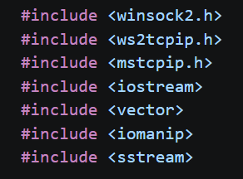
<winsock2.h> library
This is the core Windows Sockets library used for network programming in C++.
- Provides functions like socket(), bind(), recv(), and WSAStartup()
- Enables creation and management of network connections
- Essential for implementing raw sockets used in packet capturing
<ws2tcpip.h> library
This library extends Winsock functionality for TCP/IP networking.
- Provides advanced structures and functions for IP address handling
- Includes support for IPv4 and IPv6
- Used for functions like inet_ntoa() and address conversions
<mstcpip.h> library
This header provides Microsoft-specific extensions to Winsock.
- Required for advanced socket control operations
- Enables use of SIO_RCVALL, which activates promiscuous mode
- Essential for capturing all packets on the network
<iostream> , <vector> and <iomanip> libraries
They are used for:
- Isotream for cin, cout and vector for dynamic arrays.
- Iomanip is used for formatting output helps data display is hexadecimal format and provide functions like setw() and setfill() for better readability of data.
<sstream> library
Used for string stream operations.
- Converts data into formatted strings
- Helps in building:
  - Hexadecimal representations
  - JSON output
  - Structured text output

Library Linking and Macro Definition
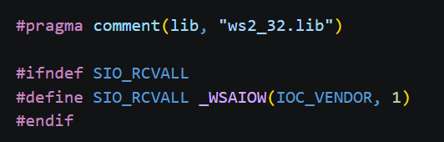
#pragma comment(lib, "ws2_32.lib")
This directive is used to link the Winsock library with the program during compilation.
- ws2_32.lib is the Windows Socket library
- It contains implementations of networking functions like:
  - socket()
  - bind()
  - recv()
  - WSAStartup()
#ifndef SIO_RCVALL
This is a preprocessor condition that checks whether SIO_RCVALL is already defined. It prevents redefinition errors and ensures compatibility across different compilers
#define SIO_RCVALL _WSAIOW(IOC_VENDOR, 1)
This line defines the constant SIO_RCVALL if it is not already available.
- SIO_RCVALL is a control code used with WSAIoctl()
- It enables promiscuous mode on the network interface
Promiscuous mode allows the program to:
- Capture all network packets
- Not just those addressed to the local system

#endif marks end of conditional line block.

Protocol Header Structures
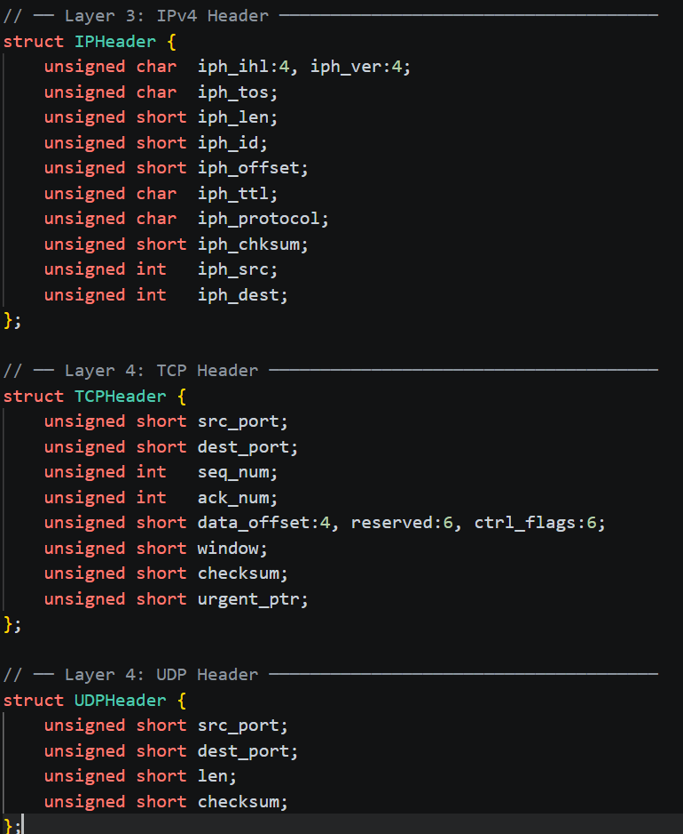
Their logic is defined as follows:
Bitfields are used like :4, :6 to store the offsets etc compactly
IPv4 Header Structure (Layer 3)
This structure represents the Internet Protocol (IP) header, which is responsible for routing packets across networks.
Key fields:
- iph_ver → IP version (typically IPv4)
- iph_ihl → Internet Header Length (size of IP header)
- iph_tos → Type of Service (priority and handling of packet)
- iph_len → Total length of the packet
- iph_id → Identification number of the packet
- iph_offset → Fragmentation offset
- iph_ttl → Time-To-Live (limits packet lifetime)
- iph_protocol → Specifies next layer protocol (TCP, UDP, ICMP)
- iph_chksum → Header checksum for error detection
- iph_src → Source IP address
- iph_dest → Destination IP address
TCP Header Structure (Layer 4)
This structure represents the Transmission Control Protocol (TCP) header used for reliable communication.
Key fields:
- src_port → Source port number
- dest_port → Destination port number
- seq_num → Sequence number (for data ordering)
- ack_num → Acknowledgment number
- data_offset → Size of TCP header
- ctrl_flags → Control flags (SYN, ACK, FIN, etc.)
- window → Flow control window size
- checksum → Error-checking value
- urgent_ptr → Urgent data pointer
UDP Header Structure (Layer 4)
This structure represents the User Datagram Protocol (UDP) header, which is simpler and connectionless.
Key fields:
- src_port → Source port number
- dest_port → Destination port number
- len → Length of UDP packet
- checksum → Error detection value

IP Address Conversion Function
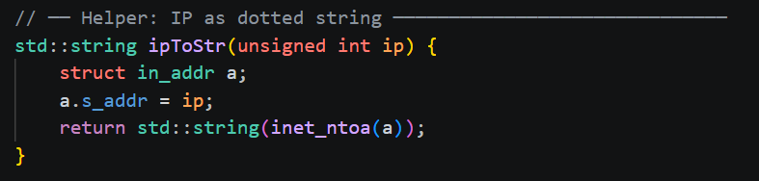
This helper function is used to convert an IP address from its numeric (binary) format into a human-readable dotted decimal format (e.g., 192.168.1.1). The input ip is received as a 32-bit integer representing the IP address. A structure of type in_addr is created and address is assigned to it.

IP Address Conversion to Hexadecimal
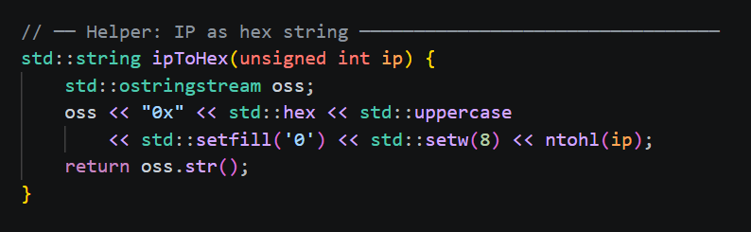
This helper function converts an IP address into its hexadecimal representation, which is useful for low-level analysis. A string stream ostringstream is used to build the formatted output
- The prefix "0x" is added to indicate hexadecimal format
- Formatting manipulators are applied:
- std::hex → converts value to hexadecimal
- std::uppercase → uses capital letters (A–F)
- std::setfill('0') → fills leading zeros
- std::setw(8) → ensures 8-digit width (32-bit value)
The function ntohl(ip) converts the IP address from network byte order to host byte order for correct representation.

32-bit value to hexadecimal conversion:
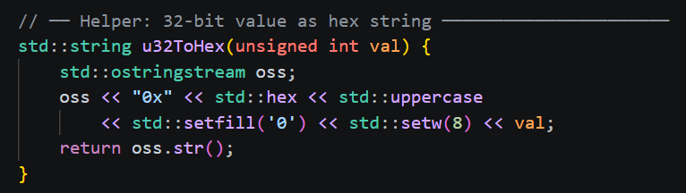

TCP checksum verification:
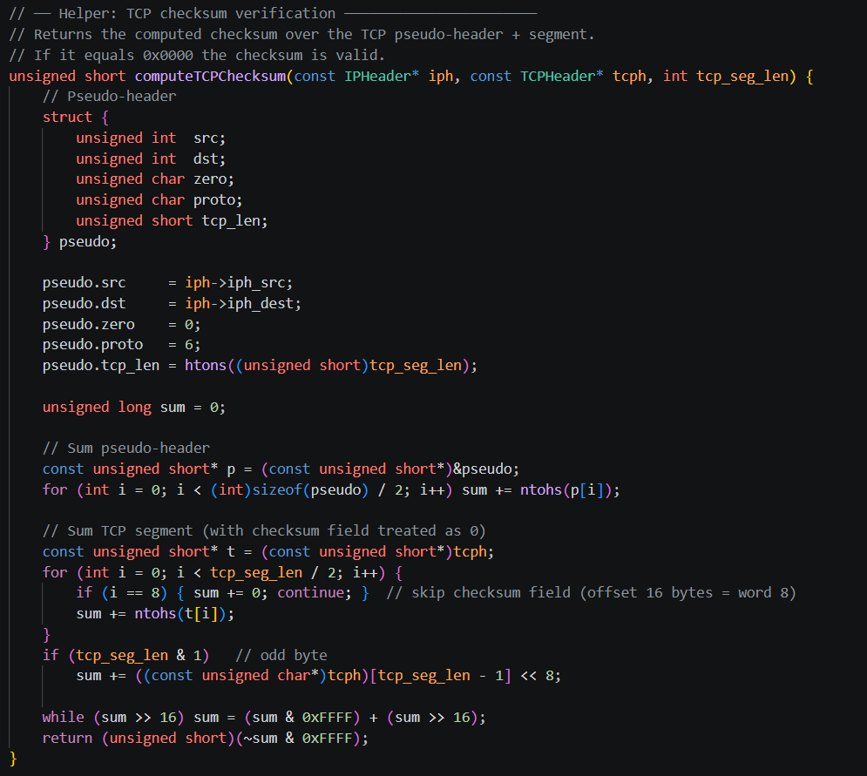

The function first constructs the pseudo-header and converts its fields into 16-bit words for processing. It then iterates over both the pseudo-header and the TCP segment, summing all 16-bit values using one’s complement arithmetic.
After summing all values, any overflow beyond 16 bits is folded back into the lower 16 bits to maintain correctness according to TCP checksum rules If (tcp_seg_len & 1) checks for odd if value is odd sum += ((const unsigned char*)tcph)[tcp_seg_len - 1] << 8; Last byte is padded with 0 in lower byte. To prevent overflow we did while (sum >> 16) sum = (sum & 0xFFFF) + (sum >> 16); Finally, the function applies a one’s complement operation to the result and returns it as the computed checksum.

UDP checksum verification:
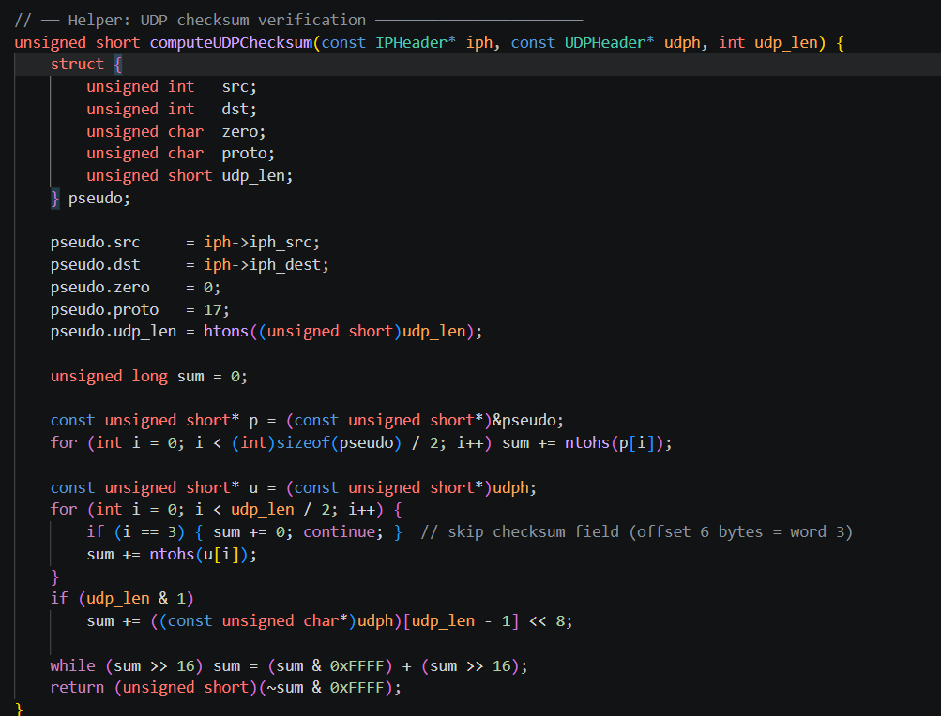
- This function computes the UDP checksum to ensure the integrity of a UDP datagram during transmission. It verifies that data has not been corrupted while traveling across the network.
- It first constructs a pseudo-header, which includes the source IP address, destination IP address, protocol number (UDP = 17), and UDP length. This helps bind the UDP segment to the correct network endpoints.
- The pseudo-header values are split into 16-bit words and added to a running sum using one’s complement arithmetic after converting them from network byte order to host byte order.
- The function then processes the UDP header and payload data, adding each 16-bit word to the checksum calculation.
- The checksum field inside the UDP header is skipped during computation (treated as zero) because it is not included when calculating the checksum.
- If the UDP segment length is odd, the last byte is padded with zero and included properly in the calculation.
- Finally, carry bits are folded back into 16 bits, and the one’s complement of the result is returned as the final UDP checksum value.

IPV4 header checksum verification:
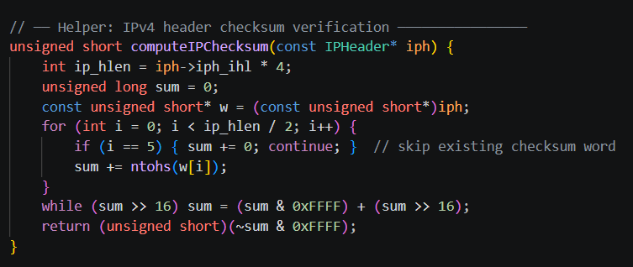
- This function computes the IPv4 header checksum, which is used to verify the integrity of the IP header during packet transmission.
- It first calculates the IP header length using the ihl field (iph->iph_ihl * 4), which gives the header size in bytes.
- The IP header is then treated as an array of 16-bit words, allowing the function to process it word by word for checksum calculation.
- Each 16-bit word is added to a running sum using one’s complement arithmetic, after converting from network byte order to host byte order.
- After summing all header words, any overflow beyond 16 bits is folded back into the lower 16 bits to maintain correctness.
- Finally, the function returns the one’s complement of the final sum, which is the computed IPv4 header checksum used for validation.

Escape a string for json
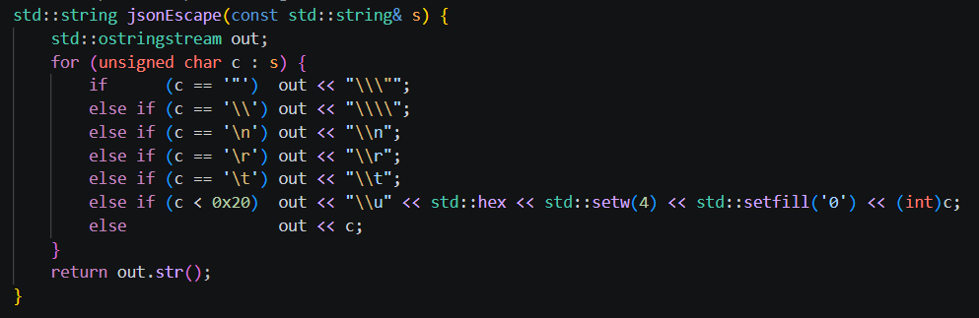
This function escapes a string so it can be safely used inside JSON format. It converts special characters like quotes, backslashes, newlines, tabs, and other control characters into their proper JSON escape sequences. This ensures the output string remains valid and does not break JSON parsing.

Hex payload building function
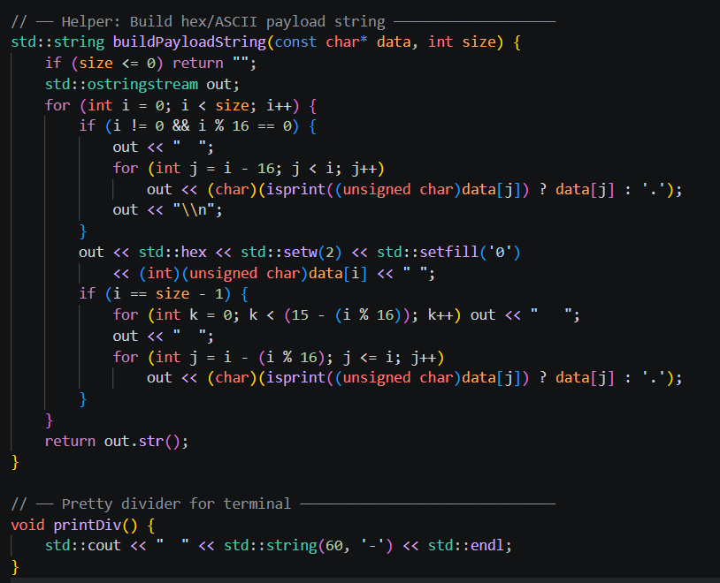
ASCII payload function
- Converts raw data into a formatted hex dump with ASCII representation for easy reading.
- Processes the input byte-by-byte and prints each byte in two-digit hexadecimal format.
- After every 16 bytes, it adds a line break and shows the ASCII equivalent of those bytes (non-printable characters are replaced with .).
- Handles incomplete final rows by adding proper spacing and alignment for consistent output.
    - Pretty divider function is for readable or differentiable output on terminal.

2.2.12 Main function:
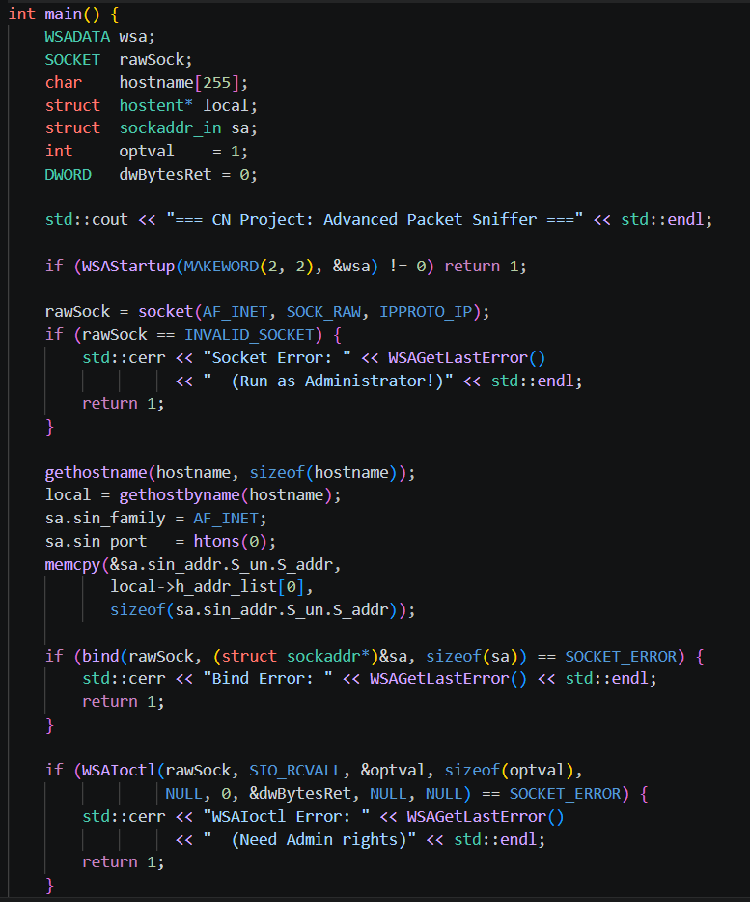
1. Winsock Initialization:
The program starts by initializing the Windows Sockets API using WSAStartup(). This is required for all network operations in Windows.
2. Raw Socket Creation:
A raw socket is created using socket(AF_INET, SOCK_RAW, IPPROTO_IP). This allows the program to capture low-level IP packets directly from the network interface.
3. Error Handling:
If socket creation fails, the program prints an error message. This usually happens if the program is not run with administrator privileges.
4. Host Information Retrieval:
The program retrieves the local machine hostname using gethostname() and resolves it into an IP address using gethostbyname().
5. Socket Address Setup:
A sockaddr_in structure is configured with IPv4 settings, port 0, and the local IP address for binding.
6. Binding the Socket:
The raw socket is bound to the local IP address using bind(), allowing it to listen to network traffic on that interface.
7. Enabling Packet Capture Mode:
WSAIoctl() with SIO_RCVALL is used to enable promiscuous mode, allowing the program to capture all IP packets passing through the system.
8. Privilege Requirement:
If enabling packet capture fails, the program indicates that administrator privileges are required.
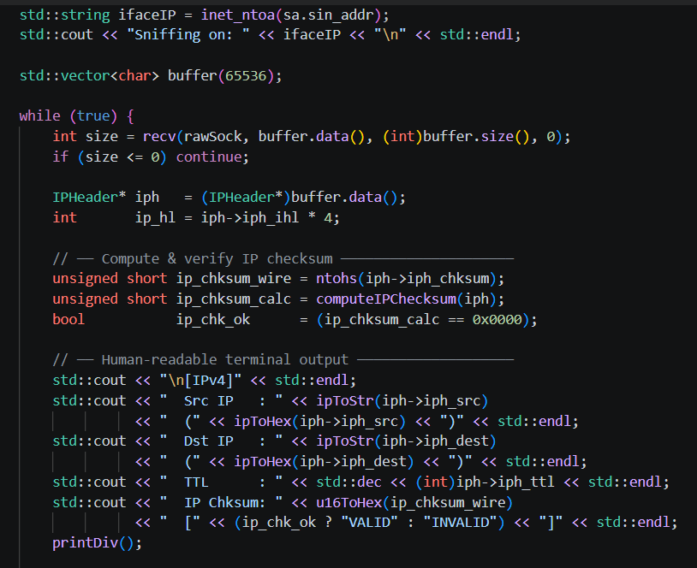
- Gets the interface IP address
std::string ifaceIP = inet_ntoa(sa.sin_addr); It converts the raw network address of your selected interface into a human-readable IP string (like 192.168.1.5).
- Prints the sniffing target interface
std::cout << "Sniffing on: " << ifaceIP; This tells you which network interface your program is actively capturing packets from.
- Creates a buffer for incoming packets
std::vector<char> buffer(65536); A large memory buffer (64 KB) is allocated to store raw network packets received from the socket.
- Continuously receives packets in a loop
while (true)
int size = recv(rawSock, buffer.data(), buffer.size(), 0); The program keeps running indefinitely, capturing packets from the raw socket. Each packet is stored in the buffer.
- Extracts the IP header from raw packet data
IPHeader* iph = (IPHeader*)buffer.data(); The raw bytes are type-casted into an IP header structure so individual fields (source IP, destination IP, TTL, etc.) can be accessed.
- Calculates IP header length
int ip_hl = iph->iph_ihl * 4;The IP header length is extracted (IHL is in 32-bit words, so multiplying by 4 converts it into bytes).
- Verifies and displays IP header checksum + packet info
  - Extracts checksum from packet: unsigned short ip_chksum_wire = ntohs(iph->iph_chksum);
  - Recalculates checksum: unsigned short ip_chksum_calc = computeIPChecksum(iph);
  - Checks if valid: bool ip_chk_ok = (ip_chksum_calc == 0x0000);
  - Prints: Source IP , Destination IP , TTL , Checksum status (VALID / INVALID)

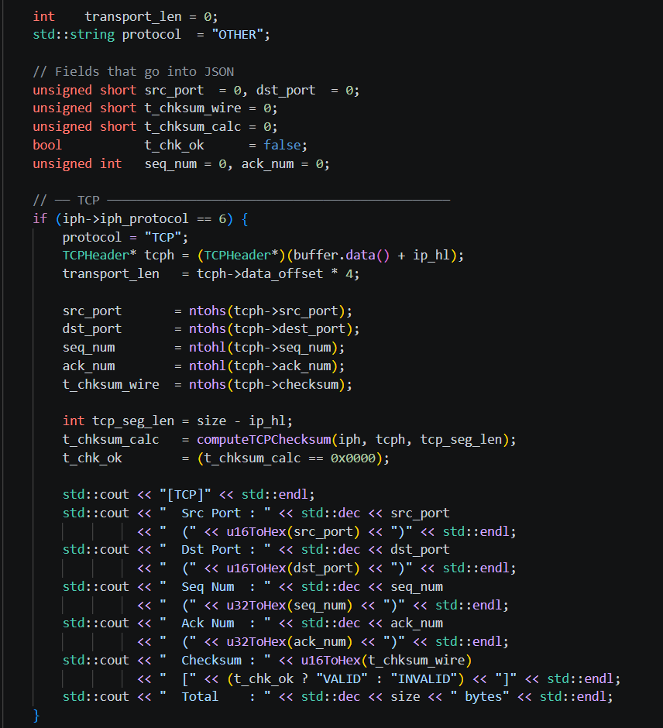
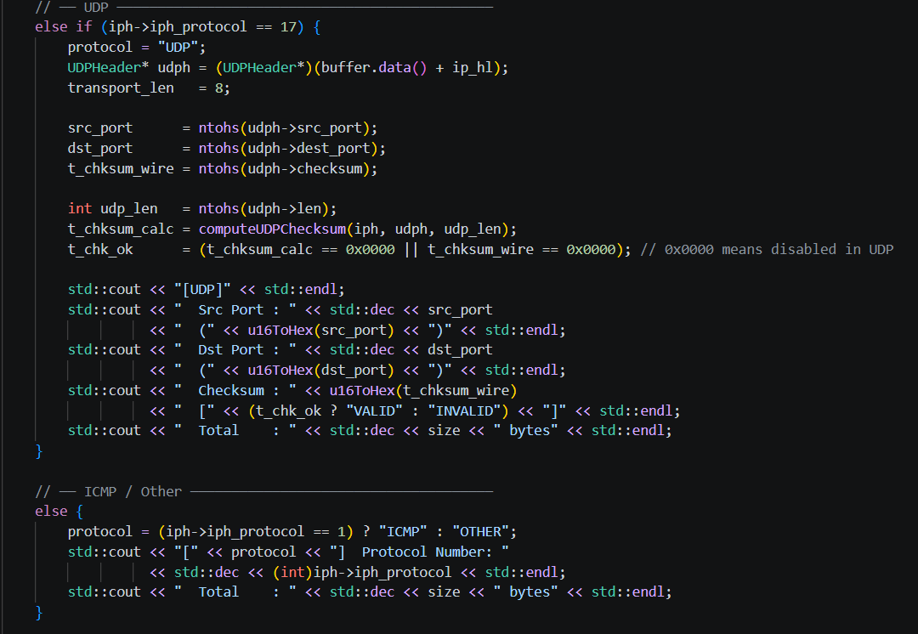
1. Interface & Buffer Setup
Gets interface IP (inet_ntoa)
Displays sniffing interface
Allocates 64KB buffer for packets
Continuously receives packets using recv()
2. IP Layer Processing
Casts raw data into IP header
Extracts source/destination IP, TTL, header length
Calculates & verifies IP checksum
Displays IP info (hex + decimal format)
Marks checksum as VALID/INVALID
3. Protocol Detection
Checks iph_protocol field:
6 = TCP, 17 = UDP, 1 = ICMP, others = OTHER
4. TCP Handling
Extracts TCP header from packet
Reads ports, sequence, acknowledgment numbers
Calculates TCP checksum for validation
Prints ports, seq/ack, checksum status, packet size
5. UDP Handling
Extracts UDP header
Reads source/destination ports & length
Verifies checksum (0x0000 allowed)
Prints ports, checksum status, total size
6. ICMP / Other
Identifies ICMP (protocol 1) or OTHER
Prints protocol number and packet size only

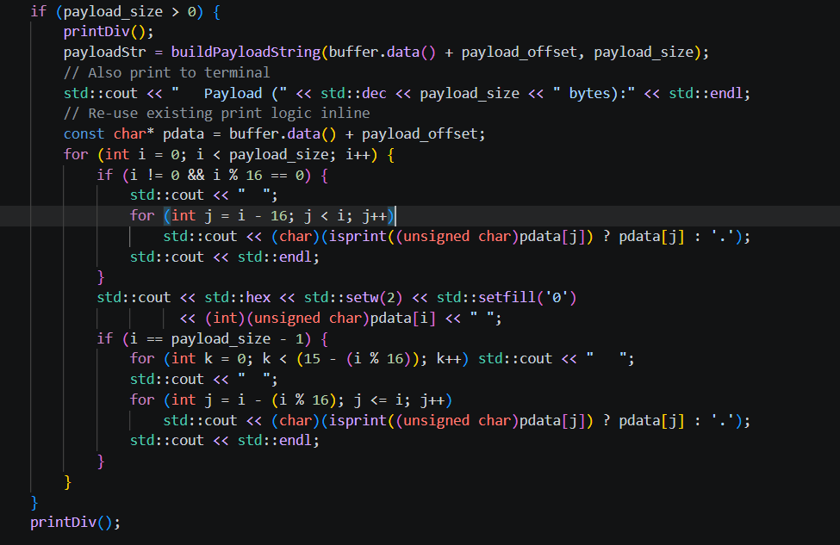
- The code first calculates the starting point of the payload by adding the IP header length (ip_hl) and the transport layer header length (transport_len). This helps in skipping protocol headers and locating the actual data section of the packet. It also determines the total payload size by subtracting this offset from the total packet size.
- It then checks whether the payload size is greater than zero to ensure that valid data exists before processing. This prevents unnecessary processing or memory access errors when no payload is present.
- If payload data is available, it is converted into a readable string format using the function buildPayloadString(). This allows the raw packet data to be interpreted or logged in a structured way.
- The payload is then printed in a structured hexadecimal format along with its ASCII representation. Each byte is displayed in hex, and printable characters are shown as-is while non-printable characters are replaced with a dot (.). This makes it easier to analyze packet contents visually.
- Finally, the output is formatted into rows of 16 bytes each, ensuring proper alignment. At the end of processing, a divider function (printDiv()) is called to separate sections for better readability in the output log.

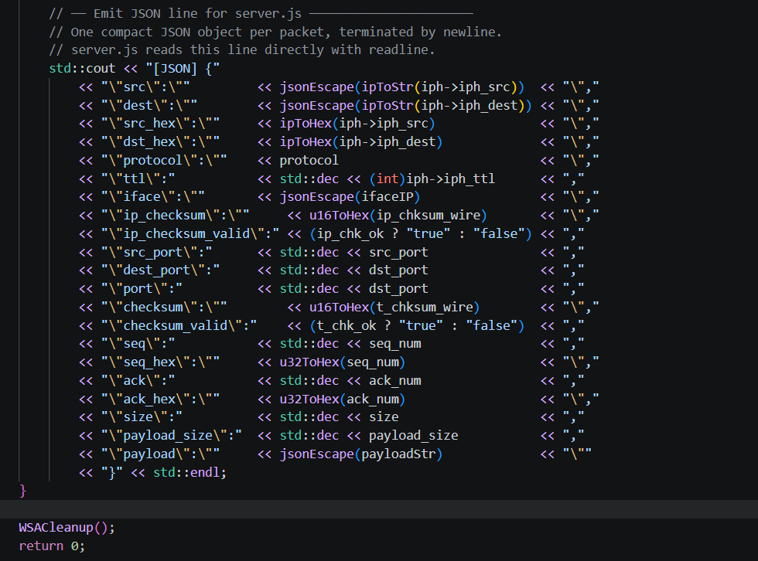
This code This code is constructing and printing a JSON-formatted packet log to the console using std::cout. It extracts network packet details (IP, ports, protocol, TTL, checksums, sequence/ack numbers, payload, etc.) and formats them into key-value pairs. Some fields are converted into hex format or validated (like checksum validity).
Finally, the JSON string is printed as a single line and the program cleans up Winsock with WSACleanup().

Enivronment framework:
Node.js is used as a bridge layer between the C++ backend sniffer and the frontend web interface. Since the C++ program is responsible for low-level packet capture and processing, it runs as a separate executable and outputs data to the standard output stream.
Node.js connects these two parts by:
- Spawning the C++ executable (sniffer.exe)
- Reading its output in real time
- Filtering and validating structured data (JSON packets)
- Forwarding the processed data to the frontend using WebSocket communication
This architecture allows:
- High-performance packet processing in C++
- Real-time data visualization in the browser
- Decoupling of backend logic from frontend implementation

2.2.1. Functionality:
- Spawning the C++ executable using child_process module
- Reading C++ output line by line using readline interface
- Filtering and validating JSON-formatted packet data
- Broadcasting data to connected WebSocket clients
- Handling errors and process termination events

2.2.2. Code:
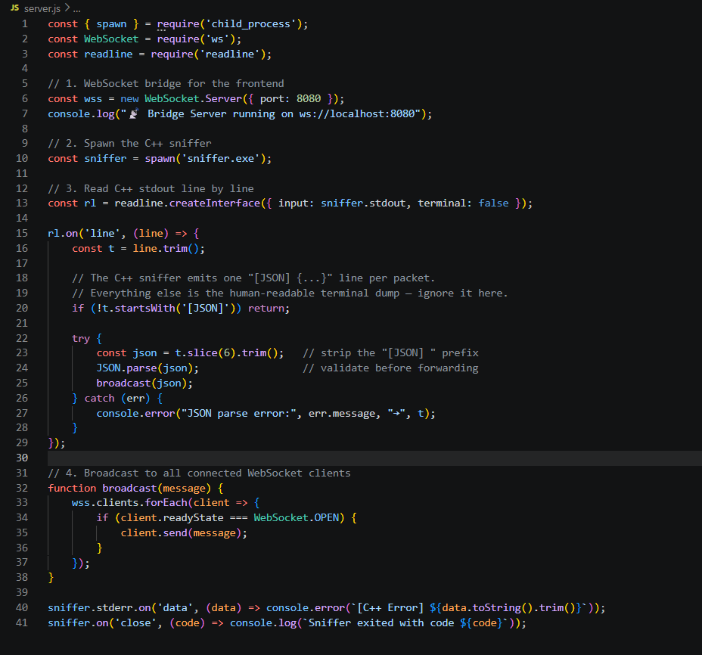

2.2.3. Integration logic:

Data Flow
C++ sniffer captures network packets.
Processed packet data is printed to stdout in JSON format.
Node.js reads and filters this output.
Valid JSON packets are broadcast via WebSocket.
Frontend receives and displays real-time data.

WebSocket Communication
A WebSocket server is created on port 8080 to enable real-time communication between the backend and frontend. All connected clients receive live packet updates simultaneously

Frontend Code Logic:

2.3. Frontend Code Logic (interface.html)
The frontend interface of the "Centipede" packet sniffer is implemented as a Single Page Application (SPA). It is built using HTML5, CSS3, and vanilla JavaScript. This interface acts as the visual dashboard for real-time packet analysis, receiving structured JSON data from the Node.js backend via WebSockets.

2.3.1. User Interface (UI) Layout and Styling
The user interface is designed with a dark, cyberpunk-inspired aesthetic, utilizing a custom CSS variables system (:root) to manage colors, fonts, and backgrounds consistently.
• Color Palette: Specific hex codes are assigned to different protocols to aid in quick visual identification. For example, TCP traffic is colored blue (--tcp: #38bdf8), UDP is yellow (--udp: #fbbf24), and ICMP is red (--icmp: #f87171).
• Typography: The styling incorporates custom web fonts. 'JetBrains Mono' is utilized for data tables and hexadecimal outputs to ensure character alignment, while 'Bebas Neue' is used for display headers and logos.
• Layout Structure: The layout is divided into several key functional areas using CSS Flexbox for dynamic resizing. The structure includes a Topbar, Toolbar, Statistics Bar, Main Packet Table, and Inspection Panels.
• Animations: CSS animations are used to enhance user experience, such as a sweeping gradient across the top bar (@keyframes sweep), a pulsing connection dot (@keyframes pulse-dot), and a flashing background for newly captured packets (@keyframes rowflash).

2.3.2. WebSocket Communication
The frontend establishes a real-time, bidirectional connection to the backend server using the WebSocket protocol.
• Connection Management: The startCapture() function initializes a new WebSocket connection to ws://localhost:8080. Conversely, stopCapture() closes the connection.
• UI Synchronization: Connection states trigger the setWsStatus(live) function, which updates the UI indicators (like the pulsing dot and "CONNECTED" text) to reflect the current network listening status.
• Data Reception: The ws.onmessage event listener intercepts incoming traffic. It attempts to parse the incoming string as JSON; if successful, the data is passed to the core ingest(d) function for processing.

2.3.3. Data Ingestion and State Management
The core data handling logic resides within the ingest(d) function, which normalizes and stores the incoming backend data.
• Packet Processing: When a new packet arrives, a global sequence number (seq) is incremented. The function calculates the elapsed time since the capture session began.
• Counters: Global state variables tracking total packets, total bytes, and protocol-specific counts (TCP, UDP, ICMP, OTHER) are continuously updated.
• Data Structuring: A standardized pkt object is constructed from the raw JSON payload. This object extracts essential fields such as source/destination IPs, ports, checksum validity (ip_chk_ok, chk_ok), sequence numbers, and raw payload strings.
• Memory Management: The constructed packet object is inserted at the beginning of the packets array using unshift(). To prevent memory exhaustion and browser freezing during high-traffic captures, the array size is strictly capped at 5000 items. Older packets are removed using pop() if this limit is exceeded.

2.3.4. Real-Time UI Updating and Statistics
The frontend utilizes asynchronous JavaScript intervals to keep the interface synchronized with the internal state.
• Live Clocks: An immediately invoked function (tickClock()) recursively calls itself using setTimeout to update the top bar's time and date display every 500 milliseconds.
• Throughput Calculation: A setInterval function executes every 1000 milliseconds (1 second) to calculate the current network throughput in Kilobytes per second (KB/s) based on the kbsAccum variable, resetting the accumulator afterward.
• Elapsed Time: Another interval calculates and formats the total elapsed capture time into a readable hours, minutes, and seconds string.

2.3.5. Packet Filtering Engine
The application includes a robust display filter system, enabling users to isolate specific traffic. This is managed by the matchFilter(pkt, filterStr) function.
• Trigger Mechanism: The filter is triggered via the oninput event listener on the filter input box, meaning the table updates in real-time as the user types.
• Strict Filtering (Wireshark Syntax): The engine supports structured syntax using the == operator. Users can filter by exact constraints, such as ip.addr == 192.168.1.1 (which checks both source and destination), ip.src, ip.dst, tcp.port, or udp.port.
• Broad Filtering: If strict syntax is not detected, the system defaults to a general string inclusion check. It converts the input to lowercase and matches it against the packet's IPs or protocol name.

2.3.6. Dynamic Table Rendering
The renderTable() function is responsible for drawing the captured packets onto the main DOM table.
• Performance Optimization: To ensure the UI remains responsive, the function limits DOM rendering to a maximum of 1000 rows (MAX = 1000), even if the underlying packets array holds more.
• Filter Application: It applies the active filter string to the packet array before rendering.
• Row Generation: HTML table rows (<tr>) are dynamically constructed using template literals. Protocol-specific CSS classes are applied to create colored badges.
• Data Formatting: Checksum flags are evaluated to display visual "✓" or "✗" markers depending on their validity. Null ports or absent data are gracefully handled by displaying "—".

2.3.7. Deep Packet Inspection (DPI) Panels
Clicking any row in the main table triggers the selectPkt() function, which highlights the selected row and populates the two bottom inspection panels.
• Packet Field Decoder (renderFields): This function dynamically generates a structured, hierarchical list of network layers. It displays IPv4 headers (Source/Dest IP, TTL, Checksum validity) and transport layer headers (TCP/UDP ports, Sequence/Acknowledgment numbers). It explicitly flags invalid checksums, outputting warnings like "INVALID — POSSIBLE TAMPERING" in red text to alert the user.
• Hex Dump Engine (renderHex): This function processes the raw payload string for low-level byte analysis. It splits the payload into an array of lines and formats the data into a standard hexadecimal dump. It aligns the byte offset, the 16-byte hex representation, and the corresponding ASCII characters, replacing non-printable characters gracefully.

PRACTICAL WORKING:
Practical working of this code required to run terminal two times as administrator and will go into my project directory
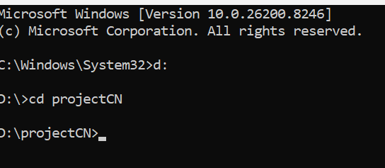.
First i will run my local server by running command for node server.js
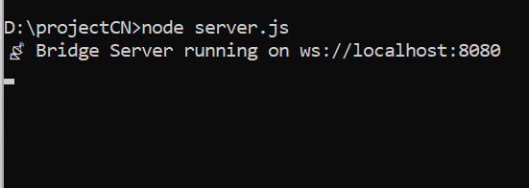
Then i will run my sniffer.exe file via command .\sniffer.exe in another terminal

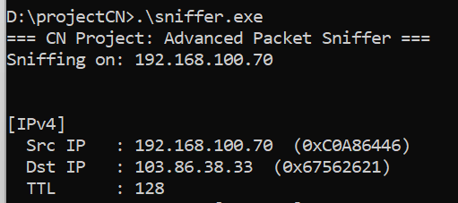
On backend terminal json plays its role and pretty divider function to make the input readable.
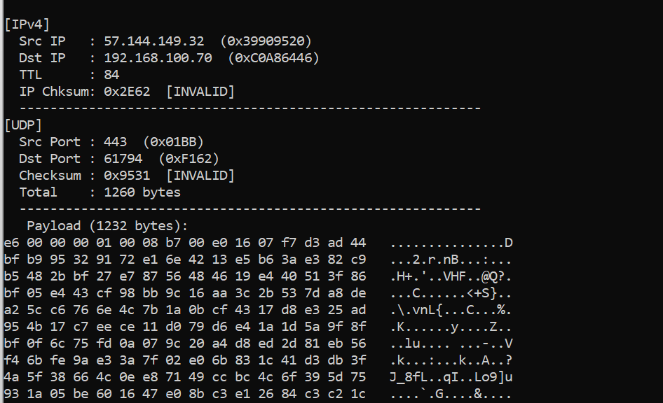
Now opening the interface.html runs the html file.
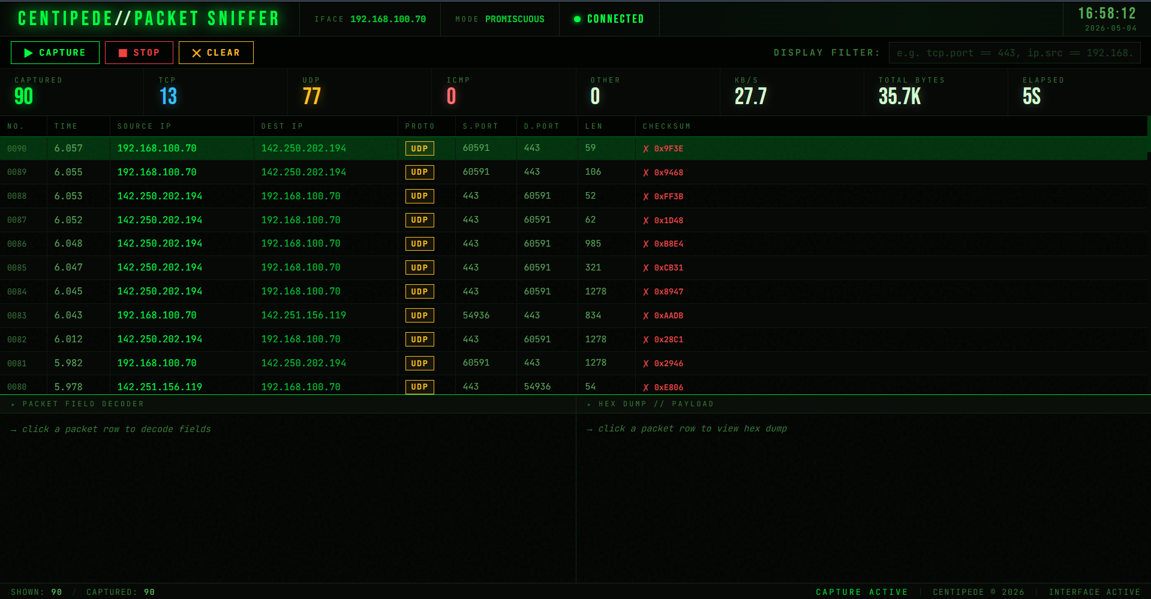
Our project name is CENTIPEDE it can give packet enough and can also filter various packets, it counts packets of specific types. Total bytes captured and time of capturing.
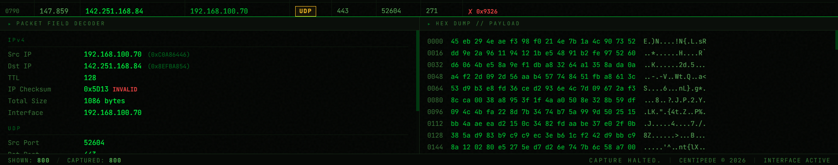
It shows payload, source and destination addresses in hexadecimal too payload in hex and ascii and checksum with time to live, acknowledgement and sequence number too.
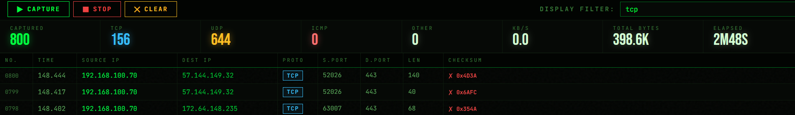

4. CONCLUSION
The "Centipede" packet sniffer project successfully demonstrates the integration of low-level network programming with modern web technologies to create a comprehensive network analysis tool. By utilizing C++ and Winsock raw sockets in promiscuous mode, the backend achieves high-performance capture and deep packet inspection across the network interface. The manual parsing of IPv4, TCP, UDP, and ICMP headers, coupled with rigorous checksum verification, ensures an accurate and secure representation of network traffic and data integrity.
Furthermore, the project highlights the effectiveness of a decoupled architecture. The Node.js bridge seamlessly connects the robust C++ backend to a dynamic Single Page Application (SPA) frontend via WebSockets. This allows for real-time data streaming without bottlenecking the capture process. The custom-designed UI offers an interface optimized for readability, featuring live statistics, active packet filtering (supporting Wireshark-like syntax), and deep inspection panels for field decoding and hexadecimal payload analysis.
Ultimately, Centipede serves as both a practical diagnostic tool and a profound educational exercise in network layers, protocol structures, and full-stack software development. It underscores the dual nature of packet sniffing—highlighting its power for network troubleshooting and cybersecurity, while reinforcing the necessity of ethical use and data privacy.

