AICTE | IBM SkillsBuild
Data Analytics with AI Internship 2026

RailSense
Indian Railway Punctuality & Delay Analytics

Submitted by: DIVYANSHU SINGH
College: VIT Chennai
Program: M.Tech Software Engineering
Dataset: etrain_delays.csv
Notebook: DivyanshuSingh_RailSense.ipynb

1. Executive Summary
RailSense is a data analytics and AI project focused on historical Indian railway train–station punctuality and delay patterns. The submitted Colab notebook works with the provided etrain_delays.csv dataset and performs data validation, cleaning, feature engineering, exploratory data analysis, station-level analysis, train-level analysis, correlation analysis, K-Means clustering, and Isolation Forest anomaly detection.
The dataset initially contained 1,900 observations and 11 columns. After removing records with missing average-delay values and validating the delay fields, the analytical dataset contained 1,664 observations. The final analysis covered 90 unique trains and 476 unique stations.
The AI component is deliberately framed as unsupervised learning rather than future-delay prediction. This is appropriate because the provided data contains aggregated historical train–station delay statistics rather than individual future journeys with complete pre-departure predictive features.

2. Project Objectives
- Clean and validate historical Indian railway train–station punctuality data.
- Explore average delay, right-time percentage, and delay-severity patterns.
- Identify stations and train services with different historical delay profiles.
- Analyze relationships among delay and punctuality metrics.
- Use K-Means clustering to discover naturally occurring train–station delay profiles.
- Use Isolation Forest to identify unusual delay observations.
- Produce evidence-based findings suitable for an academic Data Analytics with AI submission.

3. Dataset Description
The notebook uses the file etrain_delays.csv. The dataset contains 1,900 train–station observations and 11 original columns. The source_url field is retained in the dataset and records the source associated with each observation.

3.1 Original fields
- train_number — train identifier.
- train_name — train service name.
- station_code — station code.
- station_name — station name.
- average_delay_minutes — observed average delay in minutes.
- pct_right_time — percentage of observations recorded as right time.
- pct_slight_delay — percentage with slight delay.
- pct_significant_delay — percentage with significant delay.
- pct_cancelled_unknown — percentage categorized as cancelled/unknown.
- scraped_at — collection timestamp.
- source_url — source associated with the observation.

4. Data Audit & Quality Checks
The notebook first checked dimensions, data types, unique values, missing values, duplicate records, summary statistics, and consistency of the percentage fields.
There were 0 duplicate rows. The four percentage components summed to approximately 100% for every row; no row differed from 100 by more than one percentage point.
The original dataset had 236 missing values in average_delay_minutes. The cleaning pipeline removed these rows before the main analytical stages. No negative average-delay records were found.
Table 1. Dataset audit
 | Column | Dtype | Unique Values | Missing Values
0 | train_number | int64 | 90 | 0
1 | train_name | object | 42 | 0
2 | station_code | object | 480 | 0
3 | station_name | object | 480 | 0
4 | average_delay_minutes | float64 | 171 | 236
5 | pct_right_time | float64 | 470 | 0
6 | pct_slight_delay | float64 | 433 | 0
7 | pct_significant_delay | float64 | 266 | 0
8 | pct_cancelled_unknown | float64 | 48 | 0
9 | scraped_at | object | 1900 | 0
10 | source_url | object | 90 | 0

5. Data Cleaning & Feature Engineering
- Converted scraped_at to a datetime representation.
- Removed exact duplicate rows.
- Checked for and removed invalid negative delay values; none were present.
- Excluded rows with missing average_delay_minutes from the cleaned analytical dataset.
- Created delay_severity using project-defined thresholds.
- Created punctuality_score from pct_right_time.
- Created delay_risk_score as a weighted descriptive indicator using slight delay, significant delay, and cancelled/unknown percentages.
The project-defined delay severity categories are analytical categories, not official Indian Railways classifications: On Time = 0 minutes; Minor = >0 to 15 minutes; Moderate = >15 to 60 minutes; Severe = >60 minutes.

6. Descriptive Analysis
After cleaning, the analytical dataset contained 1,664 train–station observations. The mean average delay was 40.70 minutes and the median was 24.00 minutes. The mean right-time percentage was 49.78%.
Table 2. Descriptive statistics

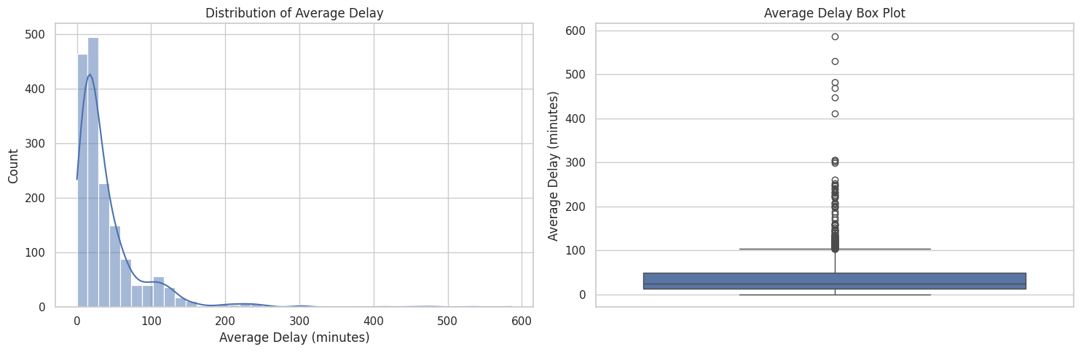
Figure 1. Distribution and box plot of average delay.
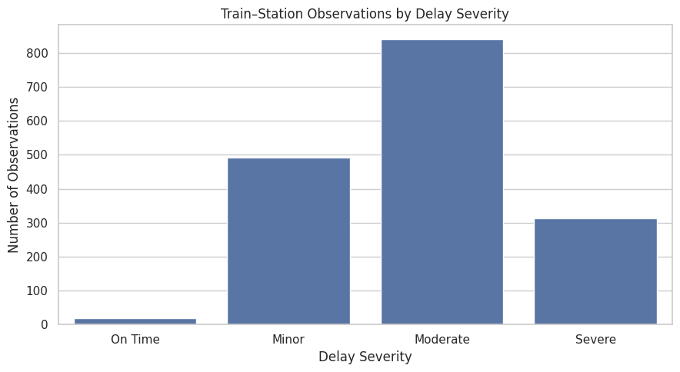
Figure 2. Distribution of project-defined delay severity categories.

6.1 Delay Severity Distribution
Among the 1,664 cleaned observations, 18 (1.08%) were categorized as On Time, 491 (29.51%) as Minor, 841 (50.54%) as Moderate, and 314 (18.87%) as Severe.
Table 3. Delay severity distribution
(' Level 0', 'Delay Severity') | ('Observations', 'Unnamed: 1 Level 1') | ('Percentage', 'Unnamed: 2 Level 1')
On Time | 18 | 1.08
Minor | 491 | 29.51
Moderate | 841 | 50.54
Severe | 314 | 18.87

7. Station-Level Analysis
Station-level summaries were calculated using observations with at least three records per station for ranking. This reduced the risk that a single observation would dominate a station-level conclusion. There were 193 stations meeting this minimum-observation rule.
Table 4. Stations with highest average observed delay
Station Code | Station Name | Observations | Avg Delay | Median Delay | Avg Right Time | Avg Significant Delay
SLO | SAMALKOT JN | 4 | 126.50 | 126.50 | 8.22 | 79.91
NDD | NIDADAVOLU JN | 4 | 124.00 | 124.00 | 6.99 | 70.87
RJY | RAJAMUNDRY | 6 | 122.17 | 131.00 | 2.76 | 75.61
ANV | ANNAVARAM | 4 | 119.00 | 119.00 | 6.99 | 70.19
TUNI | TUNI | 4 | 118.00 | 118.00 | 8.79 | 68.52
AKP | ANAKAPALLE | 4 | 117.00 | 117.00 | 12.12 | 68.08
IPM | ICHCHPURAM | 4 | 111.50 | 111.50 | 15.62 | 62.24
CAP | CHATRAPUR | 4 | 111.00 | 111.00 | 1.24 | 61.37
TEL | TENALI JN | 3 | 110.33 | 127.00 | 10.59 | 60.39
BPP | BAPATLA | 4 | 109.00 | 109.00 | 9.04 | 58.08
SPT | SOMPETA | 4 | 109.00 | 109.00 | 20.82 | 61.69
CLX | CHIRALA | 4 | 108.50 | 108.50 | 8.77 | 57.12
BALU | BALUGAN | 5 | 107.80 | 108.00 | 0.88 | 69.55
BAM | BRAHMAPUR | 6 | 100.00 | 99.00 | 3.48 | 63.44
KUR | KHURDA ROAD JN | 8 | 98.75 | 104.00 | 3.46 | 62.13

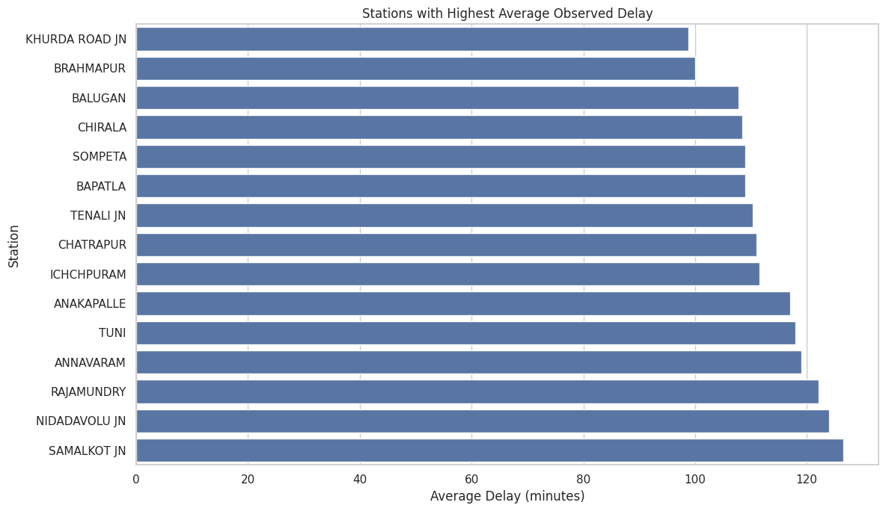
Figure 3. Stations with highest average observed delay.
Table 5. Stations with highest historical right-time percentage
Station Code | Station Name | Observations | Avg Delay | Median Delay | Avg Right Time | Avg Significant Delay
MS | CHENNAI EGMORE | 6 | 1.83 | 1.50 | 98.53 | 0.04
MBM | MAMBALAM | 3 | 5.33 | 7.00 | 94.16 | 0.64
SDAH | SEALDAH | 4 | 18.50 | 9.50 | 91.98 | 5.62
NAD | NAGDA JN | 5 | 13.20 | 13.00 | 89.22 | 4.64
DNR | DANAPUR | 3 | 6.67 | 5.00 | 88.89 | 4.45
TEN | TIRUNELVELI JN | 6 | 5.33 | 2.50 | 88.75 | 0.56
MMCT | MUMBAI CENTRAL | 8 | 7.50 | 5.50 | 88.48 | 2.27
DHN | DHANBAD JN | 7 | 10.14 | 4.00 | 87.86 | 2.88
CBE | COIMBATORE JN | 8 | 17.25 | 2.00 | 86.32 | 4.73
ST | SURAT | 10 | 13.70 | 14.50 | 85.37 | 4.04
GAYA | GAYA JN | 3 | 18.67 | 23.00 | 84.36 | 5.90
ASR | AMRITSAR JN | 4 | 16.50 | 12.50 | 84.25 | 7.40
VM | VILLUPURAM JN | 8 | 9.25 | 10.00 | 83.95 | 0.41
BRC | VADODARA JN | 7 | 15.00 | 13.00 | 83.38 | 4.95
DMM | DHARMAVARAM JN | 4 | 23.50 | 14.50 | 83.33 | 8.75

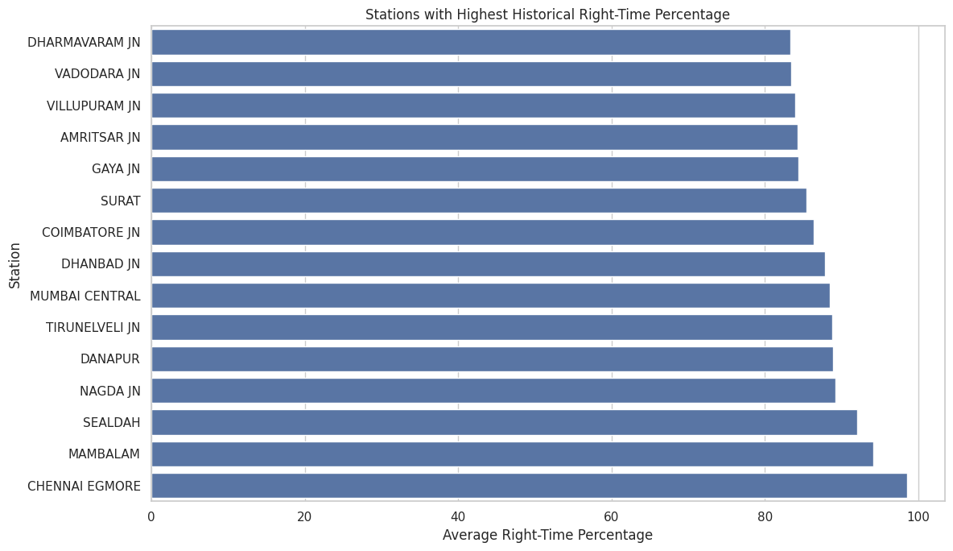
Figure 4. Stations with highest historical right-time percentage.
The station results show a strong geographic/route-related pattern in the provided sample. For example, the highest-average-delay station table is dominated by stations such as SAMALKOT JN, NIDADAVOLU JN, RAJAMUNDRY, ANNAVARAM, and TUNI. These are observations from the supplied dataset and should not be interpreted as a universal ranking of all Indian railway stations.

8. Train-Level Analysis
Train-level summaries were generated using at least three station observations per train. The analysis compares mean and median delay, right-time percentage, and significant-delay percentage.
Table 6. Train services with highest average observed delay
Train Number | Train Name | Observations | Avg Delay | Median Delay | Avg Right Time | Avg Significant Delay
12261 | Howrah Duronto | 8 | 370.50 | 305.00 | 18.66 | 58.73
12262 | Howrah Duronto | 6 | 316.83 | 356.00 | 17.71 | 69.79
12236 | Duronto Express | 7 | 148.00 | 152.00 | 35.71 | 50.00
12509 | Guwahati Sbc Express | 37 | 143.19 | 197.00 | 14.64 | 70.72
12839 | Howrah Mail | 63 | 109.37 | 106.00 | 7.14 | 66.14
12626 | Kerala Express | 39 | 101.05 | 107.00 | 32.76 | 29.76
12840 | Howrah Mail | 70 | 100.81 | 97.50 | 19.36 | 47.98
12510 | Sbc Guwahati Express | 38 | 87.97 | 97.00 | 27.53 | 49.39
12245 | Duronto Express | 5 | 78.20 | 93.00 | 31.82 | 45.46
12842 | Coromandel Express | 17 | 65.53 | 63.00 | 20.20 | 34.90
22601 | Chennai Intercity | 20 | 59.70 | 61.50 | 57.50 | 25.00
12841 | Coromandel Express | 14 | 46.29 | 48.00 | 29.76 | 26.67
12368 | Vikramshila Express | 17 | 45.71 | 41.00 | 32.55 | 23.33
12622 | Tamil Nadu Exp | 12 | 44.58 | 38.00 | 52.21 | 14.75
12295 | Sanghamitra Express | 33 | 41.30 | 38.00 | 38.38 | 16.57
12903 | Golden Temple Mail | 31 | 41.23 | 43.00 | 62.04 | 18.28
12137 | Punjab Mail | 48 | 39.31 | 36.50 | 38.04 | 13.72
11013 | Coimbatore Express | 22 | 37.95 | 30.50 | 42.27 | 17.73
17058 | Devagiri Express | 27 | 37.59 | 39.00 | 48.15 | 9.26
17057 | Devagiri Express | 24 | 36.58 | 37.50 | 35.28 | 16.25

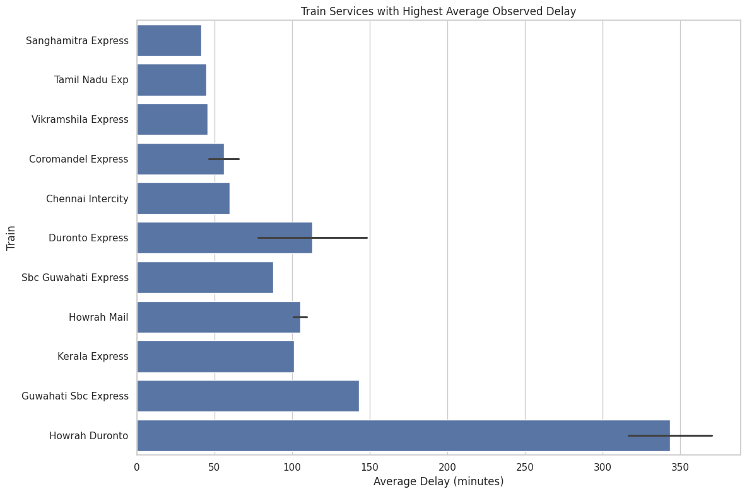
Figure 5. Train services with highest average observed delay.
The largest average-delay values in the supplied data include Howrah Duronto services and Duronto Express, followed by Guwahati Sbc Express and Howrah Mail. These figures are historical sample summaries and are not an overall operational ranking.

9. Delay vs. Punctuality Relationship
The notebook examines correlations among average delay, right-time percentage, slight-delay percentage, significant-delay percentage, and cancelled/unknown percentage. These variables are different summaries of the same historical punctuality profile; correlation therefore should not be interpreted as causal evidence.
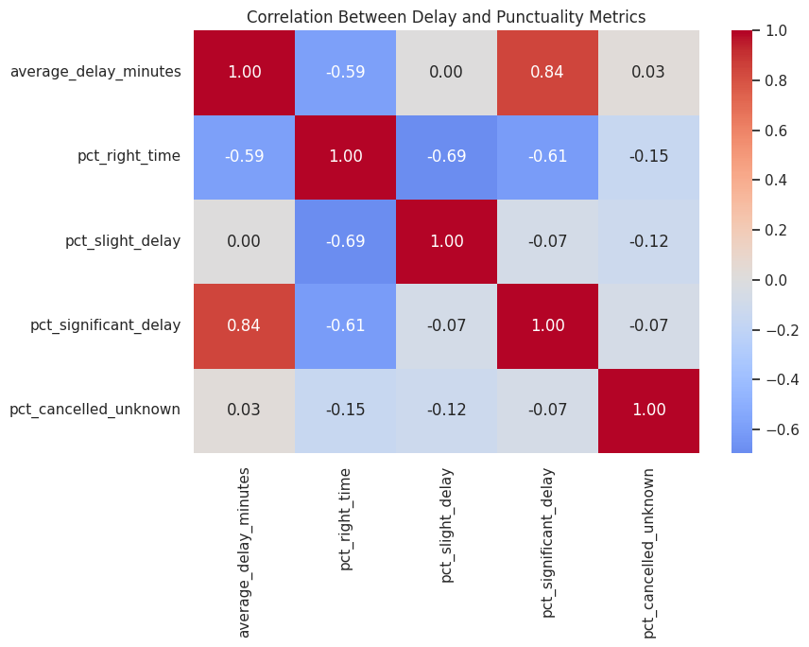
Figure 6. Correlation matrix for delay and punctuality metrics.
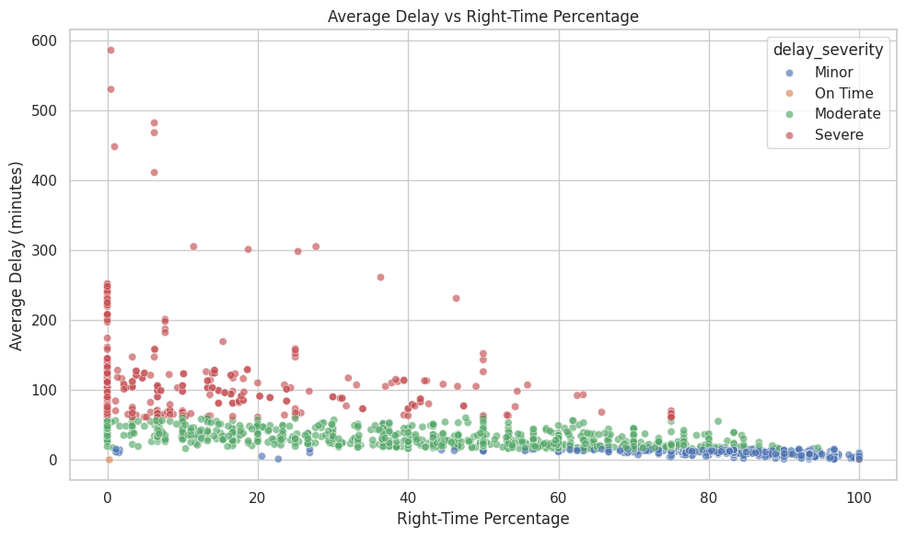
Figure 7. Average delay versus right-time percentage.

10. AI Component: K-Means Delay Profile Clustering
Because the dataset does not provide a clean real-world future-delay target, the notebook uses unsupervised learning to discover naturally occurring delay profiles. Five historical punctuality variables were standardized before K-Means: average delay, right-time percentage, slight-delay percentage, significant-delay percentage, and cancelled/unknown percentage.
Silhouette scores were evaluated for k = 2 through 8. The best score occurred at k = 4 with a silhouette score of 0.516364.
Table 7. K-Means model-selection silhouette scores
 | K | Silhouette Score
0.000000 | 2.000000 | 0.451210
1.000000 | 3.000000 | 0.492545
2.000000 | 4.000000 | 0.516364
3.000000 | 5.000000 | 0.437583
4.000000 | 6.000000 | 0.452481
5.000000 | 7.000000 | 0.449144
6.000000 | 8.000000 | 0.403684

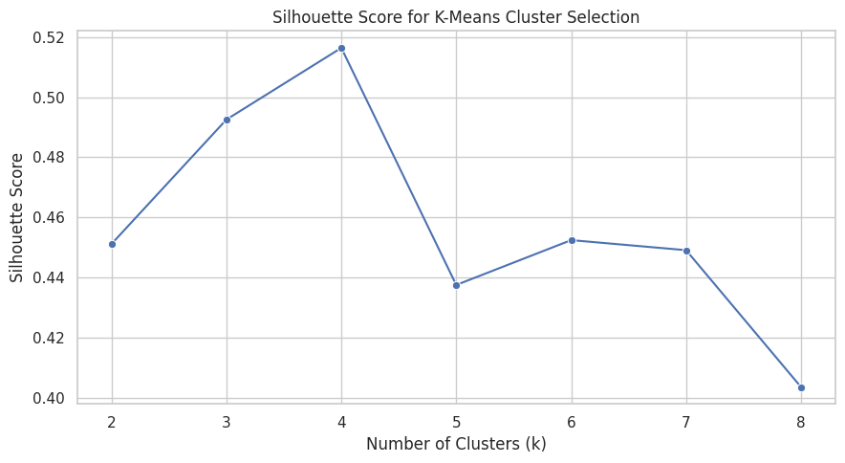
Figure 8. Silhouette score used to select the number of clusters.
Table 8. Mean profile of the four discovered clusters
(' Level 0', 'Delay Cluster') | ('Average Delay Minutes', 'Unnamed: 1 Level 1') | ('Pct Right Time', 'Unnamed: 2 Level 1') | ('Pct Slight Delay', 'Unnamed: 3 Level 1') | ('Pct Significant Delay', 'Unnamed: 4 Level 1') | ('Pct Cancelled Unknown', 'Unnamed: 5 Level 1')
2.00 | 16.97 | 77.28 | 17.30 | 5.27 | 0.15
0.00 | 44.57 | 23.21 | 61.17 | 15.45 | 0.16
3.00 | 46.85 | 7.51 | 6.77 | 1.93 | 83.79
1.00 | 147.51 | 8.73 | 19.22 | 71.82 | 0.23

The four clusters show distinct historical profiles. Cluster 2 has the lowest average delay (16.97 minutes) and the highest average right-time percentage (77.28%). Cluster 1 has the highest average delay (147.51 minutes) and a low right-time percentage (8.73%). Cluster 0 has a moderate average delay (44.57 minutes) with 23.21% average right-time observations. Cluster 3 has 46.85 minutes average delay but an unusually high 83.79% cancelled/unknown component, so it should be interpreted as a distinct data-quality/status profile rather than simply labeling it as a high-delay group.
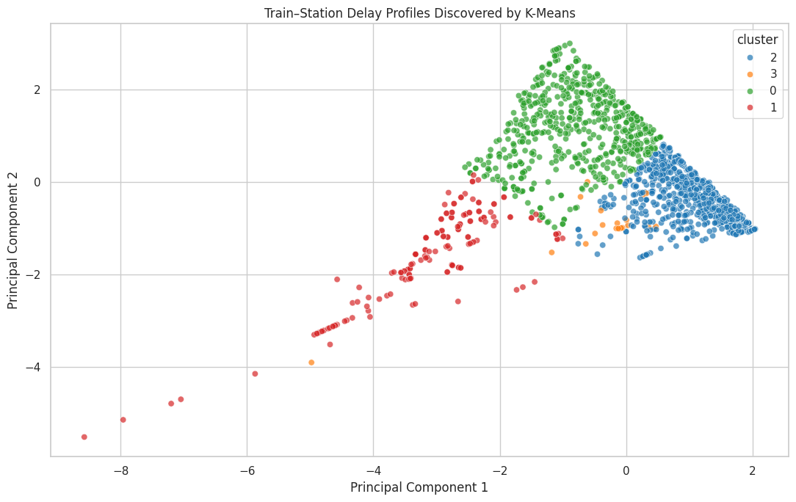
Figure 9. PCA projection of K-Means delay profiles.

11. AI Component: Isolation Forest Anomaly Detection
Isolation Forest was applied to the same five delay/punctuality characteristics to identify unusual train–station observations. The model detected 239 observations as anomalies out of 1,664 cleaned observations.
An anomaly is an observation that differs from the dominant feature patterns; it is not automatically evidence of an operational failure, safety issue, or data error.
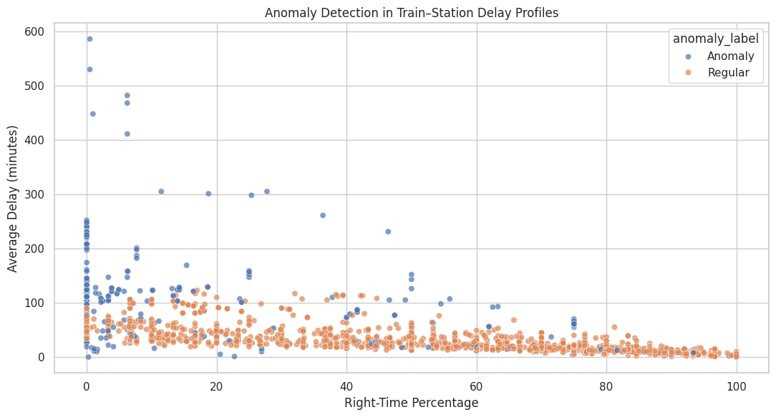
Figure 10. Isolation Forest anomaly detection in the delay/punctuality feature space.

12. Key Findings
- The raw dataset contained 1,900 observations across 11 fields; the cleaned analytical dataset contained 1,664 observations.
- The dataset contained 90 unique trains and 476 unique stations after cleaning.
- Average delay was 40.70 minutes, while the median was 24.00 minutes, indicating a right-skewed delay distribution.
- Moderate delay was the largest project-defined severity group, representing 50.54% of cleaned observations.
- Stations such as SAMALKOT JN, NIDADAVOLU JN, and RAJAMUNDRY appear among the highest-average-delay stations in the supplied sample.
- Howrah Duronto and Duronto Express services appear among the highest-average-delay train services in the supplied sample.
- K-Means selected four clusters based on the highest silhouette score (0.516364), revealing distinct delay/punctuality profiles.
- Isolation Forest identified 239 unusual observations, providing a mechanism for prioritizing records for further investigation.

13. End-to-End Methodology
- Load the CSV dataset in Google Colab.
- Inspect dimensions, data types, missing values, duplicates, unique values, and summary statistics.
- Validate the percentage components and remove invalid analytical records.
- Engineer delay severity, punctuality score, and delay-risk score.
- Perform descriptive statistics and visualize delay distributions.
- Aggregate and compare station-level and train-level performance.
- Analyze correlations among delay and punctuality measures.
- Standardize selected features and use silhouette analysis to select K for K-Means.
- Use K-Means to discover train–station delay profiles and PCA to visualize them.
- Use Isolation Forest to detect unusual delay profiles.
- Generate evidence-based findings and document limitations and future scope.

14. Technologies Used
- Python 3 / Google Colab
- Pandas — data loading, cleaning, aggregation, and tabular analysis
- NumPy — numerical operations
- Matplotlib — visualization
- Seaborn — statistical visualization
- Scikit-learn — StandardScaler, K-Means, silhouette score, PCA, Isolation Forest
- OpenPyXL — spreadsheet support in the project environment
- Jupyter Notebook / .ipynb — reproducible project notebook

15. Reproducibility & Submission Setup
The project is designed to be run in Google Colab. The notebook installs or verifies the required Python libraries, expects etrain_delays.csv, and can upload the dataset interactively if it is not already present in the Colab runtime.
The final submission package should contain the completed notebook, requirements.txt, this project document, and a README.md. The dataset itself should only be redistributed if its source/license permits redistribution; otherwise the README should provide the source and instructions for obtaining it.

16. Limitations
- The dataset contains aggregated historical train–station delay statistics rather than individual journey records.
- Scheduled versus actual arrival times are not available for every individual journey in this dataset.
- Weather, track conditions, congestion, signaling, maintenance, crew, rolling stock, and other operational variables are not included.
- Historical association does not establish causation.
- K-Means and Isolation Forest results depend on selected variables, scaling, and model parameters.
- The delay-severity thresholds are project-defined analytical categories and are not official Indian Railways classifications.
- The sample should not be generalized to all Indian railway operations without broader representative data.

17. Future Scope
- Integrate official Indian Railways timetable information.
- Add weather and seasonal disruption indicators.
- Add route distance and network topology information.
- Add train-level historical punctuality and station congestion measures.
- Include holiday/festival calendars and monsoon/fog indicators.
- Develop a true journey-level prediction model when genuine pre-departure and journey-level data are available.
- Build an interactive dashboard showing train routes, station delay profiles, clusters, and anomalies.

18. Conclusion
RailSense demonstrates how data analytics and unsupervised AI can be applied to historical Indian railway punctuality data. The project combines data-quality validation, descriptive analytics, visualization, station and train profiling, clustering, and anomaly detection within a reproducible Google Colab workflow. The analysis found substantial variation in delay and punctuality profiles and identified four distinct K-Means clusters as well as 239 anomalous observations. The project intentionally avoids overstating predictive capability because the supplied dataset does not represent individual future journeys.

19. Dataset & Source Notes
The dataset used is etrain_delays.csv. The notebook preserves a source_url field for each observation. The analysis should therefore be interpreted as an analysis of the supplied dataset and its associated source records. For final academic submission, the README should include the exact dataset download/source URL and any applicable license information.

Appendix A — Notebook Analysis Map
- Environment setup and package installation.
- Dataset loading and Colab upload fallback.
- Dataset audit and percentage validation.
- Cleaning and feature engineering.
- Descriptive statistics and delay distribution visualization.
- Delay severity distribution.
- Station-level delay and punctuality analysis.
- Train-level delay analysis.
- Correlation analysis.
- K-Means cluster selection using silhouette score.
- K-Means clustering and PCA visualization.
- Isolation Forest anomaly detection.
- Automated final findings tables.
- Limitations, future scope, and reproducibility guidance.

Appendix B — Core Code/Algorithm Summary
The submitted .ipynb file is the authoritative executable implementation. The main computational steps are summarized below for documentation:
df = pd.read_csv(DATA_PATH)
df = df.drop_duplicates()
df = df[df['average_delay_minutes'] >= 0]
delay_severity = On Time / Minor / Moderate / Severe using project-defined thresholds
StandardScaler → KMeans(n_clusters=4, random_state=42, n_init=20)
silhouette_score(...) for k = 2…8
PCA(n_components=2) for cluster visualization
IsolationForest(n_estimators=300, contamination='auto', random_state=42)
This document was generated from the executed DivyanshuSingh_RailSense.ipynb notebook, including its stored outputs, tables, and graph images.

