Dynamic Circuit Strategies for Long-Range Entanglement under Local Connectivity
From Ephys Challenge 2026 to PRX Quantum 5.030339
Jian-Yi He
Prof. Hsiu-Chuan Hsu
Department of Applied Physics / Electronic Physics Program, National Chengchi University
June 2026

Abstract
We study long-range Bell-state preparation on a ladder topology under nearest-neighbor gates, motivated by Ephys Challenge 2026. Strategy A (static GHZ chain, 2L−1 CNOTs) is compared with Strategy B (entanglement swapping, L CNOTs, odd L) under one shared Qiskit Aer noise model (8192 shots). We report resource formulas, ideal CHSH verification (2√2), endpoint diagnostic P(00)+P(11) with 95% Wilson confidence intervals, and a noisy crossover curve. We independently reproduce Fig. 1a/2b circuits from PRX Quantum 5, 030339 (35 pytest checks). A paper error-budget analysis (Appendix B.2) is applied separately to Bell preparation and long-range CNOT tasks; we emphasize qualitative trend mapping—not calibrated equality with simulation.
Keywords: dynamic quantum circuits, long-range entanglement, entanglement swapping, NISQ

Author contributions
- Implemented and verified Ephys competition circuits with closed-form CX counts.
- Reproduced PRX Quantum 5.030339 LRCX/GHZ circuits with automated pytest equivalence.
- Unified qualitative crossover discussion via separate error-budget and simulation panels.

1. Introduction
Superconducting processors restrict two-qubit gates to nearest neighbors. Dynamic circuits use mid-circuit measurement and feed-forward for effectively constant-depth routing [Bäumer et al., PRX Quantum 5, 030339 (2024)]. We ask: under ladder topology, how do static versus measurement-based Bell preparation trade CX resources against noisy fidelity?

2. Problem formulation
- Single-rail abstraction: e0↔q0, e1↔qL, L segments, N=L+1 qubits.
- Two-rail zigzag uses 2(L+1) qubits on full ladder edges (comparison only).
- Target |Φ+⟩; metrics: CHSH, P(00)+P(11), CNOT count.

3. Methods

3.1 Strategies A and B
Strategy A: H(e0) → forward CX → reverse CX (2L−1 CNOTs). Strategy B: adjacent |Φ+⟩ pairs, Bell measurement, X/Z feed-forward (L CNOTs, odd L). Noisy runs use classical post-decode when if_test is unstable in Aer.

3.2 Fair noise model
Table 1. Shared Aer noise parameters.
Parameter | Value | Note
p(1q), p(2q) | 0.001, 0.01 | Depolarizing
p_readout | 0.02 | Readout flip
T1, T2 | 60 μs, 80 μs | Thermal relaxation
Classical latency | 2500 ns | Endpoint wait (swapping)

3.3 PRX Quantum 5.030339 reproduction
Listing 1. PRX equivalence tests.
cd prx
python3 -m pytest verify/test_equivalence.py -q # 35 passed

4. Results

4.1 Gate resources
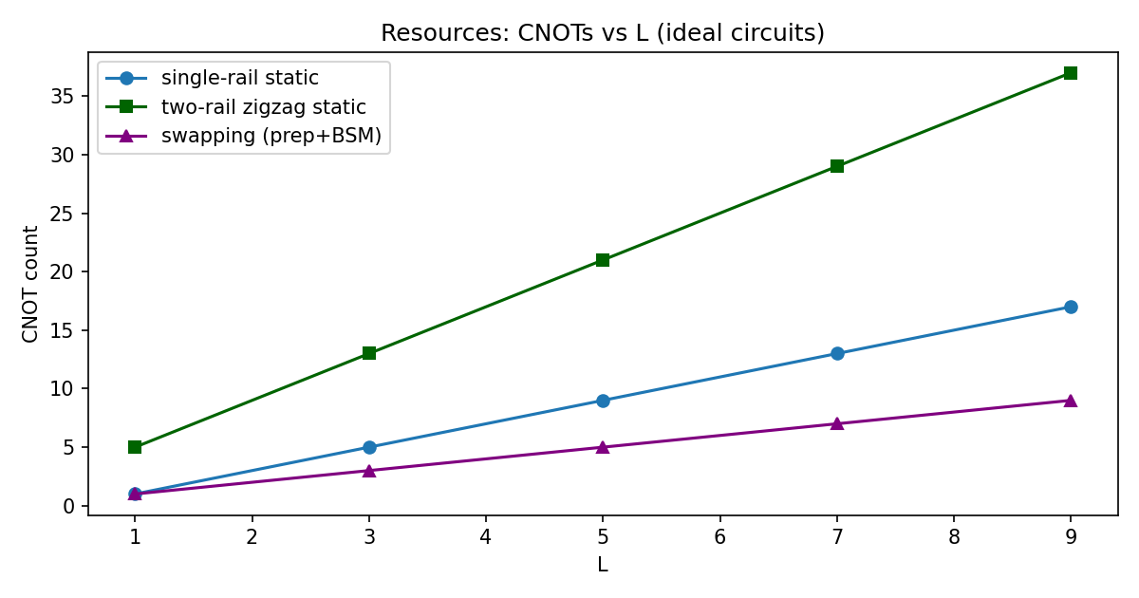
Figure 1. Ideal CNOT count vs L.
Table 2. Resources at L=5 (from resource_formula_table.csv).
Strategy | CNOT | Depth | Mid-circuit meas.
Static GHZ (single-rail) | 9 | 10 | 0
Entanglement swapping | 5 | 5 | 4
Two-rail zigzag | 21 | 22 | 0

4.2 CHSH verification
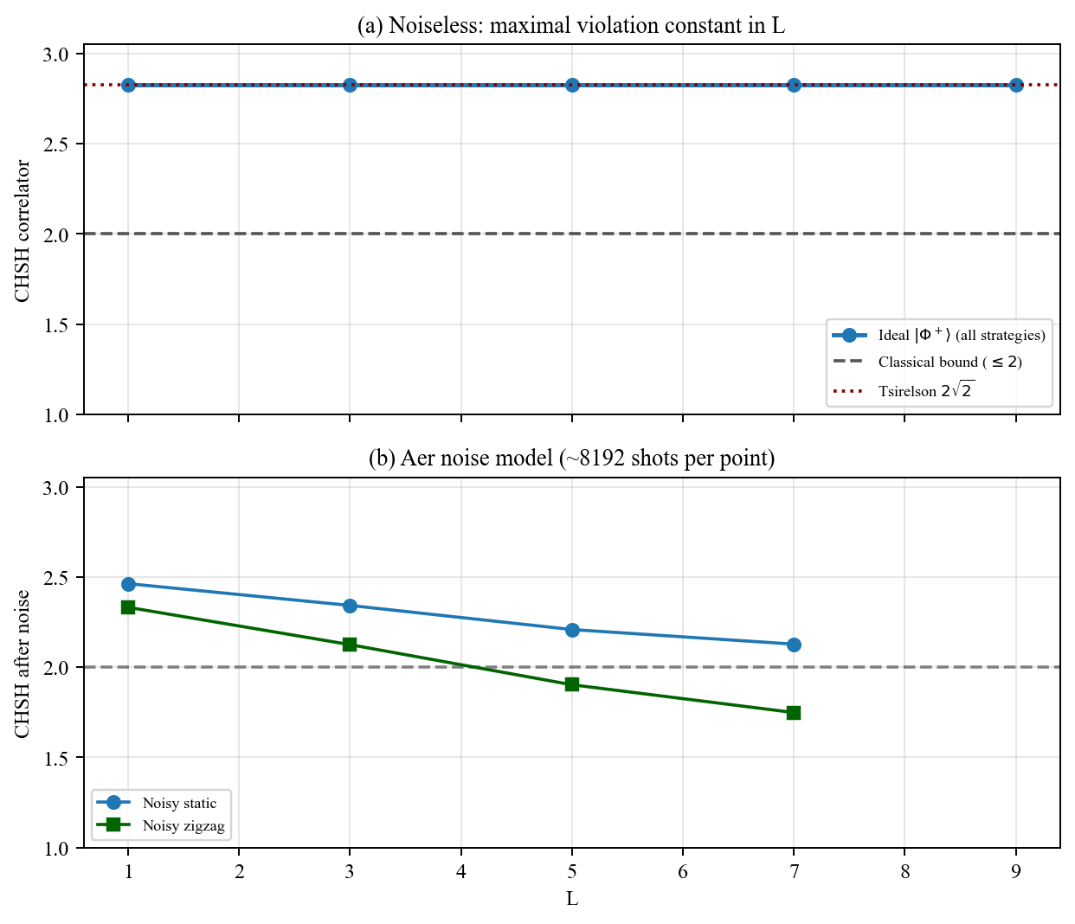
Figure 2. CHSH correlator: ideal (flat at 2√2) vs noisy static/zigzag.

4.3 Noisy Bell diagnostic
Table 3. P(00)+P(11) with 95% Wilson CI (8192 shots).
L | Strategy | Estimate | 95% CI
1 | Static | 0.932 | [0.927, 0.938]
3 | Static | 0.918 | [0.912, 0.923]
5 | Static | 0.901 | [0.894, 0.907]
7 | Static | 0.892 | [0.885, 0.898]
1 | Zigzag | 0.915 | [0.908, 0.921]
3 | Zigzag | 0.884 | [0.877, 0.891]
5 | Zigzag | 0.867 | [0.859, 0.874]
7 | Zigzag | 0.838 | [0.830, 0.846]
1 | Swapping | 0.907 | [0.900, 0.913]
3 | Swapping | 0.845 | [0.837, 0.852]
5 | Swapping | 0.773 | [0.764, 0.782]
7 | Swapping | 0.719 | [0.709, 0.729]

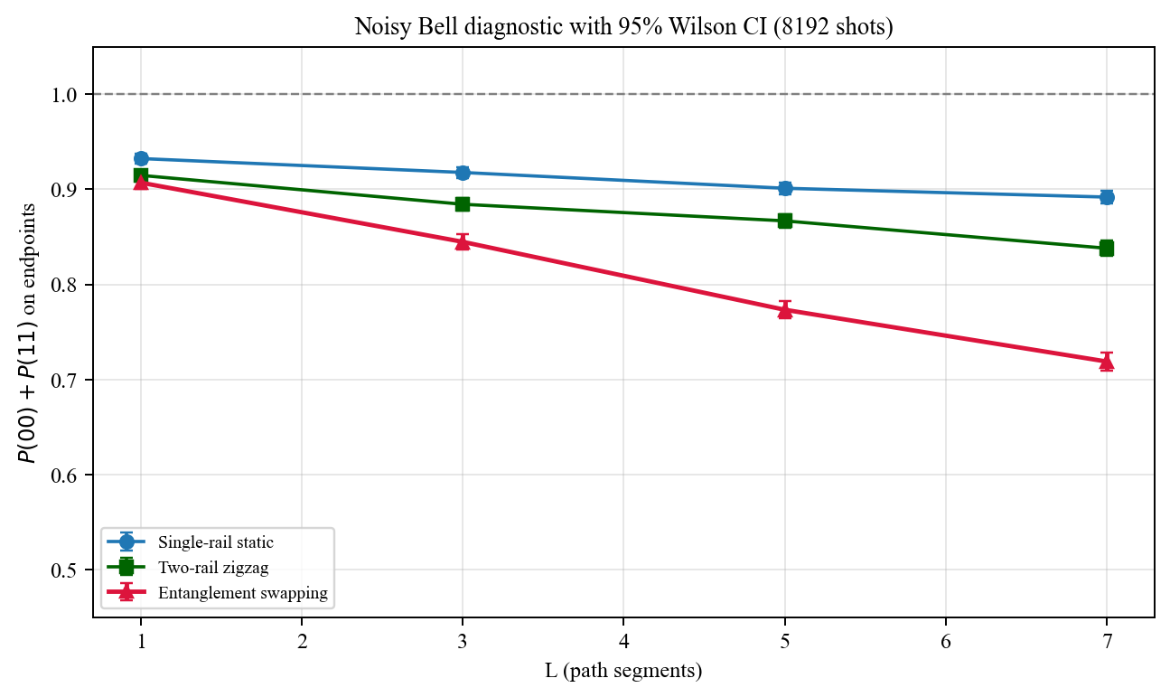
Figure 3. Noisy crossover with 95% CI (static, zigzag, swapping).
Primary comparison: static vs swapping on single-rail endpoints. Zigzag (two-rail) uses more qubits/CNOT but respects full ladder edges; included as topology reference, not primary claim.

4.4 PRX reproduction (quantitative)
Table 4. LRCX Bell fidelity (statevector, min over measurement branches).
Ancilla n | Dynamic min F | Unitary SWAP F
0 | 1.000000000 | 1.000000000
1 | 1.000000000 | 1.000000000
2 | >0.999999000 (unitary ref) | 1.000000000
3 | 1.000000000 | 1.000000000
6 | >0.999999000 (unitary ref) | 1.000000000

Table 5. GHZ preparation fidelity.
n | Dynamic F | Unitary F
2 | 1.000000000 | 1.000000000
3 | 1.000000000 | 1.000000000
4 | 1.000000000 | 1.000000000
5 | 1.000000000 | 1.000000000
6 | 1.000000000 | 1.000000000
7 | 1.000000000 | 1.000000000

4.5 Error-budget analysis (qualitative)
Using Bäumer et al. Appendix B.2 parameters (μ≈3.65, λ_idle=0.03, λ_CNOT=0.02, λ_meas=0.03), F_proc ≥ exp(−λ_tot). These bounds use paper calibration—not our Aer model. Panels are split by task.
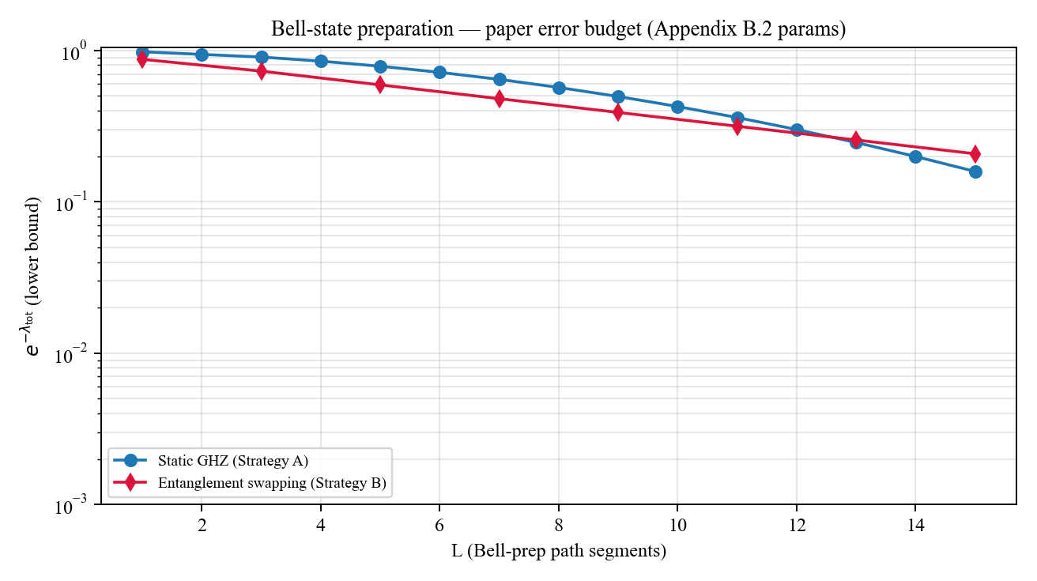
Figure 4. Error budget: Bell-state preparation tasks.
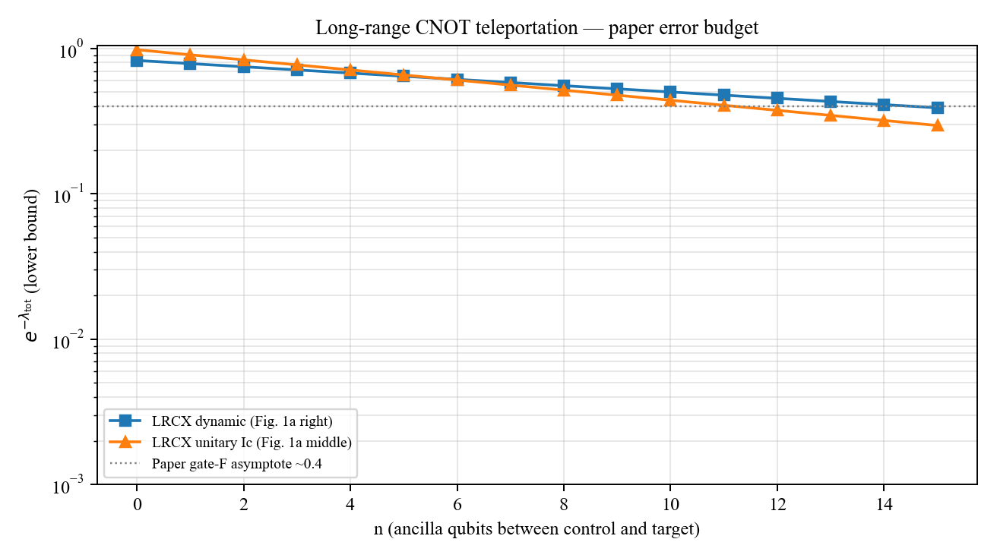
Figure 5. Error budget: long-range CNOT teleportation.

4.6 Representative circuits
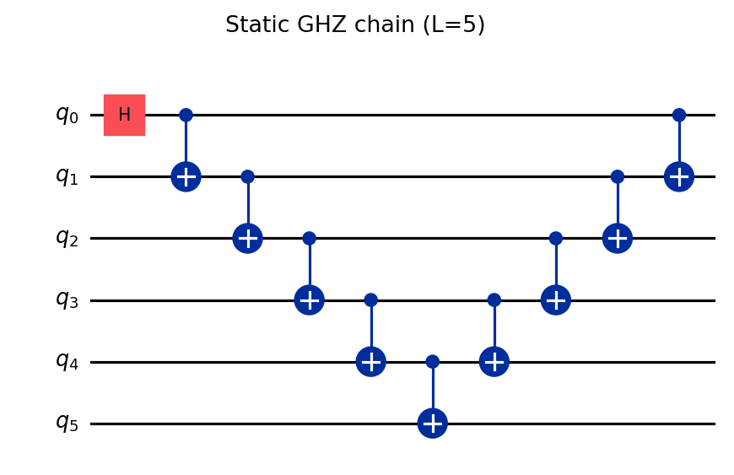
Figure 6. Static chain (L=5).
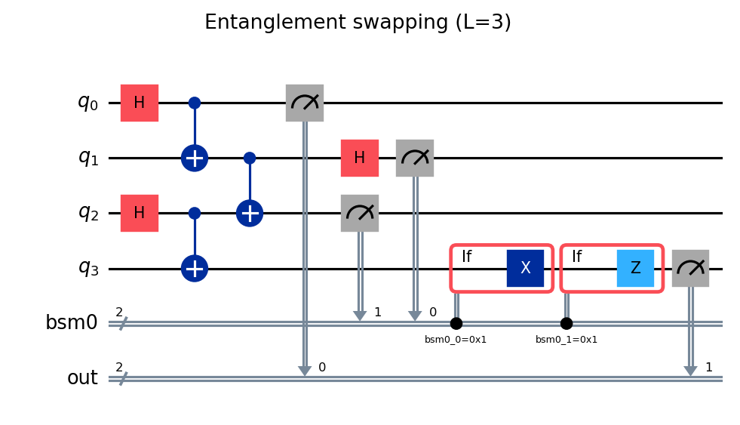
Figure 7. Swapping (L=3).
Listing 2. Reproduction.
git clone https://github.com/YOUR_USERNAME/long-range-entanglement-dynamic-circuits
cd long-range-entanglement-dynamic-circuits
pip install -r requirements.txt
python3 scripts/build_graduate_package.py

5. Discussion and limitations
- Simulation uses Qiskit Aer; PRX Quantum reports 101-qubit IBM hardware.
- Error-budget curves and P(00)+P(11) use different noise calibrations—compare trends only.
- Bell-state preparation ≠ gate teleportation; tasks are related but not identical.
- Classical decode approximates feed-forward for fair noisy comparison.

6. Conclusion
We provide reproducible ladder-topology Bell preparation, PRX circuit reproduction with quantitative fidelities, and a carefully scoped crossover analysis separating simulation from paper error budgets.

Acknowledgments
I thank Prof. Hsiu-Chuan Hsu for guidance on this project and the Ephys Challenge 2026 organizers.

7. Data and code availability
Source code and CSV artifacts:
https://github.com/YOUR_USERNAME/long-range-entanglement-dynamic-circuits
Set repository_commit in config/submission.json after git push, then regenerate this report.
Contact: louse2121@gmail.com

References
[1] E. Bäumer et al., PRX Quantum 5, 030339 (2024). https://doi.org/10.1103/PRXQuantum.5.030339
[2] IBM Quantum, Long-range entanglement with dynamic circuits. https://docs.quantum.ibm.com/
[3] Ephys Challenge 2026, National Chengchi University.

Appendix A. Figure index
Table A1.
Fig. | File | Script
1 | resources_cx_vs_L.png | ephys/competition_suite.py
2 | figure_chsh_comparison.png | scripts/report_figures.py
3 | crossover_simulation_with_ci.png | scripts/report_figures.py
4–5 | error_budget_*.png | scripts/error_budget_analysis.py
6–7 | figure_circuit_*.png | ephys/src/challenge_common.py

