**TRƯỜNG ĐẠI HỌC THỦ DẦU MỘT**

**VIỆN KỸ THUẬT – CÔNG NGHỆ**



**ĐỒ ÁN MÔN HỌC  
ĐỒ ÁN CHUYÊN NGÀNH**

**BUILD A TIVI STORE MANAGER WEBSITE**

**GVHD: TH.S HỒ ĐẮC HƯNG**

**SVTH: NGUYỄN MINH QUANG**

**MSSV: 1724801030106**

**LỚP: D17PM02**

**BÌNH DƯƠNG – 12/2020**

**TRƯỜNG ĐẠI HỌC THỦ DẦU MỘT**

**VIỆN KỸ THUẬT – CÔNG NGHỆ**



**ĐỒ ÁN MÔN HỌC  
ĐỒ ÁN CHUYÊN NGÀNH**

**BUILD A TIVI STORE MANAGER WEBSITE**

**GVHD: TH.S HỒ ĐẮC HƯNG**

**SVTH: NGUYỄN MINH QUANG**

**MSSV: 1724801030106**

**LỚP: D17PM02**

**BÌNH DƯƠNG – 12/2020**

**TRƯỜNG ĐẠI HỌC THỦ DẦU MỘT**

**VIỆN KỸ THUẬT – CÔNG NGHỆ**

**NHẬN XÉT VÀ CHẤM ĐIỂM CỦA GIẢNG VIÊN**

Họ và tên giảng viên: **Hồ Đắc Hưng**

Tên đề tài: **BUILD A TIVI STORE MANAGER WEBSITE**

Nội dung nhận xét:

**Điểm:**

Bằng số:

Bằng chữ:

|  |  |
| --- | --- |
|  | **GIẢNG VIÊN CHẤM**  *(Ký, ghi rõ họ tên)* |

**ThS. Hồ Đắc Hưng**

OPENINGS

Along with the continuous development of computer technology and electronic networks, information technology has also gained high-class technologies and conquered one after another peak. The Internet is one of the products of great value and is increasingly becoming an indispensable tool, a major platform for information transmission and exchange globally. Now everything related to information becomes easy for users: just have a computer connected to the internet and a tracing data stream is almost instant ... the whole world of your problem. Are interested will appear, full of information, images and sometimes even sound if you need ...

Using the Internet, we can get things done at a much faster speed and at a much lower cost than the traditional way. This has promoted the birth and development of e-commerce and e-government all over the world, significantly changing the cultural face, improving the quality of human life. In production and business activities, now, e-commerce has affirmed the role of promoting and promoting the development of the business. For a store or shop, the promotion and introduction to customers of new products to meet the needs of customers will be necessary. So how to advertise is to build a Website for my store to promote all of the products I sell. Therefore, I have implemented the project ***"*** ***BUILD A TIVI STORE MANAGER WEBSITE".*** The shop owner puts those products on his website and manages it by that website. Customers can order goods on the website without going to the store. The shop owner will send the product to the customer when the money is received.

With the guidance of teacher **Ho Dac Hung**, I have completed this project report. Although we have tried our best to learn and analyze the system design and setup, the shortcomings are inevitable. I look forward to receiving your sympathy and suggestions. Thank you sincerely.

TABLES OF CONTENTS

TABLES OF CONTENTS iv

SHAPE CATEGORY vi

TABLE CATEGORY vii

CHAPTER 1. INTRODUCE 1

1.1. Introduce The Topic 1

1.1.1. Name topic 1

1.1.2. Function 1

1.1.3. Request in place 1

1.2. System design and analysis 2

1.2.1. Survey the current situation and build the system 2

1.2.2. System analysis 2

1.3. Customer functional hierarchy diagram 3

1.4. Functional hierarchy map of admin 6

CHAPTER 2. DESIGN ANALYSIS 7

2.1. List of Actors 7

2.2. List of functions 7

2.3. Use Case Diagram 9

2.3.1. General use case chart 9

2.3.2. Cart management use case chart 9

2.3.3. Product management use case chart 10

2.3.4. Use case chart for account management 10

2.3.5. Use case chart for slide management 11

2.3.6. Use case chart for order management 11

2.3.7. Manufacturer management use case chart 12

2.4. Set a use case description 12

2.4.1. UC login 12

2.4.2. UC register 13

2.4.3. UC product details 14

2.4.4. UC ordered 14

2.4.5. UC payment 15

2.4.6. UC Search 15

2.4.7. UC Management 15

2.5. Class Diagram 16

2.6. Activity Diagram 17

2.6.1. Activity Diagram Register 17

2.6.2. Activity Diagram view cart 17

2.6.3. Activity Diagram Login 18

CHAPTER 3. DATABASE DESIGN 20

3.1. Database Diagram 20

3.2. Schema 20

3.3. Detailed schema 21

3.3.1. The table contains account information 21

3.3.2. Table of products 21

3.3.3. Table manufacturer 22

3.3.4. Bills table 22

3.3.5. Slide table 23

3.3.6. Table of customers 23

3.3.7. Invoice details table 23

3.4. Test plan 24

3.4.1. Introduce 24

3.4.2. Resources 27

3.4.3. Test scope 28

3.4.4. Test schedule 28

CHAPTER 4. WEBSITE INTERFACE DESIGN 29

CONCLUSION 31

REFERENCES 33

SHAPE CATEGORY

**Figure 1.1:** Customer management diagram 6

**Figure 1.2:** Product management chart **Error! Bookmark not defined.**

**Figure 2.1:** General Usecase 9

**Figure 2.2:** Cart management use case chart 10

**Figure 2.3:** Product management use case chart 10

**Figure 2.4:** Use case chart for account management 11

**Figure 2.5:** Use case chart for slide management 11

**Figure 2.6:** Use case chart for order management 12

**Figure 2.7:** Manufacturer management use case chart 12

**Figure 2.8:** Class diagram 16

**Figure 2.9:** Activity Diagram Register 17

**Figure 2.10:** Activity Diagram view cart 18

**Figure 2.11:** Activity Diagram Login 19

**Figure 3.19:** Database diagram 20

TABLE CATEGORY

**Table 2.1:** List of Actors 7

**Table 2.2:** List of functions 7

**Table 3.1:** Overview schema 20

**Table 3.2:** The table contains account information 21

**Table 3.3:** Table of products 21

**Table 3.4:** Table manufacturer 22

**Table 3.5:** Bills table 22

**Table 3.6:** Slide table 23

**Table 3.7:** Table of customers 23

**Table 3.8:** Invoice details table 24

**Table 3.9:** Related document 25

**Table 3.10:** Table Risk 26

**Table 3.11:** Treatment strategy 26

**Table 3.12:** Table Hardware 27

**Table 3.13:** Table Software 27

**Table 3.14:** Test tools 27

**Table 3.15:** Table Test scope 28

**Table 3.16:** Table Test schedule 28

1. INTRODUCE
   1. Introduce The Topic
      1. Name topic

* Build a tivi store manager website.
  + 1. Function
* This is a website to introduce and manage products of the store, company to consumers with product details at exact prices. Contains the following functions:
* Display a list of items by producttype.
* Display a list of items by product
* Display a list of items by admins
* Display list customer information.
* Update customers, admins, product, producttype.
  + 1. Request in place
* The system has 2 parts:
* First: User section
* Users are those who need to buy goods, they will search for necessary items from the system and order these items. There fore the following functions are required:
* Displays a list of store items for customers to view, choose and buy.
* Users view information and promotions on the website.
* Second: Administrator section
* The owner has the right to control all activities of the system. This person is given a username and password to log into the system to perform his functions:
* Function to update, correct, delete items, categories, manufacturers, customer accounts, slider
* Reception of checking customer orders. Show orders.
* In addition to the above functions, the website must be designed so that it is easy to understand, has a beautiful easy-to-use interface and makes it easy for customers to see the information to look for, provide attractive advertising information, and Promotional news to attract customers. It is important to ensure absolute safety of customer information during the online ordering process. At the same time, the website must always be innovative and attractive.
  1. System design and analysis
     1. Survey the current situation and build the system
* After surveying, I have grasped the information:
* Customer manage: Each customer is managed with the following information: name, address, phone number, email.
* Product manage: Product code, name of goods, unit price, quantity, image, details, product code, name of the product.
* Produttype manage: Manufacturer code, manufacturer name.
* Admin manage
  + 1. System analysis
* After surveying the current status of the system and building the system, I have presented the database files of "Build a tivi store manager website".
* Through the process of surveying, analyzing the current situation and building development directions for the new system, I have built the structure of the system "Build a tivi store manager website".
* Building functional hierarchy chart. Data flow chart: We construct the data flow chart as follows:

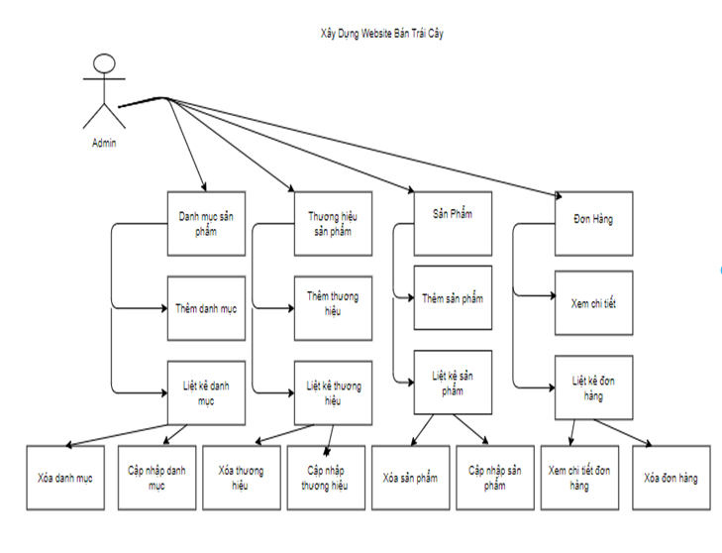

* 1. Customer functional hierarchy diagram

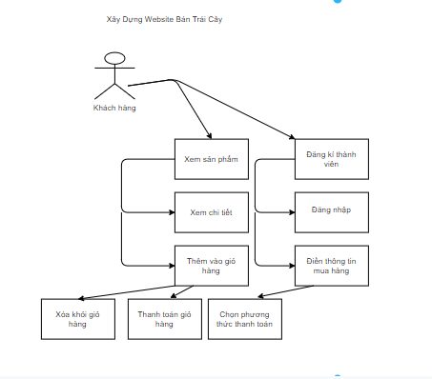

* Function to view product information
* Lets see information related to products.
* Item selection function
* List of product items by group, type, detail ... allows customers to choose and add items to cart.
* Input: Product related information: Item name
* Processes to be performed:
* Module lists, displays the list of items by group, type, details.
* Module adds items to cart.
* Module removes items from the cart.
* The module displays the list of items currently in the shopping cart.
* Registration function
* Customers can register to become regular customers (members) of the store and are given a user account (Acount) to log in when they need to order, pay ...
* Input :
* Personal information of customers.
* User name.
* Password.
* Full name
* Address.
* Email.
* Phone Number.
* Implementation processes:
* Enter personal information of the customer.
* Confirm the information you have entered.
* Notify the customer and ask to re-enter the user account if that account is already registered.
* Save information about customer just registered in the database.
* Output:
* Notify the customer and request to re-enter the account or Email if the account or Email already exists in the database.
* Notice and request to re-enter information in case the information entered is inaccurate or inappropriate.
* Switch to the login page.
* Search function
* Find information about products
* Input :
* Search word or phrase.
* Search form (product search).
* Implementation processes:
* Search the database.
* Display search results.
* Output: Search Results.
* Payment function
* After customers choose the products to be placed into their shopping cart, customers can order officially through the Website.
* Input:
* The category of items in the shopping cart.
* Personal information of customers (Customer ID, Full name, password, ...).
* Information regarding the purchase (date of purchase, quantity of each item ordered.
* Implementation processes:
* Module displays full information related to the product selected by the customer.
  1. Functional hierarchy map of admin

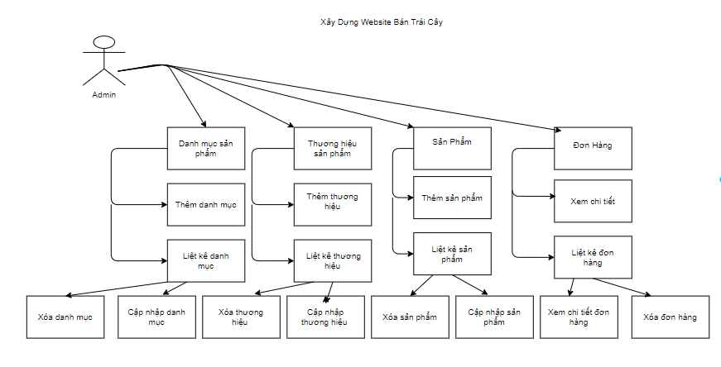

* + - 1. Customer management diagram

2. DESIGN ANALYSIS
   1. List of Actors
      * + 1. List of Actors

|  |  |  |
| --- | --- | --- |
| **STT** | **Tên Actor** | **Ý nghĩa** |
| 1 | Admin | The manager is the person who has full rights to interact with the system, the right to use all the functions that the website builds, control and control all activities of the website. |
| 2 | User | The users here are those who visit the website, can register as members or not. Users only have certain rights to the website. |

* 1. List of functions
     + - 1. List of functions

|  |  |  |  |
| --- | --- | --- | --- |
| **STT** | **Tên chức năng** | **Mô tả** | **Actor** |
| 1 | Sign In | Users, after registering to become a member, log on to continue using the functions on the web. | Admin, User |
| 2 | Sign Up | Users create accounts to use additional functions of the member. | Admin, User |
| 3 | Sign Out | Users and Admin can log out when not using the website anymore. | Admin, User |
| 4 | Buy order | Users can order products after logging into the website. | User |
| 5 | Pay | User view and click "Checkout" button.  The system validates the information and displays the payment page.  User enter full information.  The system gives the message and returns to the cart page. | User |
| 6 | View product information | Users can view product information on the website. | User |
| 7 | Tìm kiếm sản phẩm | Search product | Admin, User |
| 8 | Look for information | Admin can search for information such as: product, customer, supplier, manufacturer. | Admin |
| 9 | Manage Shopping Cart | Allows users to: add, delete products. | User |
| 10 | Product Management | The admin permission can:  + Add new  + Editing  + View details (Show)  + Delete | Admin |
| 11 | Manage user accounts | The admin permission can:  + Add new  + Editing  + View details (Show)  + Delete | Admin |
| 12 | Order management | The admin permission can:  + Add new  + Editing  + View details (Show)  + Delete | Admin |
| 13 | Manufacturer management | The admin permission can:  + Add new  + Editing  + View details (Show)  + Delete | Admin |
| 14 | Manage slides | The admin permission can:  + Add new  + Editing  + View details (Show)  + Delete | Admin |

* 1. Use Case Diagram
     1. General use case chart

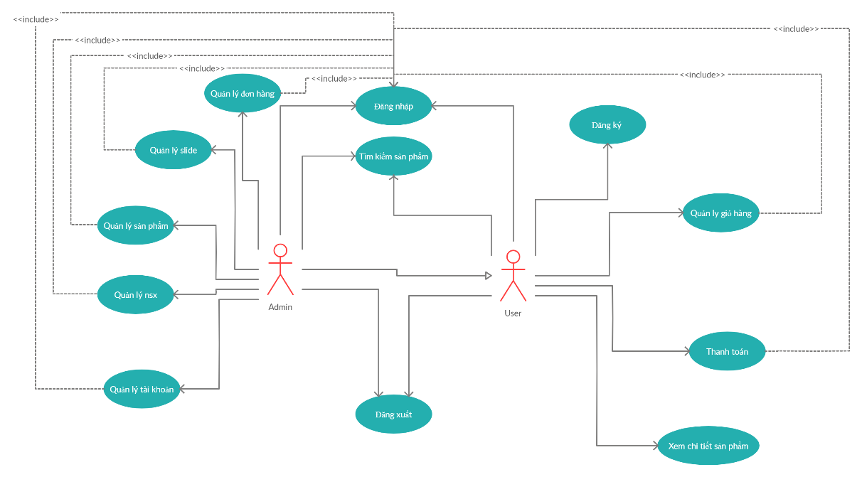

* + - 1. General Usecase
    1. Cart management use case chart

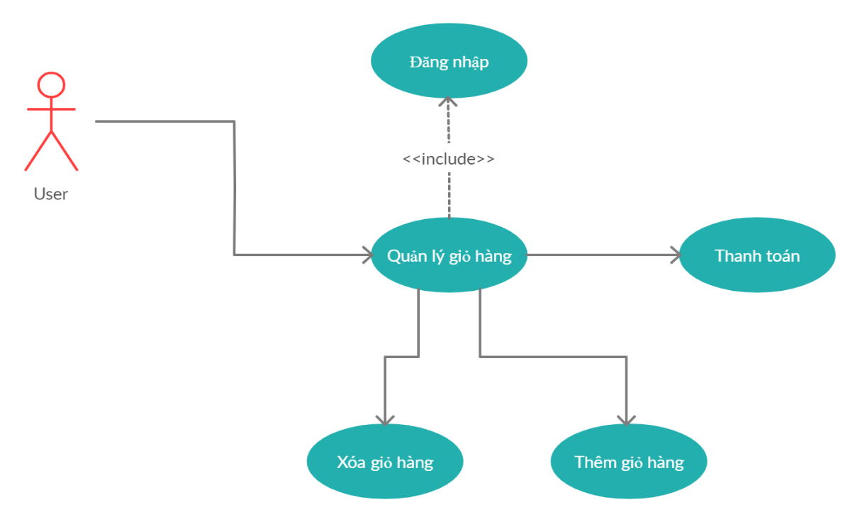

* + - 1. Cart management use case chart
    1. Product management use case chart

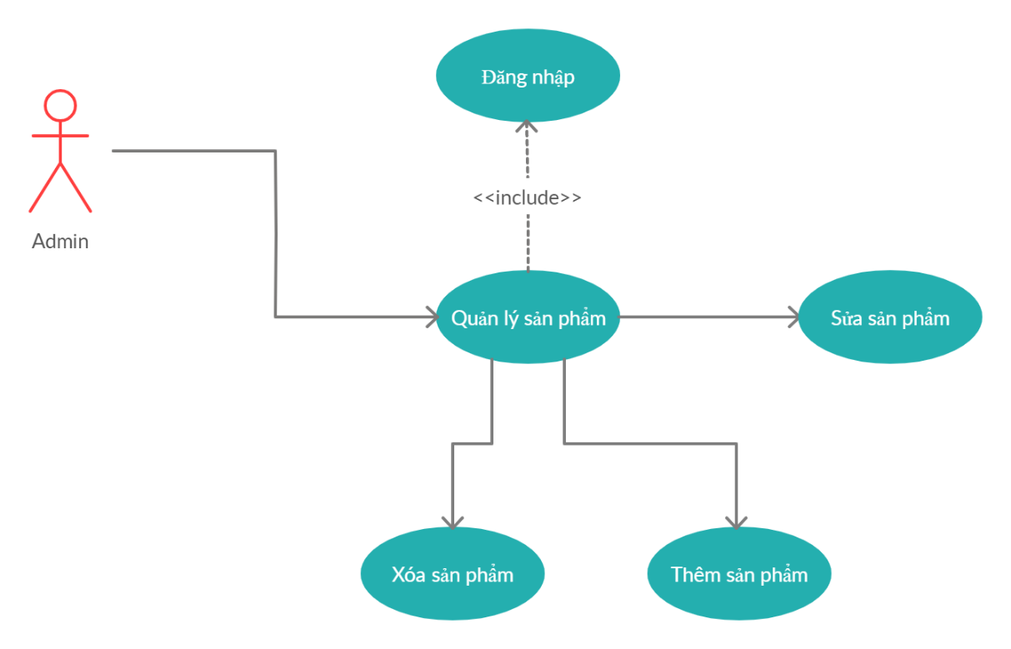

* + - 1. Product management use case chart
    1. Use case chart for account management

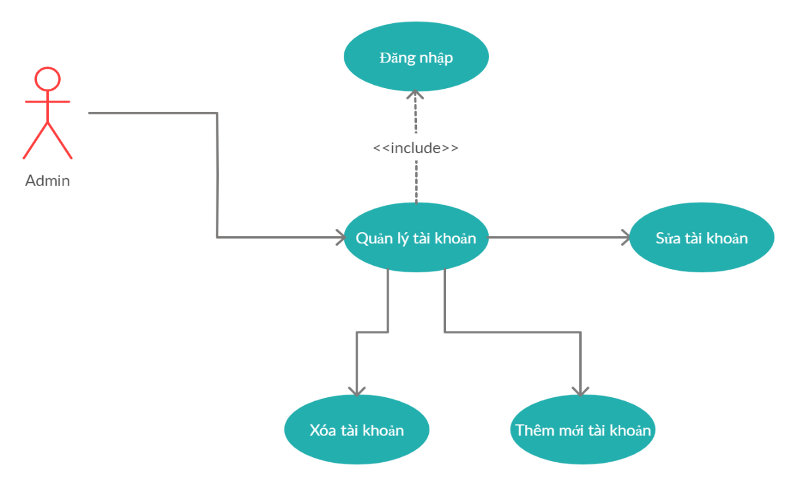

* + - 1. Use case chart for account management
    1. Use case chart for slide management

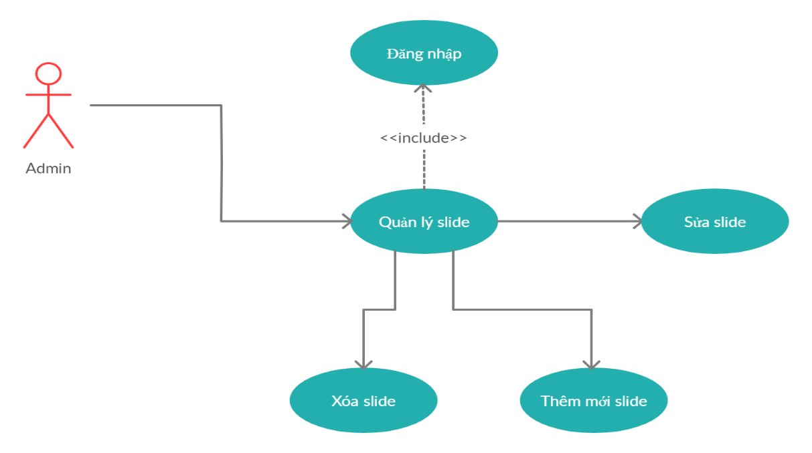

* + - 1. Use case chart for slide management
    1. Use case chart for order management

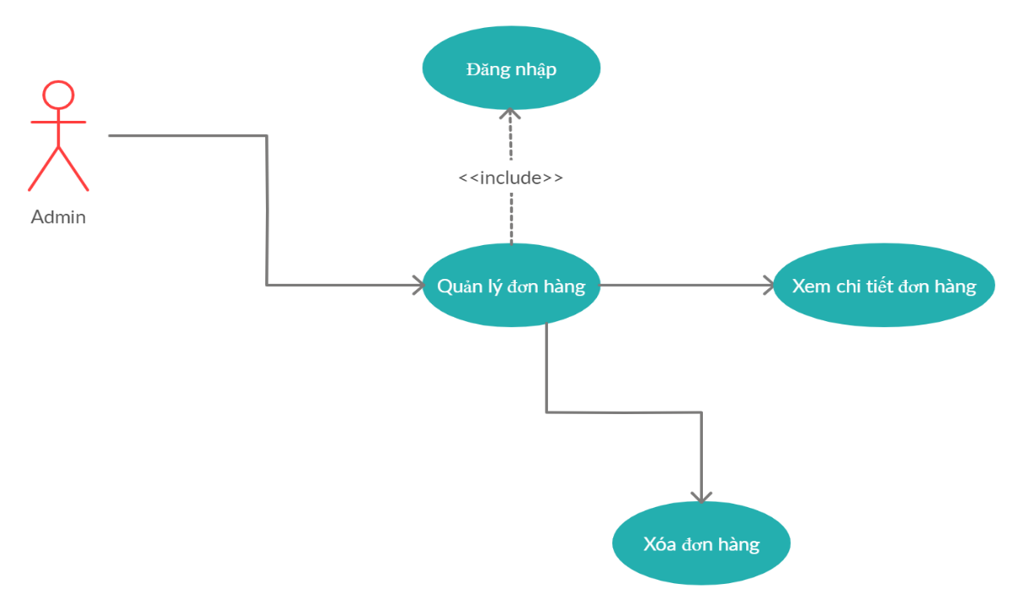

* + - 1. Use case chart for order management
    1. Manufacturer management use case chart

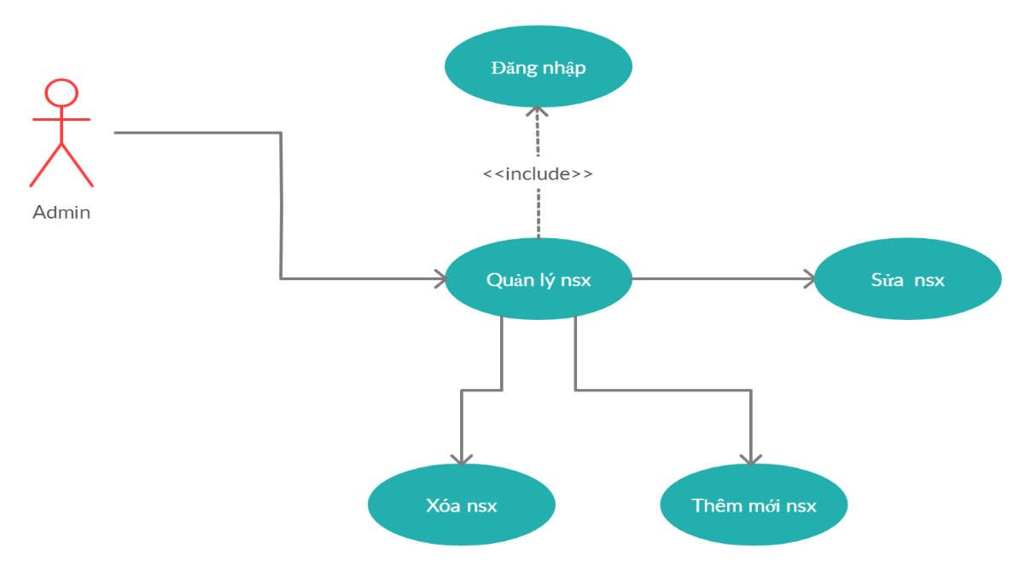

* + - 1. Manufacturer management use case chart
  1. Set a use case description
     1. UC login
* User objects (Actor) include: user, admin.
* This UC describes the steps for logging into the system.
* Follow these steps:
* The system requires actor to provide login information including: username and password.
* Actor completes the login information and clicks the login button.
* The system checks the login information and informs the actor success / failure. If successfully logged in, the system based on the login information will simultaneously decentralize depending on the type of employee. If the login fails, the system will notify the user and request to log in again.
  + 1. UC register
* Actor The user is the user who uses this use case. This UC is used to perform the function of registering user's account. After registering for an account, then the new User can log into the website and perform functions such as: Payment.
* Stream of events
* Main event stream

1. The user chooses the registration function from the website homepage.
2. The homepage will open to the registration page.
3. User enter full account information and personal information.
4. The system validates the information and saves it.
5. Show notification.
6. End of UC.

* Other event streams

1. User cancels subscription request.
2. The system skips the registration page, returns to the current page.
3. End of UC.

* System status after performing UC
* In case of successful registration: the system displays a login page so that users can log into the website.
* In case of failed registration: The system gives notice of unsuccessful registration.
  + 1. UC product details
* This UC is used to perform the function of viewing user's product information. After accessing the website, users can view the product information on the website.
* Stream of events
* Main event stream

1. Users access the website and click to select the product.
2. The home page will open to the product details page.
3. User view product information.
4. End Use Case.
   * 1. UC ordered

* This UC is used to perform the user's product ordering function. After accessing the website and viewing product information, users can order products that they feel satisfied.
* Stream of events
* Main event stream

1. The user selects the function to view detailed information of the product.
2. The home page will open to the product details page.
3. Users view and click the button "Add to cart".
4. The system validates the information and saves it.
5. Display product information page.
6. End of UC.
   * 1. UC payment

* This UC is used to make payment function for ordered product. After ordering the product, the user's shopping cart already has one or more products. If you want to have these products in your hand, you need to choose this UC to pay.
* Stream of events
* Main event stream

1. User selects the ordering function.
2. The homepage will open to the user's shopping cart page.
3. User view and click "Checkout" button.
4. The system validates the information and displays the payment page.
5. User enter full information.
6. The system gives the message and returns to the cart page.
7. End of UC.
   * 1. UC Search

* This UC is used to perform product search function. With this function, users can search for products they love and see if that product exists in the website or not.
* Stream of events
* Main event stream

1. The user chooses the search function from the homepage.
2. User enters search information.
3. The system validates information and performs a search.
4. The system returns search information.
5. End of UC.
   * 1. UC Management

* This UC is used to perform the information management function of the Admin. After logging into the system, the administrator can add, update information, delete objects in the system such as: products, slides ...
* Stream of events
* Main event stream

1. The admin selects the information management function from the admin home page.
2. The system displays the information management page.
3. Admin enter full information of objects.
4. Inspection system and information storage.
5. Show notification.
6. Display information management page
7. End of UC.
   1. Class Diagram

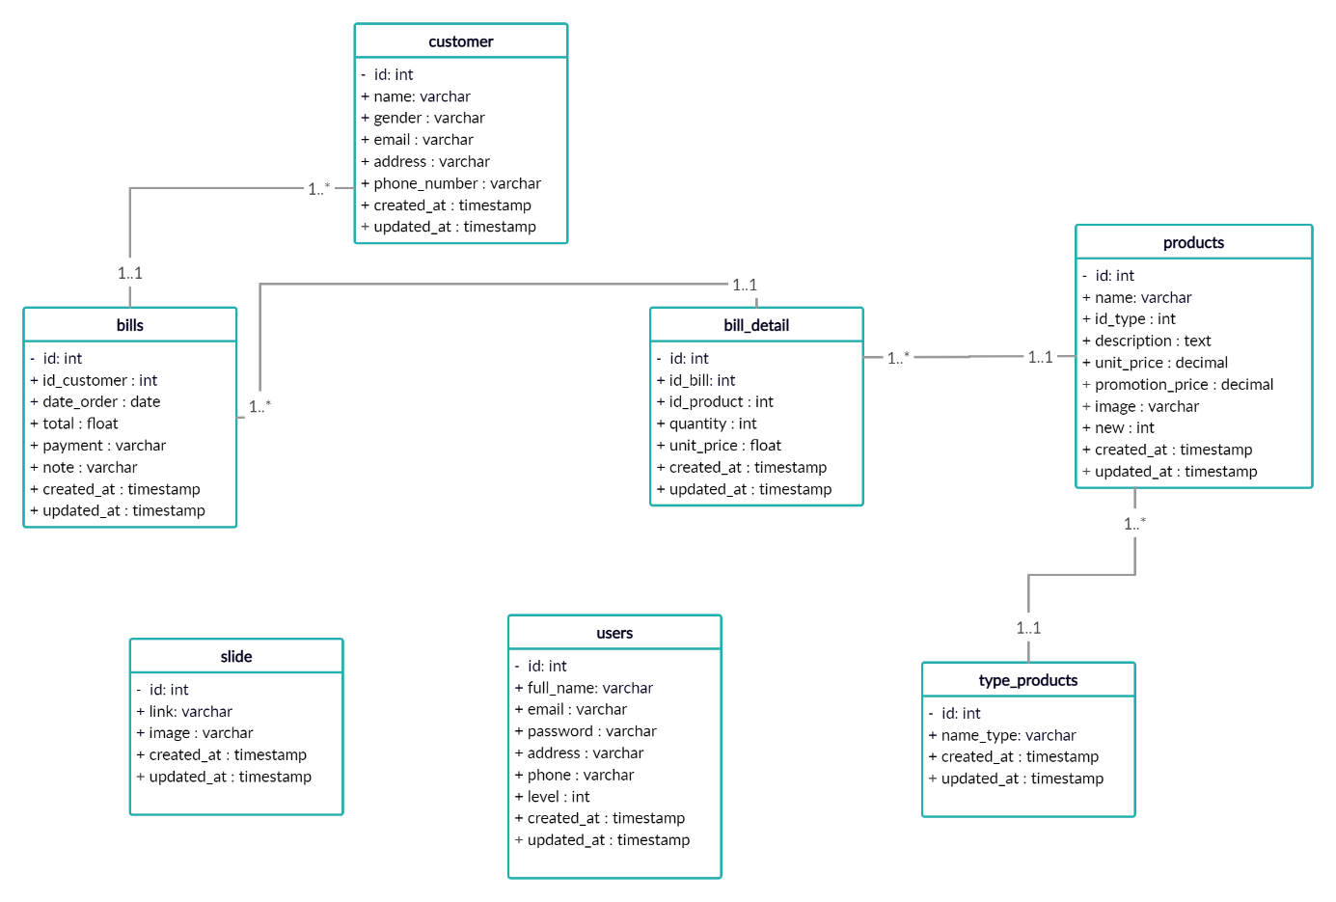

* + - 1. Class diagram
  1. Activity Diagram
     1. Activity Diagram Register

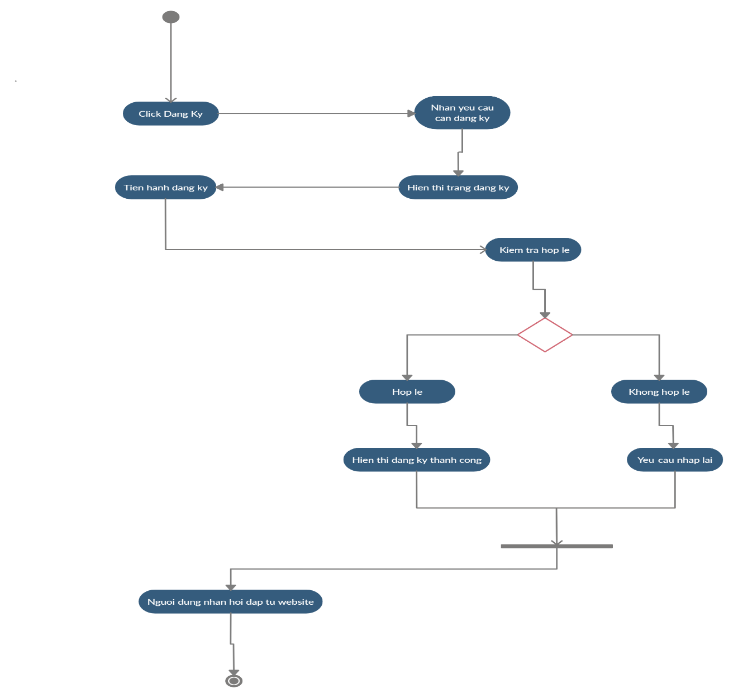

* + - 1. Activity Diagram Register
    1. Activity Diagram view cart

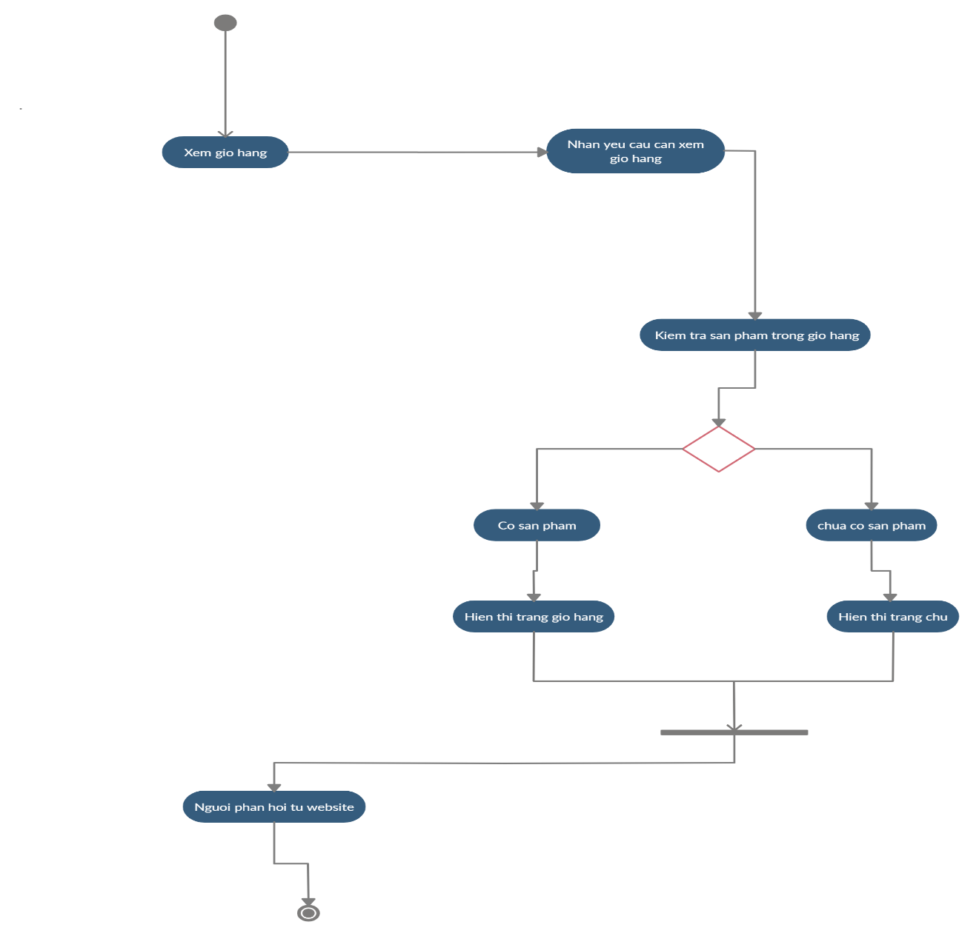

* + - 1. Activity Diagram view cart
    1. Activity Diagram Login

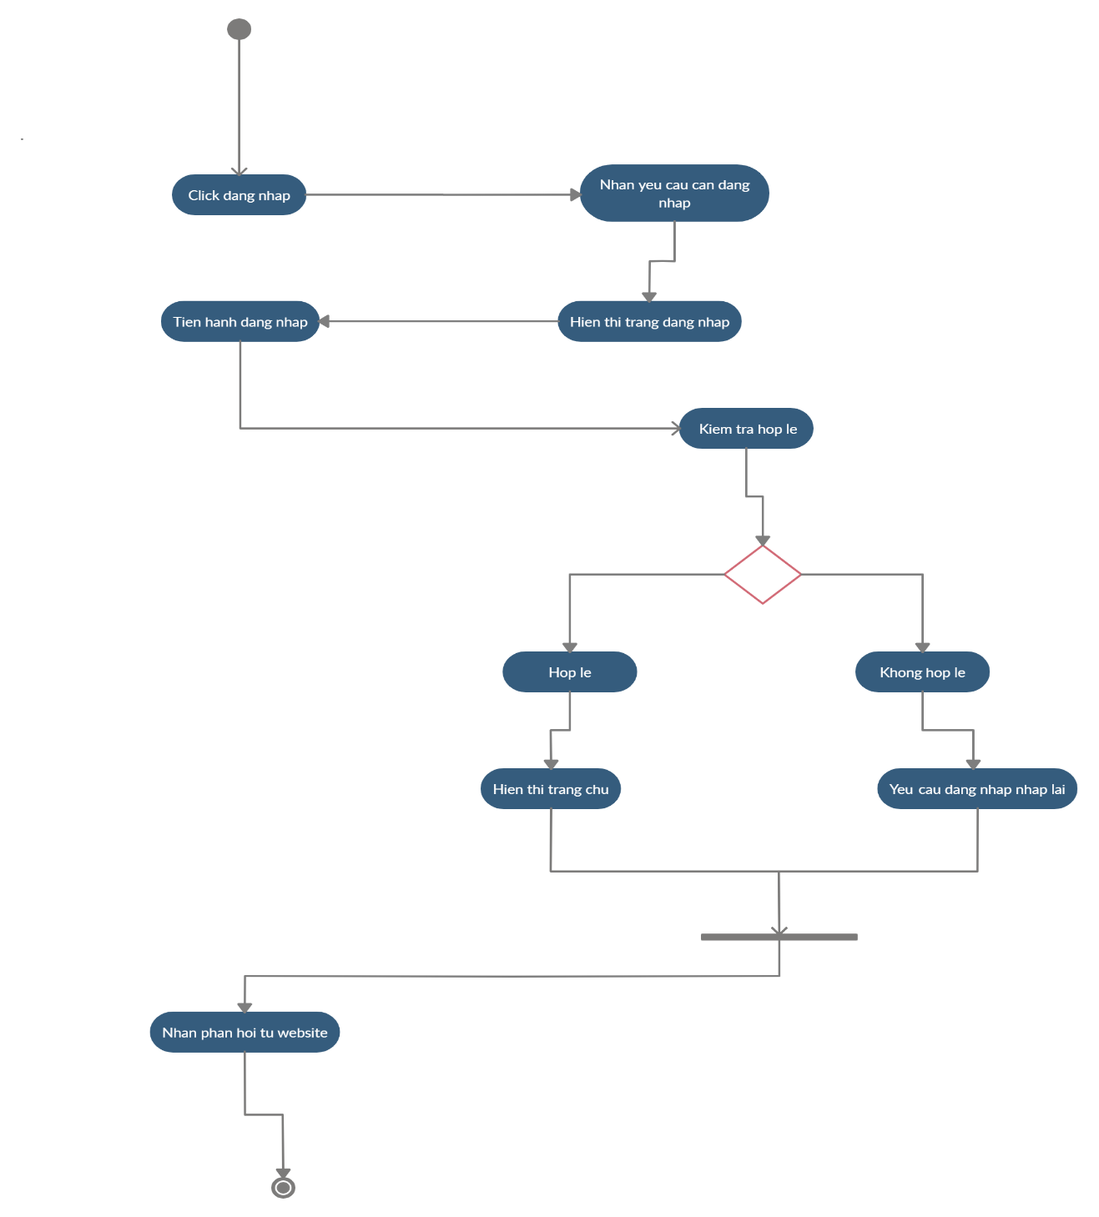

* + - 1. Activity Diagram Login

1. DATABASE DESIGN
   1. Database Diagram

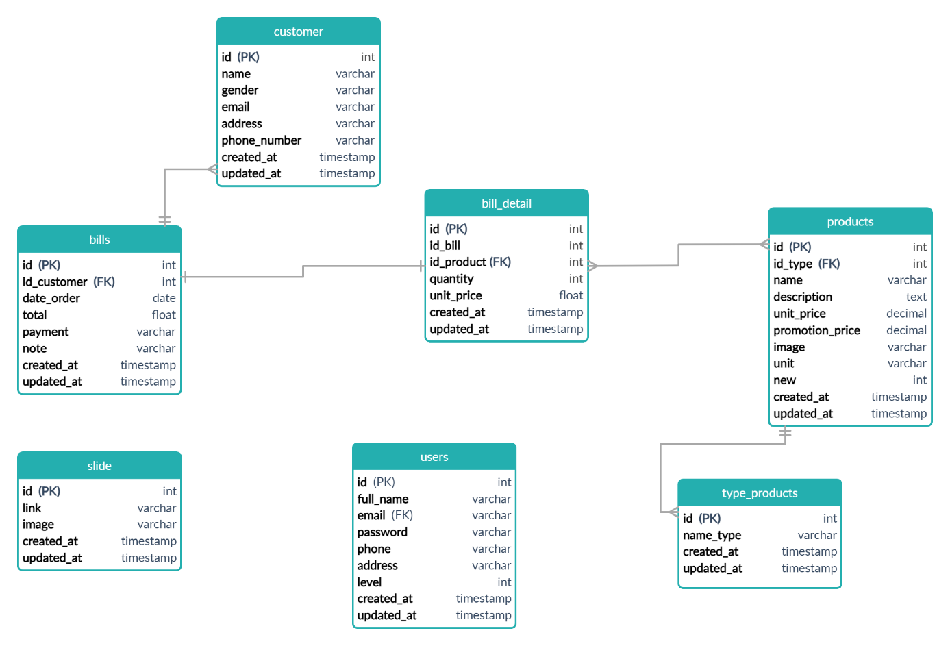

* + - 1. Database diagram
  1. Schema
     + - 1. Overview schema

|  |  |  |
| --- | --- | --- |
| STT | Tên | Mô tả |
| 1 | Users | List of account information |
| 2 | Products | List of product information |
| 3 | Type_products | List of product's manufacturer |
| 4 | Bills | List of invoice information |
| 5 | Slide | List of information slides |
| 6 | Bill_detail | List of invoice details |
| 7 | Customer | List of information customers have ordered |

* 1. Detailed schema
     1. The table contains account information
        + 1. The table contains account information

|  |  |  |  |
| --- | --- | --- | --- |
| **Field name** | **Type** | **Max Length** | **Descrition** |
| id | int | 10 | Save user code, auto increment |
| Full_name | varchar | 255 | Save the user's first and last name |
| email | varchar | 255 | Save email |
| password | varchar | 255 | Save password |
| phone | int | 20 | Save phone numbers |
| address | varchar | 255 | Save the address |
| level | int | 11 | Save the level |
| created_at | timestamp |  | Save the creation date |
| updated_at | timestamp |  | Save the date of the update |

* + 1. Table of products
       - 1. Table of products

|  |  |  |  |
| --- | --- | --- | --- |
| **Field name** | **Type** | **Max Length** | **Descrition** |
| id | int | 10 | Save the Product code, automatically increment |
| name | varchar | 255 | Save the product name |
| id_type | int | 10 | Save the product type id |
| description | varchar | 255 | Save product details |
| unit_price | decimal | 19,2 | Save money prices |
| promotion_price | decimal | 19,2 | Save promotion price |
| image | varchar | 255 | Save image |
| new | int | 10 | Save level product |
| created_at | timestamp |  | Save the creation date |
| updated_at | timestamp |  | Save the date of the update |

* + 1. Table manufacturer
       - 1. Table manufacturer

|  |  |  |  |
| --- | --- | --- | --- |
| **Field name** | **Type** | **Max Length** | **Descrition** |
| id | int | 10 | Save Manufacturer code, auto increment |
| name_type | varchar | 255 | Save name |
| created_at | timestamp |  | Save the creation date |
| updated_at | timestamp |  | Save the date of the update |

* + 1. Bills table
       - 1. Bills table

|  |  |  |  |
| --- | --- | --- | --- |
| **Field name** | **Type** | **Max Length** | **Descrition** |
| id | int | 10 | Save invoice code, automatically increase |
| id_customer | int | 10 | Save customer code |
| date_order | date |  | Save the order date |
| total | float |  | Save the form of purchase |
| payment | varchar | 255 | Save the form of purchase |
| note | varchar | 500 | Save notes |
| created_at | timestamp |  | Save the creation date |
| updated_at | timestamp |  | Save the date of the update |

* + 1. Slide table
       - 1. Slide table

|  |  |  |  |
| --- | --- | --- | --- |
| **Field name** | **Type** | **Max Length** | **Descrition** |
| Id | int | 10 | Slide code save, auto increment |
| link | varchar | 255 | Save the path to Slide |
| image | varchar | 255 | Save the Slide image |
| created_at | timestamp |  | Save the creation date |
| updated_at | timestamp |  | Save the date of the update |

* + 1. Table of customers
       - 1. Table of customers

|  |  |  |  |
| --- | --- | --- | --- |
| **Field name** | **Type** | **Max Length** | **Descrition** |
| id | int | 10 | Save customer code, automatically increase |
| name | varchar | 100 | Save customer name, automatically increase |
| gender | varchar | 10 | Save the customer's gender |
| email | varchar | 50 | Save email |
| address | varchar | 100 | Save the client's address |
| phone_number | varchar | 20 | Save phone number of customer |
| created_at | timestamp |  | Save the creation date |
| updated_at | timestamp |  | Save the date of the update |

* + 1. Invoice details table
       - 1. Invoice details table

|  |  |  |  |
| --- | --- | --- | --- |
| **Field name** | **Type** | **Max Length** | **Descrition** |
| id | int | 10 | Save invoice detail code, automatically increase |
| id_bill | int | 10 | Save the invoice code |
| id_product | int | 10 | Save the product code |
| quantity | int | 10 | Save quantity |
| unit_price | decimal | 19,2 | Save money prices |
| created_at | int |  | Save the creation date |
| updated_at | int |  | Save the date of the update |

* 1. Test plan
     1. Introduce
* Purpose:
* This test plan document provides the following purposes:
* Identify the project basics and the tested and not tested functional components
* List the requirements for testing (Test Requirements)
* Test strategies should be used
* Estimate your resource requirements and testing costs
* These documents are created after completing the testing
* Tested functions:
* Login
* Register
* Search
* Functions not tested:
* Aesthetics.
* User experience.
* Testing strategy:
* API test
* The resource requirements:
* Hardware:
* Hardware:
* Computer
* Internet
* Selling keys
* Mouse
* Software:
* Windows 10
* Web browser
* Test tools
* The following documents are prepared after completing the test:
* Test Plan
* Test cases
* Related document
  + - * 1. Related document

|  |  |  |
| --- | --- | --- |
| **STT** | **Tên tài liệu** | **Nguồn** |
| 1 | Software Quality Assurance | Phan Thị Hoài Phương (2010), [*Đảm bảo chất lượng phần mềm*](https://drive.google.com/file/d/1P64L5CeCqDrywCMqSJWPFzUKGazAdI07/view?usp=sharing), HV Công nghệ Bưu chính Viễn thông. |
| 2 | Software Quality Assurance and Testing | Thạc Bình Cường (2011), [*Kiểm thử và bảo đảm chất lượng phần mềm*](https://drive.google.com/file/d/1NfavvUEpNa59won20sIXD6zrM0v2NvLQ/view?usp=sharing), Trường Đại học Bách khoa Hà Nội |
| 3 | Software testing - Step by step become a professional tester | Nguyễn Thị Kiêm Ái (2020), Kiểm thử phần mềm – Từng bước trở thành tester chuyên nghiệp, Nhà xuất bản Thanh Niên. |
| 4 | Software testing | R.M.D, Sundaram (2019), *Software testing*, Alpha Science International. |

* List your risks:
* Lack of resources
* The performers do not understand the requirements, limit the ability to test difficult cases such as concurrent testing, performance testing, real-time testing, reliability, security.
* Not enough time to do it.
* Infulence level:
  + - * 1. Table Risk

|  |  |  |
| --- | --- | --- |
| **Risk** | **Probability** | **Impact** |
| Not enough time to do it | High | High |
| Lack of resources | High | High |
| Inexperienced human resources | High | High |

* Treatment strategy:
  + - * 1. Treatment strategy

|  |  |  |
| --- | --- | --- |
| **Risk** | **Mitigation Strategy** | **Contingency** |
| Not enough time to do it | Optimize test schedules and come up with a strategy for overtime | Increasing resources (people, equipment) |
| Lack of resources | Request resource support soon | Use personal resources |
| Inexperienced human resources | Human resource improvement | Hire outside staff |

* + 1. Resources
* Hardware
  + - * 1. Table Hardware

|  |  |  |
| --- | --- | --- |
| Device | Configuration | Operating system |
| Laptop | RAM 16GB, CPU core i5 | Windows 10 |

* Software
  + - * 1. Table Software

|  |  |  |
| --- | --- | --- |
| Software name | Version | Type |
| Chrome | 79 | Trình duyệt web |
| Postman |  | Phần mềm test api |

* Test tools
  + - * 1. Test tools

|  |  |  |  |
| --- | --- | --- | --- |
| Activity | Instrument | Provider | Version |
| Task management | Microsoft Office Excel | Microsoft | 2019 |
| Test case management | Microsoft Office Excel | Microsoft | 2019 |
| Configuration management | Microsoft Office Word | Microsoft | 2019 |
| Test cases api | Postman | Postman | 3.13 |

* + 1. Test scope
* List the modules, functions to be tested, and the corresponding test type.
  + - * 1. Table Test scope

|  |  |  |  |
| --- | --- | --- | --- |
| **STT** | **Priority** | **content** | **Test type** |
| 1 | 1 | Login | API test |
| 2 | 2 | Register |
| 3 | 3 | Search |

* + 1. Test schedule
       - 1. Table Test schedule

|  |  |  |  |
| --- | --- | --- | --- |
| **Work** | **Time** | **Begin** | **End** |
| Test planning | 2 date | 5/11/2020 | 8/11/2020 |
| Test login | 2 date | 7/11/2020 | 9/11/2020 |
| Test Register | 2 date | 11/11/2020 | 13/11/2020 |
| Test Search | 2 date | 15/11/2020 | 17/11/2020 |

1. WEBSITE INTERFACE DESIGN
   1. Several admin interfaces
      1. Page admin manage

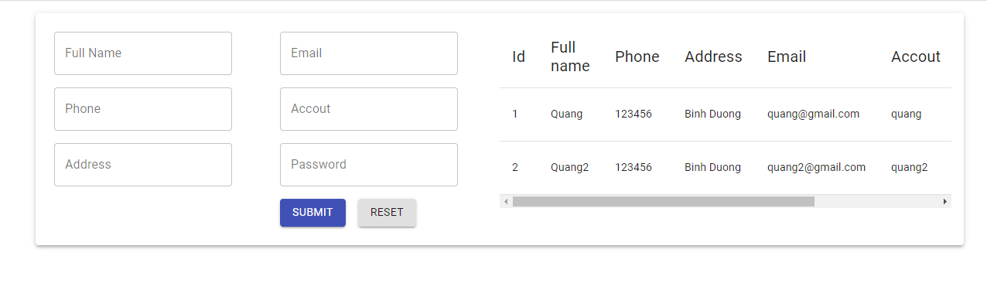

* + 1. Trang customer manage



* + 1. Trang producttype manage

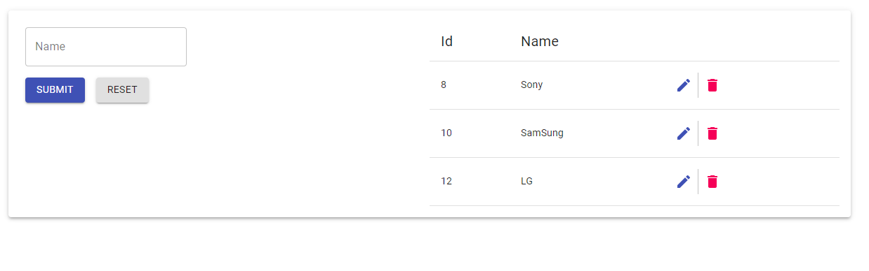

* + 1. Page product manage

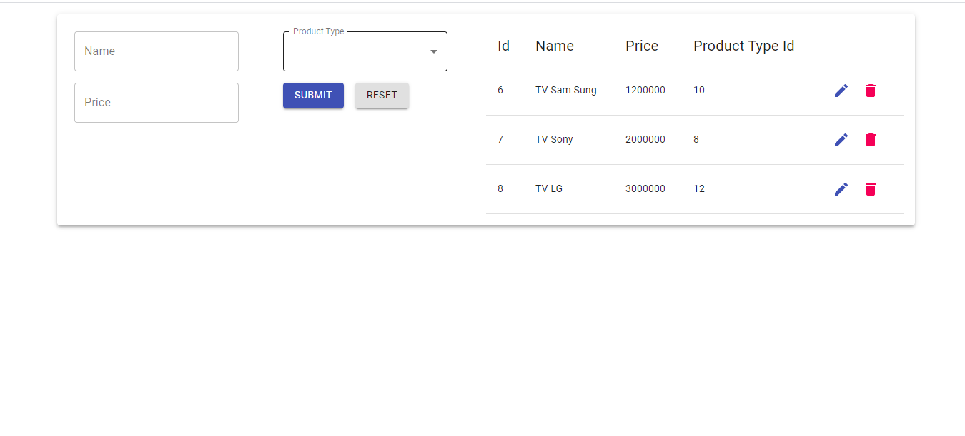

CONCLUSION

**1. Result**

* For users
* Ways of searching and searching by different topics, combining many topics according to customers.
* View detailed product information.
* Allows customers to register information to make product purchases.
* Check the validity of the client's login system.
* Create orders.
* Can run on multiple operating systems.
* For administrators
* View information of items to manage such as: Customers, products, orders ...
* Provides forms for entering new data of document types.
* The above data can be modified and updated.
* In adding new product, the program automatically generates product code, this is convenient for the administrator and the data is always consistent.
* These functions are performed through a web interface.
* Can run on multiple operating systems.

**2. Development direction of the topic**

Development guidance of Website is the process of becoming an e-commerce company with full functionality of online payment. The site's main problem is the ad server. Since then, besides commercial work, the problem needs to focus on attracting customers to associate and agree on the design and installation of a certain project in the specialized field of the company or store.

Therefore, in the future, it is necessary to add additional inventory functions: Database access statistics, import and export price statistics, inventory, revenue statistics, automatic invoice processing.

Warehouse management (automatic inventory check), electronic payment using Edit card.

Adding a number of functions to check input data, change access passwords of customers as well as administrators.

Despite trying to complete the requirements, the report still has many shortcomings, looking forward to receiving the guidance of other teachers to help consider, propose more comments and supplement issues. serve for building Website so that you can be more complete. I would like to thank the teachers.

REFERENCES

**Website**

1. <https://buihuycuong.medium.com/thi%E1%BA%BFt-k%E1%BA%BF-document-v%C3%A0-vesion-cho-api-87d52fdae3f7> Truy cập ngày 20/07/2020
2. <https://tedu.com.vn/khoa-hoc-mien-phi/khoa-hoc-lap-trinh-aspnet-mvc-25>. Truy cập ngày 20/04/2020. Truy cập ngày 25/07/2020
3. <http://mauweb.monamedia.net/dongho/>. Truy cập ngày 20/07/2020
4. <https://hiepsiit.com/>. Truy cập ngày 21/07/2020
5. <https://www.youtube.com/watch?v=fom80TujpYQ&ab_channel=CodAffection>
6. https://www.youtube.com/watch?v=fmvcAzHpsk8&ab_channel=LesJackson