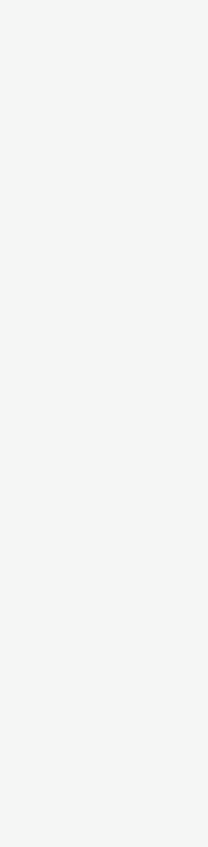.

AYINDE SODIQ OJO

C:\Users\abdou\Desktop\Resumes for Customer\Customer Project\Resume 1\address.pngC:\Users\abdou\Desktop\Resumes for Customer\Customer Project\Resume 1\linkedin.pngC:\Users\abdou\Desktop\Resumes for Customer\Customer Project\Resume 1\phone.pngC:\Users\abdou\Desktop\Resumes for Customer\Customer Project\Resume 1\mail.png

**INTERESTT**

[ayindesodeeq2@gmail.com](mailto:ayindesodeeq2@gmail.com)

+2348108160545

Iwo, Osun State

SOFTWARE ENGINEER & DATA ANALYST

linkedin.com/in/realayinde

**ABOUT ME**

I considered myself a proactive and disciplined person, result oriented, self-driven, highly motivated, and hungry to learn new technologies, methodologies, strategies and processes. I am ready to explore and work to achieve success. I am Software engineer with 2 years of experience using HTML, CSS, JavaScript, Python, VueJs and Django Framework. Possess a BSc in Computer Science and expertise in Microsoft Word.

**WORK EXPERIENCE**



Data Science & Analysis

Product Design

Philosophy and Ethics

Fashion

**SOFTWARE ENGINEER (Intern)**

*WePrototype Technologies, Lagos / January 2020 – August 2020*

* Worked with the back-end engineer with some tasks to ease their workload.
* Helped with ERD diagram for two projects the back-end engineer worked on.
* Contributed to the Company weekly sessions.
* Contributed to company growth by participating in decision making and critical thinking.

**HOBBIES**



TV Shows/Cinema

Reading

**SKILLS**

**Bsc. COMPUTER SCIENCE**

Adeleke University, Ede, Osun State.

Aug 2017 – July 2021



**PROGRAMMING LANGUAGES:** JavaScript, Python and C#(beginner)

**WEB TECHNOLOGIES:** HTML, CSS/SASS

**FRAMEWORKS:** Vuejs, Django and .Net Framework.

**OTHER TECHNOLOGIES:** Git, Parcel, Bootstrap

**EDUCATION**



**PROJECTS**

**CERTIFICATIONS**



**MY SIMPLE PORTFOLIO**

*A minimal portfolio to test my HTML and CSS Skill*

* GitHub link: [*https://github.com/realAyinde/myportfolio*](https://github.com/realAyinde/myportfolio)
* HTML, CSS/SASS, JavaScript, Parcel (Bundler) and NPM
* Website link: ayindesodiq.netlify.app



**PORTFOLIOMVC**

*Added articles page to MyPortfolio for publishing articles using C# .Net for backend*

* GitHub link: [*https://github.com/realAyinde/Portfolio*](https://github.com/realAyinde/Portfolio)*MVC*
* HTML, CSS/SASS, C# .Net MVC
* Currently on development

**MOS: Word 2016**

Microsoft

Dec 2020