Pre Study  Web2000 Project | Version 1.0 (Beta)  Zurich, January 4th , 1998 | Author  Rene Buchle |  | BUC

Purpose of this document
Defines the goals of the Win/Web2000 project

Management Summary
Whereas Hyperwave Server will only be used to manage unstructured but linked documents (press articles, memos, notes and reports), structured data (for example used by the Y2K inventory) will be kept as objects in a relational database which will be accessed with two different User Interfaces:
- Web2000 via INTERNET (standard Browser) for global access
- Win2000or a more user friendly Windows application for standalone laptop solutions

Goals and Requirements
* = Must

Reference Model
This project must be considered as a pilot reference model for building flexible state of the art INTERNET/INTRANET applications.
Focus is on providing a Technical standard for key functions like security handling, transaction processing, common interface and navigation.
Standards for common "controls" as for ex. ComboBox, SelectionBox, TabViews, "Tree Selection" should be provided

Standard Software Components
Only state of the art components should be used which are proved to be available and supported over the next 2 years.
The amount of such components should be reduces to a minimum.
Microsoft products are preferred
Every usage of standard components must be reviewed by the project owner

Flexibility
Although this pilot will implement some needs of the Y2K programme, it should not be specific to it and it should be easily adapted to further and additional needs by KUONI internal staff.
Goal: New functionality = new data without new code

Multi user access *
When accessed via Inter/Intranet the data must be able to be accessed by multiple users.

Concurrent views
Possibility to split the "screen" or to run two dependent sessions (Selection / Detail)

Transaction processing *
Any user must be able to cancel a current transaction without corrupting the database.
The database must always be consistent

Stand Alone and INTERNET ( *)
The same application (code) should run with the same data on a stand alone computer and should be accessed via Internet.
The choice of the correct data source will be done before Login (Login Information is part of the database)

Security Handling via Login
Security must be part of the data and therefore must be handled by the applications program.
(data sources may change (SQL Server, MS Access, different versions, different server) and therefor their build in security models cannot be used).
Management must be done via Usergroups.
Every change of the database should be logged
"Single module"
Read only, Update, Insert on "Object" and "Screen" level
Admins bypass security handling (performance)
Security handling will be used to activate/deactivate information
Web2000 Login = Single entry Point and single check for security

Data on demand
To increase performance and reduce transmission costs and network traffic
- retrieve only the data needed to fill the actual screen ?
- Use of tags

Corporate Identity
The layout and the navigation features of all "screens" should be the same and can be changes at one location.

Printing / Reporting
All printouts / reports should be previewed

Downloads
Update local (Access) database with global (SQL Server) data

Documentation
- By the jobs for installation to creation of the database
- Web2000.htm is the single entry point to find all relevant documentation
- Detail.doc describes the approach and the system components in detail
- All final documentation must be in HTML format and UK English

Schedule
January = Technology Study
February = Implementation of the Pilot

Performance
The behavior of performance is well defined and has been reviewed by the project owner.

Responsibility
Project Owner: BUC
Project Account: KUONI Group: Y2K

Ownership
Owner of all source code, documentation and concepts is KUONI

English ! *
Everything must be in UK English

Simple Data Model
Under the assumption that we do not have a need for deep verification of business rules we consider all data as data objects with attributes linked to each other by relation objects.

Figure 1: ICONDB01.AF3

Pilot definition

Scope
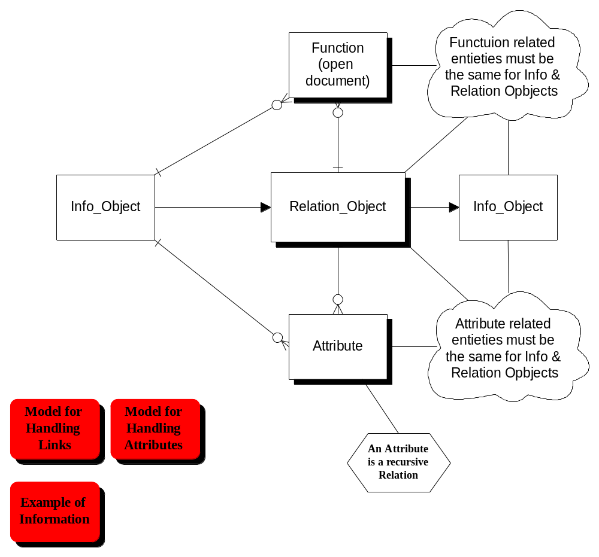Document management as defined by IN2000.mdb

Why
Data structure and terminology is simple and final
Most urgent need to go for the INTERNET

Inventory database is not yet final (terminology, scope)

