Họ và tên: **Nguyễn Tấn Hưng**

MSSV: **16141175**

Lớp thứ 4 tiết 123

# BÁO CÁO BÀI TẬP LAB 7: *Printing The Results*

# 1. Code python

#XXXXXXXXXXXXXXXXXXXXXXXXX COPY LAB6 XXXXXXXXXXXXXXXXXXXXXXXXXXXXXXXXXXXXXXXX

filenames **=** **[**"Beagle_01141.jpg"**,** "Beagle_01125.jpg"**,** "skunk_029.jpg" **]**

pet_labels **=** **[**"beagle"**,** "beagle"**,** "skunk"**]**

classifier_labels **=** **[**"walker hound, walker foxhound"**,** "beagle"**,**

"skunk, polecat, wood pussy"**]**

pet_label_is_dog **=** **[**1**,** 1**,** 0**]**

classifier_label_is_dog **=** **[**1**,** 1**,** 0**]**

# tao mot bien result_dic

results_dic **=** dict**()**

# so sanh trung khop thi gan

**for** idx **in** range **(**0**,** len**(**filenames**),** 1**):**

# neu chua co trong result_dic thi them vao result_dic

**if** filenames**[**idx**]** **not** **in** results_dic**:**

results_dic**[**filenames**[**idx**]]** **=** **[** pet_labels**[**idx**],** classifier_labels**[**idx**]** **]**

found **=** classifier_labels**[**idx**].**find**(**pet_labels**[**idx**])**

#lay cac nhan cua bo phan loai tim trong pet_labels neu co thi dem 1 nguoc lai giu nguyen

**if** found **>=** 0**:**

results_dic**[**filenames**[**idx**]]** **+=** **[** 1 **]**

**else:**

results_dic**[**filenames**[**idx**]]** **+=** **[** 0 **]**

#neu ket qua trug khop nhan pet và phan loai nhan pet

#in ra ket qua " pet_label_is_dog=1"

#in ra ket qua " classifier_label_is_dog=1" nguoc lai bang 0

**for** idx **in** range **(**0**,** len**(**filenames**),** 1**):**

results_dic**[**filenames**[**idx**]].**append**(**pet_label_is_dog**[**idx**])**

results_dic**[**filenames**[**idx**]].**append**(**classifier_label_is_dog**[**idx**])**

**for** key **in** results_dic**:**

**print(**"\nFilename="**,** key**,** "\npet_image Label="**,** results_dic**[**key**][**0**],**

"\nClassifier Label="**,** results_dic**[**key**][**1**],** "\nmatch="**,**results_dic**[**key**][**2**],**

"\nImage is dog="**,** results_dic**[**key**][**3**],**"\nClassifier is dog="**,** results_dic**[**key**][**4**])**

#tao result_stats_dic

results_stats_dic **=** dict**()**

#Khoi tao cac gia tri

results_stats_dic**[**'n_dogs_img'**]** **=** 0

results_stats_dic**[**'n_match'**]** **=** 0

results_stats_dic**[**'n_correct_dogs'**]** **=** 0

results_stats_dic**[**'n_correct_notdogs'**]** **=** 0

results_stats_dic**[**'n_correct_breed'**]** **=** 0

# tinh tong so luong

results_stats_dic**[**'n_images'**]** **=** len**(**results_dic**)**

**for** key **in** results_dic**:**

**if** results_dic**[**key**][**2**]** **==** 1**:**

results_stats_dic**[**'n_match'**]** **+=** 1

**pass**

**if** results_dic**[**key**][**3**]** **==** 1**:**

results_stats_dic**[**'n_dogs_img'**]** **+=** 1

# 

**if** results_dic**[**key**][**4**]** **==** 1**:**

results_stats_dic**[**'n_correct_dogs'**]** **+=** 1

**else:**

**pass**

**pass**

# tinh so buc anh khong phai anh cho

results_stats_dic**[**'n_notdogs_img'**]** **=** **(**results_stats_dic**[**'n_images'**]** **-** results_stats_dic**[**'n_dogs_img'**])**

results_stats_dic**[**'n_correct_notdogs'**]** **=** **(**results_stats_dic**[**'n_dogs_img'**]** **-** results_stats_dic**[**'n_correct_dogs'**])**

#ti le phan tram trung và khong trung

results_stats_dic**[**'pct_match'**]** **=** 0.0

results_stats_dic**[**'pct_correct_dogs'**]** **=** 0.0

results_stats_dic**[**'pct_correct_notdogs'**]** **=** 0.0

results_stats_dic**[**'pct_correct_breed'**]** **=** 0.0

# phan tram hinh cho trung khop voi nhan cho chinh xac

results_stats_dic**[**'pct_correct_dogs'**]** **=** **(**results_stats_dic**[**'n_correct_dogs'**]** **/**results_stats_dic**[**'n_dogs_img'**])\***100.0

#phan tram hinh cho khong trung khop voi nhan cho

**if** results_stats_dic**[**'n_notdogs_img'**]** **>** 0**:**

results_stats_dic**[**'pct_correct_notdogs'**]** **=** **(**results_stats_dic**[**'n_correct_notdogs'**]** **/**results_stats_dic**[**'n_notdogs_img'**])\***100.0

**else:**

results_stats_dic**[**'pct_correct_notdogs'**]** **=** 0.0

#pham tran trung khop chinh xac

results_stats_dic**[**'pct_match'**]** **=** **(**results_stats_dic**[**'n_match'**]** **/**results_stats_dic**[**'n_images'**])\***100.0

**print(**"\nNumber of image="**,**results_stats_dic**[**'n_images'**]** **,**"\nNumber of match="**,**results_stats_dic**[**'n_match'**]** **,**

"\nNumber of dog="**,**results_stats_dic**[**'n_dogs_img'**],**

"\nNumber of not dog="**,**results_stats_dic**[**'n_notdogs_img'**]** **,**

"\nNumber of correct dogs="**,**results_stats_dic**[**'n_correct_dogs'**],**

"\nNumber of correct not dogs="**,**results_stats_dic**[**'n_correct_notdogs'**],**

"\nPercent of match="**,**results_stats_dic**[**'pct_match'**],**

"\nPercent of correct no dog="**,**results_stats_dic**[**'pct_correct_notdogs'**],**

"\nPercent of correct dog="**,**results_stats_dic**[**'pct_correct_dogs'**])**

#XXXXXXXXXXXXXXXXXXXXXXXXXXXXXXXX END LAB6 XXXXXXXXXXXXXXXXXXXXXXXXXXXXXX

# In ra ket qua thong ke cac thong so

**print(**"\n Results Summary for CNN Model Architecture : VGG"**)**

**print(**"%25s: %3d" **%** **(**'Number Images'**,**results_stats_dic**[**'n_images'**]))**

**print(**"%25s: %3d" **%** **(**'Number Dog Images'**,**results_stats_dic**[**'n_dogs_img'**]))**

**print(**"%25s: %3d" **%** **(**'Number Not-Dog Images'**,**results_stats_dic**[**'n_notdogs_img'**]),**'\n'**)**

# in ra ket qua tong

**for** key **in** results_stats_dic**:**

**if** key**[**0**]** **==** 'p'**:**

**print(**"%25s: %5.1f" **%** **(**key**,**results_stats_dic**[**key**]))**

# IF print_incorrect_dogs == True AND there were images incorrectly

# classified as dogs or vice versa - print out these cases

**if** **((**results_stats_dic**[**'n_correct_dogs'**]** **+** results_stats_dic**[**'n_correct_notdogs'**])!=** results_stats_dic**[**'n_images'**]):**

**print(**"\n INCORRECT Dog/NOT Dog Assignments: "**)**

# process through results dict,printing incorrectly classified dogs

* **Hình ảnh**

# process through results dict,printing incorrectly classified dogs

**for** key **in** results_dic**:**

# Pet Image Label is a Dog - Classified as NOT-A-DOG -OR-

# Pet Image Label is NOT-a-Dog - Classified as a-DOG

**if** sum**(**results_dic**[**key**][**3**:])** **==** 1**:**

**print(**"Real: %-26s Classifier: %-30s" **%** **(**results_dic**[**key**][**0**],**results_dic**[**key**][**1**]))**

# IF print_incorrect_breed == True AND there were dogs whose breeds

# were incorrectly classified - print out these cases

**if** **(**results_stats_dic**[**'n_correct_dogs'**]** **!=** results_stats_dic**[**'n_correct_breed'**]):**

**print(**"\nINCORRECT Dog Breed Assignment:"**)**

# process through results dict, printing incorrectly classified breeds

**for** key **in** results_dic**:**

# Pet Image Label is-a-Dog, classified as-a-dog but is WRONG breed

**if** **(** sum**(**results_dic**[**key**][**3**:])** **==** 2 **and** results_dic**[**key**][**2**]** **==** 0 **):**

**print(**"Real: %-26s Classifier: %-30s" **%** **(**results_dic**[**key**][**0**],**results_dic**[**key**][**1**]))**

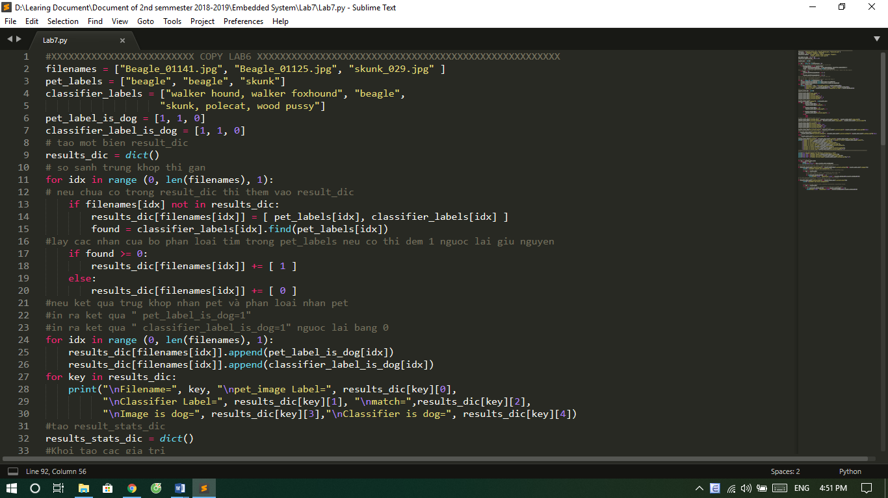

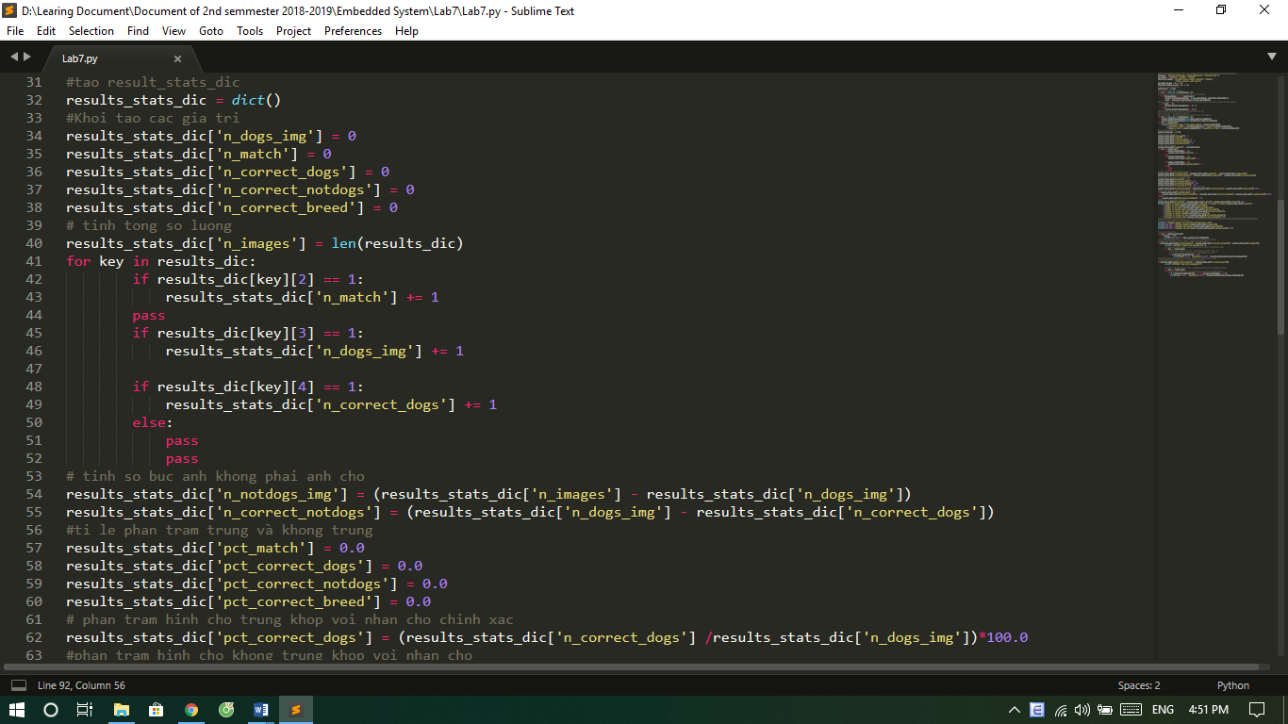



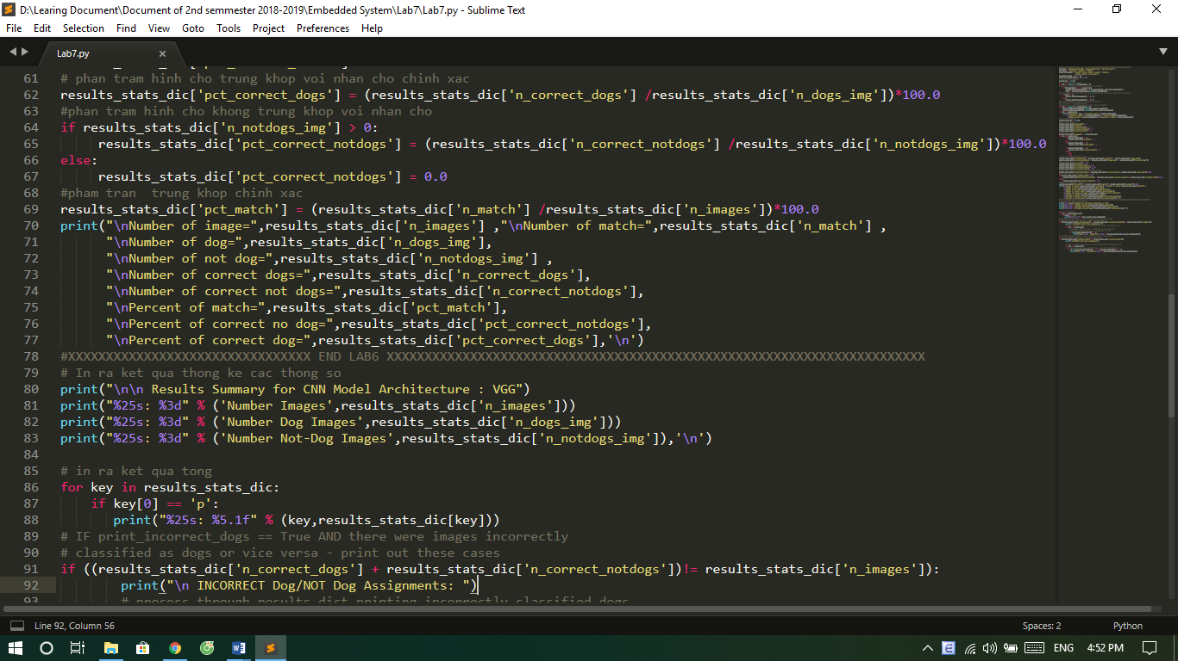

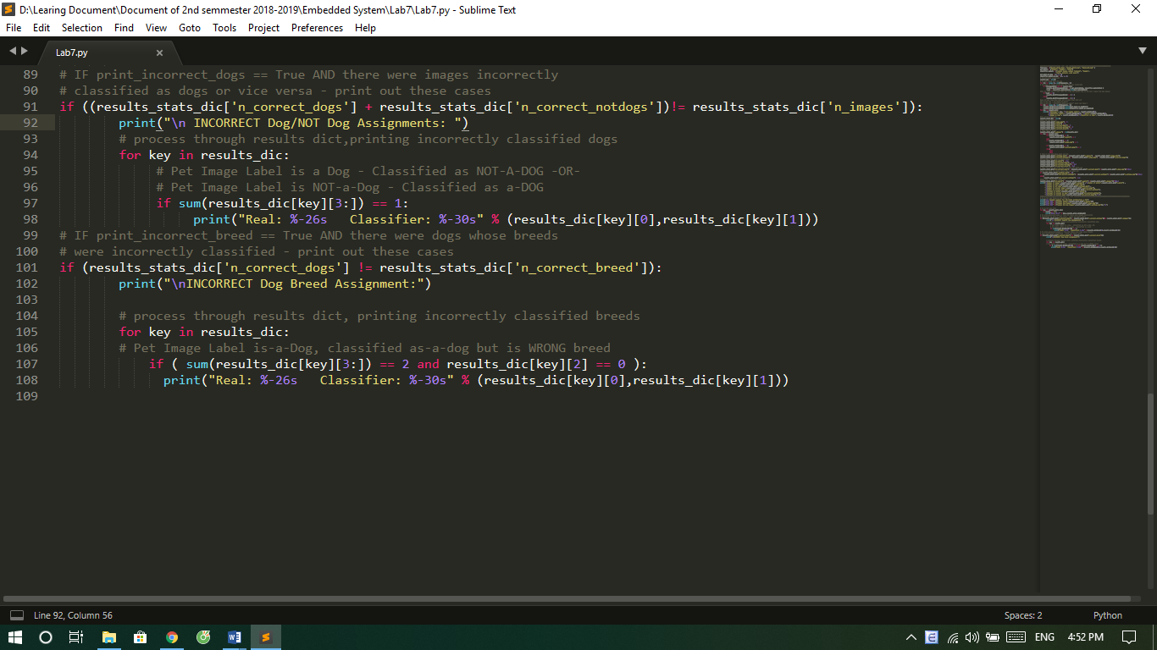

**2. Kết quả**

