**VIVEKANANDA INSTITUTE OF PROFESSIONAL STUDIES**

**VIVEKANANDA SCHOOL OF INFORMATION TECHNOLOGY**



**BACHELOR OF COMPUTER APPLICATION**

**Practical-VI DBMS Lab File**

**BCA-176**

**Guru Gobind Singh Indraprastha University   
Sector - 16C Dwarka, Delhi – 110078**



**SUBMITTED TO:                                   SUBMITTED BY:**

Ms. Vani Nijhawan Karthik Nair

Assistant Professor

VSIT

**INDEX**

|  |  |  |  |  |
| --- | --- | --- | --- | --- |
| **S.No.** | **Question** | **Page No.** | **Date** | **Signature** |
| 1. | Create Database Company | 3 | 05/05/22 |  |
| 2. | Populate tables with data | 6 | 05/05/22 |  |
| 3. | Display all the details of all employees working in the company. | 9 | 12/05/22 |  |
| 4. | Retrieve the birthdate and address of the employee whose name is 'Franklin T. Wong'. | 9 | 12/05/22 |  |
| 5. | Retrieve all distinct salary values. | 10 | 12/05/22 |  |
| 6. | Retrieve all employee names whose address is in ‘Bellaire’. | 10 | 12/05/22 |  |
| 7. | Retrieve all employees who were born during the 1950s. | 10 | 12/05/22 |  |
| 8. | Retrieve all employees in department 5 whose salary is between 50,000 and 60,000(inclusive). | 11 | 12/05/22 |  |
| 9. | Retrieve the names of all employees who do not have supervisors. | 11 | 12/05/22 |  |
| 10. | Find the sum of the salaries of all employees, the maximum salary, the minimum salary, and the average salary. | 11 | 12/05/22 |  |
| 11. | Find the sum of the salaries of all employees, the maximum salary, the minimum salary, and the average salary. Display with proper headings. | 12 | 12/05/22 |  |
| 12. | Retrieve the name and address of all employees who work for the 'Research' department. | 12 | 19/05/22 |  |
| 13. | For every project located in 'Stafford', list the project number, the controlling department number, and the department manager's last name, address, and birthdate. | 13 | 19/05/22 |  |
| 14. | Increase the salary of all employees by 15%. Retrieve employee name and increased salary of these employees. | 13 | 19/05/22 |  |
| 15. | Increase the salary of all employees working on the 'ProductX' project by 15%. Retrieve employee name and increased salary of these employees. | 14 | 19/05/22 |  |
| 16. | Retrieve a list of employees and the project name each works in, ordered by the employee's department, and within each department ordered alphabetically by employee first name. | 14 | 19/05/22 |  |
| 17. | Retrieve the employee numbers of all employees who work on project located in Bellaire, Houston, or Stafford. | 15 | 19/05/22 |  |
| 18. | Select the names of employees whose salary is greater than the average salary of all employees in department 10. | 16 | 19/05/22 |  |
| 19. | For each department, retrieve the department number, the number of employees in the department, and their average salary | 16 | 19/05/22 |  |
| 20. | Update the salary and deptno of employee 'Franklin T. Wong' to 50000 and 4. | 17 | 19/05/22 |  |
| 21. | Insert a record in Project table which violates referential integrity constraint with respect to Department number. Now remove the violation by making necessary insertion in the Department table. | 18 | 19/05/22 |  |
| 22. | Perform a query using alter command to drop/add field and a constraint in Employee table. | 18 | 19/05/22 |  |

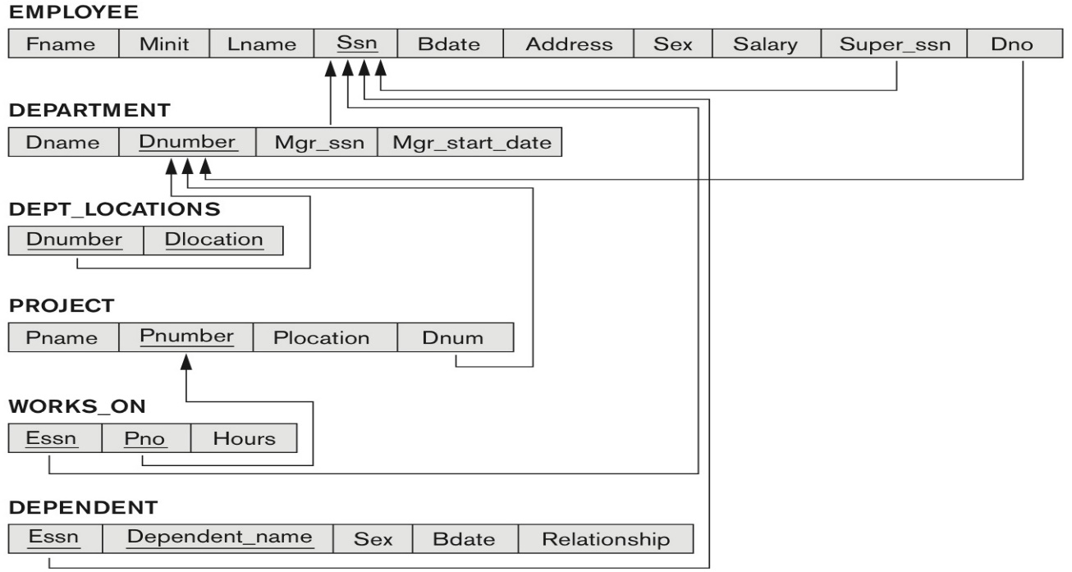

**I . Create a database named COMPANY with the above tables/relations using relevant data types and constraints such as primary key, foreign key, not null unique etc.**

**Queries:**

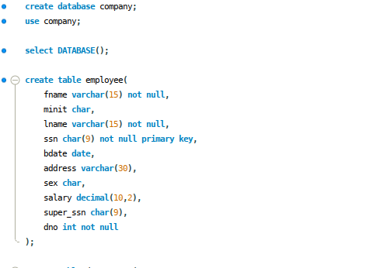

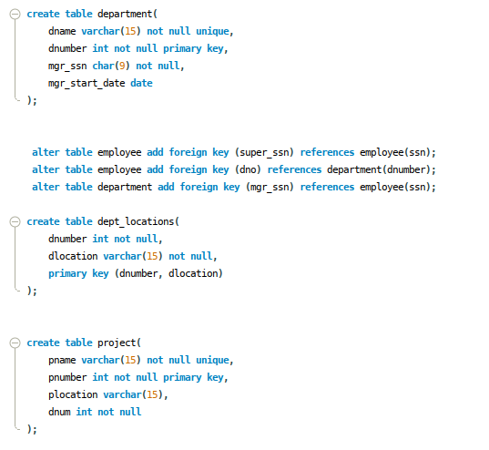

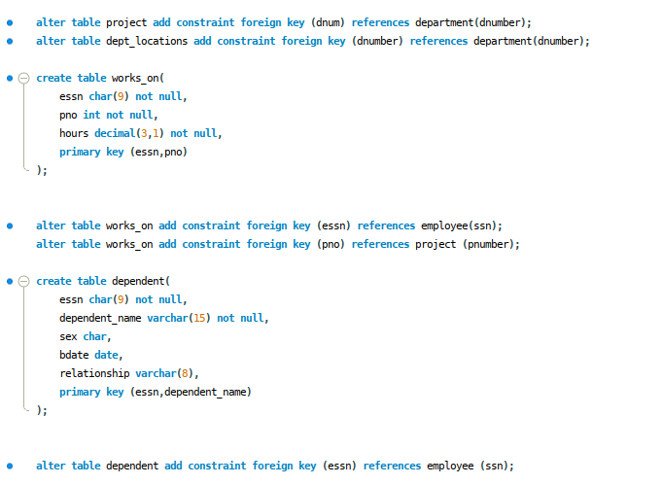

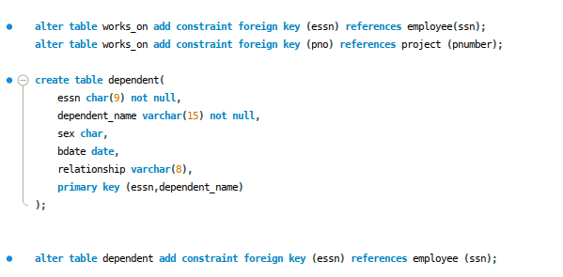

**II. Populate the tables with data (Insert the following records into the appropriate tables)**

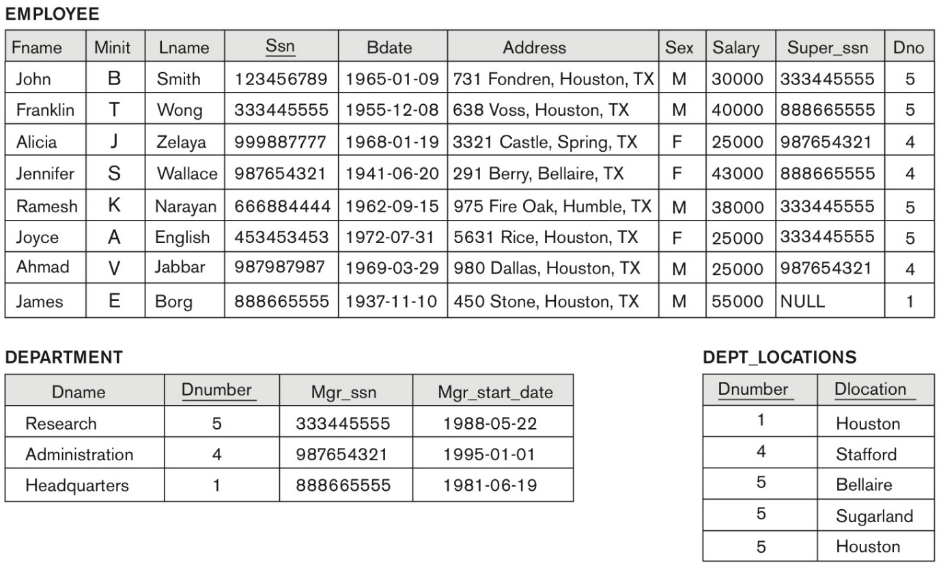

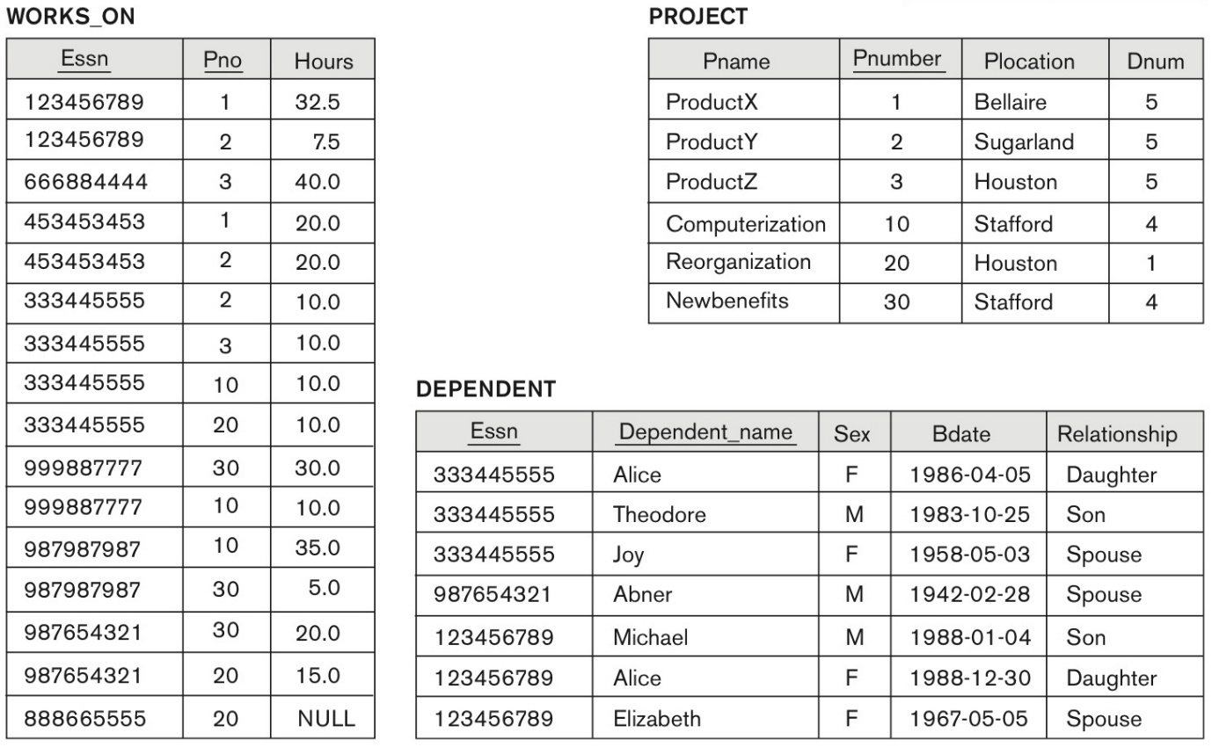

**Queries:**

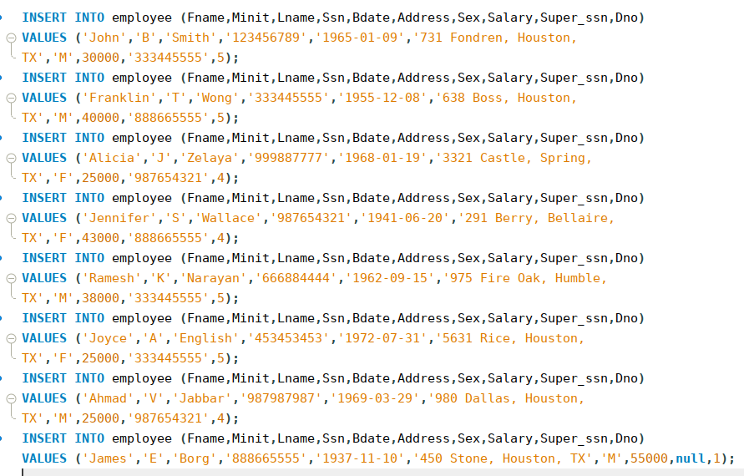

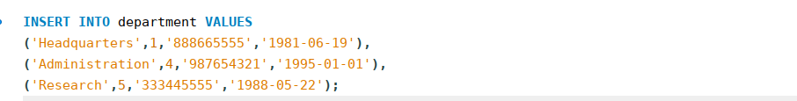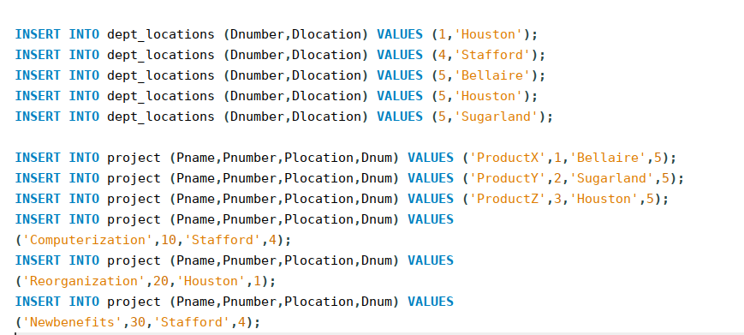

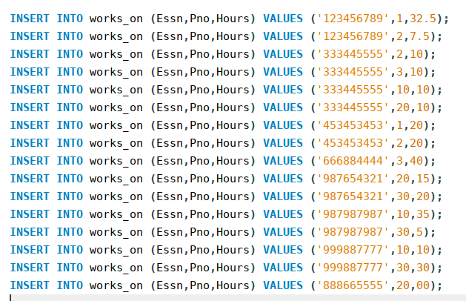

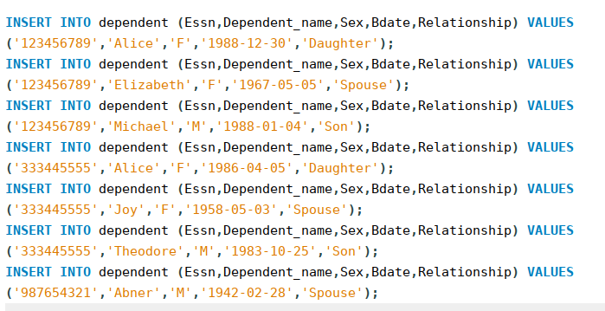

**3. Display all the details of all employees working in the company.**

**Query:**



**Output:**

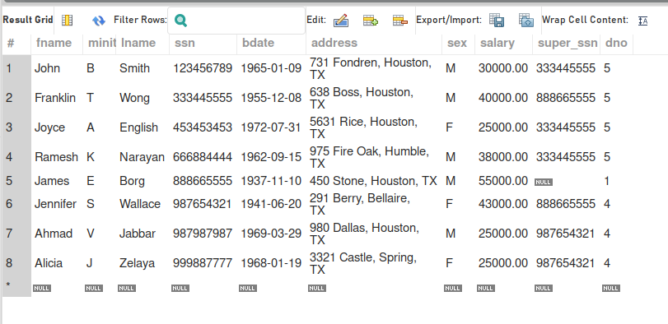

**4. Retrieve the birthdate and address of the employee whose name is 'Franklin T. Wong'.**

**Query:**



**Output:**

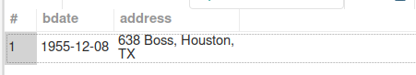

**5. Retrieve all distinct salary values.**

**Query:**



**Output:**

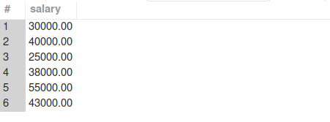

**6. Retrieve all employee names whose address is in ‘Bellaire’.**

**Query:**



**Output:**



**7. Retrieve all employees who were born during the 1950s.**

**Query:**



**Output:**

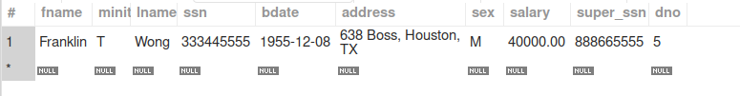

**8. Retrieve all employees in department 5 whose salary is between 50,000 and 60,000(inclusive).**

**Query:**



**Output:**



**9. Retrieve the names of all employees who do not have supervisors.**

**Query:**



**Output:**



**10. Find the sum of the salaries of all employees, the maximum salary, the minimum salary, and the average salary.**

**Query:**



**Output:**



**11. Find the sum of the salaries of all employees, the maximum salary, the minimum salary, and the average salary. Display with proper headings.**

**Query:**



**Output:**

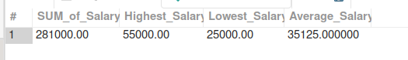

**12. Retrieve the name and address of all employees who work for the 'Research' department.**

**Query:**



**Output:**

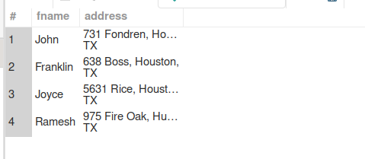

**13. For every project located in 'Stafford', list the project number, the controlling department number, and the department manager's last name, address, and birthdate.**

**Query:**

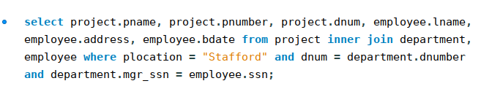

**Output:**

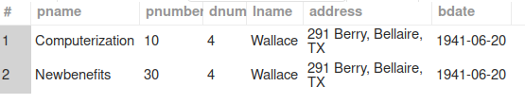

**14. Increase the salary of all employees by 15%. Retrieve employee name and increased salary of these employees.**

**Query:**

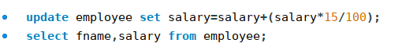

**Output:**

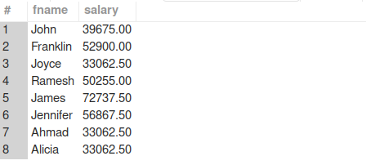

**15. Increase the salary of all employees working on the 'ProductX' project by 15%. Retrieve employee name and increased salary of these employees.**

**Query:**

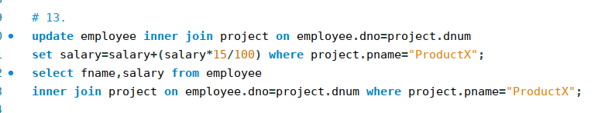

**Output:**

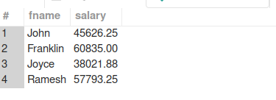

**16. Retrieve a list of employees and the project name each works in, ordered by the employee's department, and within each department ordered alphabetically by employee first name.**

**Query:**

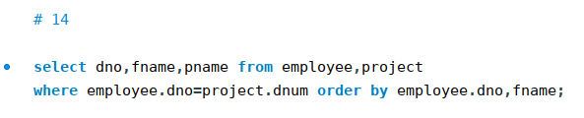

**Output:**

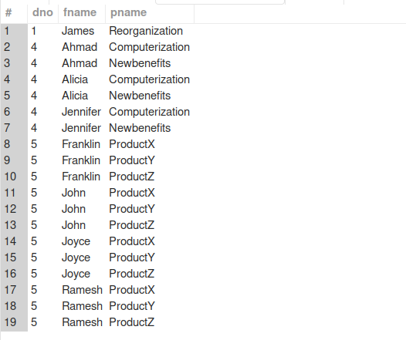

**17. Retrieve the employee numbers of all employees who work on project located in Bellaire, Houston, or Stafford.**

**Query:**

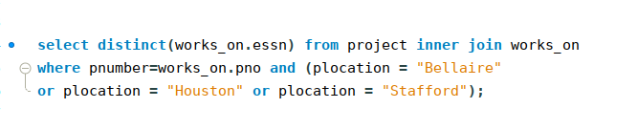

**Output:**

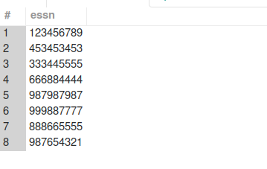

**18. Select the names of employees whose salary is greater than the average salary of all employees in department 10.**

**Query:**

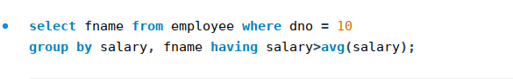

**Output:**



**19. For each department, retrieve the department number, the number of employees in the department, and their average salary**

**Query:**

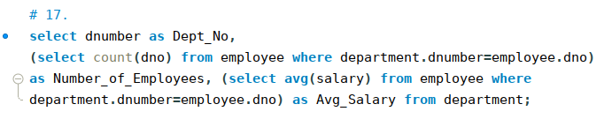

**Output:**

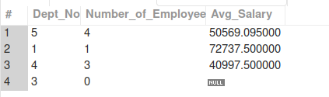

**20. Update the salary and deptno of employee 'Franklin T. Wong' to 50000 and 4.**

**Query:**

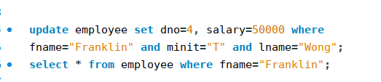

**Output:**

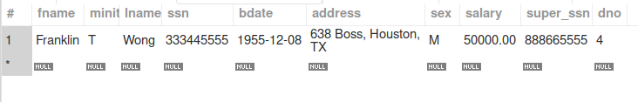

**21. Insert a record in Project table which violates referential integrity constraint with respect to Department number. Now remove the violation by making necessary insertion in the Department table.**

**Queries:**

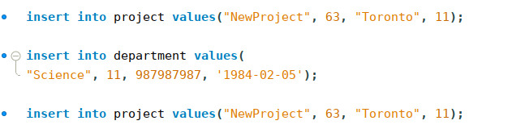

**Output:**



**22. Perform a query using alter command to drop/add field and a constraint in Employee table.**

