C Programming Assignment 1

Submitted by: Karthik Nair, EA, CET Rank: 585, dated 27th January 2022

Compiler used - gcc 11.2.0 (Ubuntu 11.2.0-7ubuntu2)

1. Write a C program to find maximum between two numbers.

// Write a C program to find maximum between two numbers.

#include <stdio.h>

int main()

{

printf("Name: Karthik Nair, Class: BCA1EA\n");

int a,b;

printf("\nEnter the first number: ");

scanf("%d", &a);

printf("Enter the second number: ");

scanf("%d", &b);

if (a>b)

{

printf("\n%d is the maximum number", a);

}

else if (a<b)

{

printf("\n%d is the maximum number", b);

}

// Exception

else

{

printf("Entered numbers are equal");

}

printf("\n");

return 0;

}

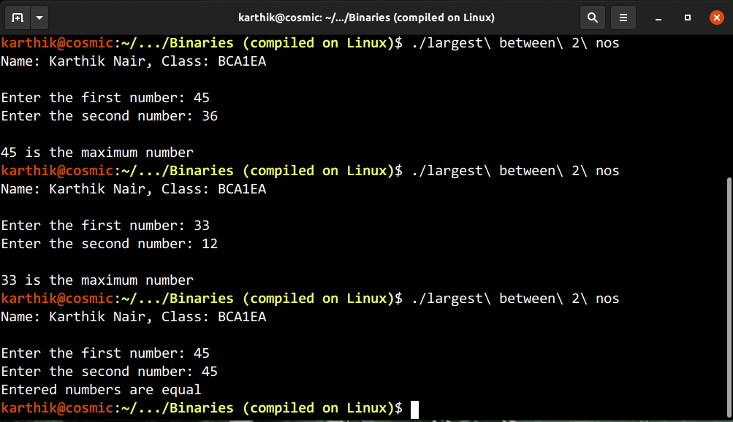

2. Write a C program to find maximum between three numbers.

// Write a C program to find maximum between three numbers

#include <stdio.h>

int main()

{

printf("Name: Karthik Nair, Class: BCA1EA\n");

int a,b,c;

printf("Enter the first number: ");

scanf("%d", &a);

printf("Enter the second number: ");

scanf("%d", &b);

printf("Enter the third number: ");

scanf("%d", &c);

if ((a>b)&&(a>c))

{

printf("%d is the largest number !",a);

}

else if ((b>a)&&(b>c))

{

printf("%d is the largest number !",b);

}

else if ((c>a)&&(c>b))

{

printf("%d is the largest number !",c);

}

// Exception

else

{

printf("Entered numbers are equal");

}

printf("\n");

}

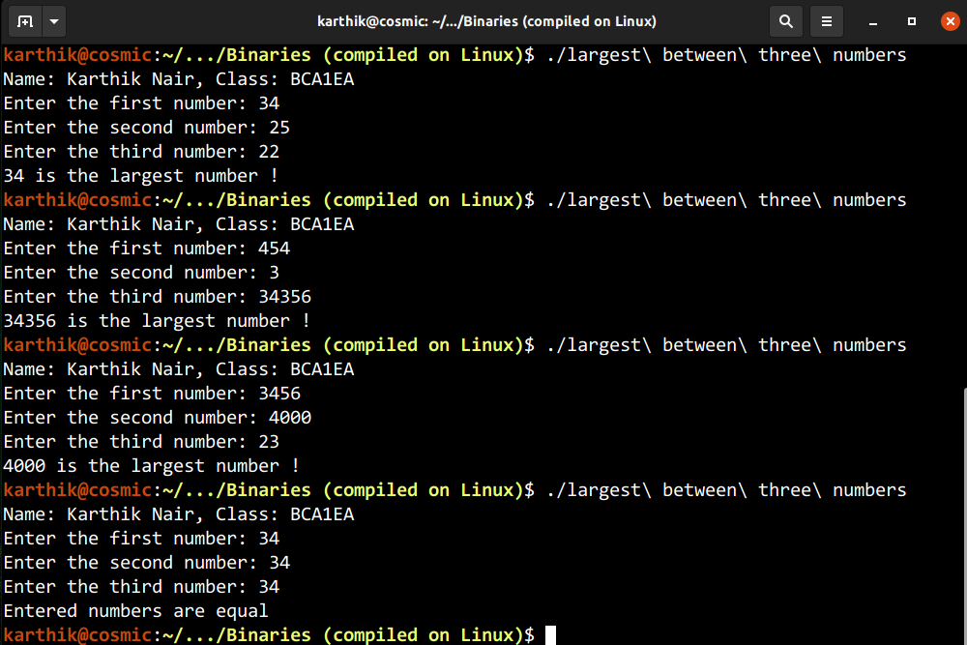

3. Write a C program to check whether a number is negative, positive or zero.

// Write a C program to check whether a number is negative, positive or zero

#include <stdio.h>

int main()

{

printf("Name: Karthik Nair, Class: BCA1EA\n");

int num;

printf("Enter a number: ");

scanf("%d",&num);

printf("The entered number '%d' is ",num);

if (num>0)

{

printf("positive!");

}

else if (num<0)

{

printf("negative!");

}

else

{

printf("zero!");

}

printf("\n");

}

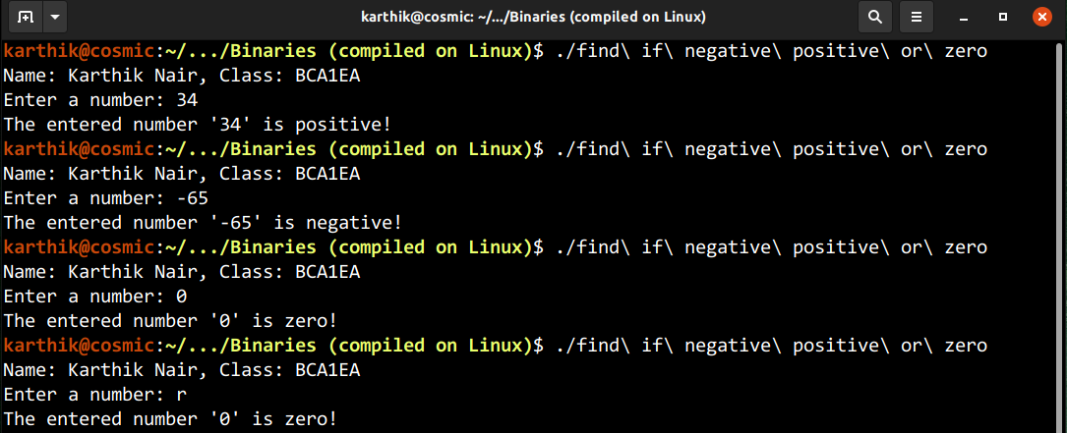

4. Write a C program to check whether a number is divisible by 5 and 11 or not

// Write a C program to check whether a number is divisible by 5 and 11 or not

#include <stdio.h>

int main()

{

printf("Name: Karthik Nair, Class: BCA1EA\n");

int num;

printf("Enter a number: ");

scanf("%d",&num);

if ((num%5==0)&&(num%11==0))

{

printf("%d is divisible by 5 and 11", num);

}

else

{

printf("%d is not divisible by 5 and 11", num);

}

printf("\n");

}

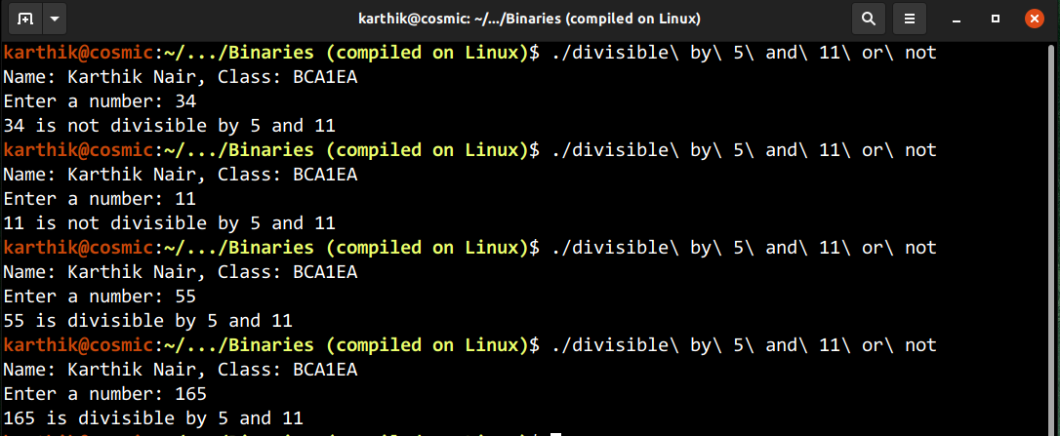

5. Write a C program to check whether a number is even or odd

// Write a C program to check whether a number is even or odd

#include <stdio.h>

int main()

{

printf("Name: Karthik Nair, Class: BCA1EA\n");

int num;

printf("Enter a number: ");

scanf("%d", &num);

printf("%d is an ", num);

if (num%2==0)

{

printf("even");

}

else

{

printf("odd");

}

printf(" number\n");

}

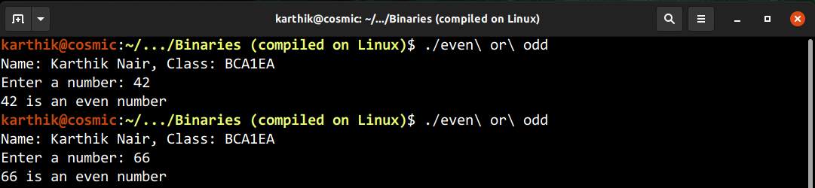

6. Write a C program to check whether an year is leap year or not

// Write a C program to check whether a year is leap year or not

#include <stdio.h>

int main()

{

printf("Name: Karthik Nair, Class: BCA1EA\n");

int year;

printf("Enter an year: ");

scanf("%d",&year);

printf("%d is ", year);

if ((year%4==0)&&((year%400==0)||((year%100)!=0)))

{

printf("a leap year");

}

else

{

printf("not a leap year");

}

printf("\n");

}

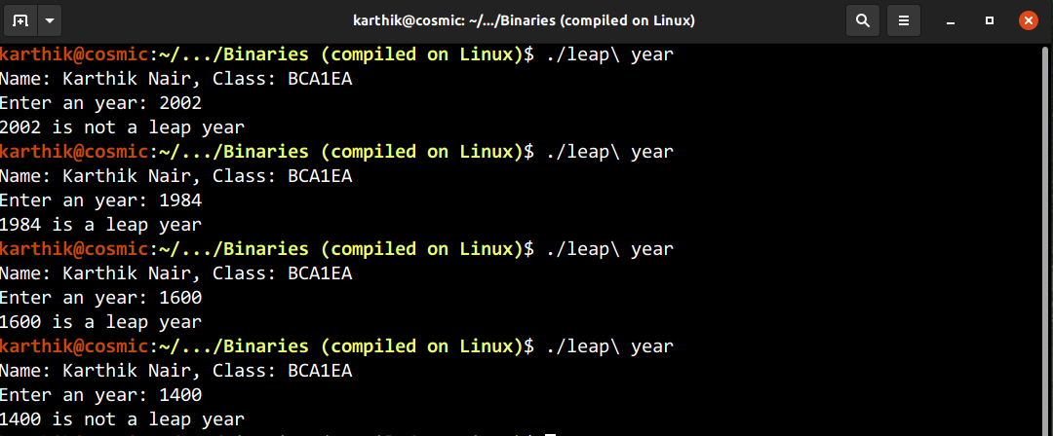

7. Write a C program to check whether a character is alphabet or not.

// Write a C program to check whether a character is alphabet or not

#include <stdio.h>

int main()

{

printf("Name: Karthik Nair, Class: BCA1EA\n");

char a;

printf("Enter a character: ");

scanf("%c",&a);

printf("%c is ", a);

if (((a>='a')&&(a<='z'))||((a>='A')&&(a<='Z')))

{

printf("an Alphabet");

}

else

{

printf("not an Alphabet");

}

printf("\n");

}

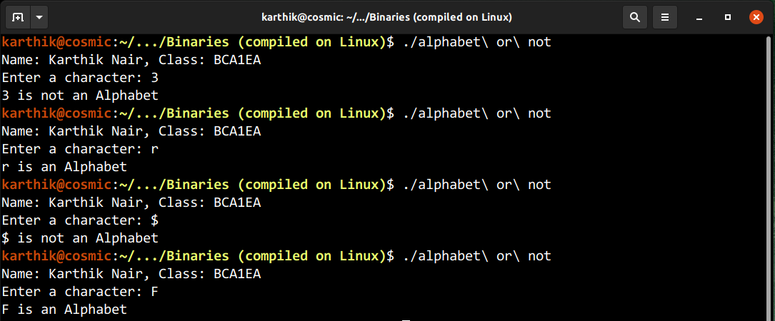

8. Write a C program to input any alphabet and check whether it is vowel or consonant

// Write a C program to input any alphabet and check whether it is vowel or consonant

#include <stdio.h>

int main()

{

printf("Name: Karthik Nair, Class: BCA1EA\n");

char a;

printf("Enter a character: ");

scanf("%c",&a);

printf("%c is ", a);

if ((a=='a')||(a=='A')||(a=='e')||(a=='E')||(a=='i')||(a=='I')

||(a=='o')||(a=='O')||(a=='u')||(a=='U'))

{

printf("a vowel!\n");

}

else if (((a>='a')&&(a<='z'))||((a>='A')&&(a<='Z')))

{

printf("a consonant!\n");

}

// Exception

else

{

printf("neither a vowel nor a consonant!\n");

}

}

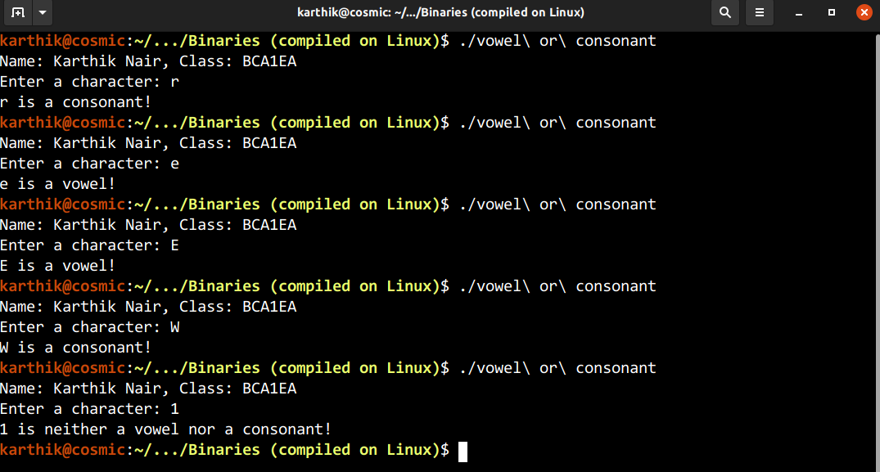

9. Write a C program to input any character and check whether it is alphabet, digit or special character.

#include <stdio.h>

int main()

{

printf("Name: Karthik Nair, Class: BCA1EA\n");

char a;

printf("Enter a character: ");

scanf("%c", &a);

printf("Entered character is ");

if (((a>='a')&&(a<='z'))||((a>='A')&&(a<='Z')))

{

printf("an alphabet");

}

else if ((a>='0')&&(a<='9'))

{

printf("a number");

}

else

{

printf("a special character");

}

printf("\n");

}

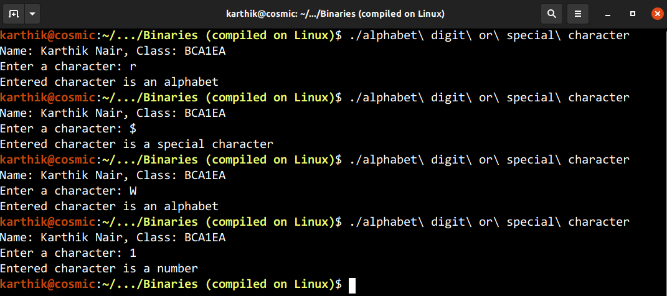

10. Write a C program to check whether a character is uppercase or lowercase alphabet.

// Write a C program to check whether a character is uppercase or lowercase alphabet

#include <stdio.h>

int main()

{

printf("Name: Karthik Nair, Class: BCA1EA\n");

char a;

printf("Enter a character: ");

scanf("%c", &a);

printf("entered character '%c' is ", a);

if (((a>='a')&&(a<='z'))||((a>='A')&&(a<='Z')))

{

if ((a>='a')&&(a<='z'))

{

printf("lowercase");

}

else

{

printf("uppercase");

}

}

// Exception

else

{

printf("not an alphabet");

}

printf("!\n");

}

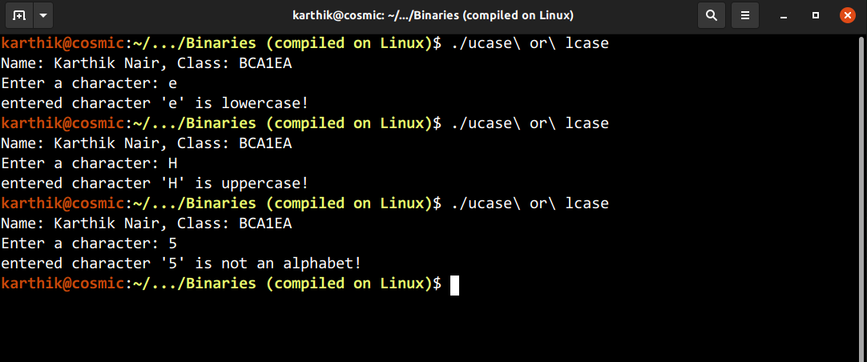

11. Write a C program to input week day number and print week day name

// Write a C program to input week day number and print week day name

#include <stdio.h>

int main()

{

int week_day_num;

printf("Enter week day number: ");

scanf("%d", &week_day_num);

if ((week_day_num>0)&&(week_day_num<8))

{

switch (week_day_num)

{

case 1: printf("Monday"); break;

case 2: printf("Tuesday"); break;

case 3: printf("Wednesday"); break;

case 4: printf("Thursday"); break;

case 5: printf("Friday"); break;

case 6: printf("Saturday"); break;

case 7: printf("Sunday"); break;

}

}

else

{

printf("Input must be numbers within 1 to 7 ");

}

printf("\n");

}

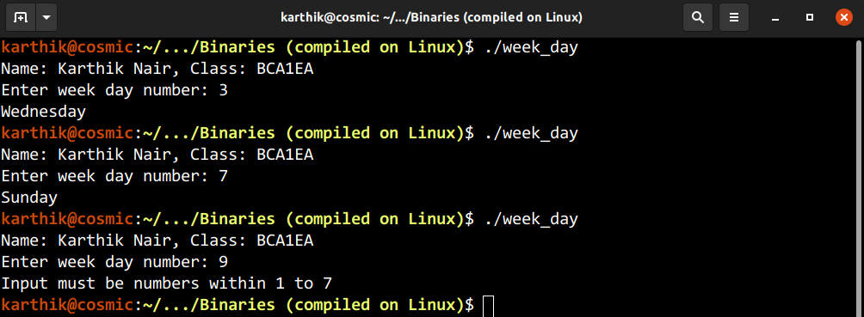

12. Write a C program to input month number and print number of days in that month.

// Write a C program to input month number and print number of days in that month

#include <stdio.h>

int main()

{

printf("Name: Karthik Nair, Class: BCA1EA\n");

int num, days;

printf("Enter month number: ");

scanf("%d", &num);

if ((num>=1)&&(num<=12))

{

if (num==2)

{

days=28;

}

else if ((num==1)||(num==3)||(num==5)||(num==7)||(num==8)||(num==10)||(num==12))

{

days=31;

}

else

{

days=30;

}

printf("Month %d has %d days", num, days);

}

// Exception

else

{

printf("input should be within 1 to 12");

}

printf("\n");

}

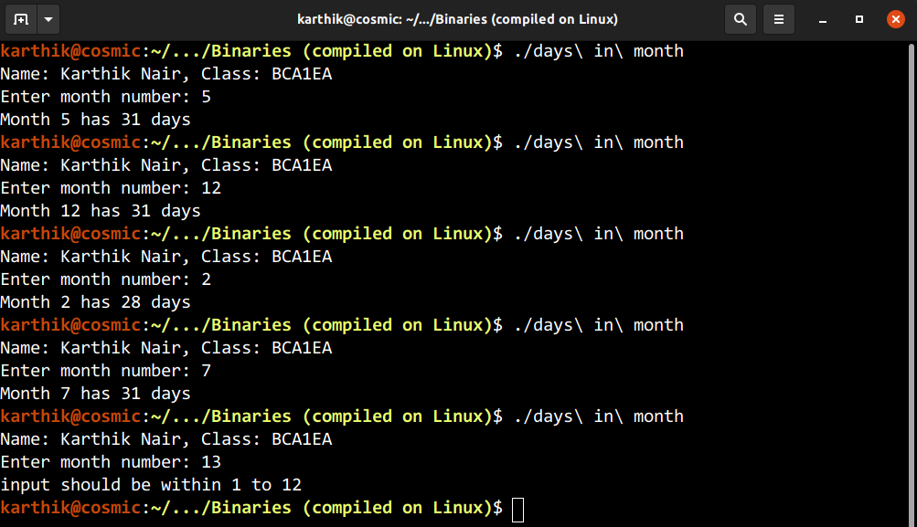

13. Write a C program to count total number of notes in given amount

// Write a C program to count total number of notes in given amount

#include <stdio.h>

int main()

{

printf("Name: Karthik Nair, Class: BCA1EA\n");

int n;

printf("Enter amount: ");

scanf ("%d",&n);

while (n!=0)

{

if (n>=2000)

{

printf("%d 2000 notes\n", n/2000);

n=n%2000;

}

else if (n>=500)

{

printf("%d 500 notes\n", n/500);

n=n%500;

}

else if (n>=200)

{

printf("%d 200 notes\n", n/200);

n=n%200;

}

else if (n>=100)

{

printf("%d 100 notes\n", n/100);

n=n%100;

}

else if (n>=50)

{

printf("%d 50 notes\n", n/50);

n=n%50;

}

else if (n>=20)

{

printf("%d 20 notes\n", n/20);

n=n%20;

}

else if (n>=10)

{

printf("%d 10 notes\n", n/10);

n=n%10;

}

else if (n>=5)

{

printf("%d 5 notes\n", n/5);

n=n%5;

}

else if (n>=2)

{

printf("%d 2 notes\n", n/2);

n=n%2;

}

else if (n>=1)

{

printf("%d 1 notes\n", n/1);

n=n%1;

}

}

}

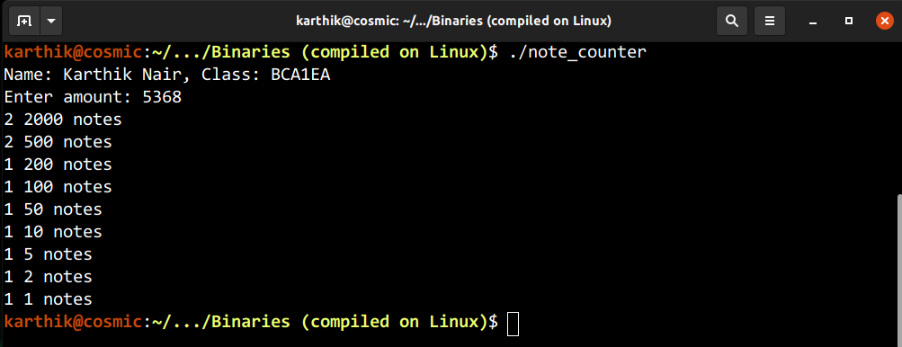

14. Write a C program to input angles of a triangle and check whether triangle is valid or not

// Write a C program to input angles of a triangle and check whether triangle is valid or not

#include <stdio.h>

int main()

{

printf("Name: Karthik Nair, Class: BCA1EA\n");

int angle1, angle2, angle3;

printf("Enter angle 1: ");

scanf("%d", &angle1);

printf("Enter angle 2: ");

scanf("%d", &angle2);

printf("Enter angle 3: ");

scanf("%d", &angle3);

if ((angle1+angle2+angle3)==180)

{

printf("Triangle is valid!");

}

else

{

printf("Triangle is invalid!");

}

printf("\n");

}

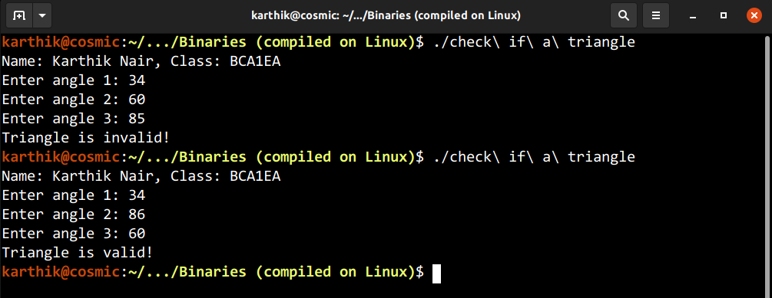

15. Write a C program to input all sides of a triangle and check whether triangle is valid or not

// Write a C program to input all sides of a triangle and check whether triangle is valid or not

#include <stdio.h>

int main()

{

printf("Name: Karthik Nair, Class: BCA1EA\n");

int side1, side2, side3;

printf("Enter side 1: ");

scanf("%d", &side1);

printf("Enter side 2: ");

scanf("%d", &side2);

printf("Enter side 3: ");

scanf("%d", &side3);

if (((side1+side2)>side3)&&((side2+side3)>side1)&&((side1+side3)>side2))

{

printf("Triangle is valid!");

}

else

{

printf("Triangle is invalid!");

}

printf("\n");

}

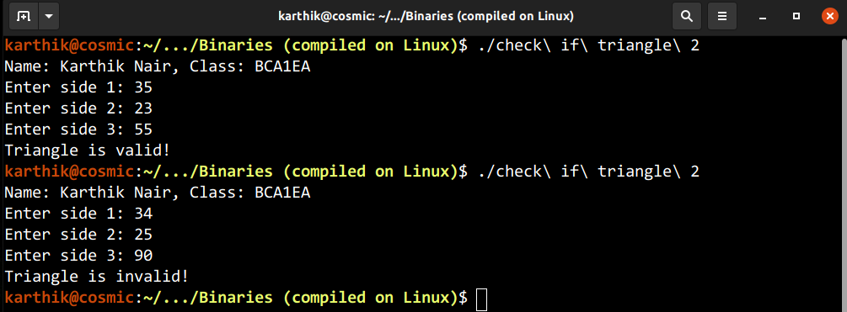

16. Write a C program to check whether the triangle is equilateral, isosceles or scalene triangle

// Write a C program to check whether the triangle is equilateral, isosceles or scalene triangle

#include <stdio.h>

int main()

{

printf("Name: Karthik Nair, Class: BCA1EA\n");

int side1, side2, side3;

printf("Enter side 1: ");

scanf("%d", &side1);

printf("Enter side 2: ");

scanf("%d", &side2);

printf("Enter side 3: ");

scanf("%d", &side3);

if (((side1+side2)>side3)&&((side2+side3)>side1)&&((side1+side3)>side2))

{

if ((side1!=side2)||(side1!=side3)||(side2!=side3))

{

if ((side1==side2)||(side1==side3)||(side2==side3))

{

printf("Triangle is isosceles!");

}

else

{

printf("Triangle is scalene!");

}

}

else

{

printf("Triangle is equilateral!");

}

}

else

{

printf("Input sides doesn't make a triangle!");

}

printf("\n");

}

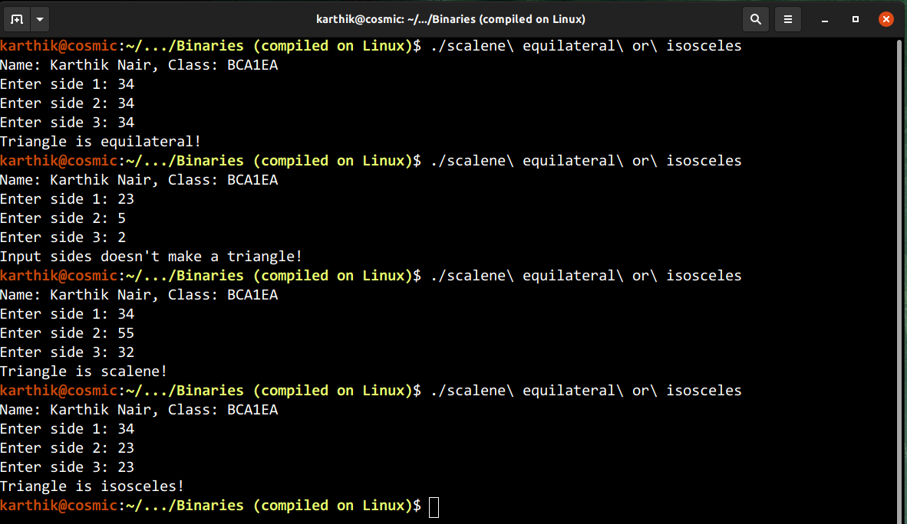

17. Write a C program to find the types roots of a quadratic equation

// Write a C program to find the types roots of a quadratic equation

#include <stdio.h>

int main()

{

printf("Name: Karthik Nair, Class: BCA1EA\n");

int a, b, c, d;

printf("Enter value of a: ");

scanf("%d", &a);

printf("Enter value of b: ");

scanf("%d", &b);

printf("Enter value of c: ");

scanf("%d", &c);

d=((b*b)-(4*a*c));

if (d>0)

{

printf("Roots are distinct");

}

else if (d==0)

{

printf("Roots are equal");

}

else

{

printf("Roots are imaginary");

}

printf("\n");

}

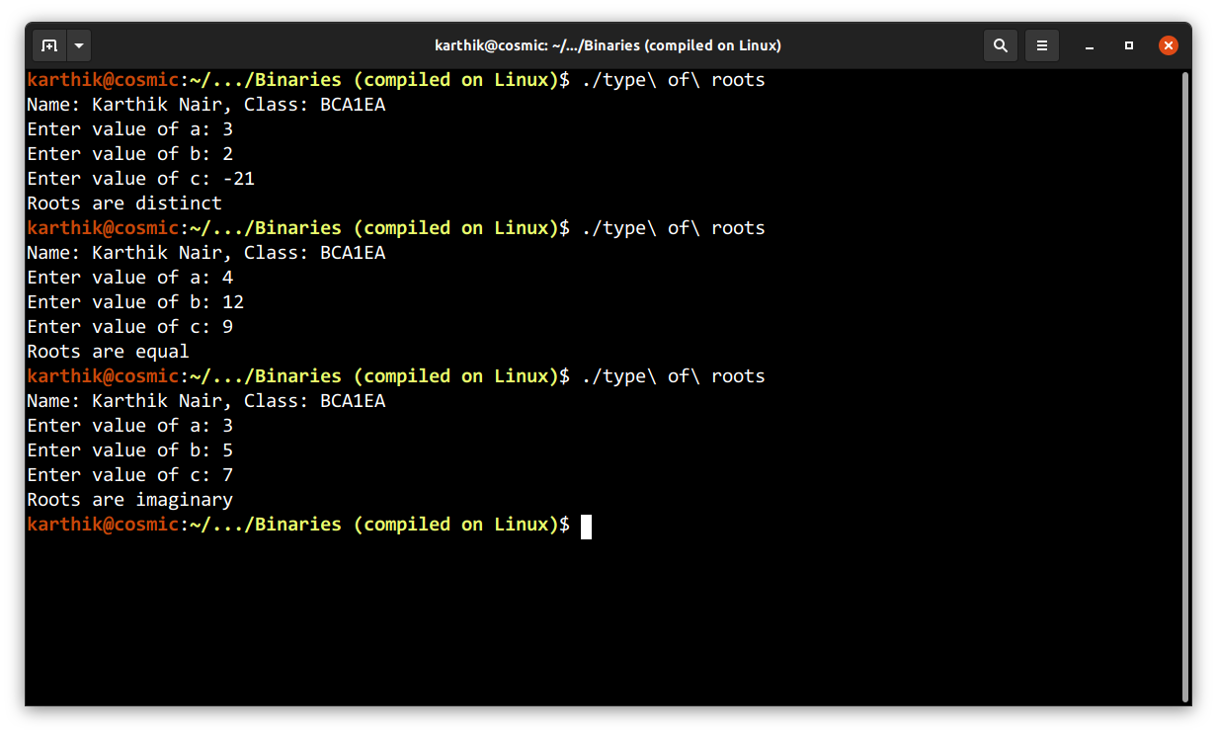

18. Write a C program to calculate profit or loss

// Write a C program to calculate profit or loss

#include <stdio.h>

int main()

{

printf("Name: Karthik Nair, Class: BCA1EA\n");

int cp, sp;

printf("Enter cost price: ");

scanf("%d", &cp);

printf("Enter sellings price: ");

scanf("%d", &sp);

if (sp>cp)

{

printf("Profit of %d", sp-cp);

}

else if (sp<cp)

{

printf("Loss of %d", cp-sp);

}

else

{

printf("No profit or loss");

}

printf("\n");

}

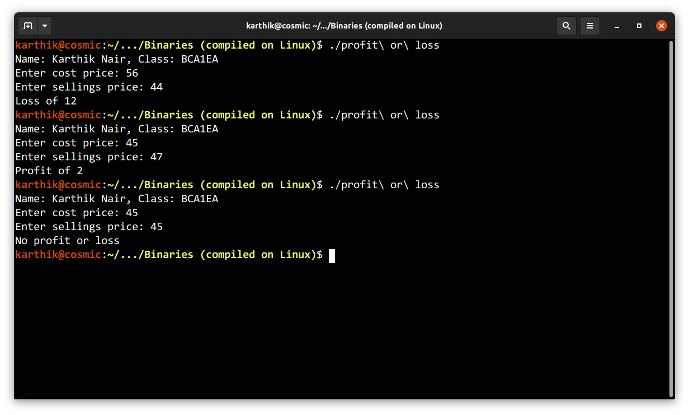

19. Write a C program to input marks of five subjects Physics, Chemistry, Biology, Mathematics and Computer. Calculate percentage and grade according to following:

Percentage >= 90% : Grade A

Percentage >= 80% : Grade B

Percentage >= 70% : Grade C

Percentage >= 60% : Grade D

Percentage >= 50% : Grade E

Percentage < 40% : Grade F

/*Write a C program to input marks of five subjects Physics, Chemistry, Biology, Mathematics and Computer. Calculate percentage and grade according to following:

Percentage >= 90% : Grade A

Percentage >= 80% : Grade B

Percentage >= 70% : Grade C

Percentage >= 60% : Grade D

Percentage >= 50% : Grade E

Percentage < 40% : Grade F */

#include <stdio.h>

int main()

{

printf("Name: Karthik Nair, Class: BCA1EA\n");

float mark1, mark2, mark3, mark4, mark5, percentage;

printf("Marks are out of 100 \n");

printf("Input marks in Physics: ");

scanf("%f", &mark1);

printf("Input marks in Chemistry: ");

scanf("%f", &mark2);

printf("Input marks in Mathematics: ");

scanf("%f", &mark3);

printf("Input marks in Biology: ");

scanf("%f", &mark4);

printf("Input marks in Computer: ");

scanf("%f", &mark5);

percentage=((mark1+mark2+mark3+mark4+mark5)/500)*100;

printf("Percentage is %f \n", percentage);

printf("Grade is ");

if (percentage>=90)

{

printf("A");

}

else if (percentage>=80)

{

printf("B");

}

else if (percentage>=70)

{

printf("C");

}

else if (percentage>=60)

{

printf("D");

}

else if (percentage>=50)

{

printf("E");

}

else

{

printf("F");

}

printf("\n");

}

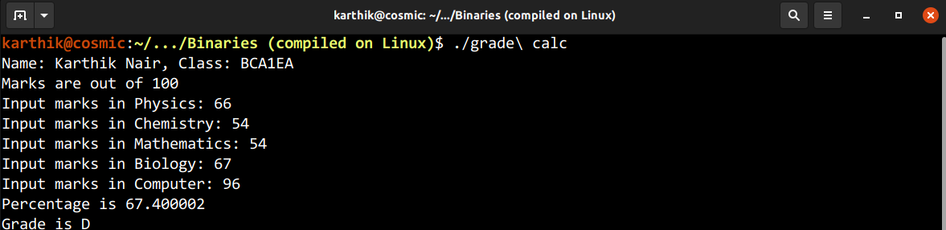

20. Write a C program to input basic salary of an employee and calculate its Gross salary according to following:

Basic Salary <= 10000 : HRA = 20%, DA = 80%

Basic Salary <= 20000 : HRA = 25%, DA = 90%

Basic Salary > 20000 : HRA = 30%, DA = 95%

/*Write a C program to input basic salary of an employee and calculate its Gross salary according to following:

Basic Salary <= 10000 : HRA = 20%, DA = 80%

Basic Salary <= 20000 : HRA = 25%, DA = 90%

Basic Salary > 20000 : HRA = 30%, DA = 95% */

#include <stdio.h>

int main()

{

printf("Name: Karthik Nair, Class: BCA1EA\n");

float HRA, DA, basic;

printf("Enter Basic Salary: ");

scanf("%f", &basic);

if (basic<=10000)

{

DA=(0.8)*basic;

HRA=(0.2)*basic;

}

else if (basic<=20000)

{

DA=(0.9)*basic;

HRA=(0.25)*basic;

}

else

{

DA=(0.95)*basic;

HRA=(0.3)*basic;

}

printf("Gross Salary is %f\n", basic+HRA+DA);

}

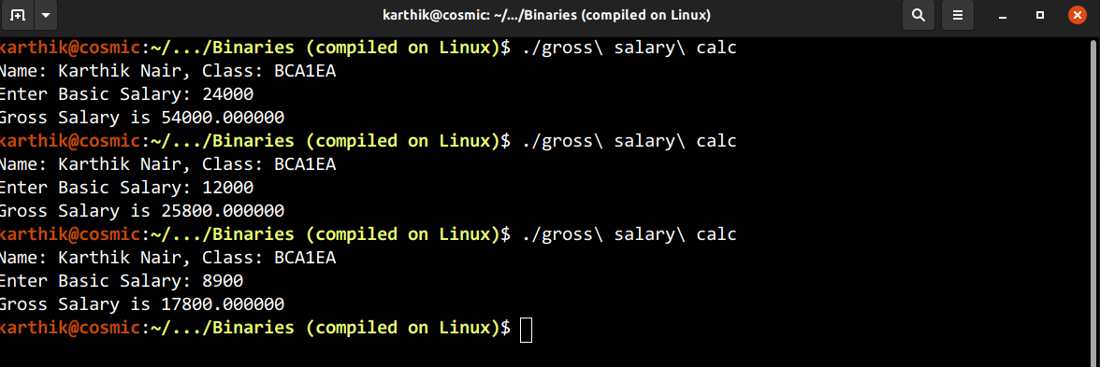

21. Write a C program to input electricity unit charges and calculate total electricity bill according to the given conditions:

For first 50 units Rs. 0.50/unit

For next 100 units Rs. 0.75/unit

For next 100 units Rs. 1.20/unit

For unit above 250 Rs. 1.50/unit

An additional surcharge of 20% is added to the bill

/*Write a C program to input electricity unit charges and calculate total electricity bill according to the given conditions:

For first 50 units Rs. 0.50/unit

For next 100 units Rs. 0.75/unit

For next 100 units Rs. 1.20/unit

For unit above 250 Rs. 1.50/unit

An additional surcharge of 20% is added to the bill*/

#include <stdio.h>

int main()

{

printf("Name: Karthik Nair, Class: BCA1EA\n");

float units, cost;

printf("Enter the number of units: ");

scanf("%f", &units);

if (units<=50)

{

cost=0.5;

}

else if (units<=150)

{

cost=0.75;

}

else if (units<=250)

{

cost=1.2;

}

else

{

cost=1.5;

}

printf("Elecricity charge is Rs %f", (0.2*(units*cost))+(units*cost));

printf("\n");

}

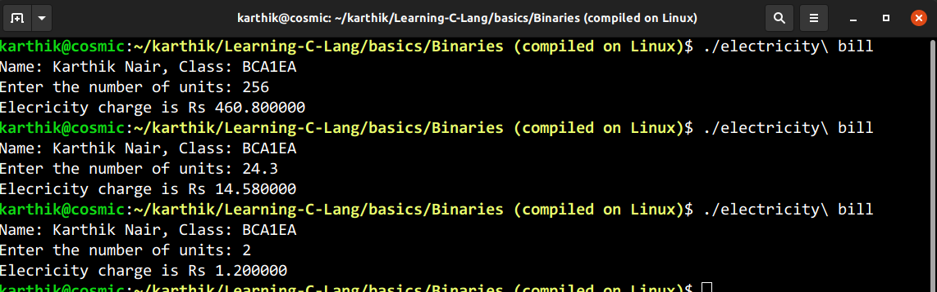

22. Display counting from 1 to 100 using while loop

// Display counting from 1 to 100 using while loop

#include <stdio.h>

int main()

{

printf("Name: Karthik Nair, Class: BCA1EA\n");

int start=1, end=100;

while (start<=end)

{

printf("%d,", start);

start++;

}

printf("\n");

}

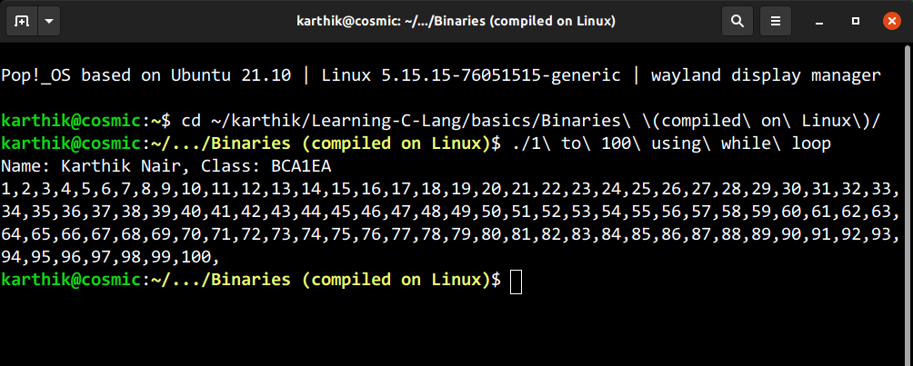

23. Display counting from 100 to 1 using while loop

// Display counting from 100 to 1 using while loop

#include <stdio.h>

int main()

{

printf("Name: Karthik Nair, Class: BCA1EA\n");

int start=100, end=1;

while (start>=end)

{

printf("%d,", start);

start--;

}

printf("\n");

}

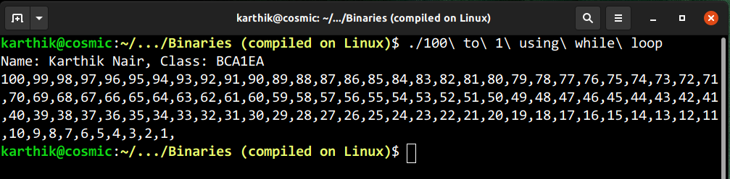

24. Display counting from 1 to n using while loop

// Display counting from 1 to n using while loop

#include <stdio.h>

int main()

{

printf("Name: Karthik Nair, Class: BCA1EA\n");

int a=1, n;

printf("Enter value of n: ");

scanf("%d", &n);

while (a<=n)

{

printf("%d,", a);

a++;

}

printf("\n");

}

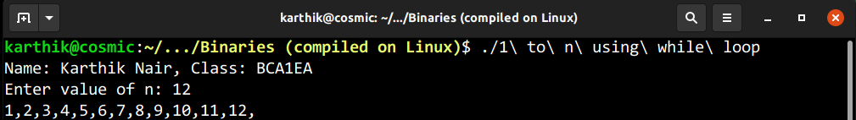

25. Display counting from n to 1 using while loop

// Display counting from n to 1 using while loop

#include <stdio.h>

int main()

{

printf("Name: Karthik Nair, Class: BCA1EA\n");

int a=1, n;

printf("Enter value of n: ");

scanf("%d", &n);

while (a<=n)

{

printf("%d,", n);

n--;

}

printf("\n");

}

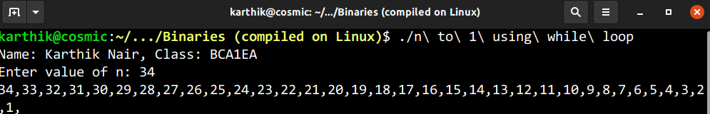

26. Display first 50 even nos. Using while loop

// Display first 50 even nos. Using while loop

#include <stdio.h>

int main()

{

printf("Name: Karthik Nair, Class: BCA1EA\n");

int a=2, n=100;

while (a<=n)

{

printf("%d,", a);

a+=2;

}

printf("\n");

}

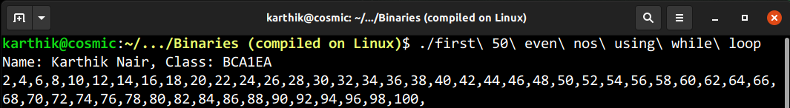

27. Display first 50 odd nos. Using while loop

// Display first 50 odd nos. Using while loop

#include <stdio.h>

int main()

{

printf("Name: Karthik Nair, Class: BCA1EA\n");

int a=1, n=99;

while (a<=n)

{

printf("%d,", a);

a+=2;

}

printf("\n");

}

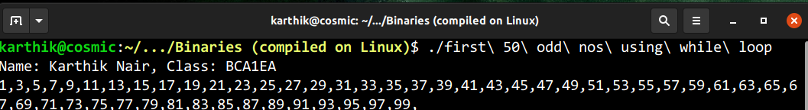

28. Display sum of first 50 even nos. Using while loop

// Display sum of first 50 even nos. Using while loop

#include <stdio.h>

int main()

{

printf("Name: Karthik Nair, Class: BCA1EA\n");

int a=2, n=100, sum=0;

while (a<=n)

{

sum+=a;

a+=2;

}

printf("%d\n", sum);

}

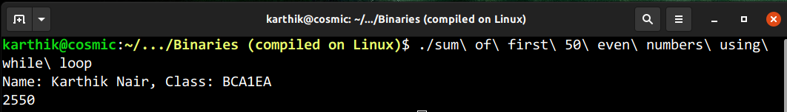

29. Display sum of first 50 odd nos. Using while loop

// Display sum of first 50 odd nos. Using while loop

#include <stdio.h>

int main()

{

printf("Name: Karthik Nair, Class: BCA1EA\n");

int a=1, n=99, sum=0;

while (a<=n)

{

sum+=a;

a+=2;

}

printf("%d\n", sum);

}

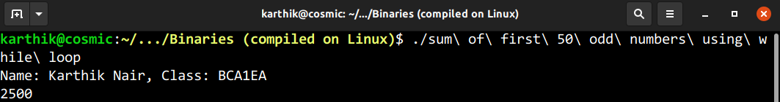

30. Display first 50 multiples of 7 Using while loop

// Display first 50 multiples of 7 Using while loop

#include <stdio.h>

int main()

{

printf("Name: Karthik Nair, Class: BCA1EA\n");

int count=1, a=7;

while (count<=50)

{

printf("%d ",a);

a+=7;count++;

}

printf("\n");

}

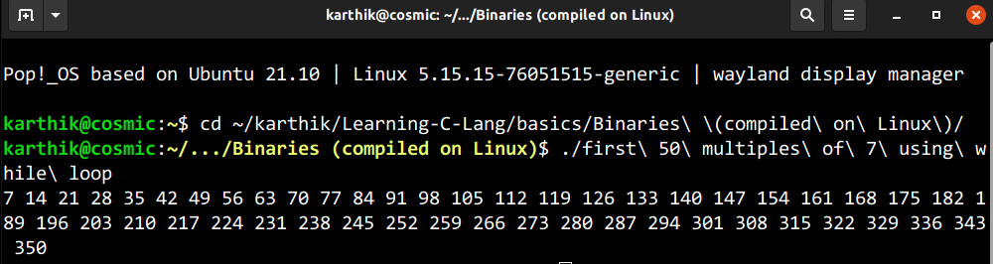

31. Display sum of first n natural nos. Using while loop

// Display sum of first n natural nos. Using while loop

#include <stdio.h>

int main()

{

printf("Name: Karthik Nair, Class: BCA1EA\n");

int a=1, n, sum=0;

printf("Enter value of n: ");

scanf("%d",&n);

while (a<=n)

{

sum+=a;

a++;

}

printf("%d\n", sum);

}

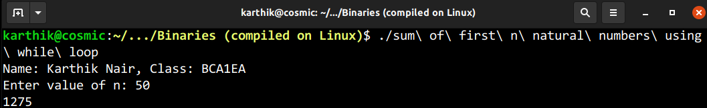

32. Display average marks of n number of students, take inputs from user Using while loop

// Display average marks of n number of students, take inputs from user Using while loop

#include <stdio.h>

int main()

{

printf("Name: Karthik Nair, Class: BCA1EA\n");

int n, marks, count=1; float sum=0;

printf("Enter number of students: ");

scanf("%d", &n);

while (n>=count)

{

printf("Enter marks of student %d: ", count);

scanf("%d", &marks);

count++;sum+=marks;

}

printf("Average marks of %d students is %f", n, (sum/n));

}

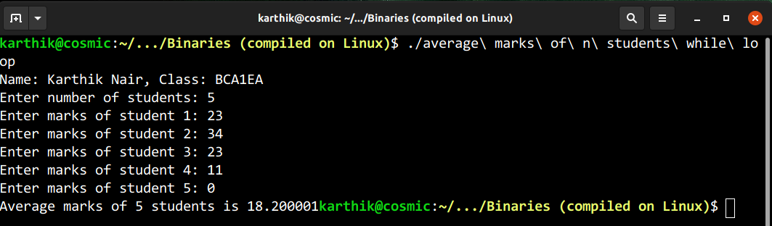

33. Display counting from 1 to 100 using for loop

// Display counting from 1 to 100 using for loop

#include <stdio.h>

int main()

{

printf("Name: Karthik Nair, Class: BCA1EA\n");

int i;

for (i = 1; i <= 100; i++)

printf("%d,", i);

printf("\n");

}

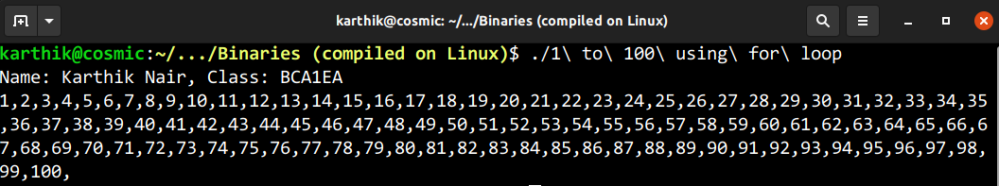

34. Display counting from 100 to 1 using for loop

// Display counting from 100 to 1 using for loop

#include <stdio.h>

int main()

{

printf("Name: Karthik Nair, Class: BCA1EA\n");

int i;

for (i = 100; i >= 1; i--)

printf("%d,", i);

printf("\n");

}

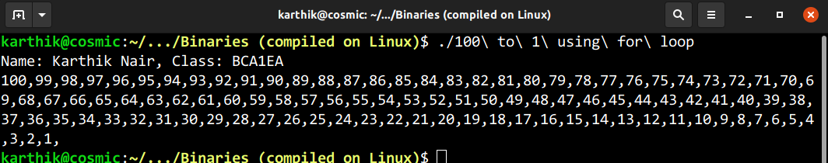

35. Display counting from 1 to n using for loop

// Display counting from 1 to n using for loop

#include <stdio.h>

int main()

{

printf("Name: Karthik Nair, Class: BCA1EA\n");

int i=1,n;

printf("Enter value of n: ");

scanf("%d",&n);

for (i;i<=n;i++)

{

printf("%d,",i);

}

printf("\n");

}

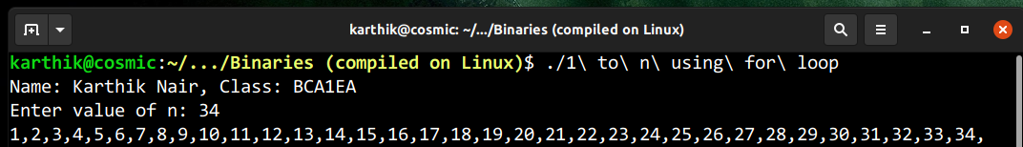

36. Display counting from n to 1 using for loop

// Display counting from n to 1 using for loop

#include <stdio.h>

int main()

{

printf("Name: Karthik Nair, Class: BCA1EA\n");

int i=1,n;

printf("Enter value of n: ");

scanf("%d",&n);

for (n;n>=i;n--)

{

printf("%d,",n);

}

printf("\n");

}

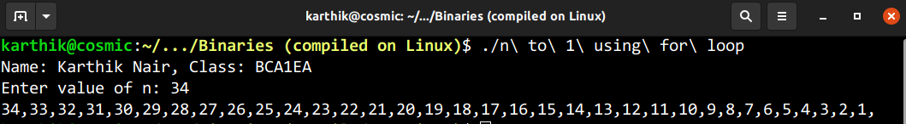

37. Display first 50 even nos. Using for loop

// Display first 50 even nos. Using for loop

#include <stdio.h>

int main()

{

printf("Name: Karthik Nair, Class: BCA1EA\n");

int i=2;

for (i; i<=100; i+=2)

{

printf("%d,", i);

}

printf("\n");

}

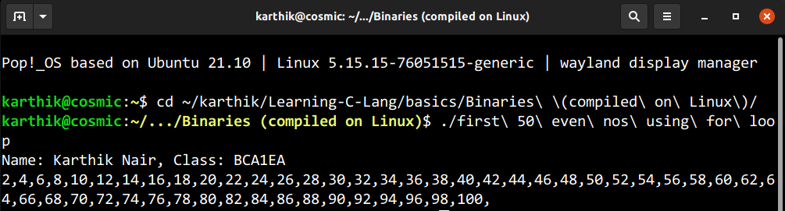

38. Display first 50 odd nos. Using for loop

// Display first 50 odd nos. Using for loop

#include <stdio.h>

int main()

{

printf("Name: Karthik Nair, Class: BCA1EA\n");

int i=1;

for (i; i<=99; i+=2)

{

printf("%d,", i);

}

printf("\n");

}

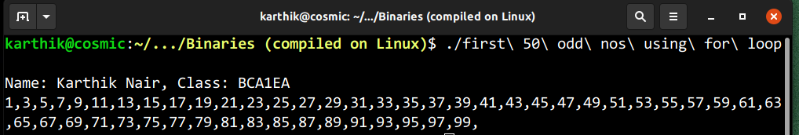

39. Display sum of first 50 even nos. Using for loop

// Display sum of first 50 even nos. Using for loop

#include <stdio.h>

int main()

{

printf("Name: Karthik Nair, Class: BCA1EA\n");

int i=2,sum=0;

for (i;i<=100;i+=2)

{

sum+=i;

}

printf("%d\n",sum);

}

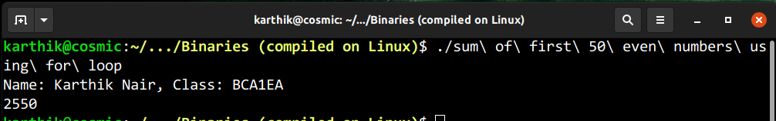

40. Display sum of first 50 odd nos. Using for loop

// Display sum of first 50 odd nos. Using for loop

#include <stdio.h>

int main()

{

printf("Name: Karthik Nair, Class: BCA1EA\n");

int i=1,sum=0;

for (i;i<=99;i+=2)

{

sum+=i;

}

printf("%d\n",sum);

}

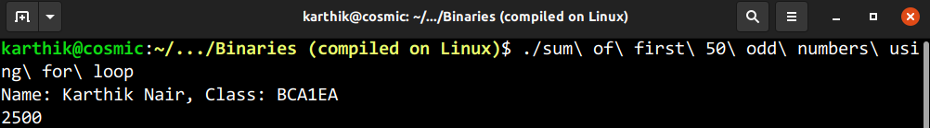

41. Display first 50 multiples of 7 using for loop

// Display first 50 multiples of 7 using for loop

#include <stdio.h>

int main()

{

printf("Name: Karthik Nair, Class: BCA1EA\n");

int a=7;

for (a; a<=(7*50); a+=7)

{

printf("%d ", a);

}

}

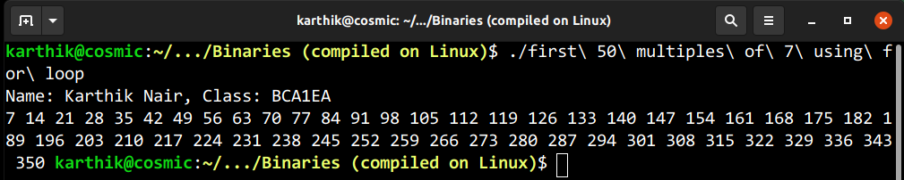

42. Display sum of first n natural nos. using for loop

// Display sum of first n natural nos. using for loop

#include <stdio.h>

int main()

{

printf("Name: Karthik Nair, Class: BCA1EA\n");

int n, sum=0;

printf("Enter value of n: ");

scanf("%d", &n);

for (n; n>=1; n--)

{

sum+=n;

}

printf("%d\n", sum);

}

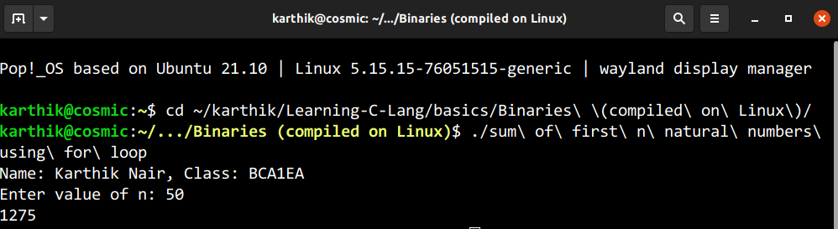

43. Display average marks of n number of students, take inputs from user using for loop

// Display average marks of n number of students, take inputs from user using for loop

#include <stdio.h>

int main()

{

printf("Name: Karthik Nair, Class: BCA1EA\n");

int n, marks, i=1;

float sum=0;

printf("Enter the number of students: ");

scanf("%d", &n);

for (i; n>=i; i++)

{

printf("Enter marks of student %d: ", i);

scanf("%d", &marks);

sum += marks;

}

printf("Average marks of %d students is %f\n", n, sum/n);

}

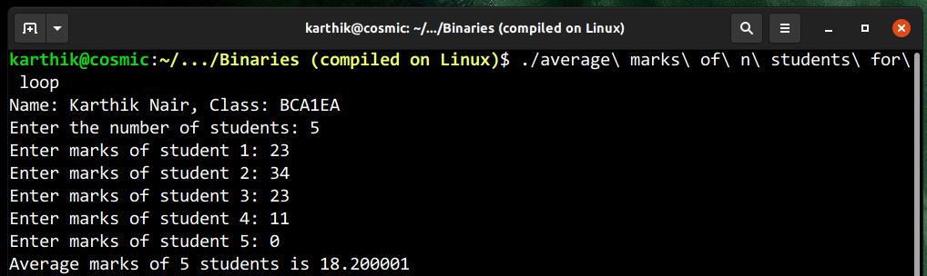

44. Display the following pattern on screen: (Up to n rows)

*

**

***

/*Display the following pattern on screen: (Up to n rows)

*

**

****/

#include <stdio.h>

int main()

{

printf("Name: Karthik Nair, Class: BCA1EA\n");

int i, n, j;

printf("Enter value of n: ");

scanf("%d", &n);

for (i=1; i<=n; i++)

{

for (j=1; j<=i; j++)

{

printf("*");

}

printf("\n");

}

}

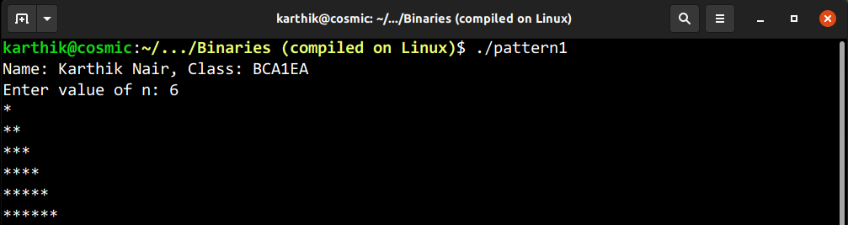

45. Display the following pattern on screen: ( Up to n rows)

1

1 2

1 2 3

1 2 3 4 …

/*Display the following pattern on screen: ( Up to n rows)

1

1 2

1 2 3

1 2 3 4 … */

#include <stdio.h>

int main()

{

printf("Name: Karthik Nair, Class: BCA1EA\n");

int i, n, j;

printf("Enter value of n: ");

scanf("%d", &n);

for (i=1; i<=n; i++)

{

for (j=1; j<=i; j++)

{

printf("%d", j);

}

printf("\n");

}

}

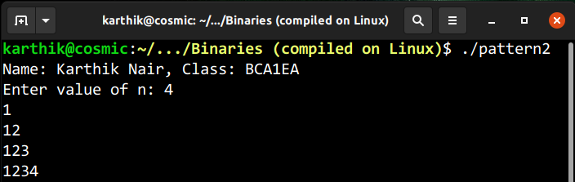

46. Display the following pattern (Floyd’s Triangle) on screen: ( Up to n rows)

1

2 3

4 5 6

7 8 9 10…

/*Display the following pattern (Floyd’s Triangle) on screen: ( Up to n rows)

1

2 3

4 5 6

7 8 9 10… */

#include <stdio.h>

int main()

{

printf("Name: Karthik Nair, Class: BCA1EA\n");

int i=1, j=1, n=1, r;

printf("Enter value of n: ");

scanf("%d", &r);

for (i=1; i<=r; i++)

{

for (j=1; j<=i; j++)

{

printf("%d ", n);

n++;

}

printf("\n");

}

}

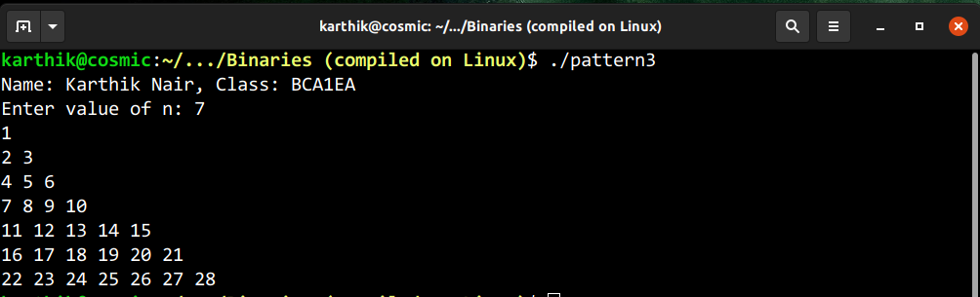

47. Display the following pattern on screen: ( Up to n rows)

*****

****

***

**

*

/*Display the following pattern on screen: ( Up to n rows)

*****

****

***

**

*

*/

#include <stdio.h>

int main()

{

printf("Name: Karthik Nair, Class: BCA1EA\n");

int i, n, j;

printf("Enter value of n: ");

scanf("%d", &n);

for (n; i<=n; n--)

{

for (j=1; j<=n; j++)

{

printf("*");

}

printf("\n");

}

}

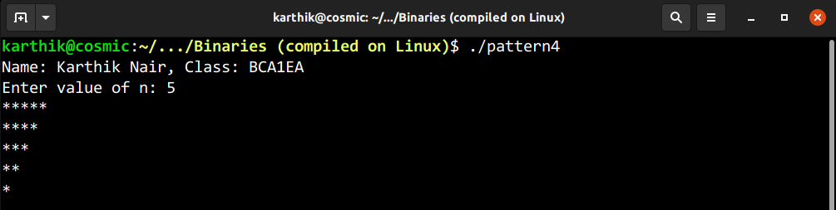

48. Display the following pattern on screen: ( Up to n rows)

1 2 3 4 5

1 2 3 4

1 2 3

1 2

1

/*Display the following pattern on screen: ( Up to n rows)

1 2 3 4 5

1 2 3 4

1 2 3

1 2

1

*/

#include <stdio.h>

int main()

{

printf("Name: Karthik Nair, Class: BCA1EA\n");

int i, n, j;

printf("Enter value of n: ");

scanf("%d", &n);

for (i=1; i<=n; n--)

{

for (j=1; j<=n; j++)

{

printf("%d", j);

}

printf("\n");

}

}

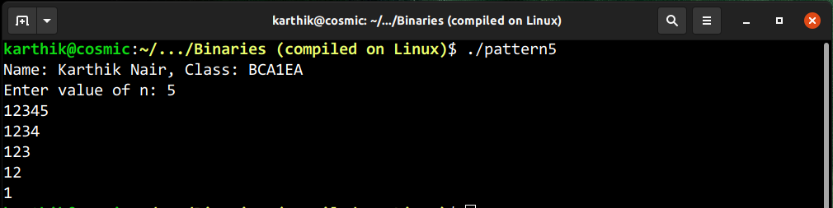

49. Display the following pattern on screen: ( Up to n rows)

A

B B

C C C

D D D D

/*Display the following pattern on screen: ( Up to n rows)

A

B B

C C C

D D D D*/

#include <stdio.h>

int main()

{

printf("Name: Karthik Nair, Class: BCA1EA\n");

int i=1,j=1,n;

char a='A';

printf("Enter value of n: ");

scanf("%d",&n);

for (i=1;i<=n;i++)

{

for (j=1; j<=i; j++)

{

printf("%c ", a);

}

a++;

printf("\n");

}

}

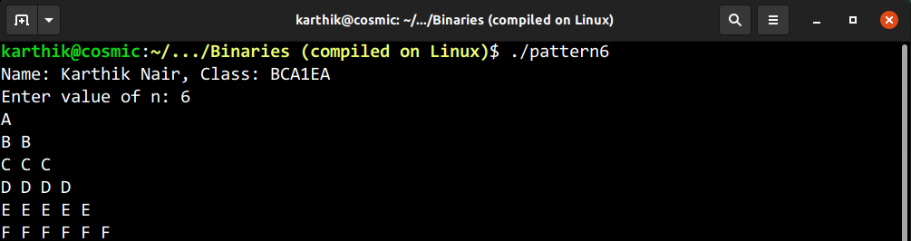

50. Display the following pattern on screen (inverted full pyramid): ( Up to n rows)

* * * * * * * * *

* * * * * * *

* * * * *

* * *

*

/*50. Display the following pattern on screen( inverted full pyramid): ( Up to n n)

* * * * * * * * *

* * * * * * *

* * * * *

* * *

*

*/

#include <stdio.h>

int main()

{

printf("Name: Karthik Nair, Class: BCA1EA\n");

int i,j,n,k,m=1;

printf("Enter value of n: ");

scanf("%d", &n);

for (i=n;i >= 1;i--)

{

for (j=1;j<=m;j++)

{

printf(" ");

}

for (k=1;k<=(2*i-1);k++)

{

printf("* ");

}

m++;

printf("\n");

}

}

