

学生实验实习报告册

学年学期： | 2021 - 2022 学年 春□秋 学期
课程名称/编号： | 程序设计实践/ A2041240
开课单位： | 计算机学院
任课教师： | 肖丹
教师电话：
学生学院： | 计算机学院
学生专业： | 计算机科学与技术
学生班级：
学生学号：
学生姓名：
最终成绩：

重庆邮电大学教务处印制
实验实习名 | 程序设计实践
实验实习地点 | 综合实验楼C405/C406/C407 | 完成起止日期
实验报告成绩  （满分30） |  | 现场考核成绩  （满分70）
教师评语 | 教师签名：  年 月 日

一、实验实习目的及要求
加强对面向对象程序设计思想的深入理解，提高学生分析问题，解决综合问题的能力。
二、实验实习设备（环境）及要求（软硬件条件）
设备：PC机
操作系统：Windows 10 家庭中文版
编译软件：jdk 11.0.12
三、实验实习内容简介：
系统应实现的主要功能：使用Java Swing技术模拟生活中十字道路的交通灯情况，交通灯按设置的时间自动指挥交通，汽车按交通规则行驶。
各模块的具体功能和简单算法：
1、窗口模块。该模块负责承载本项目的所有Swing组件，例如：JMenuBar、汽车JLabel与交通灯JLabel等。
2、控制器模块。该模块主要负责实现汽车与交通灯的逻辑控制，使交通灯与汽车组件按正确的逻辑规则进行运行。
3、线程工厂模块。该模块主要负责生产本项目中所需的线程。自定义线程工厂的目的是配合Java集合来更好的控制和统计线程。
4、工具类模块。由于项目中需要频繁创建各种汽车组件，所以将创建汽车组件封装成工具类方法。
5、公共常量模块。该模块定义了项目中常用的常量，以供全局调用，例如：交通灯转换频率，交通灯的转换规则。
汽车、交通灯组件运行逻辑流程图：
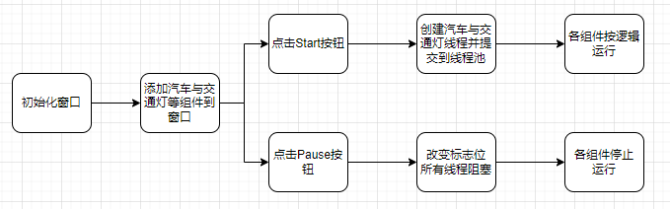
监听器线程运行逻辑流程图：
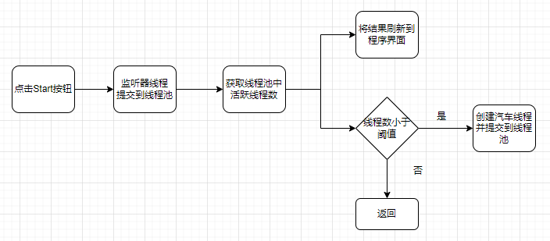
汽车组件移动逻辑流程图：
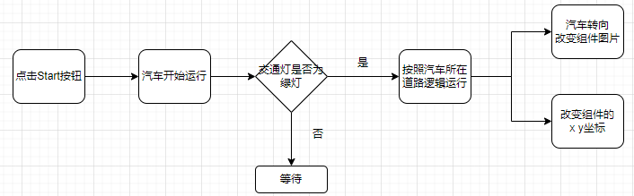
四、源程序（代码）
WindowInit.java
/**
* @author 志昊的刘
* @date 2022/6/17
*/
@Slf4j
@Data
public class WindowInit {
private static JFrame jFrame;
// 红绿灯
private static DownLight downLight;
private static UpLight upLight;
private static LeftLight leftLight;
private static RightLight rightLight;
// 道路(车辆)
private LeftRoadRight leftRoadRight;
private LeftRoadStraight leftRoadStraight;
private LeftRoadLeft leftRoadLeft;
private RightRoadRight rightRoadRight;
private RightRoadStraight rightRoadStraight;
private RightRoadLeft rightRoadLeft;
private UpRoadLeft upRoadLeft;
private UpRoadStraight upRoadStraight;
private UpRoadRight upRoadRight;
private DownRoadRight downRoadRight;
private DownRoadStraight downRoadStraight;
private DownRoadLeft downRoadLeft;
// private ThreadPoolExecutor pool;
private ThreadPoolExecutor pool;
private JMenu menu;
// 锁集合，用于线程之间的通信
public static List<Thread> lockList;
public static volatile boolean state = true;
private Set<Thread> set;
public WindowInit() {
// 1.初始化窗口
initFrame();
// 2.初始化菜单条
initMenuBar();
// 5.初始化路灯
initPauseButton();
initLight();
initCar();
// 3.初始化车辆、道路、start按钮
// 6.初始化Start按钮(启动线程)
initStartButton();
// 4.初始化地图、路标
initMap();
}
private void initPauseButton() {
JButton STOP = new JButton("");
STOP.setIcon(new ImageIcon(WindowInit.class.getResource("/com/lzh/resources/Pause.png")));
STOP.addActionListener(e -> {
state = !state;
if (state) {
// 使用LockSupport线程阻塞与唤醒工具类实现暂停功能
for (Thread thread : set) {
LockSupport.unpark(thread);
}
}
});
STOP.setBounds(662, 746, 160, 63);
jFrame.getLayeredPane().add(STOP, JLayeredPane.PALETTE_LAYER);
}
private void initStartButton() {
JButton startButton = new JButton("");
startButton.setIcon(new ImageIcon(WindowInit.class.getResource("/com/lzh/resources/Start.png")));
pool = (ThreadPoolExecutor) Executors.newCachedThreadPool();
set = new HashSet<>();
// TODO 如何获取线程池中的线程 https://www.cnblogs.com/itbac/p/12210680.html
ThreadFactory oldThreadFactory = pool.getThreadFactory();
pool.setThreadFactory(new MyThreadFactory(oldThreadFactory, set));
Monitor monitor = new Monitor(jFrame, menu, this.pool);
// start开始事件
startButton.addActionListener(e -> {
this.pool.execute(downLight);
this.pool.execute(upLight);
this.pool.execute(leftLight);
this.pool.execute(rightLight);
this.pool.execute(leftRoadRight);
this.pool.execute(leftRoadStraight);
this.pool.execute(leftRoadLeft);
this.pool.execute(rightRoadRight);
this.pool.execute(rightRoadStraight);
this.pool.execute(rightRoadLeft);
this.pool.execute(upRoadLeft);
this.pool.execute(upRoadStraight);
this.pool.execute(upRoadRight);
this.pool.execute(downRoadLeft);
this.pool.execute(downRoadRight);
this.pool.execute(downRoadStraight);
this.pool.execute(monitor);
});
startButton.setBounds(662, 650, 160, 63);
jFrame.getLayeredPane().add(startButton, JLayeredPane.PALETTE_LAYER);
}
public static void main(String[] args) {
WindowInit window = new WindowInit();
window.jFrame.setVisible(true);
}
private void initMap() {
// 初始化路标
JLabel compass = new JLabel("");
compass.setIcon(new ImageIcon(WindowInit.class.getResource("/com/lzh/resources/compass.jpg")));
compass.setBounds(65, 62, 155, 155);
// jFrame.getContentPane().add(compass);
jFrame.getLayeredPane().add(compass, JLayeredPane.PALETTE_LAYER);
// 初始化地图
JLabel map = new JLabel();
map.setBounds(0, 0, 896, 857);
// jFrame.getContentPane().add(map);
map.setHorizontalAlignment(SwingConstants.CENTER);
map.setIcon(new ImageIcon(WindowInit.class.getResource("/com/lzh/resources/road1.jpg")));
jFrame.getLayeredPane().add(map, JLayeredPane.DEFAULT_LAYER);
}
/**
* 初始化车辆、道路、按钮
*/
private void initCar() {
// 左侧车辆
JLabel carLeftStraight = BuildCarUtil.leftStraightBuild();
JLabel carLeftRight = BuildCarUtil.leftRightBuild();
JLabel carLeftLeft = BuildCarUtil.leftLeftBuild();
// 右侧车辆
JLabel carRightStraight = BuildCarUtil.rightStraightBuild();
JLabel carRightRight = BuildCarUtil.rightRightBuild();
JLabel carRightLeft = BuildCarUtil.rightLeftBuild();
// 上边车辆
JLabel carUpLeft = BuildCarUtil.upLeftBuild();
JLabel carUpStraight = BuildCarUtil.upStraightBuild();
JLabel carUpRight = BuildCarUtil.upRightBuild();
// 下边车辆
JLabel carDownLeft = BuildCarUtil.downLeftBuild();
JLabel carDownRight = BuildCarUtil.downRightBuild();
JLabel carDownStraight = BuildCarUtil.downStraightBuild();
leftRoadRight = new LeftRoadRight(carLeftRight, leftLight);
leftRoadStraight = new LeftRoadStraight(carLeftStraight, leftLight);
leftRoadLeft = new LeftRoadLeft(carLeftLeft, leftLight);
rightRoadRight = new RightRoadRight(carRightRight, rightLight);
rightRoadStraight = new RightRoadStraight(carRightStraight, rightLight);
rightRoadLeft = new RightRoadLeft(carRightLeft, rightLight);
upRoadLeft = new UpRoadLeft(carUpLeft, upLight);
upRoadStraight = new UpRoadStraight(carUpStraight, upLight);
upRoadRight = new UpRoadRight(carUpRight, upLight);
downRoadRight = new DownRoadRight(carDownRight, downLight);
downRoadLeft = new DownRoadLeft(carDownLeft, downLight);
downRoadStraight = new DownRoadStraight(carDownStraight, downLight);
}
private void initLight() {
JLabel Light_L = new JLabel("");
Light_L.setIcon(new ImageIcon(WindowInit.class.getResource("/com/lzh/resources/light.png")));
Light_L.setBounds(305, 430, 54, 137);
jFrame.getLayeredPane().add(Light_L,JLayeredPane.PALETTE_LAYER);
JLabel Light_U = new JLabel("");
Light_U.setIcon(new ImageIcon(WindowInit.class.getResource("/com/lzh/resources/light_U.png")));
Light_U.setBounds(319, 272, 137, 54);
jFrame.getLayeredPane().add(Light_U,JLayeredPane.PALETTE_LAYER);
JLabel Light_R = new JLabel("");
Light_R.setIcon(new ImageIcon(WindowInit.class.getResource("/com/lzh/resources/light_R.png")));
Light_R.setBounds(557, 287, 54, 137);
// jFrame.getContentPane().add(Light_R);
jFrame.getLayeredPane().add(Light_R,JLayeredPane.PALETTE_LAYER);
JLabel Light_D = new JLabel("");
Light_D.setIcon(new ImageIcon(WindowInit.class.getResource("/com/lzh/resources/light_D.png")));
Light_D.setBounds(463, 534, 137, 54);
// jFrame.getContentPane().add(Light_D);
jFrame.getLayeredPane().add(Light_D,JLayeredPane.PALETTE_LAYER);
downLight = new DownLight(Light_D);
upLight = new UpLight(Light_U);
leftLight = new LeftLight(Light_L);
rightLight = new RightLight(Light_R);
}
private void initMenuBar() {
// 菜单条
JMenuBar jMenuBar = new JMenuBar();
jMenuBar.setLocation(0, 0);
jMenuBar.setSize(95, 22);
jMenuBar.setBackground(Color.WHITE);
// 刷新菜单
menu = new JMenu("活动线程：0");
menu.setBackground(Color.LIGHT_GRAY);
menu.setHorizontalAlignment(SwingConstants.CENTER);
jMenuBar.add(menu);
jFrame.getLayeredPane().add(jMenuBar,JLayeredPane.PALETTE_LAYER);
}
private void initFrame() {
jFrame = new JFrame();
jFrame.setBounds(400, 100, 900, 900);
// 退出即关闭
jFrame.setDefaultCloseOperation(JFrame.EXIT_ON_CLOSE);
// 禁止拉伸
jFrame.setResizable(false);
// 布局设空
JPanel contentPane = new JPanel();
jFrame.setContentPane(contentPane);
contentPane.setLayout(null);
// contentPane.setOpaque(true);
JLayeredPane layeredPane = jFrame.getLayeredPane();
layeredPane.setLayout(null);
}
public static JFrame getjFrame() {
return jFrame;
}
public static LeftLight getLeftLight() {
return leftLight;
}
public static DownLight getDownLight() {
return downLight;
}
public static UpLight getUpLight() {
return upLight;
}
public static RightLight getRightLight() {
return rightLight;
}
}

Monitor.java
/**
* @author 志昊的刘
* @date 2022/6/19
*/
@SuppressWarnings("all")
@Slf4j
public class Monitor implements Runnable {
private JFrame jFrame;
private JMenu menu;
private ThreadPoolExecutor pool;
private List<Runnable> list;
public Monitor(JFrame jFrame, JMenu menu, ThreadPoolExecutor pool) {
this.jFrame = jFrame;
this.menu = menu;
this.pool = pool;
}
// log.warn("线程池中正在执行任务的线程数量：{}", pool.getActiveCount());
// log.warn("线程池当前的线程数量：{}", pool.getPoolSize());
// log.warn("线程池的最大线程数量：{}", pool.getMaximumPoolSize());
@Override
public void run() {
while (true) {
StringBuilder stringBuilder = new StringBuilder();
stringBuilder.append("活动线程：");
int activeCount = pool.getActiveCount();
stringBuilder.append(activeCount);
menu.setText(stringBuilder.toString());
if (activeCount <= 9) {
log.warn("添加车辆....");
// 循环添加车辆
for (int i = 0; i < 4; i++) {
randomAddCar();
}
}
try {
Thread.sleep(1000);
} catch (InterruptedException e) {
e.printStackTrace();
}
}
}
private void randomAddCar() {
int randomIndex = new Random().nextInt(12);
switch (randomIndex) {
case 0: {
JLabel carLeftStraight = BuildCarUtil.leftStraightBuild();
pool.execute(new LeftRoadStraight(carLeftStraight, WindowInit.getLeftLight()));
break;
}
case 1: {
JLabel carLeftRight = BuildCarUtil.leftRightBuild();
pool.execute(new LeftRoadRight(carLeftRight, WindowInit.getLeftLight()));
break;
}
case 2: {
JLabel carLeftLeft = BuildCarUtil.leftLeftBuild();
pool.execute(new LeftRoadLeft(carLeftLeft, WindowInit.getLeftLight()));
break;
}
case 3: {
JLabel carRightStraight = BuildCarUtil.rightStraightBuild();
pool.execute(new RightRoadStraight(carRightStraight, WindowInit.getRightLight()));
break;
}
case 4: {
JLabel carRightRight = BuildCarUtil.rightRightBuild();
pool.execute(new RightRoadRight(carRightRight, WindowInit.getRightLight()));
break;
}
case 5: {
JLabel carRightLeft = BuildCarUtil.rightLeftBuild();
pool.execute(new RightRoadLeft(carRightLeft, WindowInit.getRightLight()));
break;
}
case 6: {
JLabel carUpLeft = BuildCarUtil.upLeftBuild();
pool.execute(new UpRoadLeft(carUpLeft, WindowInit.getUpLight()));
break;
}
case 7: {
JLabel carUpStraight = BuildCarUtil.upStraightBuild();
pool.execute(new UpRoadStraight(carUpStraight, WindowInit.getUpLight()));
break;
}
case 8: {
JLabel carUpRight = BuildCarUtil.upRightBuild();
pool.execute(new UpRoadRight(carUpRight, WindowInit.getUpLight()));
break;
}
case 9: {
JLabel carDownLeft = BuildCarUtil.downLeftBuild();
pool.execute(new DownRoadLeft(carDownLeft, WindowInit.getDownLight()));
break;
}
case 10: {
JLabel carDownRight = BuildCarUtil.downRightBuild();
pool.execute(new DownRoadRight(carDownRight, WindowInit.getDownLight()));
break;
}
case 11: {
JLabel carDownStraight = BuildCarUtil.downStraightBuild();
pool.execute(new DownRoadStraight(carDownStraight, WindowInit.getDownLight()));
break;
}
}
jFrame.validate();
}
}

BuildCarUtil.java
/**
* @author 志昊的刘
* @date 2022/6/20
*/
public class BuildCarUtil {
public static JLabel leftStraightBuild() {
JLabel carLeftStraight = new JLabel("");
carLeftStraight.setIcon(new ImageIcon(WindowInit.class.getResource("/com/lzh/resources/car1.png")));
carLeftStraight.setBounds(142, 470, 70, 70);
// WindowInit.getjFrame().getContentPane().add(carLeftStraight);
WindowInit.getjFrame().getLayeredPane().add(carLeftStraight, JLayeredPane.MODAL_LAYER);
return carLeftStraight;
}
public static JLabel leftRightBuild() {
JLabel carLeftRight = new JLabel("");
carLeftRight.setIcon(new ImageIcon(WindowInit.class.getResource("/com/lzh/resources/car2.png")));
carLeftRight.setBounds(142, 525, 70, 70);
// WindowInit.getjFrame().getContentPane().add(carLeftRight);
WindowInit.getjFrame().getLayeredPane().add(carLeftRight, JLayeredPane.MODAL_LAYER);
return carLeftRight;
}
public static JLabel leftLeftBuild() {
JLabel carLeftLeft = new JLabel("");
carLeftLeft.setIcon(new ImageIcon(WindowInit.class.getResource("/com/lzh/resources/car3.png")));
carLeftLeft.setBounds(142, 410, 80, 80);
// WindowInit.getjFrame().getContentPane().add(carLeftLeft);
WindowInit.getjFrame().getLayeredPane().add(carLeftLeft, JLayeredPane.MODAL_LAYER);
return carLeftLeft;
}
public static JLabel rightStraightBuild() {
JLabel carRightStraight = new JLabel("");
carRightStraight.setIcon(new ImageIcon(WindowInit.class.getResource("/com/lzh/resources/car3_R_road.png")));
carRightStraight.setBounds(691, 325, 80, 80);
// WindowInit.getjFrame().getContentPane().add(carRightStraight);
WindowInit.getjFrame().getLayeredPane().add(carRightStraight, JLayeredPane.MODAL_LAYER);
return carRightStraight;
}
public static JLabel rightRightBuild() {
JLabel carRightRight = new JLabel("");
carRightRight.setIcon(new ImageIcon(WindowInit.class.getResource("/com/lzh/resources/car7_D_l.png")));
carRightRight.setBounds(691, 270, 80, 80);
// WindowInit.getjFrame().getContentPane().add(carRightRight);
WindowInit.getjFrame().getLayeredPane().add(carRightRight, JLayeredPane.MODAL_LAYER);
return carRightRight;
}
public static JLabel rightLeftBuild() {
JLabel carRightLeft = new JLabel("");
carRightLeft.setIcon(new ImageIcon(WindowInit.class.getResource("/com/lzh/resources/car4_R_s.png")));
carRightLeft.setBounds(691, 370, 70, 70);
// WindowInit.getjFrame().getContentPane().add(carRightLeft);
WindowInit.getjFrame().getLayeredPane().add(carRightLeft, JLayeredPane.MODAL_LAYER);
return carRightLeft;
}
public static JLabel upLeftBuild() {
JLabel carUpLeft = new JLabel("");
carUpLeft.setIcon(new ImageIcon(WindowInit.class.getResource("/com/lzh/resources/car1_U_d.png")));
carUpLeft.setBounds(320, 105, 70, 70);
// WindowInit.getjFrame().getContentPane().add(carUpLeft);
WindowInit.getjFrame().getLayeredPane().add(carUpLeft, JLayeredPane.MODAL_LAYER);
return carUpLeft;
}
public static JLabel upStraightBuild() {
JLabel carUpStraight = new JLabel("");
carUpStraight.setIcon(new ImageIcon(WindowInit.class.getResource("/com/lzh/resources/car4_R_d.png")));
carUpStraight.setBounds(367, 105, 70, 70);
// WindowInit.getjFrame().getContentPane().add(carUpStraight);
WindowInit.getjFrame().getLayeredPane().add(carUpStraight, JLayeredPane.MODAL_LAYER);
return carUpStraight;
}
public static JLabel upRightBuild() {
JLabel carUpRight = new JLabel("");
carUpRight.setIcon(new ImageIcon(WindowInit.class.getResource("/com/lzh/resources/car5_U_d.png")));
carUpRight.setBounds(410, 105, 70, 70);
// WindowInit.getjFrame().getContentPane().add(carUpRight);
WindowInit.getjFrame().getLayeredPane().add(carUpRight, JLayeredPane.MODAL_LAYER);
return carUpRight;
}
public static JLabel downLeftBuild() {
JLabel carDownLeft = new JLabel("");
carDownLeft.setIcon(new ImageIcon(WindowInit.class.getResource("/com/lzh/resources/car7_D_s.png")));
carDownLeft.setBounds(465, 690, 70, 70);
// WindowInit.getjFrame().getContentPane().add(carDownLeft);
WindowInit.getjFrame().getLayeredPane().add(carDownLeft, JLayeredPane.MODAL_LAYER);
return carDownLeft;
}
public static JLabel downRightBuild() {
JLabel carDownRight = new JLabel("");
carDownRight.setIcon(new ImageIcon(WindowInit.class.getResource("/com/lzh/resources/car6_D_s.png")));
carDownRight.setBounds(562, 690, 70, 70);
// WindowInit.getjFrame().getContentPane().add(carDownRight);
WindowInit.getjFrame().getLayeredPane().add(carDownRight, JLayeredPane.MODAL_LAYER);
return carDownRight;
}
public static JLabel downStraightBuild() {
JLabel carDownStraight = new JLabel("");
carDownStraight.setIcon(new ImageIcon(WindowInit.class.getResource("/com/lzh/resources/car3_up.png")));
carDownStraight.setBounds(507, 690, 70, 70);
// WindowInit.getjFrame().getContentPane().add(carDownStraight);
WindowInit.getjFrame().getLayeredPane().add(carDownStraight, JLayeredPane.MODAL_LAYER);
return carDownStraight;
}
}

MyThreadFactory.java
/**
* 自定义线程生成方式
*
* @author 志昊的刘
* @date 2022/6/20
*/
public class MyThreadFactory implements ThreadFactory {
private final ThreadFactory threadFactory;
private final Set<Thread> threadsContainer;
public MyThreadFactory(ThreadFactory threadFactory, Set<Thread> threadsContainer) {
this.threadFactory = threadFactory;
this.threadsContainer = threadsContainer;
}
@Override
public Thread newThread(Runnable r) {
Thread thread = threadFactory.newThread(r);
// 记录线程
threadsContainer.add(thread);
return thread;
}
}

LeftRoadLeft.java
/**
* @author 志昊的刘
* @date 2022/6/18
*/
@Slf4j
public class LeftRoadLeft extends Road implements Runnable {
public LeftRoadLeft(JLabel car, Light light) {
super(car, light);
}
@Override
public void run() {
log.info("左边-向左转的车发车");
int x, y;
JLabel car = getCar();
Light light = getLight();
while (true) {
if (car.getBounds().y < BoundsConstant.UP.getNum()) break;
// 车子的移动可以用线程通信来做
// 看灯的情况进行移动
if (light != null && light.isLeftGo()) {
while (true) {
if (!WindowInit.state) {
LockSupport.park();
}
x = car.getBounds().x;
y = car.getBounds().y;
if (y < BoundsConstant.UP.getNum()) break;
if (x >= 465) {
car.setIcon(new ImageIcon(WindowInit.class.getResource("/com/lzh/resources/car3_up.png")));
car.setLocation(x, y - 4);
} else {
car.setLocation(x + 5, y);
}
try {
Thread.sleep(100);
} catch (InterruptedException e) {
e.printStackTrace();
}
}
}
}
}
}

DownLight.java
/**
* @author 志昊的刘
* @date 2022/6/18
*/
@Slf4j
public class DownLight extends Light implements Runnable {
// 子类共享父类的静态变量
private static Integer stage;
public DownLight(JLabel light) {
super(light,
new ImageIcon(DownLight.class.getResource("/com/lzh/resources/light_D_l.png")),
new ImageIcon(DownLight.class.getResource("/com/lzh/resources/light_D_r+s.png")),
new ImageIcon(DownLight.class.getResource("/com/lzh/resources/light_D_off.png")));
}
@Override
public void run() {
stage = LightStageConstant.STAGE_THREE.getStage();
lightBeginChange(stage);
}
}

五、源程序调试过程
1.线间的通信问题。这个问题主要出现在实现PAUSE（暂停）过程中，暂停功能的实现逻辑是监听按钮的点击事件，当事件被触发时，阻塞所有的汽车组件线程，再次点击暂停按钮，会唤醒所有汽车组件线程。那如何实现阻塞唤醒呢？可以使用显示锁Lock，但是需要通信的线程太多，编码不方便。我选择使用线程阻塞与唤醒的LockSupport类，它可以在任意位置实现线程的阻塞，而不用先获得锁。
2.如何唤醒线程池中所阻塞的线程。因为LockSupport类的unpark()方法的参数是Thread对象，而在项目中我创建线程的方式是实现Runnable接口并重写其run()方法。并且线程的执行方式是向线程池提交任务，所以整个过程并不显式的涉及到Thread类对象。那如何唤醒汽车线程呢？我在网上查到的解决方式是提供自定义的线程工厂，并用集合保存所有线程。在唤醒线程时，遍历集合中的所有活动线程进行唤醒。
3.组件之间的覆盖问题。本次项目中组件之间的覆盖情况非常常见，比如：汽车与路灯组件、START与PAUSE按钮都是覆盖在地图上的。这个问题如果处理不好可能会出现汽车、路灯组件显示不正确的问题。我的解决方法是使用Java Swing的JLayeredPane组件，在向JLayeredPane中添加组件时可以指定组件的索引，索引高的组件会覆盖在低的组件上。通过指定组件的索引，可以确保组件的正确重叠。

六、实验实习结果及分析
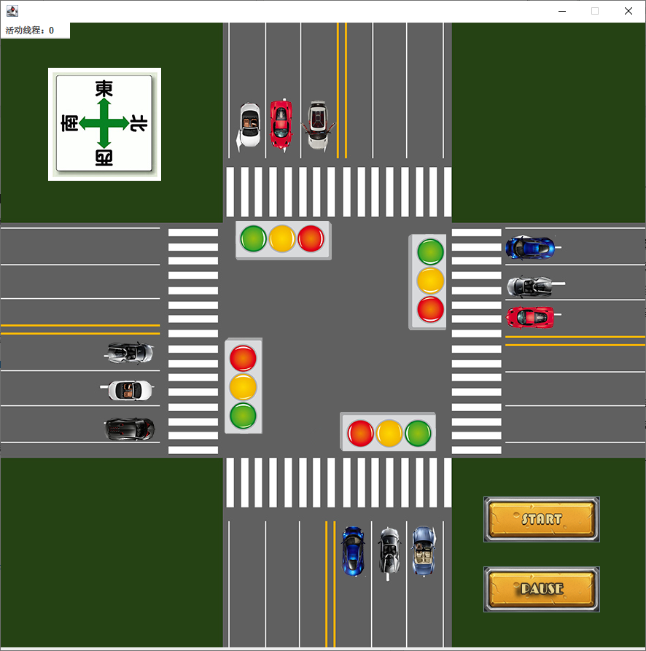
程序初始界面，此时汽车组件与交通灯组件已就位，目前的活动线程为0。
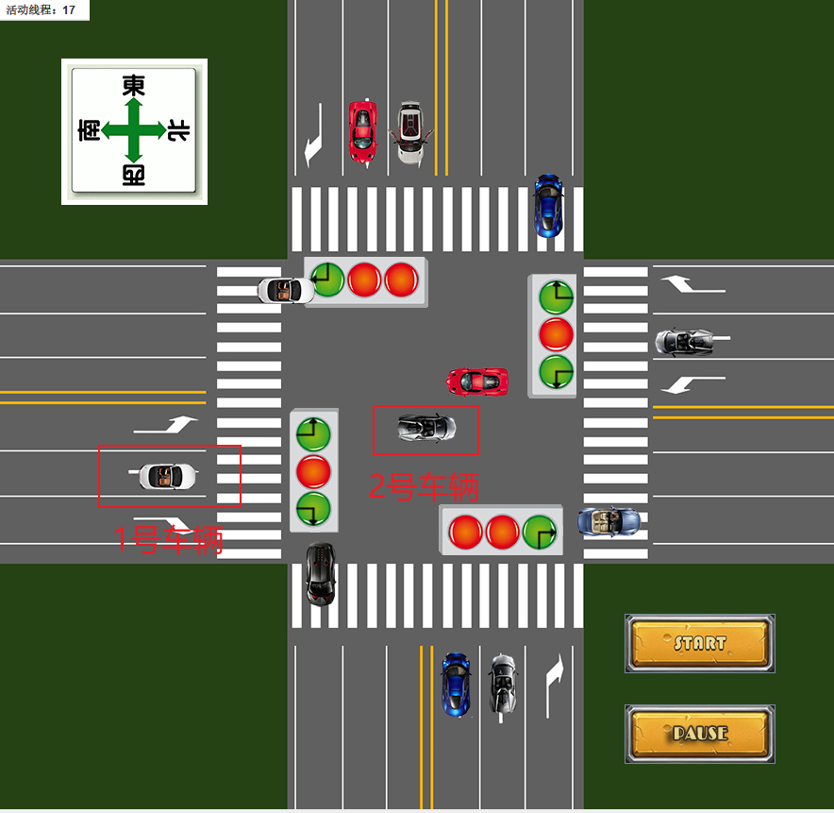
点击START按钮，程序开始运行。根据交通灯的显示情况，汽车按照交通逻辑行驶。比如1号车辆，因为交通灯目前为红灯，因此1号车辆原地等待。而2号车辆所对应的红绿灯显示为向左转，2号车辆向前行驶然后转入东西方向车道。
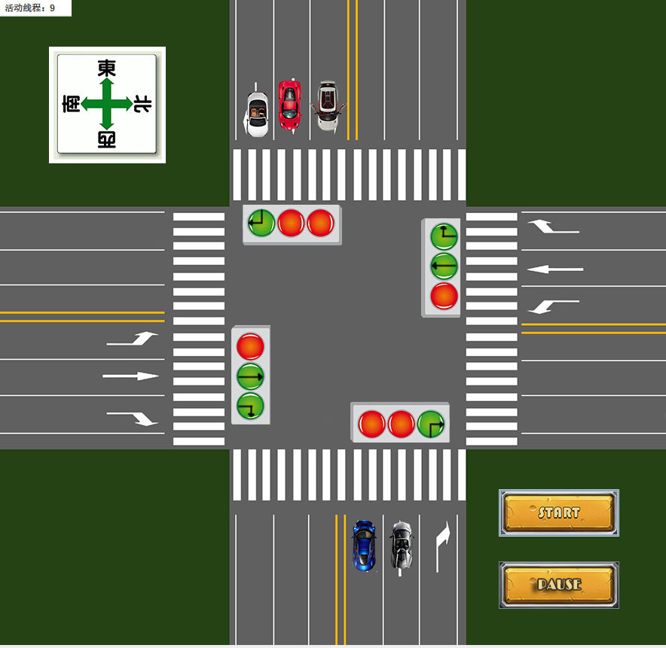
随着程序的运行汽车逐个驶出程序界面，此时意味着汽车组件所对应的线程执行完毕，线程被放回线程池。通过左上角的活动线程中可以看到线程数从一开始的17个变为了9个。这9个活动线程分别为：5个汽车组件线程，4个交通灯组件线程。
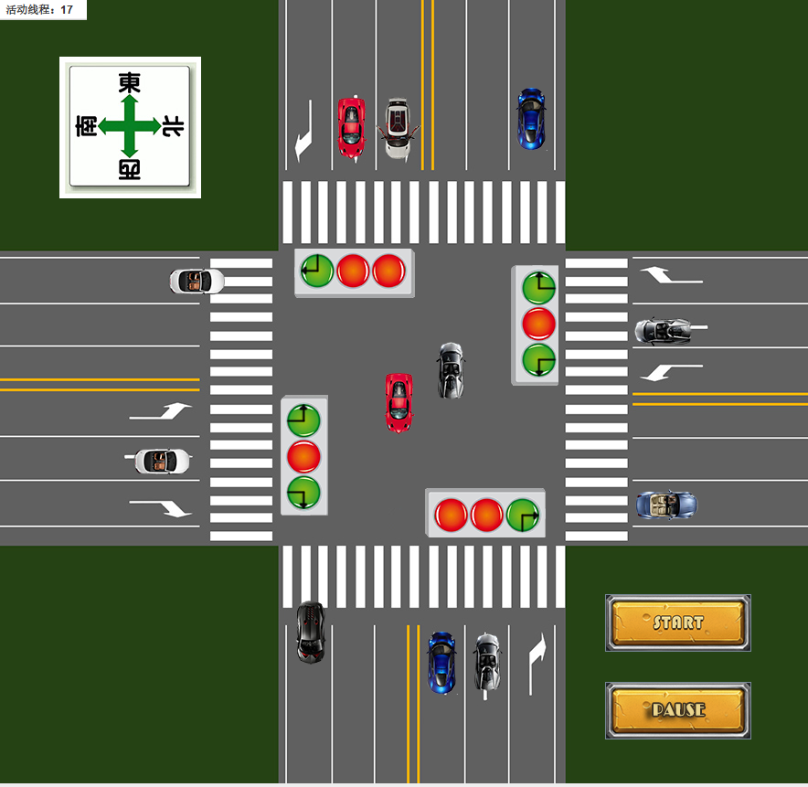
点击PAUSE按钮会阻塞所有汽车线程，以便分析汽车组件运行逻辑的正确性。当再次点击PAUSE按钮会唤醒所有汽车线程，程序正常继续运行。
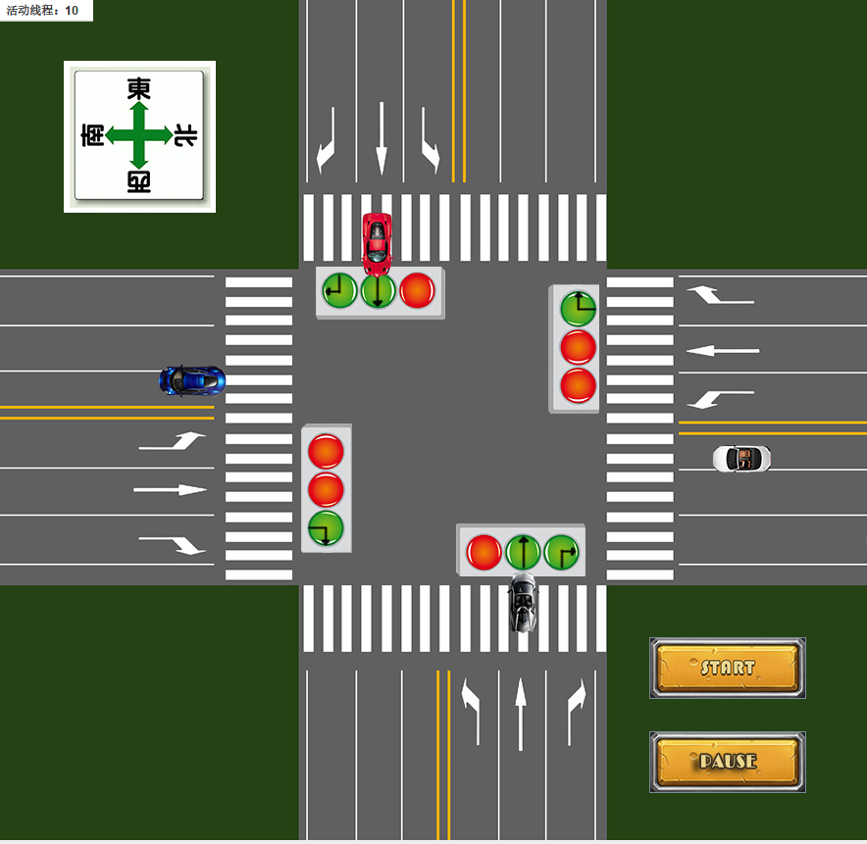
为了保证程序的演示效果，当程序中汽车组件的活动线程小于等于某个阈值（默认为9）时，程序会自动补充汽车组件线程。
七、总结
通过本次项目经历我了解了一般Java Swing项目的实现逻辑，我的理解就是使用组件(JMenu、JLabel等)来实现页面的布局，并为组件添加监听事件来实现组件相应的功能。
除此之外，本次项目中运用了很多关于多线程的知识，包括线程的创建、线程之间的通信、线程池的创建与使用等。运用多线程技术，可以开发出功能更加复杂的应用。还有就是利用好继承与多态功能可以降低编码的困难难度，在本项目中，我将所有汽车组件的共有属性抽取出来设计了一个汽车抽象类，将所有路灯组件的共有属性抽取出来设计了一个路灯抽象类。通过继承与多态可以实现代码的复用，降低项目的代码量。

