附录二 实验器件管脚图
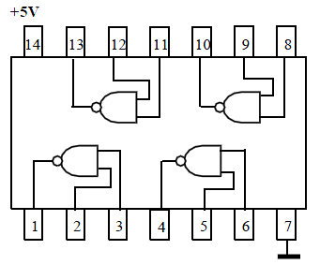
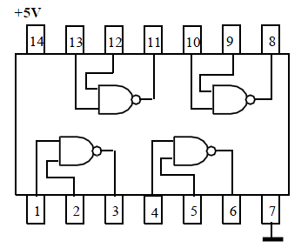
74HC01

74HC00

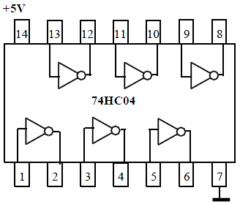
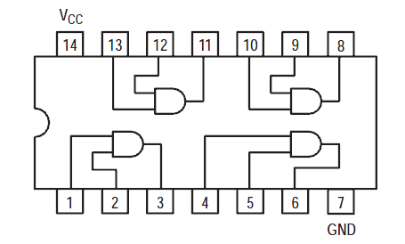
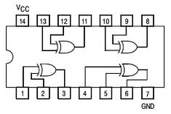
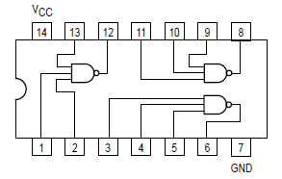
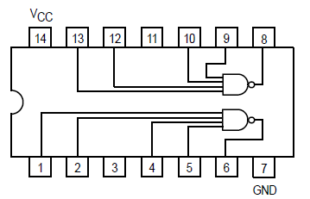
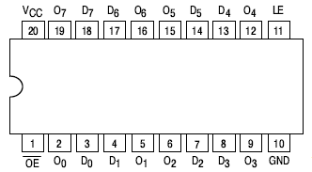
74HC08

74HC86

74HC10

74HC20

74HC373

Vcc
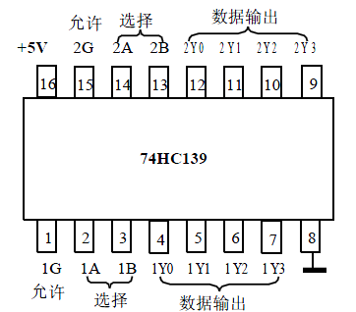
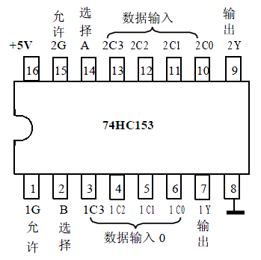
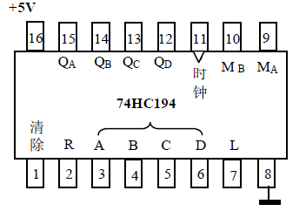
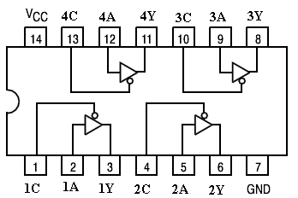
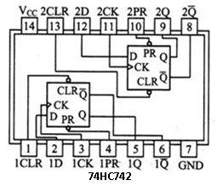
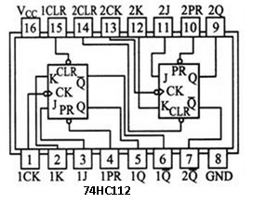
1
2
3
4
5
6
7
14
9
8
13
10
12
110
2
NC
Q0
Q3
GND
Q1
R9(2)
R9(1)
VCC
NC
R0(2)
R0(1)
CP1
CP0
Q2
74HC90
74HC126
1
2
3
4
5
6
7
14
9
8
13
10
12
110
2
H
G
F
E
NC
GND
NC
NC
D
C
B
1Y
A
74HC55

