实验4 WebSocket网页聊天室
姓名 |  |  | 院系 | 机电学院媒体系 |  |  | 学号
任课教师 |  | 景东 |  |  | 指导教师 | 景东
实验地点 |  | 学士楼440 |  |  | 实验时间 | 2017.11.30
实验课表现 |  | 出勤、表现得分10% |  |  | 实验报告  得分40% |  |  | 实验总分
 |  | 操作结果得分50%
指导教师评语

签字：
日期：
实验学时：4学时
实验目的：
掌握WebSocket通信的协议，Socket服务器和Websocket客户端的通信原理，基于WebSocket通信实现一个多人在线的简易聊天室，使用select或者多线程，编程实现聊天室的网页登录（含界面）、网页聊天（含界面）、服务器端、Session身份保持。进一步实现数据格式化及用户一对一聊天。
实验内容及要求：
- 使用socket搭建聊天服务器端；
- 实现websocket通信协议和HTTP通信协议。
- 实现数据格式化（或者数据协议）。
- 实现网页登录、聊天。
- *实现一对一聊天。
考核方法：
- 是否成功搭建网页聊天客户端和服务器端。
- 是否实现websocket通信协议。
- 是否实现数据格式化。
- 是否实现一对一聊天。
实验报告要求：
完整的实验报告应包含：
- 按要求覆盖实验内容
- 描述实验中遇到的问题、解决方法及心得。

实验过程及结果 (40分) |  |  |  |  |  |  | 得分
硬件环境：计算机1：阿里云1核CPU ,1G RAM，40G硬盘
计算机2：MacBook Pro 2017
OS环境：计算机1：Windows server 2012 R2
计算机2：win10 pro
开发环境：计算机1：Python27，IDLE
计算机2：Python27，Visual Studio

- 使用socket搭建聊天服务器端；
- 服务端代码如下：
#-*- coding:utf8 -*-

import threading
import hashlib
import socket
import base64

global clients
clients = {}
USERNAME_PASSWORD = {"admin": "123456", "fox": "123456", "planet": "123456"}
#通知客户端
def notify(message):
for connection in clients.values():
connection.send('%c%c%s' % (0x81, len(message), message))

#客户端处理线程
class websocket_thread(threading.Thread):
def __init__(self, connection, username):
super(websocket_thread, self).__init__()
self.connection = connection
self.username = username

def run(self):
print 'new websocket client joined!'
data = self.connection.recv(1024)
headers = self.parse_headers(data)
token = self.generate_token(headers['Sec-WebSocket-Key'])
self.connection.send('\
HTTP/1.1 101 WebSocket Protocol Hybi-10\r\n\
Upgrade: WebSocket\r\n\
Connection: Upgrade\r\n\
Sec-WebSocket-Accept: %s\r\n\r\n' % token)
while True:
try:
data = self.connection.recv(1024)
except socket.error, e:
print "unexpected error: ", e
clients.pop(self.username)
break
data = self.parse_data(data)
if len(data) == 0:
continue
message = data
if '|'in data:
a = data.split('|')
if a[0] in USERNAME_PASSWORD and a[1] == USERNAME_PASSWORD[a[0]]:
message = a[0] + " log in!"
else:
message = "wrong username or password!"
notify(message)

def parse_data(self, msg):
v = ord(msg[1]) & 0x7f
if v == 0x7e:
p = 4
elif v == 0x7f:
p = 10
else:
p = 2
mask = msg[p:p+4]
data = msg[p+4:]
return ''.join([chr(ord(v) ^ ord(mask[k%4])) for k, v in enumerate(data)])

def parse_headers(self, msg):
headers = {}
header, data = msg.split('\r\n\r\n', 1)
for line in header.split('\r\n')[1:]:
key, value = line.split(': ', 1)
headers[key] = value
headers['data'] = data
return headers

def generate_token(self, msg):
key = msg + '258EAFA5-E914-47DA-95CA-C5AB0DC85B11'
ser_key = hashlib.sha1(key).digest()
return base64.b64encode(ser_key)

#服务端
class websocket_server(threading.Thread):
def __init__(self, port):
super(websocket_server, self).__init__()
self.port = port

def run(self):
sock = socket.socket(socket.AF_INET, socket.SOCK_STREAM)
sock.setsockopt(socket.SOL_SOCKET, socket.SO_REUSEADDR, 1)
sock.bind(('127.0.0.1', self.port))
sock.listen(5)
print 'websocket server started!'
while True:
connection, address = sock.accept()
try:
username = "ID" + str(address[1])
thread = websocket_thread(connection, username)
thread.start()
clients[username] = connection
except socket.timeout:
print 'websocket connection timeout!'

if __name__ == '__main__':
server = websocket_server(9000)
server.start()

- HTML文件源代码如下：
<!DOCTYPE html>
</html>
<head>
<meta charset="GBK">
</head>
<body>
<h2>1162800204的网页聊天室</h2>
<h4>先点连接，连接成功可发消息，按“回车”或点击“发送”发送消息</h4>
<div id="login">
<div>
<input id="serverIP" type="hidden" placeholder="服务器IP" value="127.0.0.1" autofocus="autofocus" />
<input id="serverPort" type="hidden" placeholder="服务器端口" value="9000" />

</div>
<div>
请输入用户名、密码：
</div>
<div>
<input id="username" type="text" placeholder="用户名" value="admin" />
<input id="password" type="password" placeholder="密码" value="123456" />
<input id="btnConnect" type="button" value="连接" onclick="connect()" />
</div>
<div>
<div>
聊天室：
</div>
<textarea id="txtContent" cols="90" rows="10" readonly="readonly"></textarea>
</div>
<div>
<input id="sendText" type="text" style="width:680px; height:20px;" placeholder="发送文本" value="Hello, world!" onkeydown="if(event.keyCode==13){send()}" />
<input id="btnSend" type="button" value="发送" onclick="send()"/>
</div>
<div>
<br />
更新内容：<br />
1.回车发送，输入更加快捷；<br />
2.增加昵称显示；<br />
3.连接丢失后，连接按钮将恢复可用；<br />
4.升级了UI界面，更加美观；<br />
5.增加了用户登录的功能，默认密码123456，内置用户：admin、fox、planet

</div>
</div>
</body>
<script>
var socket;
var username;
var password;
function connect() {
var host = "ws://" + $("serverIP").value + ":" + $("serverPort").value + "/"
socket = new WebSocket(host);
username = $("username").value;
password = $("password").value;
try {

socket.onopen = function (msg) {
$("btnConnect").disabled = true;
var msg = username + "|" +password;
socket.send(msg);

alert("连接成功！");
};

socket.onmessage = function (msg) {
if (typeof msg.data == "string") {
displayContent(msg.data);
}
else {
alert("非文本消息");
}
};

socket.onclose = function (msg) { alert("socket closed!");$("btnConnect").disabled = false; };
}
catch (ex) {
log(ex);
}
}

function send() {
var msg = username + " : " + $("sendText").value
socket.send(msg);
document.getElementById("sendText").value="";
}

window.onbeforeunload = function () {
try {
socket.close();
socket = null;
}
catch (ex) {
}
};
function $(id) { return document.getElementById(id); }
Date.prototype.Format = function (fmt) {
var o = {
"M+": this.getMonth() + 1, //月份
"d+": this.getDate(), //日
"h+": this.getHours(), //小时
"m+": this.getMinutes(), //分
"s+": this.getSeconds(), //秒
"q+": Math.floor((this.getMonth() + 3) / 3), //季度
"S": this.getMilliseconds() //毫秒
};
if (/(y+)/.test(fmt)) fmt = fmt.replace(RegExp.$1, (this.getFullYear() + "").substr(4 - RegExp.$1.length));
for (var k in o)
if (new RegExp("(" + k + ")").test(fmt)) fmt = fmt.replace(RegExp.$1, (RegExp.$1.length == 1) ? (o[k]) : (("00" + o[k]).substr(("" + o[k]).length)));
return fmt;
}
function displayContent(msg) {
$("txtContent").value += "\r\n" +new Date().Format("yyyy/MM/dd hh:mm:ss")+ ">>> " + msg;
}
function onkey(event) { if (event.keyCode == 13) { send(); } }
</script>
</html>

- 本地测试如下：
客户端运行结果如下：
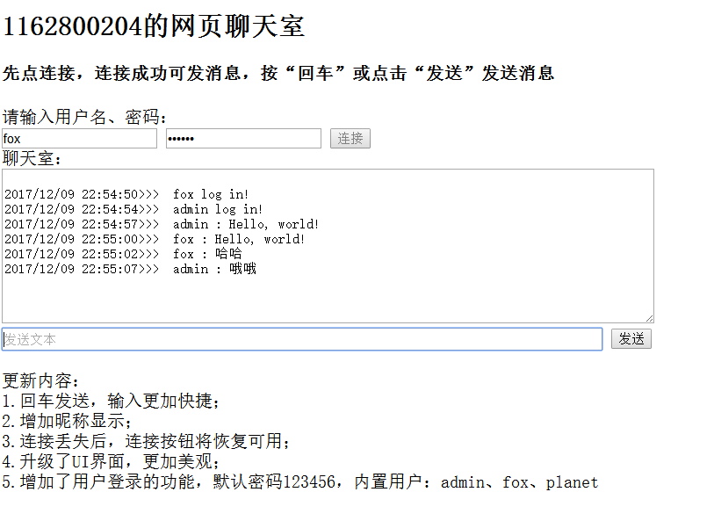
服务端运行结果如下：
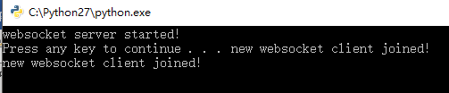

- 公网测试如下：
修改连接的IP为：
客户端运行如下：
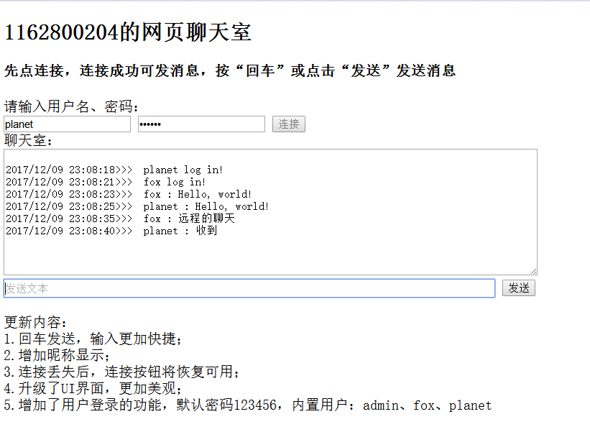
服务端运行结果如下：
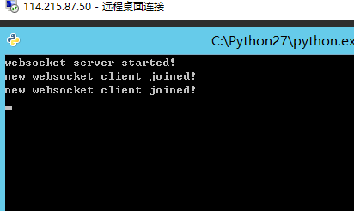

- 实现websocket通信协议和HTTP通信协议。
- 在第一步中已经实现了websocket通信协议，再看http服务器的代码如下：
#encoding=utf-8
import socket
import uuid
IP_PORT = ('127.0.0.1', 8085)
socket = socket.socket(socket.AF_INET, socket.SOCK_STREAM)
socket.bind(IP_PORT)
socket.listen(5)
while True:
connection, address = socket.accept()
request = connection.recv(1024)
request_array = request.split("\r\n\r\n")
head = request_array[0]
head_array = head.split("\r\n")
request_line = head_array[0]
head_dict = {}
for head_line in head_array[1:]:
head_line_array = head_line.split(": ")
key = head_line_array[0]
value = head_line_array[1]
head_dict[key] = value
response_cookie_head = ""
if "Cookie" not in head_dict:
print "=============create cookie=========="
ssid = str(uuid.uuid1())
response_cookie_head = "Set-Cookie: ssid=" + ssid + "\r\n"
print "=============set cookie============="
print response_cookie_head
url = request_line
if "/news.html" in url:
f = open("html/news.html", "r")
file_content = f.read()
f.close()
response_body = file_content
elif "/mychat.html" in url:
f = open("html/mychat.html", "r")
file_content = f.read()
f.close()
response_body = file_content
else:
f = open("html/index.html", "r")
file_content = f.read()
f.close()
response_body = file_content
response_line = "HTTP/1.1 200 ok\r\n"
response_head = "Content-Type:text/html\r\n\r\n"
response = response_line + response_cookie_head + response_head + response_body
connection.send(response)
connection.close()

- 本地测试结果如下（mychat.html）：
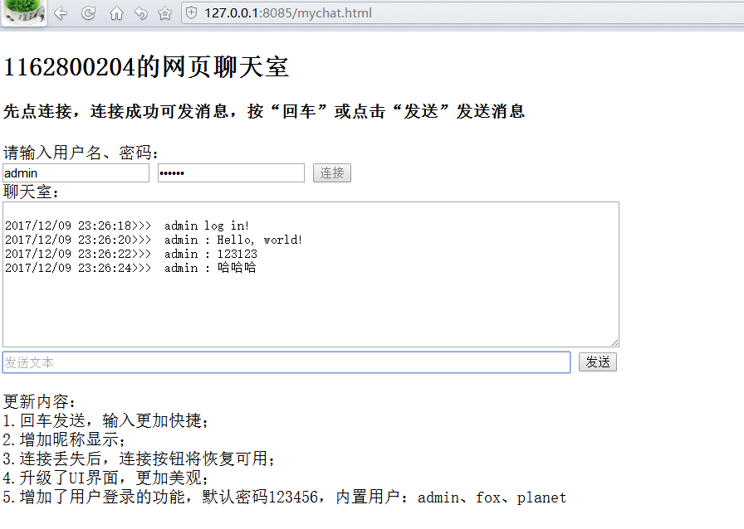
- 公网测试如下：
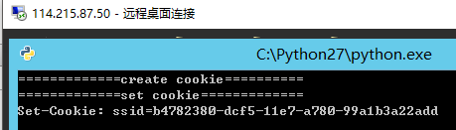
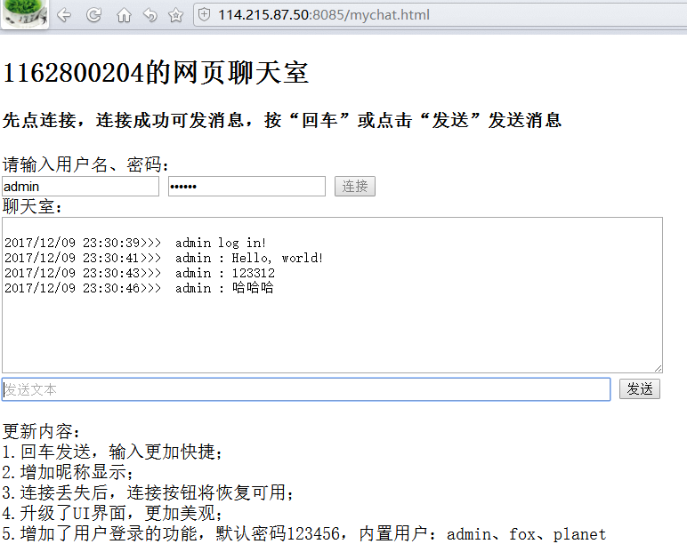

- 实现数据格式化（或者数据协议）。
- 在html的script段，增加全局变量username和password，约定连接时，发送用户名和密码，发送数据时，发送用户名和聊天内容。
- 连接时发送的数据格式如下：
- 聊天时发送的数据如下：
- 服务端解析登录数据：
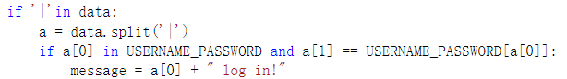
- 服务端解析聊天数据：
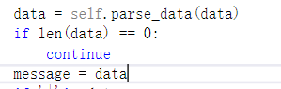

- 实现网页登录、聊天。

在前几步骤中已经完成，在此不再赘述。

- *实现一对一聊天。
- 修改服务端代码如下：
#-*- coding:utf8 -*-

import threading
import hashlib
import socket
import base64

global clients
clients = {}
global NAME_ID
NAME_ID={}
USERNAME_PASSWORD = {"admin": "123456", "fox": "123456", "planet": "123456"}
#通知客户端
def notify(message):
for connection in clients.values():
connection.send('%c%c%s' % (0x81, len(message), message))

def p2p(message, username):
connection = clients[NAME_ID[username]]
connection.send('%c%c%s' % (0x81, len(message), message))

#客户端处理线程
class websocket_thread(threading.Thread):
def __init__(self, connection, username):
super(websocket_thread, self).__init__()
self.connection = connection
self.username = username

def run(self):
print 'new websocket client joined!'
data = self.connection.recv(1024)
headers = self.parse_headers(data)
token = self.generate_token(headers['Sec-WebSocket-Key'])
self.connection.send('\
HTTP/1.1 101 WebSocket Protocol Hybi-10\r\n\
Upgrade: WebSocket\r\n\
Connection: Upgrade\r\n\
Sec-WebSocket-Accept: %s\r\n\r\n' % token)
while True:
try:
data = self.connection.recv(1024)
except socket.error, e:
print "unexpected error: ", e
clients.pop(self.username)
break
data = self.parse_data(data)
if len(data) == 0:
continue
message = data
if '|'in data:
a = data.split('|')
if a[0] in USERNAME_PASSWORD and a[1] == USERNAME_PASSWORD[a[0]]:
message = a[0] + " log in!"
NAME_ID[a[0]] = self.username;
else:
message = "wrong username or password!"
notify(message)
elif '@' in data:
a={'admin', 'fox', 'planet'}
for i in a:
if i in data:
p2p(message, i)
else:
notify(message)

def parse_data(self, msg):
v = ord(msg[1]) & 0x7f
if v == 0x7e:
p = 4
elif v == 0x7f:
p = 10
else:
p = 2
mask = msg[p:p+4]
data = msg[p+4:]
return ''.join([chr(ord(v) ^ ord(mask[k%4])) for k, v in enumerate(data)])

def parse_headers(self, msg):
headers = {}
header, data = msg.split('\r\n\r\n', 1)
for line in header.split('\r\n')[1:]:
key, value = line.split(': ', 1)
headers[key] = value
headers['data'] = data
return headers

def generate_token(self, msg):
key = msg + '258EAFA5-E914-47DA-95CA-C5AB0DC85B11'
ser_key = hashlib.sha1(key).digest()
return base64.b64encode(ser_key)

#服务端
class websocket_server(threading.Thread):
def __init__(self, port):
super(websocket_server, self).__init__()
self.port = port

def run(self):
sock = socket.socket(socket.AF_INET, socket.SOCK_STREAM)
sock.setsockopt(socket.SOL_SOCKET, socket.SO_REUSEADDR, 1)
sock.bind(('127.0.0.1', self.port))
sock.listen(5)
print 'websocket server started!'
while True:
connection, address = sock.accept()
try:
ID = "ID" + str(address[1])
thread = websocket_thread(connection, ID)
thread.start()
clients[ID] = connection
except socket.timeout:
print 'websocket connection timeout!'

if __name__ == '__main__':
server = websocket_server(9000)
server.start()

- 本地运行结果如下：
Planet登录并@fox：
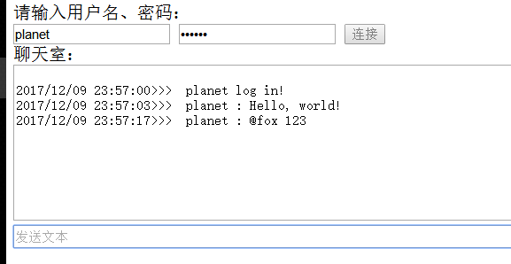
Fox成功收到@：
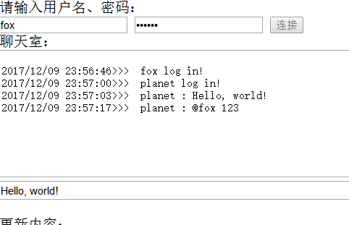
Admin没有收到@：
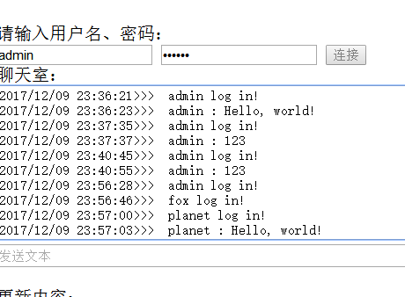
- 公网测试如下：
Admin只能观察到planet的普通发言：
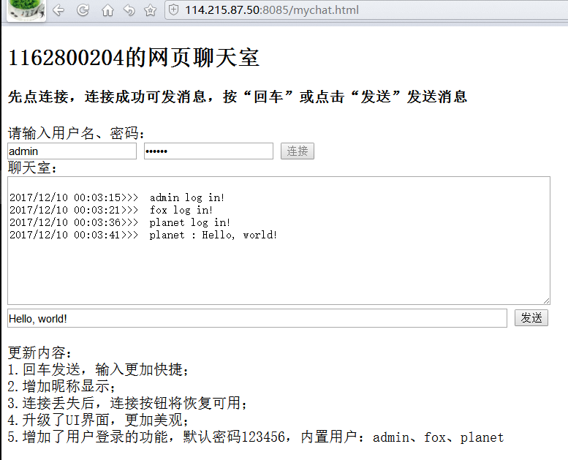
Planet说的@被fox收到了：
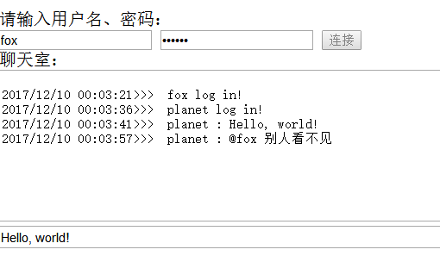

至此，本试验圆满结束！

实验心得(实验过程中遇到的问题如何解决的？本实验的收获？10分） |  |  |  |  |  |  |  |  |  |  | 得分
请填写此处

