**Screen design**

*Design a screen or screens that you think would be suitable for the “Report Card” (or other) program.*

**Keep in mind the information that needs to be displayed on the screen(s).**

**o Use Photoshop, Paint, etc to design the screen(s), and then use PrintScreen to capture your final version of the screen. Copy the screenshot into your word-processed report.**

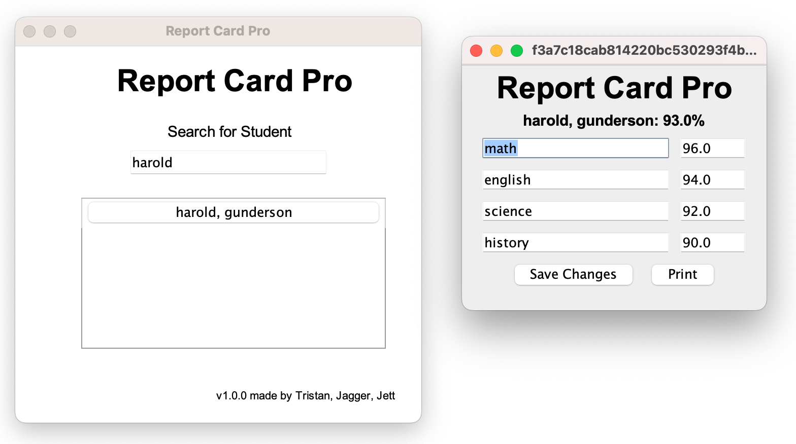

**o Indicate the type of Swing component needed for each item displayed on the screen(s).**

**Appropriate screen messages**

JFrame, JPanel, JLabel, JTextField, etc.

**o Determine the messages that would appear on the screen(s) during different stages of the “Report Card” (or other) program.**

Display the marks, display the grades, save changes button, search for the student, report card pro header, and search input.

**Relevant data to display**

**o What is the important data that needs to be displayed on the screen(s)?**

Students, New Student Button, Remove Student Button, Grades, Courses, Save Changes Button

**Algorithms (customize as needed for alternate programs)**

**o How will the student’s information be stored in an external file to the program and internal to the program?**

The student’s information will be stored in a JSON file

**o How will student information be added to the external file?**

The JSON data will be read and then stored in a cache. The user will be added to the cache, then the cache JSON data will be exported back into the file.

**o How will student information be removed from the external file?**

The JSON data will be read and then stored in a cache. The user will be removed from the cache, then the cache JSON data will be exported back into the file.

**o What variables will be needed in this program?**

UI variables and classes, components variables and classes, students map

**o What are the global variables? Local variables?**

Global: Component Manager, Cache, UI Frame

Local: Student name, id, courses, etc.

**Methods: functions and/or procedures**

**o What functions need to be created for this program?**

UI functions, read/write to JSON file,

**o What events need to be considered?**

Button Clicks, Input changes, page changes, etc.

**o Will the user need a manual to use this program?**

No. Because it’s so easy to use.

**o Will the programmer use internal comments in the program?**

Yes. To describe the functions.