CNN(Convolutional Neuraul Network) Code review

1. First get data from kaggle(or UCI).
2. Get Dogs and cats images, and our goal is to train a model and distinguish whether an image is a dog or a cat.
3. First, we use feature detector to do Convolution, some information can refer to

[A Beginner's Guide To Understanding Convolutional Neural Networks](https://adeshpande3.github.io/adeshpande3.github.io/A-Beginner%27s-Guide-To-Understanding-Convolutional-Neural-Networks/)

1. Max Pooling, preserve main feature, reduce size and prevent overfitting.
2. Adding a second convolutional layer.
3. Flatten outputs of convolutional layer in order to feed into full connection layer.
4. fully connected layer are applied, and the number of outputs depend on how many predictions would be.
5. Not only the weights are trained, but also the feature detectors are trained.

Data:

Lots dogs and cats images from kaggle

Code:

|  |
| --- |
| # Part 1 - Building the CNN  # Importing the Keras libraries and packages  **from** keras.models **import** Sequential  **from** keras.layers **import** Conv2D  **from** keras.layers **import** MaxPooling2D  **from** keras.layers **import** Flatten  **from** keras.layers **import** Dense  # Initialising the CNN  classifier = Sequential()  # Step 1 - Convolution  classifier.add(Conv2D(32, (3, 3), input_shape = (64, 64, 3), activation = 'relu'))  # Step 2 - Pooling  classifier.add(MaxPooling2D(pool_size = (2, 2)))  # Adding a second convolutional layer  classifier.add(Conv2D(64, (3, 3), activation = 'relu'))  classifier.add(MaxPooling2D(pool_size = (2, 2)))  classifier.add(Conv2D(64, (3, 3), activation = 'relu'))  classifier.add(MaxPooling2D(pool_size = (2, 2)))  # Step 3 - Flattening  classifier.add(Flatten())  # Step 4 - Full connection  classifier.add(Dense(units = 128, activation = 'relu'))  classifier.add(Dense(units = 1, activation = 'sigmoid'))  # Compiling the CNN  classifier.compile(optimizer = 'adam', loss = 'binary_crossentropy', metrics = ['accuracy'])  # Part 2 - Fitting the CNN to the images  **from** keras.preprocessing.image **import** ImageDataGenerator  train_datagen = ImageDataGenerator(rescale = 1./255,  shear_range = 0.2,  zoom_range = 0.2,  horizontal_flip = True)  test_datagen = ImageDataGenerator(rescale = 1./255)  training_set = train_datagen.flow_from_directory('dataset/training_set',  target_size = (64, 64),#input size  batch_size = 32, #batch size for updating weights every epoch  class_mode = 'binary')#how many classes  test_set = test_datagen.flow_from_directory('dataset/test_set',  target_size = (64, 64),  batch_size = 32,  class_mode = 'binary')  classifier.fit_generator(training_set,  steps_per_epoch = 8000,  epochs = 25,  validation_data = test_set,  validation_steps = 2000)  **import** numpy **as** np  **from** keras.preprocessing **import** image  test_image = image.load_img('dataset/single_prediction/cat_or_dog_6.jpg', target_size = (64, 64))  test_image = image.img_to_array(test_image)  test_image = np.expand_dims(test_image, axis = 0)  result = classifier.predict(test_image)  training_set.class_indices  **if** result[0][0] == 0:  **print**('cat');  **else**:  **print**('dog'); |

Result:

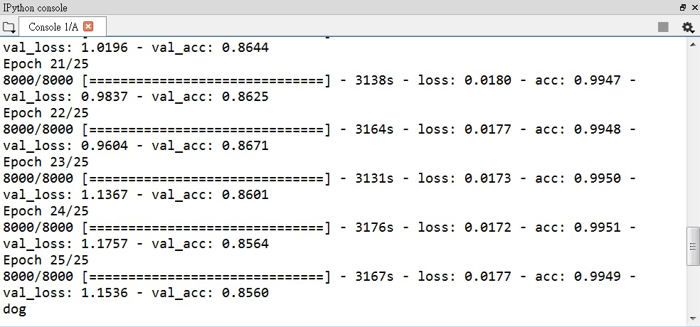

Summary:

Here, we use adam optimizer and cross validation 10 times to reach average 84% accuracy. To adjust the parameter, we can use other optimizer which can refer to [Deep Learning optimizers](https://medium.com/towards-data-science/types-of-optimization-algorithms-used-in-neural-networks-and-ways-to-optimize-gradient-95ae5d39529f), and also we can change batch size, epoch and then use cross validation to find better training model for our test set data.