realXtend: a platform for networked 3d applications

Toni Alatalo
realXtend association

toni@playsign.net

ABSTRACT
Here we present realXtend Tundra SDK, a platform for networked 3d applications. It is suitable for research experiments and education, for example networked multiplayer game development as programming exercises.
Keywords
3d graphics, realtime system, networked application

INTRODUCTION
realXtend is an open source project that develops an application platform, featuring realtime 3d graphics, efficient networking, integrated GUI and user input APIs and scripting.
It has been used for virtual meeting environments, collaborative architectural design and multiplayer gaming.
One of the outcomes of the project is the new Tundra SDK, which was released in early 2011. It is a complete solution, on which application development is very simple. The Tundra SDK is intended for developers who wish to create applications that need realtime graphics rendering, possibly combined with networking for e.g. multiuser functionality.

FEATURES
Tundra SDK is made by integrating a set of open source libraries in a modular framework. These provide the basic functionality for 3d, multimedia and networking. They are divided in two categories: the core API, and optional modules.

Basic functionality
These basic features are provided by the core API, which is always available:
- Ogre3D for graphics rendering
  - OpenGL, DirectX and OpenGL ES renderer plugins. Suitable for desktop and mobile environments.
  - Widely available support for exporting models from other applications
- Qt as the main framework library
  - QApplication based main loop for module updates and rendering
  - Exposing framework APIs and other objects for scripting languages with QtScript (to JavaScript and Python)
  - Framework heavily relies on QObject signal and slot mechanism as its event system
  - Keyboard and mouse input events from Qt translated into our InputAPI events
- kNet for networking
  - KristalliNet, or kNet for short, is a new but quite mature library.
  - Can use either UDP or TCP for transport
  - Supports defining own custom messages
- OpenAL for audio playback
  - Spatial audio support

Additional modules
There is also a set of optional modules, which typically integrate some open source library to implement additional functionality.
The core framework is used to expose these features for scripting as well, so for example VOIP groups for Mumble can be implemented in application specific Javascript.

Currently available modules include:
- XMPP instant messaging and video calls, using the Telepathy library
- Mumble for in-world voice chat (similar to Teamspeak), combined with OpenAL for spatial audio
- OpenAssetimport - for reading mesh files in other formats, including Collada, Wavefront OBJ and PLY
- CAVE support, by rendering multiple viewports
- Text-to-speech synthesis, using the Festival library
- Separate Javascript (with QtScript) and PythonQt scripting support modules. Lua could be added with QtLua.
- Bullet for physics
  - bullet is an open source rigid body physics library from continousphysics.com
  - is used also in several commercial games
  - is also integrated in Blender
- OpenCV for video camera input and machine vision analysis

The reference documentation for both the Core API and the additional modules included in the central repository is in
http://www.realxtend.org/doxygen/ .

The extensible scene model
The aggregation based scene entity model is described in a previous article [1]. In short, it provides the application developer the means to create custom components, which can then be added to any scene entity. That application specific scene data is then automatically synchronized among all participants in the network, and handled when saving or loading scenes from files.

The application can be written in pure Javascript or Python, but still utilize the powerful C++ libraries such as Ogre and Bullet. Or in C++ using the module system there. Javascript applications have the great advantage that the code for them can be downloaded live from the servers, similar to how HTML+JS web pages work.

Usage
Applications are authored as documents which describe the static data and refer to the software modules which implement the application specific functionality. This is similar to HTML, where the static data file can refer to external Javascript files which implement the client side functionality of the web application. The equivalent format for the networked 3d applications in Tundra is called TXML, and there is also a binary serialization format called TBIN.
The platform provides two scene GUI tools for editing the scene: the scene structure window, and the entity-component (EC) editor. The scene window shows all the entities in the scene, and the EC editor shows all the components of the selected entity. This does not differentiate the component types that are available by default and custom components, but they are technically identical in the system so all the basic features work similarly. You can even add new custom components with arbitrary data in the editor, and it then gets automatically synchronized over the network and saved. Figure 1 shows a realXtend demo scene, with these editors open.
Figure 1.A realXtend scene in Tundra, with the scene structure and entity-component editor tools.
At any time, you can save the whole scene state, or part of it, into these file formats for later loading. You can also import multiple scene files into the same scene. The .txml or .tbin files do not need to store whole scenes. You can also store individual scene entities in these files, and later on use a script to instantiate these entities to the world. Tundra does not make a distinction between an object/entity file and a scene file.
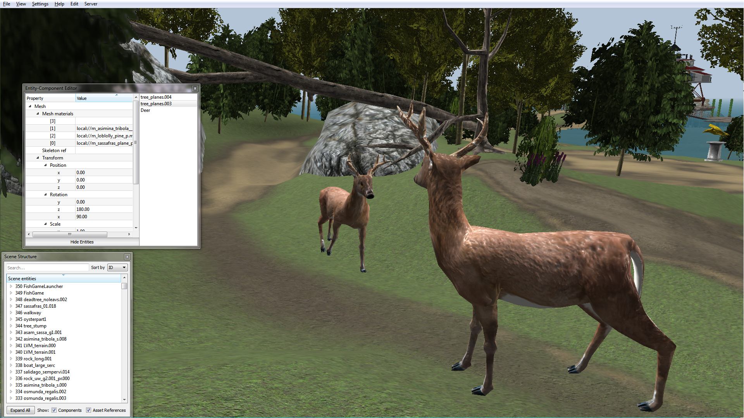Figure 1: A Tundra scene with the scene structure and entity-component editor tools.
Typically, a scene file holds references to several asset files (textures, meshes, etc). Also this is similar to HTML, which supports multimedia via external URI references. Like web browsers, also Tundra can work both with local files and download remote ones with HTTP. To add new 3d models to a scene you can just drag&drop them from the local filesystem or from a web browser. Special applications made on the platform support also adding images, audio and even automatical conversion of powerpoint slides with drag&drop.
In networked settings, the same codebase is used both for running servers and clients. For local single user applications Tundra can run standalone. You can simply click an a scene file to launch that application.

Example applications
There is a growing set of example applications in the code repository: https://github.com/realXtend/naali/blob/tundra/bin/scenes/ .
This video demonstrates several of the basic ones: http://www.youtube.com/watch?v=Wg6SAQPW-9k

Relevance for multimedia and education
The Tundra SDK makes developing 3d and/or networked applications relatively easy, without giving away any of the power. This can be very useful for research experiments and learning exercises. For example, one person at the Oulu university technical faculty has built a CAVE setup and integrated own custom controllers and logic to it in Python in a few months time, without any previous experience about the platform or similar technologies. That will be his diploma thesis work.
Another diploma thesis was completed last year, on the field of information visualization. In that work the student wrote a module which automatically creates a 3d scene based on the information about any given software project. More information and a video are available in a blog post, "Visualising Software Projects using OpenSim Virtual World Server", http://blog.knowsense.co.uk/blog/_archives/2010/12/20/4707937.html and a screenshot is here in figure 2.
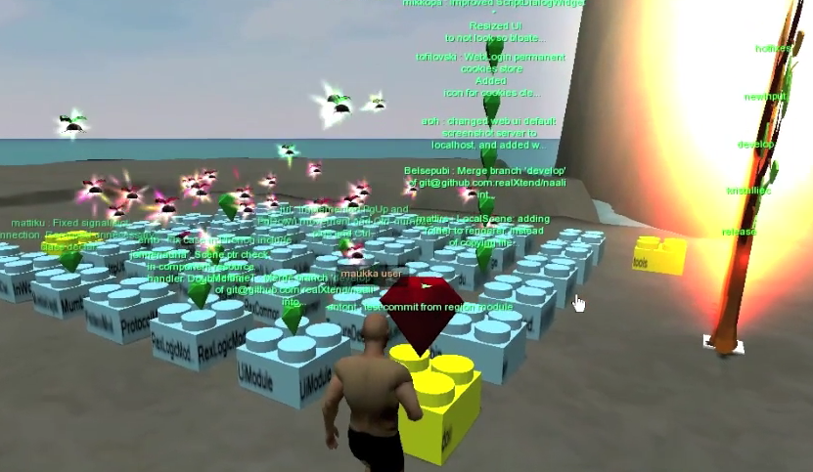Figure 2: Tundra software project as an automatically generated 3d scene, using the info from source code version control, issue tracker, and build bot status.
realXtend combines many media technologies: 3d graphics, 3d spatial audio, streaming voice over the net (Mumble VOIP), xmpp instant messaging. Additionally, during spring 2011 developers at Adminotech are adding new modules for video camera input and augmented reality functionality (e.g. drawing virtual objects on top of real ones, selectively). We've also experimented with machine vision based head tracking, and now using Kinect.
One idea is to use Tundra for teaching programming. The immediacy of the execution combined with the highly visual outcomes can be a fun way to learn, similar to how Scratch is used even by small children. Developing with Javascript in local Tundra works so that can just edit the code in your favorite editor, save the file when want to apply the changes, and see the result automatically immediately in the graphical view which can have open on the side. The asset system monitors the file system for changes in the files used in the current scene. Same live reloading works also for 3d models, images and qt ui files.
This video demonstrates it with editing the Javascript source of the minimal pong example while the game is running: http://www.youtube.com/watch?v=ty8LdX80KaE
realXtend is also one of the official platforms of the Immersive Education initiative. This video shows a Maryland blue crab in realXtend, Open Wonderland and Sirikata: SNEAK PEEK : Smithsonian 3D blue crab in 3 virtual worlds http://www.youtube.com/watch?v=cUKuDnEMuAk&NR=1

CONCLUSION
realXtend Tundra SDK provides a feature rich entirely open source toolkit for multimedia applications. The main purpose is to support networked 3d applications well. But it is also simple to use for other purposes, for example just combining local video camera input with some custom control logic written in javascript in a standalone application. On the other hand, native code can be used too for example when need custom udp messaging or efficient 3d geometry processing.
For more information, see http://www.realxtend.org/ .
The source code is available at https://github.com/realXtend/naali

REFERENCES
- Alatalo, T. 2011. An entity-component model for extensible virtual worlds. Upcoming in the IEEE Internet Computing magazine, special issue on next generation virtual world architectures. Draft available at https://github.com/realXtend/doc/raw/master/arch_article/simple.pdf

