**Plotting graphs in Excel (2)**

**Example 1:**

Plot a graph of **in the domain from *x = 0* to *x = 360°* using intervals of 30°

1. Using this interval size, set out the x-values as follows: *0, 30, 60, 90, 120 etc*

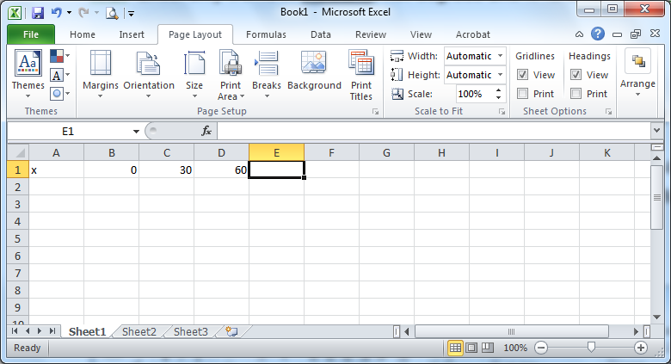

Fig 1.

1. Calculate the set of y-values by entering the following formula into cell B2:

**=4*sin(radians(B1))** as shown (Fig. 2):

**Note 1:** The formula comes from the right-hand side of the function** Instead of **, we use where the first ** value is located (i.e. cell B1). We also must use the * in Excel to explicitly state multiplication.

**Note 2:** Excel only works in **Radians**, not degrees. To use the sin or cos function in Excel we must convert our degrees value to radians. The Excel function **radians( )** does this for us.

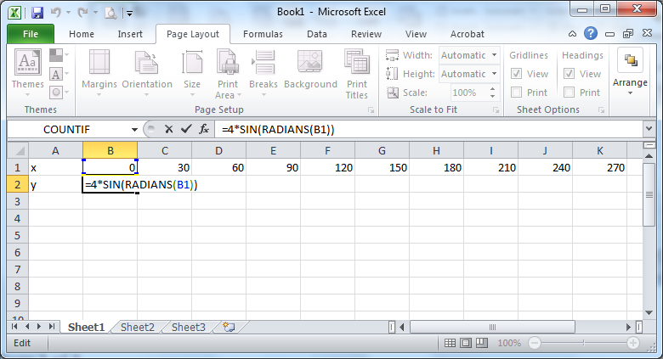

Fig 2.

1. The formula may be copied along row 2 by moving the cursor to the bottom right-hand corner of cell B2 until a black cross (**+)** appears. Drag this cross along row 2 and drop it at cell N2. This produces the following set of values for row 2 in Fig. 3 below:

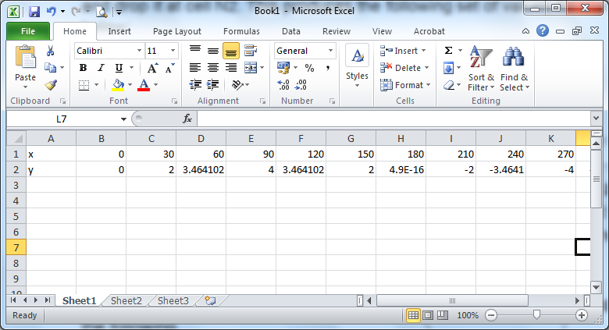

Fig. 3

**Note:** There are 2 strange looking numbers in cells H2 and N2. These numbers are in Standard Form (e.g. 4.9E-16 means**, which is a very small number i.e. virtually zero). We can interpret this number to be *exactly* zero because ** in Excel is stored only as an approximation due to the fact that **is an irrational number with an infinite number of decimal places and hence can only be approximated by a computer!!

So, in effect, these strange looking numbers can be simply ignored!

1. Now, refer back to last week’s handout to draw and customise the graph to give the following.

**Now plot the graphs of the following yourself.**

**Q1. Plot the graph of y = cos3x for values 0 ≤ x ≤ $360°$ using intervals of $30°$ What is the amplitude? What is the period?**

**Q2. Plot the graph of y = 4sin2x for values 0 ≤ x ≤ $360°$ using intervals of $20°$**

**What is the amplitude? What is the period?**

**Q3. Plot the graph of y = 2cos(x + 30°) for values 0 ≤ x ≤ $360°$ using intervals of $30°$. What is the amplitude? What is the period?**

**Q4. Plot the graph of y = 3sin(2x + 10°) for values 0 ≤ x ≤ $360°$ using intervals of $20°$. What is the amplitude? What is the period?**