**Plotting graphs in Excel – Stage 1**

**Example 1:** Plot a graph of y = x2 in the domain from x = -3 to x =3

Solution:

1. Set out the x-values as shown in row 1 of Fig. 1
2. Calculate the y-value that squares each x-value as follows: To enter a formula in Excel, highlight the cell where the answer is required (i.e. B2 in this example) and type: **=B1^2** as shown:

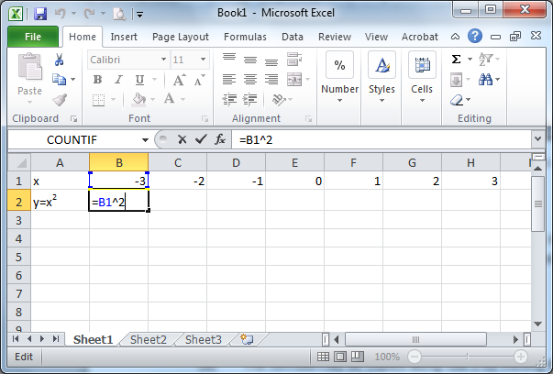

Fig. 1

1. The formula may be copied along row 2 by moving the cursor to the bottom right-hand corner of cell B2 until a black cross (**+)** appears. Drag this cross along row 2 and drop it at cell F2. This produces the following set of values for row 2 in Fig. 2 below:

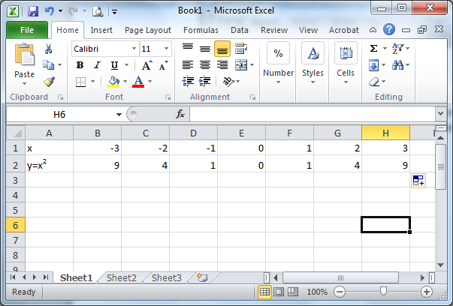

Fig. 2

1. Highlight both rows 1 & 2 using the mouse as shown in Fig. 3 and click on **Insert** from the set of main menu options at the top of the screen. Then choose Scatter (graph type).

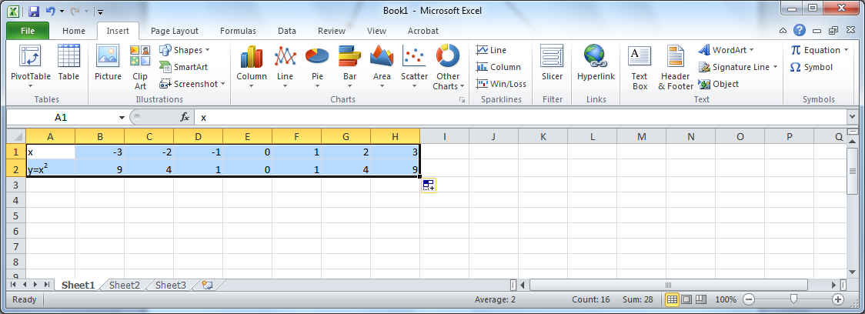

Fig. 3

1. From the 5 graph types that drop down, choose the one on the top right (Scatter graph with smooth lines and markers). This produces the following graph on your Excel spreadsheet automatically:

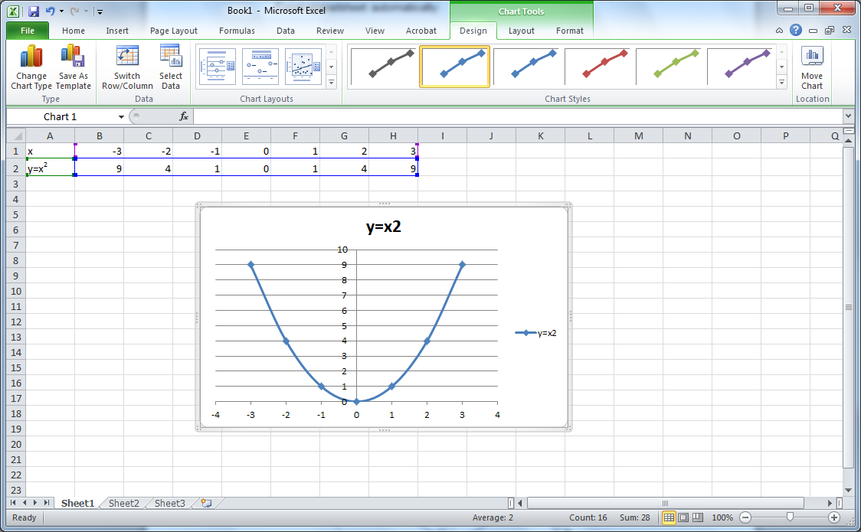

Fig. 4

1. You can move your graph by clicking and dragging it to a desired location – (Try it). Customise your graph by clicking it, which produces a new set of **layout** menu options at the top of your screen as shown in Fig. 5 below:

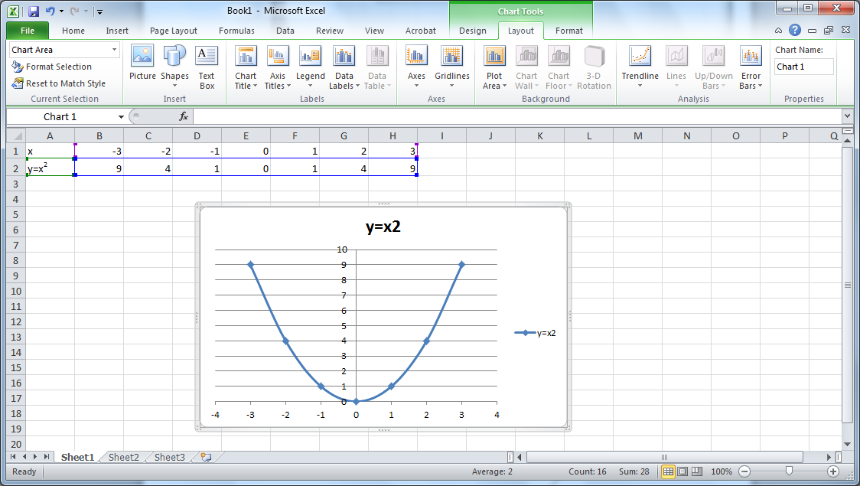

Fig. 5

1. Customise your graph so that it looks like the one below (Fig. 6).

Fig. 6

**Note:**

1. You can change the title by clicking on it and re-typing it
2. You can add/remove the gridlines by choosing:

**Gridlines** -> **Primary Horizontal Gridlines** -> **etc**

1. You can insert an X axis label by choosing:

**Axis Titles** -> **Primary Horizontal Axis Title** -> **Title below axis**

(This can be moved around and edited also)

**For the following graphs:**

* **Use values of x in the range -5 to 5.**
* **Use a relevant chart title, label axes etc**
* **Use a new sheet for each graph renaming the sheet to (a), (b), etc**

(a) y = 4x + 7

(b) y = x2 + 6x + 3

(c) y = 3x2 -5

**Example 2:** Use Excel to plot the graph of y = 2x + 6 and y = 2x2 + 5x – 3 for values of x in the range x = -4 to x = +4. Use your graph to find the intersection of the graphs.

**Solution:** (i)Set up the x values in row 2 as shown in screen shot below.

(ii) In cell B3 enter the following formula **=2*B2 + 6** and use autofill to copy this formula in the cell range C3 to J3.

(iii) In cell B4 enter the following formula **=2*B2^2 +5*B2 – 3** and use autofill to copy this formula in the range C4 to J4.

(iv) Highlight the cell range A2 to J4 using the mouse and click on **Insert** from the set of main menu options at the top of the screen. Then choose **Scatter** (graph type).

(v) From the 5 graph types that drop down, choose the option **Scatter graph with smooth lines and markers**. This produces the following graph on your Excel spreadsheet automatically:

(vi) Label axis etc as above.

(vii) Read of the intersection (approximate) of the two graphs yourself from the screen.

|  |  |  |
| --- | --- | --- |
| **x** | -3 | 1.5 |
| **y** | 0 | 9 |

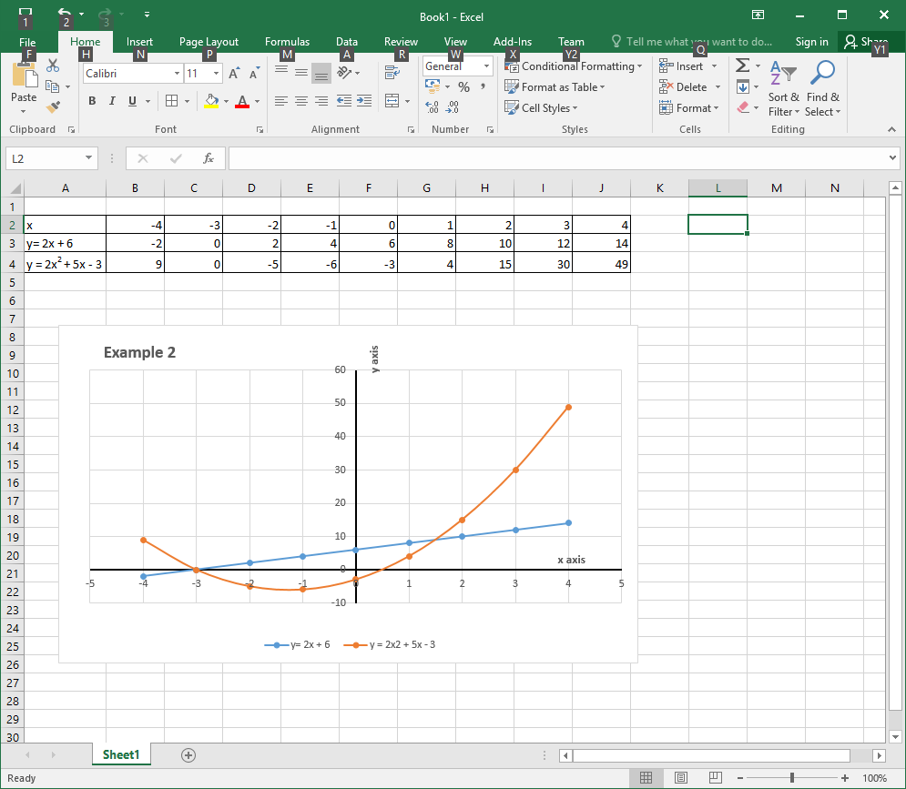

**Example 3:** Use Excel to plot the graph of y = 2e0.5x for values of x from x = -2 to x = +8.

**Solution:** (i) Set up the x values in row 2 as shown below.

(ii) In cell B3 enter the following formula **=2*exp(0.5*B2)** and use autofill to copy this formula in the cell range C3 to L3.

(iii) Create the graph as in the previous examples and label axes etc.

